**Week 2: Working With Wireframe**

**Aim:**

Create a wireframe for your given project as a preliminary design tool to outline the structure and functionality of your project.

A wireframe is a simplified visual representation that shows the layout and elements of a project, such as a website or app, before detailed design and development.

Review the project goals and features. Draft a basic structure with key elements. Use wireframing tools to create a detailed version. Show how users will interact with the project. Refine based on feedback. Provide a brief description of the wireframe and its elements.

A clear wireframe and a document explaining the design and functionality.

**Screenshot :**

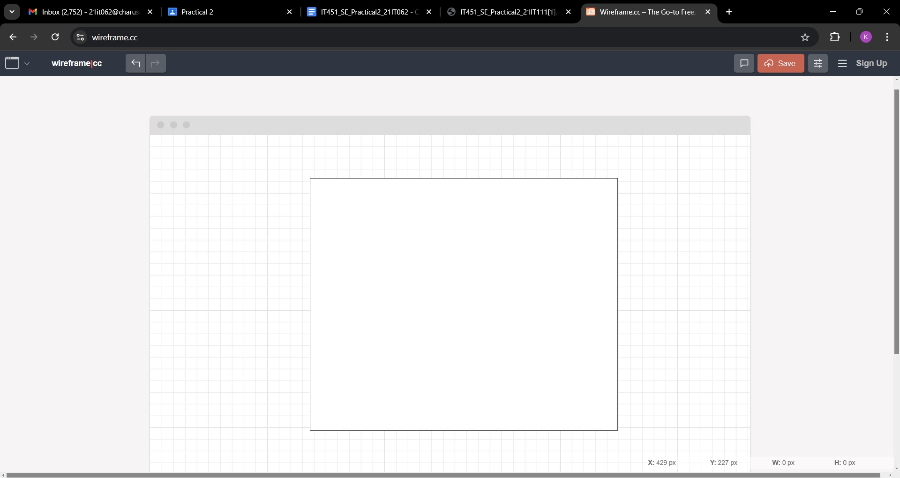

**Figure 2.1: Getting started with wireframe.cc and firstly create a structure for the project**

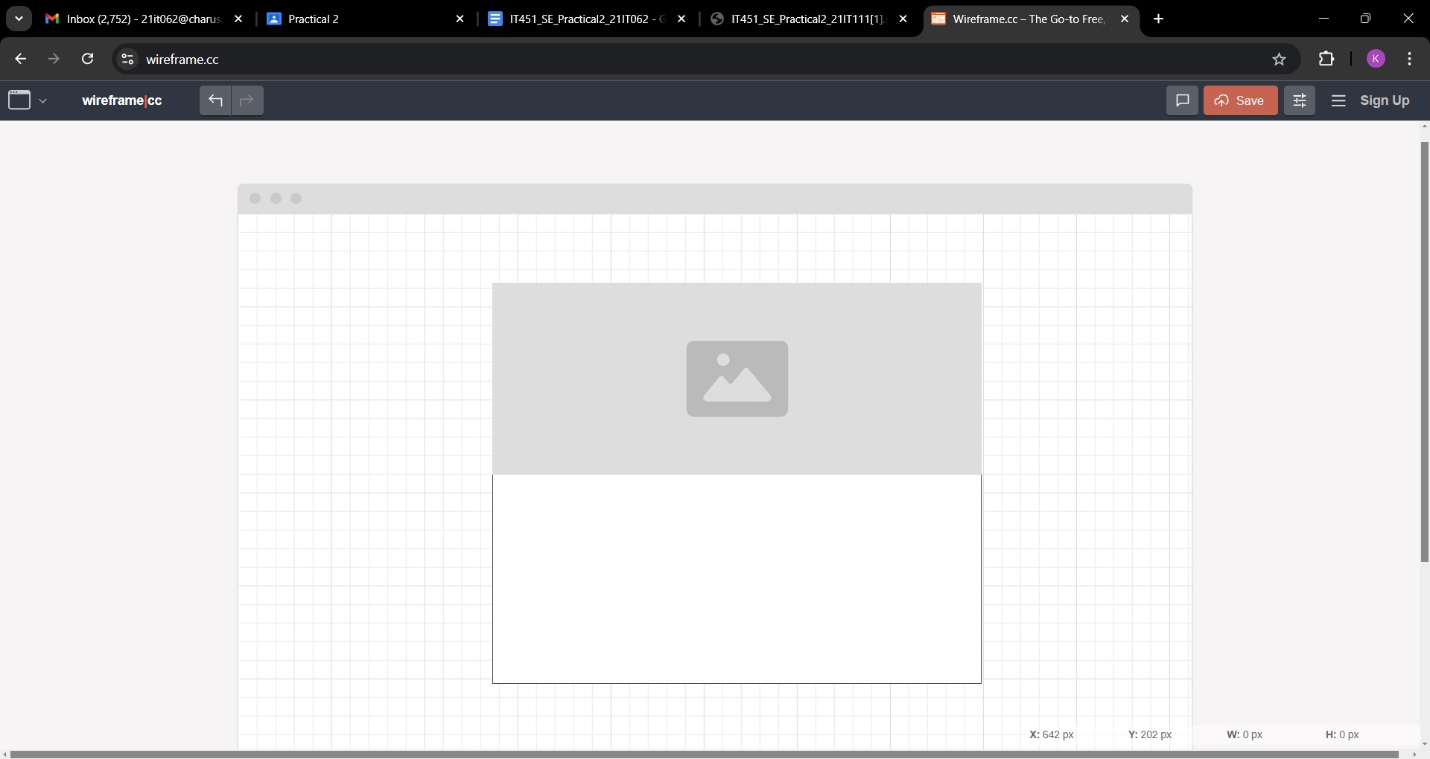

**Figure 2.2: Inside the structure add the image box**

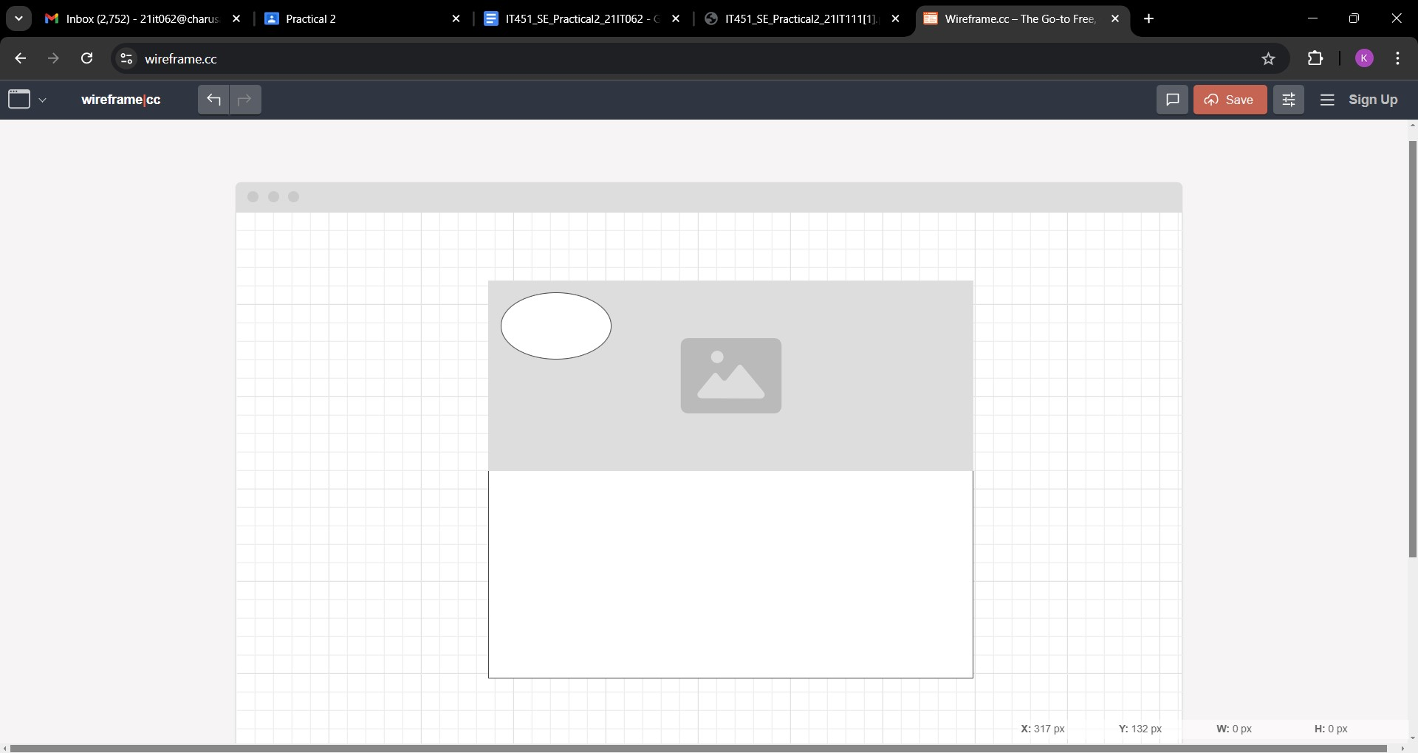

**Figure 2.3: Now add the logo at the header**

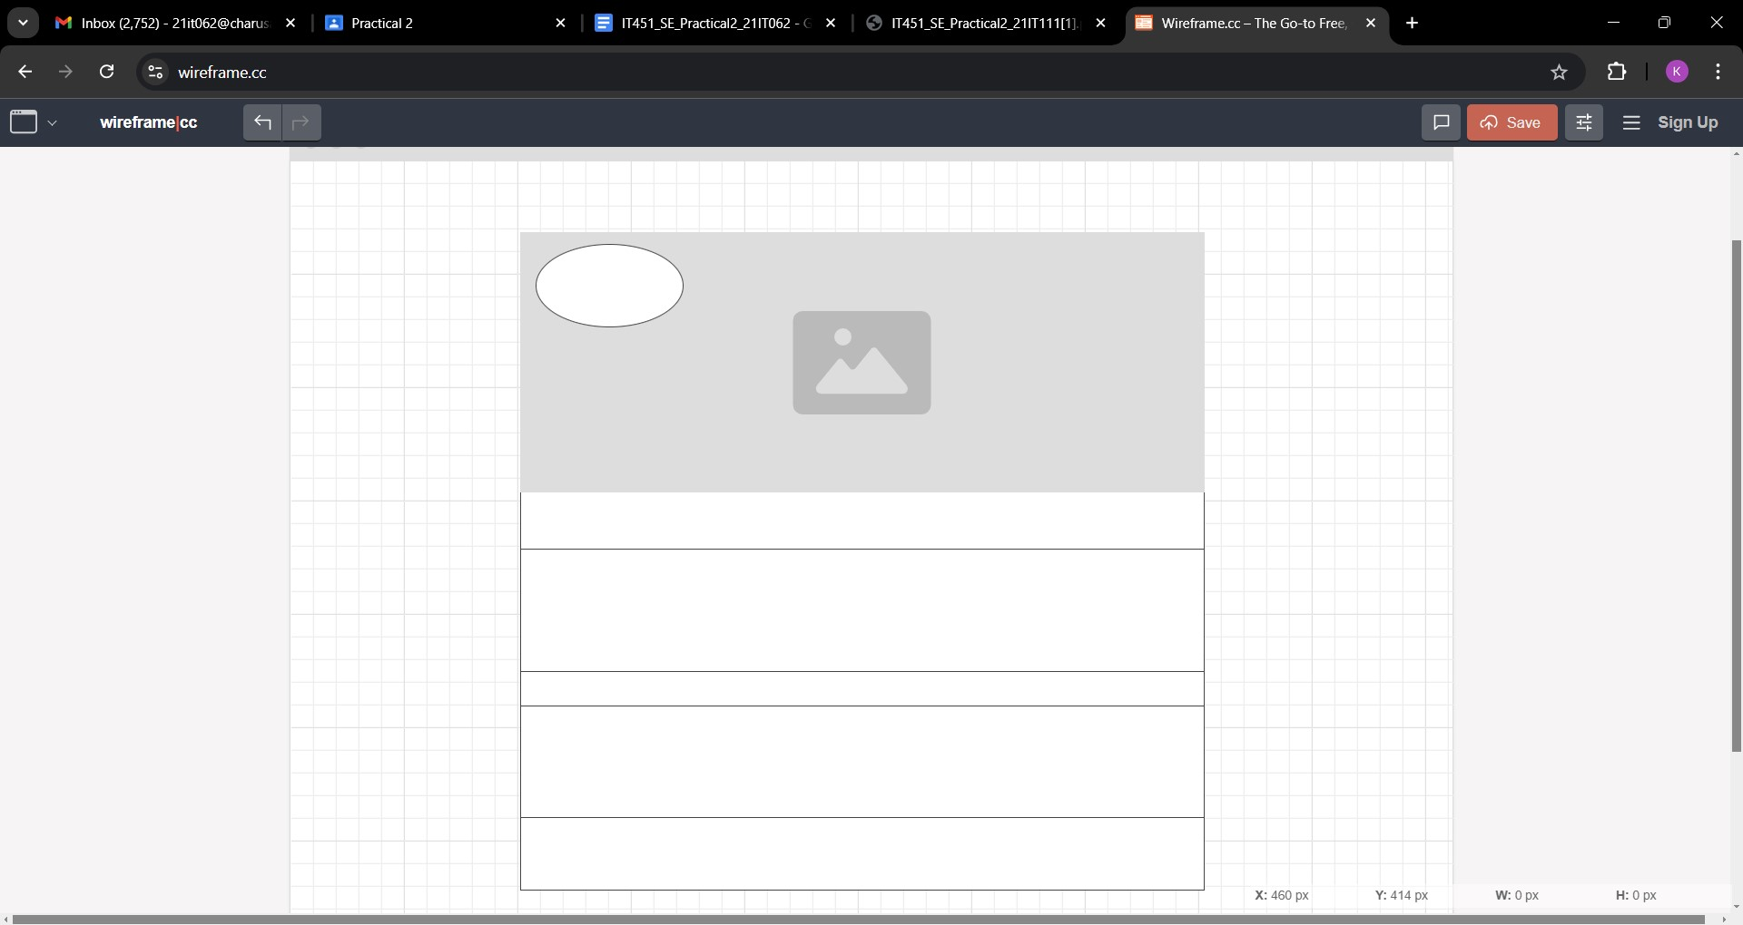

**Figure 2.4: Create buttons for Username and Password field**

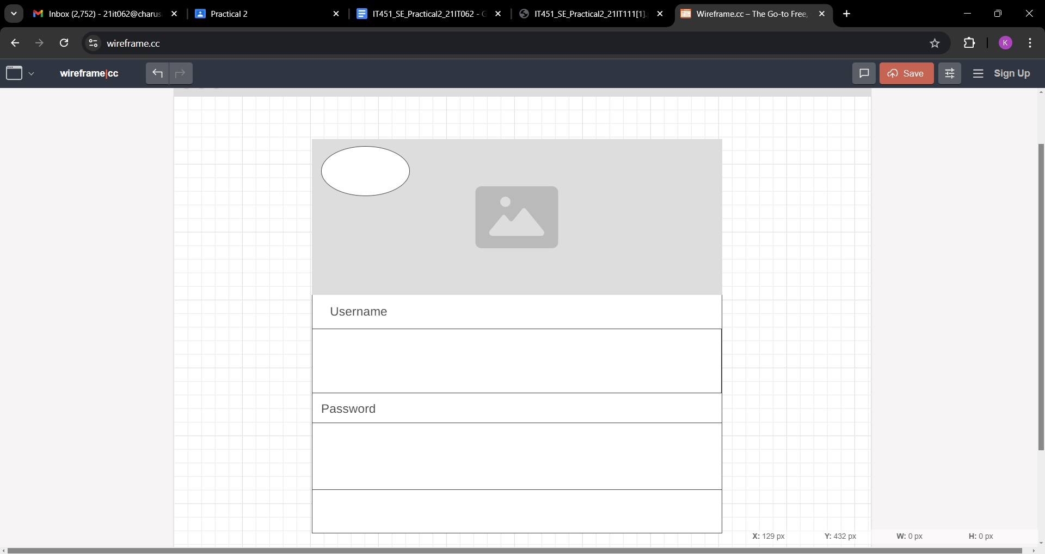

**Figure 2.5: Getting started with wireframe.cc and firstly create a structure for the project**

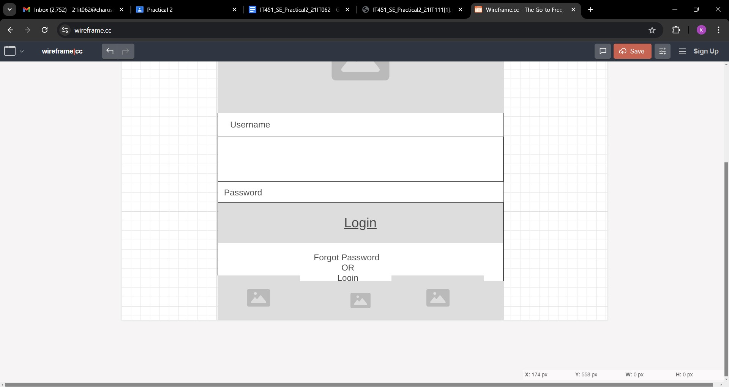

**Figure 2.6: Now add the “Sign up with” field with where to add the three logos. So the basic structure is ready**

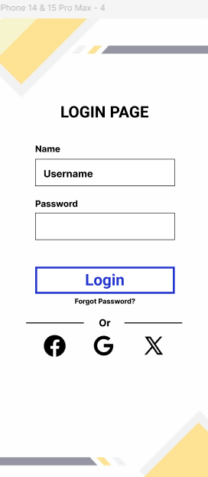

**Figure 2.7: Wireframe outline structure and detailed project**

**Figma:**

https://www.figma.com/design/nc07G7aDCm8PCGJg3O7fXI/Untitled?node-id=0-1&t=3vVP5AZBzeWHpzLg-0

**Wireframe.cc:** <https://wireframe.cc/>

**Learning Outcome:**

In this practical exercise, I developed a comprehensive understanding of wireframe design through the use of wireframe.cc and Figma. I learned to assess project goals and features to draft a basic structure featuring key elements. Using wireframing tools, I created detailed visual representations, emphasizing user interaction and incorporating feedback to refine the design. This process ensured that the design effectively met user needs. The experience significantly improved my ability to visualize and plan a project's layout before progressing to detailed design and development.