EcoEnergy AI
AI-Powered Smart Campus Energy Consumption Prediction and Optimization System
1M1B AI for Sustainability Virtual Internship

Student Name: MANAN SUTARIYA
College Name: SARDAR VALLABHBHAI PATEL INSTITUTE OF TECHNOLOGY, VASAD

Contents
1. Project Description
2. SDG Alignment
3. Problem Statement
4. Target Users
5. Design Thinking Approach
6. AI Solution Overview
7. System Workflow
8. Dataset and Data Preparation
9. Exploratory Data Analysis
10. Machine Learning Models
11. Model Evaluation and Results
12. Future 12-Month Forecast
13. Potential Anomaly Detection
14. AI-Assisted Sustainability Recommendations
15. Prototype / Demo
16. Responsible AI Considerations
17. Expected Impact
18. Impact Statement
19. Limitations
20. Future Scope
21. Conclusion

1. Project Description

1.1 Project Title
“EcoEnergy AI — AI-Powered Smart Campus Energy Consumption Prediction and Optimization System”

1.2 Project Overview
EcoEnergy AI is a sustainability-focused AI prototype designed for the smart-campus context. Its purpose is to demonstrate how historical electricity data can be converted into useful information for energy planning. The system studies past electricity values, learns patterns using machine learning, predicts future values, identifies potential unusual observations, and produces simple recommendations for energy-management teams.
The project is intentionally designed as a decision-support system. It does not automatically control electrical equipment. Instead, it gives information that a campus administrator or energy-management team can review before taking action.

1.3 Objectives
- Understand historical electricity patterns.
- Prepare time-series data for machine-learning forecasting.
- Train and compare two machine-learning models.
- Select the better-performing model using evaluation metrics.
- Forecast electricity values for the next 12 months.
- Identify potential unusual electricity patterns.
- Generate simple sustainability-oriented recommendations.
- Demonstrate responsible and transparent use of AI.

2. SDG Alignment

2.1 Primary SDG — SDG 7: Affordable and Clean Energy
SDG 7 is the primary SDG for EcoEnergy AI. The project connects AI with energy management by showing how electricity data can be analyzed and forecasted. Better information can help an institution plan energy use more carefully and identify periods that need attention.

2.2 Secondary SDG Connections
- SDG 11 — Sustainable Cities and Communities: a campus is part of the wider built environment and can improve resource efficiency.
- SDG 13 — Climate Action: better energy management can contribute to sustainability and climate goals when actual energy and emissions data are available.
SDG 7 remains the main focus of the project. The other SDGs are supporting connections rather than the main project target.

3. Problem Statement

3.1 Problem
Educational campuses use electricity for classrooms, laboratories, offices, lighting, cooling, computers, and other facilities. Electricity requirements can change from month to month. Some changes may be normal seasonal behavior, while others may be unusual.
If historical electricity data is only viewed after consumption occurs, it is difficult to use that information for forward planning. A forecasting system can provide an estimate of future electricity values and help decision-makers review periods that may require attention.

3.2 Current Gap
- Historical electricity data does not automatically provide a forecast of future demand.
- Long time-series data can be difficult to interpret manually.
- Unusual observations may not be obvious without comparison against an expected value.
- Campus teams need simple information that can support practical energy decisions.

3.3 How-Might-We Statement
How might we use AI to predict and analyze electricity values so that educational institutions can make better and more sustainable energy-management decisions?

4. Target Users
Target User | Problem / Need | How EcoEnergy AI Helps
Campus administration | Needs information for energy planning. | Provides future forecasts and simple summaries.
Facility / energy-management team | Needs to identify periods that require review. | Shows historical patterns and potential anomalies.
Sustainability team | Needs evidence for sustainability planning. | Provides data-based energy insights.
Students and staff | Need greater awareness of responsible energy use. | The project demonstrates how energy data can support sustainability awareness.

5. Design Thinking Approach

5.1 Empathize
The project starts with the people who manage or are affected by campus energy use. Campus administrators and facility teams need to understand changing electricity demand. Sustainability teams need information that can support energy-efficiency planning.

5.2 Define
The defined problem is the lack of a simple forward-looking approach for understanding electricity patterns and identifying periods that may need attention.

5.3 Ideate
The proposed idea combines prediction, pattern analysis, anomaly detection, and decision support. These uses are suitable because the internship guideline allows AI to be used for prediction, pattern detection, and decision-making support.

5.4 Prototype
The Jupyter Notebook is the working prototype. It demonstrates the complete process from data loading to forecasting and recommendations.

5.5 Test and Refine
Two models are tested on later observations that were not used for training. Their performance is compared using MAE, RMSE, and R². The project also clearly identifies the limitations of the current dataset instead of presenting it as real campus-meter data.

6. AI Solution Overview
The main AI task in EcoEnergy AI is electricity forecasting. The model learns from previous electricity values and time information. The project also uses the model's prediction errors to identify potential unusual observations.
AI Component | What it does | Project Output
Prediction | Learns historical patterns to estimate future values. | 12-month forecast
Pattern detection | Studies yearly and monthly changes. | Trend and seasonal graphs
Anomaly detection | Finds observations with unusually large prediction errors. | Potential anomaly alerts
Decision support | Turns results into simple recommendations. | Energy-management suggestions

6.1 Why AI is Needed
A normal chart describes what happened in the past. Machine learning adds a forward-looking component by learning relationships in the historical data and producing predictions. This can make the information more useful for planning.

7. System Workflow
The EcoEnergy AI prototype follows this workflow:
- Historical electricity dataset
- Data checking and preprocessing
- Historical, yearly, and monthly pattern analysis
- Feature engineering using time and previous electricity values
- Time-based train/test split
- Random Forest and Gradient Boosting training
- Model evaluation using MAE, RMSE, and R²
- Selection of the better-performing model
- Next 12-month forecasting
- Potential anomaly detection
- Sustainability recommendations

8. Dataset and Data Preparation

8.1 Dataset Description
The prototype uses the uploaded Electric_Production.csv dataset. It contains 397 monthly observations and two columns: DATE and Value.
Property | Result
Records | 397
Columns | 2
Columns used | DATE and Value
Frequency | Monthly
Start date | January 1985
End date | January 2018
Missing values | 0
Duplicate rows | 0
Mean | 88.847218
Standard deviation | 15.387834
Minimum | 55.315100
Maximum | 129.404800

8.2 Data Preprocessing
- The DATE column was converted from text into a date format.
- The Value column was treated as a numeric value.
- Rows with missing date or value were removed if present.
- The data was sorted in chronological order.
- No missing values or duplicate rows were found in the uploaded dataset.

8.3 Important Dataset Limitation
The dataset contains only date and electricity-value information. It does not contain campus building names, occupancy, weather, HVAC usage, appliance-level data, electricity prices, or personal information. Therefore, the project uses this dataset to demonstrate the forecasting method, not to claim that the values are actual measurements from a specific campus.

9. Exploratory Data Analysis

9.1 Historical Electricity Trend
The historical graph shows changes in electricity values across the complete dataset. The values vary over time and show a general increase from the earlier part of the dataset toward the later years. This confirms that a simple constant-value assumption would not describe the entire series well.
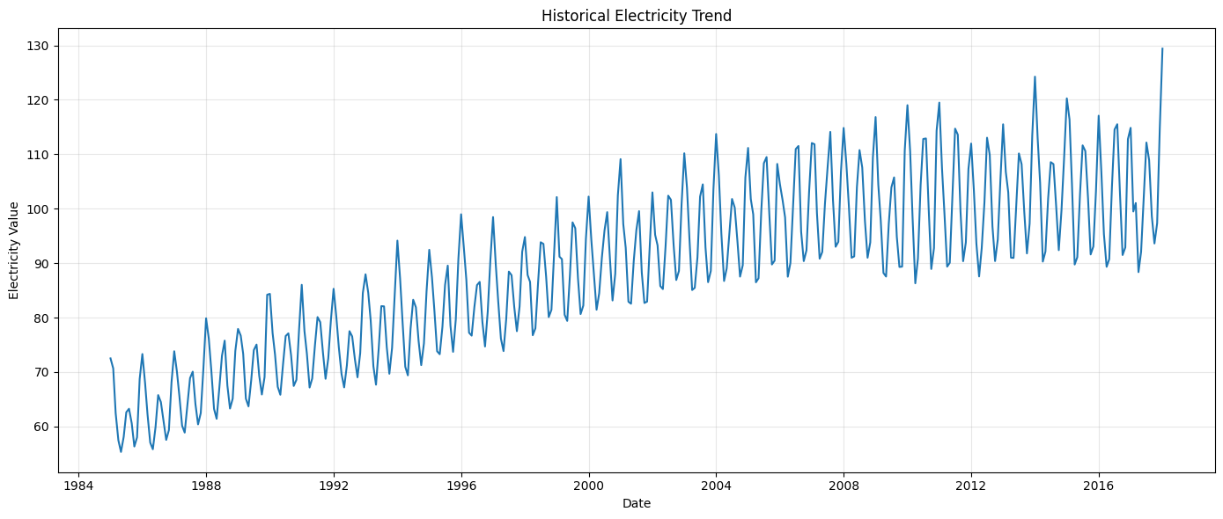
Figure 1. Historical electricity trend.

9.2 Yearly Average Trend
The yearly average values generally increase over the dataset period. For example, the average value for 1985 is approximately 62.17, while the average for 2017 is approximately 101.94. The January 2018 value is only one observation, so it should not be treated as a full-year average.
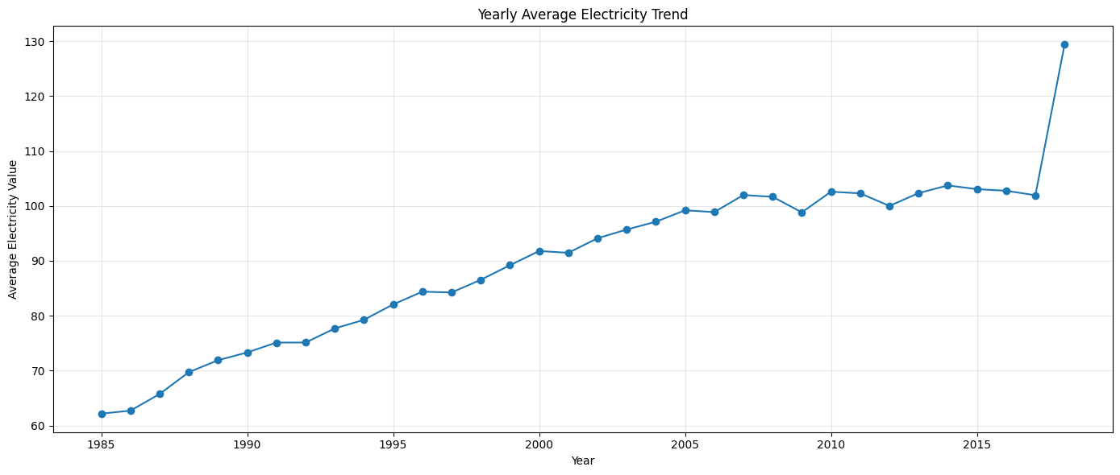
Figure 2. Yearly average electricity trend.

9.3 Monthly Pattern
The monthly analysis shows a repeating pattern. January has the highest average monthly value at approximately 102.10, while April has the lowest at approximately 79.13. This supports including the month as a model feature and using previous-year information.
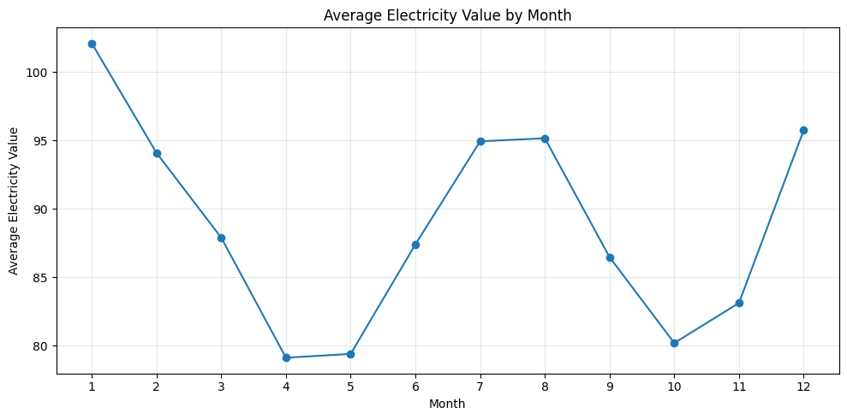
Figure 3. Average electricity value by month.

10. Machine Learning Models

10.1 Feature Engineering
The model needs useful inputs that describe the time series. The project creates year and month features, lag features, and rolling averages.

Feature | Meaning
Year | Calendar year.
Month | Month number from 1 to 12.
Lag_1 | Previous month's value.
Lag_2 | Value from two months earlier.
Lag_3 | Value from three months earlier.
Lag_6 | Value from six months earlier.
Lag_12 | Value from twelve months earlier.
Rolling_Mean_3 | Average of the previous three values.
Rolling_Mean_6 | Average of the previous six values.
Rolling_Mean_12 | Average of the previous twelve values.
Creating these features reduced the usable dataset from 397 to 385 records because the first observations do not have enough previous values to calculate all lag features.

10.2 Training and Testing
The data was divided chronologically rather than randomly. The first 308 usable records were used for training and the last 77 records were used for testing. The training period is January 1986 to August 2011, while the testing period is September 2011 to January 2018.
This approach is important because the model should learn from the past and then be tested on later data. Randomly mixing future and past observations could give an unrealistic evaluation.

10.3 Random Forest
Random Forest is a machine-learning method that combines many decision trees. The project uses 500 trees. It can learn non-linear relationships between historical values and the target.

10.4 Gradient Boosting
Gradient Boosting builds models one after another, with each new model trying to improve the errors made by earlier models. The project uses 300 boosting stages with a learning rate of 0.03.

11. Model Evaluation and Results

11.1 Evaluation Measures
- MAE — Mean Absolute Error: the average size of the prediction error. Lower is better.
- RMSE — Root Mean Squared Error: gives greater importance to larger errors. Lower is better.
- R² Score: indicates how much variation in the target is explained by the model. Higher is better.

11.2 Results
Model | MAE | RMSE | R² Score | Selected?
Random Forest | 2.981245 | 4.127173 | 0.813956 | Yes
Gradient Boosting | 3.226218 | 4.288972 | 0.799083 | No
Random Forest was selected because it had the lower MAE and RMSE and the higher R² score. Its RMSE was approximately 4.1272 and its R² score was approximately 0.8140.
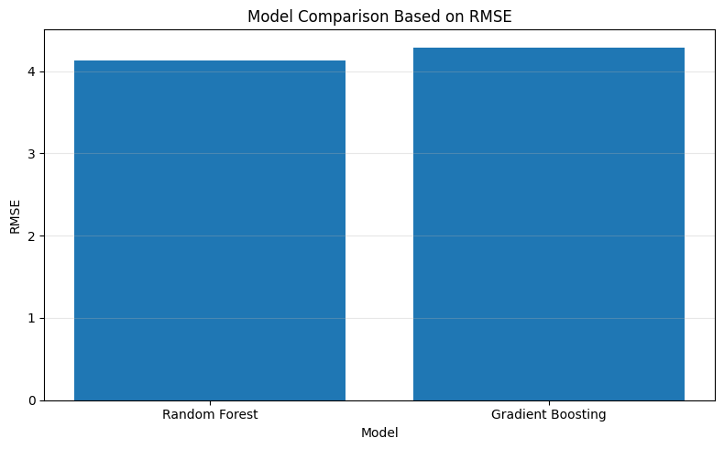
Figure 4. RMSE comparison between the two forecasting models.

11.3 Actual vs Predicted
The actual-versus-predicted graph compares the model's predictions with the real test-period values. The prediction follows the broad movement of the actual series, while differences remain at some points. These differences are normal in forecasting and are one reason why the model is evaluated using numerical error measures.
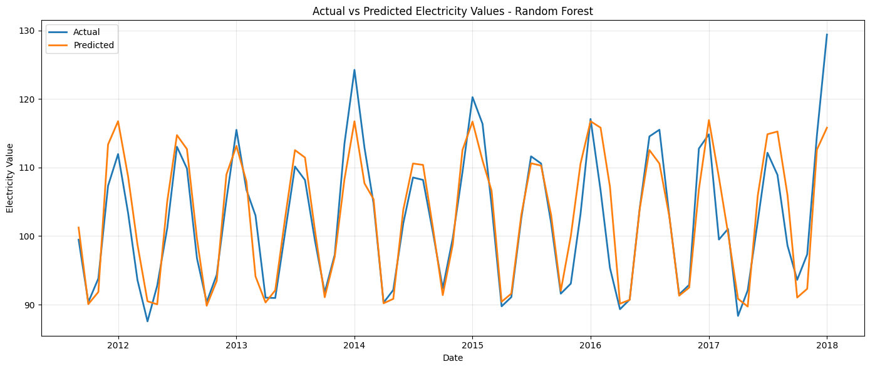
Figure 5. Actual versus predicted electricity values.

12. Future 12-Month Forecast
After selecting Random Forest, the project uses it to estimate the next 12 monthly values. The forecast starts after January 2018 and covers February 2018 through January 2019.
Month | Predicted Value
February 2018 | 102.6172
March 2018 | 101.2804
April 2018 | 90.5540
May 2018 | 91.6578
June 2018 | 104.3042
July 2018 | 113.2972
August 2018 | 110.1450
September 2018 | 99.8092
October 2018 | 92.8534
November 2018 | 98.8591
December 2018 | 114.7395
January 2019 | 116.5736
The average forecast is approximately 103.06, compared with the historical average of approximately 88.85. The highest forecasted value is approximately 116.57 in January 2019.
These numbers are model estimates. They should not be treated as guaranteed future measurements, especially because the dataset is not campus-specific.
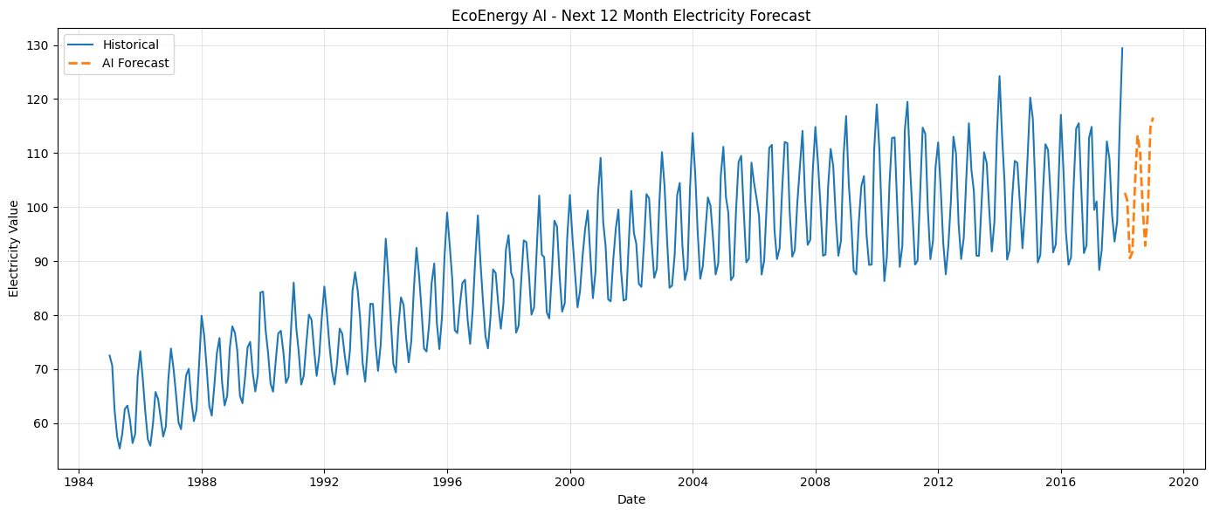
Figure 6. Historical electricity values and the next 12-month forecast.

13. Potential Anomaly Detection
The prototype also checks whether actual test-period values are unusually different from the model's predictions. The absolute prediction error is compared with a threshold equal to 2.5 times the standard deviation of the training errors.
The calculated threshold is approximately 3.7274. Using this rule, 21 test-period observations were marked as potential anomalies.
A potential anomaly does not mean that the campus has a fault. It only means that the observed value was unusually different from what the model expected. A person should investigate the cause.
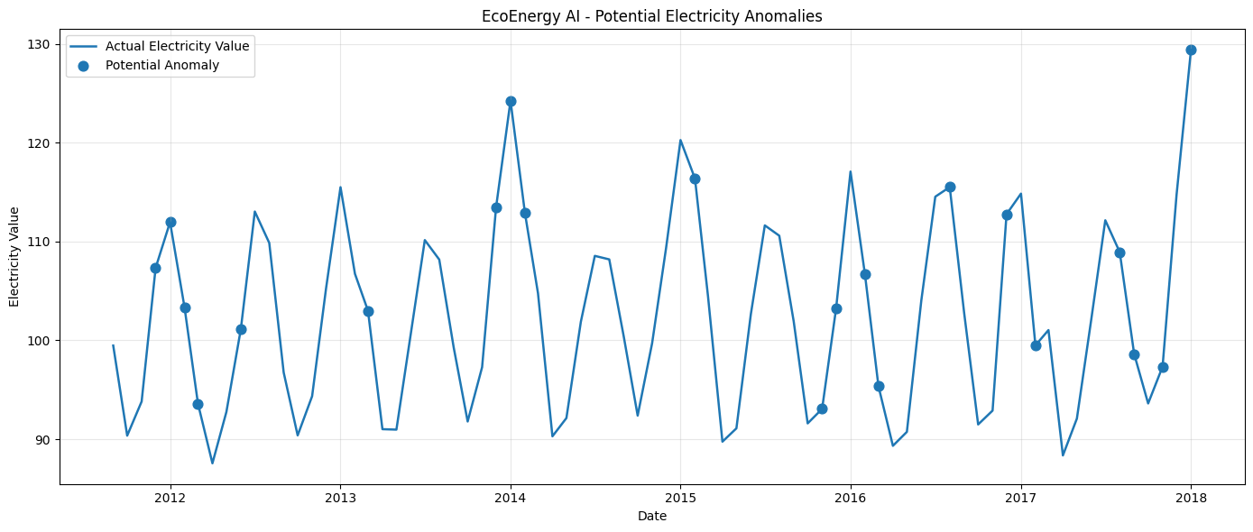
Figure 7. Potential electricity anomalies identified using prediction error.

14. AI-Assisted Sustainability Recommendations
The notebook converts the forecast and anomaly results into simple decision-support suggestions. The historical average is approximately 88.85, while the forecast average is approximately 103.06. Because the forecast average is higher, the system suggests that energy-intensive operations should be reviewed during higher-demand periods.
- Review HVAC, lighting, laboratory equipment, and other energy-intensive systems during periods of higher expected demand.
- Use the forecast to plan energy-saving checks before high-demand periods occur.
- Investigate potential unusual electricity patterns to determine whether they are caused by normal operations, unusual demand, or data issues.
- Treat all recommendations as decision support rather than automatic instructions.
The prototype does not automatically switch equipment on or off. This is important because the model is intended to support human decisions, not replace responsible campus management.

15. Prototype / Demo
The Jupyter Notebook is the working prototype for EcoEnergy AI. It demonstrates the complete workflow without requiring a complex production application.

15.1 Demo Sequence
- Load the electricity dataset and inspect its quality.
- Show the historical electricity trend.
- Show yearly and monthly patterns.
- Create forecasting features.
- Train Random Forest and Gradient Boosting.
- Compare model performance.
- Show actual-versus-predicted values.
- Show the feature-importance result.
- Show the next 12-month forecast.
- Show potential anomalies.
- Show the sustainability recommendations.

15.2 Recommended Visual Evidence
The strongest screenshots are the historical trend, model comparison, actual-versus-predicted graph, future forecast, and anomaly detection graph. The other visualizations can be retained as supporting evidence.

16. Responsible AI Considerations
The 1M1B guideline makes Responsible AI mandatory. EcoEnergy AI addresses the four required areas.

16.1 Fairness
The current dataset does not contain information about individual people, buildings, or groups. Therefore, the project does not make unsupported claims about any specific group. If campus-level data is added later, the data should be checked for missing or unbalanced representation.

16.2 Transparency
The project clearly identifies the dataset, model inputs, models used, evaluation metrics, and limitations. It also explains why Random Forest was selected. Predictions are presented as estimates, not as guaranteed outcomes.

16.3 Ethics
The system is intended for energy-management support. Potential anomalies should be investigated before action is taken. The system should not be used to make harmful or unsupported operational decisions.

16.4 Privacy
The current dataset contains no student, staff, or other personal information. A future campus deployment should minimize data collection and avoid collecting personal information unless it is necessary and appropriately protected.

17. Expected Impact

17.1 Environmental Impact
If a campus uses the system with real meter data, better forecasting and monitoring could help identify periods where energy-saving attention is useful. If unnecessary electricity use is reduced, the environmental impact associated with electricity consumption could also be reduced. The actual reduction would need to be measured after implementation.

17.2 Economic Impact
Better energy planning may help an institution identify avoidable electricity use and potentially reduce energy costs. The current prototype does not calculate financial savings because electricity tariff data is not included.

17.3 Social and Educational Impact
The project can improve awareness of energy sustainability among campus decision-makers, students, and staff. It also demonstrates a practical application of AI to a sustainability problem.

18. Impact Statement

18.1 What Changes if the Solution is Implemented?
With actual campus energy-meter data, EcoEnergy AI could change energy management from mainly looking at past consumption to also using forecasts and alerts for planning. Campus teams could prepare for higher-demand periods, review unusual observations, and use the information to guide energy-saving actions.

18.2 Who Benefits and How?
Beneficiary | Potential Benefit
Campus administration | Better information for energy planning and sustainability decisions.
Facility teams | Earlier identification of periods or observations that need review.
Sustainability teams | Data-based evidence for sustainability activities.
Students and staff | Greater awareness of energy use and sustainable practices.
Environment | Potential reduction in avoidable energy consumption if effective actions are implemented.

19. Limitations
- The current dataset is a public electricity time series and is not campus-specific.
- Only date and electricity value are available.
- Weather, occupancy, building usage, holidays, HVAC status, appliance usage, and electricity price are not included.
- The 12-month forecast is an estimate and can differ from real future values.
- Potential anomalies are not confirmed faults and require human investigation.
- The prototype does not automatically control campus equipment.
- The project does not calculate actual carbon-emission reduction because emissions-factor data is not included.

20. Future Scope
- Connect the system to actual campus smart-meter data.
- Add building-level electricity consumption.
- Add weather and temperature information.
- Add occupancy and academic-calendar information where appropriate.
- Add electricity tariff data to estimate potential cost savings.
- Add emissions-factor data to estimate environmental impact.
- Develop a simple dashboard for authorized campus users.
- Compare additional forecasting models using stronger time-series validation.
- Add alerts for high-demand periods and potential anomalies.
- Allow authorized users to review and confirm anomaly explanations.

21. Conclusion
EcoEnergy AI demonstrates how AI can be applied to an energy-management problem connected to sustainability. The prototype analyzes historical electricity data, learns patterns using machine learning, compares two forecasting models, predicts future values, identifies potential unusual observations, and provides simple recommendations.
Random Forest was the better-performing model in the current experiment, with an MAE of approximately 2.9812, an RMSE of approximately 4.1272, and an R² score of approximately 0.8140. The model was then used to generate a 12-month forecast.
The project is a prototype rather than a complete real-campus deployment. Its main limitation is the absence of campus-specific variables. A future version should use actual campus meter data and additional contextual information. Even with this limitation, the prototype demonstrates a clear connection between AI, energy forecasting, responsible use of AI, and sustainability.

