WEEK 3 TASK
Unsupervised Learning and Clustering Analysis
Dataset: BostonHousing.csv

1. Objective
The objective of this task is to apply an unsupervised learning technique to a publicly available dataset. K-Means clustering is used to divide Boston housing observations into groups with similar characteristics. The analysis is intentionally kept simple and focuses on preprocessing, feature scaling, choosing a suitable number of clusters, visualizing the results, and interpreting the resulting groups.

2. Dataset Overview
The supplied Boston Housing dataset contains 506 rows and 14 columns. The columns describe characteristics of housing areas, including crime rate, number of rooms, pupil-teacher ratio, lower-status population percentage, and other neighborhood variables.
Metric | Value
Rows | 506
Columns | 14
Missing cells before cleaning | 5
Duplicate rows before cleaning | 0
Target/value column excluded from clustering | medv

3. Libraries Used
import pandas as pd
import numpy as np
import matplotlib.pyplot as plt
from sklearn.preprocessing import StandardScaler
from sklearn.cluster import KMeans
from sklearn.metrics import silhouette_score

4. Data Loading and Exploration
df = pd.read_csv("BostonHousing.csv")
print(df.head())
print(df.shape)
print(df.info())
print(df.isnull().sum())
print(df.describe())

5. Data Preprocessing
Missing numerical values were filled with the median of their respective columns. Duplicate records were removed if present. For clustering, the target/value column medv was excluded because clustering should be based on input characteristics rather than a known outcome. Four simple numerical features were selected: rm, lstat, ptratio, crim. These features were standardized so that variables measured on different scales would contribute more fairly to the distance calculations used by K-Means.
# Fill missing numerical values
for col in df.select_dtypes(include=np.number).columns:
df[col] = df[col].fillna(df[col].median())
# Remove duplicates
df = df.drop_duplicates()
# Select clustering features
features = ["rm", "lstat", "ptratio", "crim"]
X = df[features]
# Standardize features
scaler = StandardScaler()
X_scaled = scaler.fit_transform(X)

6. Selecting the Number of Clusters
The Elbow Method was used to compare K-Means inertia for different values of K. Silhouette scores were also calculated as a simple supporting measure. The selected value of K was based on the strongest silhouette score among K values from 2 to 6.
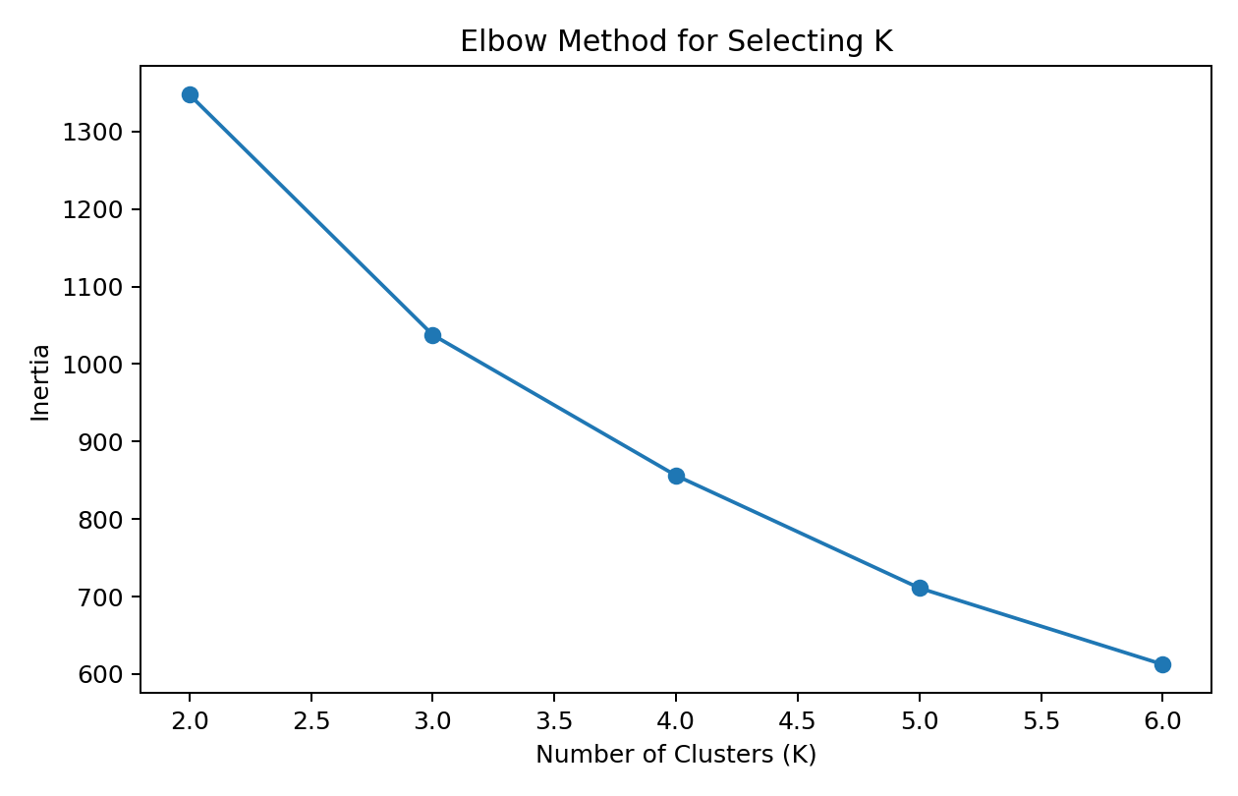
Figure 1. Elbow Method for K = 2 to 6.
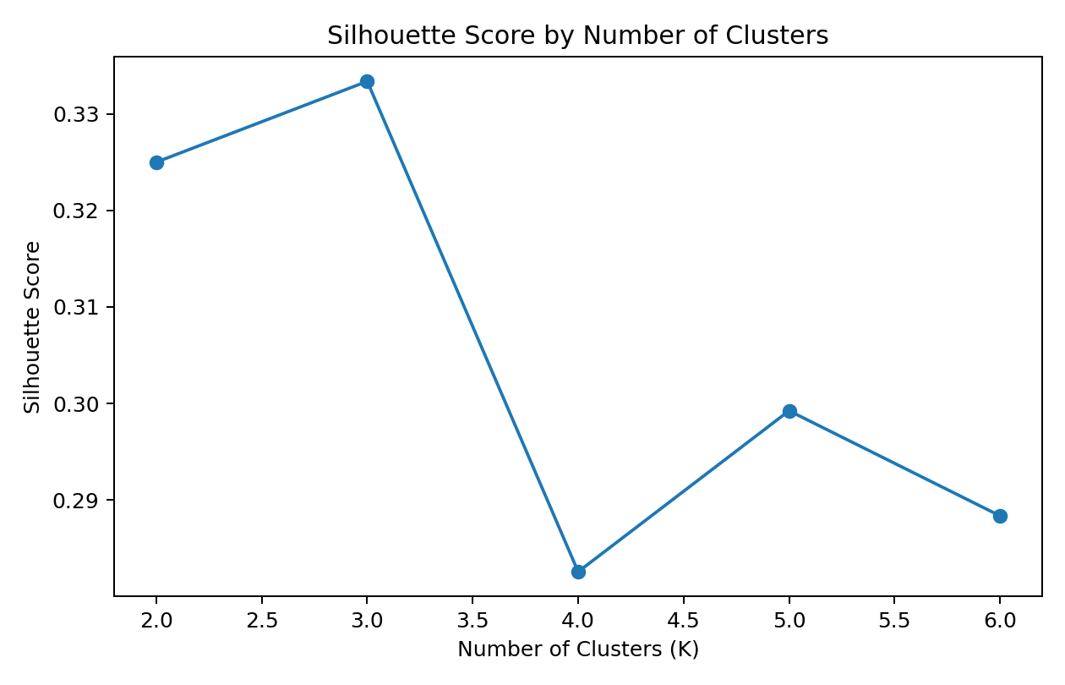
Figure 2. Silhouette scores for K = 2 to 6.
The selected number of clusters for this analysis was K = 3.
inertias = []
silhouette_scores = []
for k in range(2, 7):
kmeans = KMeans(n_clusters=k, random_state=42, n_init=10)
labels = kmeans.fit_predict(X_scaled)
inertias.append(kmeans.inertia_)
silhouette_scores.append(
silhouette_score(X_scaled, labels)
)

7. Applying K-Means Clustering
kmeans = KMeans(
n_clusters=3,
random_state=42,
n_init=10
)
df["Cluster"] = kmeans.fit_predict(X_scaled)
df.head()
K-Means assigned every cleaned observation to one of 3 clusters. Each cluster represents observations that are relatively similar to one another according to the selected standardized features.

8. Cluster Visualization
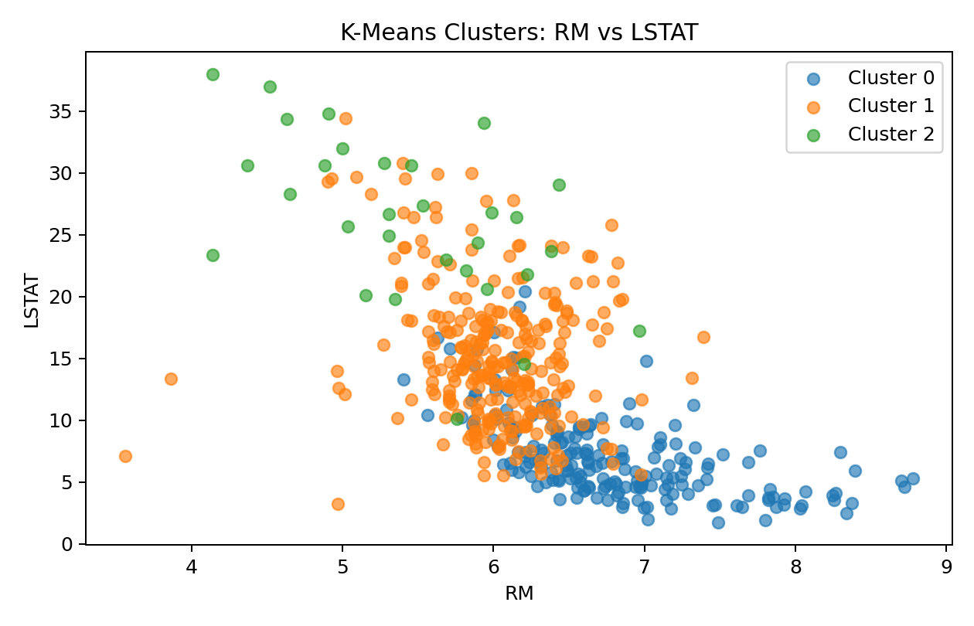
Figure 3. Cluster visualization using RM and LSTAT.
The scatter plot shows the resulting groups using RM and LSTAT as the two plotted dimensions. Because K-Means uses all selected standardized features, the plot is a simplified visual representation rather than a complete view of the clustering space.

9. Cluster Sizes
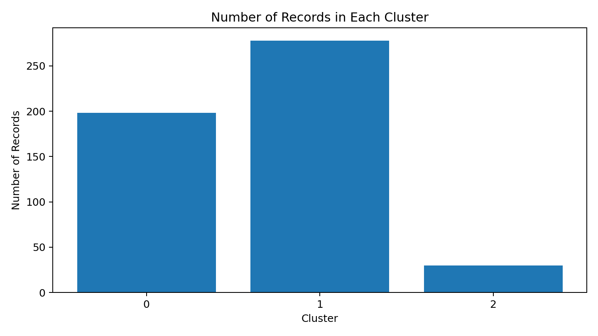
Figure 4. Number of observations assigned to each cluster.
Cluster | Records | Percentage
0 | 198 | 39.13%
1 | 278 | 54.94%
2 | 30 | 5.93%

10. Cluster Characteristics
Cluster profiles were calculated by taking the mean of the selected clustering features for each group. These averages provide a simple way to describe how the clusters differ.
Cluster | RM | LSTAT | PTRATIO | CRIM
0 | 6.79 | 7.08 | 16.58 | 0.44
1 | 6.02 | 15.15 | 19.60 | 3.13
2 | 5.43 | 26.28 | 20.20 | 28.99

11. Optional Post-Clustering Comparison
The medv column was not used to create the clusters. After clustering, its average was examined by cluster only to understand the economic differences between the groups.
Cluster | Average MEDV
0 | 29.74
1 | 18.75
2 | 10.03

12. Interpretation of Clusters
Cluster | Simple interpretation
Cluster 0 | higher average rooms; lower lower-status population percentage; lower pupil-teacher ratio; lower crime rate.
Cluster 1 | lower average rooms; higher lower-status population percentage; higher pupil-teacher ratio; lower crime rate.
Cluster 2 | lower average rooms; higher lower-status population percentage; higher pupil-teacher ratio; higher crime rate.

13. Potential Business/Research Implications
The clusters can be viewed as broad neighborhood segments. A group with more rooms and lower values of lstat may represent comparatively more favorable housing characteristics, while groups with higher crime or higher lstat values may represent areas with different socioeconomic or housing conditions. These clusters could help researchers compare neighborhoods and investigate why housing characteristics differ between groups. The clustering is descriptive and should not be treated as a causal explanation.

14. Challenges and Solutions
Challenge | Solution
Missing numerical values | Median imputation was used to retain observations.
Different feature scales | StandardScaler was used before K-Means.
Choosing K | Elbow Method and silhouette score were compared for K = 2 to 6.
Interpreting clusters | Cluster means and simple feature comparisons were used.

15. Conclusion
K-Means clustering was successfully applied to the Boston Housing dataset using 4 selected features. The data was cleaned and standardized before clustering, and K = 3 was selected using a simple combination of the Elbow Method and silhouette score. The resulting clusters were visualized and compared using their average feature values. This demonstrates how unsupervised learning can segment observations into groups without using a target variable during cluster formation.

16. Complete Jupyter Notebook Code
import pandas as pd
import numpy as np
import matplotlib.pyplot as plt
from sklearn.preprocessing import StandardScaler
from sklearn.cluster import KMeans
from sklearn.metrics import silhouette_score
# Load data
df = pd.read_csv("BostonHousing.csv")
# Handle missing values
for col in df.select_dtypes(include=np.number).columns:
df[col] = df[col].fillna(df[col].median())
# Remove duplicates
df = df.drop_duplicates().reset_index(drop=True)
# Select simple clustering features
features = ['rm', 'lstat', 'ptratio', 'crim']
X = df[features]
# Standardize
scaler = StandardScaler()
X_scaled = scaler.fit_transform(X)
# Elbow and silhouette analysis
inertias = []
silhouette_scores = []
for k in range(2, 7):
model = KMeans(n_clusters=k, random_state=42, n_init=10)
labels = model.fit_predict(X_scaled)
inertias.append(model.inertia_)
silhouette_scores.append(silhouette_score(X_scaled, labels))
# Select K
best_k = range(2, 7)[int(np.argmax(silhouette_scores))]
print("Selected K:", best_k)
# Final K-Means
kmeans = KMeans(n_clusters=best_k, random_state=42, n_init=10)
df["Cluster"] = kmeans.fit_predict(X_scaled)
# Cluster profile
print(df.groupby("Cluster")[features].mean())
# Visualize
plt.figure(figsize=(8, 5))
for cluster in sorted(df["Cluster"].unique()):
subset = df[df["Cluster"] == cluster]
plt.scatter(subset["rm"], subset["lstat"], label=f"Cluster {cluster}", alpha=0.65)
plt.xlabel("RM")
plt.ylabel("LSTAT")
plt.title("K-Means Clusters")
plt.legend()
plt.tight_layout()
plt.show()
# Save results
df.to_csv("BostonHousing-Clustered.csv", index=False)

