**Support Vector Machines**

*Exercise Session 2 - Regression,*

*report by,*

*Marimuthu Ananthavelu (r0652832), KU Leuven.*

*2.1* With random data points in the vector space, the following second degree polynomial as drawn below;

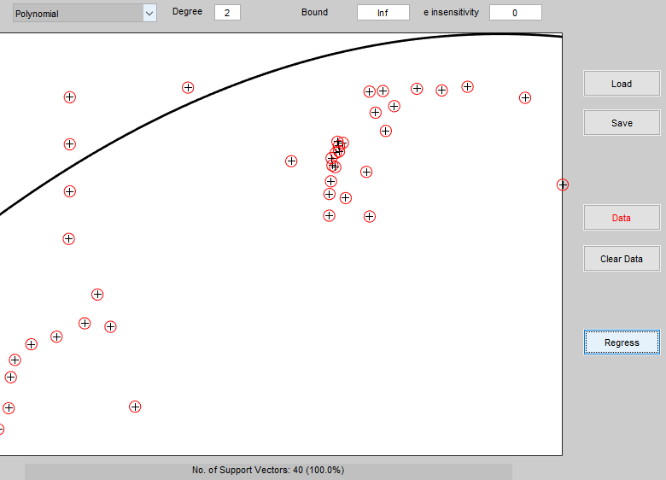

Lineary Kernel:

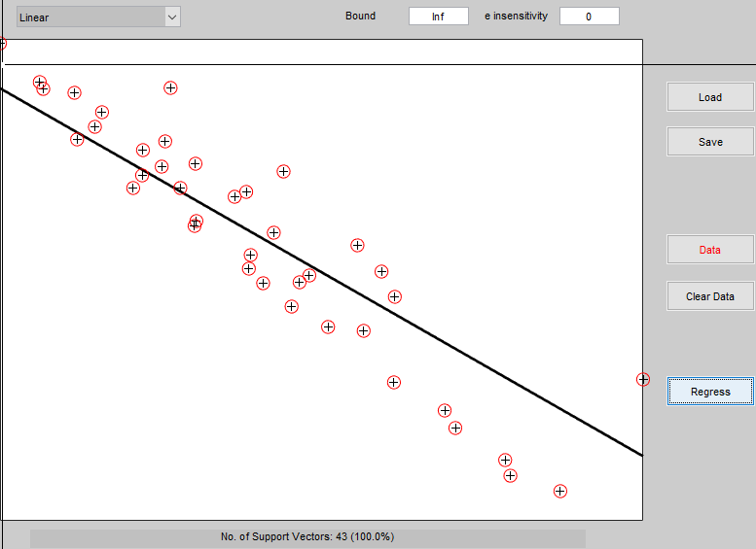The linear kernel construction is as below;

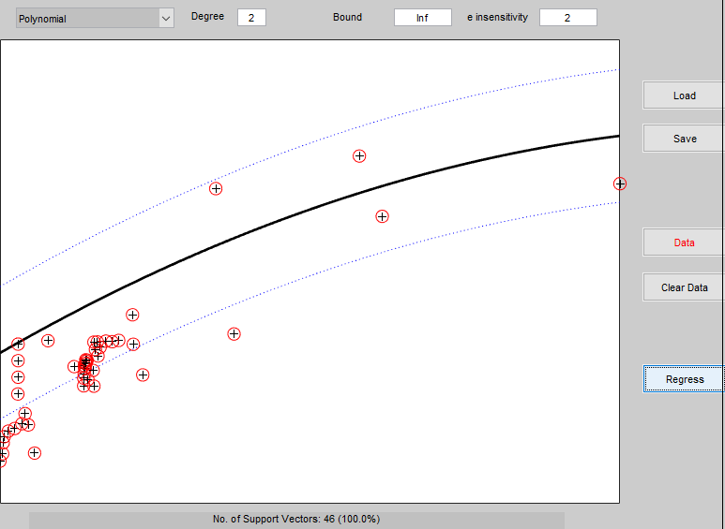

With increased value of ‘e’ , the margin is getting smaller. For an example, the margin with values of e as ‘1’ and ‘2’ are as below;

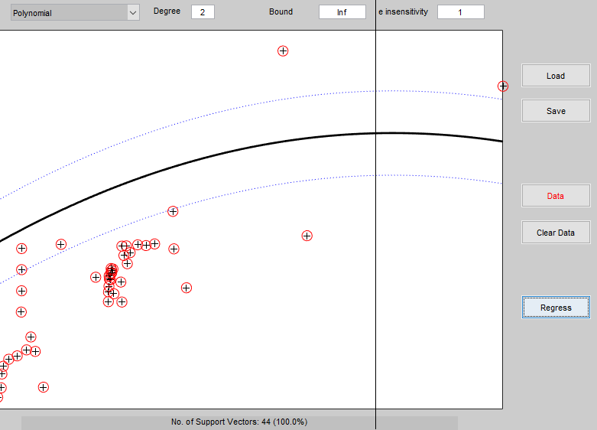

Difference between SVM classification and SVM regression