PROJECT REPORT
AI-BASED MEDICAL SKIN SPECIALIST
Multimodal Skin-Image and Voice-Assisted Health Information System

Project Type | AI / Machine Learning / Multimodal Application
Primary Interface | Web-based UI with image upload and voice interaction
Core Inputs | Skin image + optional user text/voice query
Core Output | AI-generated preliminary information and guidance

Important scope note: This project is designed as a decision-support and health-information prototype. It does not replace a dermatologist, provide a confirmed diagnosis, or prescribe medication.

1. Project Overview
The proposed AI Medical Skin Specialist is a multimodal application that accepts a photograph of a visible skin condition and a user's question through text or voice. The uploaded image is processed by a vision-capable AI model, while voice input is converted into text using Speech-to-Text (STT). The system combines these inputs with a large language model (LLM) to generate an understandable preliminary response. The response can then be converted into natural speech using Text-to-Speech (TTS).
The practical purpose is not to replace clinical examination. Instead, the system aims to make basic skin-related health information more accessible, explain what may be visible in an image, suggest sensible next steps, and indicate when professional medical evaluation may be appropriate.

2. Problem Statement
People commonly notice skin changes such as rashes, acne-like lesions, pigmentation, redness, irritation, or spots but may not know how to describe them or whether they require professional attention. A conventional text-only chatbot cannot directly use the visual information present in a skin photograph. This project addresses that limitation by combining image understanding with natural-language and voice interaction in one system.

3. Project Objectives
The objectives are intentionally limited to functions that can be demonstrated clearly in a student project:
- Accept a user-uploaded skin image through the application interface.
- Analyze the uploaded image using a vision-capable AI model to identify visible patterns or features.
- Accept the user's question through text or voice input.
- Convert voice input into text using a Speech-to-Text model/API.
- Combine the image analysis and user query to generate a clear, non-diagnostic AI response.
- Convert the generated response into speech using a Text-to-Speech service.
- Provide simple safety guidance, including when the user should seek professional medical advice.
- Maintain a simple web interface so the complete image → AI → response workflow can be demonstrated in real time.

3.1 Objectives We Are NOT Claiming
- The system will not claim to provide a medically confirmed diagnosis.
- The system will not replace a dermatologist or physical clinical examination.
- The project will not autonomously prescribe medicines or determine a treatment dosage.
- The project will not claim 100% accuracy for every skin condition or every image.
- The project will not be presented as a certified medical device.

4. Technical Architecture
The system is divided into four implementation phases. This separation makes the project easier to develop, test, explain, and demonstrate.
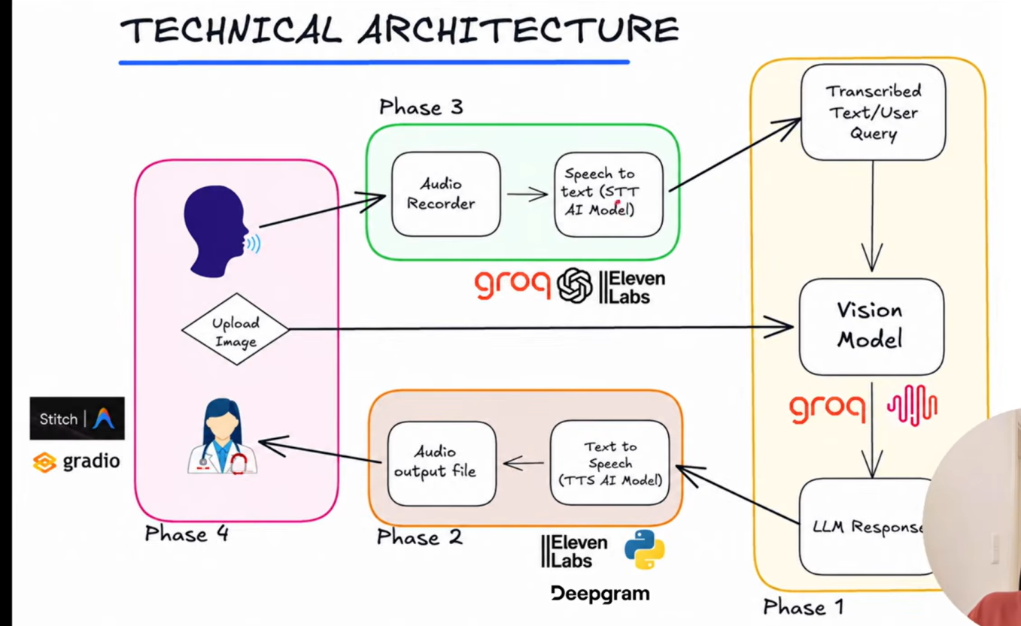
Figure 1. Proposed technical architecture and data flow.

5. Implementation Phases
Phase | Module | Main Work | Output
Phase 1 | Doctor's Brain (LLM + Vision) | Connect AI API/model; accept image; process image and user query; generate response. | Text-based AI response
Phase 2 | Doctor's Voice (TTS) | Send generated response to a TTS service and produce an audio file. | Spoken AI response
Phase 3 | Patient's Voice (STT) | Record user audio and convert speech into text. | Transcribed user query
Phase 4 | UI & Frontend | Integrate image upload, text/voice input, response display, and audio playback. | Complete working prototype

6. End-to-End Working
1. User Input: The user uploads a clear image of the affected skin area and enters a question, either by typing or speaking.
2. Voice Processing: If voice is used, the audio recorder captures the query and an STT model converts it into text.
3. Image Processing: The application sends the image to the vision-capable AI model for visual analysis.
4. AI Reasoning: The system combines the image information with the user's question and generates a cautious, understandable response.
5. Voice Output: The response text is sent to the TTS service to create an audio response.
6. User Interface: The application displays the response as text and can play the generated audio.
7. Safety Guidance: The response includes appropriate advice to seek professional medical care when the situation may require examination.

7. Real-Life Implementation
A realistic deployment can be implemented as a lightweight web application. The user opens the application on a phone or computer, uploads a skin photograph, and asks a question. The backend sends the required inputs to the AI services and returns the generated response to the frontend.
Component | Practical Implementation | Purpose
Frontend | Gradio or similar Python web UI | Image upload, text box, microphone, response and audio playback
Backend | Python | Connects UI, AI models/APIs and application logic
Vision + LLM | Multimodal AI service/model | Interprets the image and user's question
STT | Speech-to-Text AI model/API | Converts patient's voice into text
TTS | ElevenLabs / Deepgram or equivalent | Converts response text into speech
Optional UI support | Google Stitch / design workflow | Helps structure or prototype the frontend interface

7.1 Example Real-Life Use Case
Example: A user notices a red patch on the arm. They upload a photograph and ask, 'What could this look like and what should I do next?' The system analyzes the visible image and the question, then provides a preliminary explanation using non-diagnostic language. It can mention general possibilities, ask for relevant context if required, and recommend professional evaluation if the presentation appears concerning. The answer is also available as audio for accessibility.

8. Data Flow
Image path: Skin Image → Vision Model → Visual Information → LLM → Response
Voice input path: User Voice → Audio Recorder → STT → Text Query → LLM
Voice output path: LLM Response → TTS → Audio File → User

9. Project Implementation Plan
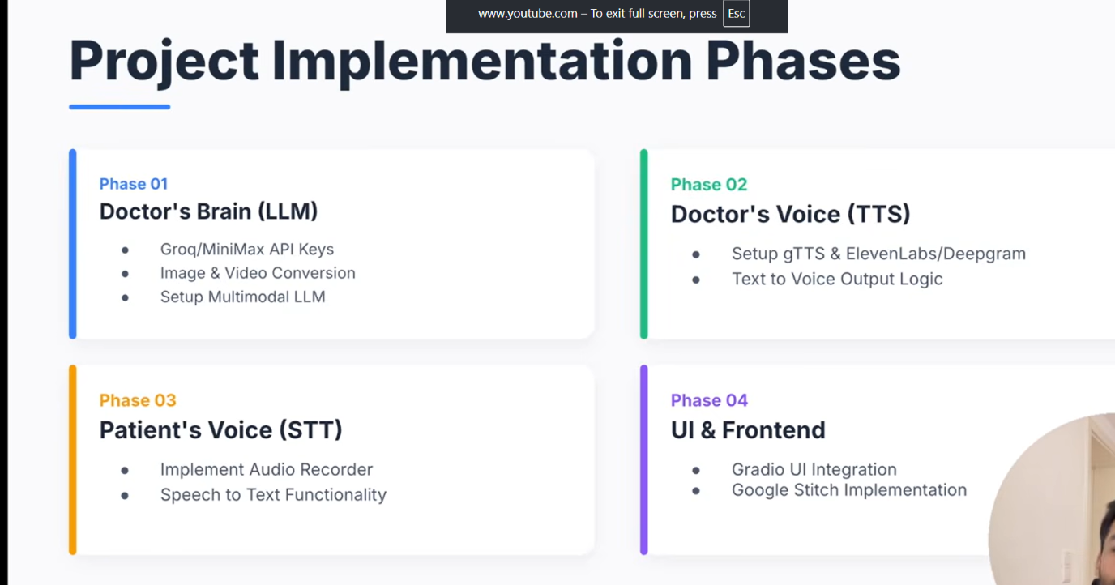
Figure 2. Implementation phases for the proposed prototype.

10. Testing Strategy
- Image upload test: verify that supported image formats are accepted and invalid files are handled.
- STT test: verify that short voice queries are transcribed correctly under normal audio conditions.
- Vision test: verify that the AI can describe visible features without making unsupported certainty claims.
- LLM test: verify that the response uses the image and the user's question together.
- TTS test: verify that generated responses can be converted to playable audio.
- Integration test: verify the complete image + voice/text → AI → response workflow.
- Safety test: verify that the application displays a clear disclaimer and recommends professional care for potentially urgent situations.

11. Limitations
- Image quality, lighting, camera angle, skin tone variation, and occlusion can affect AI output.
- A photograph does not provide the complete clinical information available during an in-person examination.
- The model may produce an incorrect or incomplete interpretation.
- Internet/API availability can affect response time and system operation.
- The prototype should not be used as the sole basis for medical decisions.

12. Privacy and Responsible Use
- Avoid storing user images unless storage is specifically required and consent is obtained.
- Use secure API credentials and do not expose keys in frontend code or public repositories.
- Minimize personally identifiable information collected by the application.
- Clearly tell users that the output is AI-generated and not a confirmed medical diagnosis.
- For a real deployment, follow applicable privacy, security, medical-software, and data-protection requirements.

13. Expected Outcomes
- A working multimodal prototype capable of accepting a skin image and user query.
- Voice-based input through STT and voice-based output through TTS.
- A single interface demonstrating the complete workflow.
- A clear AI-generated preliminary explanation with safety-oriented guidance.
- A modular architecture that can later be improved with better models, validation, logging, and clinical oversight.

14. Future Scope
- Add a curated, clinically reviewed knowledge base for more consistent health information.
- Add structured symptom questions such as duration, itching, pain, and changes over time.
- Add image-quality checks before analysis.
- Evaluate the system using a properly sourced and ethically handled dataset.
- Add clinician review or referral workflows for cases requiring professional attention.
- Explore multilingual voice interaction for wider accessibility.

15. Supervisor/Viva-Safe Project Statement
The safest and most accurate way to describe the project is:
"Our project is a multimodal AI-based skin health information and decision-support prototype. It accepts a skin image and a user's text or voice query, uses vision and language models to generate a preliminary explanation, and provides the response in text and optionally in speech. It is not intended to replace a dermatologist or provide a confirmed diagnosis."

15.1 Simple Answers to Likely Supervisor Questions
Question | Short Answer
Why did you use AI? | Because the system needs to process both visual information and natural-language questions.
Why use a vision model? | A text-only model cannot directly interpret the visual content of a skin photograph.
Why use STT? | It allows the user to ask questions by voice instead of typing.
Why use TTS? | It makes the system more accessible and provides an audio response.
Can it diagnose a disease? | No. In this project it provides preliminary, non-diagnostic information and recommends professional evaluation when appropriate.
What is the main input? | A skin image, with an optional text or voice question.
What is the main output? | A text explanation and optional audio response.
What is the main limitation? | A photograph alone cannot provide all clinical information, and AI output can be incorrect.
How is it useful in real life? | It can help users understand visible skin concerns and decide whether professional medical advice may be appropriate.

16. Conclusion
The AI Medical Skin Specialist provides a practical demonstration of multimodal AI by combining image understanding, language processing, speech recognition, and speech synthesis. The proposed four-phase architecture keeps the implementation manageable while still demonstrating a realistic end-to-end application. The project should be presented as a health-information and decision-support prototype rather than an autonomous diagnostic system. This scope is technically achievable, easier to validate, and appropriate for a student project demonstration.

17. Technologies and Services Referenced in the Design
- Python – application/backend logic.
- Gradio – rapid web interface and component integration.
- Multimodal LLM / Vision Model – image and language understanding.
- Speech-to-Text (STT) – voice query transcription.
- Text-to-Speech (TTS) – audio response generation.
- Groq / compatible AI API – model/API integration layer where applicable.
- ElevenLabs / Deepgram – TTS or speech-related services where applicable.

