People's Democratic Republic of Algeria,

Ministry of Higher Education and Scientific Research,

Higher School of Computer Science and Digitalization Technologies -ESTIN-

AI Assignment 1:
Maze solving robot

Prepared by:
Manar Nadji
Group: 1CS2

12 april 2026

Contents:

- The search space as a graph……………...…………………………………. 3
- Formulatation of the problem………………………………………….…. 4
  - State …….………………….……………………………………………….4
  - Initial State ..………………………....……………………………………..4
  - Goal State..………………………….. …………………….……………….4
  - Actions ……….…………………………………………………………….4
  - Transition Model: ………………………….………………………………4
  - Cost .…….. ………………………………………………………………...4

- Using Breadth first search (BFS) and depth first search(DFS)
to solve this problem…………………………………………..…4
  - BFS ………………………………………………………………………… 4
3.1.1 Queue …………………………………….….……………………..4
3.1.2 Expanded…………………………………….……………………...4
3.1.3 Optimal solution path……………………………………….………4
  - DFS …………….……..………………………………………………….....4
    - Stack ………………………………….………………………….4
3.2.2 Expanded..….………………………………………………………4
3.2.3 Optimal solution path………………………………………………4
- Using A* Algorithm (Informed Search)…………………………………..5
  - Queue………………………………………………………….………………5
  - Expanded ………………….………………………………………………….5
  - Optimal solution path …………………….……………………………..……5
  - Optimal path cost …..…………..…………………………………………….5
- Simulation of the problem and develop a visual representation of the robot's path through the maze……………………………6
5.1. Python code …………………………………………………………………...6

1-The search space as a graph:

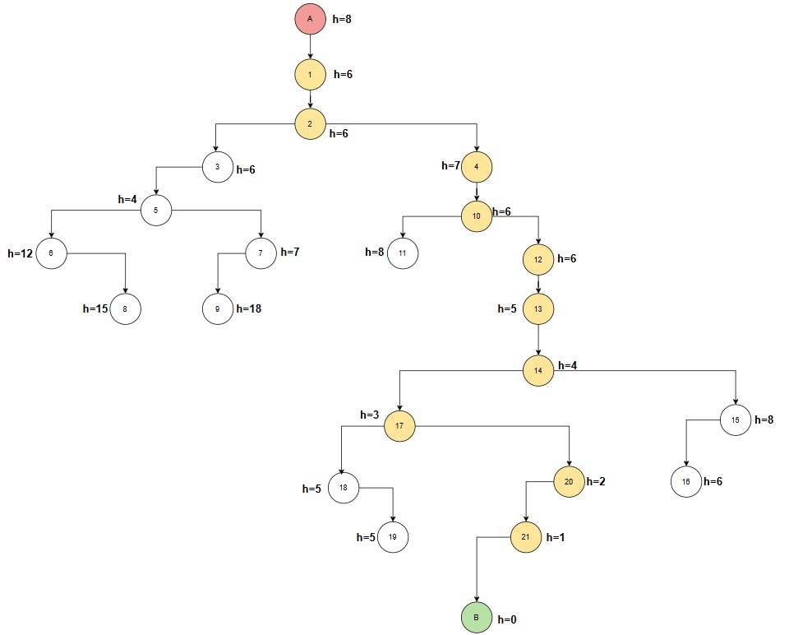

2-Formulatation of the problem:

1.State :A state represents the current position of the robot in the maze.
It can be any node: S = {A, 1, 2, 3, ..., 21, B}

2. Initial State :The robot starts at: A

3. Goal State : The objective is to reach: B

4. Actions : From any state, the robot can move to an adjacent node using the following actions: Move ( Left , Right ) :(only if the movement is allowed, no wall)

5. Transition Model: The transition function defines how the robot moves between states: Result (s, a) → s'
Where: s = current state , a = action , s' = next state
- Cost : Each move has a uniform cost: Cost(s → s') = 1

3-Using Breadth first search (BFS) and depth first search (DFS) to solve this problem:

A- BFS :
- Queue : A ,1,2,3,4,5,10,6,7,11,12,8,9,13,14,15,17,16,18,20,19,21,B
- Expanded : A ,1,2,3,4,5,10,6,7,11,12,8,9,13,14,15,17,16,18,20,19,21,B
- Optimal Solution Path: A - 1 – 2 - 4 – 10 – 12 - 13 - 14 - 17 - 20 - 21 - B
B- DFS :
- Stack : A ,1,2,3,5,6,8,7,9,4,10,11,12,13,14,15,16,17,18,19,20,21,B, 15,16
- Expanded : A ,1,2,3,5,6,8,7,9,4,10,11,12,13,14, 17,18,19,20,21,B
- Optimal Solution Path: A - 1 – 2 - 4 – 10 – 12 - 13 - 14 - 17 - 20 - 21 – B

4-Using A* Algorithm (Informed Search):

Based on the evaluation function f(n) = g(n) + h(n), where g(n) is the path cost (depth) and h(n) is the heuristic value from the provided table.

f(A) = 0 + 8=8, f(1) = 1+ 6=7, f(2) = 2 + 6=8, f(3) = 3+6=9,
f(4) = 3 + 7=10, f(5) = 4 + 4 =8, f(6) = 5+ 12=17, f(7) = 5 + 12=17,
f(8) = 6+15=21, f(9) = 6+ 18=24, f(10) = 4+ 6 =10, f(11) = 5+ 8=13,
f(12) = 5+ 6=11, f(13) = 6+5=11, f(14) = 7+ 4=11, f(15) = 8+ 8 =16,
f(16) = 9+ 6=15, f(17) = 8+3=11, f(18) = 9+5=14, f(19) =10 +5=15,
f(20) = 9 + 2 =11, f(21) = 10+ 1=11, f(B) = 11+ 0=11,

- Expanded: A, 1, 2, 3, 5, 4, 10, 12, 13, 14, 17, 20, 21, B
- Optimal Solution Path: A -1 - 2 – 4- 10 - 12 - 13 - 14 - 17 - 20 - 21 - B
- Optimal Path Cost : 11

5- Simulation of the problem and develop a visual representation of the robot's path through the maze:

import heapq
from collections import deque
import networkx as nx
import matplotlib.pyplot as plt

graph = {
'A': ['1'], '1': ['2'], '2': ['3', '4'], '3': ['5'],
'4': ['10'], '5': ['6', '7'], '6': ['8'], '7': ['9'],
'10': ['11', '12'], '11': [], '12': ['13'], '13': ['14'],
'14': ['17', '15'], '15': ['16'], '17': ['18', '20'],
'18': ['19'], '20': ['21'], '21': ['B'],
'8': [], '9': [], '16': [], '19': [], 'B': []
}

heuristics = {
'A': 8, '1': 6, '2': 6, '3': 6, '4': 7,
'5': 4, '6': 12, '7': 12, '8': 15, '9': 18,
'10': 6, '11': 8, '12': 6, '13': 5, '14': 4,
'15': 8, '16': 6, '17': 3, '18': 5, '19': 5,
'20': 2, '21': 1, 'B': 0
}

def a_star(start, goal):
pq = []
heapq.heappush(pq, (heuristics[start], 0, start, [start]))
expanded = []
order = 1
while pq:
f_score, _, node, path = heapq.heappop(pq)
if node not in expanded:
expanded.append(node)
if node == goal:
return expanded, path
g_score = len(path)
for neighbor in graph.get(node, []):
if neighbor not in expanded:
new_path = list(path)
new_path.append(neighbor)
f = g_score + heuristics[neighbor]
heapq.heappush(pq, (f, order, neighbor, new_path))
order += 1
return expanded, []

astar_expanded, optimal_path = a_star('A', 'B')

G = nx.DiGraph()
for node, neighbors in graph.items():
for neighbor in neighbors:
G.add_edge(node, neighbor)

def get_node_color(node):
if node in optimal_path:
return 'lightgreen'
elif node in astar_expanded:
return 'lightpink'
else:
return 'lightpink'

node_colors = [get_node_color(node) for node in G.nodes()]

edge_color = 'red'

pos = nx.kamada_kawai_layout(G)

plt.figure(figsize=(14, 10))
plt.title("A* Maze Solver - Visualization (Green Optimal, Pink Others, Red Arrows)", fontsize=16, fontweight='bold')

nx.draw(G, pos, with_labels=True,
node_color=node_colors,
edge_color=edge_color,
node_size=1000, font_size=11, font_weight='bold',
arrows=True, arrowsize=20, width=1.5)

plt.show()

print("="*40)
print(f"Optimal Solution Path (Correct): {' -> '.join(optimal_path)}")
print(f"A* Explored Path (Incorrect/Other): {', '.join([node for node in astar_expanded if node not in optimal_path])}")
print("="*40)

