scJDO2: label-free flow operators of single-cell dynamics from sampled time courses
David Redd, Sam Green, Tommy W. Terooatea*
Genomics & Bioinformatics Center, Department of Biology, Brigham Young University, Provo, UT, USA *To whom correspondence should be addressed: tommy.terooatea@byu.edu
Application Note — Systems biology / Gene expression

Abstract
Motivation: Local Jacobians of single-cell dynamics are used to find cells near fate decisions, but they require a velocity, and splicing or metabolic-labeling velocities are often unavailable or disagree with each other. Many single-cell studies have sampling times. No tool turns sampling times alone into a per-cell dynamical operator in one step, together with evidence of what that operator can and cannot identify.
Results: scJDO2 provides scjdo2.flow, a single call that estimates a velocity by entropic optimal transport between sampling times, fits a smooth drift and returns the per-cell flow operator, its leading eigenvalue λ₁ and magnitude-free operator-space descriptors in an AnnData object. With a-priori settings, λ₁ ranked fate-bifurcation cells above committed cells on held-out synthetic data (AUC 0.89–1.00). On LARRY lineage-traced hematopoiesis, the fitted drift predicted each barcoded cell’s clonal displacement beyond population movement and a held-out sampling day better than baselines. Mini-batch transport ran on all 130,887 cells in 26 min with a peak memory of 2.5 GB. The operator does not recover the values of the true Jacobian and depends on the embedding metric; the documentation states how to use it.
Availability and implementation: Python (≥ 3.10), MIT license. Source, documentation, test data and reproduction scripts: https://github.com/manarai/scJDO2. Archived version: Zenodo, doi:[to be added on release].
Contact: tommy.terooatea@byu.edu
Supplementary information: Supplementary data are available at Bioinformatics online and in the companion preprint (Redd et al., 2026).

1 Introduction
A Jacobian of the velocity field describes how a cell’s neighbourhood expands, contracts or rotates. Its leading eigenvalue λ₁ has been used to locate unstable cells and transition genes (Qiu et al., 2022; Bocci et al., 2022; Barcenas et al., 2024). These methods differentiate RNA velocity (La Manno et al., 2018; Bergen et al., 2020) or metabolic-labeling velocity, which are not always available and can disagree: on scNT-seq hematopoiesis, labeling, scVelo and Dynamo velocities had median per-cell cosines between −0.05 and 0.15 (Redd et al., 2026).
Many experiments instead sample cells at several times. Optimal transport (OT) between sampling times gives cell-level couplings and velocities without labels (Schiebinger et al., 2019; Klein et al., 2025), and several methods learn continuous dynamics from such data and differentiate them for gene regulatory networks (Sha et al., 2024; Zhao et al., 2025; Liu et al., 2026). What has been missing is a tool that returns, in one call and in the standard AnnData format, a per-cell operator from sampling times alone, scales to full datasets, and documents what the operator does and does not measure. scJDO2 fills this gap. It implements the configuration that was evaluated, with pre-registered tests, in the companion preprint (Redd et al., 2026).

2 Implementation
scjdo2.flow(adata, time_key=...) runs four steps (Fig. 1a).
OT velocity. Cells of consecutive sampling times are coupled by balanced entropic OT (Sinkhorn; Cuturi, 2013; POT, Flamary et al., 2021) in a PCA of log-normalized counts (default 15 components), with regularization ε = 0.05 × the median squared distance of the pair. Each cell of the earlier time receives the barycentric velocity (barycentre of its image − z)/Δt. When a pair exceeds 64 × 10⁶ cell pairs, transport switches to mini-batches of 4,000 cells in which every source cell appears ten times (Fatras et al., 2020), and the barycentres are averaged. Cells of the last time point receive no velocity.
Drift. A multilayer perceptron f(z) (three hidden layers of 96 units; AdamW, weight decay 10⁻⁴) is fitted to the velocities by mean-squared error (PyTorch; Paszke et al., 2019) and evaluated at every cell, including the last time point.
Flow operator. J_flow(z) = ∂f/∂z is computed for every cell by batched automatic differentiation (torch.func). It is generally non-symmetric and can carry rotation.
Descriptors. λ₁ (largest real part) and eight magnitude-free descriptors are returned, rank-transformed within the dataset: six functions of the eigenvalues (sign of Re λ₁, number of eigenvalues with positive real part, Re λ₁/max|λ|, rotational index max|Im λ|/max|λ|, spectral gap and trace normalized by the spectrum), which are invariant under any linear change of coordinates, and Henrici non-normality and transient gain, which are invariant only under orthogonal changes.
Outputs are written to the AnnData object (Virshup et al., 2024): obs["flow_lambda1"], obsm["flow_velocity"], obsm["flow_drift"], obsm["flow_descriptors"], the operators in uns["scjdo2"]["J"] (read by the scJDO2 operator-space and plotting modules) and per-pair OT diagnostics in uns["flow"]. All defaults are the a-priori reference configuration of the evaluation; every parameter is documented (docs/flow.md). A quickstart with built-in test data (examples/flow_quickstart.py) runs in seconds on a laptop CPU, and the package is compatible with Scanpy workflows (Wolf et al., 2018).

3 Evaluation
The evaluation was carried out in the companion preprint (Redd et al., 2026); here we summarize it and verify the released function. Run through the public API on the three held-out transition test datasets (12,784–12,884 cells), scjdo2.flow reproduced the stored fork AUCs exactly (0.960, 0.960, 0.924; per-cell λ₁ Spearman 1.000 with the analysis code) in 11–13 s each on an Apple M3 Max (script scripts/appnote_validate_api.py).
Branching cells, untuned. On a synthetic benchmark calibrated to six real datasets, λ₁ of the flow operator separated cells at the true saddle from committed cells on held-out seeds with AUC 0.89–1.00 across 10–20 components and four presets (Fig. 1b). A configuration tuned on two development seeds did worse on the same held-out seeds (0.42–0.95), so the released defaults are the untuned ones. On an independent simulator (dyngen; Cannoodt et al., 2021) with eight time points, λ₁ detected two of three bifurcations, the rotational index separated two of three cycles from linear trajectories, and no cell of any linear trajectory had Re λ₁ > 0.
Lineage and prediction. On LARRY in vitro hematopoiesis (Weinreb et al., 2020), integrating the drift over each 48-h interval predicted the displacement of 554 barcoded cells to the centroid of their clone at the next day (Spearman 0.56; maximum of 1,000 permutations 0.15; Fig. 1c). Agreement persisted after centring each coordinate within each interval (0.50; null maximum 0.04), whereas a population mean-shift predictor reached 0.19, so the drift captures cell-level movement beyond the population trend. λ₁ was unrelated to displacement magnitude (−0.04): lineage validates the velocity and drift, not λ₁. Fitted on days 2 and 4 only, the drift predicted the held-out day-6 distribution better than mean-displacement and no-movement baselines (energy distance 0.69, 95 % bootstrap interval 0.66–0.73, vs 0.87 [0.85–0.89] and 0.88 [0.83–0.94]; Fig. 1d).
Scaling. Mini-batch OT reproduced dense OT at 8,000 cells per day (median velocity cosine 0.9998; λ₁ Spearman 0.9999) with bounded memory (Fig. 1e). On all 130,887 LARRY cells, transport took 291 s (2.5 GB) and drift fitting with Jacobians 21 min (1.3 GB); dense OT would need a ≈ 21 GB cost matrix. Low-rank OT (moscot rank 50 or 200) did not preserve the operator (λ₁ Spearman ≈ 0).
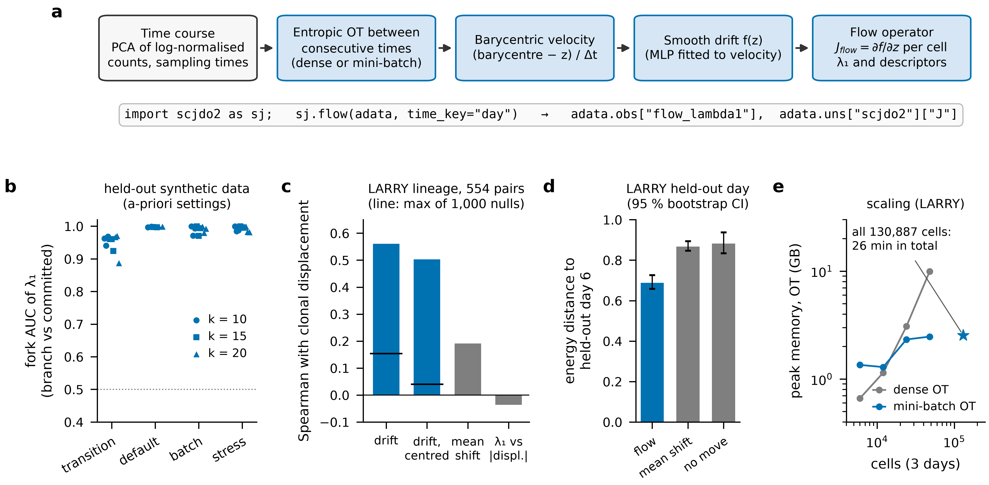
Fig. 1. scjdo2.flow and its evaluation. (a) Pipeline and call. (b) Fork AUC of λ₁ (branch-point vs committed cells) on 11 held-out synthetic datasets at 10, 15 and 20 principal components with the released defaults; dotted line, chance. (c) LARRY: Spearman correlation, pooled over 15 PCA coordinates of 554 barcoded cell–clone pairs, between drift-predicted and observed clonal displacement, before and after centring each coordinate within a sampling interval (black line, maximum of 1,000 permutations), for a population mean-shift predictor, and between λ₁ and displacement magnitude. (d) Energy distance between the predicted and observed held-out day-6 distributions for the drift (fitted on days 2 and 4) and two baselines; error bars, 95 % bootstrap intervals (200 resamples). (e) Peak memory of the OT stage for dense and mini-batch OT; star, all 130,887 cells (total run time 26 min). Source data: benchmarks/synthetic_multimodal/s14/ and benchmarks/scaling/; figure script notebooks/appnote_fig1.py.

4 Usage notes and limitations
λ₁ is an empirical ranking of branching cells in a stated transport space, not a measured regulatory Jacobian: compared with the Jacobian of the generator’s true velocity, the per-cell relative error was ≈ 1.0 and the λ₁ Spearman correlation at most 0.11 in magnitude. Consistent with eigenvalue-level benchmarks of Jacobian methods (Balubaid et al., 2025), we recommend reading only signs and ranks. The operator depends on the transport metric: in Factor Analysis coordinates the fork AUC fell to 0.04–0.53, against 0.88–1.00 in PCA-10; a variance-weighted PCA with 10–20 components is the documented default. Three sampling times were too coarse on dyngen, and per-cell operators from independent velocity sources on real data agreed only at null level, although cell-type orderings agreed. Detecting the timing of critical transitions and estimating diffusion are not supported. These diagnostics are reported in uns["flow"] and in the documentation.

5 Conclusion
scJDO2 turns a sampled single-cell time course into per-cell flow operators with one call, at full-dataset scale, with defaults that were fixed before evaluation and an explicit account of what the operator identifies.

Funding
This work was supported by a New Faculty Start-up award from the College of Life Sciences, Brigham Young University (to T.W.T.).
Conflict of Interest: none declared.

Data availability
LARRY: GEO GSE140802 (Weinreb et al., 2020). scNT-seq hematopoiesis: GEO GSE193517 (Qiu et al., 2022). Synthetic benchmarks are regenerated by scripts in the repository; dyngen settings are listed in the companion preprint. Result tables underlying Fig. 1 are in the repository (benchmarks/).

References
Balubaid, A. et al. (2025) Fundamental limits of inferring dynamical gene regulatory models from single-cell data. bioRxiv, doi:10.1101/2025.09.12.674509.
Barcenas, M., Bocci, F. and Nie, Q. (2024) Tipping points in epithelial-mesenchymal lineages from single-cell transcriptomics data. Biophys. J., 123, 2849–2859.
Bergen, V. et al. (2020) Generalizing RNA velocity to transient cell states through dynamical modeling. Nat. Biotechnol., 38, 1408–1414.
Bocci, F., Zhou, P. and Nie, Q. (2022) spliceJAC: transition genes and state-specific gene regulation from single-cell transcriptome data. Mol. Syst. Biol., 18, e11176.
Cannoodt, R. et al. (2021) Spearheading future omics analyses using dyngen, a multi-modal simulator of single cells. Nat. Commun., 12, 3942.
Cuturi, M. (2013) Sinkhorn distances: lightspeed computation of optimal transport. Adv. Neural Inf. Process. Syst., 26, 2292–2300.
Fatras, K. et al. (2020) Learning with minibatch Wasserstein: asymptotic and gradient properties. Proc. AISTATS, PMLR 108, 2131–2141.
Flamary, R. et al. (2021) POT: Python Optimal Transport. J. Mach. Learn. Res., 22, 1–8.
Klein, D. et al. (2025) Mapping cells through time and space with moscot. Nature, 638, 1065–1075.
La Manno, G. et al. (2018) RNA velocity of single cells. Nature, 560, 494–498.
Liu, J. et al. (2026) Learning stochastic dynamics and cell-fate landscapes from single-cell snapshots via optimal transport. Sci. Adv., 12, eaeb4205.
Paszke, A. et al. (2019) PyTorch: an imperative style, high-performance deep learning library. Adv. Neural Inf. Process. Syst., 32, 8024–8035.
Qiu, X. et al. (2022) Mapping transcriptomic vector fields of single cells. Cell, 185, 690–711.
Redd, D., Green, S. and Terooatea, T.W. (2026) Label-free flow operators and stability operators from single-cell time courses: what local dynamical operators can and cannot identify. bioRxiv, doi:10.64898/2026.08.21.745996 (version 57).
Schiebinger, G. et al. (2019) Optimal-transport analysis of single-cell gene expression identifies developmental trajectories in reprogramming. Cell, 176, 928–943.
Sha, Y. et al. (2024) Reconstructing growth and dynamic trajectories from single-cell transcriptomics data. Nat. Mach. Intell., 6, 25–39.
Virshup, I. et al. (2024) anndata: access and store annotated data matrices. J. Open Source Softw., 9, 4371.
Weinreb, C. et al. (2020) Lineage tracing on transcriptional landscapes links state to fate during differentiation. Science, 367, eaaw3381.
Wolf, F.A., Angerer, P. and Theis, F.J. (2018) SCANPY: large-scale single-cell gene expression data analysis. Genome Biol., 19, 15.
Zhao, W. et al. (2025) Optimal transport reveals dynamic gene regulatory networks via gene velocity estimation. PLoS Comput. Biol., 21, e1012476.

