Software Requirements Specification

Version 1.0

June 16/6/2020

**Airline Flight Booking System**

Manara Othman

Nouha Elewi

Submitted in partial fulfillment

Of the requirements of

CS 310 Software Engineering

**Table of Contents**………………………………………………………………………………………………………………

1. Introduction .................................................................................................................................................................

1.1 Purpose ...................................................................................................................................................

1.2 Project Scope...........................................................................................................................................

1.3Glossary....................................................................................................................................................

1.4 References...................................... .........................................................................................................

2. Overall Description…………………………………………………………………………………………………………………………………..

2.1 System Environment………………………………………………………………………………………………………………………………

2.2 Functional Requirements Specification…………………………………………………………………………………………………

2.2.1 Use Case User …………………………………………………………………………………………………………………………………

2.2.1.1 Log In Use Case…………………………………………………………………………………………………………………….

2.2.1.2Enrollment Use Case…………………………………………………………………………………………………………………

2.2.1.3 Book Flights………………………………………………………………………………………………………………………………..

2.2.1.4 Reserve Seat Use Case…………………………………………………………………………………………………………………

2.2.1.5 Log Out………………………………………………………………………………………………………………………………………

2.3 User Characteristics……………………………………………………………………………………………………………………………

2.4 Non-Functional Requirements…………………………………………………………………………………………………………….

2.4.1 Software Quality Attributes………………………………………………………………………………………………………….

2.4.1.1 Usability………………………………………………………………………………………………………………………………….

2.4.1.2 Robustness…………………………………………………………………………………………………………………………………..

# 3.0. Requirements Specification…………………………………………………………………………

## 3.1 External Interface Requirements…………………………………………………………………….

3.1.1User Interfaces ………………………………………………………………………………………………………………… 3.1.2Communications Interfaces........................................................................

4.0 Other Nonfunctional Requirements…………………………………………………………………………………………

4.1 Performance Requirements ………………………………………………………………………………………………

5.2 Security Requirements …………………………………………………………………………………………………………………

# 1.0. Introduction

## 1.1. Purpose

This SRS document presents a detailed description of the Airline Flight Booking system, version 1.0. It represents the client requirements analysis that defines the functional and nonfunctional requirements of the airline website and its different functionalities. It defines the abilities, reactions from stimuli, guidelines and limitations of the system. This document will be complete in its scope of the system and the functions required. The system provides a solution to allow the user to search for flights satisfying the user criteria, to reserve seats, to manage the user account, and to book a flight.

The intended audiences of this document are Dr. Chen, who is the client, software engineers, the spring 2009 CS5391 software engineering class and for anyone who has interest in software engineering.

## 1.2. Scope of Project­­

The airline booking website is an application stored in the user server. The purpose of the website is to resolve the client to allow website users to perform tasks related to booking an airline flight. Non-member users are only allowed to search for available flights; nonmember users are required to create an account in order to reserve a seat or to book a flight. Member users have the right to search for available flights, to reserve a seat, to book a flight, cancel a flight and to edit their member information. Member users are required to login into their account prior to flight booking..

## Glossary

|  |  |
| --- | --- |
| **Term** | **Definition** |
| Authentication | The process of identifying an individual, usually based on username and password |
| Cached | A form of storing information/data, usually this data is repeatedly accessed. |
| CSS | Cascading Style Sheets is a feature to give users and developers more control on how web site pages are displayed. |
| Database | Is a structured collection of records or data that is stored in a computer system . In our system, this may pertain to flight records or user information. |
| Dynamic Links | A pointer to a particular scope called during runtime. |
| Encryption Algorithm | A mathematical procedure for performing encryption on data, which is translating data into secret code. |
| HTTP | Hyper Text Transfer Protocol is the underlying protocol used by the World Wide Web. It defines how messages are formatted and transmitted and what actions should be taken in response to various commands. |
| Hyper Links | Also called link, is a directly followable reference within a hypertext document |
| Input Criteria | A defined particular group of criteria, which defines inputs. |
| Query or Queries | A form of questioning. In this document, query pertains to a search entered by a user into a search engine to return results. |

## 1.4. References

Pressman, Roger S. Software Engineering: A Practitioner’s Approach. New York, NY: McGraw-Hill, 2005. - Lecture slides.

**2.0.Overall Description**

## 2.1 System Environment

The main actors in the system are (1) the user, (2) a flight and (3) a Flight Seat. The user will select a flight and book seats on the flight. They will then reserve specific seats on that flight. . Our user may be associated with multiple flights, and many users may be associated with any particular flight. Thus, a many-to-many relationship exists through the act of booking flights. Flights are associated to many Flight Seats. Each Flight Seat is only attached to one Flight. So, this is a one-to-many relationship The flight is but an object to be acted upon, so careful emphasis should be placed on satisfying the user in his/her booking experience. The user is our primary customer.

## 2.2 Functional Requirements Specification

### This section provides detailed requirements for the website design, including functional requirements

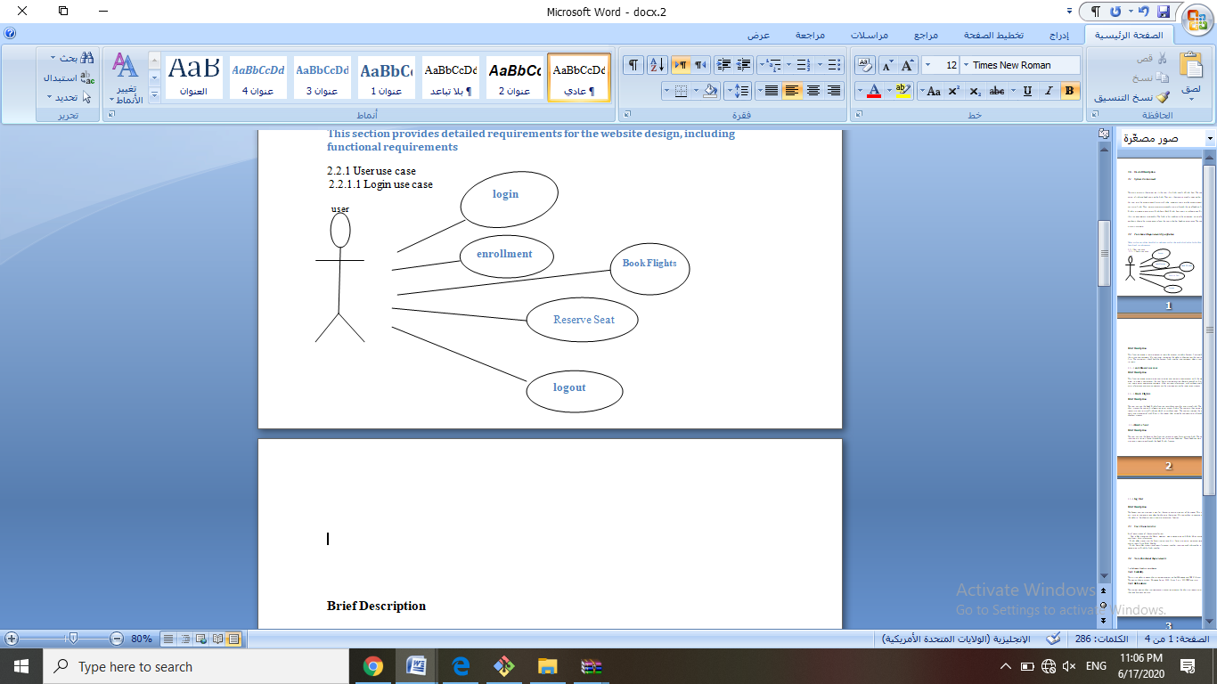

**Brief Description**

This function allows a registered user to login his account using his frequent flyer number with the airline and password. If a user is not registered, the website should allow the user to enroll first. The system will check both the frequent flight number and password, when a user attempts to login.

2.2.1.2 **enrollment use case**

**Brief Description**

This function allows unregistered user to enroll and to create a new account with the website. In order to create a new account, the user has to provide required information such as first name, last name, email address and password. Other optional information, such as phone number, credit card information and mailing address, can be provided during the registration process.

2.2.1.3 **Book Flights**

**Brief Description**

The user can use the Book Flights function to purchase seats for an airplane flight. The system shall present the user with information on all current flights. The user may then select a pair (departure and return) of flights on which to purchase seats. The user can indicate the number of seats and placement of such. Finally, the system shall guide the user completely through the checkout process.

2.2.1.4 **Reserve Seat**

**Brief Description**

The user can use the Reserve Seat function to reserve seats for an airplane flight. The seats to be reserved are initially found through the user’s previous bookings. These bookings were previously completed through the Book Flight function

2.2.1.5 **Log Out**

**Brief Description**

The Logout section provides a way for the user to securely log out of the system. This process will save all user operations when he/she exits the system. If a user wishes to continue accessing the website, he/she must log-in again to access user features

## 2.3 User Characteristics

Brief descriptions of these classes follow:

• User o Has properties like Name, Address, Age o Associated with Flight Miles accumulated and Credit Card information.

• Flight o Has properties like Departing/Arriving City, Departure/Arrival dates and times, Miles, and an identifying Flight Number.

• Flight Seat o Has properties of identifying seat number, reserved and flight number Associated to Flight by flight number

## 2.4 Non-Functional Requirements

**2.4.1 Software Quality Attributes**

**2.4.1.1 Usability**:

The airline website design shall allow deployment on both Windows and UNIX (Linux) servers. The design should support Windows Server 2003, Linux 2.6.x, V10 UNIX and later.

**2.4.1.2 Robustness:**

the system design shall include recovery scenarios allowing the ability to restore a state no older than one business day old.

# 3.0. Requirements Specification

## 3.1 External Interface Requirements

**3.1.1User Interfaces**

A Help link will appear on every screen that describes the function of each page to the user. The implementation should be written so that blind users can still interact with the system (using a screen reader.)

**3.1.2Communications Interfaces**

The system must utilize the standard Hyper Text Transfer Protocol (HTTP) to ensure maximum inter-browser compatibility. The client accesses the system through a web browser.

**4.Other Nonfunctional Requirements**

**4.1 Performance Requirements**

• The Airline Website shall have capabilities to accept 500 connections. For each session, system shall guarantee the connection time 5 minutes from last input, after which the connection will be deemed expired. A close operation will be performed when expired. This design is to satisfy each user’s usability and connection quality.

• The system shall send out verification request immediately (within 100ms) after the it receives a user submitted form.

• The system shall update all flight status information every 5 minutes.

**5.2 Security Requirements**

• Passwords must be a minimum of eight characters and must contain one to seven digits.

• Email addresses should be verified before the system grants user access. This verification shall be exercised by sending the prospective user a confirmation email after enrollment. This email must contain information specific to completing the enrollment process.

• All exchanges from client to server involving private data shall occur using the highest available level of secure connection (e.g., https).