stepper motor with 8086 µp

*this project explains how to control -5 leads unipolar- stepper motor using 8086 micro processor This project is programmed in assembly language, and designed using protous 8.6

-we start with controlling the mode of the motor:

stepper motor works in 3 different modes ,we will cover only two of them :1-full mode

2-half mode

,-then control the direction of each mode, either rotates in 1-anti clockwise

or

2-clockwise

,finally control the speed of the motor

1-low speed

2-midium speed

3-high speed

1-FULL MODE

The motor rotates a full revolution in 4 steps ,each step is a 90o  step angle , In this mode two coils are energized - logic 1 is given to two coils - at a time

This table shows the logic of programming stepper motor in full mode in clock wise direction where A,B,C and D are the coils of the motor.

To rotate the motor in anti-clock wise just reverse the logic from bottom to top

|  |  |  |  |
| --- | --- | --- | --- |
| A | B | C | D |
| 0 | 0 | 1 | 1 |
| 1 | 0 | 0 | 1 |
| 1 | 1 | 0 | 0 |
| 0 | 1 | 1 | 0 |

1-HALF MODE

The motor rotates a full revolution in 8 steps ,each step is a 45o  step angle . This mode works on the alternate energizing principle ,at one moment only 1 coil is energized, but in the very next moment 2 coils are energized, then again back to 1.

This table shows the logic of programming stepper motor in full mode in clock wise To rotate the motor in anti-clock wise just reverse the logic from bottom to top.

|  |  |  |  |
| --- | --- | --- | --- |
| A | B | C | D |
| 1 | 0 | 0 | 0 |
| 1 | 1 | 0 | 0 |
| 0 | 1 | 0 | 0 |
| 0 | 1 | 1 | 0 |
| 0 | 0 | 1 | 0 |
| 0 | 0 | 1 | 1 |
| 0 | 0 | 0 | 1 |
| 1 | 0 | 0 | 1 |

to control the speed:

we used 3 buttons..

the 1st btn makes the motor rotates with an low speed

the 2nd btn makes the motor rotates with an intermediate speed

the 3rd btn makes the motor rotates with high speed

the main components:

1-8086 µp

2- latch : 74HC373

3- I/O device : 8255A

4- motor driver: ULN2003A

5-stepper motor

6-battary 12V

7-logicstates

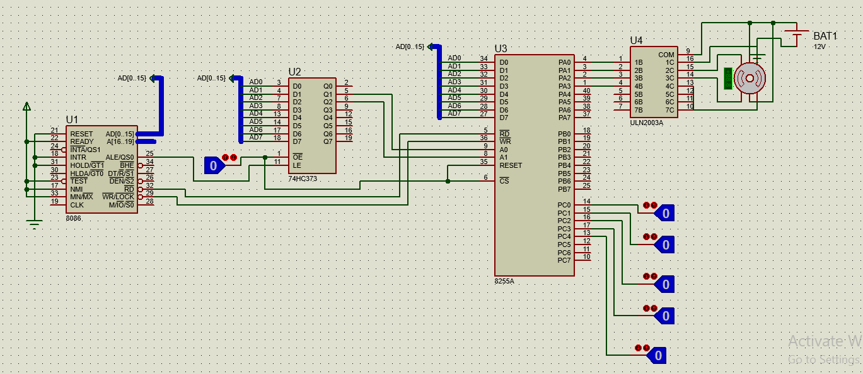

A brief description for the components:

The 8086 µp is only the CPU of our program -processes and executes our assembly code- so it needs to be connected to a storage device and an I/O device, here comes the rule of …

1. 74HC373: is an octal D-type transparent latch , works as storage device, holds data through feedback lane
2. 8255A: intel general purpose programmable I/O device, used in 2 modes either i/o mode or BSR mode, in out project it’s used in i/O mode

It has 3-ports are used as i/o ,(PortA,PortB,PortC).

PORTC is consist of PC Lower, PC Upper

There are different modes ,we use mode 0

So,let D6=0 , D5=0 ,D2=0

To use as i/o mode : let D7=1

|  |  |  |  |  |  |  |  |  |
| --- | --- | --- | --- | --- | --- | --- | --- | --- |
| D7 | D6 | D5 | D4 | D3 | D2 | D1 | D0 |  |
| i/o | m0 | m0 | PA | PC Upper | m0 | PB | PC Lower |  |
| 1 | 0 | 0 | 1 | 1 | 0 | 0 | 1 | i/p |
| 1 | 0 | 0 | 0 | 0 | 0 | 1 | 0 | o/p |

Control register (CR)= D7 D6 D5 D4 D3 D2 D1D0

In our code use :

portA o/p

PORTB

PORTC I/P

So,CR=10000001

1. Uln2003a: is a type of motor driver used to amplify the current produced by our circuit to suit the current needed by the stepper

a description of our code

we have in our code 11 Procedures.

1-MODE PROC

Determine whice mode is choosed by user by:

Get input from portc by logic gates (0 or 1 )

PC0 =1 go to full mode.

PC0 =0 go to half mode.

Call in the start of code.

2- PRESS PROC

Check if user change mode,or direction ,or speed by:

Compare the Present value of portc by the provious value of portc.

Call after ever steps in half or full mode.

3-FULLCW

4-FULLACW

5-HALFCW

6-HALFACW

This 4 procedures have code of every mode (steps that motor do).

Port A is get its value for every revolution from this procedure.

Is Determined after call MODE PROC by check PC1.

PC1 =0 go to clock wise

PC1 =1 go to anti clock wise

7- DELAY PROC

In our project ,we control speed by using different delays after every revolution.

We have 3 speeds low , intermediate , high.

Every speed has its own delay.

Delay low >> delay intermediate >> delay high

Is determined by check PC2 , PC3 , PC4

PC2 =1 speed is low.

PC3 =1 speed is intermediate.

PC3 =1 speed is high.

If PC2 =0 && PC3 =0 && PC4 =0

Motor will stop.

8- NORMP PROC

9- MIDP PROC

10- FASTP PROC

This 3 procedure have code whice control delay for every speed.

11- STOPP PROC

This proc let portA take 00H as o/p to let motor stop working.