

Communication Plan
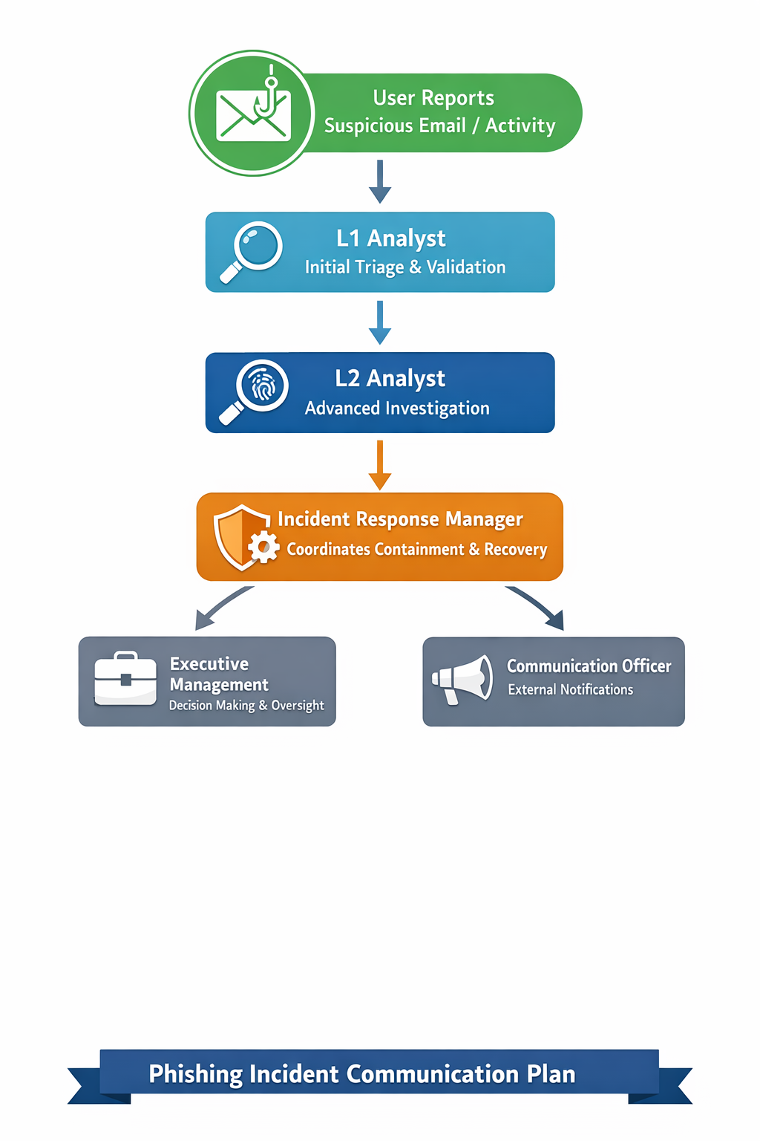
- Critical points:
  - Only Communication Officer contacts external parties.
  - Document all updates in incident log.

