Experiment – 2

**Aim:** To understand Version Control System by installing git and create GitHub Account.

**Theory:**

### **Version Control System: Installing Git and Creating a GitHub Account**

Version Control Systems (VCS) are crucial tools in software development that help manage changes to source code over time. They track revisions, manage collaboration, and enable rollback to previous states. Git is one of the most popular VCS, and GitHub is a web-based platform that uses Git to provide collaborative features.

#### **Version Control Systems (VCS)**

**Purpose and Benefits:**

1. **Track Changes**: VCS keeps a record of every change made to files in a project, including who made the change and when.
2. **Branching and Merging**: Allows developers to work on different features or fixes in parallel (branches) and merge them back into the main codebase.
3. **Collaboration**: Facilitates multiple developers working on the same project simultaneously without overwriting each other’s changes.
4. **Backup and Recovery**: Provides the ability to revert to previous versions of code if something goes wrong, ensuring data integrity and reducing the risk of losing work.
5. **Audit Trail**: Maintains a history of changes that can be reviewed for auditing purposes or understanding the evolution of the project.

**Installing Git**

**Step 1:** To download the Git installer, visit the Git's official site and go to the download page. The link for the download page is <https://git-scm.com/downloads>. The page looks like as

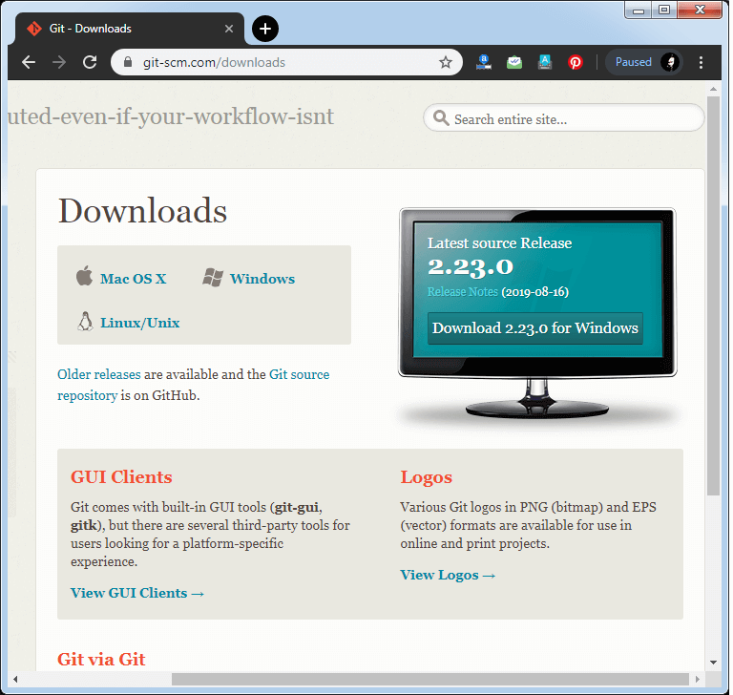

Click on the package given on the page as **download 2.23.0 for windows**. The download will start after selecting the package.

Now, the Git installer package has been downloaded.

**Step 2:** Click on the downloaded installer file and select yes to continue. After the selecting yes the installation begins, and the screen will look like as

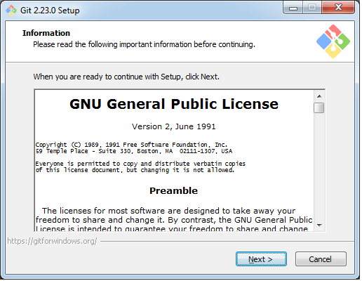

Click on **next** to continue.

**Step 3:** Default components are automatically selected in this step. You can also choose your required part.

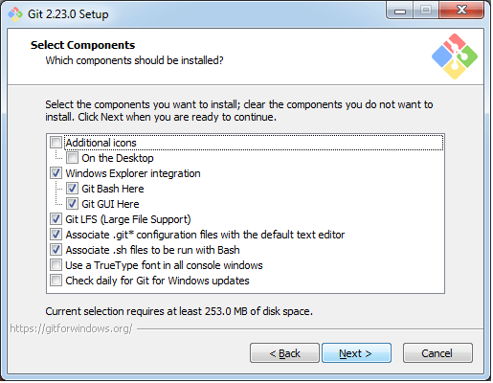

Click next to continue.

**Step 4:** The default Git command-line options are selected automatically. You can choose your preferred choice. Click next to continue.

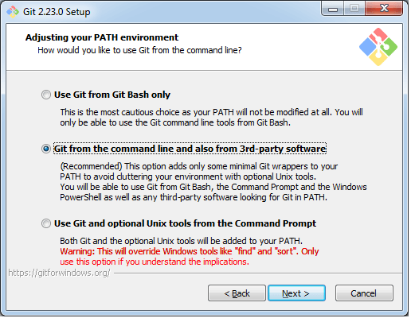

**Step 5:** The default transport backend options are selected in this step. Click next to continue.

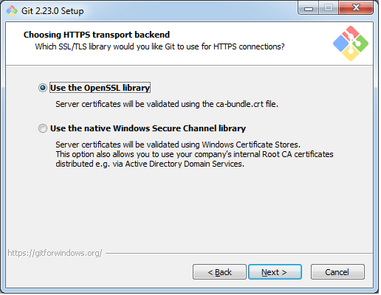

**Step 6:** Select your required line ending option and click next to continue.

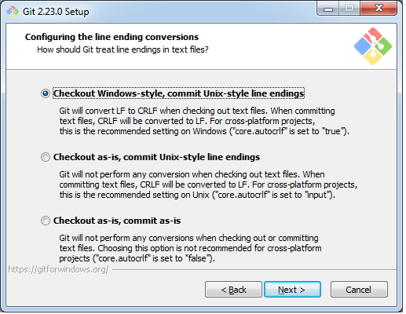

**Step 7:** Select preferred terminal emulator clicks on the next to continue.

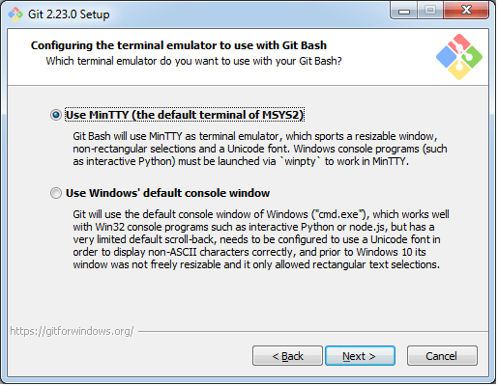

**Step 8:** This is the last step that provides some extra features like system caching, credential management and symbolic link. Select the required features and click on the next option.

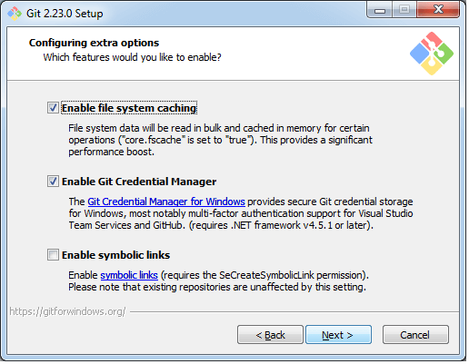

**Step 9:** The files are being extracted in this step.

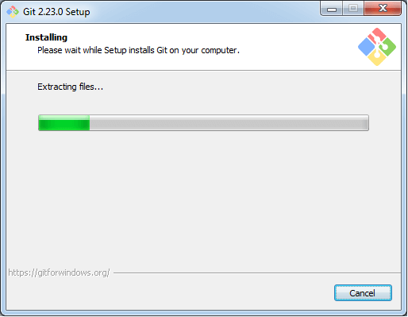

Therefore, The Git installation is completed. Now you can access the **Git Gui** and **Git Bash**.

**Creating a GitHub Account**

**Step 1:** Go to <https://github.com/join> in a web browser.

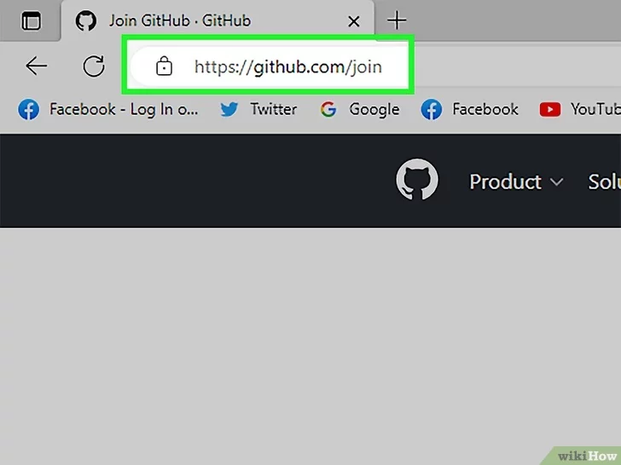

**Step 2:** Enter your personal details.

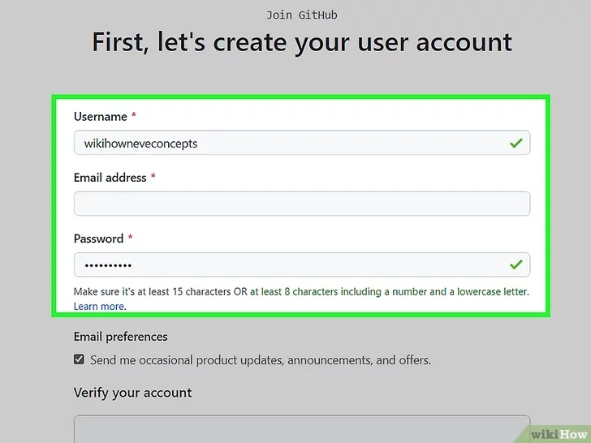

**Step 3:** Click Verify to start the verification puzzle.

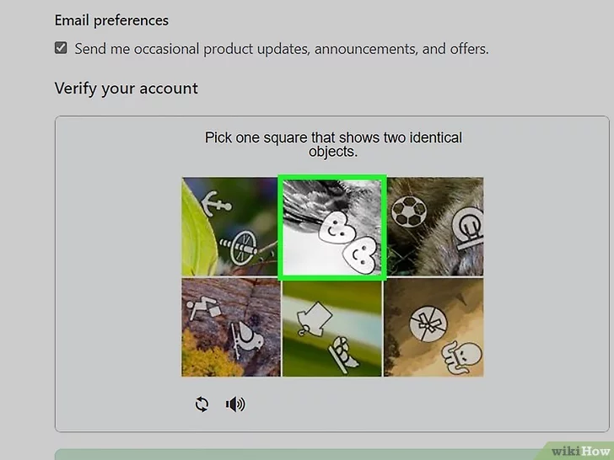

**Step 4:** Click the green Create account button.

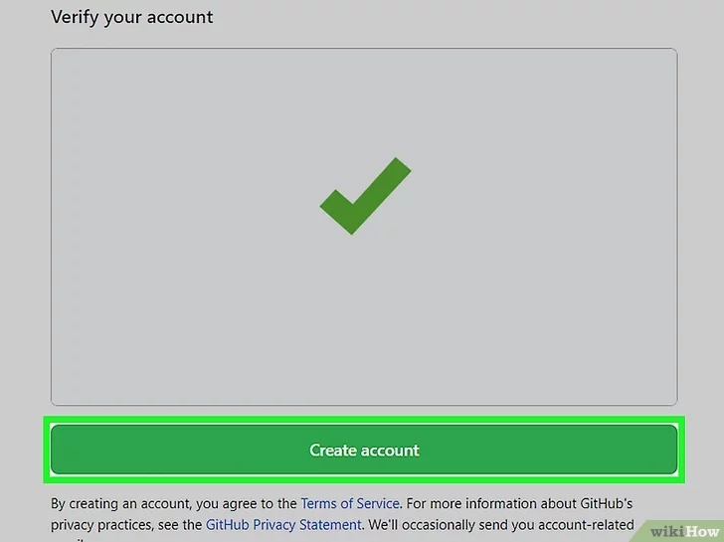

**Step 5:** Verify your email by entering the code.

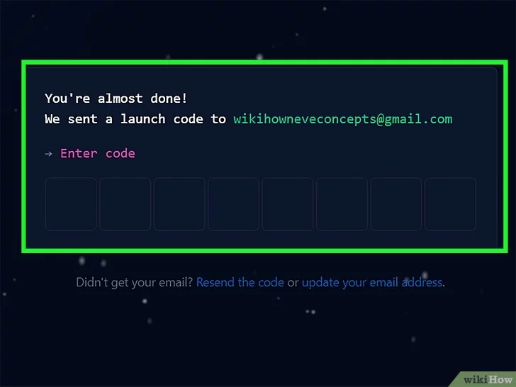

**Step 6:** Select your preferences and click Continue.



**Step 7:** Note the types of plans offered by GitHub**.**

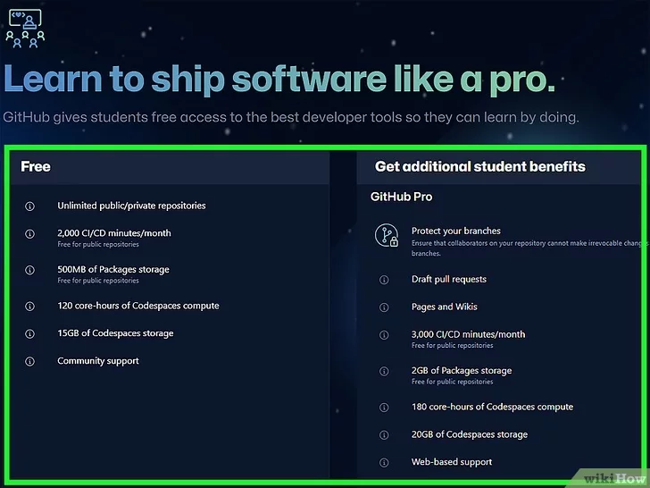

**Step 8:** Select the free plan.

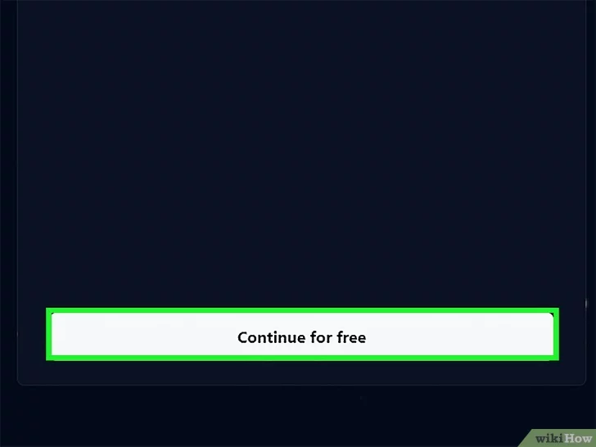

**Experiment:**

