Experiment – 3

**Aim:** To understand Continuous Integration, install and configure Jenkins to build a job and to execute Python and Java programs.

**Theory:**

**Continuous Integration (CI) -** Continuous Integration (CI) is a software development practice where developers regularly integrate their code changes into a shared repository, typically several times a day. The goal is to detect and address integration issues as early as possible, thus improving software quality and accelerating development cycles. CI relies heavily on automation and collaboration, making it a cornerstone of modern software development practices.

**Core principles:-**

1. Frequent Integration
2. Automated Testing
3. Immediate Feedback
4. Version Control Integration
5. Automated Deployment (Continuous Delivery/Continuous Deployment)

**Installing and configuring Jenkins**

**Step 1:** Go to “https://jenkins.io/download/”

**Step 2:** Choose the platform on which you are interested to install.

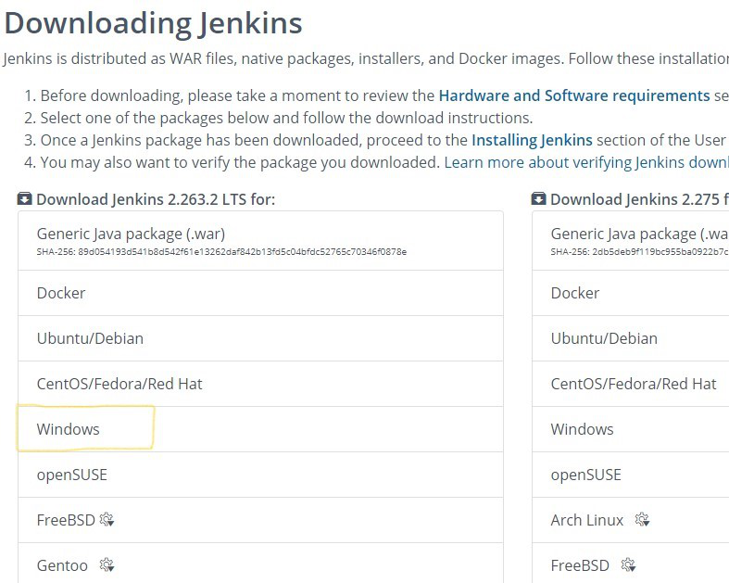

**Step 3:** For this we selected Windows, you can download either LTS or weekly releases. Click on Download for Windows 64-bit. File will download.

**Step 4:** Double-click on the file which is downloaded, this will lead to the below window. Click Next twice.

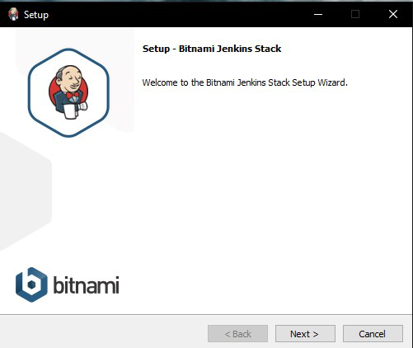

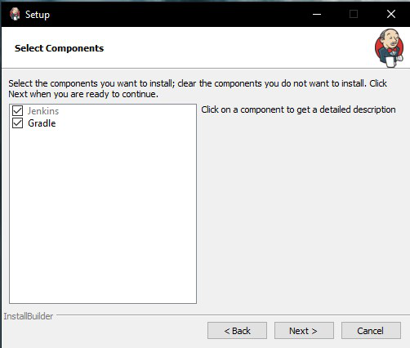

**Step 5:** Click next and give your name and mail details and click next.

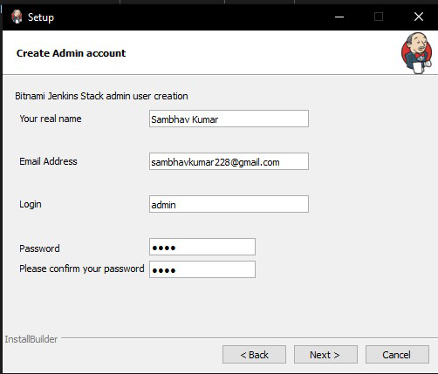

**Step 6:** Click on the Allow access button and Finish Button.

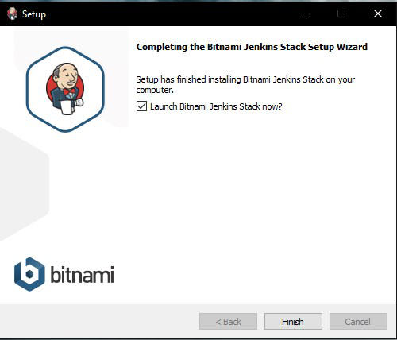

**Step 7:** Click on Access Jenkins.

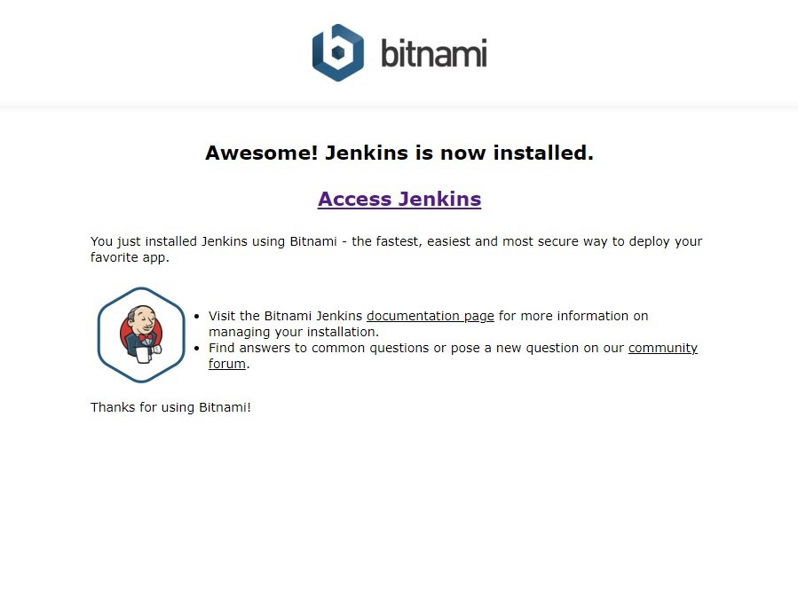

**Step 8:** Type the user name and password which had given earlier to open Jenkins.

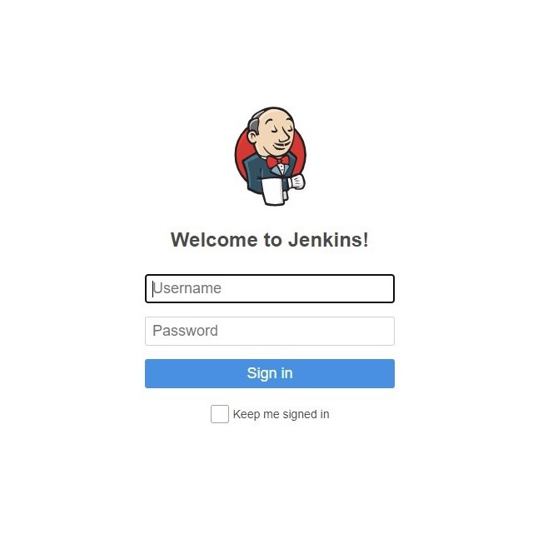

**Step 9:** Click install suggested plug-in and click continue.

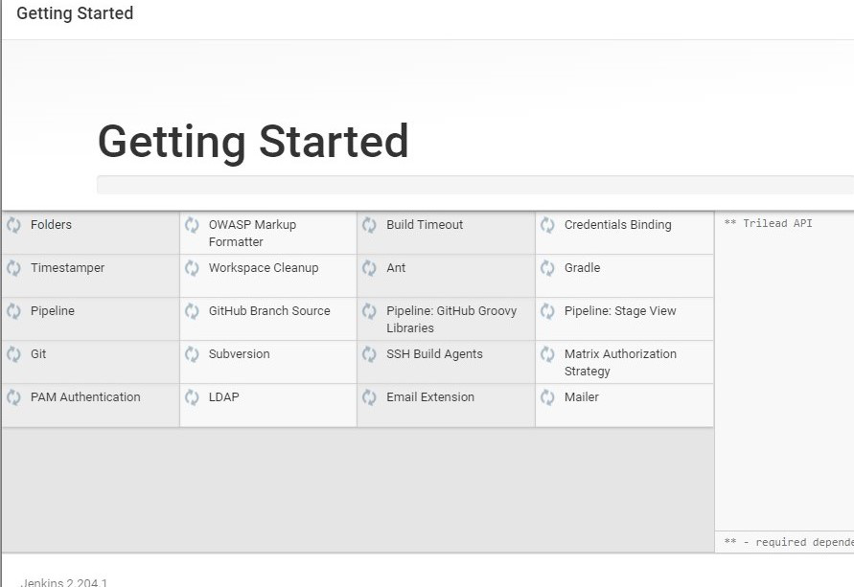

**Step 10:** Click on Save and Finish.

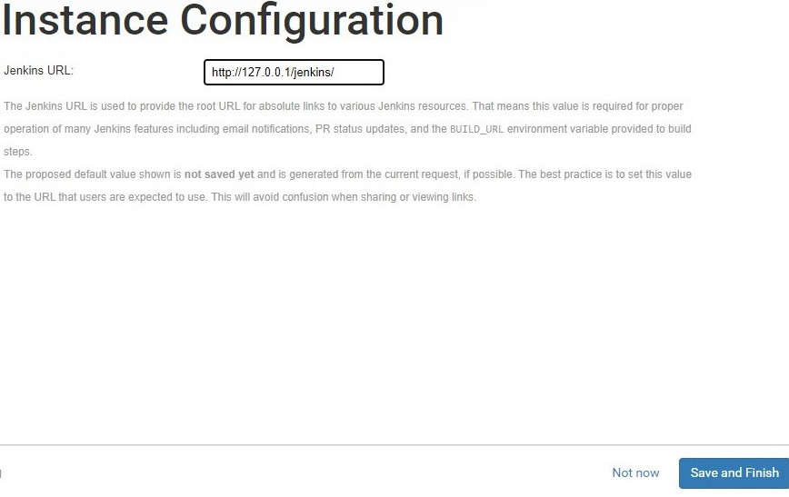

**Step 11:** Refresh the screen and you will login into Jenkins.

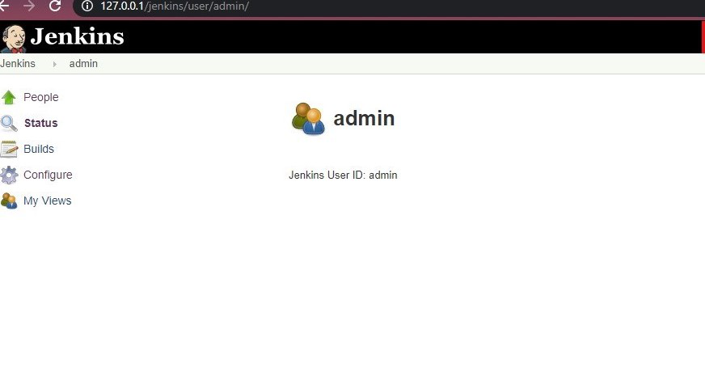

**Experiment:**