Experiment – 8

**Aim:** To manage images and interact with container.

**Theory:**

**Basic Docker Commands:**

1. **List Images**:

Lists all Docker images on your system.

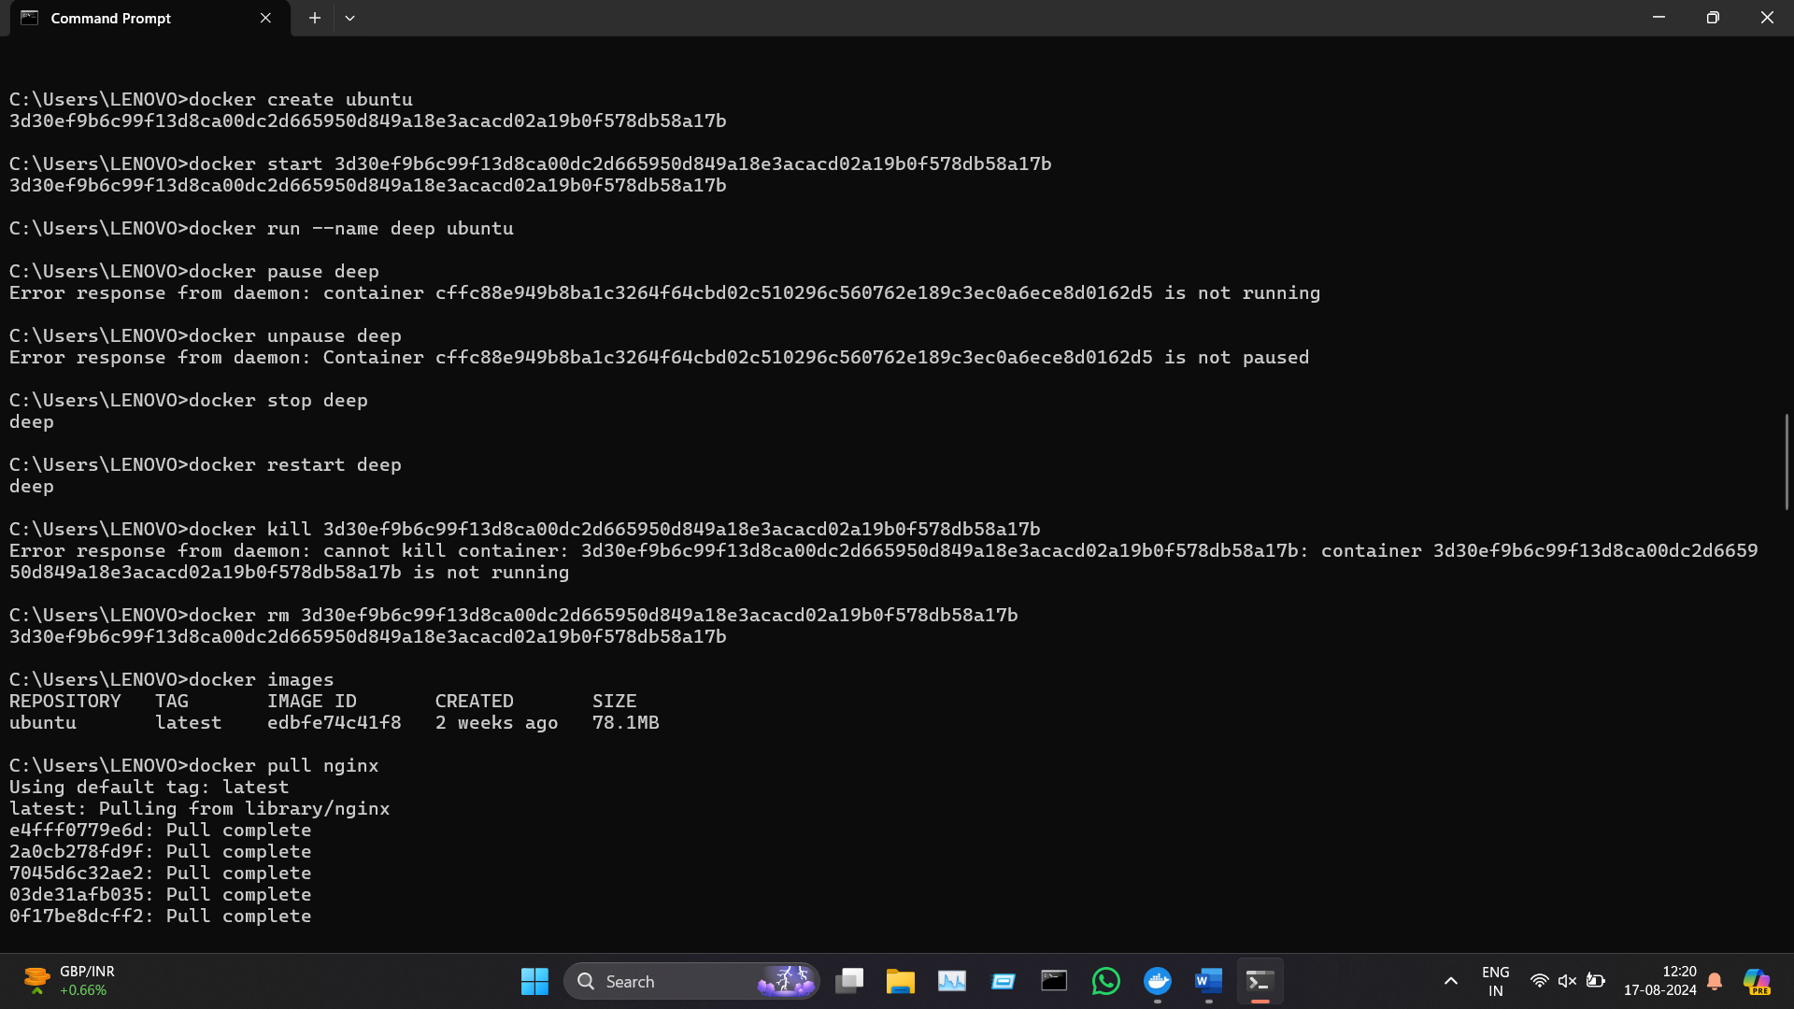

1. **Pull Image**:

Downloads an image from a Docker registry.

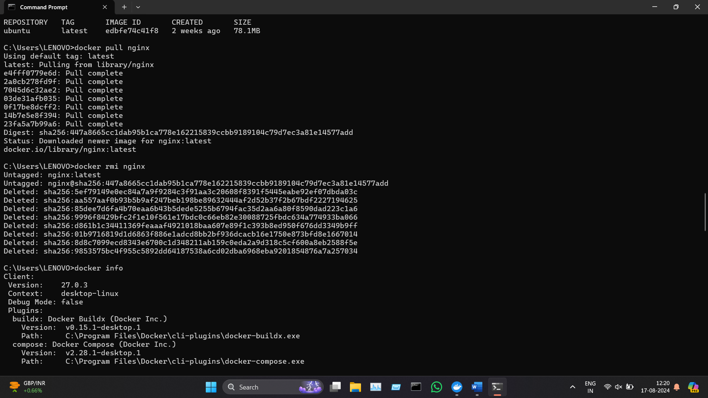

1. **Remove Image**:

Deletes a Docker image.



1. **Show System Information**:

Displays system-wide information about Docker.



1. **Prune Unused Resources**:

Cleans up unused containers, networks, images, and volumes.

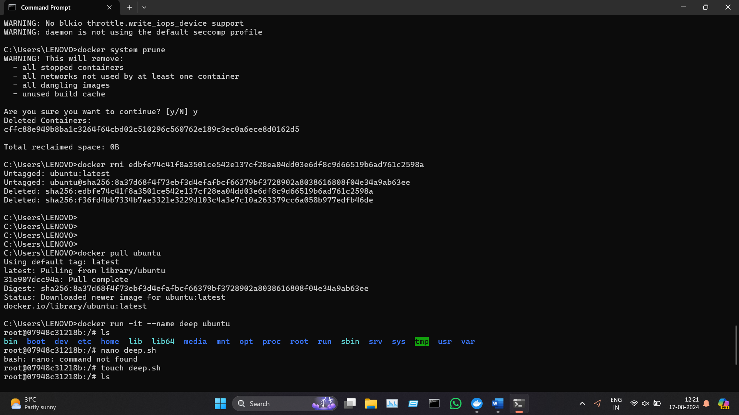

**Container Management and Interaction:**

Certainly! Here are some essential Docker commands for managing and interacting with containers:

### Management Commands

1. **List Running Containers**:

Lists all currently running containers.

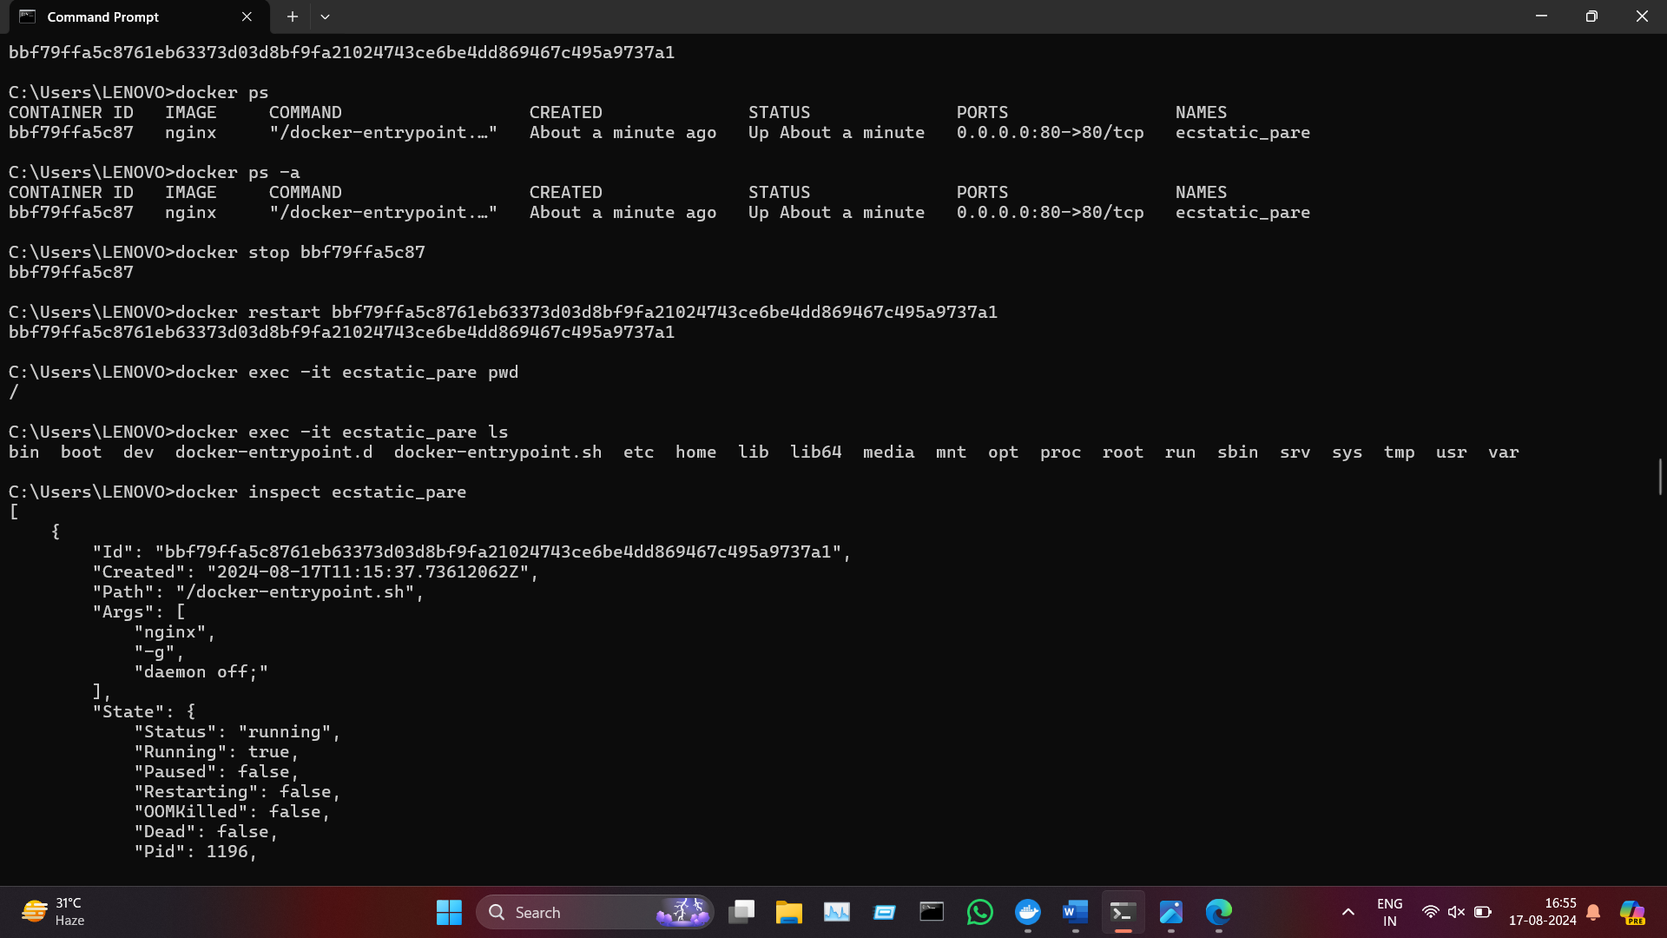

1. **List All Containers**:

Lists all containers, including stopped ones.



1. **Stop a Container**:

Stops a running container.



1. **Restart a Container**:

Restarts a container.



1. **Execute a Command in a Running Container**:

Runs a command inside a running container. The -it flag allows interactive mode.

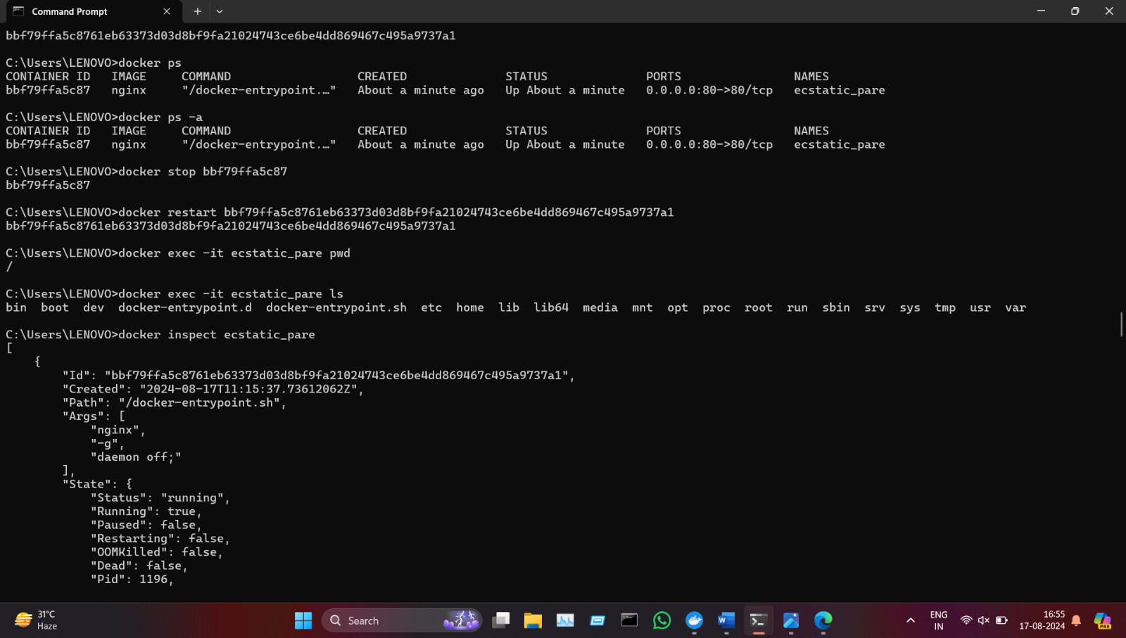

1. **Inspect a Container**:

Displays detailed information about a container in JSON format.



1. **View Container Logs**:

Shows the logs of a container.

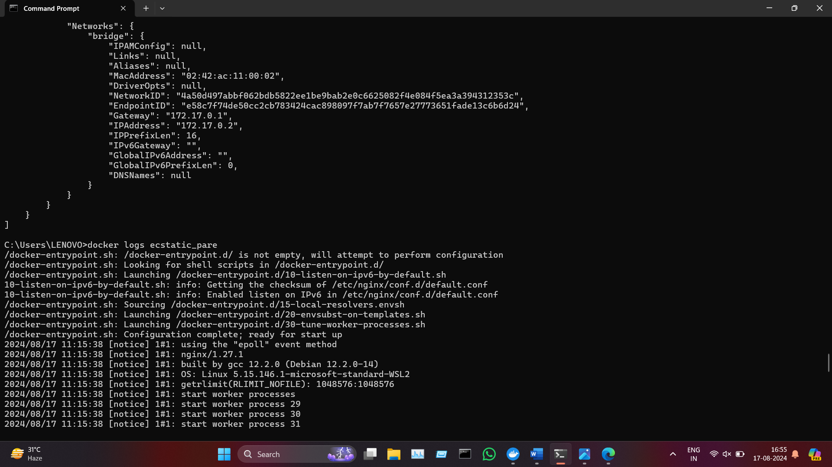

1. **Rename a Container**:

Renames a container.

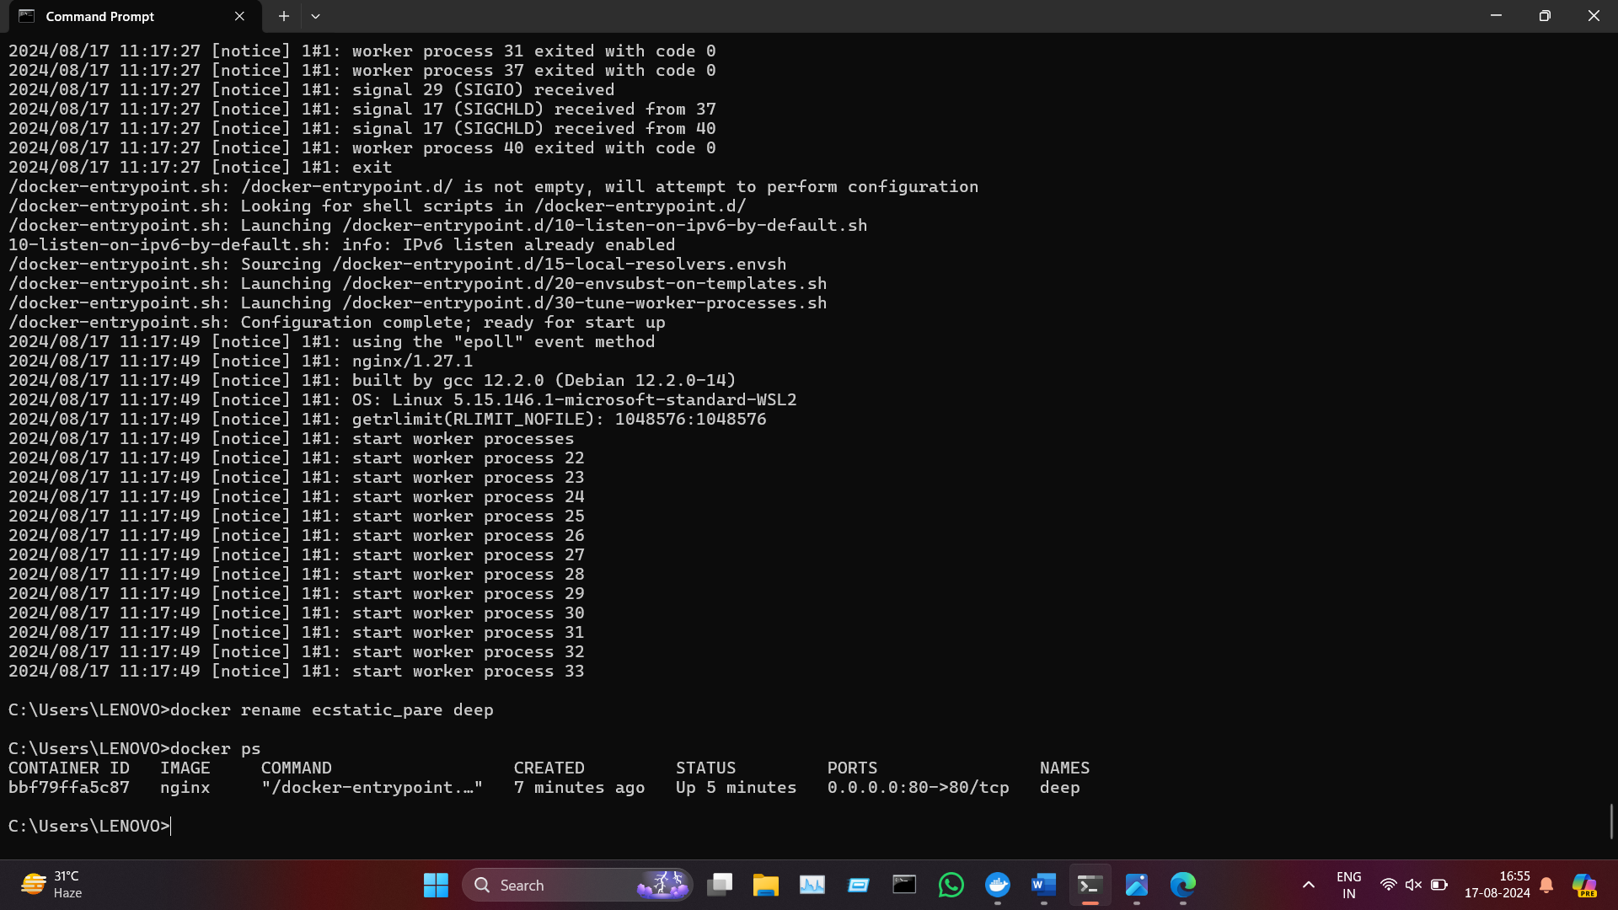

**Experiment:**

