Name : Manas Dange
Roll No : 150096724122
Cohort : ELON MUSK

OS Sem3 Sprint 2 Exam

Problem Statement :

Case Study 63 – IoT Sensor Data Aggregation

Smart IoT sensors (temperature, motion, humidity, etc.) generate continuous data streams.

These readings are queued on a central server for processing and visualization.

Without synchronization, sensor data could be lost, delayed, or processed twice.
Consumers such as analytics dashboards read this data sequentially.

IPC ensures reliable and time-stamped sensor
aggregation.

Objectives
● Collect in FIFO.
● Prevent overwriting.

OS Concepts Mapped
● Process → Sensors / Aggregator
● Shared Buffer → Data queue

Example Execution Trace
● Sensor1 sends Temp=25.
● Sensor2 sends Humidity=60.

Solution :

The provided solution implements the Producer-Consumer model using C pthreads.
The sensors act as producers, and the aggregator acts as the consumer, sharing a circular buffer (FIFO queue).
Synchronization is achieved using three mechanisms:
- empty_slots Semaphore: Initialized to the buffer size, it forces sensors to wait if the buffer is full, preventing data overwriting.

- full_slots Semaphore: Tracks available data, forcing the aggregator to wait if the buffer is empty.

- Mutex Lock: Wraps the critical section (buffer access and index updates) to ensure mutual exclusion, preventing race conditions between threads.
This ensures safe, ordered, and reliable data aggregation.
- Make file :
- Code in c :
#include <stdio.h>
#include <stdlib.h>
#include <pthread.h>
#include <semaphore.h>
#include <unistd.h>
#include <time.h>

#define BUFFER_SIZE 5
#define NUM_SENSORS 2 // Number of producer threads

// --- Data Structures ---
typedef struct {
int sensor_id;
char type[20]; // e.g., "Temperature", "Humidity"
float value;
time_t timestamp;
} SensorData;

// --- Shared Resources ---
SensorData buffer[BUFFER_SIZE];
int in = 0; // Index for writing (Producer)
int out = 0; // Index for reading (Consumer)

// --- Synchronization Primitives ---
sem_t empty_slots; // Counts available slots to write
sem_t full_slots; // Counts filled slots to read
pthread_mutex_t mutex; // Protects the critical section

// --- Helper: Get Current Time String ---
void get_time_string(char* buffer) {
time_t now = time(NULL);
struct tm *t = localtime(&now);
strftime(buffer, 26, "%H:%M:%S", t);
}

// --- Producer Function (The Sensors) ---
void* sensor_node(void* arg) {
int id = *((int*)arg);
char time_str[26];

while(1) {
// 1. Simulate data generation interval
sleep(rand() % 3 + 1);

// 2. Prepare Data
SensorData data;
data.sensor_id = id;
data.timestamp = time(NULL);

// Differentiate sensors for the demo
if (id == 1) {
sprintf(data.type, "Temperature");
data.value = 20.0 + (rand() % 15); // Random temp 20-35
} else {
sprintf(data.type, "Humidity");
data.value = 40.0 + (rand() % 40); // Random humidity 40-80
}

// 3. WAIT if buffer is full (sem_wait decrements empty_slots)
sem_wait(&empty_slots);

// 4. LOCK the buffer (Enter Critical Section)
pthread_mutex_lock(&mutex);

// --- CRITICAL SECTION START ---
buffer[in] = data;
get_time_string(time_str);
printf("[Sensor %d] Wrote: %s = %.2f at %s (Buffer Index: %d)\n",
id, data.type, data.value, time_str, in);

in = (in + 1) % BUFFER_SIZE; // Circular increment
// --- CRITICAL SECTION END ---

// 5. UNLOCK and SIGNAL that a slot is full
pthread_mutex_unlock(&mutex);
sem_post(&full_slots); // Increment full_slots
}
}

// --- Consumer Function (The Aggregator) ---
void* aggregator(void* arg) {
char time_str[26];

while(1) {
// 1. Simulate processing time
sleep(2);

// 2. WAIT if buffer is empty
sem_wait(&full_slots);

// 3. LOCK the buffer
pthread_mutex_lock(&mutex);

// --- CRITICAL SECTION START ---
SensorData data = buffer[out];
get_time_string(time_str);

printf(" --> [Aggregator] Read: Sensor%d %s=%.2f (Processed at %s)\n",
data.sensor_id, data.type, data.value, time_str);

out = (out + 1) % BUFFER_SIZE; // Circular increment
// --- CRITICAL SECTION END ---

// 4. UNLOCK and SIGNAL that a slot is empty
pthread_mutex_unlock(&mutex);
sem_post(&empty_slots);
}
}

int main() {
pthread_t sensors[NUM_SENSORS], agg_thread;
int sensor_ids[NUM_SENSORS];

// Initialize Synch Primitives
sem_init(&empty_slots, 0, BUFFER_SIZE); // Initial empty slots = 5
sem_init(&full_slots, 0, 0); // Initial full slots = 0
pthread_mutex_init(&mutex, NULL);

printf("--- IoT Sensor Aggregation System Started ---\n");
printf("--- Buffer Size: %d | Policy: FIFO ---\n\n", BUFFER_SIZE);

// Create Consumer Thread (Aggregator)
pthread_create(&agg_thread, NULL, aggregator, NULL);

// Create Producer Threads (Sensors)
for (int i = 0; i < NUM_SENSORS; i++) {
sensor_ids[i] = i + 1;
pthread_create(&sensors[i], NULL, sensor_node, &sensor_ids[i]);
}

// Join threads (In a real OS, we'd handle termination signals)
pthread_join(agg_thread, NULL);
for (int i = 0; i < NUM_SENSORS; i++) {
pthread_join(sensors[i], NULL);
}

// Cleanup
sem_destroy(&empty_slots);
sem_destroy(&full_slots);
pthread_mutex_destroy(&mutex);

return 0;
}

4. File made :

5. Compile code
6. Run iot_sim :

7. Output : 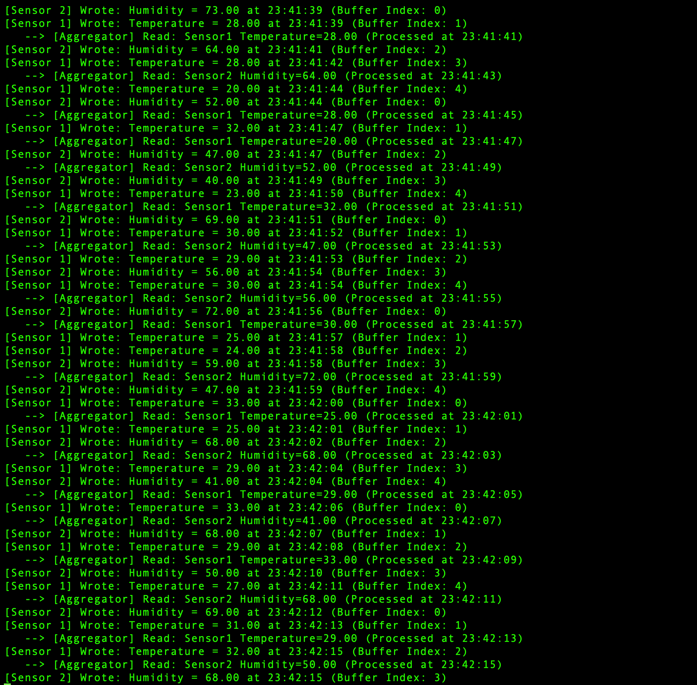

Github repo :

