IDEF0 FUNCTIONAL MODEL
Multi-Agent Software Engineering Team
A controlled, auditable agent pipeline that turns requests into reviewed pull requests without touching protected code
Document control
Model name | Multi-Agent Software Engineering Team (MA-SET)
Method | IDEF0 (ICOM: Inputs, Controls, Outputs, Mechanisms)
Status | Draft v1.1 for design review (adds work breakdown and visualization phase)
Date | 8 October 2026

1. Purpose, scope and viewpoint
IDEF0 requires a model to state why it exists, what it covers, and whose perspective it takes. These three statements keep every later diagram consistent.
Item | Statement
Purpose | Specify how a team of cooperating AI agents can take a feature request or bug ticket and deliver a tested, reviewed pull request, while guaranteeing that protected (legacy) code is never modified without explicit human approval.
Scope | From ticket intake to an open pull request and release notes, including a real-time and replayable view of how the agents are orchestrated. Out of scope: production deployment, infrastructure provisioning, and training or fine-tuning of the underlying models.
Viewpoint | The engineering lead or enterprise client who must trust the system: someone who cares about safety, auditability, cost control and measurable results.
Context | Python-based implementation on zero budget: free-tier hosted LLM APIs, open-source orchestration, local development on an 8 GB machine.

1.1 Notation key
Arrow side | Meaning
Left (Input) | Material or information transformed by the function
Top (Control) | Rules, constraints or policies that govern how the function runs; they are not consumed
Right (Output) | What the function produces
Bottom (Mechanism) | The agents, tools and people that perform the function

1.2 Node tree
Node | Function | Primary mechanism
A-0 | Deliver software changes using a multi-agent team | Whole system
A1 | Plan requirements | Planner agent
A2 | Analyze codebase and design solution | Architect agent
A3 | Implement changes | Developer agent
A4 | Verify and review | Tester and Reviewer agents, CI
A5 | Integrate and deliver | DevOps agent, human approver
A6 | Coordinate and monitor | Orchestrator (LangGraph)

2. Context diagram (A-0)
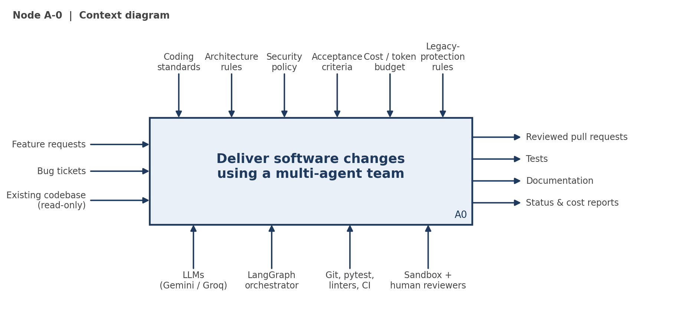
Figure 1. Node A-0. The Legacy-protection rules arrow is a first-class control on the whole system.

3. Decomposition diagram (A0)
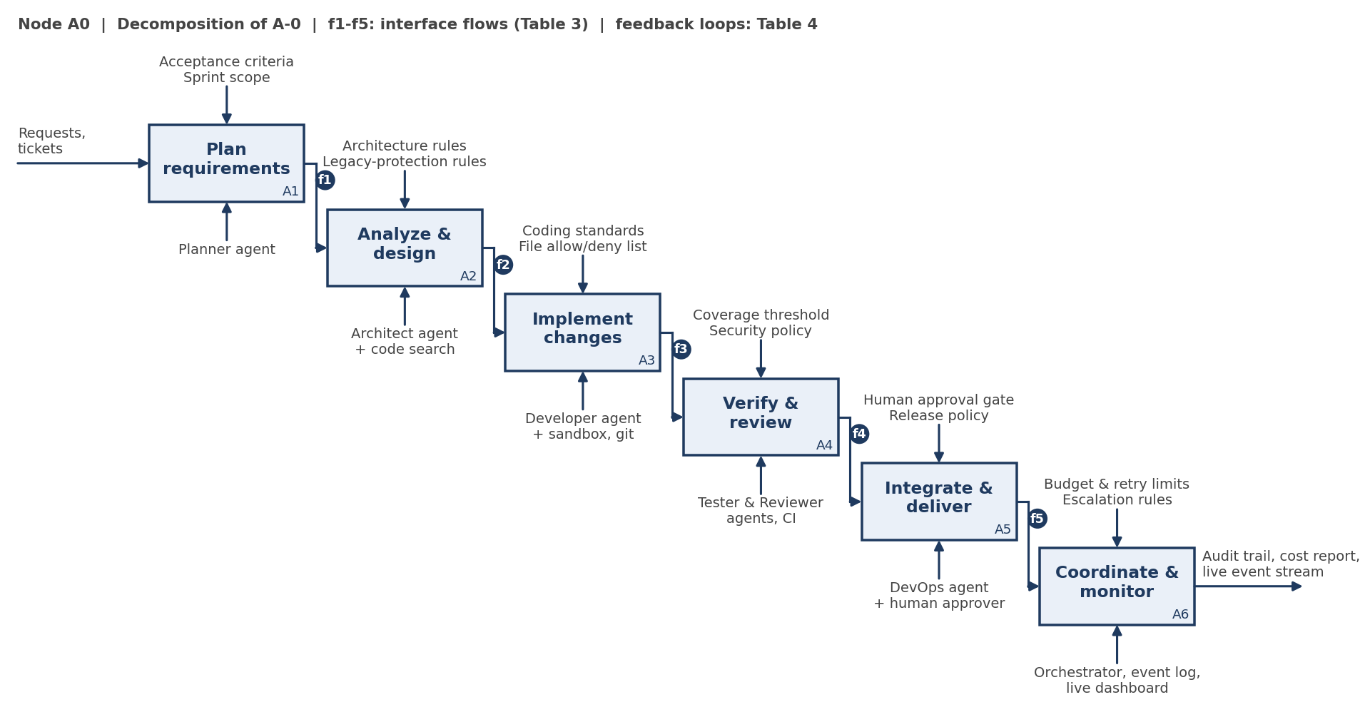
Figure 2. Node A0 decomposed into six functions. Tags f1-f5 are interface flows described in Table 3.

4. Context node (A-0) in detail
ICOM | Content
Function | Deliver software changes using a multi-agent team
Inputs | Feature requests; bug tickets; existing codebase (read-only)
Controls | Coding standards; architecture rules; security policy; acceptance criteria; token and cost budget; legacy-protection rules
Outputs | Reviewed pull requests; tests; documentation; status and cost reports
Mechanisms | LLMs (Gemini Flash primary, Groq fallback); LangGraph orchestrator; git, pytest, linters and CI; sandbox; human reviewers
Table 1. ICOM definition of the context node.

5. Node specifications (A1-A6)
Node | Function | Inputs | Controls | Outputs | Mechanisms
A1 | Plan requirements | Ticket; backlog | Acceptance criteria; sprint scope | Task breakdown; user stories | Planner agent
A2 | Analyze and design | Task breakdown; repo snapshot | Architecture rules; legacy-protection rules | Impact report; design spec | Architect agent; code search and AST tools
A3 | Implement changes | Design spec | Coding standards; file allow/deny list | Code diff on a feature branch | Developer agent; sandbox; git
A4 | Verify and review | Code diff; design spec | Coverage threshold; security policy | Test results; review verdict; defect list | Tester and Reviewer agents; linters; CI
A5 | Integrate and deliver | Approved diff | Human approval gate; release policy | Pull request; release notes | DevOps agent; human approver
A6 | Coordinate and monitor | Agent states; logs | Budget limits; retry limits; escalation rules | Routing decisions; audit trail; cost report; live event stream | Orchestrator; event log; live dashboard
Table 2. ICOM definitions for nodes A1 to A6.

5.1 Interface flows shown on diagram A0
Tag | From | To | Content
f1 | A1 | A2 | Task breakdown and user stories
f2 | A2 | A3 | Design spec and impact report
f3 | A3 | A4 | Code diff on a feature branch
f4 | A4 | A5 | Approved diff with passing test results
f5 | A5 | A6 | Delivery events (pull request opened, release notes produced) for logging
Table 3. Interface flows between functions.

5.2 Feedback loops
Loop | From | To | Behaviour
FB1 | A4 | A3 | Defect list returns to the Developer. Capped at 3 retries, then escalated to a human.
FB2 | A4 | A2 | A design flaw found in review sends the work back to the Architect.
FB3 | A5 | A1 | Post-release feedback becomes a new ticket.
Table 4. Feedback loops.

5.3 Optional enhancement for A1: ticket refinement
Client requests are usually vague (for example, "make the signup page better"). The Planner agent can rewrite each request into a precise specification with acceptance criteria before any code is produced. This reduces wasted LLM calls, which matters under free-tier limits, and improves the quality of every downstream node.

6. Protection controls for protected code
These controls apply to every node. They are enforced by the tool layer in code, not only by prompts, so an agent cannot bypass them by being persuaded.
# | Control | How it is enforced
1 | Read-only main branch | Agents read from a clone mounted read-only and write only to feature branches.
2 | File allow-list and deny-list | A path filter inside the file-write tool rejects edits outside the allowed set.
3 | Disposable sandbox | All code execution happens in an isolated environment that is discarded after each task.
4 | Impact analysis (A2) | The design spec must list every protected file touched; any touch requires human sign-off.
5 | Regression gate | The existing test suite must pass before a pull request is opened. Where tests are missing, characterization tests are written first.
6 | Human-only merge | Agents may open pull requests but have no merge permission.
7 | Budget and retry caps | Maximum LLM calls per task and 3 retries per loop, enforced by the orchestrator.
8 | Audit trail | Every prompt, tool call, diff and decision is logged with timestamp and agent identity.
Table 5. Protection controls.

7. Mechanism selection (zero-cost stack)
Layer | Selected | Alternatives considered
Orchestration | LangGraph (Python, open source) | Plain Python state machine; CrewAI
LLM access | Gemini Flash free tier, Groq as fallback, behind a model adapter | OpenRouter free models; Mistral free mode; small local model for offline use
Code search | ripgrep and tree-sitter, so agents see only relevant files | Local embeddings added later
Isolation | Git worktree on a clone, read-only mount | Docker via Colima if stronger isolation is needed
Verification | pytest, ruff, type checks | Additional security scanners
CI | GitHub Actions | Local pre-push script
Visualization | Event log (JSON Lines) feeding a lightweight web dashboard with live and replay modes | Streamlit; LangGraph developer tooling (verify current availability and terms)
Documentation | IDEF0 in this document; draw.io for editable diagrams | Mermaid in repository docs
Free-tier limits change often and some tiers carry data-use terms. The model adapter keeps providers swappable, and the demonstration should run against public repositories only.
Table 6. Mechanism choices.

8. Phases and work breakdown
The build is organized into six phases, numbered 0 to 5. Every task has an ID of the form Pn.m (phase n, task m) and is mapped to the IDEF0 node it implements. Structured events are emitted from Phase 1 onward (task P1.6), so the visualization in Phase 5 only consumes data that already exists.

8.1 Phase overview
Phase | Name | Nodes | Exit criterion
0 | Foundation and baseline | A6 (setup) | Target repository tests run green; stub model returns canned responses; event schema documented.
1 | Developer and Tester with protection layer | A3, A4 | An agent-written change passes tests; an attempt to edit a denied path is blocked and logged.
2 | Architect and impact analysis | A2, A4 | Design spec lists touched protected files; sign-off gate pauses and resumes a run; review loop works.
3 | Intake and delivery | A1, A5 | End-to-end run from ticket to open pull request with human-only merge.
4 | Orchestration, governance and benchmark | A6 | Full graph runs under budget caps; benchmark report produced; audit log saved for every run.
5 | Visualization and demo | A6 | A saved run replays in the dashboard; a live run shows the active agent; demo video and case study complete.
Table 7. Phase overview.

8.2 Phase 0: Foundation and baseline
ID | Task name | Node | Deliverable
P0.1 | Select demo target repository | - | Written selection against criteria: Python, medium size, existing tests, permissive licence, no secrets.
P0.2 | Create project repository and Python environment | - | Project skeleton, pinned dependencies, README stub.
P0.3 | Clone target read-only and run baseline tests | - | Recorded baseline: test count, pass/fail status, run time.
P0.4 | Define event schema | A6 | Documented JSON schema: run_id, timestamp, node, agent, event_type, payload.
P0.5 | Build model adapter with stub mode and cache | A6 | One interface over Gemini and Groq; stub mode for free testing; response cache for repeat runs.
Table 8. Phase 0 tasks.

8.3 Phase 1: Developer and Tester with protection layer
ID | Task name | Node | Deliverable
P1.1 | Build path filter for allow and deny lists | A3 | File-write tool that rejects denied paths, with unit tests.
P1.2 | Build sandboxed command runner | A3, A4 | Runs commands in a disposable worktree that is discarded after each task.
P1.3 | Build Developer agent | A3 | Produces a diff on a feature branch within the allow-list.
P1.4 | Build Tester agent | A4 | Runs tests and linters; produces test results and a defect list.
P1.5 | Build Developer-Tester retry loop (FB1) | A3, A4 | Defect list returns to the Developer; stops after 3 retries and escalates.
P1.6 | Emit events from agents and tools | A6 | Every agent step, tool call and blocked action is written as an event.
Table 9. Phase 1 tasks.

8.4 Phase 2: Architect and impact analysis
ID | Task name | Node | Deliverable
P2.1 | Build code index with ripgrep and tree-sitter | A2 | Search and symbol lookup that returns only relevant files.
P2.2 | Build Architect agent | A2 | Design spec produced from the task breakdown and index results.
P2.3 | Build impact report generator | A2 | Lists every file the change touches and flags protected files.
P2.4 | Build human design sign-off gate | A2 | Pauses the run until a human approves or rejects the design; decision is logged.
P2.5 | Build Reviewer agent | A4 | Review verdict checked against the design spec and coding standards.
P2.6 | Build review-to-design loop (FB2) | A4, A2 | Design flaws found in review return to the Architect.
Table 10. Phase 2 tasks.

8.5 Phase 3: Intake and delivery
ID | Task name | Node | Deliverable
P3.1 | Build ticket intake | A1 | Reads tickets from YAML files; GitHub issues can be added later.
P3.2 | Build Planner agent with ticket refinement | A1 | Task breakdown, user stories and acceptance criteria; refinement of vague tickets is the optional enhancement in section 5.3.
P3.3 | Build regression gate | A5 | Existing test suite must pass before a pull request is opened.
P3.4 | Build DevOps agent | A5 | Creates the branch and commit and opens a pull request on a fork of the target.
P3.5 | Enforce human-only merge | A5 | Agent credentials have no merge permission; a test verifies this.
P3.6 | Generate release notes | A5 | Notes drafted from the approved diff and the tasks.
P3.7 | Convert post-release feedback into a new ticket (FB3) | A5, A1 | A feedback file becomes a new ticket in the intake queue.
Table 11. Phase 3 tasks.

8.6 Phase 4: Orchestration, governance and benchmark
ID | Task name | Node | Deliverable
P4.1 | Build orchestration graph | A6 | LangGraph graph wiring A1 to A5 with shared state.
P4.2 | Enforce budget and retry caps | A6 | Maximum LLM calls per task and 3 retries per loop; the run stops cleanly when a cap is hit.
P4.3 | Persist audit trail | A6 | Events saved to a JSON Lines file per run, ready for replay.
P4.4 | Build escalation handling | A6 | Failed or over-budget runs produce a human-readable escalation report.
P4.5 | Create benchmark task set | A6 | About 10 tasks, including at least two traps that try to edit protected files.
P4.6 | Build benchmark runner and report | A6 | Tasks completed, tests passing, calls used, cost and time per task.
Table 12. Phase 4 tasks.

8.7 Phase 5: Visualization and demo
This phase makes the agent orchestration visible, both as a real-time view during a live run and as a replay of any saved run. Replay reads the saved event log, so it needs no LLM calls and is not affected by free-tier rate limits. That makes it the safest source for the recorded video.
ID | Task name | Node | Deliverable
P5.1 | Build event stream service | A6 | Local web service that streams events from live runs and saved logs using Server-Sent Events.
P5.2 | Build live orchestration graph view | A6 | Diagram of nodes A1 to A6; the active agent is highlighted and flows are animated as events arrive.
P5.3 | Build agent activity panel | A6 | Per-agent log of prompts, outputs and tool calls.
P5.4 | Build gates and protection panel | A6 | Shows pending approvals, blocked actions and retry counts.
P5.5 | Build cost and budget meter | A6 | Live LLM calls and tokens measured against the caps.
P5.6 | Build replay mode | A6 | Plays any saved run at adjustable speed, deterministically and without LLM calls.
P5.7 | Write demo script and record video | - | A 2 to 3 minute script and a screen recording of a replay that includes one blocked-change moment.
P5.8 | Write case study and README | - | One-page case study with benchmark numbers; README with architecture and safety sections.
Table 13. Phase 5 tasks.

8.8 Visualization options
Option | Approach | Advantages | Drawbacks
A. Streamlit | Python-only app that reads the event log | Fastest to build; no front-end code | Less smooth animation of agent flow
B. FastAPI + SSE + one HTML page | Server pushes events; browser draws the graph with SVG or D3 | Smooth live animation; light on memory; full control of the look | More front-end work
C. LangGraph developer tooling | Uses built-in graph views | Little code to write | Availability and terms must be verified; less control of the look
Table 14. Visualization options. Recommended: B, with A as a fallback if time is short.
The video can be recorded with the screen-recording feature built into macOS (Shift-Command-5), so it costs nothing.

8.9 Traceability
Controls from section 6 map to the tasks below, and each node maps to its build phase.
Protection control | Implemented by tasks
1. Read-only main branch | P0.3, P1.2
2. File allow-list and deny-list | P1.1
3. Disposable sandbox | P1.2
4. Impact analysis (A2) | P2.3, P2.4
5. Regression gate | P1.4, P3.3
6. Human-only merge | P3.5
7. Budget and retry caps | P1.5, P4.2
8. Audit trail | P1.6, P4.3, P5.6
Table 15. Controls mapped to tasks.
Node | Function | Built in
A1 | Plan requirements | Phase 3 (P3.1, P3.2, P3.7)
A2 | Analyze codebase and design solution | Phase 2 (P2.1 to P2.4, P2.6)
A3 | Implement changes | Phase 1 (P1.1 to P1.3, P1.5)
A4 | Verify and review | Phase 1 (P1.4) and Phase 2 (P2.5, P2.6)
A5 | Integrate and deliver | Phase 3 (P3.3 to P3.7)
A6 | Coordinate and monitor | Phase 0 (P0.4, P0.5), Phase 1 (P1.6), Phase 4 and Phase 5
Table 16. Nodes mapped to phases.

9. Success measures for the demonstration
- Tasks attempted and the share completed with all tests passing.
- LLM calls and tokens per task, and total cost (target: zero).
- At least one recorded case where the protection layer blocked an unsafe change.
- Time from ticket to pull request compared with a manual baseline.
- A complete audit trail that a reviewer can replay for any task.
- The dashboard shows the active agent, blocked actions and budget use live, and any saved run replays with the same event order and no LLM calls.

10. Open decisions
- Demo target (task P0.1): purpose-built messy Python web app, a small open-source project, or both.
- Visualization stack (tasks P5.1 and P5.2): option A, B or C from Table 14.
- Whether to include the optional ticket-refinement step (task P3.2).

