Output after executing Testing1.java :-

101 Manas 100
102 Swapnil 100
103 Tuhnish 100
104 Arthi 99

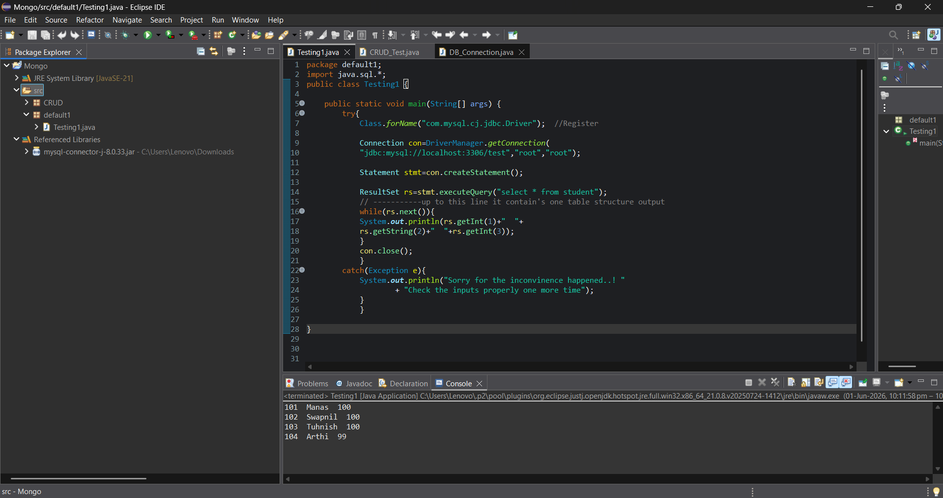

MySQL workbench code :-
