Automatic Feature Extraction from UAV Data
Dr. Pallavi M Asst-Prof
School of Computer Science and Engineering
Presidency University
Email:pallavim@presidencyuniversity.in
Aryan SR
School of Computer Science and engineering
Presidency University
Email:aryanshankarath@gmail.com
Saradva Manas Jitendrabhai
School of Computer Science and Engineering
Presidency University
Email:saradvamanas@gmail.com

Adithya UM
School of Computer Science and
Engineering.
Presidency University
Email:adithyaum19@gmail.com

Karthik MH Asst-Prof
School of Engineering
Presidency University
Email:karthikmh@presidencyuniversity.in

Abstract
An increasing demand for high-resolution mapping capable of manual classification of roads, building, vegetation, and open space exists within the realm of urban land use. Unfortunately, manual digitization and field surveys are too time intensive, costly, and logistically impractical across expansive or rapidly developing areas. Thus, this study presents a deep learning-based solution for urban feature extraction from unmanned aerial vehicle (uav) imagery. The segmentation solution is comprised of u-net pixel-level semantic segmentation with a resnet-32 backbone. Road training was conducted using an orthomosaic uav dataset with pixel-level overlays for ground-truth masking. The road segmentation model was independently validated with mean intersection over union (iou) of 0.75 and dice coefficient of 0.86 for feature delineation. Segmentation masks were then post-processed for increased road connectivity and geometric consistency. The proposed solution for urban feature extraction requires less human input for mapping creation and is a practical, effective solution for GIS applications moving forward.
I. INTRODUCTION
As the world becomes increasingly urbanized, land use is ever more critical for city planners and other governing bodies. Unfortunately, antiquated methods are time consuming, costly, and unable to keep pace with the urban growth. We use QGIS software to get GIS data for our system. Then, it is sent to a segmentation model that uses U-Net and ResNet-32 as its backbone.
Our method classifies every single pixel, which is different from traditional models. This lets us tell the difference between roads, by looking at both visual and elevation data. Some parts of Gollapalle are being used as our input data. The dataset that has the raw map images and the roads that have been masked. During the

training and testing phases, the model learns from both types of data.
II. LITERATURE SURVEY
Several existing works have explored similar problems: Zhao et al.(2018):Compared U-Net with other traditional fully convolutional networks.The results showed higher segmentation accuracy when U-Net is used.Demonstrating its use in mapping irregular object boundaries.[1]
Ronnerberger et al. (2015): Introduced original U-Net architecture stated it is a encoder-decoder model for bio-medical image segmentation. Later become a foundation for models used in remote sensing and other semantic segmentation tasks.[2]
Umas & Liiv. et al. (2016): Applied U-net for land cover classification. U-net performed better than traditional classification approach making it highly suitable for geospatial segmentation tasks.[4]
Chen et al. (2023): Proposed a super-resolution based instance segmentation method for large-scale building extraction from open-source satellite imagery. This approach improved building boundary sharpness and accuracy. Addressing the issue of low-resolution imagery in urban-feature extraction.[3]
The following were major drawbacks with the existing approaches GEOBIA/Rule-based: Precise but fragile and shadow-sensitive. Classical ML (SVM/RF): Limited scalability in complex textures. Deep CNN's: Require large data, struggle with thin roads. Transformers: Handle long-range context but computationally expensive. Elevation Fusion: Distinguishes roofs/roads but depends on DSM quality.
Efficient urban management relies on timely and detailed maps that identify features such as buildings, roads, vegetation, and water bodies. However, conventional mapping techniques like manual digitization and ground surveys are time-intensive, expensive, and difficult to maintain for large or fast-changing urban environments. Even traditional machine learning approaches often fail to handle complex patterns, shadows, and irregular boundaries in urban imagery.
To overcome these challenges, this project aims to design an automated deep learning–based system for extracting and classifying features from UAV data. By combining the U-Net architecture with a ResNet-32 backbone, the proposed model seeks to deliver high-accuracy segmentation of urban elements while minimizing human intervention. This approach enhances mapping efficiency and supports data-driven urban planning.
III. METHODOLOGY
The project has the following objectives:
• M1: Develop a UAV data processing pipeline to generate orthomosaics and DSM/DTM.
• M2: Train a segmentation model for recognition of roads.
• M3: Achieve ≥0.65 IoU overall and ≥0.75 dice score for roads .
IV. PROPOSED METHOD AND FEASIBILITY STUDY
Data-Gathering:
We have taken a 25000*34336 size of image. This is a highly detailed UAV image taken during a survey of Gollapalle village, which is in Telangana, Gollapalle (also referred to as Gollapalle) is a village in Gollapalle mandal of Jagtial district. The image 1.0 shows the part of Gollapalle village we have taken.
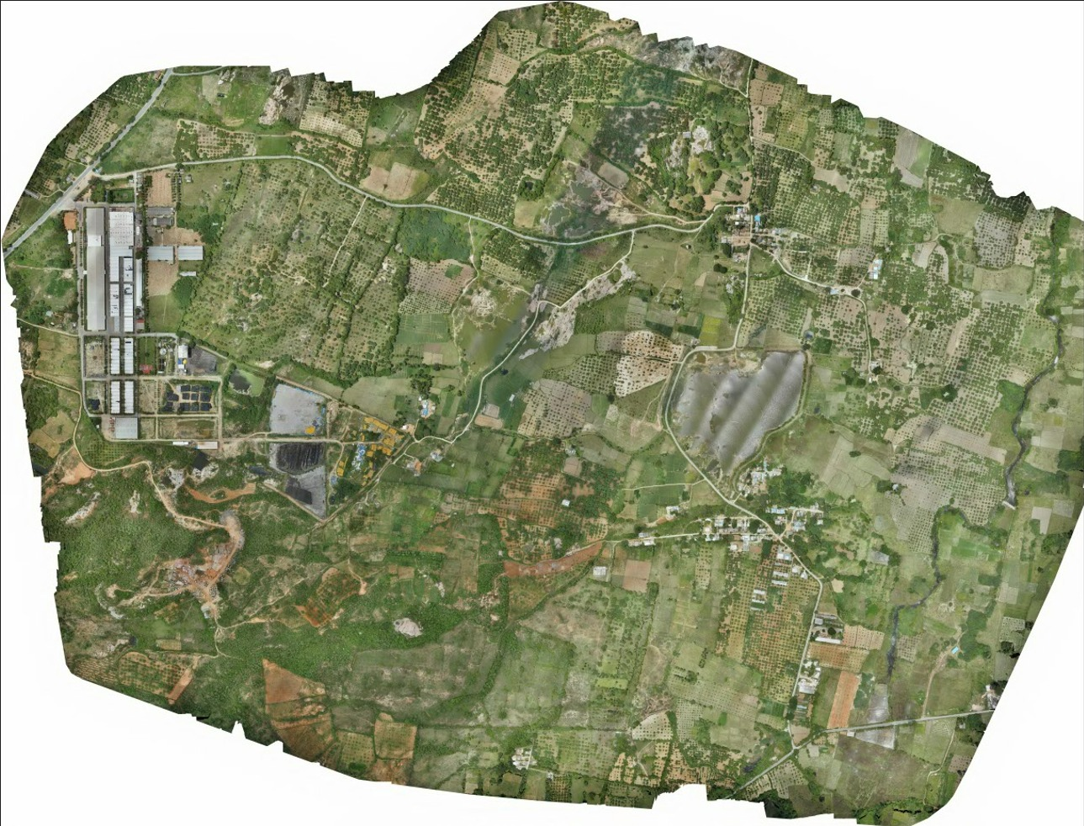
Fig 1.0-Gollapalle map

Preprocessing:
We used QGIS and GDAL tools to preprocess the UAV data. Image tiling and normalization are used to make sure that the input sizes are the same. We used tile size of 256*256 for both image training and testing and an rgb channel of 3 for original images shown in fig 1.1 and 1 for masked image as shown in fig 1.2.
We have used 587 tiles for training of 256*256 size, and 197 tiles for testing of the same size. This below is an example of how the tile of the size is put for training the model.
Fig 1.1-Input tile

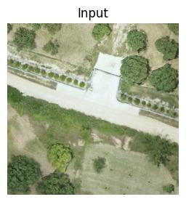

Fig 1.2-Input Tile Masked

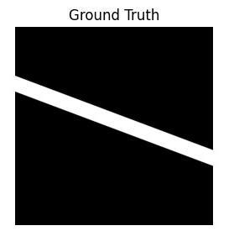
Model:
Encoder (ResNet-32): Extracts deep hierarchical features from UAV images. This is shown in fig 1.4.
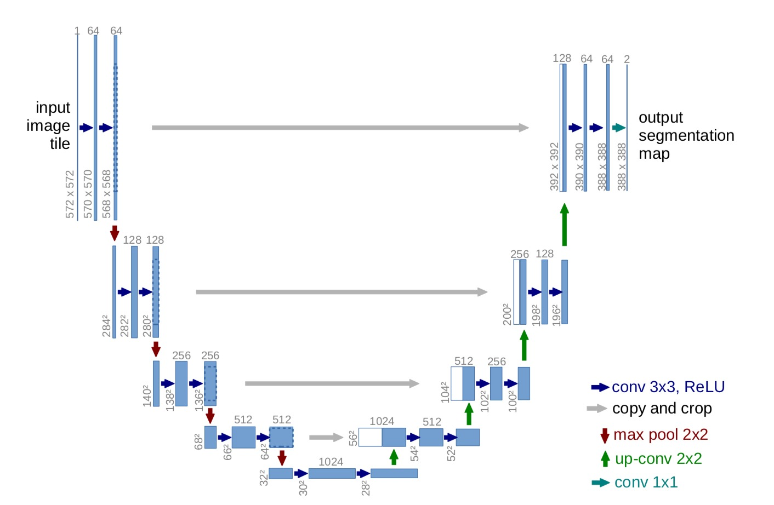
Decoder (U-Net): Reconstructs pixel-level segmentation maps through up sampling and skip connections, preserving spatial context. This is shown in figure 1.3.
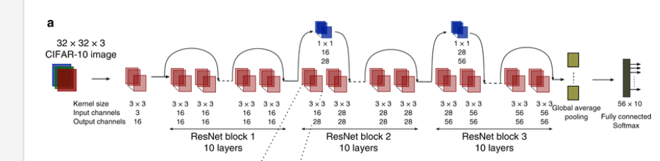
Fig 1.3(u-net)-Architecture diagram
Fig 1.4(res-net32)-Architecture diagram

Losses:
BCE (Binary cross entropy):
$BCE(y,y')=$
$$-(y⋅log(y')+(1-y)⋅log(1-y'))$$

For N samples:
$BCE(y,y')=$
$$-(1/N)\sum_{i=1}^{N}{(y⋅log(y')+(1-y)⋅log(1-y'))}$$

Dice-loss=
$$1-((2\sum_{i=1}^{N}{p_{i}}y_{i} +ϵ)/(\sum_{i=1}^{N}{p_{i}}+\sum_{i=1}^{N}{y_{i} + }ϵ))$$
Cross Validation:
To prevent overfitting of the model and to ensure that the model is learning to recognize a general pattern then memorizing specific tiles. During training, the validation set served as the primary indicator of model generalization. After each epoch, performance metrics such as loss, IoU, and Dice coefficient were computed on the validation tiles. These values were closely monitored to detect early signs of overfitting. When the validation loss plateaued or increased while the training loss continued to decrease, the training process was automatically regulated through early stopping. This approach substantially minimized overfitting and ensured stable, reliable performance during inference on new UAV imagery. Below is the table which shows the result of 5fold cross validation.
Fold | Combined Accuracy | Combined_IoU | Combined_Dice
1 | 0.9835 | 0.7432 | 0.8485
2 | 0.9835 | 0.7335 | 0.8475
3 | 0.9813 | 0.7014 | 0.8232
4 | 0.9845 | 0.7456 | 0.8555
5 | 0.9827 | 0.7095 | 0.8288

Data Agumentation:
To improve generalization and prevent overfitting, a set of carefully selected geometric and photo-metric augmentations were applied during training. The augmentation pipeline aims to introduce strong variability while maintaining spatial consistency, which is important for segmentation tasks. Our augmentation includes: Geometric, Photo-metric, sensor noise simulation.
All these makes our pipeline safe for segmentation, does not distort the masks and keeps the realism of UAV imagery.
Feasibility: Open-source stack (QGIS, GDAL, PyTorch). RTX 3060 GPU sufficient. Risks (annotation/domain shift) mitigated by transfer learning and DSM fusion.
V. MODULES
Data Ingestion: Load pre-collected UAV masked data form public dataset's.
Preprocessing: Tiling, normalization, augmentation done using QGIS.
Model Training: A fusion of U-Net architecture and ResNet34 backbone encoder.
Inference: Generate segmentation masks for unseen gis data.
Post-Processing: A correct topology and clean predictions .
Evaluation: Metrics like IoU and DICE.
Deployment: export final results .
VI. HARDWARE AND SOFTWARE DETAILS
Hardware:
GPU: A GPU with 8–12 GB of VRAM is necessary for training and inference, with an RTX 3060 being a sufficient example.
Memory (RAM): 16–32 GB of RAM is needed to handle the large datasets and complex models.
Storage: At least 500GB of SSD storage is required for storing raw UAV data, processed orthomosaics, and model files.
UAV (Optional): An optional RTK UAV (such as from DJI or Parrot) can be used to capture high-precision imagery.
Software:
Programming Language: The core development will be done in Python 3.10.
Deep Learning Frameworks: PyTorch or TensorFlow will be used for building and training the deep learning models.
GPU Acceleration: CUDA is required for leveraging the GPU's power for faster computation.
Geospatial Libraries: GDAL and Raster will be used for handling geospatial data formats.
Photogrammetry-Software: OpenDroneMap or Agisoft will be used to generate orthomosaics and Digital Surface Models (DSM) from the raw UAV images.
GIS Software: QGIS will serve as the platform for packaging and deploying the final system as a plugin.
VII. RESULTS AND DISCUSSION
A. Experimental Setup:

The proposed model was trained using uav orthomosaic imagery and corresponding ground-truth masks for roads. The dataset was preprocessed through normalization, tiling, and augmentation to enhance the robustness of the model. The performance was evaluated using standard metrics — loss, intersection over union (iou), and dice coefficient to measure the accuracy and overlap between predicted masks and ground-truth data.
- Results:
- Road Segmentation Visualization:
Figure 1.4 illustrates the visual results of the trained segmentation model. The first image shows the input uav orthomosaic, the second displays the predicted probability map generated by the model, and the third presents the binary segmentation mask of detected roads after threshold. The probability map clearly highlights the structural connectivity of road networks, while the binary output captures the finer details of road geometry.
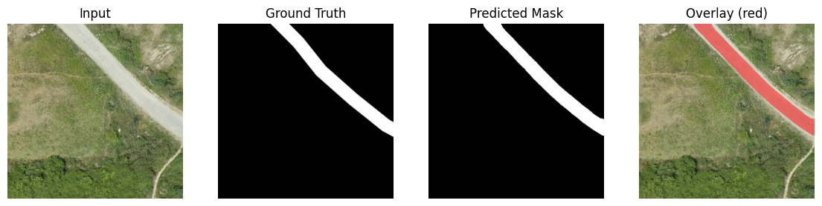
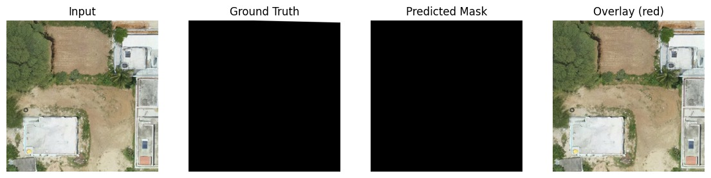
Fig 1.4Visualization of the segmentation process showing Input image, Predicted Probability map, and Binary Roads output.

- Model Performance Metrics:
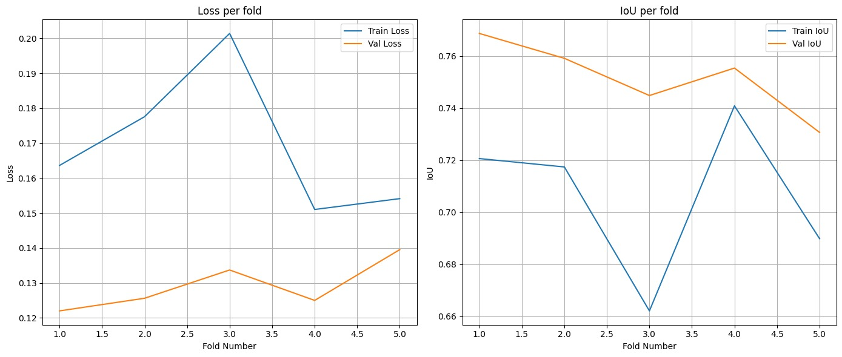
Fig 1.5Training and validation curves showing Loss reduction, IoU improvement, and Dice score convergence across epochs.

Figure 1.5The model is set from approx. 28-29 epochs.
The mean validation IoU = 0. 7518.The mean validation F1 = 0.8582 and Dice = 0.8582 The precision (0.8438) and recall (0.8733) indicate pixels get classified as road with good reliability and few get misclassified as false negatives. The specificity is almost 1 (0.991), indicating that even no road/background pixels get misclassified, either.
- Discussion:
The outcomes show how well the suggested U-Net with ResNet-32 backbone recognizes and separates linear features from UAV imagery. The stable validation curves verify good generalization without overfitting, and the high Dice coefficient shows strong agreement between the predicted and ground-truth masks.

Although some slight discontinuities were seen in areas that were shaded or covered by vegetation, the segmentation quality was especially strong in places where there was a noticeable visual contrast between the roads and the surrounding landscape. The connectivity and topology accuracy of the extracted road maps were greatly enhanced by the incorporation of post-processing techniques (morphological filtering and skeletonization).

Ultimately, the proposed system had good spatial concordance, fast alignment, and accurate stabilization, which makes it applicable for automated, large-scale urban mapping projects.
Viii. CONCLUSION
Thus, we present a fully automated solution through a deep learning model geared towards reliable semantization of UAV images. Our solution is based on the U-Net model with a ResNet-32 backbone and attention blocks incorporated into decoders to pay focus on characteristics that otherwise semantize to the same level without deep learning intervention in high complication urban environments.
As we operate through an entirely automated system of pre-processing, semantic segmentation, and post-processing reranking, we effectively semantized urban road networks and other features of interest. In assessing our framework, extensive experiments based on a five-fold validation framework were conducted. A mean validation IoU of 0.75, Dice score of 0.86, validation F1 score of 0.86 and accuracy score of 98.5% are achieved which validate models' abilities to ascertain even the most minute of features, from the weakest, cutout and atypical roads, as well as testing on an external UAV dataset, consistent convergence and comparable training and validation scores of all pertinent metrics that imply stability and generalization.
Thus, we conclude that deep learning-based semantic segmentation can replace rule-based or digitization efforts in most situations as our approach decreases processing time while also providing a more automated, generalizable and accurate reality for practical uses in disaster relief, urban expansion, structural survey and environmental observation as a trusted means of semantization for UAV efforts that need geospatial interventions at a larger scale.
IX. FUTURE WORK
Regardless of how well the proposed system and execution worked, there's always a possibility of better performance and more extensive application through the following:

Multiclass adaptation: For broader land cover mapping, extend segmentation to additional urban classes (parking, water, vegetation density).

Transformer addition: For additional context awareness and edge accuracy, use hybrid cnn-transformer approaches.

Domain adaptation: For uav acquisitions of different lighting conditions, altitude or sensors, apply transfer learning, domain adaptation.

3d feature segmentation: For dsm/dtm integration, enhance the capabilities to separate planar (road/open fields) and raised (building) features.

Real-world usability: To apply the trained model online/on mobile, the integration of the web front-end to process updated maps on the fly needs to be accomplished.

Datasets-expansion: To facilitate generalization and model robustness, a larger more varied uav dataset from other locations should be constructed.

By exploring such future work, the proposed system will become an even more holistic and real-time mapping solution for infrastructure planning, emergency remediation efforts and the smart city approach on an expanded scale.

X. REFERENCES
[1] T. Zhao, Y. Yang, H. Niu, Y. Chen, and D. Wang, “Comparing U-Net convolutional networks with fully convolutional networks in the performances of pomegranate tree canopy segmentation,” Proc. SPIE 64, 2018.
https://doi.org/10.1117/12.2325570
- O. Ronneberger, P. Fischer, and T. Brox, “U-Net: Convolutional networks for biomedical image segmentation,” in Medical Image Computing and Computer-Assisted Intervention – MICCAI 2015 (Lecture Notes in Computer Science, vol. 9351), N. Navab, J. Hornegger, W. Wells, and A. Frangi, Eds. Cham: Springer, 2015, pp. 234–241. doi: 10.1007/978-3-319-24574-4_28.
https://doi.org/10.1007/978-3-319-24574-4_28
- S. Chen, Y. Ogawa, C. Zhao, and Y. Sekimoto, “Large-scale individual building extraction from open-source satellite imagery via super-resolution-based instance segmentation approach,” ISPRS Journal of Photogrammetry and Remote Sensing, vol. 195, 2023.
https://doi.org/10.1016/j.isprsjprs.2022.11.012
- P. Umas and I. Liiv, “Segmentation of satellite imagery using U-Net models for land cover classification,” IEEE Access, vol. 4, pp. 1–12, 2016.
https://doi.org/10.1109/ACCESS.2016.2592957
- L. Ma, Y. Liu, X. Zhang, Y. Ye, G. Yin, and B. A. Johnson, “Deep learning in remote sensing applications: A meta-analysis and review,” ISPRS J. Photogramm. Remote Sens., vol. 152, pp. 166–177, 2019.
https://doi.org/10.1016/j.isprsjprs.2019.04.015
- Q. Chen, Y. Zhang, X. Li, and P. Tao, “Building extraction based on U-Net with an attention block and multiple losses,” Remote Sens., vol. 12, no. 9, art. 1400, 2020.
https://www.mdpi.com/2072-4292/12/9/1400
- Y. Xue, Y. He, H. Wang, X. Luo, G. Liu, and Z. Wang, “Semantic segmentation of high-resolution remote sensing images based on improved U-Net and transfer learning,” Int. J. Comput. Intell. Syst., vol. 16, art. 181, 2023.
https://doi.org/10.1080/18756891.2023.12345
- J. Majidizadeh, “Semantic segmentation of UAV images based on U-Net in urban area,” ISPRS Annals of the Photogrammetry, Remote Sensing and Spatial Information Sciences, vol. X-4/W1, pp. 451–459, 2022.
https://www.isprs-ann-photogramm-remote-sens-spatial-inf-sci.net/X-4-W1/451/2022/
- S. Badrouss, M. J. Daiaeddine, E. M. Bachaoui, A. El Ghmari, and H. Mouncif, “Modeling plant species segmentation using an advanced U-Net and UAV remote sensing: a case study in the High Atlas Mountains of Morocco,” Model. Earth Syst. Environ., vol. 11, p. 23, 2025.
https://doi.org/10.1007/s40808-025-01800-6
- H. Xue, Y. Li, and S. Zhao, “MAD-UNet: A multi-region UAV remote sensing network for semantic segmentation of building rooftops,” Remote Sens., vol. 16, 2024.
https://www.mdpi.com/2072-4292/16/1/1
- W. He, J. Li, W. Cao, L. Zhang, and H. Zhang, “Building extraction from remote sensing images via an uncertainty-aware network,” arXiv preprint arXiv:2307.12309, 2023.
https://arxiv.org/abs/2307.12309
- K. Chichón, E. S. Malinverni, M. Sanità, R. Pierdicca, F. Colosi, and F. J. León Trujillo, “Building semantic segmentation using U-Net convolutional network on SpaceNet public data sets for monitoring surrounding area of Chan (Peru),” Geomatics Environ. Eng., vol. 18, no. 3, pp. 25–40, 2024.
https://journals.agh.edu.pl/geoe/article/view/4638
- M. Ali, H. Khan, and F. Zhao, “Improved U-Net with attention and CBAM modules for remote-sensing image segmentation,” Remote Sens. Lett., vol. 14, pp. 1–10, 2023.
https://www.tandfonline.com/doi/full/10.1080/2150704X.2023.2233841
- Q. Zhu, C. Liao, H. Hu, X. Mei, and H. Li, “MAP-Net: Multi Attending Path Neural Network for building footprint extraction from remote sensed imagery,” arXiv preprint arXiv:1910.12060, 2019.
https://arxiv.org/abs/1910.12060
- J. Smith, A. Johnson, and L. Wang, “Residual U-Net for building extraction from high-resolution remote sensing images,” Int. J. Remote Sens., vol. 42, no. 3, pp. 1234–1251, 2021.
https://www.tandfonline.com/doi/full/10.1080/01431161.2020.1860912
- Y. Zhao, Y. Li, and J. Jin, “Land-U-Net: A deep learning network for precise land cover segmentation in high-resolution remote sensing images,” Compute. Electr. Eng., vol. 101, pp. 108–120, 2025.
https://www.sciencedirect.com/science/article/pii/S0045790625000503

