Software Requirements Specification

ExpCalc

Handwritten calculator

Version 3.0

Prepared by: Rajdeep Mondal(17CS10041)

Manas Madine(17CS10025)

Department of Computer Science and Engineering, Indian Institute of Technology Kharagpur

Email: mondalrajdeep814@gmail.com

12.02.2019

**Requirement Analysis:**

***The Need*:**

Handwriting calculator can find a variety of uses among kids and adults alike with varying interests and skill levels. Younger elementary-age kids can write a number on the screen and then watch it magically transform into text, to build confidence with accurate number formation. Parents who might not be confident in solving difficult math calculations can use the app as a strategy to provide a solution. Children with dyscalculia, which impacts their ability to learn new math concepts, the app can be used for additional instruction and educational activities that may help improve their overall success and confidence. As with any app that readily provides answers, parents should supervise when and how it's used. Students, professors and researchers can quickly check their calculations if they use this app, as they do not always have access to a calculator.

***Addressing the Need*:**

The plan is to use deep learning and computer vision techniques for recognizing the handwritten expressions. The basic ambition of the project is to develop a robust enough system which will take as input an arithmetic expression in the user’s own handwriting traced by him on a GUI, perform the required calculations and display the output.

***Prospective Users*:**

The prospective users of this application include kids, students, teachers, parents, professors and researchers alike. It will also include people who require it for quick, fast and small calculations so this incorporates companies, banks, shops and departmental stores.

***Issues/Challenges to Overcome*:**

Since it involves handwriting recognition, we need to develop a neural network for recognizing the digits. But the neural network must be robust enough to be able to recognize variations in handwriting since the users include people of all ages. So, there are small kids who are just learning to write and then there are elderly people who may not have adequate strength in their hands to write with proper discernible handwriting, such as those suffering from Alzheimer's disease. So, the dataset on which the neural network must be trained must have exemplar handwriting from people of all ages. Also, deep learning networks require large datasets to train properly and produce satisfactory results. So, we would need to create a large enough dataset for the neural network to not overfit the training data and perform poorly. It will be a highly iterative process as it would require the hyperparameters to be tuned properly for it to yield the best performance. Also, training on a huge dataset would require a lot of time and higher end hardware.

**Functional Requirements:**

1. **Mode Selection**

The user is offered two modes of operation of the application, namely Child Mode and Calculator Mode. The Child Mode is especially meant for young children to perfect their handwriting by practicing writing digits. The Calculator Mode is designed to perform simple calculations following the BODMAS rule.

1. **Write numbers**

The user presses down the left mouse button and drags the mouse around to draw the numbers.

1. **Select Operator**

The user can select any operator from among +, -, * and / by clicking on the corresponding button provided in the upper part of the screen. This option is available in the Calculator Mode.

1. **Display recognized numbers and operators**

The recognized numbers and operators are displayed at the bottom of the screen.

1. **Calculate expression**

By clicking on “=” button, the user can get his expression calculated.

1. **Display result**

The calculated result is displayed at the bottom of the screen.

1. **Clear screen**

The user can clear the screen by clicking on “CLEAR” in case he wants to write a new expression.

**Other Non-functional Requirements:**

1. **Human Computer Interaction (HCI)**

A Graphical User Interface where the user is supposed to trace the numbers and the operators for performing the desired calculations, it will also show the calculated result of the input arithmetic expression

1. **Memory for storing the parameters for storing the neural network as well as to perform calculations**
2. **Reliability**

The computer must be able to recognize digits with a very high degree of accuracy.

1. **Response Time**

The response time of the calculator must be under 2 seconds.

**Software Requirements:**

***Programming Language****:* Python 3.6 / Java 8

***Libraries/Frameworks****:*

1. PyGame (version 1.9.4)
2. NumPy (version 1.15.4)
3. TensorFlow (version 1.12.0)
4. Keras (version 2.2.4)
5. OpenCV (version 3.4.5)
6. Swing
7. AWT

***Operating Systems****:* Windows 10/Linux

**Hardware Requirements:**

We will be using Google Cloud Service for storing the datasets and train the convolutional neural network using Google Colab which offers free K80 GPU, 12.76 GB RAM and 33GB storage memory.

**Project Plan:**

The general workflow of the software is as follows:

The project as such is implemented heavily so it is wise enough to apply a **bottom-up approach** for developing the system.

Initially, the plan is to develop the GUI using PyGame and OpenCV. The GUI will have a white background and it will use digital ink and mouse click events for tracing and drawing the digits and operators. The user can personalize the ink colour and write on the screen using his own handwriting. On the event that the left mouse button is pressed, the pointer starts drawing on the whiteboard. When the user relaxes his/her press on the mouse button, the pointer stops drawing. Post completion of writing the expression on the whiteboard, the user clicks on an ‘OK’ button at the bottom of the window.

The whiteboard frame will be converted to gray scale and the contours demarcated. The regions of interest will be extracted from the frame and resized accordingly to yield 28x28 gray scale images. All these tasks are accomplished using OpenCV.

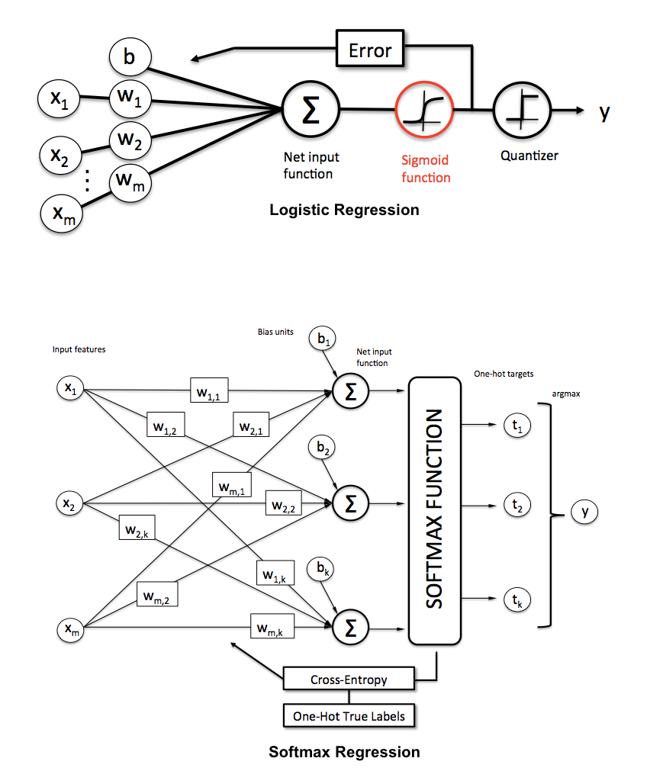

Parallelly, the work on the machine learning part will also be going on. Roughly speaking, it will be a feedforward deep neural network with a terminal SoftMax layer. Since it will take time to manually select the best architecture for the model as it involves experimentation with the number of layers, tuning the hyperparameters like learning rate, batch size, optimization algorithm, etc. The neural network must be robust enough to be able to differentiate between similar looking numbers like 3 and 8. Also, since a good and reliable dataset for the operators +, -, /, * is not easily available on the online, it is required to generate the dataset on our own. Another possible option is to add buttons to the GUI for selecting the required operators.

The expression will be read and recognized by the computer as the digit and operator images are fed into the neural network one by one. Then the expression will be evaluated, and the result displayed on the screen as a string.

Keras and NumPy libraries will be used to build the architecture for the neural network and for training and testing it. The trained model will be saved in a .pkl file whence it can be loaded and used as per requirement. The Keras library uses TensorFlow backend.

.

**Publicity and cost:**

In today’s modern world what if we could simply write an equation with your hand on the graphical user interface on the screen and get the result of the arithmetic equation. Gone are those days where a user uses the stereotypical calculator on the computer in which the user uses the mouse clicking for typing even basic expressions. How cool it would be if you could simply write an equation on the screen and automatically get its output.

So here is our product EXPCALC which is a handwritten calculator in which a user simply with his hand and his own handwriting writes on our graphical user interface and gets the result of his expression and gets digit and operation of his expression displayed.

For professionals (students, engineers, professors, etc.) if there is no calculator available you can just scribble your equations on the screen and get the result of the expression. You need not worry about the neatness of the digits as our product is well trained to recognize and handle all sort of handwritings.

So, our product could be used not only as a calculator but also could be used by elementary school children to learn digits as our product displays the digit written by the user. If the child writes a digit our system predicts the digit closest to the written digit if it is wrong the child learns how to write the digit properly and neatly.

So why being old fashioned and using the 90’s calculators when you can use our new AI driven handwritten calculator.

**Cost estimate**: We estimate that our product could cost around 2000 $.

**Use Case Diagram**

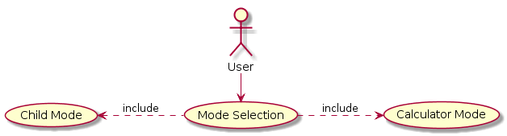

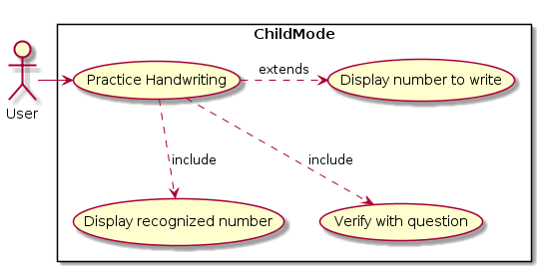

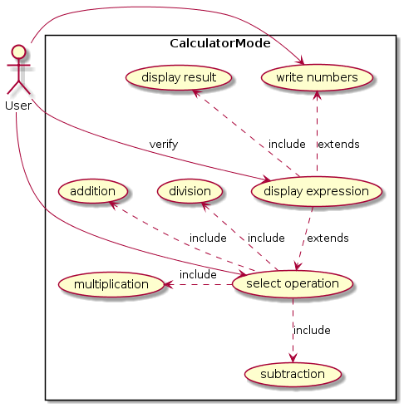

**Sequence Diagrams**

