Login

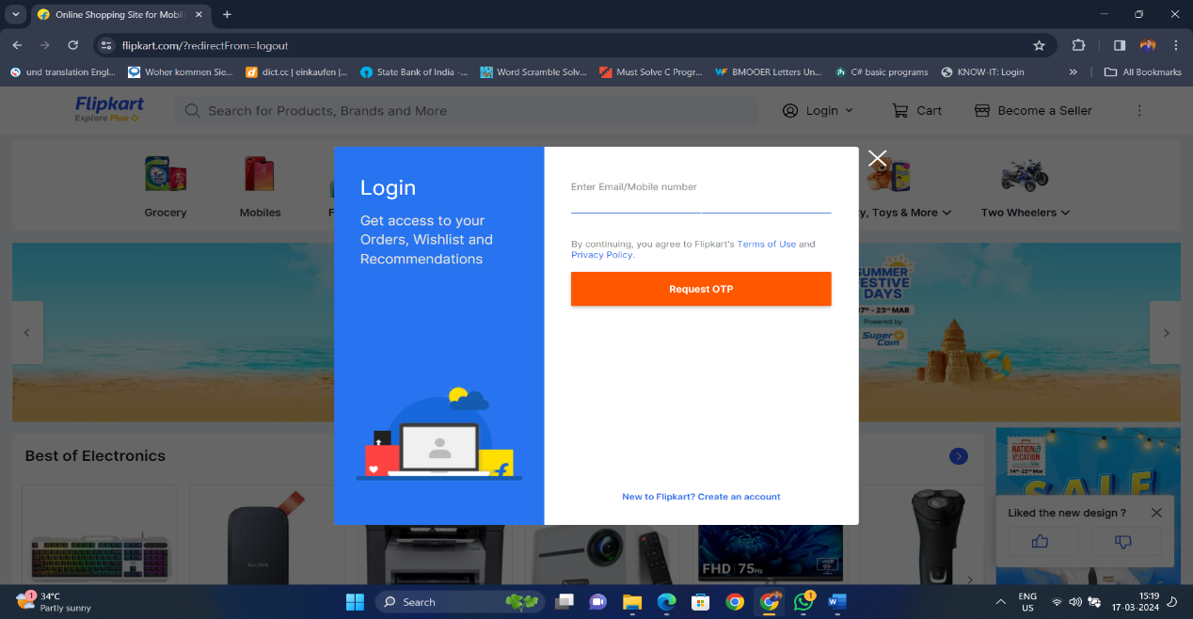

Products

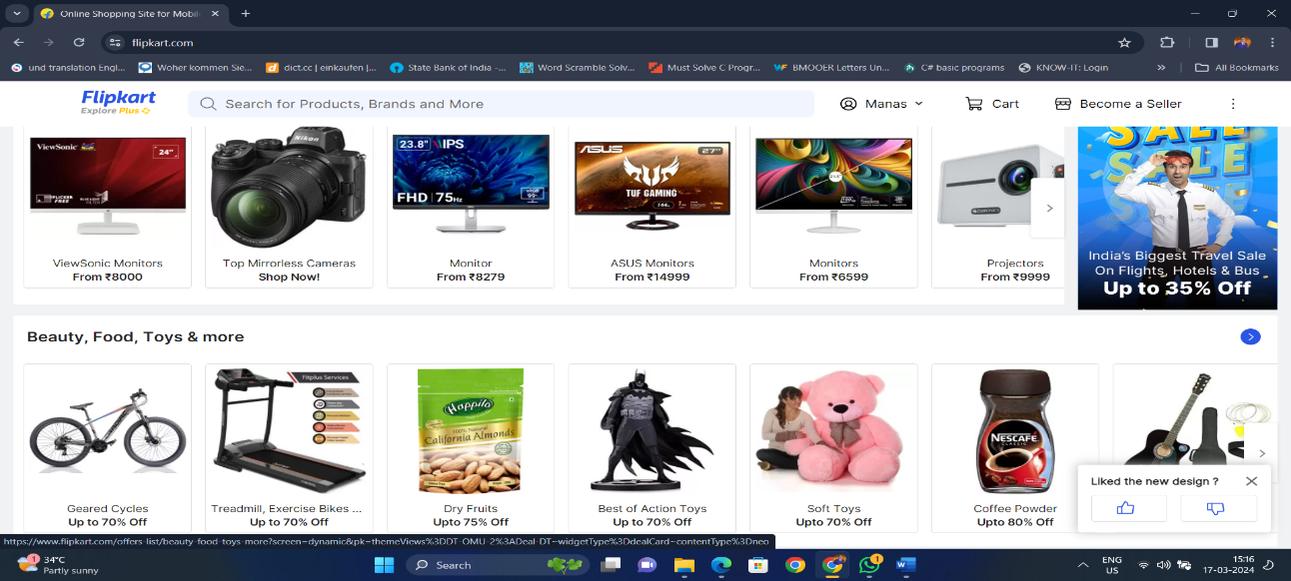

Add to Cart

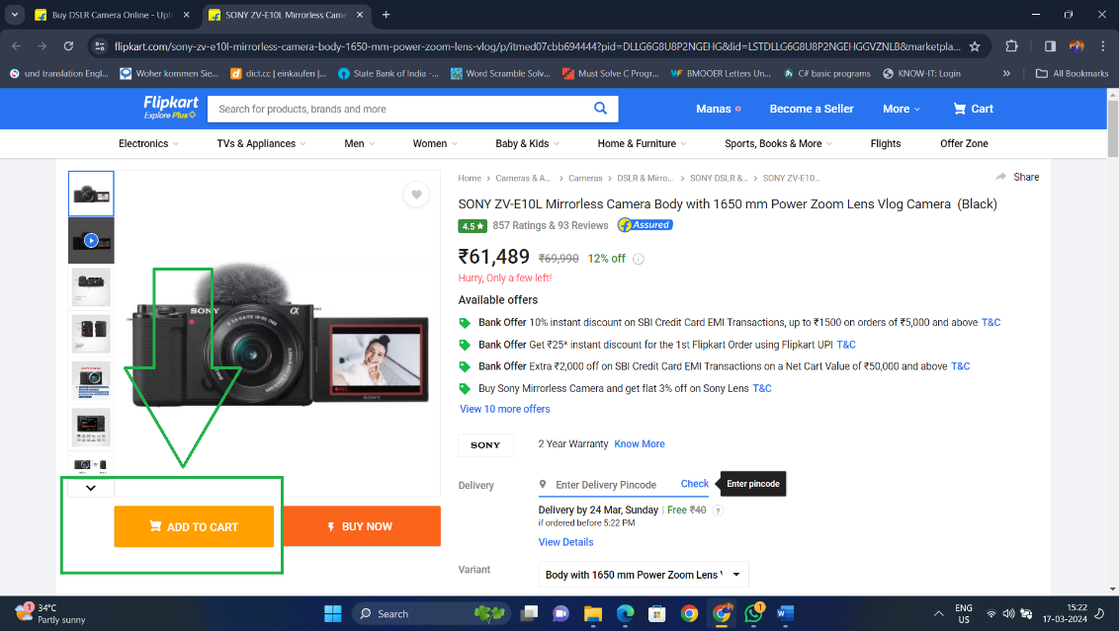

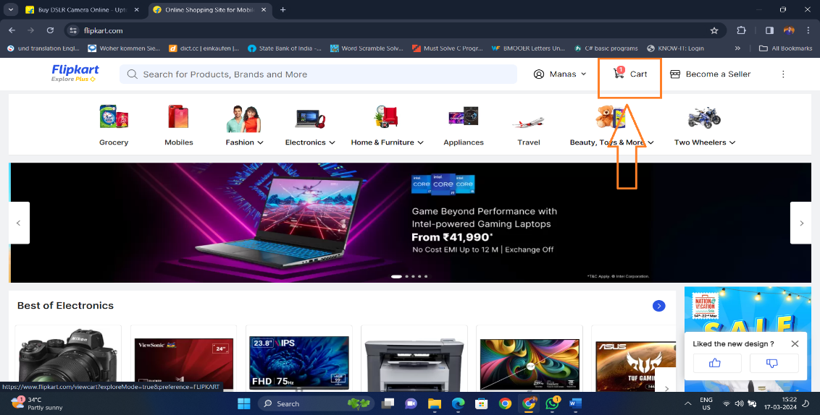

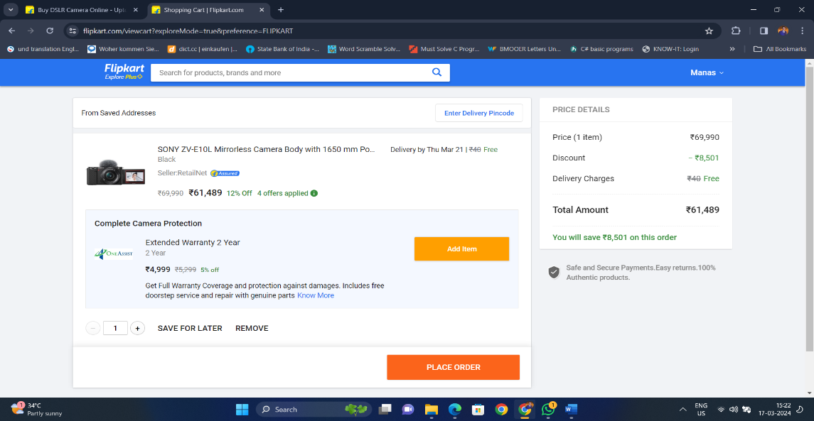

Usability Testing :

* Evaluate how easily users can find their way around the homepage.
* Assess the effectiveness of product search and browsing features.
* Test the website’s usability on mobile devices.

Smoke Testing :

* User Registration and Login Processes.
* Product Catalog and Search Functionality.
* Adding Items to the Cart and Checkout.
* Completing a Purchase.

UI Testing :

* Ensure that the homepage displays critical elements correctly.
* Evaluate the product listing page.
* Examine individual product pages.

Description Test Cases.

1. Adding Items to the Cart and Checkout:

* Add items to the cart and verify that they appear correctly.
* Proceed to checkout and ensure the process works smoothly.
* Test different payment methods (credit card, PayPal, etc.).

1. Evaluate the product listing page.

* Confirm that products are displayed in a grid or list format.
* Test sorting options (price, popularity, etc.).
* Check filters (category, brand, price range) and ensure they work as expected.

1. Registration Page Test Cases:

* Ensure secure and user-friendly registration.
* Test successful registration with valid details.
* Validate error messages for invalid email formats.
* Check for uniqueness of registered email addresses.
* Test registration with a weak password.