Automated Testing for Amazon.in using Selenium in Java

# Project Details

* Manas Tripathi
* 2023-11124

# Table of Contents

1. Introduction

2. Objectives

3. Existing Use of Automation in E-commerce

4. About the Topic

5. Software Requirements Specification (SRS)

6. Conclusion

# 1. Introduction

This project aims to automate key functionalities of the Amazon.in website using Selenium and Java. The automation process covers user sign-in, product search, adding products to the cart, and performing checkout. The project is designed to enhance testing efficiency, accuracy, and coverage by automating repetitive and time-consuming tasks.

# 2. Objectives

• Automate user sign-in process

• Search for a product

• Add the product to the cart

• Perform checkout process

• Ensure seamless user experience through automation

# 3. Existing Use of Automation in E-commerce

Existing automation systems in e-commerce, such as those used by companies like Amazon and eBay, leverage automated testing tools like Selenium to streamline their testing processes. These systems provide significant benefits, including increased efficiency by automating repetitive tasks, reduced human errors ensuring reliability, and faster release cycles due to the speed of automated tests. Additionally, these systems enable comprehensive test coverage, allowing thorough validation of various functionalities and early detection of bugs, ultimately leading to a more stable and high-quality user experience.

# 4. About the Topic

## Project Structure

• SignIn: Handles user authentication.

• ProductSearch: Handles product search functionality.

• AddToCart: Handles adding the product to the cart.

• Checkout: Handles the checkout process.

## Tools and Technologies

• Selenium WebDriver

• Java

• TestNG or JUnit

• Maven for dependency management

# 5. Software Requirements Specification (SRS)

## Functional Requirements

1. **User Sign-In**

- The system shall allow users to sign in using valid credentials.

- The system shall display appropriate error messages for invalid credentials.

2. **Product Search**

- The system shall allow users to search for products using keywords.

- The system shall display a list of products matching the search criteria.

3. **Add to Cart**

- The system shall allow users to add selected products to the shopping cart.

- The system shall display the correct number of items and total price in the cart.

4. **Checkout**

- The system shall allow users to proceed to checkout from the cart.

- The system shall capture and process payment information securely.

## Non-Functional Requirements

1. **Performance**

- The system shall execute test cases within a reasonable time frame.

- The system shall handle concurrent test executions without significant degradation in performance.

2. **Usability**

- The system shall provide clear and concise error messages and feedback.

- The test scripts shall be easy to understand and maintain.

3. **Security**

- The system shall ensure the confidentiality and integrity of user credentials and payment information during testing.

- The system shall prevent unauthorized access to the test environment and test data.

4. **Reliability**

- The system shall execute test cases reliably and consistently.

- The system shall handle unexpected errors gracefully and log them appropriately.

5. **Maintainability**

- The system shall use a modular design to facilitate updates and maintenance.

- The system shall provide comprehensive documentation for test scripts and configuration.

# 6. Screenshots

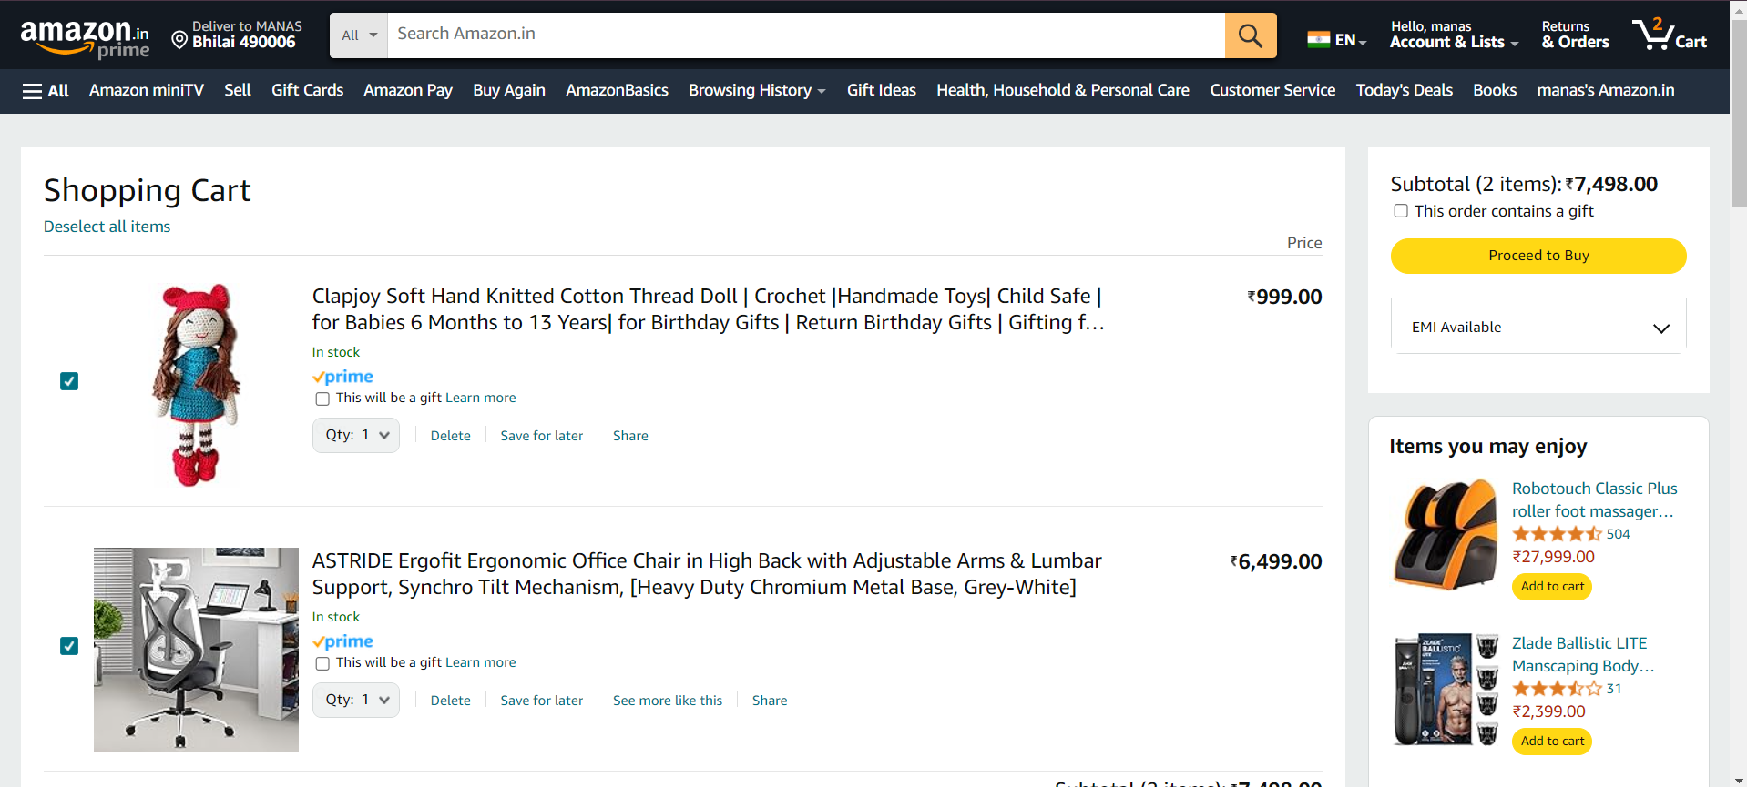



# 7. Conclusion

The automated testing project for Amazon.in using Selenium in Java significantly enhances testing efficiency, accuracy, and coverage by automating critical functionalities like user sign-in, product search, adding to cart, and checkout. It ensures consistent and reliable test execution, early bug detection, and cost savings over time. The project also lays a robust foundation for future enhancements such as scalability, integration with advanced technologies, and cross-platform testing. Ultimately, adopting automation in e-commerce not only ensures high-quality standards and customer satisfaction but also provides a competitive edge by enabling faster and more reliable releases.