**ULTRA SONIC WAVE REPELLENT WITH NANOMATERIALS**

**A report submitted in partial fulfillment of the Academic requirements for the award of the degree of**

**Bachelor of Technology**

Submitted by

**MANAS CHHATWAL 21H51A0512**

**B.SATHVIK 21H51A6701**

**G.PRIYANKA 21H51A0408**

**HARINI DASARI 21H51A0502**

**PAVAN KUMAR 21H51A0418**

**UNDER THE COURSE**

**INTRODUCTION TO SOCIAL INNOVATION**



**CENTRE FOR ENGINEERING EDUCATION RESEARCH**

**CMR COLLEGE OF ENGINEERING & TECHNOLOGY**

**(Autonomous)**

**(NAAC Accredited with ‘A’ Grade & NBA Accredited)**

**(Approved by AICTE, Permanently Affiliated to JNTU Hyderabad)**

**KANDLAKOYA, MEDCHAL ROAD, HYDERABAD-501401**

**2021-22**

**CENTRE FOR ENGINEERING EDUCATION RESEARCH**

**CMR COLLEGE OF ENGINEERING & TECHNOLOGY**

**(Autonomous)**

**(NAAC Accredited with ‘A’ Grade & NBA Accredited)**

**(Approved by AICTE, Permanently Affiliated to JNTU Hyderabad)**

**KANDLAKOYA, MEDCHAL ROAD, HYDERABAD-501401**



**CERTIFICATE**

This is to certify that the report entitled **“ULTRA SONIC WAVE REPELLENT USING NANOMATERIALS”** is a bonafide work done by **Manas Chhatwal(21H51A0512), B.Sathvik (21H51A6701), G.Priyanka(21H51A408), Harini Dasari(21H51A0502) and Pavan Kumar (21H51A0418)** of I B.Tech, in partial fulfillment of the requirements for the award of the degree of Bachelor of Technology, submitted to Centre for Engineering Education Research, CMR College of Engineering & Technology, Hyderabad during the Academic Year 2021-22.

**(Names of the Project Coordinators) (Dr. A. Kotiswar)**

1. Dr. R. Venkateshwar Reddy (Asst.Prof CSE) Head

2. Mr. K. Raju (Asst Prof ECE) CEER

3. Ms. ShilpaRani H Rajapur (Asst.Prof CSE)

**DECLARATION**

We, the students of I B. Tech of Centre for Engineering Education Research, CMR COLLEGE OF ENGINEERING AND TECHNOLOGY, Kandlakoya, Hyderabad, hereby declare, that under the supervision of our course coordinators, we have independently carried out the project titled “**ULTRA SONIC WAVE REPELLENT USING NANO MATERIALS**” and submitted the report in partial fulfillment of the requirement for the award of Bachelor of Technology in by the Jawaharlal Nehru Technological University, Hyderabad (JNTUH) during the academic year 2021-2022.

|  |  |  |
| --- | --- | --- |
| **NAME** | **ROLL NUMBER** | **SIGNATURE** |
| MANAS CHHATWAL | (21H51A0512) |  |
| B.SATHWIK | (21H51A6701) |  |
| G.PRIYANKA | (21H51A0408) |  |
| HARINI DASARI | (21H51A0502) |  |
| PAVAN KUMAR | (21H51A0418) |  |

**ACKNOWLEDGEMENT**

We are obliged and grateful to thank **Dr. A. Kotishwar**, Head (CEER), CMRCET, for his cooperation in all respects during the course.

We would like to thank the Principal of CMRCET, **Dr.V.A. Narayana**, for his support in the course of this project work.

We would like to thank my Project coordinators **Mr. R. Venkateshwar Reddy**, **Mr. K. Raju** and **Ms. ShilpaRani H Rajapur** for his/her guidance to complete my project work.

Finally, we thank all our faculty members and Lab Assistants for their valid support.

We own all our success to our beloved parents, whose vision, love and inspiration has made us reach out for these glories.

**TABLE OF CONTENTS**

|  |  |  |  |
| --- | --- | --- | --- |
| **CHAPTERS** | | **DESCRIPTION** | **PAGE NO** |
| **1** |  | Introduction |  |
|  | 1.1 | Community Visit Report |  |
|  | 1.2 | Problems Identified |  |
|  | 1.3 | Abstract |  |
|  | 1.4 | Root Cause of Problem |  |
| **2** |  | Literature Review |  |
| **3** |  | Methodology |  |
|  | 3.1 | Problem Statement |  |
|  | 3.2 | Objective |  |
|  | 3.3 | Requirement Analysis |  |
|  | 3.4 | Conceptual Design |  |
|  | 3.5 | Block Diagram |  |
|  | 3.6 | Design Description |  |
| **4** |  | Results and Discussion |  |
| **5** |  | Conclusions |  |
|  | 5.1 | References |  |
| **6** |  | One page complete project |  |
| **7** |  | Poster |  |
| **8** |  | Paper Publications |  |
| **9** |  | Team Photo |  |
| **10** |  | Team Details |  |

1. **INTRODUCTION**

**1.1 COMMUNITY VISIT**

**Community Visited**: Gowdavelli

**Date of Visit**: 04/01/2022

**Description about the Visit**: We surveyed various residents about their daily life in the community and questioned what problems they are facing. We surveyed senior citizens, house wives, farmers and labor. We can say the village is a mixture of both rural and suburban localities. The people in the village were supportive and proactive in the conversation. The visit was a good occasion and informative for us as we learnt how to interact with people of a community and ask them about problems which they were facing.

**People whom you interacted with**:

We interacted with many people; some of them are listed below**:**

1. Vijaynath - Shopkeeper
2. Jyothi - House Wife
3. Mallesh - Farmer
4. Usha - Teacher
5. Narashima - Fisher Man
6. Vennela - BHEL Worker
7. Ramesh - Mill Worker
8. Arleen - Shopkeeper
9. Sadhana - Laundry worker
10. Harika - Business Women
11. Akshaya - Milk Vendor
12. Kishore - Poultry Farm
13. Aslam - Chicken Shop
14. Asif - Liquor Shop
    1. **PROBLEMS IDENTIFIED**
15. No proper installation of sewage manholes
16. No proper paving of roads near agricultural lands
17. No public washrooms/restrooms even though Swachh Bharat Abhyaan has been implemented all over India
18. No playgrounds and parks for children and people for exercising
19. Frequent power cuts have been noticed in the village
20. No proper cuts have been provided even though Digital India has been approved by Ministry Of India
21. Excess amounts of rodents found in fields
22. The advancement/development of the railways has been stopped
23. No proper garbage disposal is done

Implementation of street lights by solar and automatic lights

Unwanted and uneven speed breakers

Rodents and other insects affecting the productivity of crops

* 1. **ABSTRACT**

Rodents are the major vertebrate pests causing damage to various crops and commodities. This is the most common problem which is found out in crops and fields. The major effect is seen in the yielding of crops as well as the productivity of crops decreases by 31%.

In the difficult time of Covid-19, Many Indian States like Mizoram, Uttar Pradesh, Bihar and others have seen a major rise in the rodents, insects affecting the crops according to the reports.

Globally, the study was conducted in Farta district from 2019 to 2020 and it was that the highest crop damage was seen at the maturity stage and the lowest during sowing in all experimental plots and cropping years.

This is the Ultrasonic Wave repellent for controlling the pests and rodent attacks in the fields. The device containing of the various sensors which has Nanomaterials present in it enhancing the effectiveness of the sensors and better functioning of the device.

* 1. **ROOT CAUSE OF THE PROBLEM**

The estimate of food grains losses by rodents in India range from 2.4 million tons to 26 million tons per year. According to an estimate 6 rats eat one man’s food daily and there are ~2400 million rats in India. According to Panse’s report about 2.5% losses are caused due to rodents in storage. The rodents on an average consume food grains about 8 to 15% of their body weight daily. The root cause of the problem is that the habit, nature, behaviour and ecological adaptation of rodents have become major factors for their wide distribution and enormous population. The issue is that the rodents feed from dusk and down damaging the crops and decreasing the soil quality. The main reason for the damage of the crops is that the rodents absorb all the water and its minerals from the crops and this makes the decrease in the yielding.

Water is essentially required daily by the rodents, but mouse can survive without water for many days. Rats can survive without food up to a week but it cannot survive without water continuously for more than 3 days.

We have personally interacted with an individual who is a retired army personal and the issue which he discussed with us in his farm lands were related to the insects, pest attacks during the medieval stage of cultivation.

1. **LITERATURE REVIEW**

**Existing work related to Ultrasonic Wave Repellent**

# Solar energy driven autonomous smart ultrasonic mosquito repeller system

Few hundred species of mosquitoes cause disease like malaria, dengue etc. In order to eradicate these malaises, people have resorted to many remedies like chemical repellents which causes nervous breakdown, increase blood pressure and also ravage crops in the fields. In order to overcome this plight, solar energy driven autonomous smart ultrasonic mosquito repeller system has been proposed. The proposed system is driven by solar energy employing dynamic offset feed mirror parabolic dish integrated with solar panel. The proposed system is harmless to human beings as it produces ultrasonic sound waves by utilizing piezoelectric effect. The frequency range of ultrasonic sound waves is above 20 kHz which are inaudible to human beings. The ultrasonic sound waves of frequency range 38 kHz-44 kHz are audible to mosquitoes and other insects. When mosquitoes and other insects communicate, they continuously sense ultrasonic sound waves from repeller through antenna present on their body, they get irritated and are forced to repel away from that area. The microcontroller Atmega 328P-PU is used to turn on and off the repeller. The proposed system can be effectively used to repel mosquitoes from lawns, city parks, universities campus and organizations. The proposed smart mosquito repeller system is effective within 255 square meters.

**Role of Nano Biosensor in Agriculture**

**Abstract**

Nano-biosensors play an important role in revolutionizing farming through the development of diagnostic tools and techniques. These sensors are accurate, efficient, and cost-effective in dealing with various food, agriculture, and environmental issues. Some of the sensor applications in agriculture include the identification of heavy metal ions, pollutants, microbial load, and pathogens, along with rapid temperature, traceability, and humidity monitoring. In this review study, we are analyzing the selective nature of Nano sensors for the target of molecules with immobilized bio receptor probes and various specific agricultural applications. These Nano sensors have unique characteristics that make them important for the agricultural industry such as small size, compact, effective, unique, sensitive and relatively inexpensive. These sensors are placed on the leaves of the plant where hydrogen peroxide signaling waves are observed. Plants use Hydrogen peroxide (H2O2) inside their leaves to communicate. They send signals that activate the leaf cells to create compounds that help fend off predators, such as insects, to fix them. Nano sensors consist of nanoscale particles such as nanoscale wires (high sensitivity to detection), carbon nanotubes (high surface area), thin films, nanoparticles and nanomaterials from polymers. These sensors detect the change in the conductance when a semiconducting carbon nanotube is exposed to certain chemicals. In our review study, we are analyzing the application and role of Nano sensors in agriculture and crop protection. Thus, Nano sensors play a vital role in crop protection and promoting the concept of sustainable agriculture and will be discussed in this study.

# Advanced compact and portable sensing solutions for agriculture and environmental applications

**Abstract**

### We present four sensors for agriculture and environmental applications, which are based on different sensing concepts including microwave microfluidics, nanomaterials, and fluorescence method. The configurations and working principles of the proposed sensors are explained. The proposed solutions are characterized by good sensitivity and selectivity, as well as by simple design and cost-effective fabrication.

### Also, the solutions are very compact and two of them have been realized as portable device while most EM sensors operate in microwave regime, the majority of optical sensors comprise fibre optical devices and devices based on Surface Plasmon Resonance (SPR). Also, various nanoscale materials including nanoparticles, carbon nanotubes and graphene have been investigated for sensing applications since their properties are very sensitive to changes in surrounding media. In this publication the work has been done on the sensors made up of various particles and the Nanomaterials have been discussed as how specific and effective is the sensing capacity if the carbon based nanomaterials are used in the devices so that sensing is enhanced gradually.

**Existing Solutions for Killing of Rodents:**

**Electric Traps:** The rodent enters the trap and gets a fatal electric shock, to these traps can be mains or battery powered

**Snap Traps:** One of the oldest methods to kill the rodents, here the animal trap is specialized type of trap designed especially primarily to catch and usually killing mice, this kind of practice is generally found in homes.

**Glue Traps:** A thick glue/adhesive is attached to the plate and the rats are caught easily but the setup in agricultural lands is very difficult as the adhesive plates are required in large quantities for farm lands.

**Live Capture Traps:** The rat or mouse is lured into and trapped and kept alive inside a cage for later disposal/removal

**Rubber Ring Traps:** Once the rat enters the trap it triggers a thick rubber band to latches tightly around the rodent’s neck, choking the rodent to death

**Bait Stations and Poison:** The poison is attractive to rodents and once the bait is eaten then slowly a few days to a week later the rodent is found to be expired

**Good Nature Traps:** The rodent enters and triggers a gas powdered piston, hitting the rodent in the head, killing it swiftly, The trap then resets itself, ready for the next one

1. **METHODOLOGY**

The methodology involved in our project is that we are going to design a device which is even portable to any part of the field as per the requirement and the mechanism of the device is such that whenever the proximity sensor (enabled with metal oxides nanoparticles AuNp as fluorescent screen) the main role of this sensor is to detect the various species which are feeding on the fields with precise distance and as soon it detects the movements within its radius, thereby it sends a signal to IR sensor to transmit waves from ultrasonic sensor which is more than 130dB(This is the frequency where rodents are found to get irritated and are killed) The ultrasonic sensor are capable to produce the higher decibel and the nanomaterials integrated in the proximity sensor demonstrates tremendous potential in sensing the nearby objects due to its extremely high sensitivity detection and high specific surfaces which makes the rodents no chance to get escaped and are prone to fall into the trap.

**3.1 PROBLEM STATEMENT:**

Even though there are existing solutions to kill rodents by various methods such as mechanical controls like snap traps, live traps to that addition there are chemical controls like zinc phosphide, barium carbonate aluminum phosphide carrying on with biological control methods like jungle cats, owls, foxes while coming to microscopic rodent repellents such as bacteria, microbes, arthropods, micro parasites, The problem of rodents is still existing majorly affecting the crops every year and this is because ever since the preventive methods were discovered the rodents or the insects which are feeding on the yields also get habituated to the preventive methods after using it for several times as in the case of pesticides, insecticides. Using these in the fields also make the pests to take control over the chemicals. For that reason, we have finalized rodents as the major problem after surveying in the village of gowdavelli.

**3.2 OBJECTIVE**

The main aim of this project is to benefit the farmers and help out eradicating rodents in a new and more effective way by introducing Nano sensors in killing rodents and advancing in preventive methods. The objective of this device is to emit an ultrasonic wave which is not harmful for the crops and cultivation. Rodent control is a problem of applied ecology and the control measures should be based on proper translation of ecological factors into management polity. The primary aim is to effectively decrease the issue, settling down and feeding on the fields.(AuNp) and metal oxides are embedded with proximity sensor to enhance the sensing capabilities and detect the approximate location of the nearby objects specifically the rats feeding over the crops.

**3.3 REQUIREMENT ANALYSIS**

1. The stake-holders of our project are mainly the farmers who are going to get benefited eradicating the rodents in a technological way

2. The above project can help the agricultural lands to yield at a higher success rate in the production of crops

3. This project is also useful not only in the case of farmers but also to individual households

4. The methods to control pests, rats and insects are not much effective as compared to the technological methods

5. Existing control methods are costlier compared to technical gadgets as these are one time investment and saves the money especially for farmers

6. To get measurable, tested, traceable the device is made such that there is no such harm to the crops while vanishing the rodents.

**3.4 CONCEPTUAL DESIGN**

**CONCEPT**

**DESIGN**

**3.5 BLOCK DIAGRAM**

WITH THE FREQUENCY OF 130dB

RODENTS GETTING KILLED

ENHANCING THE SENSOR

EMBEDDED WITH AgNp

TRASMITTING ULTRASONIC WAVES

SIGNALLING THE IR TRANSMITTER

ULTRASINIC WAVE SENSOR

SENDING THE SIGNALS

DETECTION OF RODENTS

PROXIMITY SENSOR

**3.6 DESIGN DESCRIPTION**

Ultrasonic wave are capable to destroy the rodents and this device is designed in such a way that there is no lose/affect to the productivity of the cultivated crops.   
The device will emit the radiations as soon as the rodents or any suspicious movements are sensed by the proximity sensor.

The detection can be precise by the help of AgNp nanoparticle due to its small size and highly versatile in nature.

This is the benefit of inserting nanotechnology making the sensing more advanced when compared to other technology.

It is tested that ultrasonic waves of 130dB are very much effective as compared to lower frequency.

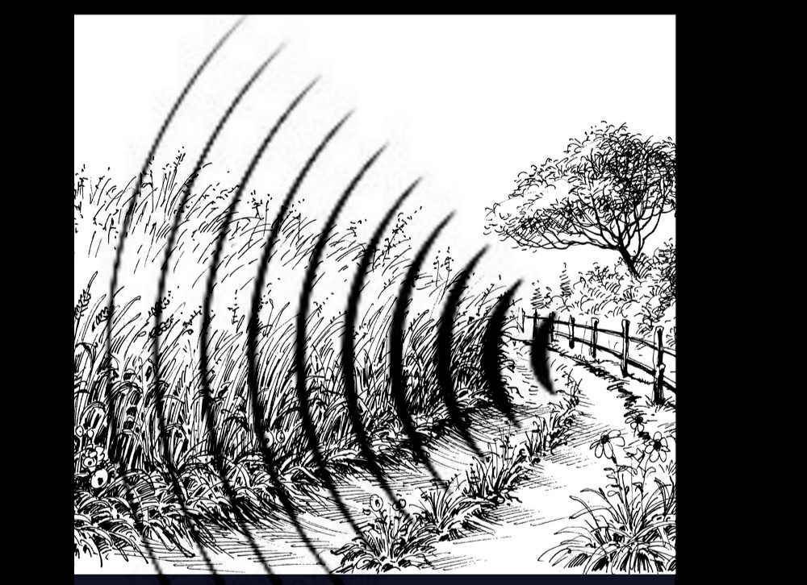

1. **RESULTS AND DISCUSSION**

Rodents are the major vertebrate pests causing damage to various crops and commodities by feeding and indirect damage by spoilage, contamination and hording during on-farm and post-harvest stages.

Rodents are the quadruped mammals having their body completely covered with fur. They are having a pair of sickle shaped ever growing incisor teeth in each jaw adopted for gnawing. But they lack canine teeth.

To see the improvement in the number of productivity which has been damaged by the rodents therefore this technological advancement must be implemented and used by the farmers

The device which is designed by our group will not only be useful to farmers but also for those who are having large go downs

Sensors used in the device are cheap and easily available in the market for use and this makes our innovation helpful being cost effective and on the other hand making them available for use

**5. CONCLUSION**

The conclusion of our project is that this device is going to benefit the farmers who are suffering with loss in productivity of crops due to various pests, insects and rodents attack while the cultivation is going on (In the Initial and medieval period). During 2001 it was reported that the overall losses of grain to rodents in India were approximately 25% in pre harvest and 25-30% in post-harvest situations bringing the loss to at least US$ 5 billion annually in stored food and seed grain in India.

This device is very much cost effective resulting in the favor of farmers. Old methods to prevent are not much effective as these prevailing methods get habituated to the pests and rats too. So to add over, the use of nanoparticles can be a more effective way to eradicate the rodents.

**5.1 REFERENCES:**

[**https://ieeexplore.ieee.org/document/7918230**](https://ieeexplore.ieee.org/document/7918230)**Solar energy driven autonomous smart ultrasonic mosquito repeller system**

[**https://ieeexplore.ieee.org/document/7970408**](https://ieeexplore.ieee.org/document/7970408)

**Study, testing and application of proximity sensors for experimental training on measurement systems**

[**https://ieeexplore.ieee.org/document/8092549**](https://ieeexplore.ieee.org/document/8092549)

# Transmission of high-intensity aerial ultrasonic waves by using a straight rigid tube for sound wave transmission

[**https://ieeexplore.ieee.org/document/8808524**](https://ieeexplore.ieee.org/document/8808524)

# Nanoplasmonics Enhanced Broadband Ultra-Sensitive Mid-Ir Sensor Array Integrated with Microfluidics

**6. ONE PAGE COMPLETE PROJECT:**

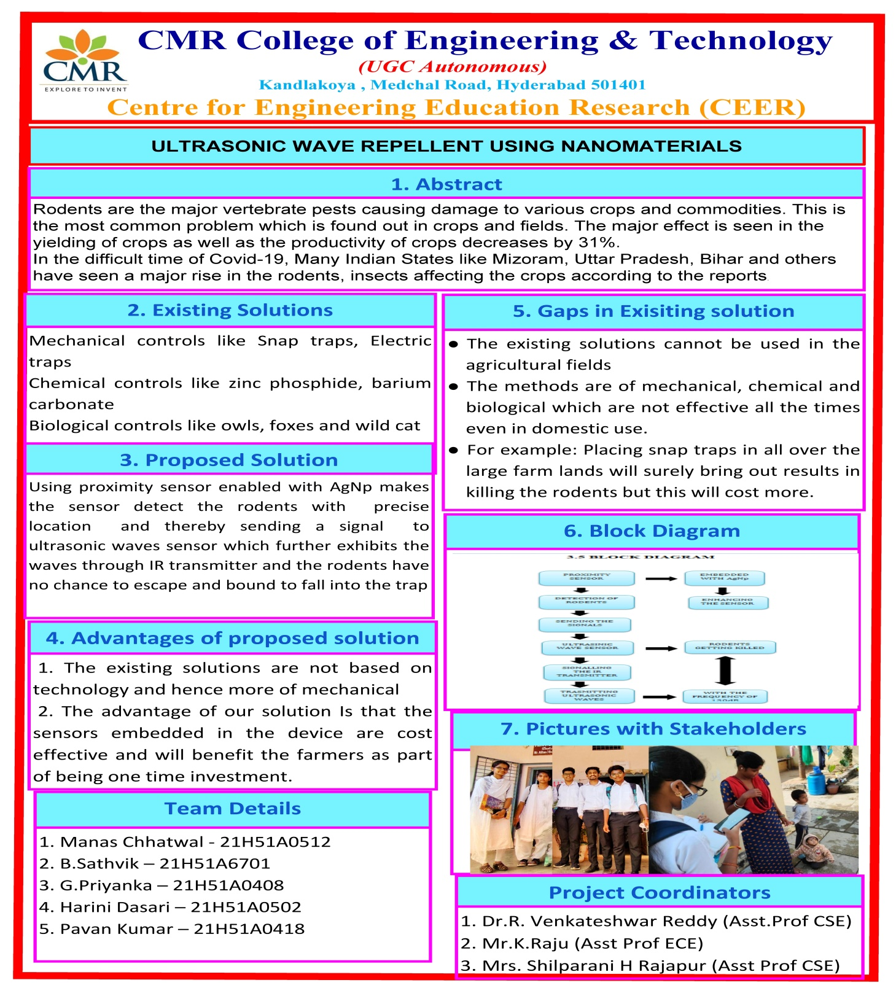

**7. POSTER:**

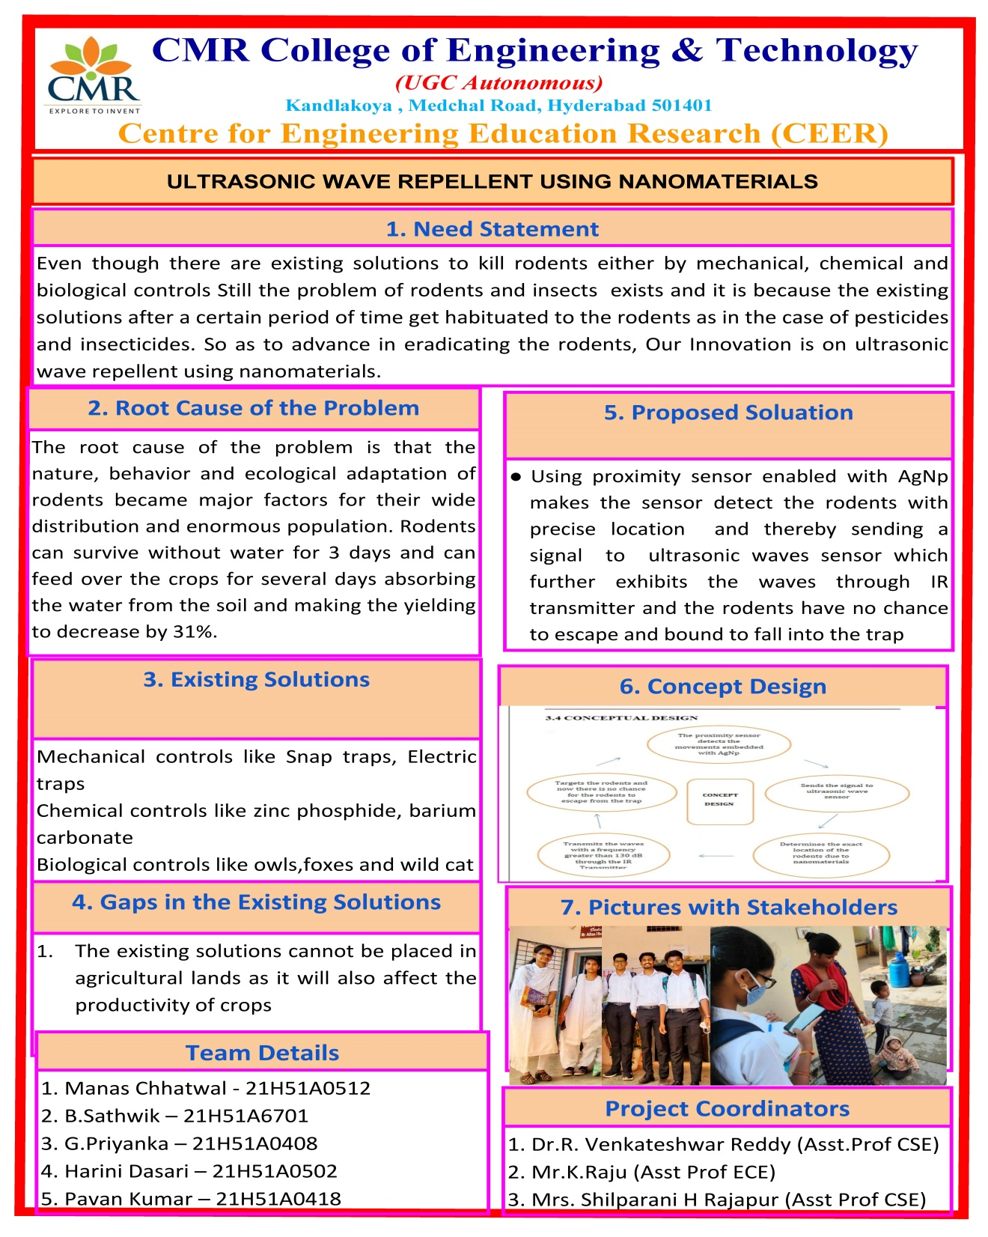

**8. PAPER PUBLICATIONS:**

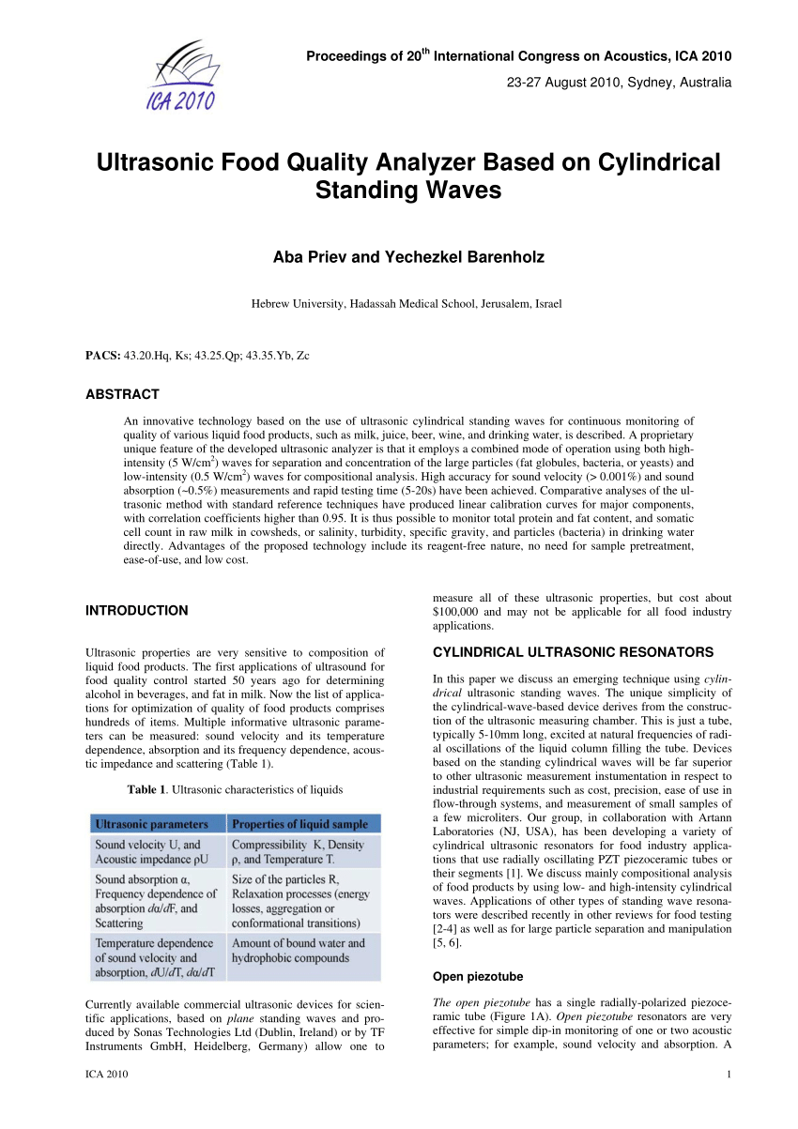

1. **TEAM PHOTO**

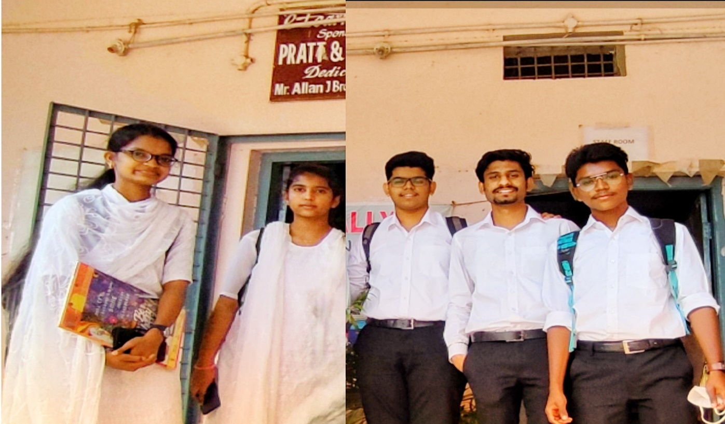

**Group photo with team members and Stakeholders**

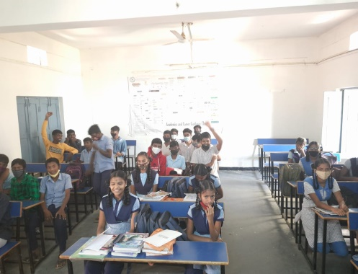 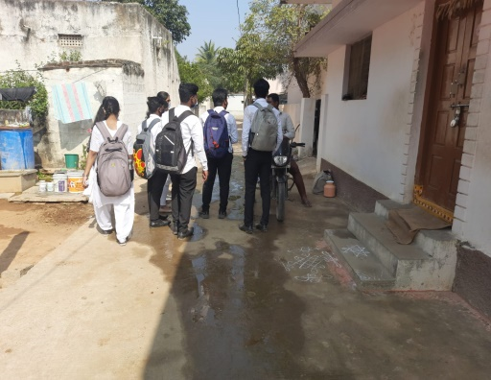 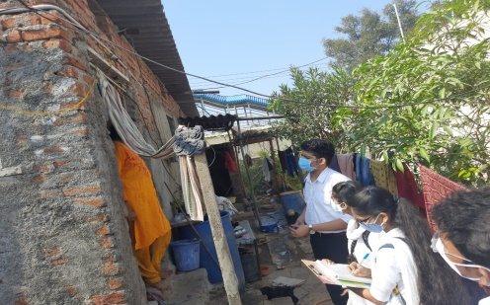 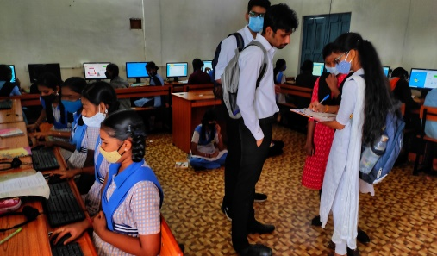

**10. TEAM DETAILS**

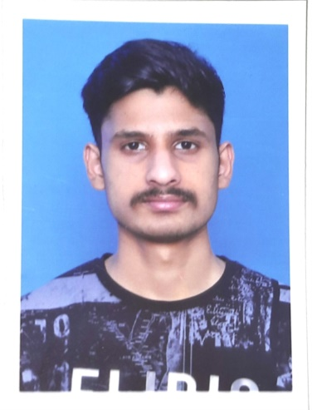  

Manas Chhatwal Pavan Kumar B.Sathvik

(21H51A0512) (21H51A0418) (21H51A6701)

[21h51a0512@cmrcet.ac.in](mailto:21h51a0512@cmrcet.ac.in) [21h51a0418@cmrcet.ac.in](mailto:21h51a0418@cmrcet.ac.in) [21h51a06701@cmrcet.ac.in](mailto:21h51a06701@cmrcet.ac.in)

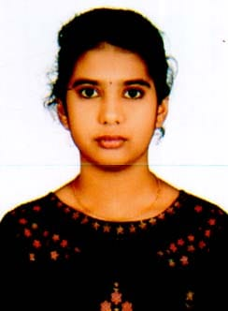 

Harini Dasari G.Priyanka

(21H51A0502) (21H51A0408) [21h51a0502@cmrcet.ac.in](mailto:21h51a0502@cmrcet.ac.in) [21h51a0408@cmrcet.ac.in](mailto:21h51a0408@cmrcet.ac.in)