ASSIGNMENT NO. 4

The final throughput and response time graph with varying number of users are-

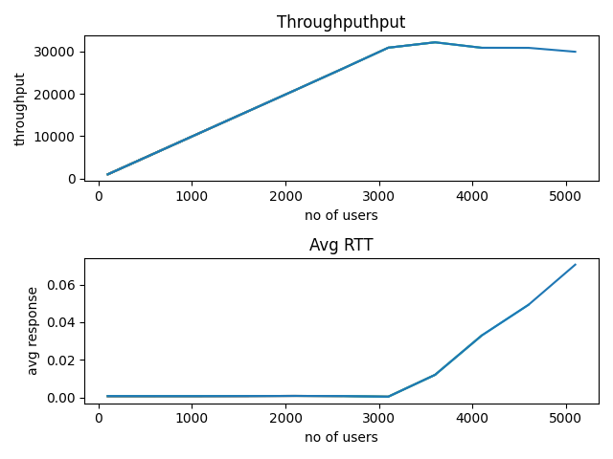

Here while tracking it thru htop I found that cpu utilization was 100%

And the server is saturated

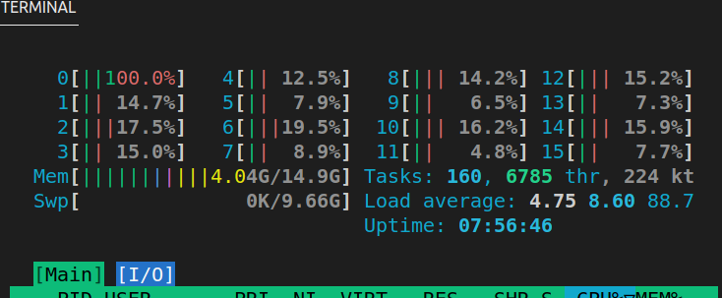

Here server executable is running on core0 and the load generator is running on remaining cores.

The configuration of computer is

Processor-Ryzen 7(16 cores)

Here the parameters set are that for 1st iteration the number of users are 100 and then the number of users are increasing by 500 in every iteration.

Think time used is 0.1 sec

And the test time is 60 sec

Here during graph formation, the observation was that first when cpu utilization was low the throughput was low and increasing linearly after that in middle cpu utilization% increased with very high % and for that iteration response time decreased but after that response time increased and when cpu utilization is 100% response time increased with a very high amount.