FINAL COMPREHENSIVE REPORT
AI-Powered Resume Intelligence
End-to-End Machine Learning Project Lifecycle

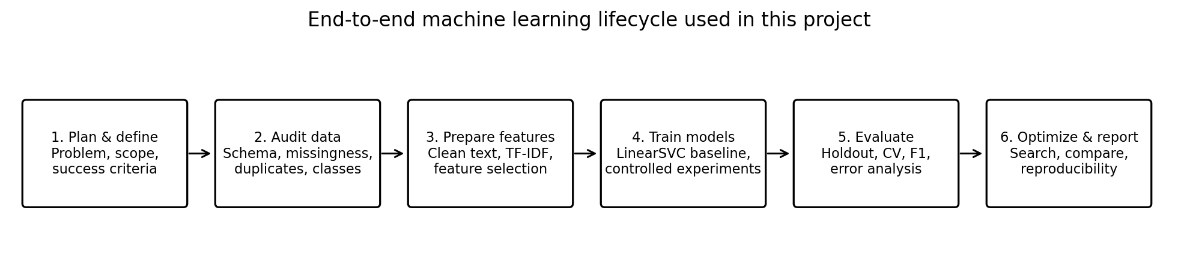
Project case study: Resume Category Classification using TF-IDF and LinearSVC
Consolidated from project planning, preprocessing, implementation, evaluation, and optimization reports
Technology stack: Python • pandas • NumPy • scikit-learn • Matplotlib • joblib

Table of Contents
For a navigable view, use Word's Navigation Pane (View → Navigation Pane). Headings are styled for navigation; page numbers can be refreshed in Word after opening the document.
- 1. Executive Summary
- 2. Project Vision, Context and Objectives
- 3. Problem Definition and Scope
- 4. Project Planning and Research
- 5. Dataset Understanding and Quality Audit
- 6. Data Preprocessing and Feature Engineering
- 7. Model Implementation and End-to-End Workflow
- 8. Evaluation and Validation Strategy
- 9. Experimental Analysis and Optimization
- 10. Results Interpretation and Project Outcomes
- 11. ML Engineering Practices and Reproducibility
- 12. Challenges and Lessons Learned
- 13. Limitations, Ethics and Risk Management
- 14. Recommendations and Future Work

14.5 Requirements Traceability and Completion Review
This matrix maps the assignment brief to report evidence and clarifies what is demonstrated versus what remains a recommendation. It prevents planned product capabilities from being mistaken for experimentally verified deliverables.
Completion criteria for the current classifier: (1) the duplicate policy is documented; (2) vectorization is fitted only on training data; (3) the held-out metrics and cross-validation variability are reported; (4) experiments are clearly separated by configuration; (5) limitations are explicit; and (6) a saved model can be reloaded and used for inference. The full resume-job matching product should not pass a production gate until it has relevance-labelled evaluation data, ranking metrics, privacy review, API tests, and deployment verification.
- 15. Conclusion
Assignment requirement | Where addressed | Status / evidence
Project vision, objectives and ML-engineering relevance | Sections 2–4 | Addressed; separates broader product vision from the implemented classification task.
Preprocessing and feature engineering | Sections 5–6 | Addressed; data audit, duplicate removal, text normalization, TF-IDF, feature selection and dimensionality-reduction considerations.
Model implementation | Section 7 | Addressed; LinearSVC pipeline, input checks, persistence and inference practices described.
Experiments and hyperparameter tuning | Section 9 | Addressed; search strategies and observed comparisons are reported with experiment-boundary cautions.
Evaluation and validation | Section 8 | Addressed; holdout and CV results, metrics and uncertainty are discussed.
Tables, charts and diagrams | Figures 1–5 and result tables | Addressed; lifecycle, architecture, data audit, validation and optimization visuals included.
Lessons learned and future recommendations | Sections 12–14 | Addressed; actionable next steps are prioritized.
Production deployment of the full product | Sections 3, 4, 10, 13–14 | Not claimed as complete; API/database/container deployment is future work unless separately demonstrated.
- Appendix A. Consolidated Metrics
- Appendix B. Reproducibility Checklist
- References and Technical Resources
Note: This report consolidates the supplied project documents. Results from different reports may use different split configurations or experiment setups; those values are labeled by experiment and should not be treated as a single directly comparable leaderboard.

1. Executive Summary
This report consolidates the project planning, data preprocessing, model implementation, model evaluation, and model optimization work for an AI-Powered Resume Intelligence project. The implemented and measured component is a supervised multiclass text classifier that predicts one of 25 resume/job categories from resume text. The original dataset contains 962 records and two fields—Category and Resume—but 796 exact duplicate rows were found. Removing those duplicates leaves 166 unique records, which materially changes how performance results must be interpreted.
The selected baseline is a scikit-learn Pipeline built around TF-IDF word features (unigrams and bigrams) and LinearSVC. This combination is appropriate for sparse, high-dimensional text features and provides an efficient, interpretable starting point. The evaluation report records a fixed holdout accuracy of 88.24%, macro-F1 of 0.8276, and weighted-F1 of 0.8550. Five-fold stratified cross-validation recorded mean accuracy of 89.77% ± 5.48% and mean macro-F1 of 0.8741 ± 0.0671. The optimization report includes a separate holdout experiment in which randomized search raised macro-F1 from 0.7794 to 0.8232; these numbers come from a different documented experiment setup and are presented separately.
The most important outcome is not a single score: it is a repeatable lifecycle, with explicit data checks, duplicate handling, leakage-safe transformations, multiple metrics, validation, experiment comparison, and documented limitations. The larger resume-to-job matching system—semantic embeddings, skill extraction, ranking, FastAPI, database integration, and Docker deployment—was defined in the planning report as a proposed extension, not demonstrated as completed by the supplied experimental evidence.
Project fact | Consolidated finding
Problem | Multiclass resume-category classification
Dataset | 962 rows × 2 columns; 25 categories
Data quality | No missing values or blank strings reported; 796 exact duplicates
Usable unique records after deduplication | 166
Baseline model | TF-IDF unigrams/bigrams + LinearSVC
Primary metrics | Accuracy, macro-F1, weighted-F1; supplemented by per-class and CV metrics
Key risk | Small unique dataset and low per-class support; optimistic leakage if duplicates cross splits

2. Project Vision, Context and Objectives

2.1 Project vision
The broader project vision is an AI-Powered Resume Intelligence and Job Matching System. The plan describes a system that could accept a resume and job description, extract relevant skills and other structured information, estimate compatibility, explain matched and missing evidence, and recommend skill-gap improvements. This product vision provides the context for the implemented classifier, but it is broader than the experiment that was actually measured.

2.2 Implemented objective
The completed experimental objective is narrower and verifiable: use the text in a resume to predict its Category label. This task is supervised multiclass text classification. It demonstrates data preparation, feature extraction, model training, held-out prediction, validation, model optimization, and reproducible evaluation.

2.3 Why this matters for a Machine Learning Engineer
- Translate a broad user/business need into a measurable ML task and define what the label actually represents.
- Audit the data before training; repeated examples and poor labels can invalidate an otherwise correct algorithm.
- Build a leakage-safe preprocessing/model pipeline and compare models under controlled conditions.
- Choose metrics aligned with the problem, inspect errors, and communicate uncertainty rather than reporting accuracy alone.
- Track data versions, parameters, random seeds, software versions, artifacts, and limitations so another engineer can reproduce the work.
- Distinguish a model prototype from a production service, including API behavior, monitoring, privacy, testing, and deployment.

2.4 Project success criteria
For the implemented classifier, success means a reproducible baseline, credible evaluation after duplicate handling, documented per-class behavior, and controlled experiments that can be compared. For the larger planned system, additional success evidence would be required: reviewed resume/job-description relevance labels, semantic/hybrid comparisons, ranking metrics, an API request/response demonstration, automated tests, and a clean deployment build.

3. Problem Definition and Scope
Element | Definition
Input | Free-text resume document
Target | Category label representing a career/job family
Output | Predicted category label
Learning type | Supervised multiclass classification
Current feature representation | TF-IDF word unigrams and bigrams; up to 5,000 features in the implementation report
Classifier | LinearSVC
Intended downstream role | One possible component in a larger resume intelligence workflow
Out of current measured scope | Validated resume-to-job relevance ranking, production hiring decisions, and proven semantic/hybrid matching

A key scope distinction is necessary. A dataset with resume category labels supports category classification; it does not, by itself, establish whether a particular resume is relevant to a specific job description. Resume-job matching would need paired resume/job-description examples or a separately designed, reviewed evaluation set.

4. Project Planning and Research
The project plan established a six-week roadmap and approximately 30–35 hours of effort, progressing from research and ideation to data preparation, model development, evaluation, API/deployment planning, and final documentation. It emphasized that an ML engineering deliverable includes more than a trained estimator: input handling, preprocessing, validation, persistence, error handling, reproducibility, and deployment boundaries are also important.

4.1 Research-driven design choices
Research area | Design implication in the project
Information retrieval / TF-IDF | Build a transparent lexical baseline before adding more complex representations.
Sentence embeddings / Sentence-BERT | Potential next stage for semantic similarity where wording differs but meaning overlaps.
Skill/entity extraction | Start with a normalized skill dictionary and aliases; add statistical extraction only if reviewed errors justify it.
Ranking and recommendation | If the system is extended to job matching, use ranking metrics such as Precision@k/Recall@k or NDCG rather than classifier accuracy alone.
MLOps and deployment | Version data/model/configuration, test inference, and treat API, container, logging, and monitoring as engineering work.

4.2 Lifecycle overview
Figure 1. End-to-end workflow consolidated from the project reports.

4.3 Planned architecture versus implemented evidence
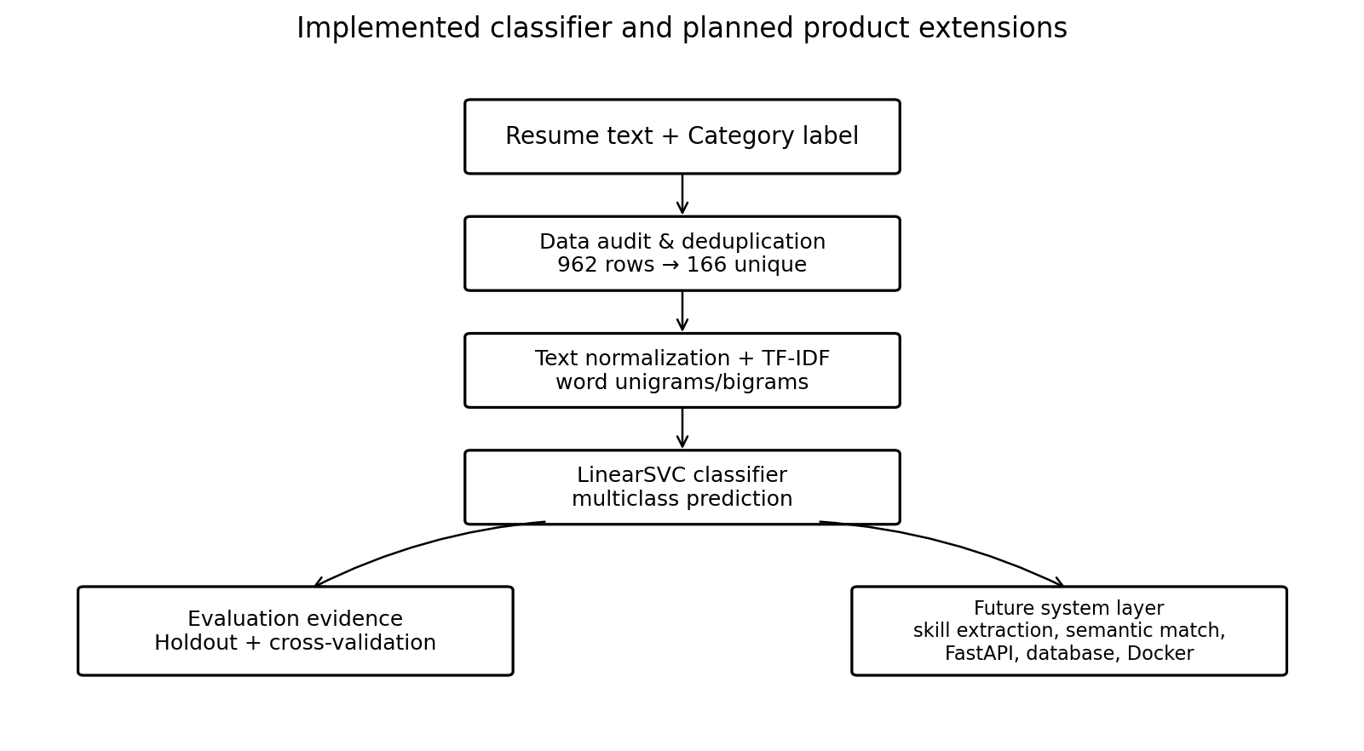
Figure 2. The classifier is the measured component; product extensions remain future work unless separately implemented and tested.
The planning report proposed FastAPI for inference, a database for structured information, and Docker for reproducible deployment. The supplied implementation and evaluation reports provide evidence for the classifier pipeline, model evaluation, and persistence-oriented practices; they do not provide sufficient evidence to claim that the full API/database/containerized job-matching product has been deployed.

5. Dataset Understanding and Quality Audit

5.1 Schema and observed quality checks
Audit check | Observed result | Interpretation
Dataset shape | 962 rows × 2 columns | Two fields: Category and Resume
Missing values | 0 in both columns | No pandas-recognized nulls were reported
Blank strings | 0 blank Resume and Category strings reported | Non-empty does not guarantee a complete or useful record
Exact duplicate rows | 796 | High duplication is the primary data-quality concern
Rows after deduplication | 166 | Limited number of independent examples for 25 classes
Target categories | 25 | Multiclass classification; some classes have low support
Resume length | Mean ≈ 3,160 characters; median ≈ 2,355; max ≈ 14,816 | Length extremes should be inspected, not automatically deleted

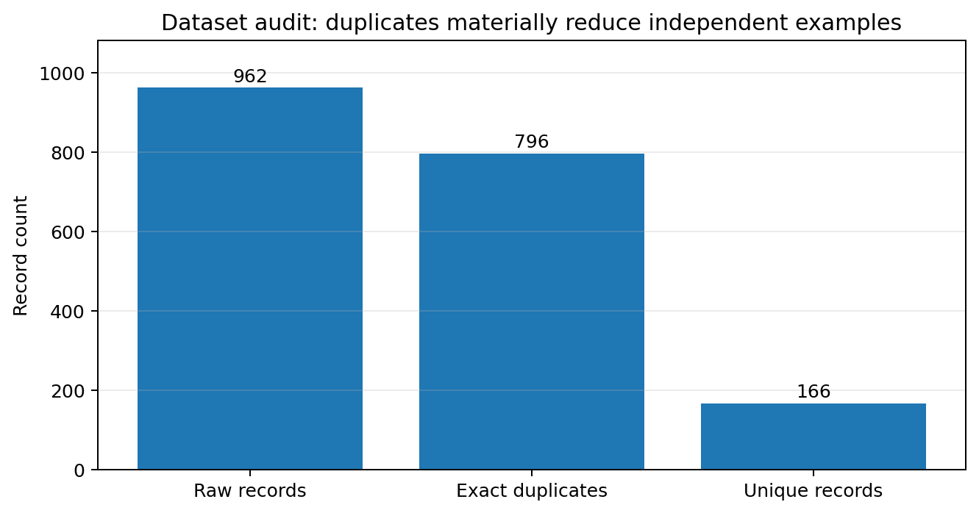
Figure 3. The duplicate count is large relative to the original dataset.

5.2 Why duplicates matter
Exact duplicates can cause train/test leakage when copies of the same resume appear in both partitions. The optimization report describes a demonstration in which a split made before deduplication achieved accuracy 1.000, compared with 0.810 after deduplication before splitting. This is a leakage illustration, not a valid model improvement. Duplicate removal therefore occurs before the split.

5.3 Class balance and descriptive exploration
The dataset contains 25 categories. The largest class reported in the preprocessing audit has 84 records and the smallest has 20 in the original file. Category-count plots and resume-length distributions were used to understand the data. Because support is uneven, macro-F1 and per-class recall are important companions to overall accuracy.

5.4 Cleaning decisions
- Keep the raw CSV unchanged and write cleaned data/artifacts separately.
- Normalize text conservatively by lowercasing and collapsing repeated whitespace.
- Do not indiscriminately remove punctuation that can be meaningful in technical identifiers such as C++, C#, .NET, or product names.
- Inspect encoding artifacts, truncated records, suspiciously short/long text, and label consistency.
- Remove exact duplicate records before the train/test split; investigate near-duplicates when a suitable similarity review is available.

6. Data Preprocessing and Feature Engineering

6.1 Feature representation
The primary input is unstructured resume text. TF-IDF converts terms into a sparse numeric representation, weighting terms by their importance in a document relative to the corpus. Unigrams capture individual tokens; bigrams capture short phrases such as skill names and role-specific expressions. This is a practical baseline for high-dimensional text because linear classifiers can operate efficiently on sparse matrices.

6.2 Processing sequence
- Load the CSV and validate expected columns and data types.
- Measure nulls, blank text, exact duplicates, class counts, and text-length statistics.
- Remove duplicate rows before partitioning the data.
- Normalize text conservatively.
- Create a stratified train/test split with a fixed random seed.
- Fit TF-IDF on training text only; transform validation/test text with the fitted vectorizer.
- Train the classifier and evaluate it on held-out data.

6.3 Feature selection and dimensionality reduction
The preprocessing report distinguishes feature selection from feature extraction. TF-IDF is a feature-extraction/representation step. Chi-square selection (SelectKBest) can select informative non-negative TF-IDF features, while ordinary PCA is usually not the first choice for very sparse text because centering may densify the matrix. TruncatedSVD is a more suitable candidate when a lower-dimensional projection of sparse TF-IDF is needed. Any selector or dimensionality-reduction transform must be fitted within each training fold to avoid leakage.

6.4 Additional feature ideas
- Character n-grams can help with spelling variants, punctuation, abbreviations, and technical tokens.
- Normalized skill indicators and section-presence features may add structured information if they are engineered and validated carefully.
- Class weighting may improve minority-class behavior, but should be evaluated using macro-F1 and class-level metrics.
- Keep feature engineering hypothesis-driven: change one major component at a time where possible.

7. Model Implementation and End-to-End Workflow

7.1 Baseline model
The implementation uses TfidfVectorizer with English stop-word removal, max_features=5000, and ngram_range=(1, 2), followed by LinearSVC(random_state=42). The classifier is a reasonable first choice because the task is multiclass, the feature matrix is sparse and high-dimensional, and distinctive domain vocabulary often carries useful signal.

7.2 Documented implementation evidence
Stage | Observed output / configuration
Load and audit | Original shape (962, 2); missing values 0; exact duplicates 796; categories 25
After deduplication | 166 unique resumes
Fixed split in implementation/evaluation report | 132 training / 34 testing resumes; random_state=42
TF-IDF feature dimensions | Training (132, 5000); testing (34, 5000)
Training | LinearSVC training completed
Artifacts | Reports describe saving/reloading the vectorizer and classifier with joblib

7.3 Inference and verification
The implementation report documents sample predictions, confusion-matrix analysis, invalid/empty-input handling, prediction-label checks, TF-IDF dimension checks, and model-artifact reload checks. These are useful engineering checkpoints because failures can occur before or after model fitting—for example, a missing CSV, empty resume text, mismatched vectorizer/model artifacts, or unexpected feature dimensions.

7.4 Pipeline discipline
A production-quality experiment should place text vectorization and the classifier in a scikit-learn Pipeline. During cross-validation, each fold then fits its own vectorizer on that fold's training portion, preventing the validation fold from influencing the vocabulary. The same pipeline should be used consistently for model selection and evaluation.

8. Evaluation and Validation Strategy

8.1 Metrics
Metric | Meaning and reason to use it
Accuracy | Fraction of all predictions correct; easy to understand but may hide minority-class errors.
Precision | Of the examples predicted as a category, the proportion that truly belongs to it.
Recall | Of the true examples in a category, the proportion recovered.
Macro-F1 | Unweighted mean of per-class F1; gives each category equal influence.
Weighted-F1 | F1 averaged by class support; reflects the observed class distribution.
Balanced accuracy | Average recall across classes; useful when class support differs.
Confusion matrix | Shows actual-versus-predicted counts and helps localize class confusions.
Top-3 accuracy | Checks whether the correct category is among the top three scored classes; supplementary to top-1 classification.

8.2 Fixed holdout results
Metric | Reported result
Accuracy | 0.882353 (88.24%)
Balanced accuracy | 0.860000
Macro precision | 0.823333
Weighted precision | 0.855392
Macro recall | 0.860000
Weighted recall | 0.882353
Macro-F1 | 0.827619
Weighted-F1 | 0.855042
Matthews correlation coefficient | 0.880488
Cohen's kappa | 0.876476
Macro Jaccard | 0.803333
Top-3 accuracy | 0.970588

These fixed-holdout values come from the Model Evaluation and Validation Report's specified split and pipeline. They should not be mixed with scores from the optimization report's separate holdout setup.

8.3 Cross-validation results
Validation method | Accuracy | Macro-F1 | Interpretation
5-fold StratifiedKFold | 0.897683 ± 0.054776 | 0.874130 ± 0.067111 | Preserves class proportions as far as feasible; reports mean and variation.
StratifiedShuffleSplit (5 runs) | 0.882353 ± 0.036022 | 0.847124 ± 0.046985 | Repeated stratified holdout estimates sensitivity to the sampled split.
Repeated StratifiedKFold (15 runs) | 0.887582 ± 0.041910 | 0.853792 ± 0.054421 | Broader view of split variation.
Standard KFold | 0.848841 ± 0.057407 | 0.801567 ± 0.084094 | Not stratified; can produce less representative class proportions.
Nested CV | — | 0.873063 ± 0.050804 | Separates tuning from outer-loop performance estimation; rare-class support makes it fragile.

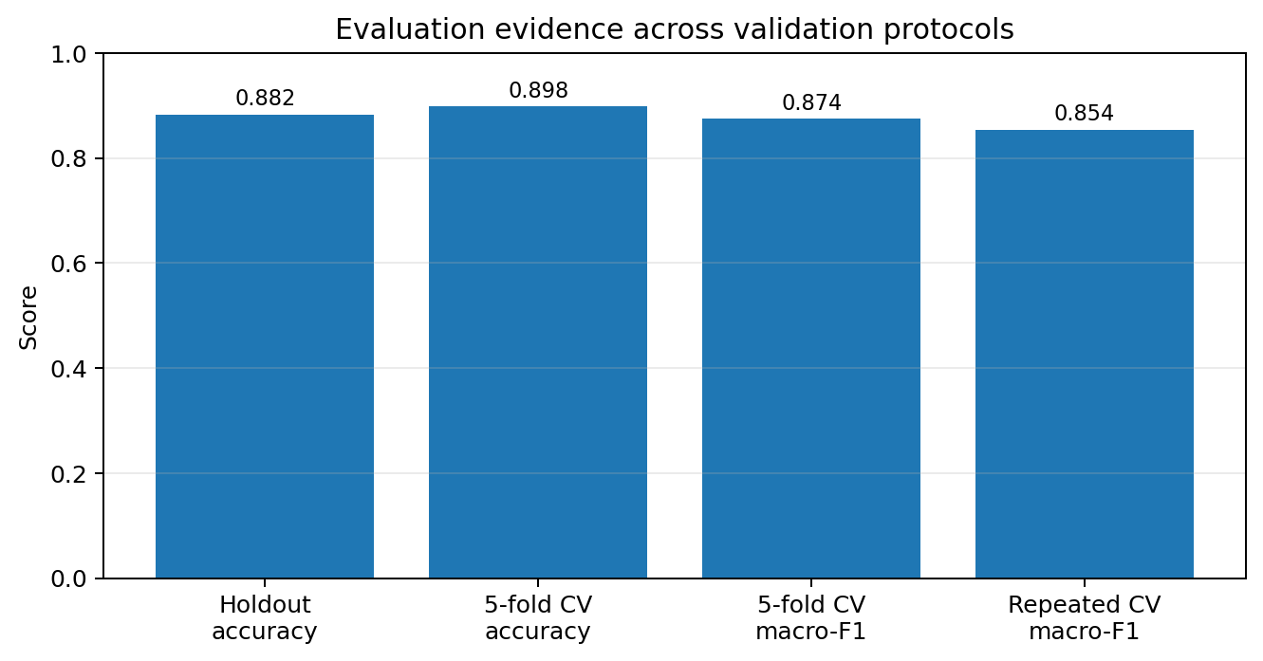
Figure 4. Results from the evaluation report; validation protocols estimate different quantities.

8.4 Interpreting variation
The fixed holdout test contains only 34 examples. With 25 categories, some classes have very little test support, so class-specific precision and recall can change substantially with a different split. Cross-validation gives a broader estimate but does not eliminate uncertainty caused by the small number of unique documents. The observed mean and standard deviation should both be reported.

9. Experimental Analysis and Optimization

9.1 Experimental design
The optimization report frames model selection as a controlled experiment: define the target metric (macro-F1), keep the dataset version, duplicate policy, split, seed, preprocessing pipeline, and evaluation metrics fixed, and change a limited number of parameters per trial. Hyperparameters include LinearSVC C and TF-IDF settings such as ngram_range, min_df, and max_features.

9.2 Optimization methods reviewed
Method | How it works | Best-fit use / caution
Grid search | Evaluates every combination in a defined grid. | Transparent for small discrete spaces; cost grows combinatorially.
Random search | Samples a fixed number of configurations. | Often efficient for broad spaces; outcome depends on budget and seed.
Bayesian optimization | Uses prior trial outcomes to choose promising next configurations. | Useful when evaluations are expensive; adds setup/overhead.
Successive halving | Starts many candidates with low resources and promotes stronger ones. | Can save compute; early ranking may discard slow-starting candidates.
Hyperband | Uses multiple resource-allocation schedules around successive halving. | Most natural for iterative models; toy demo is not resume-model evidence.
Evolutionary search / PBT | Uses mutation/selection or population-based parameter updates. | Powerful but often excessive for this small text dataset.
Feature selection / class weighting | Changes feature subset or class penalty. | Should be justified by validation results and minority-class diagnostics.

9.3 Optimization report's separate holdout comparison
The following comparison is taken from the optimization report's model-family experiment. It is a separate experiment from the fixed holdout/cross-validation results in Section 8, so its values should only be compared within this table.
Model/configuration | Accuracy | Macro-F1 | Weighted-F1 | Runtime (approx.)
Baseline TF-IDF + LinearSVC | 0.8095 | 0.7794 | 0.7760 | —
Random-search tuned LinearSVC | 0.8333 | 0.8232 | 0.8070 | —
Logistic Regression | 0.8333 | 0.8152 | 0.8082 | 2.01 s
SGDClassifier | 0.8333 | 0.8126 | 0.8050 | 0.18 s
LinearSVC + chi-square top 5,000 | 0.8333 | 0.8152 | 0.8082 | 0.17 s
LinearSVC word unigrams/bigrams (comparison run) | 0.8095 | 0.7794 | 0.7760 | 0.17 s
LinearSVC character n-grams | 0.7619 | 0.7162 | 0.7107 | 1.00 s
Complement Naive Bayes | 0.7381 | 0.6850 | 0.7033 | 0.14 s

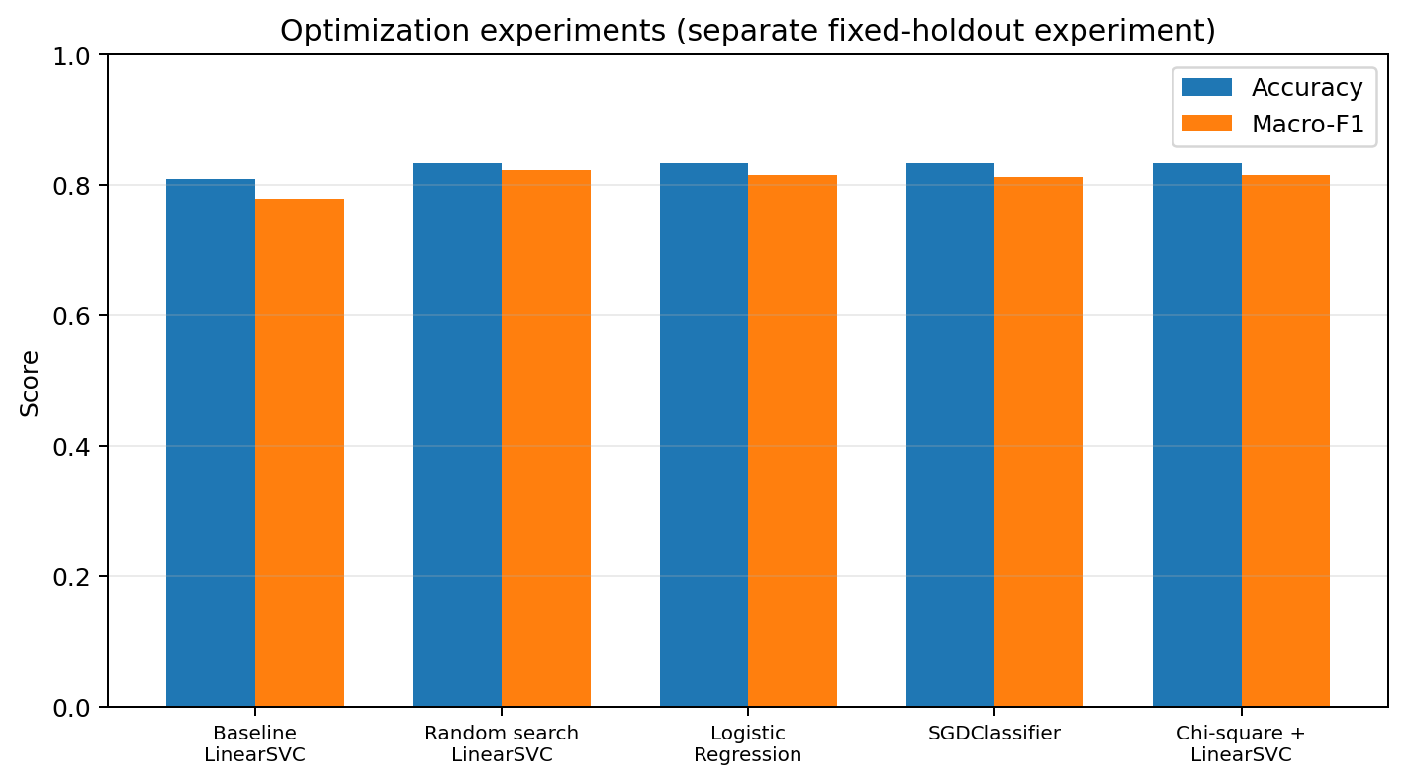
Figure 5. Accuracy and macro-F1 for selected configurations from the optimization report.

9.4 Further measured optimization observations
- Class weighting: in the documented comparison, class_weight='balanced' achieved accuracy 0.8824 and macro-F1 0.8210, compared with accuracy 0.8529 and macro-F1 0.7767 without weighting. This suggests a useful improvement on that split, not a universal guarantee.
- Parallel randomized search: n_jobs=2 produced best cross-validation macro-F1 0.8386 and holdout macro-F1 0.8187, with best parameters reported as tfidf__min_df=1 and clf__C=0.1.
- Feature selection: a selected-feature experiment reported accuracy 0.8529 and macro-F1 0.7743; it did not outperform the class-weighted full-feature result in that experiment.
- Successive halving: the run selected C=100 with CV macro-F1 0.6495; only one candidate evaluation was recorded, so the search result is not strong evidence of a robust optimum.
- Calibration: a 25-class calibrated model produced probabilities summing to 1.0000 for a sample row. Calibration does not guarantee better classification and can be unstable with few examples per class.
- Hyperband and evolutionary search outputs were toy-objective demonstrations, not measured resume-classifier improvements.

9.5 What the experiments support
Randomized search and class weighting were promising within their respective documented runs. Logistic Regression and SGDClassifier provided competitive alternatives, while character n-grams and Complement Naive Bayes scored lower in the reported comparison. Because different reports use different split setups, no single combined ranking should be inferred across all experiments. A rigorous follow-up should rerun all candidate models inside the same pipeline, on the same fixed split and identical cross-validation folds, and report mean ± standard deviation.

10. Results Interpretation and Project Outcomes

10.1 Outcomes achieved
- Established a documented, executable baseline for resume-category classification.
- Audited the data and exposed a critical duplication issue before interpreting model performance.
- Implemented a TF-IDF + LinearSVC approach and recorded real metrics and feature dimensions.
- Evaluated performance using holdout testing, multiple class-aware metrics, confusion matrices, and cross-validation.
- Compared model families and optimization choices with documented outputs and runtime observations.
- Identified the limitations that prevent the current classifier from being described as a validated hiring or resume-job ranking system.

10.2 Practical meaning
The baseline demonstrates that category-specific words and phrases provide useful signal for this dataset. The gap between accuracy and macro-F1 shows why minority-class performance deserves attention. The strong leakage demonstration also shows that data hygiene can matter more than choosing a sophisticated model.

10.3 What is not established
The reports do not establish production performance on a representative external resume population, fairness across demographic groups, the quality of resume-to-job matching, or the successful deployment of the complete API/database/Docker product. These require new data, explicit tests, and separately recorded evidence.

11. ML Engineering Practices and Reproducibility

11.1 Experiment record
Record item | Why it matters
Dataset filename/version and hash | Identifies the exact input data.
Duplicate policy and counts | Makes data cleaning auditable.
Split strategy, seed, and fold IDs | Enables fair repeat comparisons.
Pipeline and hyperparameters | Documents the model that produced each score.
Python/library versions | Reduces environment-related variation.
Metrics and confusion matrix | Preserves aggregate and class-level evidence.
Runtime and compute settings | Makes performance/cost comparisons interpretable.
Saved model/vectorizer and reload test | Supports repeatable inference without retraining.

11.2 Software practices
- Keep source data, code, reports, generated charts, and model artifacts in separate directories.
- Use a requirements file or environment lock and record the actual runtime versions.
- Use fixed seeds where supported, while recognizing that reproducibility may also depend on library versions and hardware.
- Automate checks for empty input, missing files, valid prediction labels, feature dimensions, and successful artifact reload.
- Do not load untrusted pickle/joblib artifacts.
- Keep the test set untouched during hyperparameter selection; use nested validation if an unbiased estimate of the full tuning process is needed.

12. Challenges and Lessons Learned
Challenge | Lesson learned | Recommended response
796 duplicate rows | Raw row count overstated independent evidence. | Deduplicate before splitting; inspect near-duplicates and provenance.
Only 166 unique resumes across 25 classes | Scores are uncertain and minority-class support is limited. | Collect more independent examples; report macro-F1 and per-class support.
High accuracy can conceal weak classes | One headline metric is insufficient. | Use macro-F1, balanced accuracy, class-level precision/recall, and confusion matrices.
Potential data leakage | A split performed before deduplication can inflate results dramatically. | Keep all fitted transformations inside the training/CV pipeline.
Different experiments show different values | Scores depend on split and configuration. | Label experiment setup and rerun candidates on common folds before direct ranking.
Advanced search methods may be overkill | Search overhead and low data support can outweigh benefits. | Start with simple baselines and random search; add complexity only when justified.
Planned product is broader than current evidence | A classifier is not the same as resume-job matching. | Build and evaluate each product component separately.

13. Limitations, Ethics and Risk Management

13.1 Technical limitations
- Dataset size after deduplication is small, and some categories have very few observations.
- The dataset's category labels do not constitute relevance labels for resume-to-job matching.
- The available columns contain no person identifier, employer/source identifier, or timestamp, so valid group-aware or temporal validation cannot be constructed from the supplied file alone.
- Reported holdout and cross-validation scores vary because they estimate performance under different sampling procedures.
- Some advanced-method outputs are templates or synthetic demonstrations rather than measured improvements on the resume classifier.

13.2 Responsible use
Resume data can contain personal and sensitive information. A real system should minimize collection, restrict access, establish retention rules, protect stored files and logs, and avoid exposing raw resume content unnecessarily. The model predicts a dataset-defined category; it should not be treated as an objective measure of candidate quality or used as the sole basis for employment decisions. Before any hiring-related use, the system would need representative validation, subgroup error analysis, human oversight, documented intended use, and a process to contest or correct outputs.

13.3 Risk register
Risk | Impact | Mitigation
Duplicate/data leakage | Inflated scores and false confidence | Deduplicate, group related documents if IDs become available, and audit splits.
Class imbalance | Poor performance on rare categories | Macro-F1, class weights, more examples, class-level review.
Distribution shift | Model degrades on new resume formats or terminology | External validation and ongoing monitoring.
Privacy/security | Exposure of personal information | Data minimization, access controls, secure storage, retention limits.
Automation bias | Users over-trust category predictions | Explain limitations; keep human review; avoid unsupported hiring decisions.

14. Recommendations and Future Work

14.1 Priority 1 — improve data and evaluation
- Acquire more unique resumes across all 25 categories, ensuring sufficient examples per class.
- Review labels for consistency and document the label definition.
- Add source/person/group identifiers and timestamps where permissible so group-aware or temporal evaluation can be performed.
- Create one canonical benchmark split and a common stratified CV configuration for every candidate model.
- Report mean and standard deviation, per-class support, confusion matrices, and confidence intervals where appropriate.
- Maintain a genuinely untouched external test set when the dataset grows.

14.2 Priority 2 — strengthen modeling
- Run a controlled hyperparameter search for LinearSVC and Logistic Regression using macro-F1 as the primary selection metric.
- Compare word TF-IDF, character n-grams, chi-square selection, and class weighting under the same folds.
- Perform error analysis on misclassified category pairs and use it to form new hypotheses.
- Consider TruncatedSVD only if there is a clear memory/latency or modeling reason; compare against the sparse baseline.
- Evaluate probability calibration only if downstream decisions require meaningful confidence estimates.

14.3 Priority 3 — develop the planned resume-job matching system
- Collect or construct a separately reviewed set of resume/job-description pairs with relevance judgments; category labels alone are insufficient.
- Implement skill extraction and alias normalization, beginning with a curated taxonomy and reviewed rules.
- Add sentence embeddings for semantic similarity and compare them with the TF-IDF lexical baseline.
- Build a hybrid score from lexical evidence, semantic similarity, and explicit skill coverage, with interpretable component outputs.
- Evaluate retrieval/ranking with Precision@k, Recall@k, MRR or NDCG, and conduct human review of top-ranked results.
- Only after the ML behavior is validated, expose inference through FastAPI, add input validation and error handling, persist appropriate structured records, containerize with Docker, and add automated tests and monitoring.

14.4 Suggested next-stage acceptance evidence
Deliverable | Evidence required
Expanded dataset | Schema, licensing/provenance, duplicate audit, class counts, privacy review
Classifier benchmark | Same split/folds for all candidates; macro-F1, accuracy, per-class report, runtime
Resume-job matcher | Reviewed pair labels; lexical vs embedding vs hybrid comparison; ranking metrics
API prototype | Sample request/response, validation tests, invalid-file/empty-input behavior
Deployment package | Clean environment install, Docker build/run logs, configuration and model version
Responsible-use review | Privacy controls, subgroup error analysis, human oversight and documented scope

15. Conclusion
The consolidated project demonstrates the essential stages of an ML engineering lifecycle: problem framing, data audit, preprocessing, feature representation, baseline implementation, evaluation, optimization, error analysis, and reproducibility. The strongest practical lesson is that data quality and validation design must precede claims about model quality. Removing 796 duplicate rows left only 166 unique resumes, and this small sample limits the certainty of every score.
TF-IDF with LinearSVC is a defensible baseline for the current resume-category classification task. The fixed holdout and cross-validation results indicate useful classification signal, while the optimization experiments suggest that randomized search and class weighting can be worth testing under controlled conditions. Results from different experiment setups must remain separate unless rerun on common folds.
The project is a credible foundation rather than a finished hiring product. The next phase should prioritize independent data, common evaluation protocols, transparent error analysis, and—if resume-job matching remains the goal—a dedicated relevance dataset and ranking evaluation. API, database, Docker, semantic matching, privacy, and monitoring work should then be implemented and evidenced as distinct engineering deliverables.

Appendix A. Consolidated Metrics and Configuration
Experiment family | Configuration / split | Main reported result
Implementation fixed holdout | Deduplicated data; 132 train / 34 test; seed 42; TF-IDF 5,000 features + LinearSVC | Accuracy 0.8824; Macro-F1 0.8276; Weighted-F1 0.8550
Evaluation 5-fold CV | Pipeline; StratifiedKFold(5); seed 42 | Accuracy 0.8977 ± 0.0548; Macro-F1 0.8741 ± 0.0671
Evaluation repeated CV | RepeatedStratifiedKFold(5 folds × 3 repeats) | Accuracy 0.8876 ± 0.0419; Macro-F1 0.8538 ± 0.0544
Optimization baseline | Separate fixed holdout documented in optimization report | Accuracy 0.8095; Macro-F1 0.7794
Optimization randomized search | Same optimization comparison family | Accuracy 0.8333; Macro-F1 0.8232; Weighted-F1 0.8070
Class-weight comparison | Optimization report's documented split | Balanced: Accuracy 0.8824; Macro-F1 0.8210

Interpretation rule: do not compare results from different split configurations as if they were measured on identical samples. Use the experiment configuration and source report alongside every metric.

Appendix B. Final Reproducibility Checklist
- ☐ Dataset source, license/provenance, version and schema recorded.
- ☐ Missing values, blank strings, duplicate rows, text lengths and class counts audited.
- ☐ Duplicates handled before split; any grouping logic documented.
- ☐ Text normalization preserves meaningful technical identifiers.
- ☐ Vectorizer and feature selector fitted only on training data.
- ☐ Pipeline and split seed recorded; test set kept out of tuning.
- ☐ Accuracy, macro-F1, weighted-F1, per-class metrics and confusion matrix saved.
- ☐ Cross-validation mean and variation reported.
- ☐ Hyperparameter search space, trial budget, best parameters and runtime recorded.
- ☐ Python and package versions recorded; model/vectorizer artifacts reload successfully.
- ☐ Limitations, privacy risks, intended use and non-production status clearly stated.
- ☐ Future semantic matching evaluated with paired relevance labels and ranking metrics.

References and Technical Resources
The consolidated project reports refer to the following documentation and research resources. Consult the current versions when implementing the next stage:
- scikit-learn documentation — text feature extraction, TF-IDF, Pipeline, model selection, cross-validation, metrics and feature selection: https://scikit-learn.org/stable/
- pandas documentation — data loading, duplicate checks, missing values and descriptive statistics: https://pandas.pydata.org/docs/
- NumPy documentation — numerical operations and random seed utilities: https://numpy.org/doc/
- Matplotlib documentation — plotting and visual diagnostics: https://matplotlib.org/stable/
- Sentence Transformers documentation — semantic text embeddings and similarity: https://www.sbert.net/
- Reimers, N. & Gurevych, I. (2019). Sentence-BERT: Sentence Embeddings using Siamese BERT-Networks. arXiv:1908.10084.
- spaCy rule-based matching documentation: https://spacy.io/usage/rule-based-matching
- PyMuPDF documentation — PDF text extraction: https://pymupdf.readthedocs.io/
- FastAPI documentation — file uploads and API implementation: https://fastapi.tiangolo.com/
- Docker documentation — containerization and deployment: https://docs.docker.com/

Appendix C. Glossary of Key Terms
The following definitions make the report easier to review without assuming specialist terminology.
Term | Definition in this project
TF-IDF | A sparse numerical representation that weights terms by their importance in a document relative to the corpus.
Unigram / bigram | A single token / a two-token sequence used as a text feature.
LinearSVC | A linear support-vector classifier suited to high-dimensional sparse features.
Macro-F1 | The unweighted mean of F1 across classes; each category contributes equally.
Weighted-F1 | The mean of per-class F1 weighted by each class's support.
Data leakage | Information crosses into training or model selection from data that should be held out, inflating evaluation.
Stratified cross-validation | A fold-based validation strategy that attempts to preserve class proportions in each fold.
Hyperparameter | A configuration choice, such as SVM C or TF-IDF min_df, selected outside direct model fitting.
Calibration | A check or adjustment of whether predicted probabilities correspond to observed event frequencies.
Ranking metric | A metric such as NDCG or Precision@k used to assess the ordering of candidate results.

