As per the Document section 5: Issues found the modification or justifications are clarified below.
CRIT-1: TPS54531 feedback divider gives ~5V instead of 12V Sheet: Driver | Components: U5, R20 (52.3K), R67 (10K) The feedback divider calculates: Vout = 0.8V x (1 + 52.3K/10K) = 4.98V, not 12V. The hierarchical label confirms 12V is intended (+12V_Rail). For 12V output, the upper resistor should be ~140K with 10K lower: Vout = 0.8 x (1 + 140/10) = 12V. Impact: 12V rail will regulate to ~5V. All solenoids, fans, linear actuators, and pumps will be underpowered or non-functional. DRV8876 and TB6612FNG motor drivers will not operate correctly. Fix: Change R20 from 52.3K to 140K
The IC U5 is for 12 V to 5V conversion and the feedback loop is perfect as mentioned in the Github data.
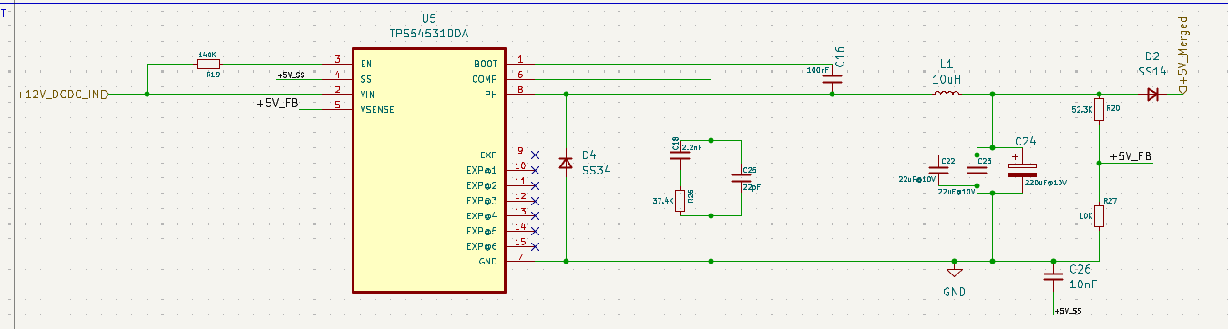

Reference of Github:
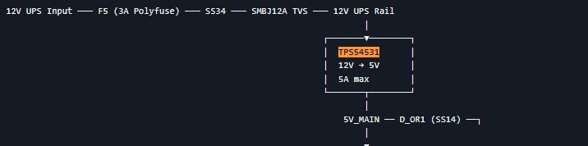
CRIT-2: MT3608 feedback divider gives ~6.6V instead of 5V Sheet: Driver | Components: U14, R23 (100K), R32 (10K) The feedback divider calculates: Vout = 0.6V x (1 + 100K/10K) = 6.6V, not 5V. For 5V output with 10K lower, the upper resistor should be ~73.3K. Impact: Battery boost output will be 6.6V, exceeding the 5.25V absolute max of many 5V rated components on the 5V_MERGED bus. Could damage the CM5 or STM32 LDO.
As it was mentioned in the Github to provide the Schematic with 732 K and 100K which make the FB work for 4.992V.
Where the R1 is 732K , R2 is 100K and as per the MT3608 Datasheet FB pins required the 0.6V on FB.
Now according to Voltage divider rule: Vout = Vin (R2/(R1+R2))
Vout = 0.6V.
R1 = 732 K.
R2 = 100K.
Resultant Vin = 4.992V.
And both FB voltage divider provided in CRIT 2 are wrong, you are referring to R23 and R32 which are connected to different locations with different functionality, the actual Resistor used for voltage divider is R64 and R65.
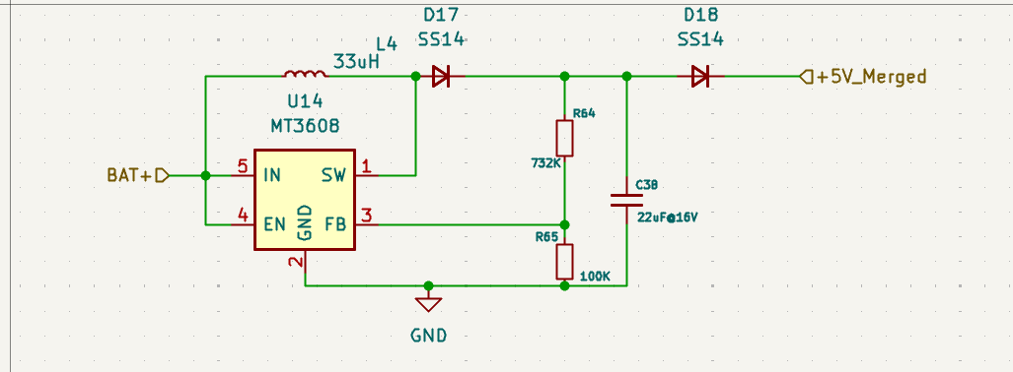
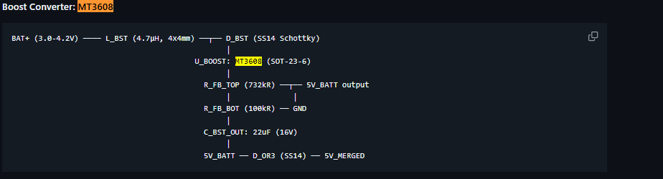
CRIT-3: SI2301-TP (P-channel) uses 2N7002 (N-channel) symbol Sheet: Driver | Component: Q2 The symbol is Transistor_FET:2N7002 (N-channel MOSFET) but the value is SI2301-TP (P-channel MOSFET). Gate, source, and drain pins are mapped incorrectly in the netlist. The circuit will not function as designed. Impact: The P-FET switching circuit will have reversed source/drain and wrong gate polarity. The generated netlist and PCB layout will have incorrect connections. Fix: Replace the 2N7002 symbol with a proper P-MOSFET symbol (e.g., Transistor_FET:SI2301CDS ) and verify pin mapping
Change is done, Symbol error was there which was resolve with PMOS symbol.
Modified Schematic Picture.
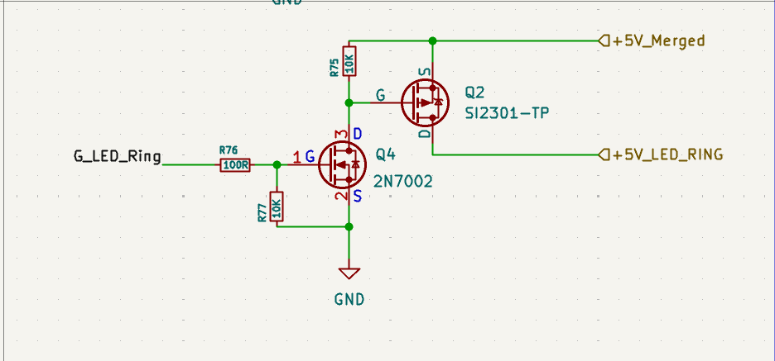.
CRIT-4: 12V input TVS clamp voltage too high (39.2V) Sheet: Connector | Component: D_IN3 (SMBJ24A) The 12V UPS input uses an SMBJ24A TVS with 39.2V clamping voltage. Downstream 12V components will see up to 39V before the TVS conducts -- this exceeds the ratings of 12V rated components. Impact: TVS provides no effective protection for the 12V rail. A transient could destroy the TPS54531 (max VIN = 40V, marginal) and downstream components. Fix: Change D_IN3 from SMBJ24A to SMBJ12A (13.3V standoff, 19.9V clamping)
Modification done, Change the orientation of the diode from series to parallel for TVS clamping functionality.
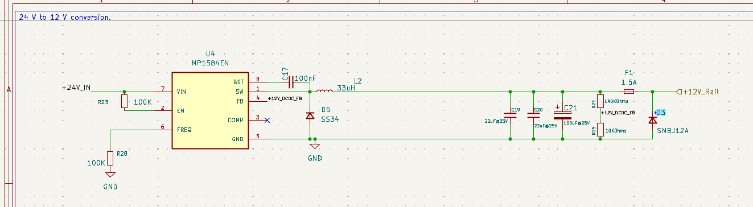
CRIT-5: J_SAFE1 symbol-footprint mismatch Sheet: Connector | Component: J_SAFE1 The schematic symbol is B4B-XH-A (JST XH, single-row 4-pin, 2.5mm pitch) but the footprint is CON4_2X2_RF_DF11_HIR (Hirose DF11, dual-row 2x2, 2.0mm pitch). These are physically incompatible connectors with different pin counts per row. Impact: BOM will list wrong part. Pin mapping between single-row (1-2-3-4) and dual-row (1 2 / 3-4) may result in swapped safety signals. Safety relay, E-stop, and pot detection could be wired incorrectly. Fix: Change the symbol to match the intended connector (likely DF11-4DP-2DS to match the footprint), and verify pin assignments.
Footprint changed from 2x2 footprint to actual B4B-XH-A footprint.
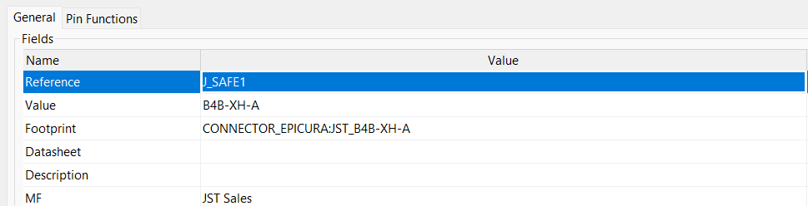
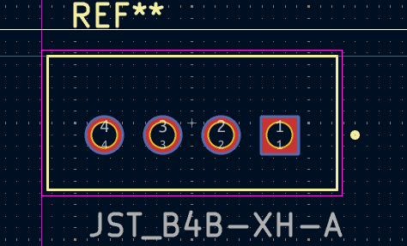
MAJ-1: No TVS/ESD protection on CAN bus at connector Sheet: Connector | Component: J_CAN1 CAN_H and CAN_L have no TVS diodes at the connector entry point. The CAN bus cable runs to the microwave induction module -- a high-EMI environment with switching transients from the induction coil. Fix: Add PESD2CAN (or CDSOT23-SM712) TVS diode across CAN_H/CAN_L at J_CAN1
New Modification done as per the provided sheet added the TVS diode across the CANH and CANL.
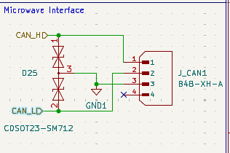
MAJ-2: VREF+ has no dedicated filtering Sheet: Control | Component: Pin 28 (VREF+) VREF+ is connected directly to +3V3 without a dedicated ferrite bead or decoupling capacitor pair. ST application notes recommend 1uF + 100nF on VREF+. Impact: ADC readings on PA1 (24V detection) and PA3 (bus detection) will be noisy, potentially causing false power-failure triggers. Fix: Add a ferrite bead and 1uF + 100nF decoupling on VREF+, separate from the VDDA filtering.
Done, Provided the power from VDDA Pin with proper 1uF and 100nF filter.
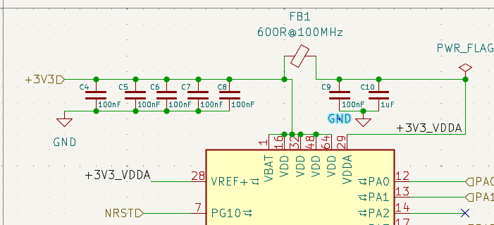
MAJ-3: VDDA missing bulk capacitor Sheet: Control | Component: FB1, C9 VDDA has ferrite bead FB1 (600R@100MHz) and a single 100nF cap (C9). ST AN4206 recommends 1uF + 100nF on VDDA. Fix: Add a 1uF ceramic capacitor in parallel with C9 on VDDA.
Error of 1uF missing is done, Kept 1uF + 100nF capacitor on VDDA Pin.


MAJ-4: No UART fallback for CM5-STM32 communication Sheet: Control The design doc specifies "SPI (primary) or UART (fallback)" but no UART pins are assigned. PA2 and PA9 (capable of USART2_TX and USART1_TX) are both No-Connect. Fix: Route at least one UART (TX+RX) to J_CM5 or to test points. PA2 (USART2_TX) and PA3 (USART2_RX) are available, though PA3 is currently used for ADC.
As the major communication between STM32 to CM5 is through SPI not UART/USART as per reference document so there are no connection established.
And the PA3 as per the comment is already used for ADC to read 24V buss status using voltage divider.
MAJ-5: TB6612FNG VM bypass capacitor undersized Sheet: Driver | Component: C_VM2 (10uF) The TB6612FNG motor power bypass is only 10uF. The datasheet recommends 100uF+ for motor applications with inductive loads (peristaltic pumps). Impact: Voltage sag during pump startup could cause erratic motor behavior or brownout the 12V rail. Fix: Increase C_VM2 to 100uF (electrolytic) or add a 100uF capacitor in parallel.
In the requirements document it was required for 100nF and 10uF so kept as it is, if any additional modifications are required please clarify.
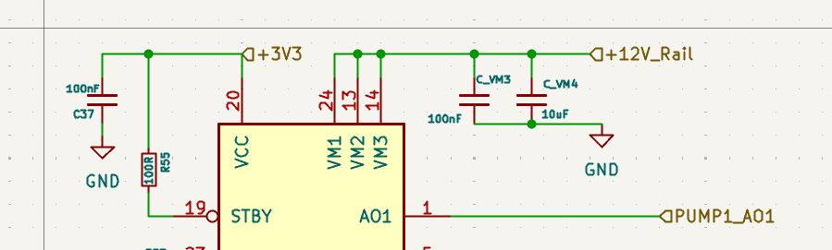
MAJ-6: Missing input bulk capacitor on TPS54531 Sheet: Driver | Component: U5 The TPS54531 datasheet requires a minimum 20uF ceramic input capacitor close to VIN. Only C35 (100nF) is visible as VIN bypass. The 100uF (C21) is on the output side. Impact: Input voltage ringing, potential instability, and EMI issues on the 24V-to-12V converter. Fix: Add a 22uF ceramic capacitor (25V rated, 0805 or 1206) on U5 VIN, placed as close as possible to the IC.
It is not mentioned in requirement, is it required then please clarify, i will add it if required.
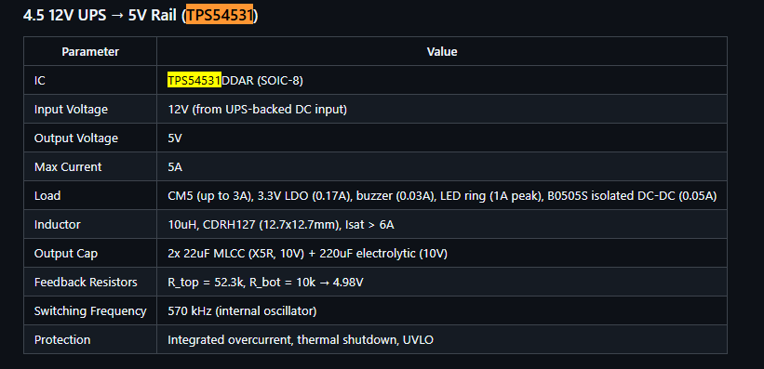
MAJ-7: No 12V rail voltage monitoring Sheet: Connector The 24V rail has a voltage divider (R1/R9) for ADC monitoring, but the 12V rail has no equivalent. The 12V rail operates at 0% headroom under peak load and powers critical actuators. Fix: Add a voltage divider on the 12V rail to an available ADC pin (e.g., PA7 or PC0).
It was not in the requirements sheet if it is required please clarify,
MAJ-8: No protection on BLDC control lines Sheet: Connector | Components: J_BLDC1 BLDC_PWM, BLDC_DIR, BLDC_EN are routed directly to the connector with no series resistors or ESD protection. The BLDC motor/ESC environment generates significant EMI. Fix: Add 100R series resistors on all three signal lines, and consider a TVS array.
The modification is done.
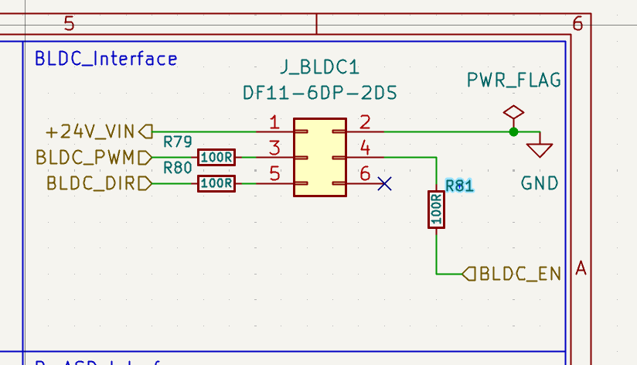
MAJ-9: No ESD protection on external I2C lines Sheet: Connector | Components: J_IR_LED1, J_PRES1 I2C_SCL and I2C_SDA run over cables to external boards (MLX90614, ADS1015) with no ESD protection at the connector. Fix: Add an I2C-rated ESD protection device (e.g., USBLC6-4SC6 or IP4220CZ6) near J_IR_LED1.
No specific requirements was there, please clarify it is doable. And please provide the part number.
MAJ-10: No filtering on HX711 load cell signals Sheet: Connector | Component: J_SLD1 HX711_OIL and HX711_WATER clock/data lines run over cables with no series resistors or decoupling. The HX711 is a 24-bit ADC extremely sensitive to noise. Fix: Add 100R series resistors and 100pF caps to GND on each HX711 signal line at the connector.
Modification done.
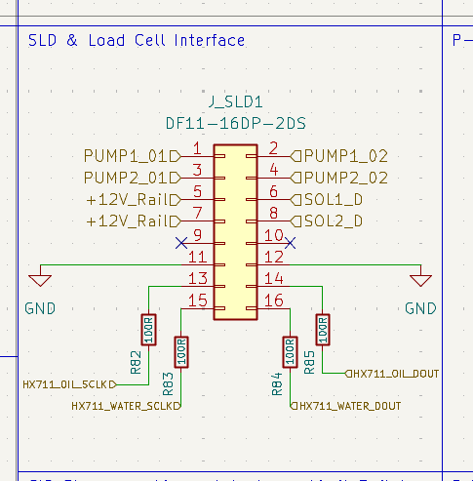
5.3 Minor Issues (recommended) MIN-1: INA219 label naming inconsistency Sheet: Driver | Component: U7 The hierarchical label reads +24V_INA226_IN but the component is an INA219 (U7), not INA226. Creates confusion during firmware development. Fix: Rename label to +24V_INA219_IN.
Done, Net name changed from INA226 to INA219.
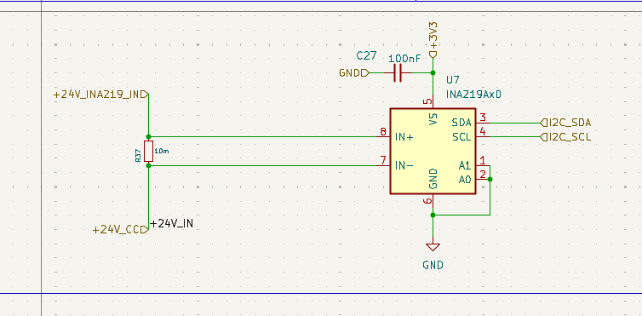
MIN-2: LED current limiting resistors too high Sheet: Driver | Components: R75, R67 (10K each) At 3.3V with ~2V LED Vf: I = (3.3 - 2) / 10K = 0.13mA. The charging (D23) and standby (D22) LEDs will be invisible. Fix: Change R75 and R67 to 1K (1.3mA) or 2.2K (0.6mA).
There is error in referencing the resistor which is mentioned as 10K actually in schematics is 1KOhms.
It is powered by +5V where the current calculations will be.
Vin = 5V.
Rseries = 1K.
Drop across LED = 2V.
Current = 5-2/1000 = 3mA.|
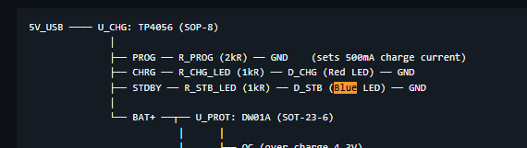

MIN-3: MP1584EN FREQ resistor out of range Sheet: Driver | Component: U4, R64 (732K) The MP1584EN datasheet specifies FREQ resistor range of 100K-360K (200kHz-1.5MHz). R64 = 732K is well outside this range. Fix: Change R64 to a value within 100K-360K per the datasheet frequency table.
It is already 100K connected on FREQ, there is some error in referring.
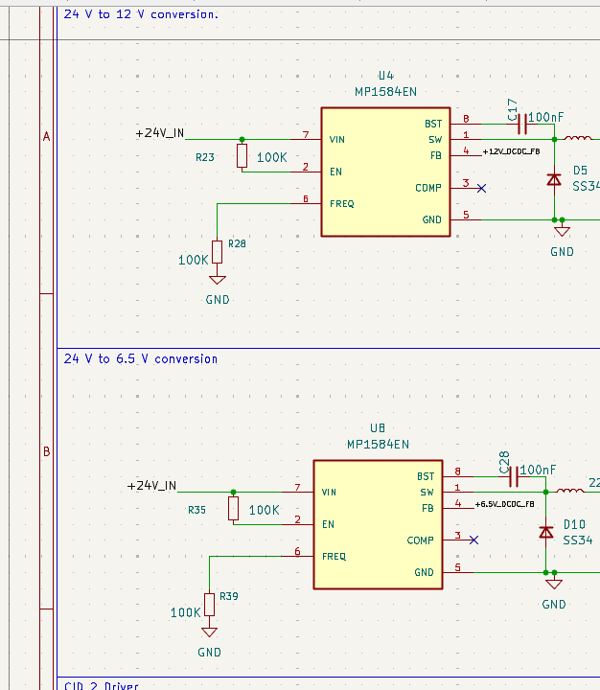
MIN-4: No debounce on switch inputs Sheet: Control | Pins: PB1 (reed switch), PB2 (E-stop), PB6 (CID1 home), PD2 (CID2 home) No hardware RC debounce networks on any mechanical switch inputs. Software debouncing is possible but hardware debounce is more reliable for safety-critical inputs like E-stop. Fix: Add RC debounce (10K + 100nF = 1ms time constant) at minimum on PB2 (E-stop). Consider for all switch inputs.
Added Section.
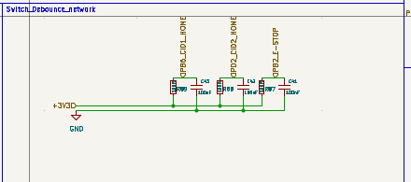

MIN-5: Boot0 pin connection unclear Sheet: Control A text note reads "Where to connect Boot ) PB* is already used for something else." The Boot0 circuit (SW1 + R4 pull-down) exists but its connection to the MCU's BOOT0 pin is not clearly traceable. Fix: Verify BOOT0 pin is properly connected and remove the ambiguous text note.

BOOT0 pin clarity required which is BOOT0.
MIN-6: PC5 timer conflict for SLD_WATER_PWM Sheet: Control | Pin: PC5 PC5 can use TIM1_CH4N (complementary output). Since TIM1_CH4 is already used on PC3 for SLD_OIL_PWM, CH4 and CH4N are complementary pairs of the same channel - they cannot be independently controlled. Fix: Move SLD_WATER_PWM to a pin with an independent timer channel (e.g., PC8/TIM3_CH3 or PB11/TIM2_CH4, both currently NC).

Modified from PC5 to PC8.
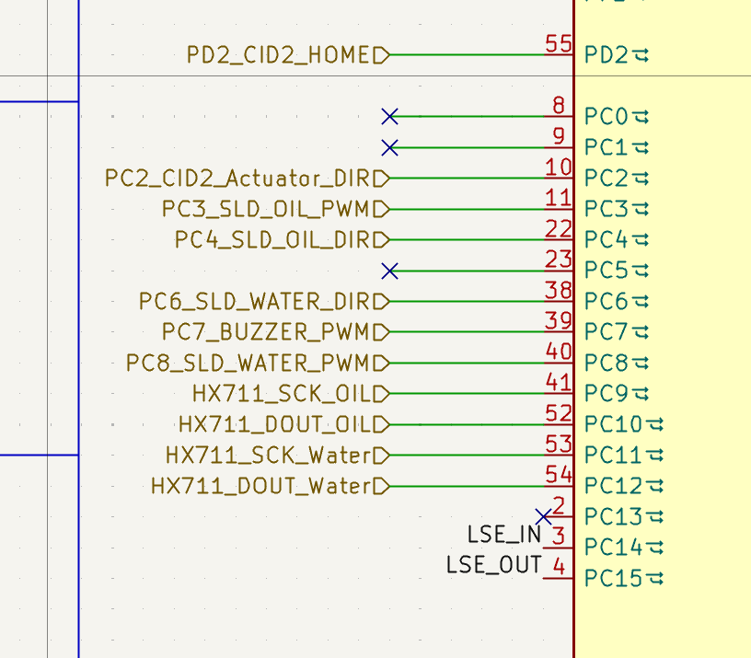

MIN-7: PCF8574AT address conflict risk Sheet: Driver | Components: U9, U10 Both I/O expanders are PCF8574AT (base address 0x38). If A0/A1/A2 pins are identically configured, they will collide on the I2C bus. Fix: Verify A0/A1/A2 pin states differ between U9 and U10.
Both address are different as mentioned in reference document.
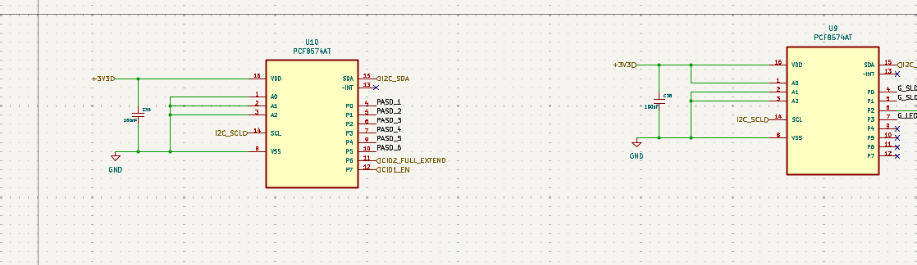

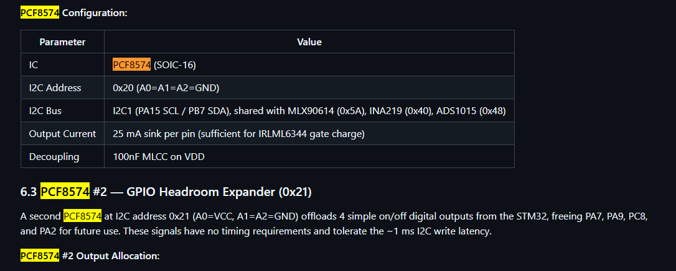

MIN-8: No bulk VDD capacitor near MCU Sheet: Control Four VDD pins have 100nF decoupling each, but no single bulk capacitor (4.7-10uF) is placed near the MCU. The 10uF caps at the LDO output may be physically distant on the PCB. Fix: Add a 4.7uF ceramic capacitor near the MCU VDD cluster.
Done, added 10uF
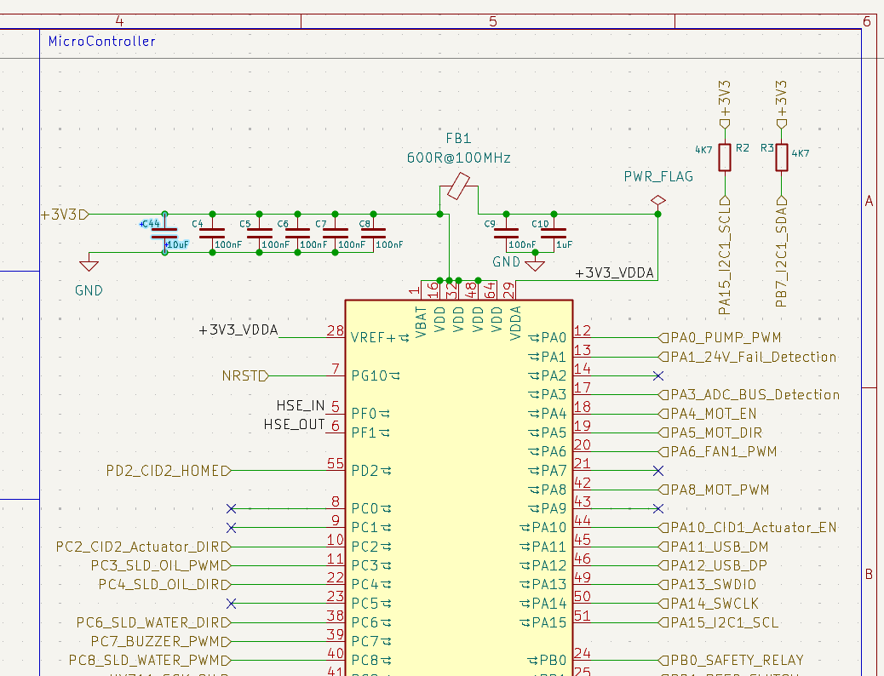
MIN-9: Unused GPIO pins not routed to test points Sheet: Control | Pins: PA2, PA7, PA9, PB11, PC0, PC1, PC8, PC13 Eight GPIO pins are No-Connect. For a prototype, routing these to test points or a header would provide debug flexibility and future expansion. Fix: Route unused pins to test pads or a 0.1" header.
All pins are unconnected.
MIN-10: J_PASD1 pin 15 is No-Connect instead of GND Sheet: Connector | Component: J_PASD1 Pins 11-14 and 16 are all GND, but pin 15 has a no-connect flag. This wastes a ground return pin on a 16-pin connector carrying 7 solenoid drives. Fix: Connect pin 15 to GND.
Connection added on pin 16.
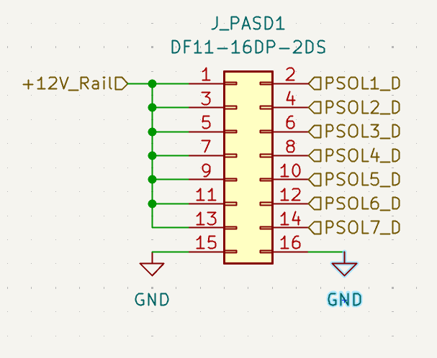
MIN-12: USB CC configuration is device-only Sheet: Connector | Components: R13, R14 (5.1K to GND) The 5.1K pull-downs on CC1/CC2 configure USB-C as UFP (device/sink only). This is correct for DFU programming and charging, but prevents USB host mode if ever needed. Action: Confirm this matches design intent (likely correct for this application).
Is the Host mode required in USB?

