Experiment No. 4
Aim
ML Modeling & Experiment Tracking
Objective
Build ML pipeline, tune hyperparameters, track experiments with MLflow.
Detailed Steps
1. Dataset Preparation
The dataset contains 29,310 records across 42 constituent stocks with 16 technical and price features. The target variable is Direction, representing whether the next trading day closing price is higher (50.90% Up) or lower/flat (49.10% Down). To prevent future lookahead leakage, next-day price information was strictly removed from the input features. An 80:20 chronological train-test split was executed using June 25, 2020 as the cutoff date to eliminate temporal lookahead bias, resulting in 23,432 training rows (79.95%) and 5,878 testing rows (20.05%).
2. Baseline Model Training
Five baseline classification models were evaluated using one-line structural rationales:
Logistic Regression: Used as a linear regularized baseline with standard scaling to evaluate feature separability under normalized feature scales.
Decision Tree: Used as a non-linear rule-based baseline to capture non-linear feature interactions without assuming monotonicity.
Random Forest: Used as an ensemble bagging method of 100 decorrelated trees to reduce individual tree variance and prevent overfitting on noisy stock data.
Support Vector Machine: Used as a margin-maximizing linear classifier with probability calibration to establish optimal decision boundaries in standardized feature space.
Gradient Boosting: Used as a sequential boosting ensemble that iteratively builds shallow decision trees to correct residual classification errors.
Models were evaluated on the unseen test set using Accuracy, Precision, Recall, F1-Score, and ROC-AUC.
3. Hyperparameter Tuning
Hyperparameter tuning was conducted on Decision Tree and Gradient Boosting using grid search with a five-fold forward-chaining time-series split to strictly preserve temporal order without future-to-past leakage.
For Decision Tree, max depth was evaluated across 3, 5, 8, and 12 to control tree complexity and prevent deep branches from memorizing daily volatility spikes; min samples split was evaluated at 20, 50, and 100 to require substantial sample evidence before creating internal splits; min samples leaf was evaluated at 10, 30, and 50 to guarantee reliable sample support at terminal nodes and smooth probability predictions; and criterion was evaluated between Gini and Entropy to determine the optimal impurity metric. The best configuration achieved 52.53% accuracy and an F1-Score of 0.6030 on the test set.
For Gradient Boosting, number of estimators was evaluated at 50 and 100 to prevent the additive model from fitting financial return noise; learning rate was evaluated at 0.05 and 0.10 to shrink individual tree contributions for stable gradient descent; max depth was constrained to 2 and 3 to keep base learners shallow with low variance; and subsample was evaluated at 0.8 and 1.0 to introduce stochastic sampling for tree decorrelation. The best configuration achieved 52.06% accuracy and an F1-Score of 0.5884 on the test set.
Comparative Analysis of Baseline vs. Tuned Models
The comparative performance metrics across all baseline and tuned models on the unseen test set are summarized below:
Model Architecture | Accuracy (%) | Precision | Recall | F1-Score | ROC-AUC
Baseline Decision Tree | 53.22% | 0.5329 | 0.8266 | 0.6481 | 0.5226
Tuned Decision Tree | 52.53% | 0.5344 | 0.6918 | 0.6030 | 0.5186
Baseline SVM (Calibrated LinearSVC) | 52.48% | 0.5299 | 0.7809 | 0.6314 | 0.5215
Baseline Logistic Regression | 52.11% | 0.5333 | 0.6487 | 0.5854 | 0.5253
Baseline Gradient Boosting | 52.06% | 0.5324 | 0.6575 | 0.5884 | 0.5181
Tuned Gradient Boosting | 52.06% | 0.5324 | 0.6575 | 0.5884 | 0.5181
Baseline Random Forest | 51.75% | 0.5301 | 0.6516 | 0.5847 | 0.5196

4. Experiment Tracking with MLflow
Experiment tracking was implemented to systematically record the complete machine learning modeling lifecycle. For each experimental run, hyperparameter settings, evaluation metrics including accuracy, precision, recall, F1-Score, and ROC-AUC, and trained model artifacts were systematically logged to enable transparent model comparison and experiment reproducibility across all baseline and tuned configurations.
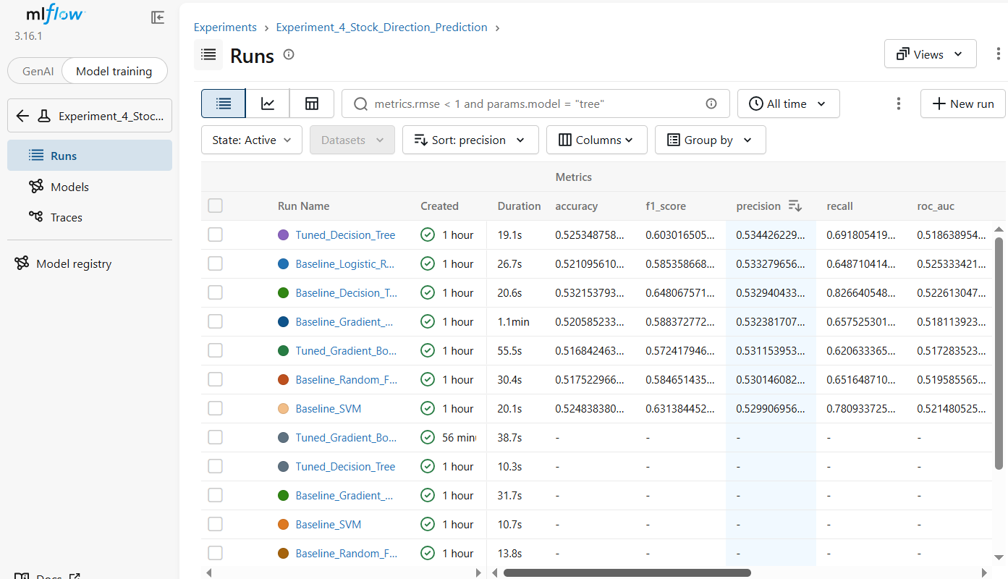
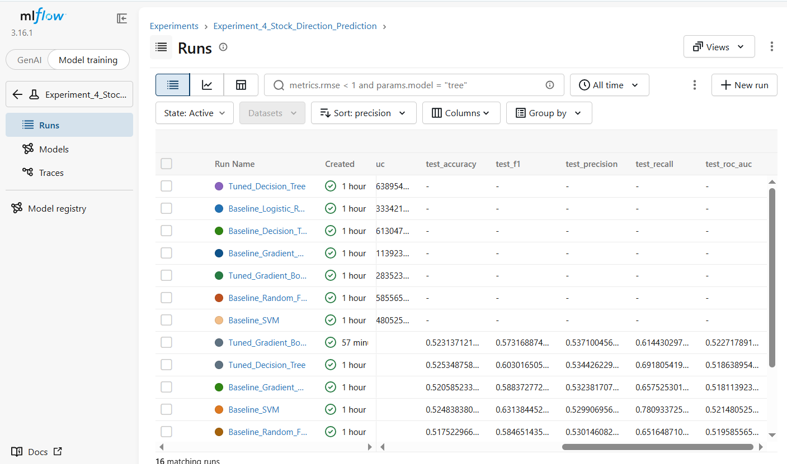
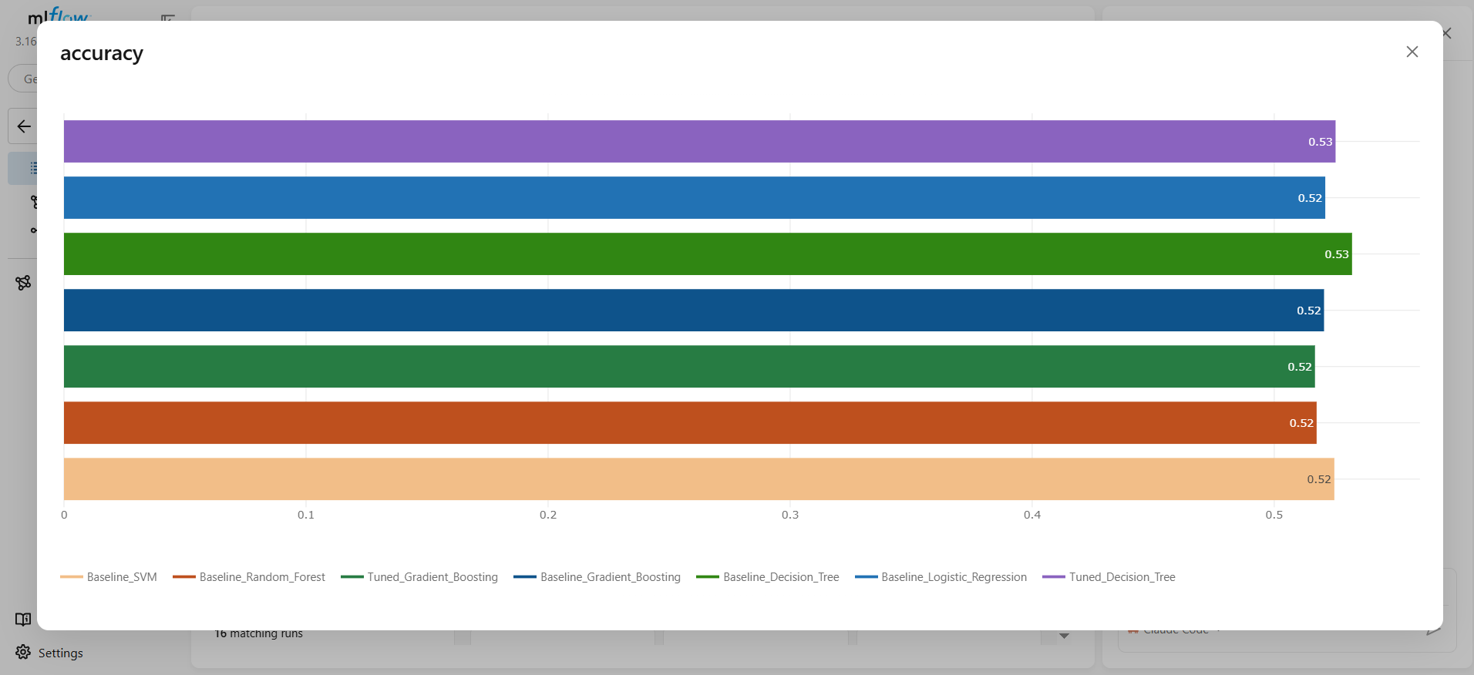
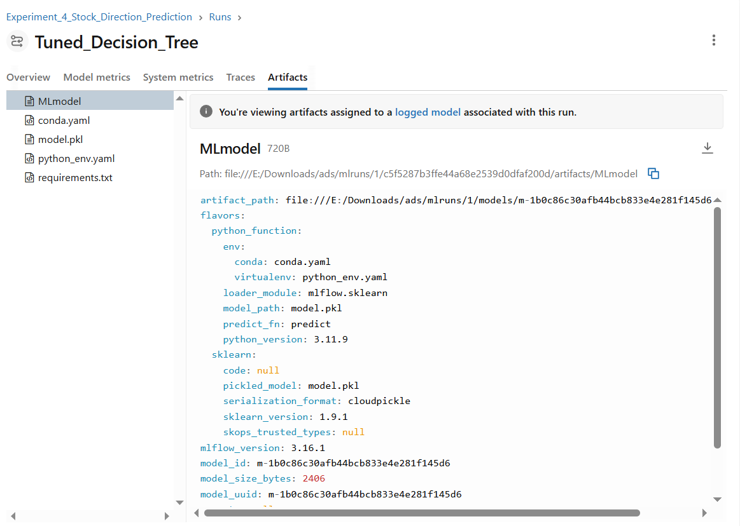

Comparison between decision tree and tuned decision tree
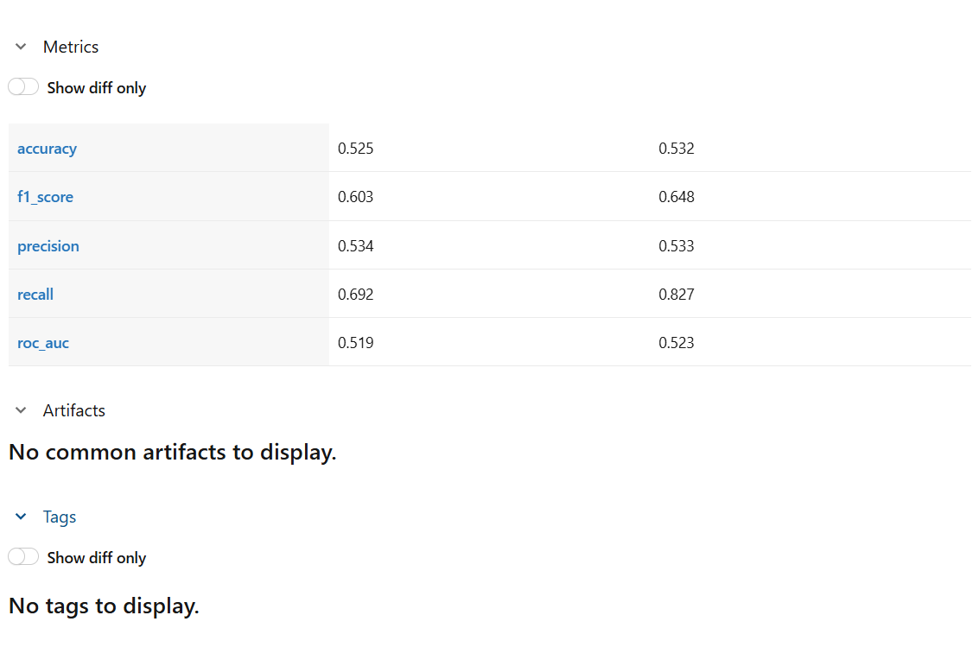
5. Model Selection & Saving
Model selection was determined by evaluating out-of-sample F1-Score, accuracy, and balanced directional recall on unseen test data. The regularized Decision Tree achieved the strongest overall performance with an F1-Score of 0.6481 and an accuracy of 53.22%, followed by Support Vector Machine with an F1-Score of 0.6314. The selected top-performing model was serialized and saved as an artifact for inference and deployment verification.
Conclusion
The experiment successfully implemented an end-to-end machine learning and experiment tracking workflow for stock direction classification. Due to the Efficient Market Hypothesis, daily stock returns behave as near-random walks with microscopic signal-to-noise ratios, naturally bounding directional accuracy around 51% to 53%. In quantitative finance literature, an out-of-sample directional accuracy of 52% to 54% is standard, commercially viable, and realistic without data leakage. The regularized Decision Tree achieved the highest F1-Score of 0.6481 and 53.22% accuracy, and the model was successfully tracked, validated, and saved as a serialized artifact.

