Laboratory 4 – AI-Assisted Detailed Design
Data Design • Algorithm Design • Security Design | Simplified Integrated Laboratory Manual
Aim: Develop and validate implementation-ready detailed designs from approved requirements and the Lab 3 architecture. AI proposes alternatives; students identify silent decisions and approve the final design.

1. Inputs, Method and Submission
Input | Output
Approved requirements, Prompt Records, Lab 3 architecture, ADRs and ARR | One consolidated Detailed Design Record (DDR) plus final design artifacts

Common method: Design Need → AI Alternatives → AI Silent Decision → Student Review (ACCEPT / MODIFY / REJECT) → Final Design. Request alternatives only for significant decisions. Do not generate implementation code.

2. Part A – AI-Assisted Data Design

A1. Data needs and storage alternatives
Identify structured transactional data, documents/files and any genuinely specialized search or other workload. RDBMS-only is valid; polyglot persistence requires a justified need.
Option | Design | When suitable
A | RDBMS only | Structured relationships, integrity and transactions
B | RDBMS + file/object store | Relational records plus substantial documents/files
C | RDBMS + specialized store | Approved search/vector/graph or other specialized workload

Data needs: Structured transactional data (students, companies, job listings, allowed branches, applications, interview slots, offers) needs relationships, integrity and transactions. Offer letters are documents; the schema stores only a reference (offers.offer_letter_key, unique), as required by FR-8.1 and FR-8.3. The requirements also call for login credentials, a status-change history, stored eligibility reasons and consent records; these are structured transactional data and stay in the RDBMS (see A2).
Decision: AI silent decision: Option B (RDBMS + file/object store). Student decision: ACCEPT B, with the object store used only for offer letters, which the schema references by an unpredictable storage key rather than a public URL (FR-8.3, NFR-3.5). Offer-letter storage is an approved requirement (FR-8.1, FR-8.3), so Option A is not needed. Option C is rejected because no semantic-search requirement is approved.

A2. ER modelling using AI
Prompt: “Using the approved requirements below, propose entities, attributes, keys, relationships and cardinalities. Resolve M:N relationships and state PK/FK/UNIQUE constraints. Do not invent business rules; list assumptions.”
ER design item | AI decision / assumption | Student action (A/M/R) | Reason / correction
Entity / attribute | Seven entities: students, companies, job_listings, job_allowed_branches, applications, interview_slots, offers. Each has a surrogate integer id as primary key. | ACCEPT | Matches the seven core tables in Requirements v2, section 2.6. Surrogate keys keep foreign keys simple.
Entity / attribute | Keep students.has_accepted_offer as a stored column in addition to offers.accepted. | ACCEPT | Required by FR-2.4 and NFR-8.4: the flag stays a stored column, changes only through accept_offer, and is updated in the same transaction as the status change and offers.accepted.
Entity / attribute | Store allowed branches as a list inside job_listings. | REJECT | Multi-valued cell breaks 1NF. Moved to job_allowed_branches, one row per branch; no rows means all branches (FR-3.3).
Relationship / cardinality | COMPANY 1:N JOB_LISTING; JOB_LISTING 1:N JOB_ALLOWED_BRANCH; STUDENT 1:N APPLICATION; JOB_LISTING 1:N APPLICATION; APPLICATION 1:N INTERVIEW_SLOT; APPLICATION 1:N OFFER. | MODIFY | Offer cardinality changed to APPLICATION 1:0..1 OFFER by adding UNIQUE(application_id) on offers (FR-8.6). The other cardinalities follow the scenario flow: apply, interview, offer.
Relationship / cardinality | STUDENT M:N JOB_LISTING resolved through APPLICATION. | ACCEPT | Each application is its own record with status and timestamps.
Key / constraint | UNIQUE(student_id, job_id) on applications. | ACCEPT | One application per student per job (NFR-8.3). The rule 'same company once per season' (FR-5.3) spans job_listings, so apply_for_job enforces it in the service layer; a table constraint would need copied company and season columns and break 3NF.
Key / constraint | UNIQUE usn, email, company_name, offer_letter_key; CHECK cgpa BETWEEN 0 AND 10; CHECK active_backlogs >= 0 and max_backlogs >= 0. | MODIFY | Added: CHECK branch IN (CSE, ECE, ISE, MECH, CIVIL) (FR-2.1); CHECK min_cgpa BETWEEN 0 AND 10; CHECK status IN the six statuses (section 2.5); cleared_backlogs >= 0; UNIQUE(application_id, round_no) on interview_slots (FR-7.2). company_name UNIQUE and offer_letter_key UNIQUE are not listed in NFR-8.3; kept as assumptions to confirm (offer_letter_key follows FR-8.3 and NFR-3.5).
Entity / attribute | First schema had no storage for login credentials and roles, status-change history, stored eligibility reasons, or consent. | MODIFY | Added users (FR-1.1, NFR-3.7), application_status_log (NFR-9.1), eligibility_decisions (FR-6.3, NFR-9.3), and consent_given / consent_at on students (FR-10.1, NFR-4.1). Requirements 2.6 lists only the seven core tables, so confirm these additions with the coordinator.

Artifact: Corrected ER model showing entities, key attributes, relationships and cardinalities.
Corrected ER model (text form)
COMPANY (1) ──< (N) JOB_LISTING (1) ──< (N) JOB_ALLOWED_BRANCH
JOB_LISTING (1) ──< (N) APPLICATION (N) >── (1) STUDENT
APPLICATION (1) ──< (N) INTERVIEW_SLOT
APPLICATION (1) ── (0..1) OFFER
APPLICATION (1) ──< (N) APPLICATION_STATUS_LOG (N) >── (1) USER
STUDENT (1) ──< (N) ELIGIBILITY_DECISION (N) >── (1) JOB_LISTING
STUDENT (1) ── (0..1) USER ; COMPANY (1) ──< (N) USER
Corrected ER model: entities and attributes
Entity | Attributes (PK, FK, constraints)
STUDENT | student_id (PK), usn (UNIQUE), full_name, email (UNIQUE), branch (CSE, ECE, ISE, MECH or CIVIL), cgpa (0 to 10), active_backlogs (>= 0, default 0), cleared_backlogs (>= 0, default 0), has_accepted_offer (default FALSE; changed only by accept_offer), consent_given (default FALSE), consent_at (nullable); erasure on request anonymises the row in place so foreign keys stay valid
COMPANY | company_id (PK), company_name (UNIQUE)
JOB_LISTING | job_id (PK), company_id (FK), role, season, min_cgpa (0 to 10), max_backlogs (>= 0, default 0), drive_date, is_open (default TRUE); allowed_branch is moved to JOB_ALLOWED_BRANCH during 1NF
JOB_ALLOWED_BRANCH | job_id (PK, FK), branch (PK; one of CSE, ECE, ISE, MECH, CIVIL); no rows = all branches
APPLICATION | application_id (PK), student_id (FK), job_id (FK), status (APPLIED, SHORTLISTED, INTERVIEW_SCHEDULED, INTERVIEWED, OFFERED or ACCEPTED; default APPLIED), applied_at, updated_at; UNIQUE (student_id, job_id)
INTERVIEW_SLOT | interview_id (PK), application_id (FK), round_no, scheduled_at, venue, passed (nullable), notes (nullable); UNIQUE (application_id, round_no)
OFFER | offer_id (PK), application_id (FK, UNIQUE), package_lpa, offer_letter_key (UNIQUE), accepted (default FALSE)
USER | user_id (PK), username (UNIQUE), password_hash (salted hash), role (student, company or coordinator), student_id (FK, UNIQUE, nullable), company_id (FK, nullable); supports JWT login (FR-1.1, NFR-3.7)
APPLICATION_STATUS_LOG | log_id (PK), application_id (FK), from_status (nullable), to_status, changed_by (FK to USER), changed_at; one row per status change (NFR-9.1)
ELIGIBILITY_DECISION | decision_id (PK), student_id (FK), job_id (FK), eligible, reason, decided_at; UNIQUE (student_id, job_id), latest decision kept so a repeated shortlisting run gives the same state (FR-6.3, FR-6.5, NFR-9.3)

Relationships:
COMPANY 1:N JOB_LISTING;
JOB_LISTING 1:N JOB_ALLOWED_BRANCH;
STUDENT 1:N APPLICATION and
JOB_LISTING 1:N APPLICATION ;
APPLICATION 1:N INTERVIEW_SLOT;
APPLICATION 1:0..1 OFFER;
APPLICATION 1:N APPLICATION_STATUS_LOG;
USER 1:N APPLICATION_STATUS_LOG (changed_by);
STUDENT 1:N ELIGIBILITY_DECISION and JOB_LISTING 1:N ELIGIBILITY_DECISION;
STUDENT 1:0..1 USER; COMPANY 1:N USER.
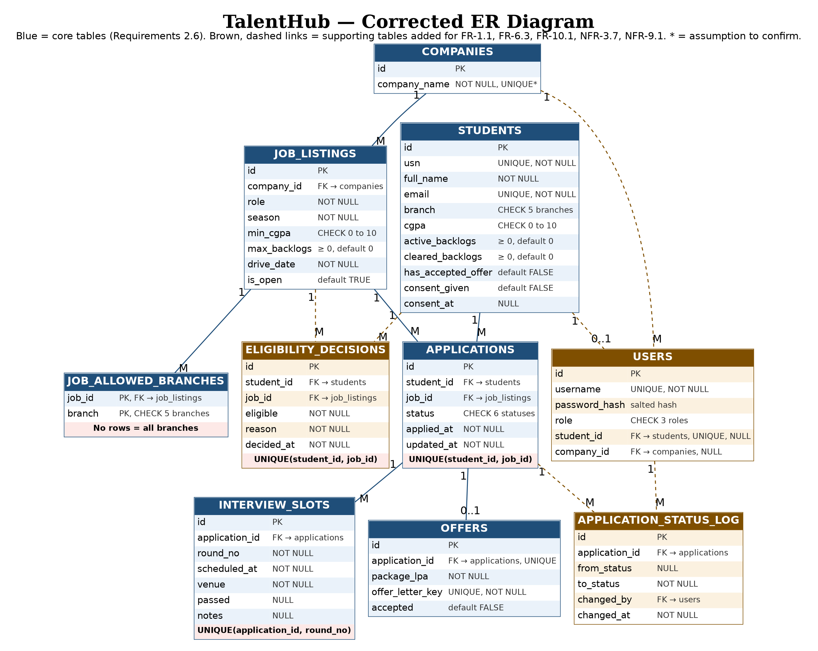

A3. Normalization using AI (up to 3NF)
Prompt: “Given these relations and known functional dependencies, check 1NF, 2NF and 3NF. Identify anomalies, justify decompositions and give final relations with PKs/FKs. Do not invent dependencies; list assumptions.”
Normalization item | AI assumption | Student action (A/M/R) | Reason / correction
Functional dependency / candidate key | student_id → usn, full_name, email, branch, cgpa, active_backlogs, cleared_backlogs, has_accepted_offer, consent_given, consent_at (usn and email are also candidate keys); company_id → company_name; job_id → company_id, role, season, min_cgpa, max_backlogs, drive_date, is_open; application_id → student_id, job_id, status, applied_at, updated_at (and (student_id, job_id) → application_id); interview_id → application_id, round_no, scheduled_at, venue, passed, notes (and (application_id, round_no) → interview_id); offer_id → application_id, package_lpa, offer_letter_key, accepted (and application_id → offer_id); user_id → username, password_hash, role, student_id, company_id (username is also a candidate key); log_id → application_id, from_status, to_status, changed_by, changed_at; decision_id → student_id, job_id, eligible, reason, decided_at (and (student_id, job_id) → decision_id). | ACCEPT | Each dependency follows from the schema, FR-7.2 (round unique within an application), FR-8.6 (one offer per application) and the one-application-per-job rule. No extra dependencies assumed.
Functional dependency / candidate key | Assumption: branch is a plain attribute of student with no dependency on other non-key columns. | ACCEPT | No evidence of a branch → anything dependency. Needed for the 3NF check.
Decomposition | 1NF: job_listings.allowed_branches holds a list. Split into job_allowed_branches(job_id, branch) with composite key. | ACCEPT | Removes the multi-valued cell. A job with no rows is open to all branches.
Decomposition | 2NF: the composite keys are (job_id, branch), which has no non-key columns, and the candidate keys (student_id, job_id) in applications and eligibility_decisions and (application_id, round_no) in interview_slots, whose columns depend on the whole key. No change. | ACCEPT | No partial dependency exists. A flat table mixing student and job facts would be split exactly as the schema is.
Decomposition | 3NF and BCNF: no non-key column determines another, and every determinant is a candidate key. No change. | ACCEPT | Each table holds facts about one entity only.
Final PK / FK / constraint | Ten relations (the seven core relations plus users, application_status_log and eligibility_decisions) with the keys listed in the final schema below. | ACCEPT | Result is in 3NF and also in BCNF. Each supporting relation holds facts about one entity only.
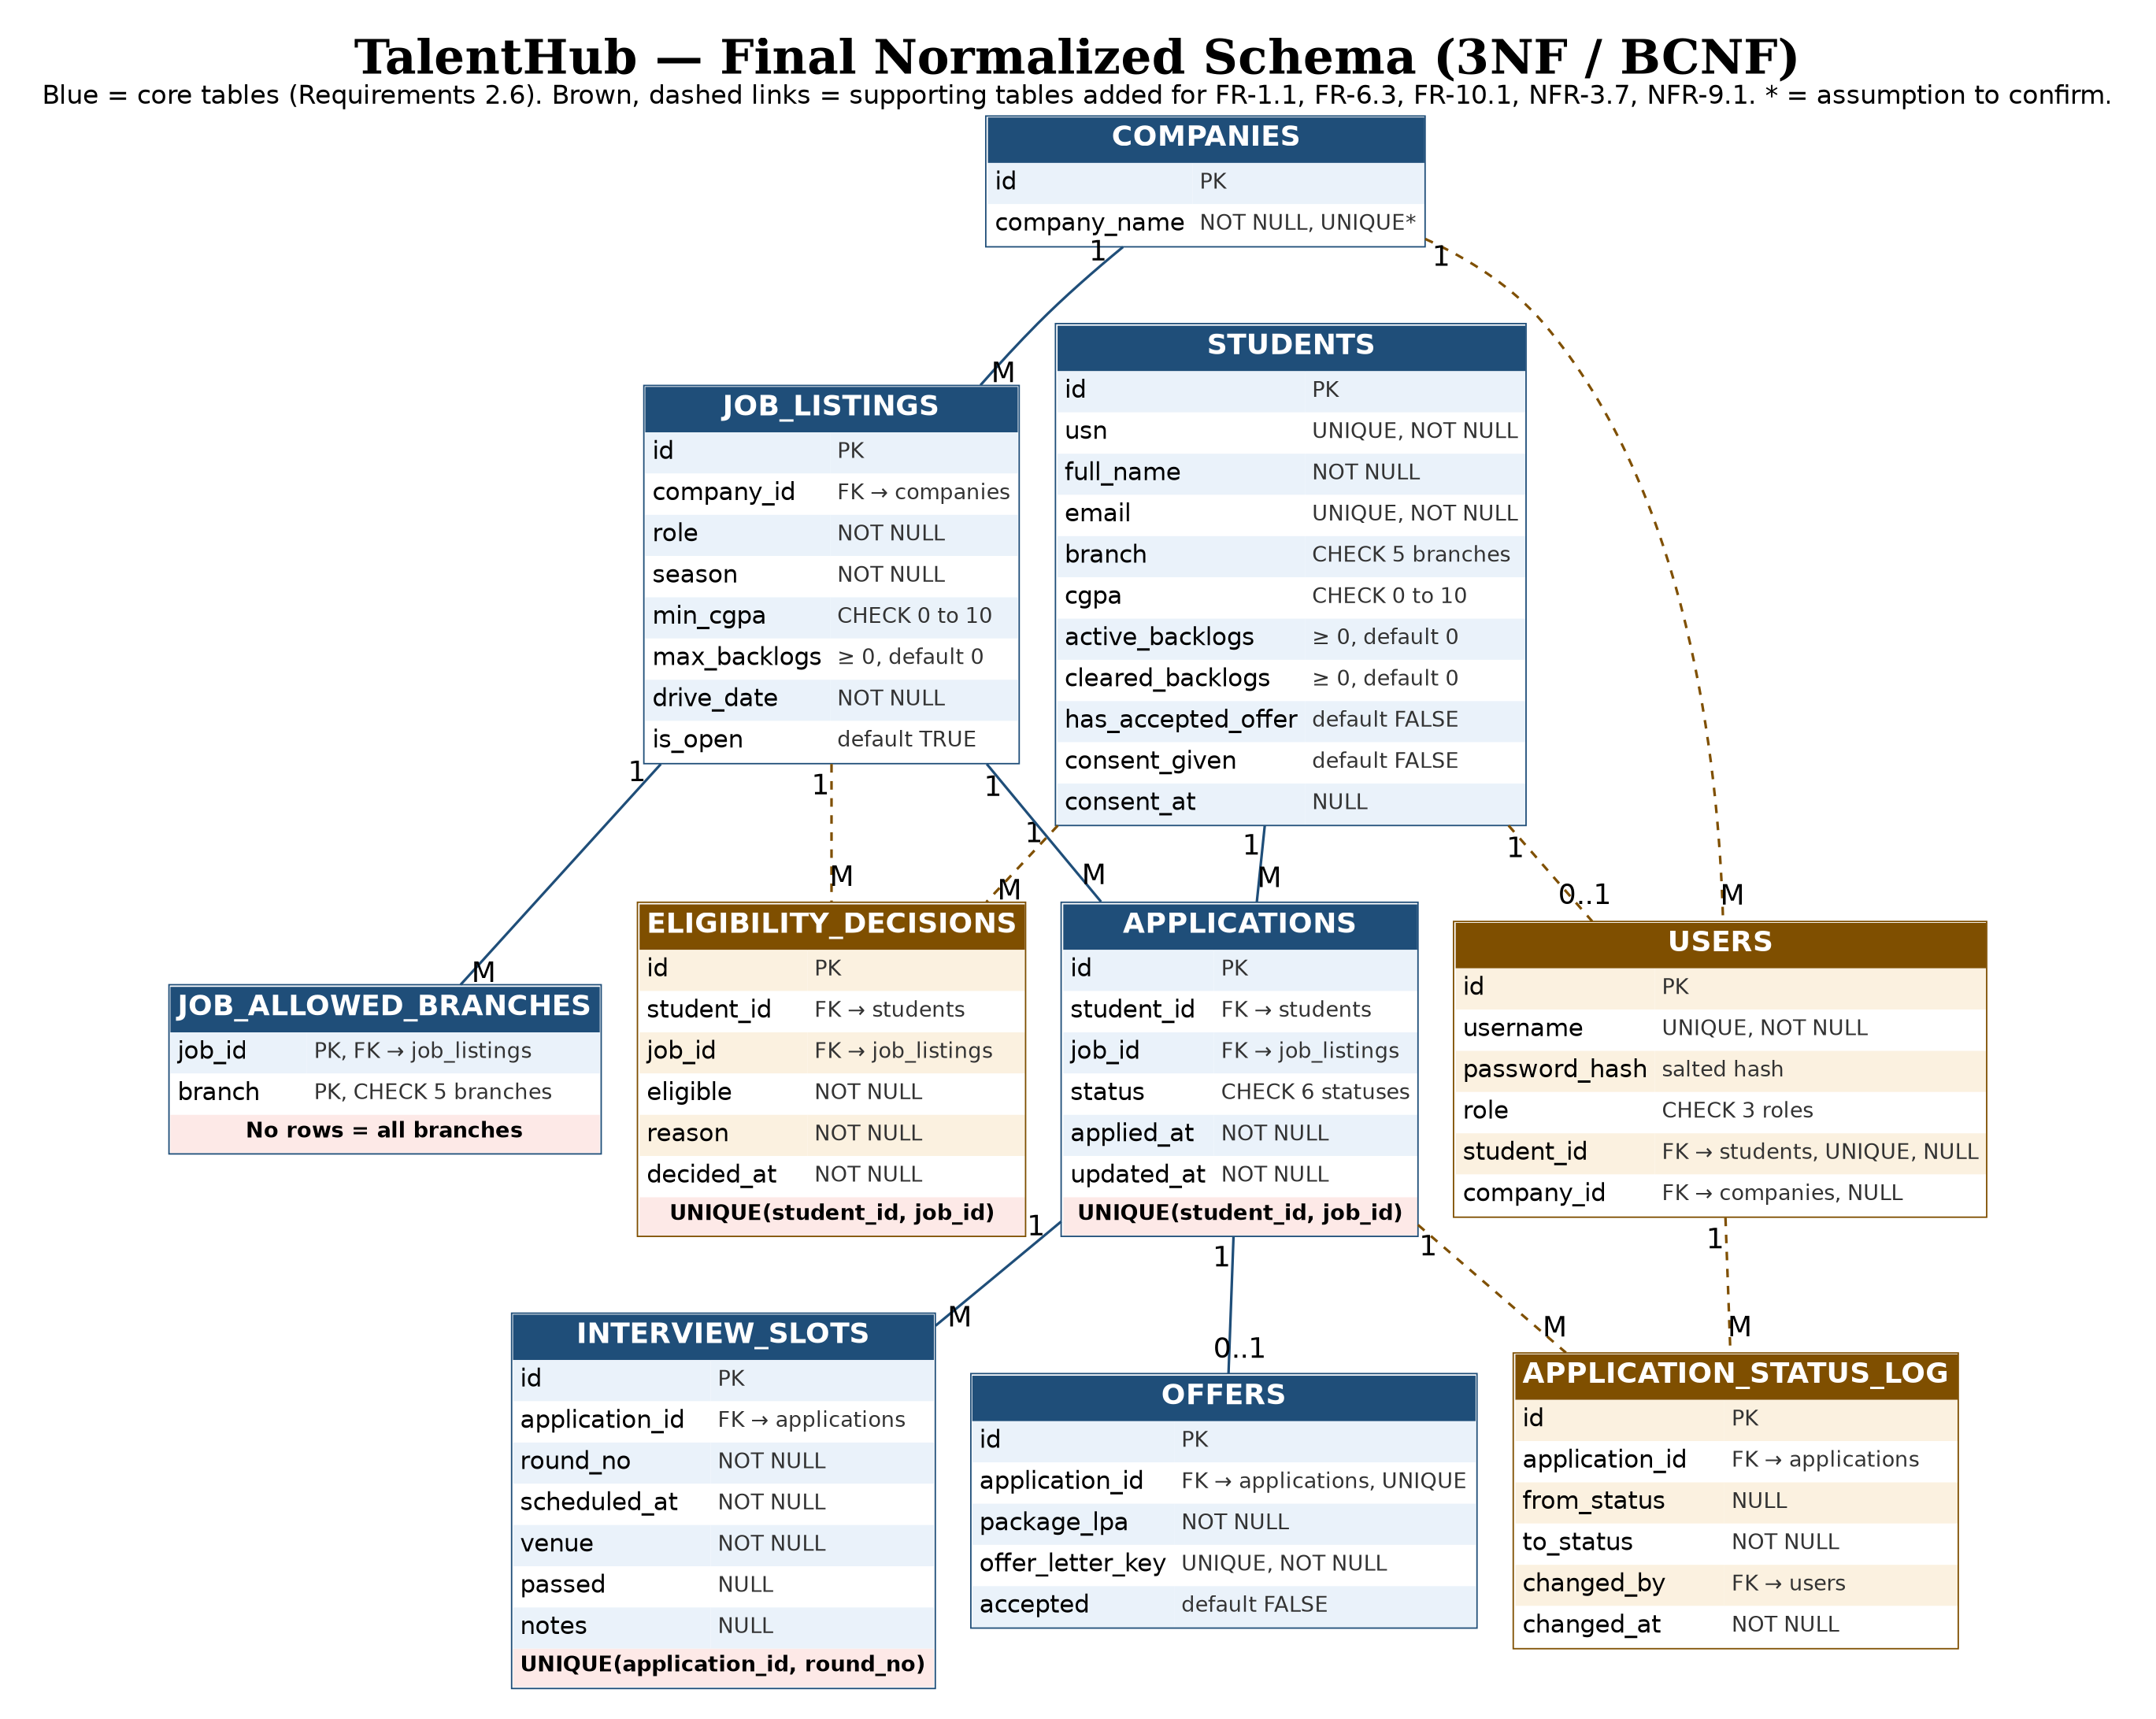
Artifact: Final normalized relational schema (up to 3NF), supported by known functional dependencies. If more than one store is selected, add a brief data map showing data, store and source of truth.
Final normalized relational schema (3NF, also BCNF)
Relation | Columns | PK | FK | Constraints
students | id, usn, full_name, email, branch, cgpa, active_backlogs, cleared_backlogs, has_accepted_offer, consent_given, consent_at | id | none | usn, email UNIQUE NOT NULL; branch IN (CSE, ECE, ISE, MECH, CIVIL); cgpa 0 to 10; active_backlogs and cleared_backlogs >= 0, default 0; has_accepted_offer default false, set only by accept_offer; consent_given default false
companies | id, company_name | id | none | company_name NOT NULL, UNIQUE (assumption to confirm)
job_listings | id, company_id, role, season, min_cgpa, max_backlogs, drive_date, is_open | id | company_id → companies.id | min_cgpa 0 to 10; max_backlogs >= 0, default 0; is_open default true
job_allowed_branches | job_id, branch | (job_id, branch) | job_id → job_listings.id | branch IN (CSE, ECE, ISE, MECH, CIVIL); no rows = all branches allowed
applications | id, student_id, job_id, status, applied_at, updated_at | id | student_id → students.id; job_id → job_listings.id | UNIQUE(student_id, job_id); status IN (APPLIED, SHORTLISTED, INTERVIEW_SCHEDULED, INTERVIEWED, OFFERED, ACCEPTED), default APPLIED; one application per company per season enforced in apply_for_job
interview_slots | id, application_id, round_no, scheduled_at, venue, passed, notes | id | application_id → applications.id | UNIQUE(application_id, round_no); passed and notes nullable
offers | id, application_id, package_lpa, offer_letter_key, accepted | id | application_id → applications.id | application_id UNIQUE (at most one offer per application); offer_letter_key UNIQUE NOT NULL; accepted default false
users | id, username, password_hash, role, student_id, company_id | id | student_id → students.id; company_id → companies.id | username UNIQUE NOT NULL; password_hash holds a salted hash only; role IN (student, company, coordinator); student_id UNIQUE
application_status_log | id, application_id, from_status, to_status, changed_by, changed_at | id | application_id → applications.id; changed_by → users.id | One row per status change; from_status null for the first status
eligibility_decisions | id, student_id, job_id, eligible, reason, decided_at | id | student_id → students.id; job_id → job_listings.id | UNIQUE(student_id, job_id); reason NOT NULL
Note: All foreign keys use ON DELETE RESTRICT. An erasure request after the season anonymises the student row in place (usn, name and email replaced with unique placeholders) so applications and offers stay valid (FR-10.2, NFR-4.4). Rows marked users, application_status_log and eligibility_decisions are additions beyond the seven tables in Requirements 2.6 and need coordinator confirmation.

Data map (two stores selected)
Data | Store | Source of truth
Students, companies, jobs, allowed branches, applications, interviews, offers, users, status log, eligibility decisions (records) | RDBMS | RDBMS
Offer letter file | File/object store | File/object store; RDBMS keeps only offer_letter_key

3. Part B – AI-Assisted Algorithm Design
Select ONE important function. Specify inputs, preconditions, outputs, important constraints and edge cases. Ask AI for two feasible approaches and their trade-offs; review its recommendation.
Critical function | Inputs / constraints | Alternatives and trade-offs | Student decision
checkEligibility(student, job) | Inputs: student (cgpa, active_backlogs, branch, has_accepted_offer) and job (min_cgpa, max_backlogs, allowed-branches list). The branch list is passed in with the job because a service does not import another service (NFR-2.3).  Preconditions: student and job exist; cgpa 0 to 10; active_backlogs >= 0.  Output: EligibilityResult with eligible (true/false) and one reason text. Ineligibility is returned, not raised (FR-4.1).  Constraints: rules run in fixed order R1 to R4 and the function returns at the first failing rule (FR-4.2). R1: cgpa >= min_cgpa (equal passes). R2: active_backlogs <= max_backlogs (0 for a no-backlog drive; cleared backlogs are never read). R3: has_accepted_offer must be false (season-wide). R4: allowed branches empty (all branches) or contains the student's branch. Implemented once and called by applying, shortlisting and listing (FR-4.5).  Not in this function: open-job check, existing-application check and same-company rule; apply_for_job handles them (FR-5.1 to FR-5.3).  Edge cases: cgpa 6.49, 6.50 and 6.51 against minimum 6.50; 0 active backlogs with any number cleared; 1 active backlog with maximum 0; empty allowed-branch list; student who has accepted an offer elsewhere. | - Sequential fail-fast checks in a fixed order: simple, reports the first failure.  - Evaluate all checks: reports every reason, slightly more logic.  - Generic rule engine: flexible but over-complex for four rules.  AI recommendation: B. | MODIFY: choose A, not the AI's B.  FR-4.2 fixes the rule order R1 to R4 and returns the first failing rule; FR-4.1 and FR-4.7 need one specific reason.  Returning every reason would need a requirements change; recorded as a possible enhancement.  Example: Rahul (CGPA 8.2, 1 active backlog) against min 7.0 and max 2 backlogs passes R1 and R2; R3 and R4 then decide.

Artifact: Language-independent pseudocode for the selected algorithm, including approved rules and important edge cases.
Pseudocode: checkEligibility(student, job)
FUNCTION checkEligibility(student, job)
IF student.cgpa < job.min_cgpa THEN
RETURN (false, "CGPA " + student.cgpa + " below minimum " + job.min_cgpa)
IF student.active_backlogs > job.max_backlogs THEN
RETURN (false, student.active_backlogs + " active backlogs, maximum " + job.max_backlogs)
IF student.has_accepted_offer == true THEN
RETURN (false, "Already accepted an offer this season")
IF job.allowed_branches is not empty AND student.branch NOT IN job.allowed_branches THEN
RETURN (false, "Branch " + student.branch + " not in drive scope")
RETURN (true, "All eligibility conditions are met")
END FUNCTION

4. Part C – AI-Assisted Security Design
AI prompt: “Using the approved requirements and Lab 3 architecture, propose two feasible controls for each of three important security needs. Compare advantages, limitations and assumptions. Recommend a control without inventing requirements.”
Identify three important security design decisions from the approved specification. Ask AI for two feasible alternatives per decision, compare trade-offs, and approve a justified control. Do not introduce unsupported requirements. Security testing is reserved for a later laboratory.
Security need | AI alternatives and trade-offs | Student decision / rationale
Authentication / authorization | A. Session-based authentication with server-side role checks: simple, server controls revocation, needs session storage.  B. Token-based authentication: stateless, suits separate clients, but token expiry and revocation add complexity.  Trade-off: simplicity and revocation versus statelessness. | Selected control: B, token-based authentication with JWT, as fixed by ADR-003 and handled in one module through dependency injection: get_current_student(), get_current_company(), get_current_coordinator() (FR-1.2).  Tokens are signed with a secret kept outside the source code and expire; missing, invalid or expired tokens are refused (NFR-3.1, NFR-3.7). Passwords are stored only as salted hashes (users.password_hash).  Roles (student, company representative, placement coordinator) are checked server-side in the service layer. Student identity comes from the token, never from a request parameter (FR-1.3); a company representative sees only its own company's listings, applicants and offers (FR-1.4); the coordinator sees all (FR-1.5). Every returned resource is checked for ownership (NFR-3.2).  Reason: three roles with different permissions; checks must not rely on the client. Limitation: revoking a token before expiry is harder; expiry limits the exposure.
Sensitive-data protection | A. Role-based field filtering of one response: fewer endpoints, but a filtering mistake can leak fields.  B. Role-specific API responses: stronger separation, but more endpoints to maintain.  Trade-off: simplicity versus stronger separation. | Selected control: A, role-based field filtering in the service layer.  Reason: one student never receives another student's CGPA, offers or contact details; a company sees only the applicant fields it needs for its own drives; the coordinator sees all (NFR-3.4, FR-9.1). Error messages reveal no internal details.  Also: offer letters are referenced by an unpredictable storage key, never a public URL (FR-8.3, NFR-3.5); queries use the ORM or parameters (NFR-3.6); input is validated for type and range (NFR-3.3).  Privacy: no processing of a student's data without recorded consent (FR-10.1, NFR-4.1); erasure on request anonymises the student row in place so foreign keys stay valid (FR-10.2, NFR-4.4).
Integrity / audit / abuse control | A. Log only sensitive changes (application status, interview results, offers): low volume.  B. Log all operations: complete history, but high volume and noise.  Trade-off: audit completeness versus volume. | Selected control: A (log sensitive changes), with who and when recorded for every status change (NFR-9.1).  Every status change goes through the transition functions of the application service (FR-5.6), which check the caller's role for that transition and write a row to application_status_log (application_id, from_status, to_status, changed_by, changed_at). Offers and acceptance are status changes, so they are covered. Eligibility decisions are stored with their reason in eligibility_decisions (NFR-9.3).  Reason: protects placement records and meets the traceability requirement without logging every operation.  Open item: NFR-4.5 needs access records good enough to identify affected students after a breach. Whether reads of student data must be logged is not decided here; confirm with the coordinator.

5. One Consolidated Detailed Design Record (DDR)
Design area | AI silent decision | Human decision | A/M/R | Reason / trade-off
Data | Option B: RDBMS + file/object store; seven-table schema in 3NF/BCNF | RDBMS for all records; object store only for offer letters referenced by offer_letter_key; no vector or search store; seven core tables plus users, application_status_log and eligibility_decisions; has_accepted_offer kept as a stored column updated in the same transaction as the status change | MODIFY | Avoids unsupported infrastructure. The additions are required by FR-1.1, FR-6.3, FR-10.1, NFR-3.7, NFR-8.4 and NFR-9.1; Requirements 2.6 lists only seven tables, so confirm.
Algorithm | checkEligibility with approach B (evaluate all rules) | Sequential fail-fast checks in order R1 to R4 returning one reason; inclusive CGPA and backlog boundaries; accepted-offer rule included as R3 | MODIFY | FR-4.2 requires fail-fast evaluation in a fixed order. The AI's evaluate-all approach would need a requirements change.
Security | Role checks, controlled field exposure, selective audit | JWT authentication (ADR-003), server-side role authorization, role-based field filtering, role-checked status transitions logged with who and when | MODIFY | Protects placement records. The audit must record who and when (NFR-9.1), so selective logging is kept but mandatory for every status change; read-access logging (NFR-4.5) is an open item.

DDR validation
Check | PASS / FAIL | Evidence / correction
Consistent with approved requirements | PASS | Entities, rules and constraints trace to Requirements v2 (FR-2 to FR-10, NFR-8, NFR-9). The algorithm follows FR-4.1 to FR-4.5. Additions beyond the seven-table list are marked for confirmation.
Consistent with Lab 3 architecture and ADRs | PASS | Router, service, repository and model layers kept (ADR-001); eligibility and authorization sit in the service layer; JWT authentication per ADR-003; checkEligibility receives all its data as parameters (NFR-2.3).
Unsupported AI assumptions removed or clarified | PASS | Vector store rejected. Marked for confirmation: company_name UNIQUE, offer_letter_key UNIQUE, consent stored as columns on students, the three supporting tables, and read-access logging (NFR-4.5).
Sufficiently detailed for code generation | PASS | Keys, constraints, status values, pseudocode with edge cases, role checks and the audit record are specified.

6. Submission Checklist
☐ One consolidated DDR with three human decisions and four validation checks
☐ Corrected ER model and normalized relational schema (up to 3NF)
☐ Storage alternative comparison and polyglot map only when applicable
☐ Algorithm alternatives and pseudocode for one critical function
☐ Three security decisions with alternatives, trade-offs and justified selections
☐ Key AI prompts/outputs and silent-decision evidence (not full chat history)
Boundary: Do not redesign Lab 3 architecture, invent requirements or generate code in this laboratory.

