Laboratory 4 – AI-Assisted Detailed Design
Data Design • Algorithm Design • Security Design | Simplified Integrated Laboratory Manual
Aim: Develop and validate implementation-ready detailed designs from approved requirements and the Lab 3 architecture. AI proposes alternatives; students identify silent decisions and approve the final design.

1. Inputs, Method and Submission
Input | Output
Approved requirements, Prompt Records, Lab 3 architecture, ADRs and ARR | One consolidated Detailed Design Record (DDR) plus final design artifacts

Common method: Design Need → AI Alternatives → AI Silent Decision → Student Review (ACCEPT / MODIFY / REJECT) → Final Design. Request alternatives only for significant decisions. Do not generate implementation code.

2. Part A – AI-Assisted Data Design

A1. Data needs and storage alternatives
Identify structured transactional data, documents/files and any genuinely specialized search or other workload. RDBMS-only is valid; polyglot persistence requires a justified need.
Option | Design | When suitable
A | RDBMS only | Structured relationships, integrity and transactions
B | RDBMS + file/object store | Relational records plus substantial documents/files
C | RDBMS + specialized store | Approved search/vector/graph or other specialized workload

Data needs: Structured transactional data (students, companies, job listings, allowed branches, applications, interview slots, offers) needs relationships, integrity and transactions. Offer letters are documents; the schema stores only a reference (offers.offer_letter_key, unique).
Decision: AI silent decision: Option B (RDBMS + file/object store). Student decision: ACCEPT B, with the object store used only for offer letters, which the schema already references by key. Option C is rejected because no semantic-search requirement is approved. If the offer-letter file reference is not an approved requirement, fall back to Option A.

A2. ER modelling using AI
Prompt: “Using the approved requirements below, propose entities, attributes, keys, relationships and cardinalities. Resolve M:N relationships and state PK/FK/UNIQUE constraints. Do not invent business rules; list assumptions.”
ER design item | AI decision / assumption | Student action (A/M/R) | Reason / correction
Entity / attribute | Seven entities: students, companies, job_listings, job_allowed_branches, applications, interview_slots, offers. Each has a surrogate integer id as primary key. | ACCEPT | Matches the TalentHub schema. Surrogate keys keep foreign keys simple.
Entity / attribute | Keep students.has_accepted_offer as a stored column in addition to offers.accepted. | MODIFY | Overlapping data. Derive it from offers, or keep the two in sync in the service layer.
Entity / attribute | Store allowed branches as a list inside job_listings. | REJECT | Multi-valued cell breaks 1NF. Moved to job_allowed_branches, one row per branch.
Relationship / cardinality | COMPANY 1:N JOB_LISTING; JOB_LISTING 1:N JOB_ALLOWED_BRANCH; STUDENT 1:N APPLICATION; JOB_LISTING 1:N APPLICATION; APPLICATION 1:N INTERVIEW_SLOT; APPLICATION 1:N OFFER. | ACCEPT | Follows the scenario flow: apply, interview, offer.
Relationship / cardinality | STUDENT M:N JOB_LISTING resolved through APPLICATION. | ACCEPT | Each application is its own record with status and timestamps.
Key / constraint | UNIQUE(student_id, job_id) on applications. | ACCEPT | One application per student per job, as stated in the TalentHub schema.
Key / constraint | UNIQUE usn, email, company_name, offer_letter_key; CHECK cgpa BETWEEN 0 AND 10; CHECK active_backlogs >= 0 and max_backlogs >= 0. | ACCEPT | These constraints are defined in the TalentHub schema. Assumption: confirm against the approved requirements.

Artifact: Corrected ER model showing entities, key attributes, relationships and cardinalities.
Corrected ER model (text form)
COMPANY (1) ──< (N) JOB_LISTING (1) ──< (N) JOB_ALLOWED_BRANCH
JOB_LISTING (1) ──< (N) APPLICATION (N) >── (1) STUDENT
APPLICATION (1) ──< (N) INTERVIEW_SLOT
APPLICATION (1) ──< (N) OFFER.
Corrected ER model: entities and attributes
Entity | Attributes (PK, FK, constraints)
STUDENT | student_id (PK), usn (UNIQUE), full_name, email (UNIQUE), branch, cgpa (0 to 10), active_backlogs (>= 0, default 0), has_accepted_offer (default FALSE)
COMPANY | company_id (PK), company_name (UNIQUE)
JOB_LISTING | job_id (PK), company_id (FK), role, season, min_cgpa, max_backlogs (>= 0, default 0), drive_date, is_open (default TRUE); allowed_branch is moved to JOB_ALLOWED_BRANCH during 1NF
JOB_ALLOWED_BRANCH | job_id (PK, FK), branch (PK)
APPLICATION | application_id (PK), student_id (FK), job_id (FK), status (default APPLIED), applied_at, updated_at; UNIQUE (student_id, job_id)
INTERVIEW_SLOT | interview_id (PK), application_id (FK), round_no, scheduled_at, venue, passed (nullable), notes (nullable)
OFFER | offer_id (PK), application_id (FK), package_lpa, offer_letter_key (UNIQUE), accepted (default FALSE)

Relationships:
COMPANY 1:N JOB_LISTING;
JOB_LISTING 1:N JOB_ALLOWED_BRANCH;
STUDENT 1:N APPLICATION and
JOB_LISTING 1:N APPLICATION ;
APPLICATION 1:N INTERVIEW_SLOT;
APPLICATION 1:0..1 OFFER.
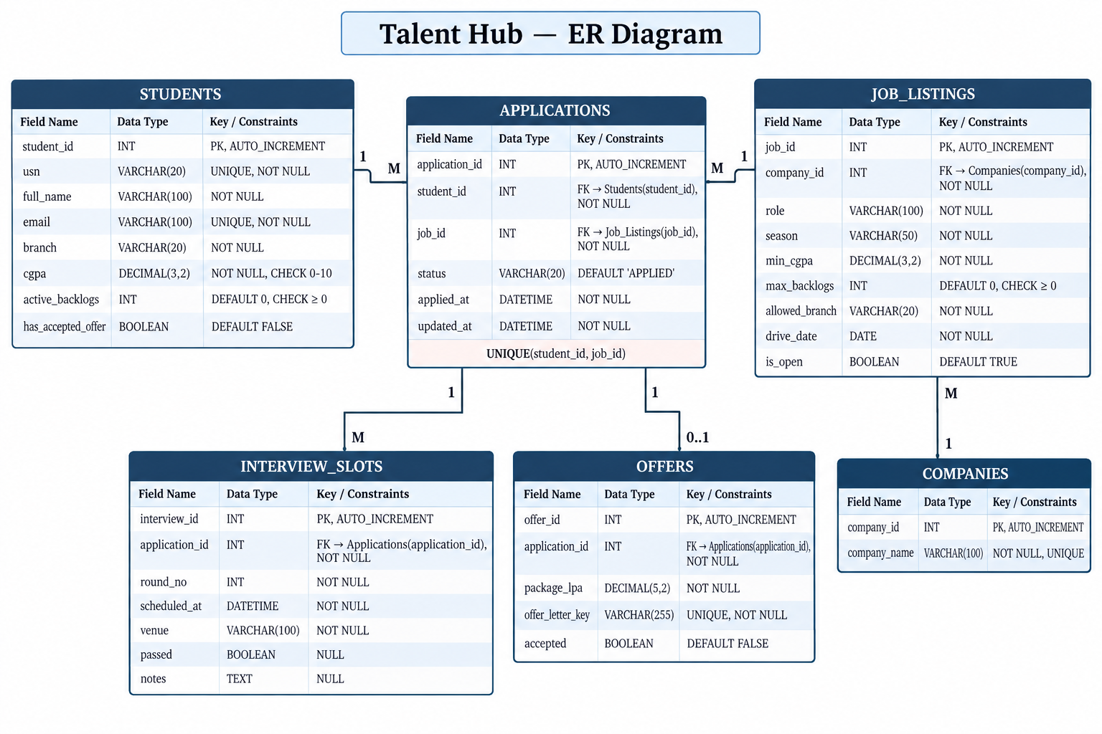

A3. Normalization using AI (up to 3NF)
Prompt: “Given these relations and known functional dependencies, check 1NF, 2NF and 3NF. Identify anomalies, justify decompositions and give final relations with PKs/FKs. Do not invent dependencies; list assumptions.”
Normalization item | AI assumption | Student action (A/M/R) | Reason / correction
Functional dependency / candidate key | student id → usn, full_name, email, branch, cgpa, active_backlogs, has_accepted_offer (usn and email are also candidate keys); company_id → company_name; job_id → company_id, role, season, min_cgpa, max_backlogs, drive_date, is_open; application_id → student_id, job_id, status, applied_at, updated_at (and (student_id, job_id) → application_id); interview_id → application_id, round_no, scheduled_at, venue, passed, notes; offer_id → application_id, package_lpa, offer_letter_key, accepted. | ACCEPT | Each dependency follows from the schema and the one-application-per-job rule. No extra dependencies assumed.
Functional dependency / candidate key | Assumption: branch is a plain attribute of student with no dependency on other non-key columns. | ACCEPT | No evidence of a branch → anything dependency. Needed for the 3NF check.
Decomposition | 1NF: job_listings.allowed_branches holds a list. Split into job_allowed_branches(job_id, branch) with composite key. | ACCEPT | Removes the multi-valued cell. A job with no rows is open to all branches.
Decomposition | 2NF: only composite keys are (job_id, branch), which has no non-key columns, and the candidate key (student_id, job_id) in applications, whose columns depend on the whole pair. No change. | ACCEPT | No partial dependency exists. A flat table mixing student and job facts would be split exactly as the schema is.
Decomposition | 3NF and BCNF: no non-key column determines another, and every determinant is a candidate key. No change. | ACCEPT | Each table holds facts about one entity only.
Final PK / FK / constraint | Seven relations with the keys listed in the final schema below. | ACCEPT | Result is in 3NF and also in BCNF.
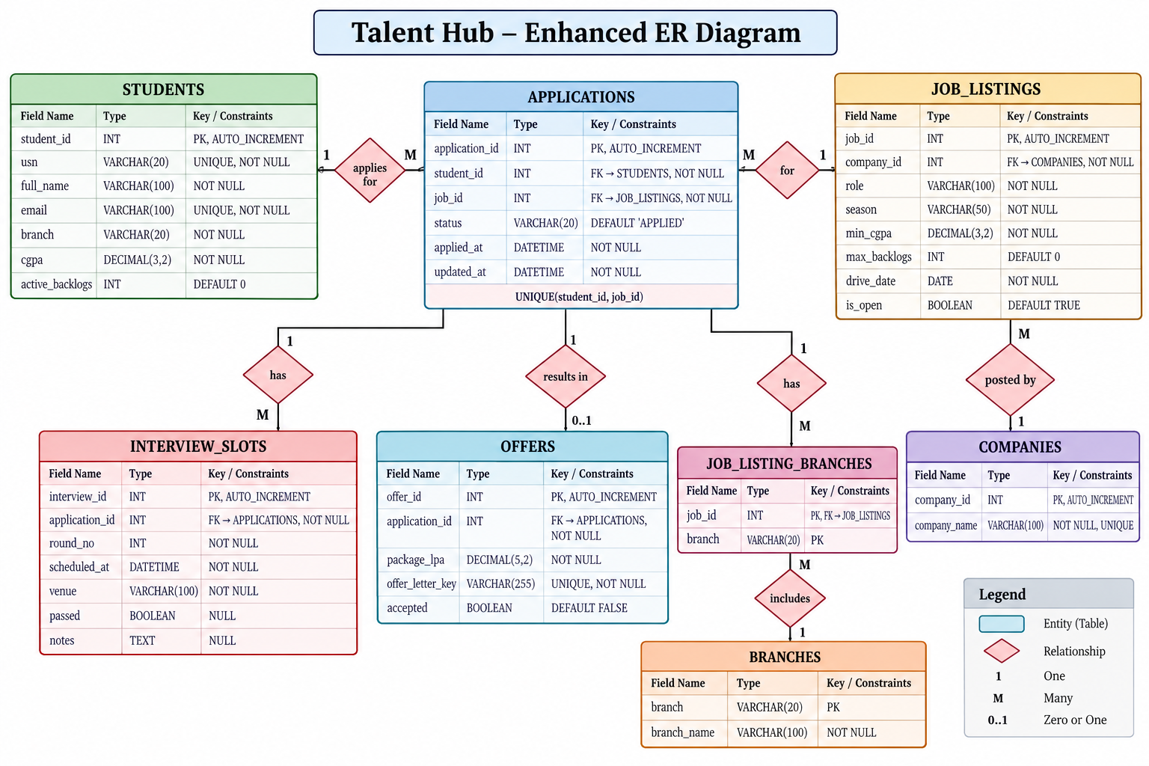
Artifact: Final normalized relational schema (up to 3NF), supported by known functional dependencies. If more than one store is selected, add a brief data map showing data, store and source of truth.
Final normalized relational schema (3NF, also BCNF)
Relation | Columns | PK | FK | Constraints
students | id, usn, full_name, email, branch, cgpa, active_backlogs, has_accepted_offer | id | none | usn, email UNIQUE NOT NULL; cgpa 0 to 10; active_backlogs >= 0, default 0
companies | id, company_name | id | none | company_name UNIQUE NOT NULL
job_listings | id, company_id, role, season, min_cgpa, max_backlogs, drive_date, is_open | id | company_id → companies.id | max_backlogs >= 0, default 0; is_open default true
job_allowed_branches | job_id, branch | (job_id, branch) | job_id → job_listings.id | No rows = all branches allowed
applications | id, student_id, job_id, status, applied_at, updated_at | id | student_id → students.id; job_id → job_listings.id | UNIQUE(student_id, job_id); status default APPLIED
interview_slots | id, application_id, round_no, scheduled_at, venue, passed, notes | id | application_id → applications.id | passed and notes nullable
offers | id, application_id, package_lpa, offer_letter_key, accepted | id | application_id → applications.id | offer_letter_key UNIQUE NOT NULL; accepted default false

Data map (two stores selected)
Data | Store | Source of truth
Students, companies, jobs, allowed branches, applications, interviews, offers (records) | RDBMS | RDBMS
Offer letter file | File/object store | File/object store; RDBMS keeps only offer_letter_key

3. Part B – AI-Assisted Algorithm Design
Select ONE important function. Specify inputs, preconditions, outputs, important constraints and edge cases. Ask AI for two feasible approaches and their trade-offs; review its recommendation.
Critical function | Inputs / constraints | Alternatives and trade-offs | Student decision
checkEligibility(student, job) | Inputs:  student (cgpa, active_backlogs, branch, has_accepted_offer), job (min_cgpa, max_backlogs, is_open, allowed branches).  Preconditions:  student and job exist;  cgpa 0 to 10;  backlogs >= 0.  Output: eligible (true/false) and a list of failure reasons.  Constraints:  CGPA boundary is inclusive (cgpa >= min_cgpa);  backlog boundary is inclusive (active_backlogs <= max_backlogs);  no allowed-branch rows means all branches; job must be open.  Edge cases:  cgpa equals min_cgpa;  backlogs equal max_backlogs;  no branch rows;  closed job;.  already-applied job (handled by UNIQUE rule). | - Sequential fail-fast checks: simple, reports only the first failure.  - Evaluate all applicable checks: reports every reason, slightly more logic.  - Generic rule engine: flexible but over-complex for four rules.  AI recommendation: B. | ACCEPT B.  A student should see all reasons they are ineligible.  Example: Rahul (CGPA 8.2, 1 backlog) against min 7.0 and max 2 backlogs passes both.  The has_accepted_offer (placement policy) check is included only if the approved requirements state it.

Artifact: Language-independent pseudocode for the selected algorithm, including approved rules and important edge cases.
Pseudocode: checkEligibility(student, job)
FUNCTION checkEligibility(student, job)
reasons = empty list
IF job.is_open == false THEN add "Job is closed" to reasons
IF student.cgpa < job.min_cgpa THEN add "CGPA below minimum" to reasons
IF student.active_backlogs > job.max_backlogs THEN add "Too many active backlogs" to reasons
branches = allowed branches of job
IF branches is not empty AND student.branch NOT IN branches THEN add "Branch not allowed" to reasons
IF placement policy approved AND student.has_accepted_offer == true THEN add "Already placed" to reasons
RETURN (reasons is empty, reasons)
END FUNCTION

4. Part C – AI-Assisted Security Design
AI prompt: “Using the approved requirements and Lab 3 architecture, propose two feasible controls for each of three important security needs. Compare advantages, limitations and assumptions. Recommend a control without inventing requirements.”
Identify three important security design decisions from the approved specification. Ask AI for two feasible alternatives per decision, compare trade-offs, and approve a justified control. Do not introduce unsupported requirements. Security testing is reserved for a later laboratory.
Security need | AI alternatives and trade-offs | Student decision / rationale
Authentication / authorization | A. Session-based authentication with server-side role checks: simple, server controls revocation, needs session storage.  B. Token-based authentication: stateless, suits separate clients, but token expiry and revocation add complexity.  Trade-off: simplicity and revocation versus statelessness. | Selected control: the mechanism already chosen in the Lab 3 architecture, with server-side role checks for Student, Company and Placement coordinator in the service layer.  Reason: three roles with different permissions; checks must not rely on the client. Authorization is not redesigned here.
Sensitive-data protection | A. Role-based field filtering of one response: fewer endpoints, but a filtering mistake can leak fields.  B. Role-specific API responses: stronger separation, but more endpoints to maintain.  Trade-off: simplicity versus stronger separation. | Selected control: role-based field filtering in the service layer.  Reason: students' usn, email, cgpa and backlogs are exposed only to authorized roles; companies see only the fields they need for shortlisting.
Integrity / audit / abuse control | A. Log only sensitive changes (application status, interview results, offers): low volume.  B. Log all operations: complete history, but high volume and noise.  Trade-off: audit completeness versus volume. | Selected control: authorize every status change by role, and log sensitive changes (status, offers, acceptance) using updated_at and an audit record.  Reason: protects placement records without adding an unapproved full audit requirement. Dedicated audit history only if required.

5. One Consolidated Detailed Design Record (DDR)
Design area | AI silent decision | Human decision | A/M/R | Reason / trade-off
Data | Option B: RDBMS + file/object store; seven-table schema in 3NF/BCNF | RDBMS for all records; object store only for offer letters referenced by offer_letter_key; no vector or search store | MODIFY | Avoids unsupported infrastructure. has_accepted_offer to be derived from offers or kept consistent.
Algorithm | checkEligibility with approach B (evaluate all rules) | Evaluate all rules and return every failure reason; inclusive CGPA and backlog boundaries | ACCEPT | Students need all reasons. Placement-policy rule included only if approved.
Security | Role checks, controlled field exposure, selective audit | Server-side role authorization, role-based field filtering, authorized status changes with logging of sensitive changes | ACCEPT | Protects placement records with minimal added complexity.

DDR validation
Check | PASS / FAIL | Evidence / correction
Consistent with approved requirements | PASS | Entities and rules come from the TalentHub scenario and schema; unapproved rules are marked as assumptions.
Consistent with Lab 3 architecture and ADRs | PASS | Router, service, repository and database layers kept; eligibility and authorization sit in the service layer. Confirm authentication mechanism against the ADRs.
Unsupported AI assumptions removed or clarified | PASS | Vector store rejected; company_name uniqueness, offer-letter reference and placement-policy rule flagged for confirmation.
Sufficiently detailed for code generation | PASS | Keys, constraints, pseudocode with edge cases and security controls are specified.

6. Worked Case Study – TalentHub
Illustrative assumptions: TalentHub stores students, companies, jobs, eligibility criteria and applications. Any resume storage or additional business rule must be supported by approved requirements.

A. Data design: alternatives and decision
Alternative | Design | Trade-off
A | RDBMS for core records; file reference if needed | Simple, one transactional store
B | RDBMS + object/file storage for resumes | Separates files; adds storage mechanism
C | B + vector store only if semantic resume matching approved | Supports semantic retrieval; adds complexity

Example AI silent decision: choose B. Student decision: MODIFY/ACCEPT only if resume storage is an approved requirement; otherwise choose A. No vector store without a documented requirement.

B. ER model and relational schema
Entity | Illustrative attributes
STUDENT | StudentID (PK), Name, Branch, CGPA, ActiveBacklogs
COMPANY | CompanyID (PK), CompanyName
JOB | JobID (PK), CompanyID (FK), Role, MinCGPA, MaxActiveBacklogs
APPLICATION | ApplicationID (PK), StudentID (FK), JobID (FK), ApplicationDate, Status

Relationships: COMPANY 1:N JOB; STUDENT M:N JOB resolved through APPLICATION; STUDENT 1:N APPLICATION and JOB 1:N APPLICATION.
AI silent decision | Student action | Reason
Create APPLICATION to resolve STUDENT–JOB M:N | ACCEPT | Represents each application as its own record
Copy StudentName and CGPA into APPLICATION | REJECT | Attributes depend on StudentID and belong to STUDENT
Add UNIQUE(StudentID, JobID) | MODIFY | Only if one application per student per job is approved

C. Normalization example (up to 3NF)
Illustrative unnormalized combined relation: APPLICATION_ALL(ApplicationID, StudentID, StudentName, Branch, CGPA, JobID, Role, CompanyID, CompanyName, ApplicationDate, Status).
Known FDs: StudentID → StudentName, Branch, CGPA; CompanyID → CompanyName; JobID → CompanyID, Role; ApplicationID → StudentID, JobID, ApplicationDate, Status.
Final decomposition: STUDENT(StudentID PK, Name, Branch, CGPA, ActiveBacklogs); COMPANY(CompanyID PK, CompanyName); JOB(JobID PK, CompanyID FK, Role, MinCGPA, MaxActiveBacklogs); APPLICATION(ApplicationID PK, StudentID FK, JobID FK, ApplicationDate, Status).
AI silent decision | Student action | Reason
StudentID determines student academic attributes | ACCEPT | Supported by the student data model
Separate STUDENT, COMPANY and JOB from APPLICATION_ALL | ACCEPT | Removes repeated descriptive data and update anomalies
CompanyName must be unique | REJECT | Not an approved constraint; CompanyID is the key

D. Algorithm design: checkEligibility(student, job)
Alternative | Approach | Trade-off
A | Sequential fail-fast checks | Simple; reports first failure
B | Evaluate all applicable checks | Can report all reasons; more logic
C | Generic rule engine | Flexible but more complex

Illustrative AI choice: B. Human decision: ACCEPT only if all failure reasons are required; otherwise MODIFY to A. Pseudocode must follow approved CGPA boundary, active-backlog, branch and placement-policy rules.

E. Security design
Security need | AI alternatives, trade-offs and student decision
Authentication / authorization | A. Session-based authentication; B. Token-based authentication (token lifecycle complexity)  Decision: Choose mechanism consistent with Lab 3; enforce server-side role checks.
Sensitive data | A. Role-based field filtering; B. Role-specific API responses (more endpoints)  Decision: Expose only approved student fields to authorized roles.
Integrity / audit | A. Log sensitive changes; B. Log all operations (higher volume and noise)  Decision: Authorize status changes; audit history only if required.

F. Example consolidated DDR
Area | AI recommendation | Human decision | Action | Rationale
Data | RDBMS + file store | Use only if resumes approved | MODIFY | Avoid unsupported infrastructure
Algorithm | Evaluate all rules | Select based on required output | MODIFY | Respect approved result format
Security | Role checks and controlled exposure | Adopt server-side authorization | ACCEPT | Protect placement records

7. Submission Checklist
☐ One consolidated DDR with three human decisions and four validation checks
☐ Corrected ER model and normalized relational schema (up to 3NF)
☐ Storage alternative comparison and polyglot map only when applicable
☐ Algorithm alternatives and pseudocode for one critical function
☐ Three security decisions with alternatives, trade-offs and justified selections
☐ Key AI prompts/outputs and silent-decision evidence (not full chat history)
Boundary: Do not redesign Lab 3 architecture, invent requirements or generate code in this laboratory.

