Executive Summary
Product Optimization & Revenue Contribution Analysis — Afficionado Coffee Roasters
Prepared for government and municipal stakeholder review · 2025 sales data

Purpose
Afficionado Coffee Roasters operates three retail locations across New York City. This summary presents the findings of a data-driven review of 2025 product sales, undertaken to strengthen operational efficiency, inform local economic activity reporting, and demonstrate responsible, evidence-based small-business management practices.

What We Analyzed
We reviewed 149,116 point-of-sale transactions covering 80 distinct products across 9 categories (coffee, tea, bakery, chocolate, and related merchandise) sold at three store locations — Lower Manhattan, Hell's Kitchen, and Astoria — generating $698,812 in total revenue over the year.

Headline Findings
Metric | Value
Total 2025 revenue | $698,812.33
Total units sold | 214,470
Products (SKUs) offered | 80
Store locations | 3 (Astoria, Hell's Kitchen, Lower Manhattan)
Revenue share — Coffee & Tea combined | 66.7%
Revenue share — top 10 products | ~25%
Menu share needed to reach 80% of revenue | 54% of products (43 of 80)

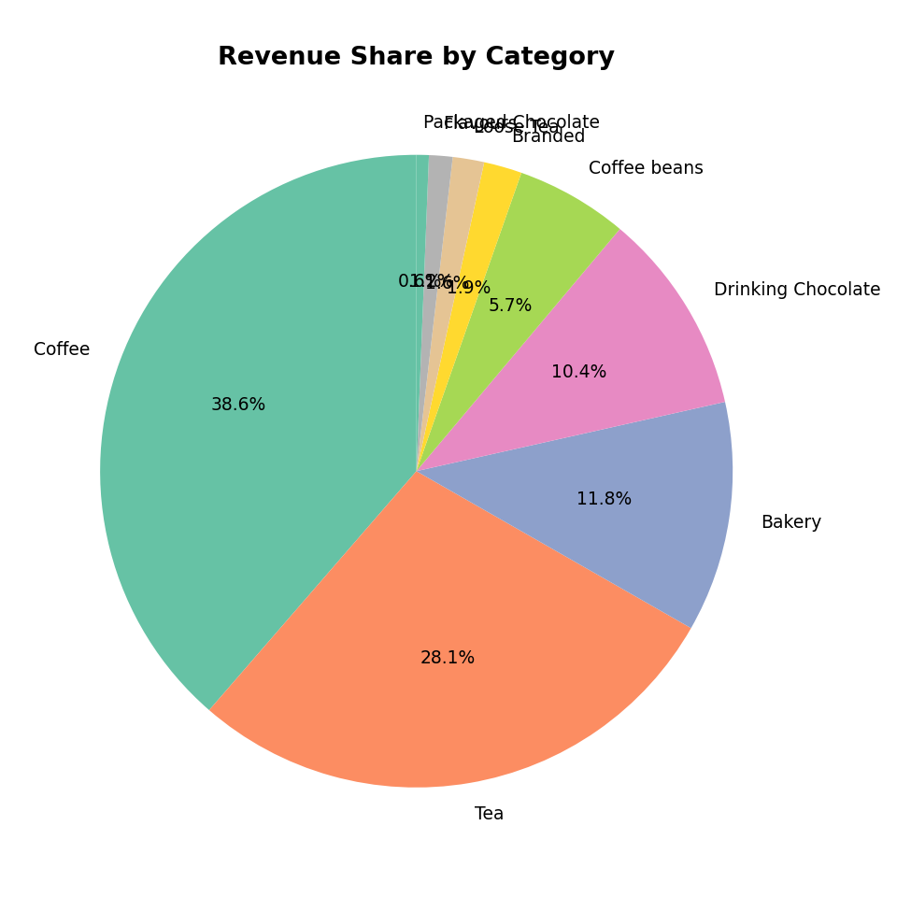
Revenue is broadly distributed across categories, led by Coffee (38.6%) and Tea (28.1%).
Store performance is well balanced: each of the three locations contributes between 32.9% and 33.8% of total revenue, indicating consistent demand across neighborhoods rather than dependence on a single site.

Key Insights
- Revenue is moderately concentrated but not overly dependent on a small number of products — a sign of a resilient, diversified menu.
- Coffee and Tea are the core of the business, together accounting for two-thirds of revenue, while smaller categories (loose tea, flavour syrups, packaged chocolate) play a supporting role.
- A small set of 14 low-performing products contributes less than 3% of revenue combined and represents an opportunity for menu simplification.
- Premium, specialty items (e.g., select whole-bean coffees) generate disproportionately high revenue per unit sold, indicating opportunity in higher-margin specialty retail.

Recommendations
- Continue promoting core, high-performing coffee and tea offerings that anchor revenue and customer footfall.
- Simplify the menu by reviewing or consolidating the lowest-performing 14–16 products to reduce operational complexity.
- Expand premium/specialty product lines, which show strong revenue efficiency relative to sales volume.
- Maintain balanced investment across all three store locations, given their comparable performance.

Broader Relevance
This analysis illustrates how small and mid-sized food and beverage businesses can use routine transaction data to make evidence-based decisions — improving efficiency, sustaining employment across neighborhood locations, and contributing to the local economy. A live analytics dashboard accompanies this summary to support ongoing, transparent monitoring of business performance.

