N. Manasa
192472031
CSA6502

Q2. Few-Shot Classification
Write a few-shot prompt (using 3 examples) that classifies customer reviews as Positive, Negative, or Neutral. Show your 3 examples and the final prompt.
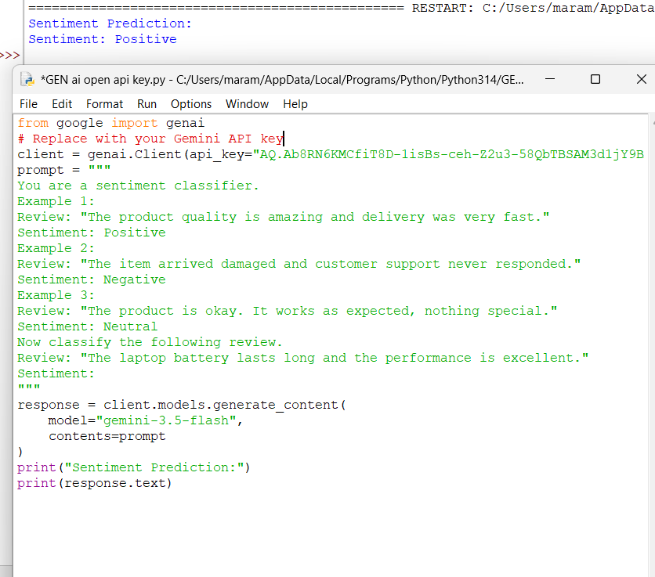

Q3. Chain-of-Thought Math Solver
Write a CoT prompt that gets an LLM to solve a multi-step word problem (e.g., a discount + tax
calculation) by reasoning step-by-step before giving the final answer.

