Exercise 1: Implementing Centralized Authentication with OAuth 2.1/OIDC

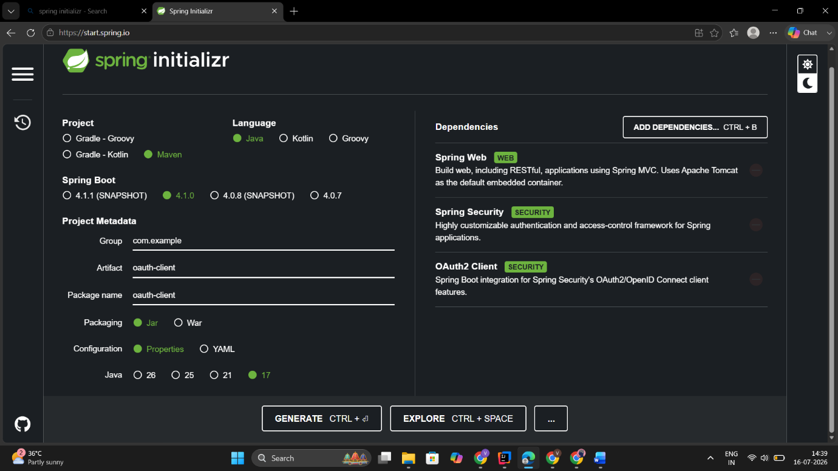

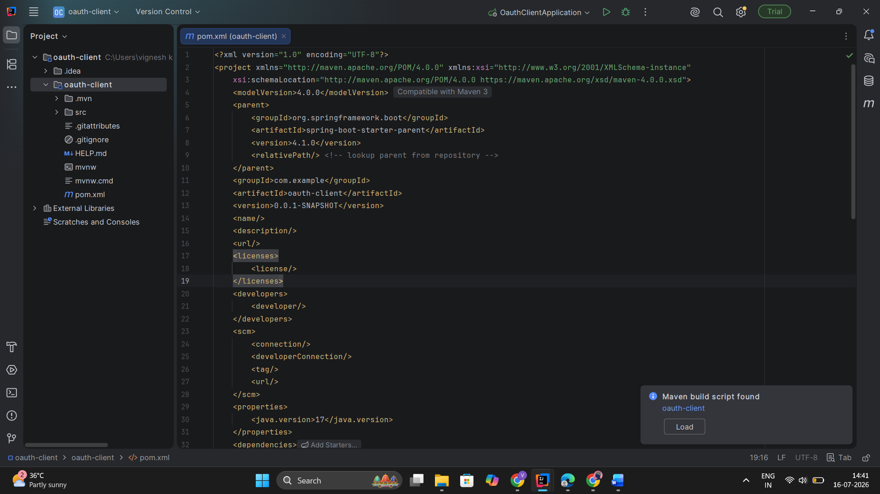

<dependency>
<groupId>org.springframework.boot</groupId>
<artifactId>spring-boot-starter-security</artifactId>
</dependency>

<dependency>
<groupId>org.springframework.boot</groupId>
<artifactId>spring-boot-starter-oauth2-client</artifactId>
</dependency>

spring:
security:
oauth2:
client:
registration:
google:
client-id: YOUR_CLIENT_ID
client-secret: YOUR_CLIENT_SECRET
scope:
- openid
- profile
- email

package com.example.oauthclient.config;

import org.springframework.context.annotation.Bean;
import org.springframework.context.annotation.Configuration;
import org.springframework.security.config.annotation.web.builders.HttpSecurity;
import org.springframework.security.web.SecurityFilterChain;

@Configuration
public class SecurityConfig {

@Bean
SecurityFilterChain securityFilterChain(HttpSecurity http) throws Exception {

http
.authorizeHttpRequests(auth ->
auth.anyRequest().authenticated()
)
.oauth2Login();

return http.build();
}
}

package com.example.oauthclient.controller;

import org.springframework.web.bind.annotation.GetMapping;
import org.springframework.web.bind.annotation.RestController;

import java.security.Principal;

@RestController
public class UserController {

@GetMapping("/user")
public Principal user(Principal principal) {
return principal;
}
}

Sample output:

{
"sub": "12345678901234567890",
"name": "John Doe",
"email": "john@example.com"
}

Exercise 2: Configuring Authorization Servers and Resource Servers

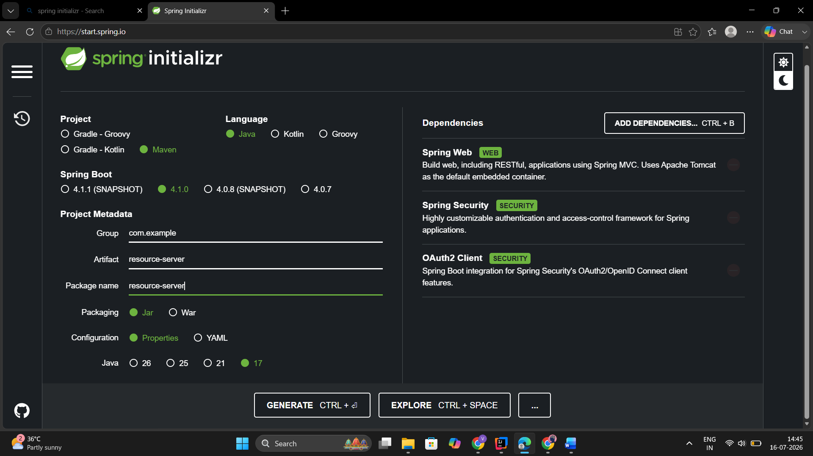
<dependency>
<groupId>org.springframework.boot</groupId>
<artifactId>spring-boot-starter-security</artifactId>
</dependency>

<dependency>
<groupId>org.springframework.boot</groupId>
<artifactId>spring-boot-starter-oauth2-resource-server</artifactId>
</dependency>

spring:
security:
oauth2:
resourceserver:
jwt:
issuer-uri: https://issuer.example.com

package com.example.resourceserver.config;

import org.springframework.context.annotation.Bean;
import org.springframework.context.annotation.Configuration;
import org.springframework.security.config.annotation.web.builders.HttpSecurity;
import org.springframework.security.web.SecurityFilterChain;

@Configuration
public class SecurityConfig {

@Bean
SecurityFilterChain securityFilterChain(HttpSecurity http) throws Exception {

http
.authorizeHttpRequests(auth -> auth
.anyRequest().authenticated()
)
.oauth2ResourceServer(oauth2 -> oauth2.jwt());

return http.build();
}
}

package com.example.resourceserver.controller;

import org.springframework.web.bind.annotation.GetMapping;
import org.springframework.web.bind.annotation.RestController;

@RestController
public class SecureController {

@GetMapping("/secure")
public String secure() {
return "This is a secure endpoint";
}
}

Sample output:
This is a secure endpoint
Without Token
401 Unauthorized

Exercise 3: Using JSON Web Tokens (JWT) for Secure Communication

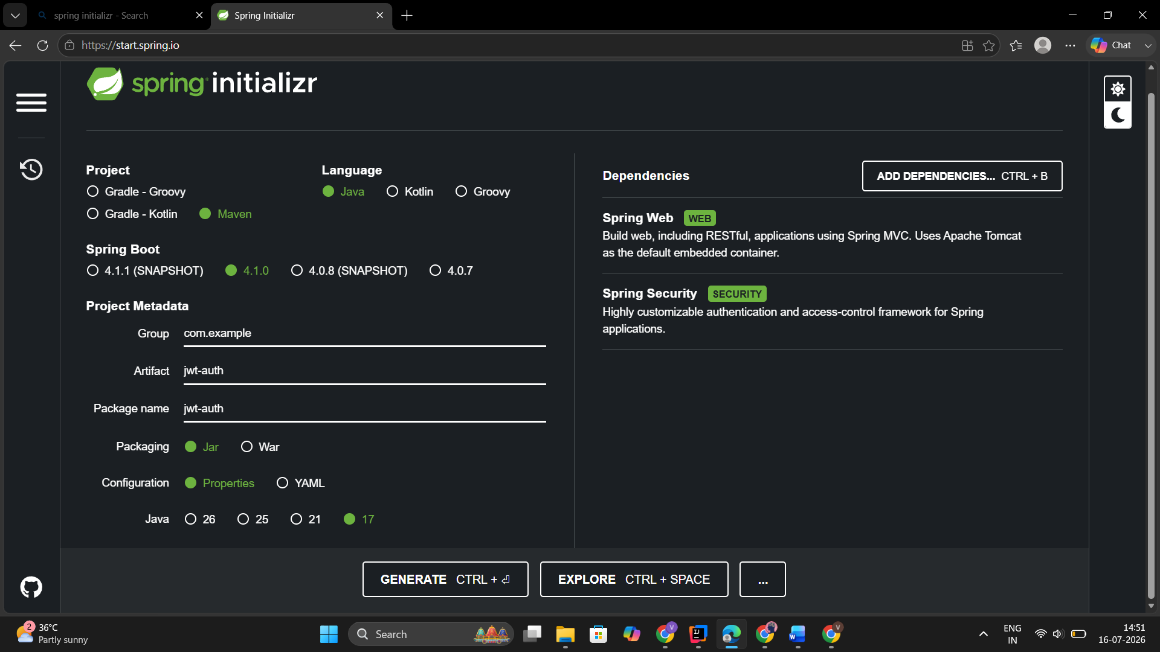

<dependency>
<groupId>io.jsonwebtoken</groupId>
<artifactId>jjwt-api</artifactId>
<version>0.12.6</version>
</dependency>

<dependency>
<groupId>io.jsonwebtoken</groupId>
<artifactId>jjwt-impl</artifactId>
<version>0.12.6</version>
<scope>runtime</scope>
</dependency>

<dependency>
<groupId>io.jsonwebtoken</groupId>
<artifactId>jjwt-jackson</artifactId>
<version>0.12.6</version>
<scope>runtime</scope>
</dependency>

spring:
security:
jwt:
secret: MySecretKey123456789012345678901234567890

@RestController
public class SecureController {

@GetMapping("/secure")
public String secure() {
return "Secure Endpoint Accessed Successfully";
}
}

Sample output:
Without JWT
401 Unauthorized

With Valid JWT
Secure Endpoint Accessed Successfully

