PROJECT REPORT
ON
EMBEDDED SYSTEM FOR ASSISTING DEAF DRIVERS

Submitted By
MANASA REDDY B.R.
Internship Domain
Embedded Systems

Submitted To
IntrnForte
2026

ABSTRACT

Road safety is important for every driver, but it can be more challenging for people with hearing disabilities as they are unable to hear warning sounds from nearby vehicles. In this project, an embedded system was developed to assist deaf drivers by providing visual indications of obstacles approaching from the left, front, and right sides of the vehicle. The system uses ultrasonic sensors to detect nearby obstacles, and the AT89C51 microcontroller processes the sensor data to activate the corresponding LED and buzzer. The circuit was designed and tested using Proteus software, while the program was developed in Embedded C using Keil µVision. The developed system provides timely warnings to improve driver awareness and demonstrates how embedded systems can be used to create practical solutions that enhance road safety and support people with hearing disabilities.

INTRODUCTION

Embedded systems are widely used in modern vehicles to improve safety, automation, and driver assistance. These systems combine hardware and software to perform specific tasks efficiently and reliably. With the increasing need for safer transportation, embedded systems have become an essential part of many driver assistance applications that help reduce accidents and improve road safety.
For deaf drivers, relying only on visual observation while driving can sometimes make it difficult to identify the direction of approaching vehicles or nearby obstacles, especially in heavy traffic. A visual warning system can provide timely alerts and help the driver recognize potential hazards more effectively.
In this project, an embedded system was developed to assist deaf drivers by detecting obstacles approaching from the left, front, and right sides of the vehicle. Three ultrasonic sensors are used to monitor the surrounding area, while an AT89C51 microcontroller processes the sensor data and activates the corresponding LED and buzzer based on the detected obstacle. The circuit was designed and simulated using Proteus software, and the program was developed in Embedded C using Keil µVision. This project demonstrates how embedded systems can be used to improve road safety by providing practical assistance for people with hearing disabilities.

.

PROBLEM STATEMENT
In a car manufacturing environment, there is a need to develop an embedded system that can assist deaf drivers by identifying the direction of approaching vehicles, objects, or animals. The system should provide timely warnings whenever an obstacle comes too close to the vehicle and indicate whether the danger is from the left, front, or right side. The main objective is to improve the driver's awareness of nearby hazards and enhance road safety using an embedded system.

OBJECTIVES
• To develop an embedded system that assists deaf drivers by providing clear visual warnings about nearby obstacles.
• To detect obstacles approaching from the left, front, and right sides of the vehicle using ultrasonic sensors.
• To indicate the direction of the detected obstacle using LEDs and a buzzer, enabling the driver to respond quickly.
• To design and simulate the complete system using the AT89C51 microcontroller in Proteus software.
• To implement the system logic using Embedded C programming in Keil µVision.
• To demonstrate the practical application of embedded systems in improving road safety and supporting people with hearing disabilities

COMPONENTS USED
 | COMPONENT | PURPOSE
1 | AT89C51(8051 Microcontroller) | Controls the entire system and processes sensor inputs.
2 | Ultrasonic Sensor (Left) | Detects obstacles approaching from the left side.
3 | Ultrasonic Sensor (Front) | Detects obstacles in front of the vehicle.
4 | Ultrasonic Sensor (Right) | Detects obstacles approaching from the right side.
5 | Crystal Oscillator | Provides the clock signal for the microcontroller.
6 | Capacitors (33 pF) | Used with the crystal oscillator for stable operation.
7 | LEDs (Green, Red, Yellow) | Indicate the direction from which the obstacle is detected.
8 | Buzzer | Produces an audible warning when an obstacle is detected.
9 | Resistors (330 Ω) | Limit the current flowing through the LEDs.
10 | Potentiometers  (RV1,RV2,RV3) | Simulate varying obstacle distances in the Proteus environment.

CIRCUIT DIAGRAM
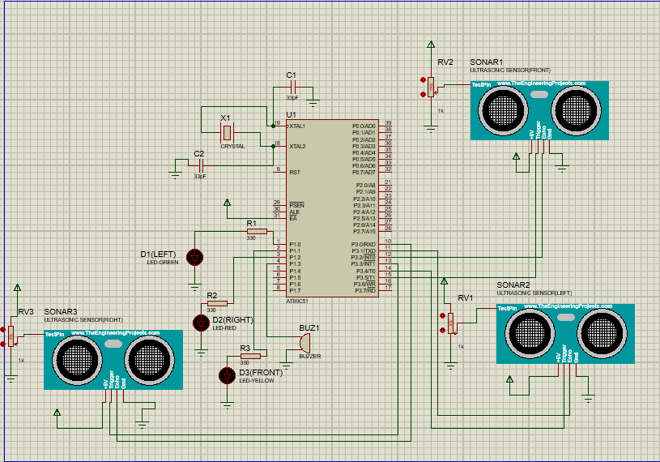

The circuit was designed and simulated using Proteus software with an AT89C51 microcontroller controlling the overall operation of the system. Three ultrasonic sensors are placed to detect obstacles approaching from the left, front, and right sides of the vehicle. Whenever an obstacle is detected within the specified range, the microcontroller activates the corresponding LED to indicate its direction and also turns ON the buzzer to alert the driver. The crystal oscillator and capacitors ensure stable operation of the microcontroller, while the resistors are used to limit the current flowing through the LEDs. This circuit demonstrates a simple and effective driver assistance system for deaf drivers.

WORKING PRINCIPLE
.
The system works by continuously detecting obstacles using three ultrasonic sensors placed on the left, front, and right sides of the vehicle. These sensors measure the distance between the vehicle and nearby objects by sending ultrasonic waves and receiving the reflected signals.
The measured distance is sent to the AT89C51 microcontroller for processing. If an obstacle is detected within the specified range, the microcontroller identifies its direction and turns ON the corresponding LED. The buzzer is also turned ON to alert the driver.
When no obstacles are detected within the specified range, all the LEDs and the buzzer remain OFF while the system continues monitoring the surroundings. This helps the driver identify obstacles in time and improves road safety for people with hearing disabilities.

FLOWCHART
START

Initialize AT89C51 Microcontroller

Initialize Timer0 and Output Devices

Read Left, Front and Right Ultrasonic Sensors

Is Left Distance < 40 cm?

Yes No
Turn ON Green LED’s and Buzzer
Do Nothing

Is Front Distance < 40 cm?

Do Nothing
Turn ON Yellow LED’s and Buzzer

Is Right Distance < 40 cm?

Yes No
Turn ON Red LED’s and buzzer
Turn OFF LED’s and buzzer

Continue Monitoring

Back to Read Left, Front and Right Ultrasonic Sensors

ALGORITHM

Step 1 – Start the system.
Step 2 – Initialize the AT89C51 microcontroller and all the required peripherals.
Step 3 – Read the distance values from the left, front, and right ultrasonic sensors.
Step 4 – Check whether any obstacle is present within the predefined detection range.
Step 5 – If an obstacle is detected on the left side, turn ON the left indicator LED and activate the buzzer.
Step 6 – If an obstacle is detected in the front, turn ON the front indicator LED and activate the buzzer.
Step 7 – If an obstacle is detected on the right side, turn ON the right indicator LED and activate the buzzer.
Step 8 – If no obstacle is detected, keep all the LEDs and the buzzer in the OFF state.
Step 9 – Wait for a short delay before the next reading.
Step 10 – Repeat the process continuously to monitor the surroundings.

EMBEDDED C PROGRAM

#include <REGX52.h>

#define uint unsigned int

/* ---------- OUTPUTS ---------- */
sbit GREEN = P1^0;
sbit YELLOW = P1^1;
sbit RED = P1^2;
sbit BUZZER = P1^3;

/* ---------- ULTRASONIC ---------- */
/* ---------- FRONT ---------- */
sbit FRONT_TRIG = P3^5;
sbit FRONT_ECHO = P3^2;

/* ---------- LEFT ---------- */
sbit LEFT_TRIG = P3^4;
sbit LEFT_ECHO = P3^1;

/* ---------- RIGHT ---------- */
sbit RIGHT_TRIG = P3^3;
sbit RIGHT_ECHO = P3^0;

/* ---------- GLOBALS ---------- */
unsigned int left_distance;
unsigned int front_distance;
unsigned int right_distance;

/* ---------- DELAY ---------- */
void delay(uint ms)
{
uint i,j;

for(i=0;i<ms;i++)
{
for(j=0;j<1275;j++);
}
}

/* ---------- FRONT TRIGGER ---------- */
void send_front_pulse(void)
{
TH0 = 0x00;
TL0 = 0x00;

FRONT_TRIG = 0;

FRONT_TRIG = 1;
FRONT_TRIG = 1;
FRONT_TRIG = 1;
FRONT_TRIG = 1;
FRONT_TRIG = 1;
FRONT_TRIG = 1;
FRONT_TRIG = 1;
FRONT_TRIG = 1;
FRONT_TRIG = 1;
FRONT_TRIG = 1;

FRONT_TRIG = 0;
}

/* ---------- LEFT TRIGGER ---------- */
void send_left_pulse(void)
{
TH0 = 0x00;
TL0 = 0x00;

LEFT_TRIG = 0;

LEFT_TRIG = 1;
LEFT_TRIG = 1;
LEFT_TRIG = 1;
LEFT_TRIG = 1;
LEFT_TRIG = 1;
LEFT_TRIG = 1;
LEFT_TRIG = 1;
LEFT_TRIG = 1;
LEFT_TRIG = 1;
LEFT_TRIG = 1;

LEFT_TRIG = 0;
}

/* ---------- RIGHT TRIGGER ---------- */
void send_right_pulse(void)
{
TH0 = 0x00;
TL0 = 0x00;

RIGHT_TRIG = 0;

RIGHT_TRIG = 1;
RIGHT_TRIG = 1;
RIGHT_TRIG = 1;
RIGHT_TRIG = 1;
RIGHT_TRIG = 1;
RIGHT_TRIG = 1;
RIGHT_TRIG = 1;
RIGHT_TRIG = 1;
RIGHT_TRIG = 1;
RIGHT_TRIG = 1;

RIGHT_TRIG = 0;
}
/* ---------- FRONT DISTANCE ---------- */
unsigned int get_front_range(void)
{
unsigned long timer_val;
unsigned int timeout = 60000;

send_front_pulse();

while(!FRONT_ECHO)
{
timeout--;
if(timeout==0)
return 999;
}

TH0=0;
TL0=0;
TR0=1;

timeout=60000;

while(FRONT_ECHO)
{
timeout--;
if(timeout==0)
{
TR0=0;
return 999;
}
}

TR0=0;

timer_val=((unsigned long)TH0<<8)|TL0;

return timer_val/58;
}

/* ---------- LEFT DISTANCE ---------- */
unsigned int get_left_range(void)
{
unsigned long timer_val;
unsigned int timeout = 60000;

send_left_pulse();

while(!LEFT_ECHO)
{
timeout--;
if(timeout==0)
return 999;
}

TH0=0;
TL0=0;
TR0=1;

timeout=60000;

while(LEFT_ECHO)
{
timeout--;
if(timeout==0)
{
TR0=0;
return 999;
}
}

TR0=0;

timer_val=((unsigned long)TH0<<8)|TL0;

return timer_val/58;
}

/* ---------- RIGHT DISTANCE ---------- */
unsigned int get_right_range(void)
{
unsigned long timer_val;
unsigned int timeout = 60000;

send_right_pulse();

while(!RIGHT_ECHO)
{
timeout--;
if(timeout==0)
return 999;
}

TH0=0;
TL0=0;
TR0=1;

timeout=60000;

while(RIGHT_ECHO)
{
timeout--;
if(timeout==0)
{
TR0=0;
return 999;
}
}

TR0=0;

timer_val=((unsigned long)TH0<<8)|TL0;

return timer_val/58;
}

/* ---------- LEFT INDICATOR ---------- */
void left_indicator(void)
{
GREEN = 1;
YELLOW = 0;
RED = 0;
BUZZER = 0;
}

/* ---------- FRONT INDICATOR ---------- */
void front_indicator(void)
{
GREEN = 0;
YELLOW = 1;
RED = 0;
BUZZER = 0;
}
/* ---------- RIGHT INDICATOR ---------- */
void right_indicator(void)
{
GREEN = 0;
YELLOW = 0;
RED = 1;
BUZZER = 1;
}

void main(void)
{
TMOD = 0x01;
TR0 = 0;
TH0 = 0x00;
TL0 = 0x00;

GREEN = 0;
YELLOW = 0;
RED = 0;
BUZZER = 0;

while(1)
{
left_distance = get_left_range();
front_distance = get_front_range();
right_distance = get_right_range();

GREEN = 0;
YELLOW = 0;
RED = 0;
BUZZER = 0;

if(left_distance < 40)
{
left_indicator();
}

if(front_distance < 40)
{
front_indicator();
}

if(right_distance < 40)
{
right_indicator();
}

delay(100);
}
}

OUTPUT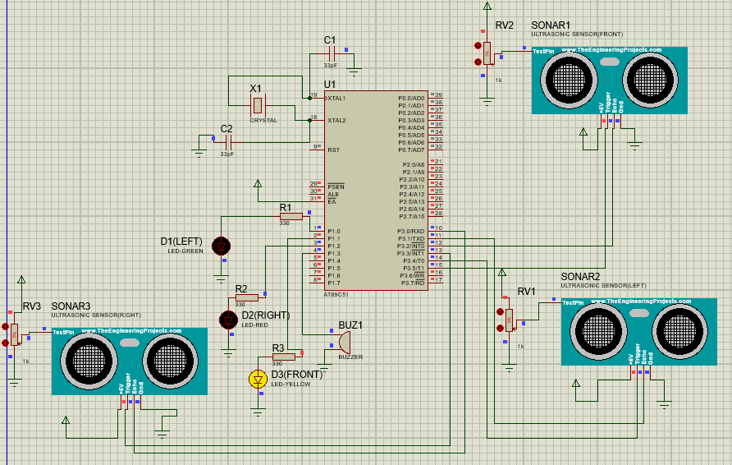

FIGURE 1: FRONT OBSTACLE DETECTION
When an obstacle is detected in front of the vehicle, the front indicator LED and the buzzer are activated to warn the driver.

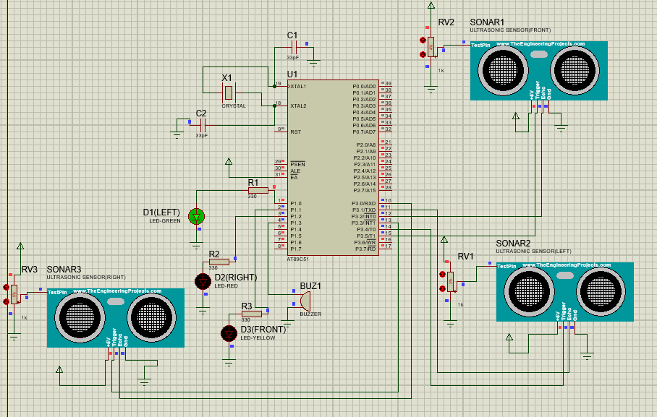

FIGURE 2: LEFT OBSTACLE SENSOR
When an obstacle is detected on the left side, the left indicator LED is activated along with the buzzer to alert the driver about the potential danger.

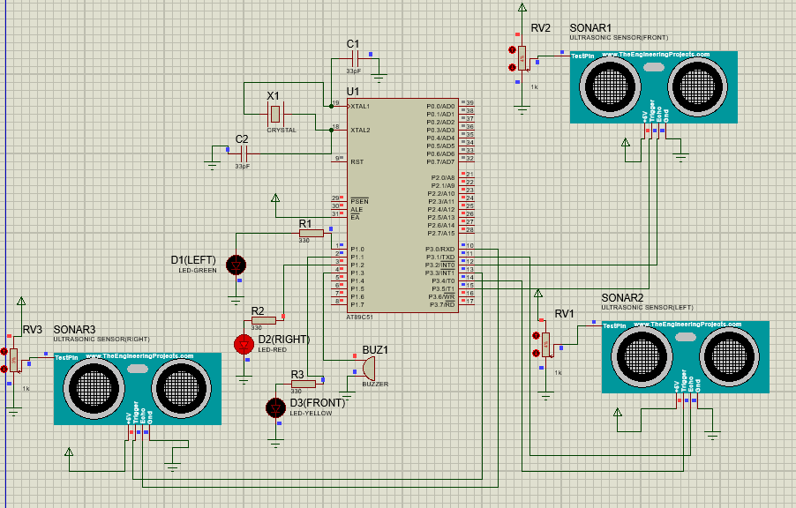

FIGURE 3: RIGHT OBSTACLE DETECTION
When an obstacle is detected on the right side, the right indicator LED and the buzzer are turned ON to indicate the direction of the obstacle.
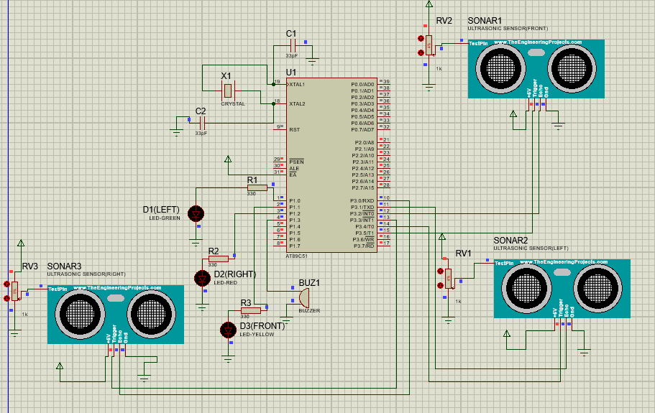

FIGURE 4: NO OBSTACLE DETECTED
When no obstacle is present within the detection range, all indicator LEDs and the buzzer remain OFF while the system continues monitoring the surroundings.

POSSIBLE LOOPHOLE IN THE SYSTEM

The developed system performs well in the Proteus simulation; however, it may face certain limitations when implemented in a real-world environment. The accuracy of obstacle detection depends on the proper positioning and calibration of the ultrasonic sensors. Environmental conditions such as heavy rain, dust, or uneven obstacle surfaces may affect the sensor readings and reduce detection accuracy. In addition, the current system is designed only to provide visual and audio warnings and does not have the ability to control the vehicle automatically. These limitations can be addressed in future versions by integrating additional sensors and more advanced control techniques.

EMBEDDED SYSTEMS FOR PERSONS WITH DISABILITIES

Embedded systems are used in many devices that help people with disabilities in their daily lives. They are commonly used in hearing aids, mobility aids, and driver assistance systems to make these devices more useful and reliable. In this project, the system helps deaf drivers by giving visual indications whenever an obstacle is detected. This reduces their dependence on sound-based warnings and helps them identify the direction of nearby obstacles more easily. Overall, this project shows how embedded systems can be used to improve road safety and provide practical support for people with hearing disabilities.

FUTURE SCOPE

This system can be improved in the future by adding more features. GPS and GSM modules can be included to send emergency alerts whenever an obstacle is detected. IoT technology can also be used for remote monitoring and notifications. More sensors or cameras can be added to improve obstacle detection in different road conditions. In future, the system can also be connected with automatic braking or steering systems to provide better safety for deaf drivers.

CONCLUSION

This project was developed to assist deaf drivers by using an AT89C51 microcontroller and ultrasonic sensors. The system detects obstacles from the left, front, and right sides of the vehicle and provides visual and audio warnings to alert the driver. The project was successfully designed and tested in Proteus, showing that embedded systems can be used to improve road safety for people with hearing disabilities. Although the system has some limitations, it can be improved further by adding more features in the future.

REFERENCES

1. Mazidi, M. A., Mazidi, J. G., & McKinlay, R. D. The 8051 Microcontroller and Embedded Systems. Pearson Education.
2. Keil µVision IDE User Guide.
3. Proteus Design Suite Documentation.
4. AT89C51 Microcontroller Datasheet.
5. ProjectIoT123. Ultrasonic Sensor Library and Proteus Project Resources. Available at: projectiot123.com.
6. Embedded Systems course material provided during the internship

