**README**

Commands to run the code

-To run server:

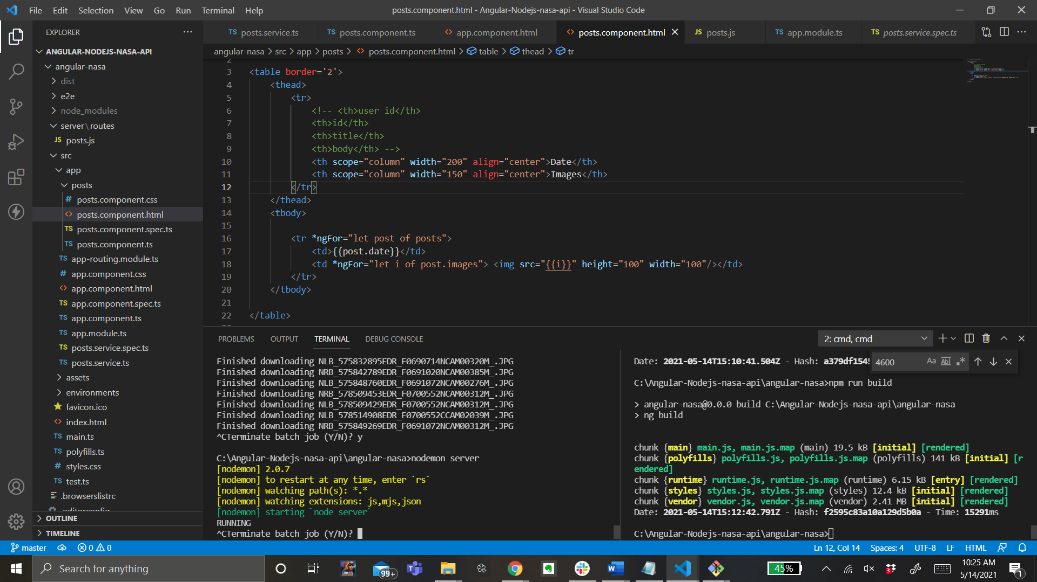

To build app

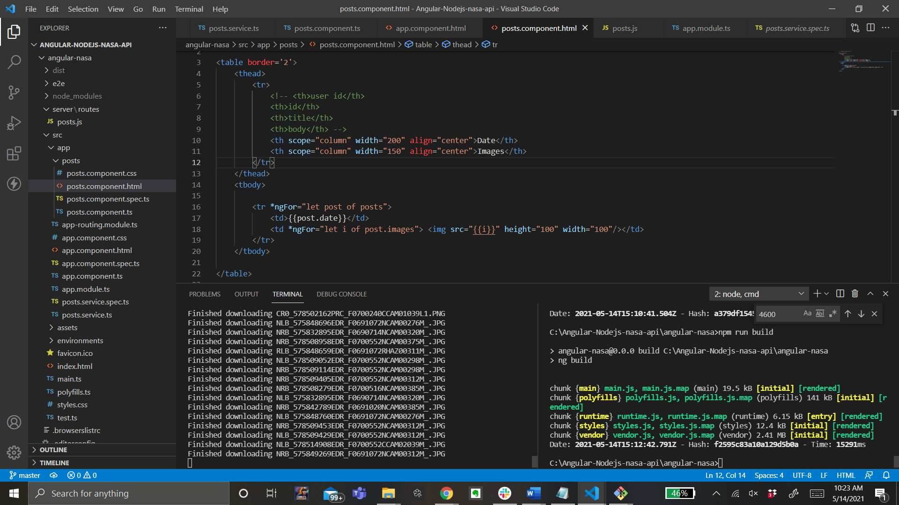

Now to check the app running on localhost

<http://localhost:4600/>

The dates for input are in dates.txt inside the angular-nasa folder.

The links of images found using the API with the given dates

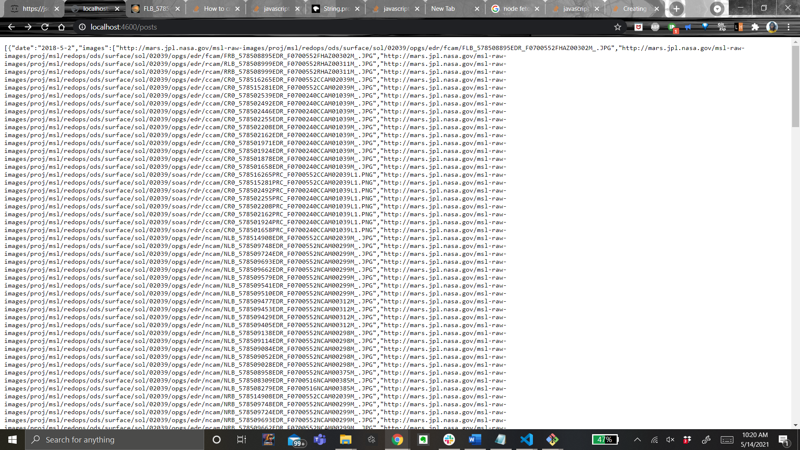

The images displayed as a table along with the dates, on Localhost (scroll right for all the images)

