### **Introduction:**

Over a few years, our country has witnessed many pathetic incidents happening to women of all age groups on social media as well in reality. Many complaints get filed every week and most are left unsolved. And more than half of the women are not brave enough to speak out. Besides all this distress, women do not feel free to talk about their personal health. Talking about periods and other health issues has always been and is still a big taboo in most parts of India. Keeping all this in mind, we have come up with a chatbot to address all these issues that women are facing and providing a platform for all women to get to know their rights.

Sarah is a chatbot that is developed to provide information and suggestions regarding women’s health and safety by providing the necessary helplines of various sectors under women's protection. This chatbot provides all the helplines. The main idea behind our project is to create an AI assistant that can help women find information about helplines, remedial solutions to women’s health, rights of women's safety and protection all at one place.

Using Artificial Intelligence and Natural Language Processing, our chatbot can simulate conversation with a user through messaging applications and websites giving them accurate and relevant information.

Using Artificial Intelligence and Natural Language Processing, our chatbot can reproduce discussion with the user through informing applications and sites giving them exact and pertinent data.

#### **Features:**

A chatbot is an adaptive and easier way to gather information. They provide the end-users with a truly personalized experience as most of them prefer texting over any other means. Perhaps the best benefit is that bots are accessible day in and day out to help users. Also, they react rapidly to each address they get. This ensures the users generally tackle their issues, regardless of the season of the day.

Based on the research of the problems that women are facing in the present day, we have filtered and listed a few of them. They include:

**Health:**

* Menstrual cycle
* Cancer-related issues
* Pregnancy issues
* Sexual problems
* Anxiety, Depression, Mood swings, PMDD, etc

**Safety:**

* Sexual harassment at the workplace
* Acid Attacks
* Rapes
* Threats and blackmailing
* Child marriages
* Marital rapes
* Dowry demands, etc

Accordingly, we have trained Sarah to respond to the users with relevant information and help them with their queries.

### **Tools and Technologies Used:**

**Kaggle**

Personality development dataset

**IBM Watson Assistant**

It is a platform that enables us to build conversational interfaces. Watson Assistant uses machine learning and intent detection algorithms to understand how to answer end-user questions accurately. The Artificial Intelligence at the core of Watson Assistant is designed to correctly identify the countless permutations of intent in real-world interactions.

### **Required skillset to build the project set:**

* Basic understanding about working of chatbots
* Natural Language Processing, Machine Learning
* Usage of IBM Watson Assistant

### **Implementation of the project:**

Using the IBM Watson Assistant, all the queries that a user can ask have been loaded and grouped into different categories as **Intents**. **Entities**, as in synonyms, have been categorized based on the trained intents. Recognizing these entities in the intents, the deliveries, or **Dialogues** are trained to display to the user for related queries.

Sarah greets you at first and displays all trained categories such as **Women health, Women safety, Women harassment, Helplines,** and other **Questions**.

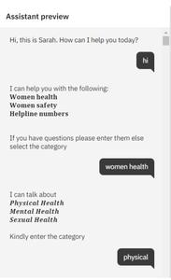

#### ***Example:* Women health**

It has three categories namely **Physical health**, **Mental health**, and **Sexual health**. Physical health is again categorized into **Periods**, **Cancer**, and **Pregnancy**. Periods is further categorized into **Irregular periods**, **PCOS**, **Period cramps**, **Heavy bleeding**,and **Vaginal dryness**. When the user chooses selected options and reaches Irregular periods, the chatbot display information about irregular periods and few home remedies.

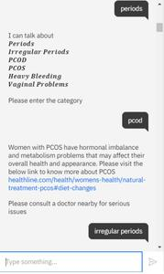

The same goes for all the other categories.

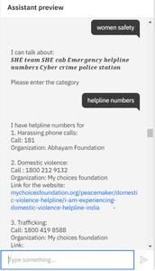

*Question:* This category does not give users any options. The user is free to ask any question in these domains and the chatbot replies with what the user is facing, any information, and home remedies.

Sarah also answers characteristic personality questions like:

User: What is your gender?

Sarah: Sigma female

User: What can you eat

Sarah: I consume RAM and binary digits.

User: Tell me a joke

Sarah: A 3-legged dog walks into an old west saloon, slides up to the bar, and announces "I'm looking for the man who shot my paw."

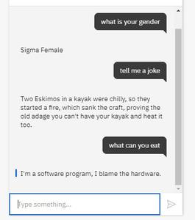

The dialogues for the bot are acquired for Kaggle. An intent has multiple dialogues displayed at random. An example of the source code for developing the bot personality is in JSON format.

**Use case diagram:**

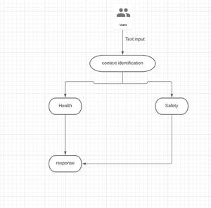 Use Case diagram for Sarah

**Flowchart:**

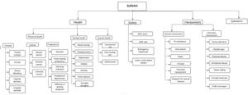Workflow Diagram

As 70% of People in our country are literate, most of the women will have access to the internet and fundamental knowledge of using a chatbot. The majority of the women have been working late nights and are concerned about their safety due to the incidents happening out in the country. This chatbot provides information about SHE cabs, police station contacts, and many more helpline numbers at any time within an instant. This also works as a junior doctor for domains that may not be 100% accurate but it provides basic knowledge about the medical problems that women face.

For future enhancements, we will include voice-based queries. The users will have to provide voice input and the system will give the text output. Adding to this, after the successful execution of chatbot in the health and safety domain, we are planning to expand into the medical domain and implement it in other domains like women's welfare, problems related to child protection, etc. It will be beneficial in all the fields as without spending much time, we are accessing the relevant information and that too without much sorting.

#### **Use Sarah here:** [**https://web-chat.global.assistant.watson.cloud.ibm.com/preview.html?region=eu-gb&integrationID=aae5a605-efb4-4d02-a355-ecf2cf82ca53&serviceInstanceID=47142624-d693-4529-8407-45bb85629709**](https://web-chat.global.assistant.watson.cloud.ibm.com/preview.html?region=eu-gb&integrationID=aae5a605-efb4-4d02-a355-ecf2cf82ca53&serviceInstanceID=47142624-d693-4529-8407-45bb85629709)

#### **Github Link:** [**https://github.com/sanjana-iyengar/Sarah_chatbot**](https://github.com/sanjana-iyengar/Sarah_chatbot)

#### **Project by:**

**Harshitha Karnatakam**

**Manasa Reddy**

**Sanjana Alaham**