Lab 4 - Inserting Data using Entity Framework Core

Objective
Insert records into the Categories and Products tables using Entity Framework Core.

Program.cs
using RetailInventory.Data;
using RetailInventory.Models;

using var context = new AppDbContext();

// Check if the category already exists
Category? category = context.Categories.FirstOrDefault(c => c.Name == "Electronics");

if (category == null)
{
category = new Category
{
Name = "Electronics"
};

context.Categories.Add(category);
context.SaveChanges();
}

// Check if products already exist before inserting
if (!context.Products.Any())
{
var product1 = new Product
{
Name = "Laptop",
Price = 65000,
CategoryId = category.Id
};

var product2 = new Product
{
Name = "Mouse",
Price = 800,
CategoryId = category.Id
};

context.Products.Add(product1);
context.Products.Add(product2);

context.SaveChanges();
}

Console.WriteLine("Data inserted successfully!");

Execution Steps
- Run the application.
- Verify the message 'Data inserted successfully!'.
- Open SSMS and execute:
- SELECT * FROM Categories;
- SELECT * FROM Products

Console output showing 'Data inserted successfully!’

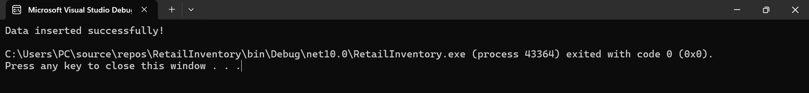

Categories table data in SSMS, Products table data in SSMS

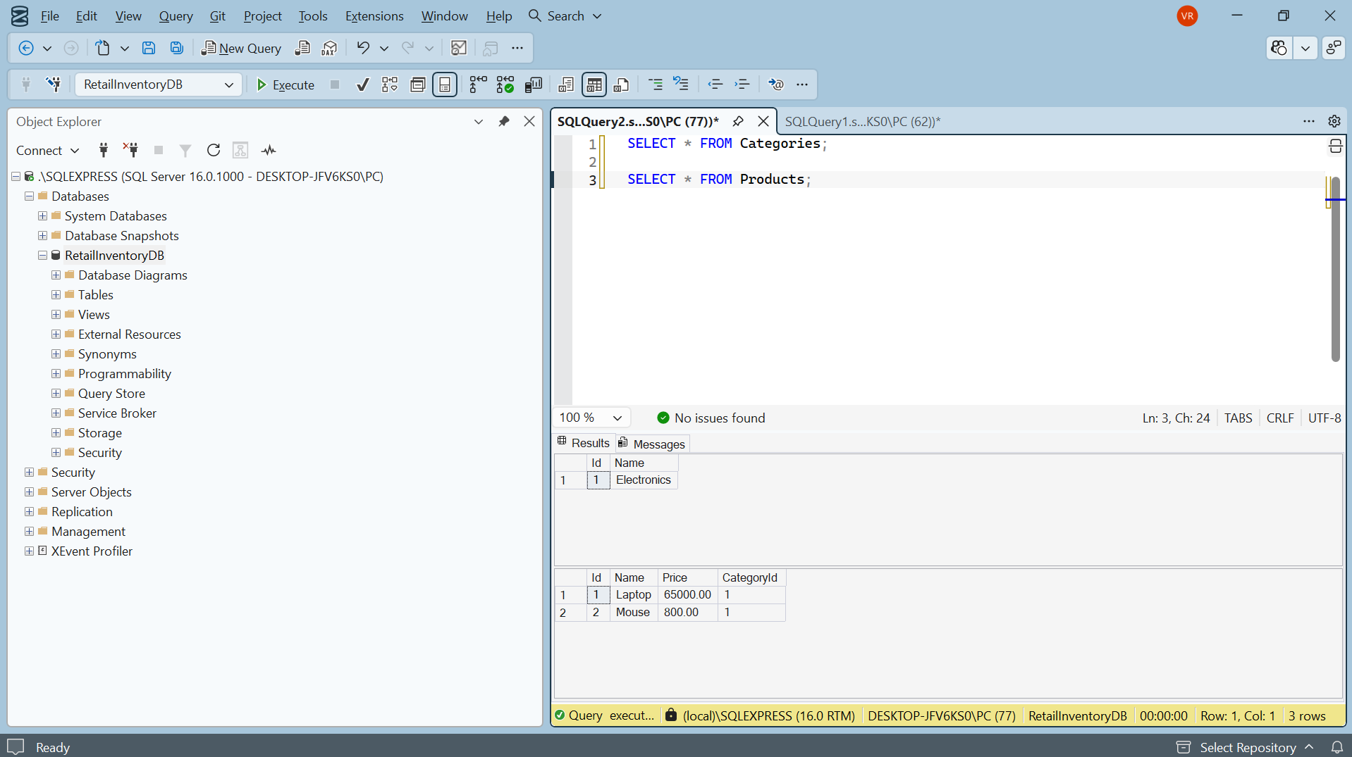

Result
Data was successfully inserted into the Categories and Products tables using Entity Framework Core and verified in SQL Server Management Studio.

