Lab 3 - Entity Framework Core Migrations

Objective
Create the initial Entity Framework Core migration and generate the SQL Server database.

Steps Performed
- Opened the RetailInventory project.
- Verified EF Core packages.
- Ran 'dotnet ef migrations add InitialCreate'.
- Ran 'dotnet ef database update'.
- Verified RetailInventoryDB in SSMS.

Commands Used
dotnet ef migrations add InitialCreate
dotnet ef database update
- Migrations folder.
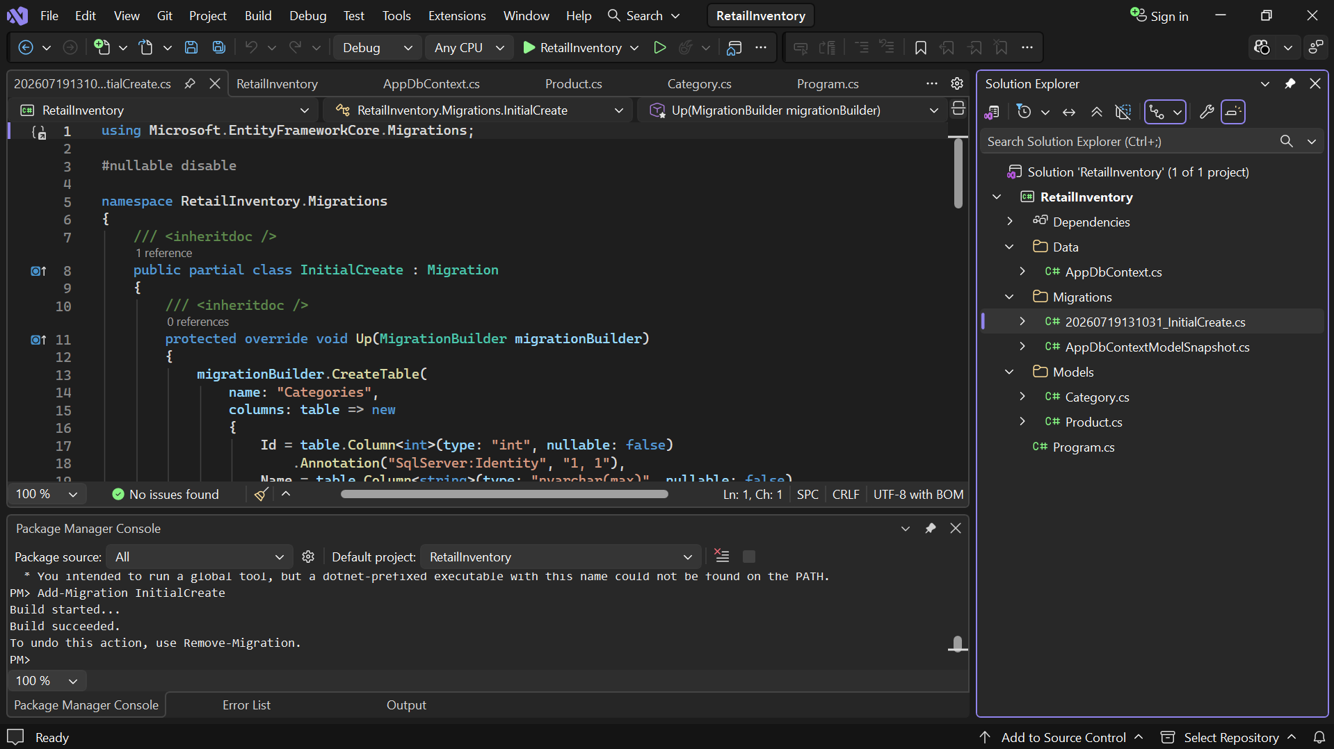

- Migration command output.

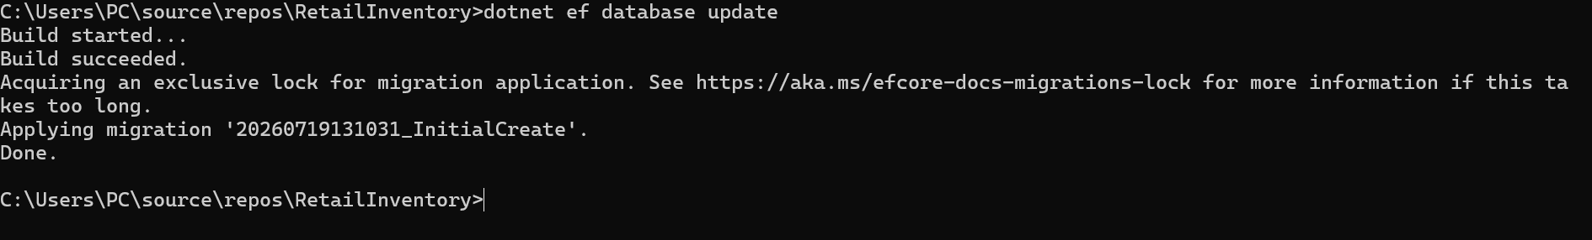

- RetailInventoryDB tables in SSMS.

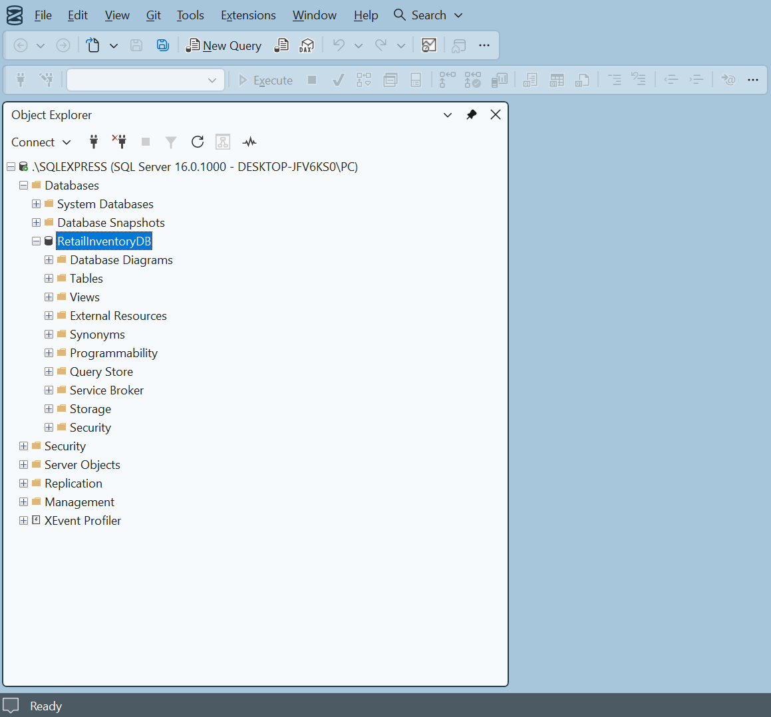

Result
The InitialCreate migration and RetailInventoryDB were created successfully using Entity Framework Core.

