3. GIT-HOL
Creating a Branch, Committing Changes, Merging and Deleting a Branch

1. Objective
The objective of this hands-on lab is to understand Git branching and merging. The activity demonstrates how to create a new branch, make changes in the branch, commit the changes, merge the branch into the main branch, view the Git history, and delete the branch after a successful merge.

2. Prerequisites
- Git environment configured on the local system.
- Git Bash available for executing Git commands.
- A local clone of the CTS-Digital-Nurture GitHub repository.
- A remote GitHub repository connected to the local repository.

3. Repository Used
The existing CTS-Digital-Nurture repository was used for this lab. The branching and merging activity was performed for the DeepSkilling Module08 work.
CTS-Digital-Nurture/DeepSkilling/Module08/

4. Create a New Branch
A new branch named GitNewBranch was created from the main branch using:
git branch GitNewBranch
The available branches were checked using:
git branch -a
The asterisk (*) indicates the branch that is currently checked out.
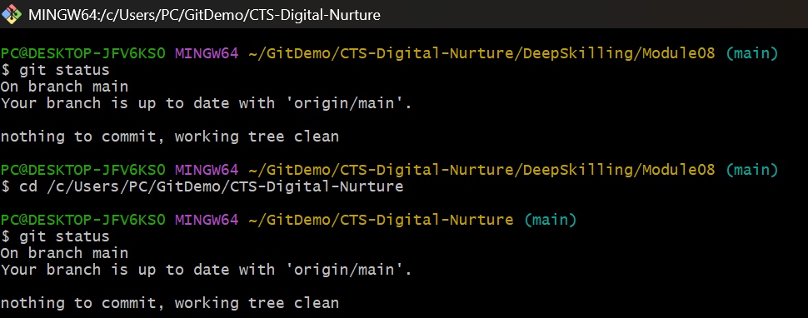

5. Switch to the New Branch
The newly created branch was checked out using:
git switch GitNewBranch
The active branch was verified using:
git branch
The output confirmed that GitNewBranch was the current branch.
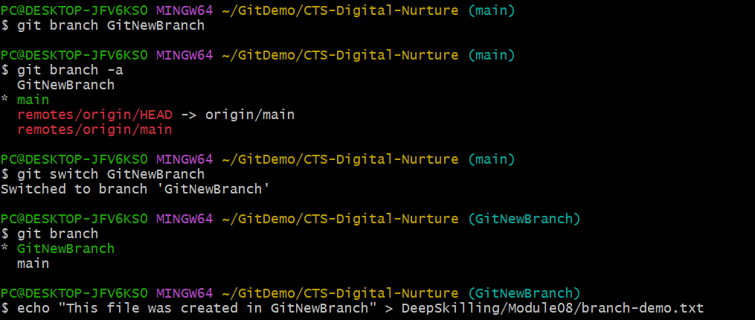

6. Create and Add a File in the Branch
A new file named branch-demo.txt was created inside DeepSkilling/Module08 while working on GitNewBranch.
echo "This file was created in GitNewBranch" > DeepSkilling/Module08/branch-demo.txt
The repository status was checked using:
git status

7. Commit the Branch Changes
The new file was staged using:
git add DeepSkilling/Module08/branch-demo.txt
The staged changes were committed using:
git commit -m "Add branch demo file"
The repository status was checked after the commit:
git status
The working tree was clean after the commit, confirming that the branch changes were successfully committed.

8. Switch Back to the Main Branch
After completing the changes in GitNewBranch, the main branch was checked out using:
git switch main
The main branch was then ready to receive the changes from GitNewBranch through merging.

9. Merge GitNewBranch into Main
The source branch was merged into the main branch using:
git merge GitNewBranch
The merge successfully brought branch-demo.txt and its commit into the main branch.

10. View Git History
The commit history and branch structure were observed using:
git log --oneline --graph --decorate
This command displays the commit history in a compact graphical format and shows branch and tag references.
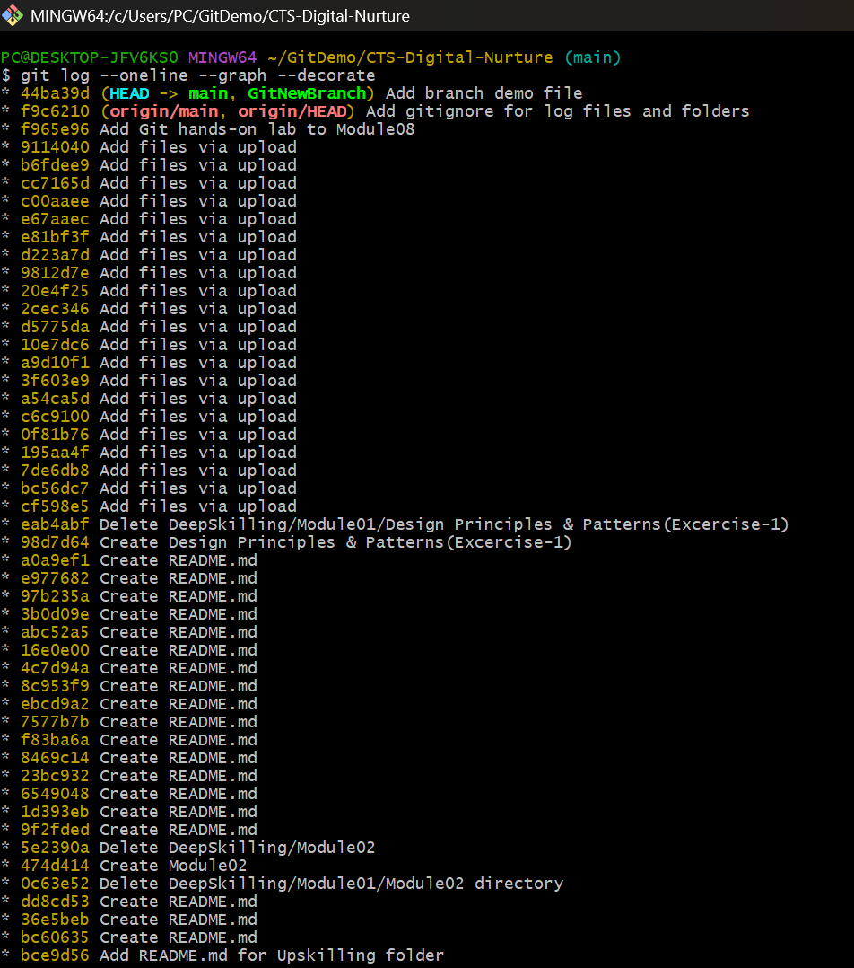

11. Delete the Branch After Merging
After confirming that GitNewBranch had been successfully merged, the branch was deleted using:
git branch -d GitNewBranch
The deleted branch was no longer required because its changes were already merged into main.

12. Synchronize with the Remote Repository
The local repository was synchronized with the latest remote changes using:
git pull --rebase origin main
The pull operation completed successfully, integrating the latest remote changes without overwriting existing work.

13. Push the Final Changes to GitHub
The merged changes were pushed to the remote GitHub repository using:
git push origin main
The push completed successfully and the final changes were available in the CTS-Digital-Nurture repository.

14. Final Repository Structure
CTS-Digital-Nurture/
└── DeepSkilling/
└── Module08/
├── welcome.txt
├── .gitignore
└── branch-demo.txt

15. Result
The Git branching and merging hands-on lab was successfully completed. A new branch named GitNewBranch was created, a file was added and committed to the branch, the branch was merged into main, the Git history was reviewed, and the merged branch was deleted. The final changes were synchronized with and pushed to the remote GitHub repository.

