MicroServices - JWT
Question-1
1. Aim
To implement JWT (JSON Web Token) based authentication in an ASP.NET Core Web API, generate a JWT token after successful login, and secure an API endpoint using the [Authorize] attribute.
2. Scenario
A microservice requires secure login and protected API access. A user provides valid credentials through a login endpoint. On successful authentication, the application generates a JWT token. The token is then supplied as a Bearer token to access a secured Employee API endpoint.
3. Software / Tools Required
- Visual Studio
- ASP.NET Core Web API
- C#
- Swagger / OpenAPI
- Microsoft.AspNetCore.Authentication.JwtBearer NuGet package
4. Install Required NuGet Package
The JWT Bearer authentication package was installed using the Visual Studio Package Manager Console:
Install-Package Microsoft.AspNetCore.Authentication.JwtBearer
5. JWT Configuration – appsettings.json
{
"Jwt": {
"Key": "MySuperSecretJwtKeyForApiLab123456789",
"Issuer": "MyAuthServer",
"Audience": "MyApiUsers",
"DurationInMinutes": 60
}
}
6. Login Model – LoginModel.cs
namespace ApiLab1.Models
{
public class LoginModel
{
public string Username { get; set; } = string.Empty;
public string Password { get; set; } = string.Empty;
}
}
7. JWT Authentication Configuration – Program.cs
builder.Services.AddAuthentication(
JwtBearerDefaults.AuthenticationScheme)
.AddJwtBearer(options =>
{
options.TokenValidationParameters = new TokenValidationParameters
{
ValidateIssuer = true,
ValidateAudience = true,
ValidateLifetime = true,
ValidateIssuerSigningKey = true,
ValidIssuer = builder.Configuration["Jwt:Issuer"],
ValidAudience = builder.Configuration["Jwt:Audience"],
IssuerSigningKey = new SymmetricSecurityKey(
Encoding.UTF8.GetBytes(
builder.Configuration["Jwt:Key"]!))
};
});
builder.Services.AddAuthorization();
app.UseAuthentication();
app.UseAuthorization();
8. AuthController.cs
using ApiLab1.Models;
using Microsoft.AspNetCore.Mvc;
using Microsoft.IdentityModel.Tokens;
using System.IdentityModel.Tokens.Jwt;
using System.Security.Claims;
using System.Text;
namespace ApiLab1.Controllers
{
[ApiController]
[Route("api/[controller]")]
public class AuthController : ControllerBase
{
private readonly IConfiguration _configuration;
public AuthController(IConfiguration configuration)
{
_configuration = configuration;
}
[HttpPost("login")]
public IActionResult Login([FromBody] LoginModel model)
{
if (model.Username == "admin" &&
model.Password == "password123")
{
var token = GenerateJwtToken(model.Username);
return Ok(new { Token = token });
}
return Unauthorized(new
{
Message = "Invalid username or password"
});
}
private string GenerateJwtToken(string username)
{
var claims = new[]
{
new Claim(ClaimTypes.Name, username)
};
var key = new SymmetricSecurityKey(
Encoding.UTF8.GetBytes(
_configuration["Jwt:Key"]!));
var credentials = new SigningCredentials(
key, SecurityAlgorithms.HmacSha256);
var token = new JwtSecurityToken(
issuer: _configuration["Jwt:Issuer"],
audience: _configuration["Jwt:Audience"],
claims: claims,
expires: DateTime.UtcNow.AddMinutes(
Convert.ToDouble(
_configuration["Jwt:DurationInMinutes"])),
signingCredentials: credentials
);
return new JwtSecurityTokenHandler()
.WriteToken(token);
}
}
}
9. Securing Employee API
The existing EmployeeController was secured by adding the [Authorize] attribute. Only clients that provide a valid JWT Bearer token can access the protected endpoint.
using Microsoft.AspNetCore.Authorization;
[ApiController]
[Route("api/Emp")]
[Authorize]
public class EmployeeController : ControllerBase
{
// Existing Employee API methods
}
10. Testing Using Swagger
- Start the ASP.NET Core Web API from Visual Studio.
- Open Swagger UI at https://localhost:7009/swagger/index.html.
- Open POST /api/Auth/login and click Try it out.
- Enter the test credentials shown below and click Execute.
{
"username": "admin",
"password": "password123"
}
- Verify that the login request returns 200 OK with a JWT token.
- Copy the generated JWT token.
- Click the Swagger Authorize button.
- Enter the token using the format: Bearer <JWT_TOKEN>.
- Open GET /api/Emp and click Execute.
- Verify that the protected Employee API returns 200 OK.
11. Authentication Flow
Client
|
| POST /api/Auth/login
| Username + Password
v
AuthController
|
| Valid Credentials
v
JWT Token Generated
|
| Bearer Token
v
GET /api/Emp
|
| [Authorize] validates JWT
v
200 OK – Employee Data

13. Screenshots
Screenshot 1 – Swagger login endpoint (POST /api/Auth/login) showing 200 OK and generated JWT token.
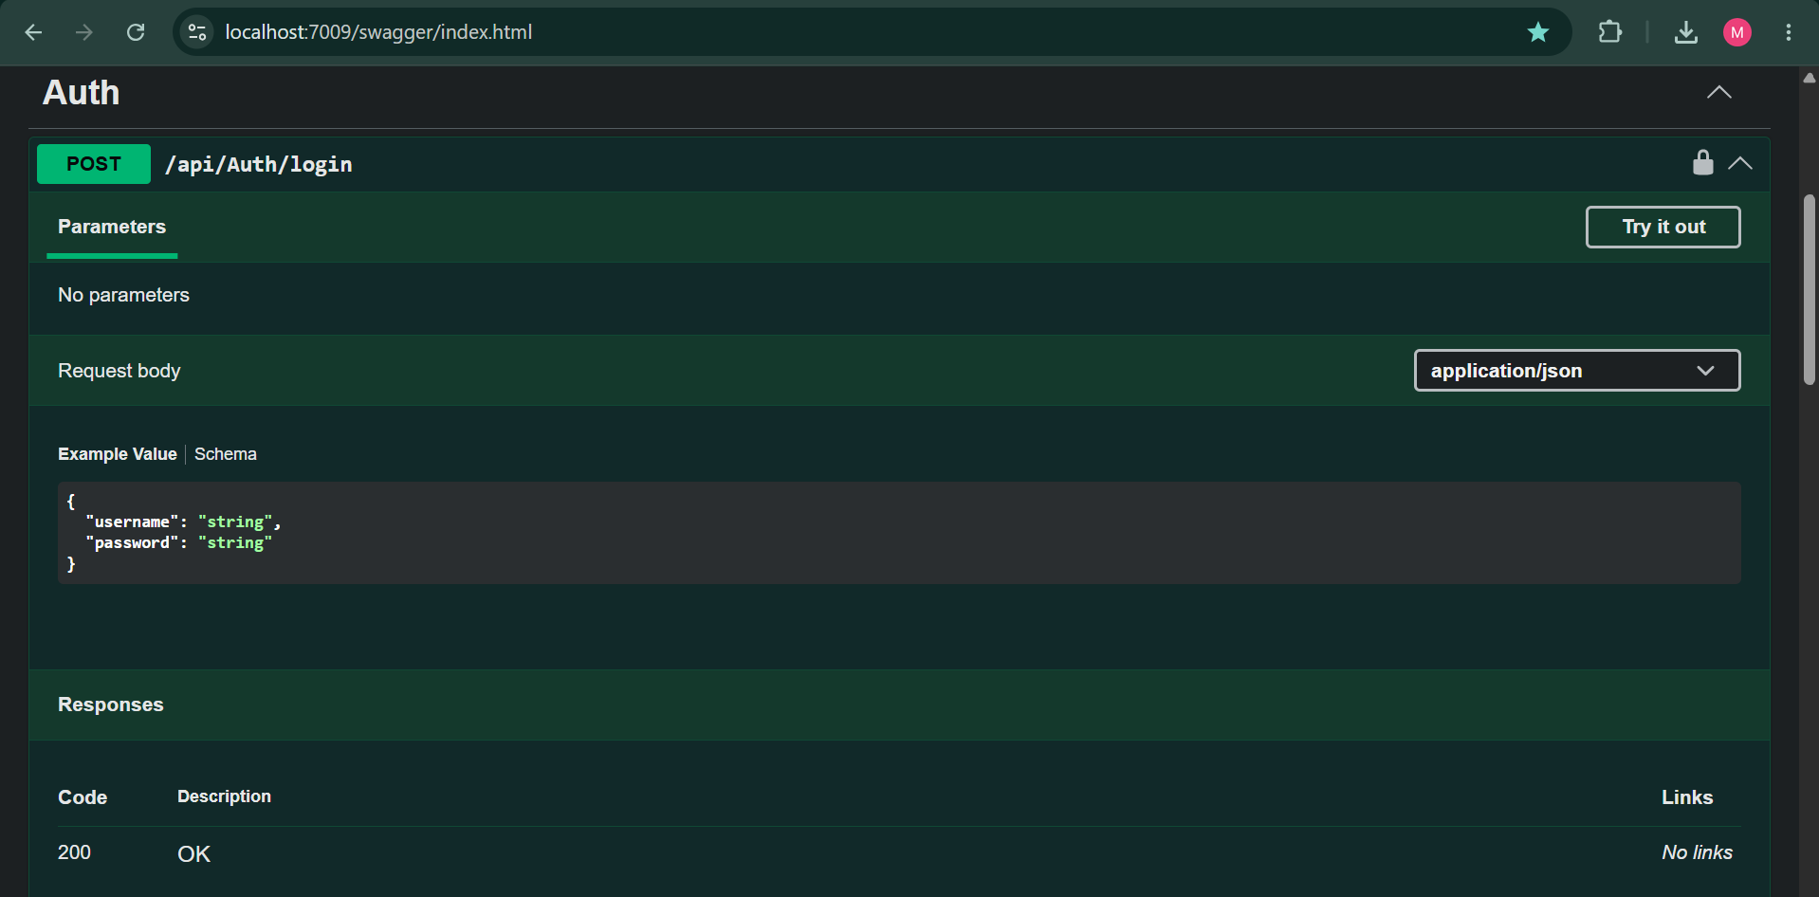
Screenshot 2 – Protected GET /api/Emp endpoint showing 200 OK after authentication.
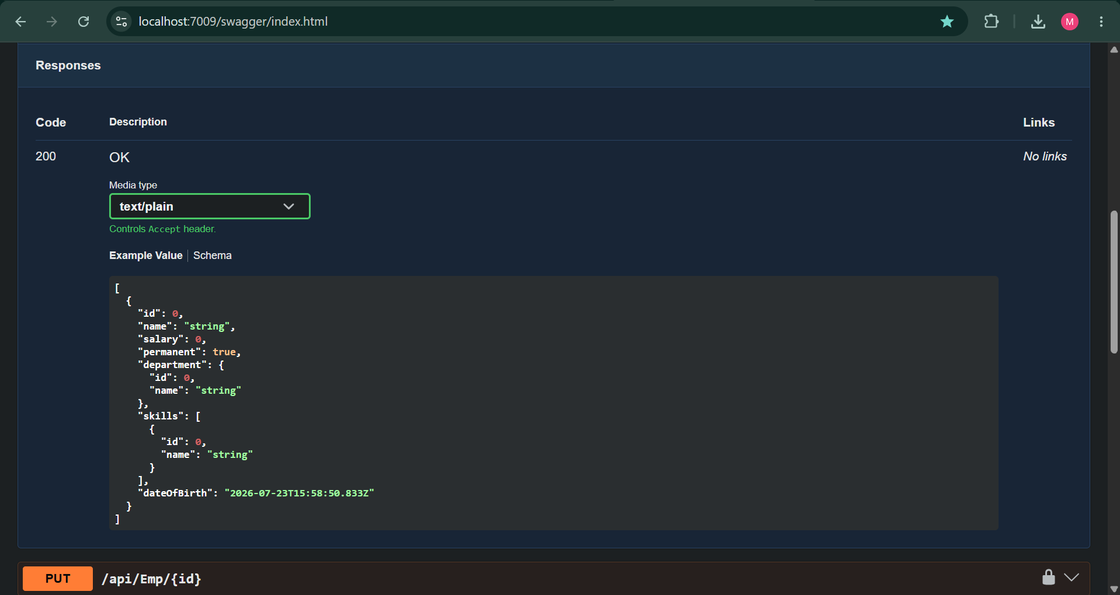

12. Result
JWT authentication was successfully implemented in the ASP.NET Core Web API. A login endpoint was created to validate user credentials and generate a JWT token. The Employee API was secured using the [Authorize] attribute. After providing a valid Bearer token through Swagger, the protected GET /api/Emp endpoint successfully returned 200 OK.

