Lab 5 - Retrieving Data using Entity Framework Core

Objective
Retrieve records from the Categories and Products tables using Entity Framework Core and display them in the console.

Program.cs
using Microsoft.EntityFrameworkCore;
using RetailInventory.Data;

using var context = new AppDbContext();

var products = context.Products
.Include(p => p.Category)
.ToList();

Console.WriteLine("========== PRODUCT LIST ==========\n");

foreach (var product in products)
{
Console.WriteLine($"Product ID : {product.Id}");
Console.WriteLine($"Product Name : {product.Name}");
Console.WriteLine($"Price : ₹{product.Price}");
Console.WriteLine($"Category : {product.Category.Name}");
Console.WriteLine("----------------------------------");
}

Console.WriteLine("\nData retrieved successfully!");

Execution Steps
- Run the application.
- Retrieve product records from the database.
- Display the product details in the console.
- Verify the data with SQL Server Management Studio if required.

Console output displaying the product list

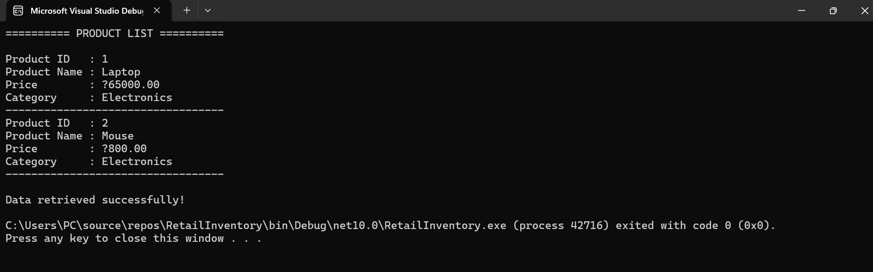

SSMS Categories table, SSMS Products table

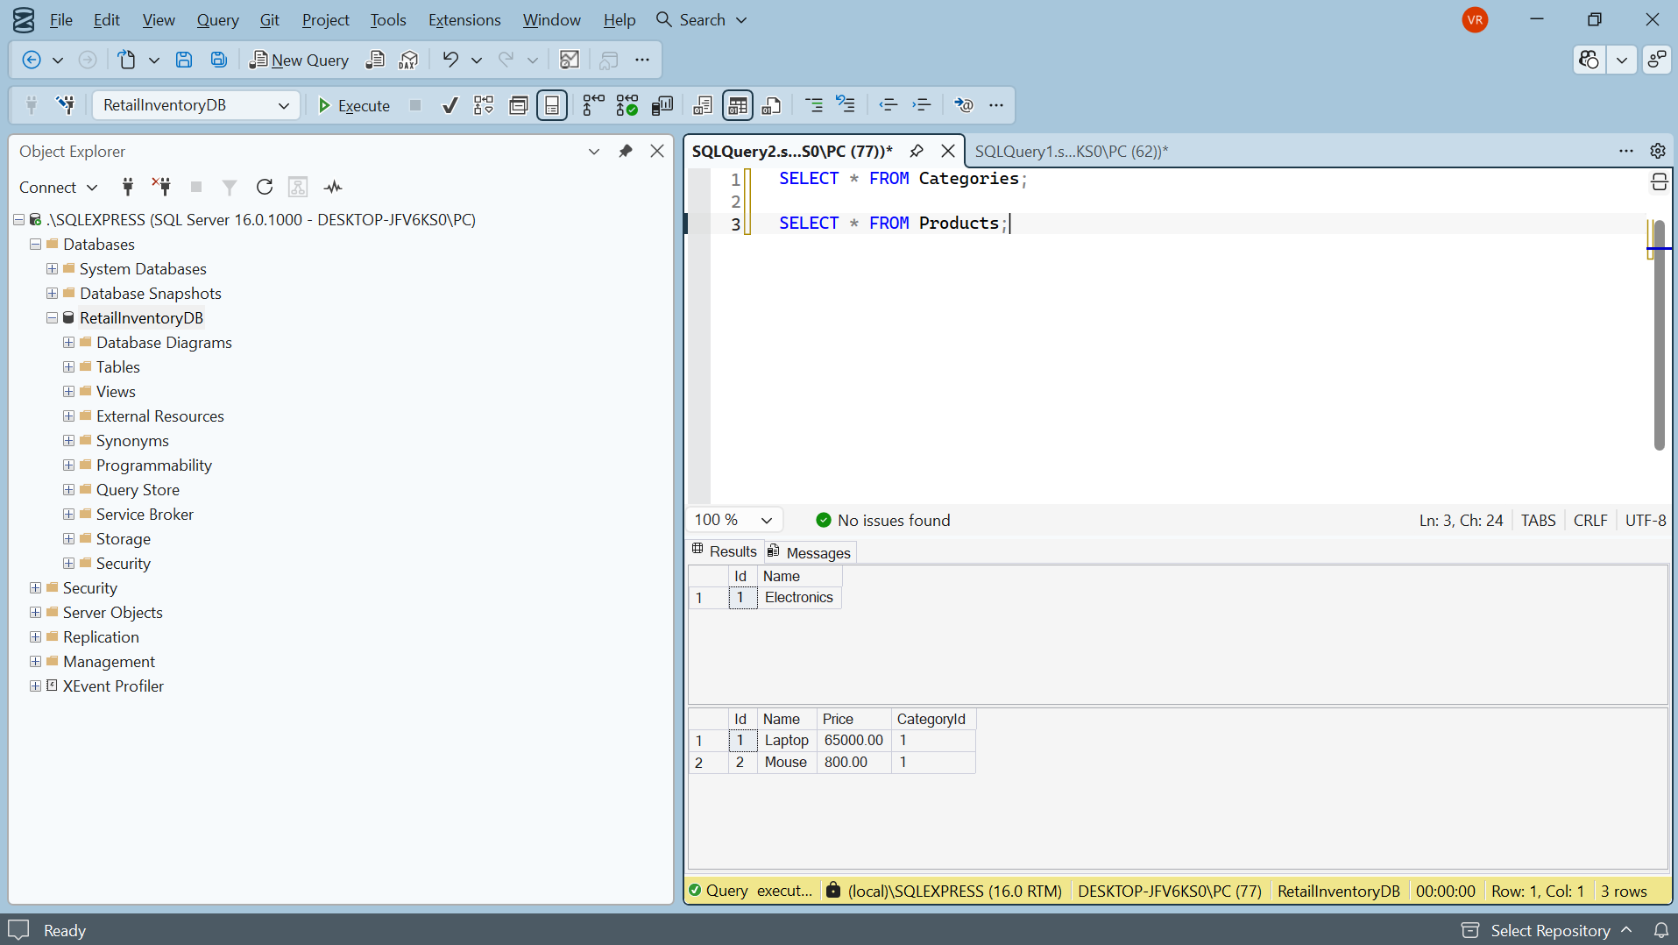

Result
The product records were successfully retrieved from the SQL Server database using Entity Framework Core and displayed in the console application.

