Healthcare Chatbot for Home Remedies

A dissertation submitted in the partial fulfilment of the academic requirements for the award of degree of

Bachelor of Engineering

In

Computer Science and Engineering (AI/ML)

By

CHETTABOINA MANASA GANGOTRI (100521729014)

SAI CHANDANA (100521729050)

Under the guidance of
Mrs. Pragnavi
Assistant Professor
Department of CSE



DEPARTMENT OF COMPUTER SCIENCE AND ENGINEERING

UNIVERSITY COLLEGE OF ENGINEERING
(AUTONOMOUS)

DEPARTMENT OF COMPUTER SCIENCE AND ENGINEERING
UNIVERSITY COLLEGE OF ENGINEERING
OSMANIA UNIVERSITY

CERTIFICATE

This is to certify that the Major project work entitled HealthCare ChatBot For Home Remedies
Signature of the Supervisor | Signature of Head of the Dept.
Mrs.Pragnavi | Prof. P.V.Sudha
Dept. of CSE, OU | Dept. of CSE, OU
submitted by Chettaboina Manasa Gangotri(100521729014), Sai Chandana(100521729050) a student of DEPARTMENT OF COMPUTER SCIENCE AND ENGINEERING(AIML), UNIVERSITY COLLEGE OF ENGINEERING, OSMANIA UNIVERSITY in partial fulfilment of the requirements for the award of the degree of Bachelor of Engineering is a record of the bonafide work carried out by them during the academic year 2024-2025.

STUDENT DECLARATION

We declare that the work reported in the project report entitled “HealthCare ChatBot For Home Remedies” submitted by Chettaboina Manasa Gangotri(100521729014), Sai Chandana(100521729050) is a record of the work done by us in the DEPARTMENT OF COMPUTER SCIENCE AND ENGINEERING (AIML), UNIVERSITY COLLEGE OF ENGINEERING, OSMANIA UNIVERSITY. No part of the report is copied from books/ journals/internet and wherever referred, the same has been duly acknowledged in the text. The reported data is based on the work done entirely by us and not copied from any other source or submitted to any other Institute or University for the award of a degree or diploma.

SIGNATURES:

Chettaboina Manasa Gangotri

Sai Chandana

ACKNOWLEDGEMENT

I would like to express my deep sense of gratitude and whole-hearted thanks to my project guide Mrs.Pragnavi, Assistant Professor, Department of Computer Science and Engineering, University College of Engineering Osmania University, for giving me the privilege of working under her guidance, with tremendous support and cogent discussion, constructive criticism and encouragement throughout this dissertation work carrying out the project work. Department of Computer Science and Engineering
I also thank Prof. P.V.Sudha, Head of Department of Computer Science and Engineering for her support from the Department and allowing all the resources available to us students.
I also extend my thanks to the entire faculty of the University College of Engineering, Osmania University who encourages us throughout the course of our Bachelor degree and allowing us to use the many resources present in the department.
Our sincere thanks to our parents and friends for their valuable suggestions, morals, strength and support for the completion of our project.

CHETTABOINA MANASA GANGOTRI(100521729014)
SAI CHANDANA (100521729050)

Abstract

This project introduces a Home Remedies Chatbot aimed at promoting natural health solutions by providing generalized home remedies for common health issues. The chatbot is developed using Rasa and integrates a pre-trained language model to understand user queries through natural language processing and respond with relevant home remedies. It also employs embedding-based similarity techniques to accurately match user-described symptoms with appropriate remedies from a curated dataset.
To improve user engagement and accessibility, the chatbot supports voice feature. For each health issue addressed, the bot not only suggests remedies but also provides external reference links for key ingredients, ensuring users can easily access or learn more about them. A distinctive feature of the system is the feedback and suggestion module, which invites users to share their own knowledge of remedies. These inputs are stored in a secure admin dashboard, enabling the administrator to review, validate, and incorporate valuable user contributions into the training data—making the chatbot continuously improvable.
The bot further offers ingredient-specific information and suggests generalized daily health schedules that users can follow to manage or prevent the given health issue. The system is designed to serve as a first-level, informative assistant for promoting wellness using traditional and natural practices.

Keywords: Home Remedies Chatbot, Natural Health Solutions, Rasa, Voice-enabled Chatbot, Cosine Similarity, Feedback System, Ingredient References, Generalized Health Advice, Symptom Matching, User-Driven Improvement, Traditional Medicine

Table of Contents

Chapter | Title | Page No.
1 | INTRODUCTION | 1
1.1 | Basic Concepts | 1
1.2 | Motivation | 3
1.3 | Problem Statement | 3
1.4 | Scope | 4
1.5 | Objectives | 4
1.6 | Advantages | 4
2 | LITERATURE REVIEW | 5
2.1 | Disease Detection Using RASA Chatbot Factorization [1] | 5
2.2 | An NLP Chatbot on Home Remedies for Common Diseases [2] | 6
2.3 | Recommender System for Home Remedy [3] | 6
2.4 | Personal Healthcare Chatbot for Medical Suggestions Using AI and ML [4] | 7
2.5 | Doctor Chatbot: Heart Disease Prediction System [5] | 8
3 | SOFTWARE REQUIREMENT ANALYSIS | 9
3.1 | Functional Requirements | 9
3.2 | Non-Functional Requirements | 10
3.3 | Software Requirements | 11
3.4 | Hardware Requirements | 11
4 | PROPOSED SYSTEM | 12
4.1 | System architecture | 12
4.2 | Process Flow Diagram | 13
4.3 | Methodology | 13
4.3.1 | Data Pre-processing | 14
4.3.2 | Voice-Based Input | 14
4.3.3 | Rasa NLU | 14
4.3.4 | Semantic Similarity Matching | 15
4.3.5 | Output | 16
4.3.6 | Feedback Mechanism | 16
4.4 | Algorithm / Pseudo Code | 16
4.4.1 | Data Preprocessing | 16
4.4.2 | Model Architecture: Rasa | 17
4.4.3 | Model Training | 18
4.5 | Dataset Collection | 21
5 | IMPLEMENTATION | 22
5.1 | Environment setup | 22
5.2 | Directory structure | 23
5.3 | Running the project | 23
5.4 | Interface and functionality snapshots | 24
5.5 | Performance analysis | 25
6 | CONCLUSION AND FUTURE WORK | 27
 | REFERENCES | 28
 | List of Figures
Fig 4.0 | System architecture | 12
Fig 4.1 | Process flow diagram | 13

Chapter I

INTRODUCTION
In an era where individuals are increasingly seeking accessible and holistic approaches to health and well-being, this project introduces an innovative solution: a Home Remedies Chatbot built upon the robust Rasa framework. This interactive platform empowers users to effortlessly inquire about common health concerns and receive relevant natural remedies. Recognizing the diverse ways users interact with technology, the chatbot accommodates both text and voice input for symptom descriptions, ensuring a user-friendly experience for all. At its core, the chatbot harnesses the power of cutting-edge natural language processing techniques, including pre-trained models for paraphrasing both user prompts and its own responses, thereby fostering clear and natural-sounding conversations. By employing sophisticated embedding models and cosine similarity algorithms, the system intelligently retrieves the most pertinent remedies based on the nuances of the user's query.
Beyond simply suggesting remedies, this chatbot enhances user understanding and trust by providing reference links to the ingredients involved, allowing for deeper exploration of their properties and benefits. Furthermore, it proactively supports preventative health by offering generalized daily routines that users can adopt to promote overall well-being and potentially mitigate the recurrence of symptoms. Addressing the inherent challenge of static datasets, the project incorporates a valuable feedback and suggestion mechanism. This community-driven feature enables users to share their knowledge of alternative remedies, which are then securely stored for administrator review and potential integration into future training data. This dynamic approach ensures the chatbot continuously learns, adapts, and evolves, becoming an increasingly comprehensive and community-enriched resource.
Ultimately, this project exemplifies the powerful synergy between artificial intelligence and traditional health knowledge, paving the way for a scalable and interactive adoption of holistic health practices.

Basic Concepts

Rasa Framework:
Rasa is a robust open-source conversational AI framework designed for building intelligent and context-aware chatbots, comprising two key components: Rasa NLU for extracting structured data like intent and entities from user messages through machine learning pipelines, and Rasa Core for managing the conversation flow and deciding the chatbot's next actions based on dialogue state and user input. Notably, Rasa's support for custom actions enables developers to execute specific Python code for tasks such as retrieving remedies, storing suggestions, or providing references, making it well-suited for complex, real-world applications like a home remedies system. Furthermore, Rasa offers versatile integration capabilities with various messaging platforms, voice assistants, and REST APIs.

- Natural Language Processing:

Natural Language Processing (NLP) is a subfield of artificial intelligence that enables machines to understand, interpret, and generate human language. In this chatbot, NLP is crucial for interpreting user inputs, particularly in identifying symptoms, health issues, or goals like weight loss. It plays a key role in determining the user’s intent—whether they are asking for a remedy, providing feedback, or seeking ingredient information—and in extracting relevant entities such as symptoms or natural ingredients. NLP techniques like stop-word removal, lemmatization, and text normalization help preprocess diverse user queries, ensuring consistent and accurate understanding of natural language across various sentence structures.

- Pre-trained models:
Pre-trained language models, including BERT, T5, and GPT, leverage transformer architectures trained on extensive datasets to achieve a deep understanding of language context, enabling capabilities such as paraphrasing and the generation of meaningful embeddings. In this project, these models play a crucial role in recognizing semantically similar user prompts expressed in different ways (prompt paraphrasing), ensuring that the chatbot's responses can be varied and more human-like (response paraphrasing), and enhancing the accuracy of matching user queries with appropriate remedies through improved semantic understanding. These powerful models can be integrated directly via APIs like Hugging Face Transformers or deployed locally to optimize response times.

Semantic Similarity Matching
To effectively connect user-described symptoms with the most suitable remedy from the knowledge base, the system employs a semantic search approach. This involves converting user input and remedy descriptions into high-dimensional text embeddings using tools such as Sentence-BERT (SBERT) or spaCy, which capture the underlying semantic meaning of the text. Subsequently, cosine similarity is calculated between these embedding vectors to quantify their relatedness. A higher cosine similarity score signifies a stronger semantic match between the user's query and a specific remedy, enabling the chatbot to understand the context of the message rather than relying solely on keyword matching.

Speech Recognition
To facilitate voice-based interactions and broaden accessibility, the chatbot incorporates speech recognition functionalities, utilizing libraries such as the Google Speech Recognition API or Python's SpeechRecognition to transcribe spoken words into text. Once converted, this textual input seamlessly integrates into the existing Rasa NLU pipeline for intent recognition and entity extraction, just as with typed queries. This feature significantly enhances the bot's usability, particularly for individuals who may have difficulty typing or prefer hands-free operation, making it especially advantageous in mobile or embedded application scenarios.

  - Motivation

The motivation behind this project stems from the growing need for quick, natural, and reliable health solutions readily accessible without requiring a healthcare visit for minor ailments. While traditional home remedies offer a wealth of knowledge, this information is often fragmented and inaccessible. Recognizing the increasing digital literacy and user expectation for interactive and personalized information, this project aims to bridge the gap between time-honored health practices and modern technology. By developing an AI-powered chatbot capable of understanding user-described symptoms and intelligently suggesting relevant home remedies, accepting voice input for ease of use, providing valuable ingredient references, and even allowing users to contribute their own knowledge, the project seeks to create a convenient, scalable, collaborative, and continuously improving health resource.

1.3 Problem Statement

The core problem this project addresses is the difficulty users face in accessing verified and reliable traditional home remedy information through an easily accessible, interactive, and continuously evolving platform tailored to their specific health concerns. Existing resources are often fragmented, lack validation, require extensive searching, or lack the sophistication to understand natural language variations and voice input.Furthermore, while existing AI-driven systems may offer some health information, they often fall short in providing verified traditional home remedies through a truly conversational and voice-enabled interface. The challenge remains in creating a platform that not only understands natural language and voice input but also intelligently matches symptoms with a curated and verified knowledge base of remedies. Moreover, there's a need for a system that continuously learns and improves by incorporating user feedback and suggestions through a robust verification process, ensuring the reliability and accuracy of the provided information.

1.4 Scope

The scope of this project involves building an intelligent chatbot using the Rasa framework that offers home remedies for various minor health issues based on user-described symptoms. The system supports both text and voice input, uses pre-trained NLP models for understanding and matching queries, and provides reference links for ingredients. Additionally, the bot allows users to provide feedback and suggest remedies, which are stored in an admin dashboard for review and further training. While the bot offers generalized remedies and information, the current scope does not include personalized treatment plans based on detailed medical history, making it suitable for common and non-critical health concerns.

1.5 Objectives
The primary objectives of this project are to develop a chatbot that can effectively understand natural language queries concerning common health symptoms through the application of Natural Language Processing (NLP). The chatbot will then suggest relevant and, importantly, verified home remedies based on the user-described symptoms. To enhance accessibility, the system will support voice-based interaction by integrating speech recognition technologies. Furthermore, the project aims to establish a collaborative improvement loop by enabling users to provide feedback and suggest their own remedies, which can be reviewed and potentially incorporated. Finally, the chatbot will offer valuable reference links and educational content pertaining to the ingredients used in the remedies, as well as generalized daily health routines for promoting overall well-being.

1.6 Advantages
This Home Remedies Chatbot offers several key benefits, starting with enhanced accessibility through both voice and text interaction, catering to users who may find typing inconvenient. It promotes the use of natural and safe remedies, providing an alternative approach to managing minor health issues without immediate reliance on pharmaceutical interventions. The system is designed for continuous learning, as it incorporates user feedback and suggestions to progressively improve the accuracy and comprehensiveness of its remedy database. By directly providing relevant remedies in response to user queries, it saves valuable time that would otherwise be spent manually searching through numerous articles or websites. Finally, the user-friendly conversational interface, powered by advanced integration, ensures ease of use and the ability to effectively handle a wide range of user input styles.
Chapter II

LITERATURE REVIEW

2.1 Disease Detection Using RASA Chatbot [1]
This research paper explores the development and application of a medical chatbot using RASA, an open-source conversational AI framework. The chatbot is designed to assist in disease detection by interacting with users and analyzing their symptoms using machine learning algorithms, primarily Support Vector Machine (SVM) and Naïve Bayes classifiers.
It leverages advancements in Natural Language Processing (NLP) to understand user input and provide meaningful responses. The chatbot aims to reduce the burden on healthcare systems, especially by offering quick consultations for minor issues, improving early disease detection, and minimizing unnecessary hospital visits.

Advantages:
The RASA-based chatbot offers continuous availability, allowing users to consult it anytime without scheduling appointments. It helps reduce the burden on healthcare facilities by addressing common or minor health concerns. By encouraging early symptom checking, it promotes preventive healthcare. The chatbot is cost-effective and user-friendly, making it accessible to a broad audience. It uses machine learning and NLP to deliver accurate responses based on user input. Integration with APIs also enables users to locate nearby specialists and book appointments easily.
Disadvantages:
The chatbot’s predictions are limited to diseases it has been trained on, reducing its effectiveness for rare or complex conditions. Its accuracy depends on the quality of training data, which may not always be comprehensive or up-to-date. It lacks the capability for physical examinations, essential for accurate medical diagnosis. Sensitive user data raises privacy and security concerns if not handled properly. The system may struggle with understanding emotional or nuanced inputs from users. Lastly, it cannot replace the personalized care and empathy provided by human medical professionals. structures or overlapping clouds. The computational cost of the method may be high for large images or datasets.

2.2 An NLP Chatbot on Home Remedies for Common Diseases [2]
The paper presents a medical assistant chatbot designed to provide home remedies for common illnesses using Natural Language Processing (NLP) techniques. It leverages TF-IDF and cosine similarity algorithms for intent matching and response generation. The system performs text preprocessing (tokenization, stemming, lemmatization) and converts user queries into vector representations. These vectors are used to fetch relevant information from a predefined database. The chatbot is built with Python using Flask for the front-end and incorporates a dialogue .
Advantages:
The chatbot system presented in the paper offers a fast, cost-effective, and accessible solution for delivering traditional home remedies to users. By leveraging lightweight NLP techniques such as TF-IDF and cosine similarity, the chatbot ensures interpretable and computationally efficient responses. The architecture separates the user interface and chatbot model, enhancing modularity and flexibility for future upgrades. Moreover, the system demonstrated strong performance in testing, with a precision rate of 85.71%, a perfect recall of 100%, and an overall F1-score of 92.3%, indicating its capability to provide accurate and relevant information for common health concerns.

Disadvantages:
Despite its strengths, the chatbot has certain limitations. The reliance on rule-based NLP approaches like TF-IDF may lead to reduced accuracy when handling ambiguous queries or natural language variations, limiting the chatbot’s scalability and adaptability. Additionally, the system operates on a static dataset and lacks dynamic learning capabilities, which means it cannot evolve or personalize responses over time. The absence of advanced semantic analysis or deep learning methods further restricts its ability to understand user context in complex conversation.

2.3 Recommender System for Home Remedy[3]

This paper presents a recommender system that suggests home remedies like fruits and herbs based on the user's selected symptoms. It uses four data mining algorithms—Decision Tree, Random Forest, Naive Bayes, and k-Nearest Neighbor—to process the symptom inputs and provide remedy suggestions. The system displays the most accurate prediction along with instructions for remedy use and also integrates a feature to locate nearby hospitals using Google Places API.

Advantages:
The proposed system provides an accessible and affordable alternative to traditional treatment by recommending natural remedies without requiring a medical prescription. By using multiple classification algorithms, it ensures robust prediction accuracy, with Naive Bayes consistently performing the best (75–85%). The user-friendly web portal allows users to easily select symptoms and receive personalized suggestions. The integration of location-based hospital search adds extra value and support for users seeking further assistance.

Disadvantages:
One limitation is that the system requires users to input exactly five symptoms, which might restrict flexibility and user convenience. The remedies are based on a fixed dataset, and the system lacks real-time learning or medical validation for the recommended items. Additionally, the system assumes general suitability of remedies without accounting for personalized health conditions, allergies, or medication conflicts, which could affect its safe applicability.

2.4 Personal Healthcare Chatbot for Medical Suggestions Using Artificial Intelligence and Machine Learning[4]

This research presents an AI-powered healthcare chatbot designed to identify diseases based on user-input symptoms and provide corresponding medical suggestions. Utilizing Natural Language Processing (NLP) and Machine Learning (ML) algorithms, the chatbot analyzes user queries to determine the severity of the condition. For negligible health issues, it offers remedies, including Ayurvedic and Homeopathic treatments. In cases of severe conditions, it advises users to consult medical professionals. The system aims to serve as an initial point of contact, offering immediate assistance and guidance.

Advantages:
The proposed healthcare chatbot provides users with immediate medical guidance based on symptoms entered via a conversational interface. One of its major advantages is its ability to distinguish between minor and severe health conditions. For less serious ailments, it offers safe home-based solutions, including Ayurvedic and Homeopathic remedies, making healthcare more accessible and affordable. The system leverages NLP and machine learning to analyze user input accurately, helping users make quick health decisions.
Disadvantages:
The chatbot only supports text-based interaction and lacks voice input, limiting accessibility for users with low literacy or disabilities. It does not personalize suggestions based on individual medical history or allergies. The system may give generic advice for complex or rare conditions.

2.5 Doctor Chatbot: Heart Disease Prediction System [5]
The paper presents a medical chatbot developed using Dialogflow and integrated with a Support Vector Machine (SVM) classifier to predict heart disease based on user symptoms and medical data. The chatbot simulates a human-like interaction to gather health-related information and leverages a heart disease dataset to make predictions. The system uses technologies such as Python (Flask), ngrok for backend communication, and Dialogflow for NLP. After prediction, the chatbot can assist in booking doctor appointments. The SVM model achieved the highest accuracy (90%) among other classifiers like k-NN, Naïve Bayes, and Decision Tree, making it the primary model used in the system. The chatbot also emphasizes disclaimers to ensure users don't fully rely on it for medical decisions.
Advantages:
The chatbot provides a cost-effective and accessible way for early heart disease detection, especially in areas with limited medical facilities. It reduces the need for in-person consultations for minor symptoms, saving time for both patients and doctors. The system ensures high accuracy in prediction by leveraging the SVM algorithm. With a friendly interface via Dialogflow, users can interact using text or voice, making it user-friendly for all age groups. The chatbot is available 24/7 and can connect users with doctors for follow-up care. Integration with modern tools (Python, Flask, ngrok) makes it scalable and adaptable for various platforms.
Disadvantages:
The chatbot cannot perform physical examinations or provide personalized medical advice, making it unsuitable for complex or emergency medical situations. Its predictions are limited by the size and quality of the training dataset, which may result in inaccurate or biased outputs for diverse patients.

Chapter III

SOFTWARE REQUIREMENT ANALYSIS

Analysis of the requirements, also known as requirements engineering, is the method of evaluating consumer demands for a new or changed product. Analysis of requirements is a team activity involving a mix of experience in engineering hardware, software, and human factors, as well as skills in communicating with people. These characteristics, called criteria, have to be quantifiable, specific, and detailed. Such criteria are also termed functional specifications in software en- gineering. Analysis of specifications is an important part of project management that requires regular contact with authorized users to establish particular function- ality preferences, dispute resolution, or uncertainty in specifications as requested by the different users or community groups.
A specification on software requirements is a detailed overview of the intended function and ecosystem for the under-research program. The Software Requirements Specification thoroughly explains what the program is going to do, and how it is supposed to function. A Software Requirement specification reduces the pro- grammer’s time and means to improve desired targets, and therefore minimizes production costs. In a wide range of real-world scenarios, a successful Software Requirement Specification determines how an application communicates with the machine hardware, other programs, and human users.
This chapter includes an analysis of the requirements for the proposed project. This chapter contains
- Functional Requirements.
- Non-Functional Requirements.

3.1 FUNCTIONAL REQUIREMENTS
Functional requirement analysis entails the thorough examination, analysis, and documentation of software and hardware requirements with the goal of addressing specific issues. This analysis aids in gaining a comprehensive understanding of the essential software and hardware elements required to effectively resolve the identified problems.
User Input Handling
The system is designed to accommodate user preferences by accepting queries through both text and voice. To facilitate voice interaction, it incorporates a speech-to-text engine, such as Google Speech Recognition, which automatically transcribes spoken input into text for subsequent processing by the chatbot's natural language understanding module.Furthermore, our model extends this accessibility by also reading the chatbot's responses back to the user, creating a truly interactive and hands-free experience.

Natural Language Understanding (NLU)
A core functionality of the bot is its ability to understand the user's intention behind their message, such as whether they are asking for a remedy, providing feedback, or seeking information about an ingredient. Complementary to this, the system must also accurately identify and extract key entities from the user's input, including specific symptoms, health conditions they are inquiring about, and any mentioned ingredients.

Paraphrased Input Interpretation
To effectively handle the natural variations and diverse phrasing in user input, the system leverages the power of pre-trained language models, such as BERT or T5. These models enable the chatbot to understand rephrased queries and accurately map them to the intended user goal and the most appropriate response, ensuring a more robust and flexible conversational experience.

Remedy Suggestion
Upon identifying the user's symptom or health issue, the chatbot is designed to provide a relevant and generalized home remedy. To enhance user understanding and facilitate further exploration, each suggested remedy will include readily accessible reference links for all the mentioned ingredients.

Feedback and Suggestion Handling
To foster user engagement and continuous improvement, the chatbot incorporates a mechanism for users to rate the helpfulness of the responses they receive and to contribute their own home remedy suggestions. These valuable user-provided suggestions are securely stored in a database or an administrative dashboard, allowing administrators to review, verify, and potentially integrate them into the chatbot's knowledge base.

Ingredient Information
The system is designed to be informative beyond just suggesting remedies; users can directly inquire about specific ingredients mentioned in the remedies or elsewhere. In response to such queries, the chatbot will provide relevant details about the ingredient, including its potential health benefits and common usage methods.

General Health Routine Suggestions
To further support user well-being, the chatbot will also offer generalized daily schedules and routines. These schedules are designed to help users maintain good overall health or aid in their recovery process from common health issues, providing practical guidance beyond immediate remedies.

3.2 NON-FUNCTIONAL REQUIREMENTS
Non-functional requirements describe how a system must behave and establish constraints on its functionality. This type of requirement is also known as the system’s quality attributes.
The Non-functional requirements of this project are:

Performance
Ensuring a seamless and responsive user experience is a priority; therefore, the system is engineered to provide real-time responses with minimal latency, ideally within a 2–3 second timeframe. This necessitates that critical processes such as voice-to-text and vice versa conversion and the retrieval of relevant remedies from the knowledge base are optimized to operate within acceptable delay limits, ensuring fluid and timely interactions.
Usability
A key aspect of the chatbot's design is an intuitive user interface that ensures ease of interaction for all users. Special attention will be paid to the clarity of both voice input processing and the synthesized voice responses, aiming to maximize accessibility for individuals across various age groups and levels of technical familiarity.
Accuracy
The core intelligence of the system lies in its ability to accurately interpret the underlying intent behind user queries and reliably extract key entities, even when the input is phrased in diverse or slightly ambiguous ways. Furthermore, the suggested remedies must be highly relevant, dependable, and precisely aligned with the user's described symptoms, ensuring the information provided is both helpful and trustworthy.

3.3 Software Requirements
Operating System: Windows 10/11 or Ubuntu 20.04
Programming Language: Python 3.8
Frameworks & Libraries: The core technologies employed include Rasa (Core & NLU) for conversational AI, Hugging Face Transformers (e.g., T5/BERT) for advanced language understanding, SpeechRecognition and pyaudio for voice interaction, and potentially scikit-learn, Spacy, and Flask/FastAPI for additional functionalities.
APIs & Tools:For handling voice input, the Google Speech Recognition API will be utilized to convert spoken language into text. To securely store user feedback and suggested remedies, a database solution such as SQLite or MongoDB will be implemented.
IDE: VS Code / PyCharm

3.4 Hardware Requirements
Modern OS (Windows 7/10 or macOS X 10.11+), i3 or higher processor, x86 64-bit CPU.
8GB DDR4 RAM or above; optional 4GB+ GPU for enhanced performance.
Chapter IV

PROPOSED SYSTEM

4.1 System Architecture
In the figure 4.0 we can see the interactions between different components of the system.

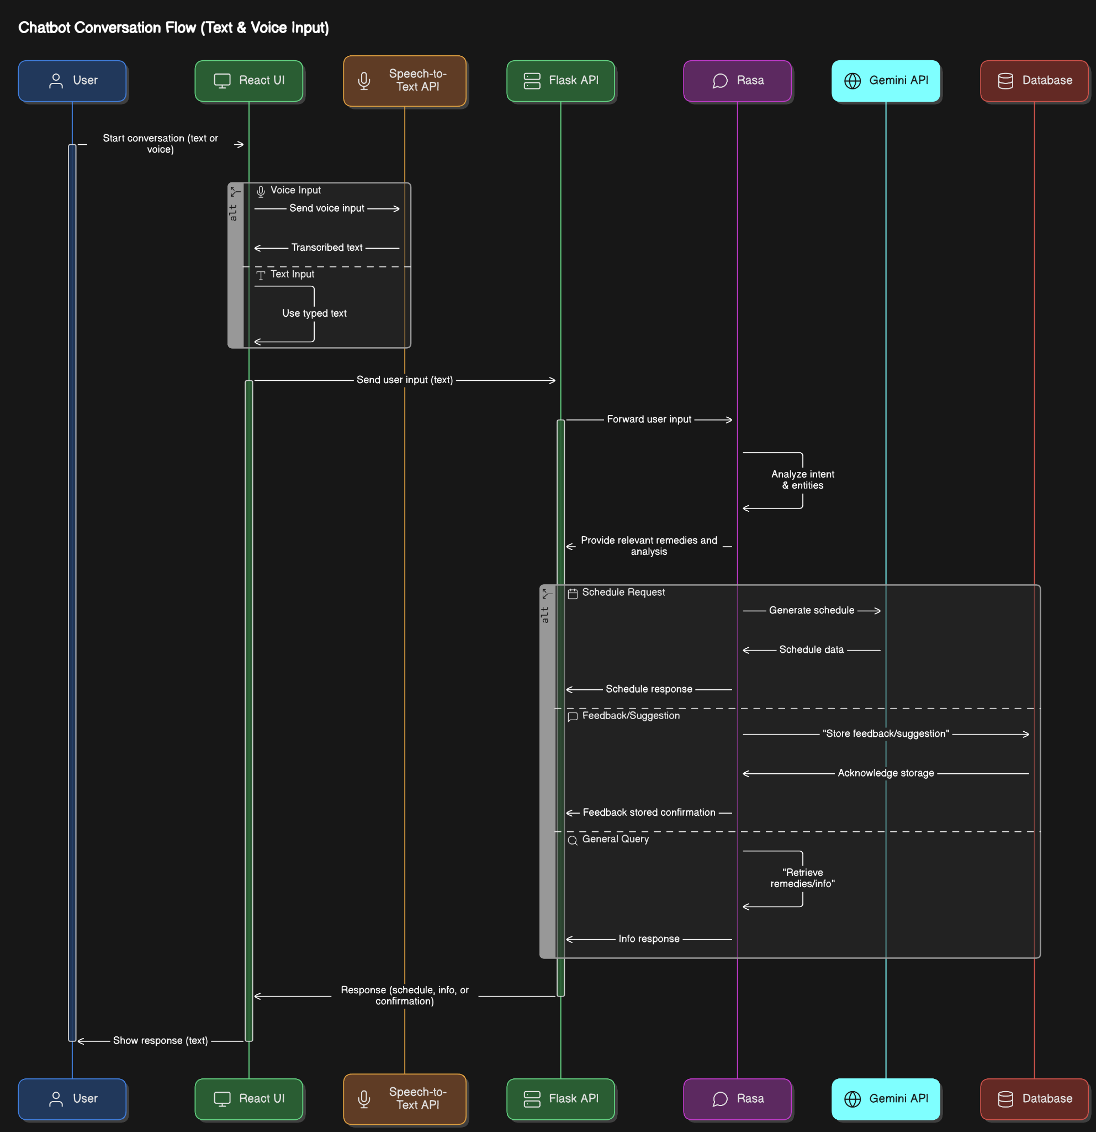

Figure 4.0

4.2 Process Flow Diagram
In the figure 4.1 we can see the flowchart for processor execution of user queries.

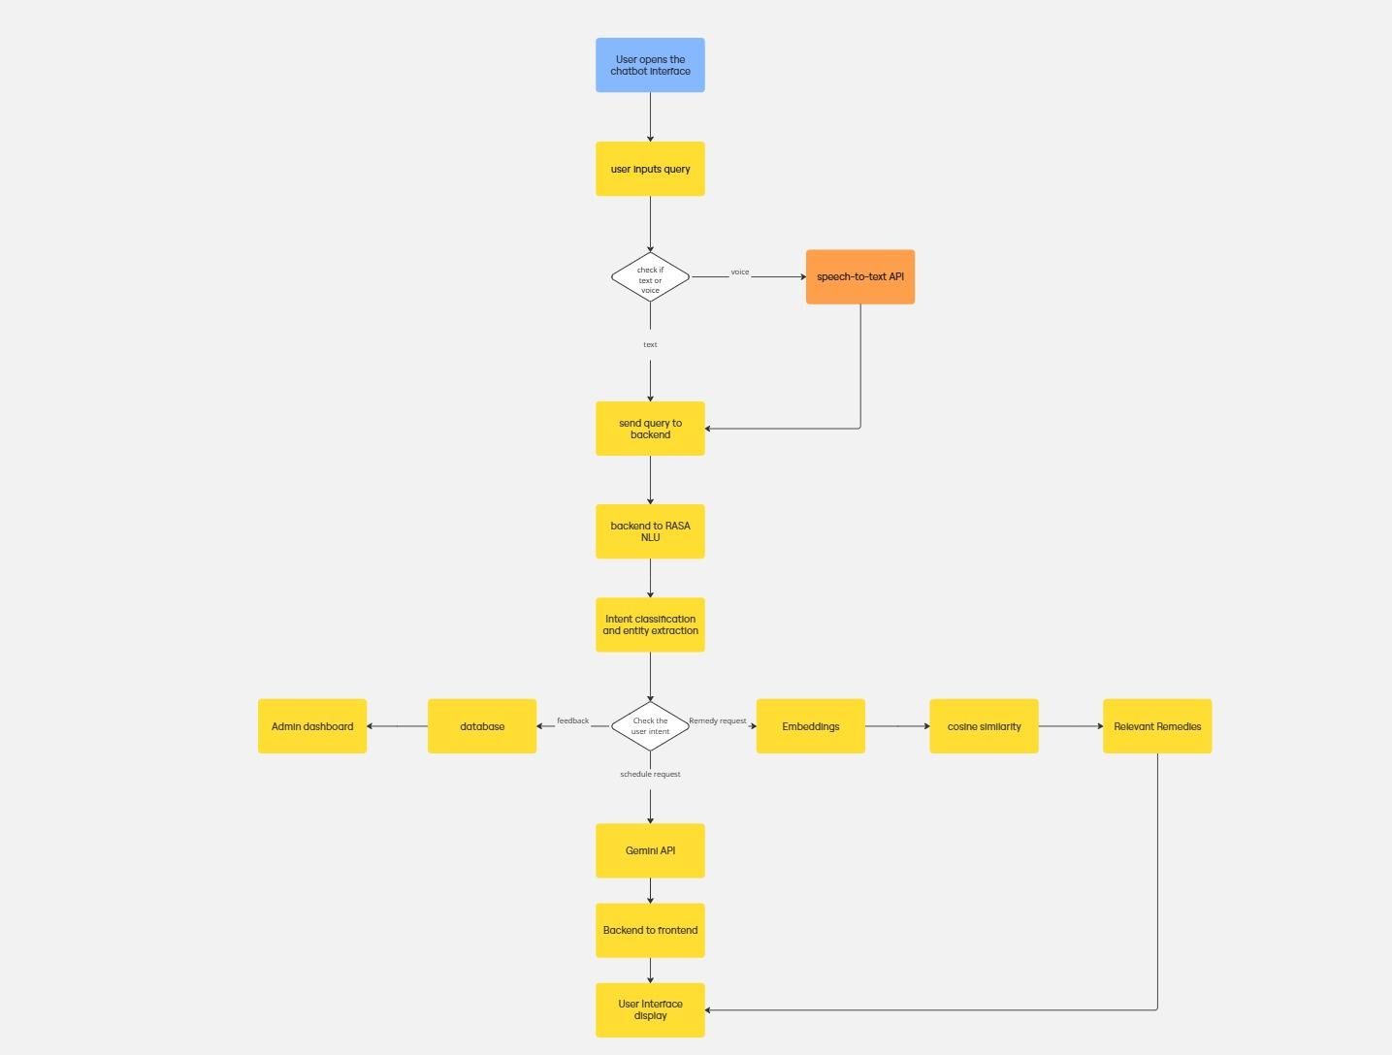
‘
Figure 4.1

4.3 Methodology
The different modules implemented in the project are discussed in this section. The modules included are Data collection, Pre-processing, Training and Testing and Output.

4.3.1 Data Pre-processing
The initial stage of data preprocessing focused on cleaning and preparing the dataset, sourced from Kaggle and WebMD, to ensure consistency and usability. This involved removing duplicate entries, addressing missing values appropriately, and normalizing textual data, such as symptoms and remedies, through techniques like lowercasing. Subsequently, to enhance the chatbot's semantic understanding of user queries, health issue descriptions were transformed into dense vector representations using the pre-trained language model sentence-transformers/gtr-t5-base from the Sentence Transformers library. This embedding generation process captures the contextual meaning of symptoms, enabling the chatbot to understand the underlying concepts beyond mere keyword matching. These embeddings were pre-computed and stored for rapid retrieval during chatbot interactions, significantly improving the efficiency of matching user queries with relevant remedies.

4.3.2 Voice Based Input
The voice input methodology in the home remedies chatbot enhances user accessibility by allowing users to interact through speech instead of typing. This feature uses a speech-to-text API, such as Google Speech Recognition, which converts spoken language into written text in real-time. Once the user's voice input is transcribed, it is processed by Rasa’s NLU pipeline just like any other text input. This ensures seamless integration with the chatbot's core functionalities, including intent recognition and entity extraction. By supporting voice interaction, the chatbot becomes more user-friendly, especially for individuals with limited typing ability or those who prefer natural verbal communication.

4.3.3 Rasa NLU

Rasa NLU (Natural Language Understanding) is a key component of the Rasa framework that handles the essential tasks of intent recognition and entity extraction. It processes user input by classifying the intent behind the query, such as requesting a remedy or asking about ingredients, and simultaneously extracts relevant entities like symptoms, ingredient names, and health goals. Rasa NLU uses machine learning models like the DIET (Dual Intent and Entity Transformer) classifier, which leverages transformer-based architecture to perform both tasks efficiently in a single step
- Intent Recognition:
The DIET classifier in Rasa NLU is responsible for identifying the user's intent from their input. It accurately classifies various types of user queries, such as requesting a remedy, giving feedback, or asking for details about specific ingredients or health issues. By leveraging its transformer-based architecture, the DIET classifier can process and understand diverse inputs, ensuring that the chatbot can provide relevant and context-aware responses. This enables the system to efficiently handle multiple user intents in a seamless and effective manner, improving the overall user experience in the home remedies chatbot.
- Entity extraction:
The DIET classifier in Rasa NLU also performs entity extraction alongside intent recognition. It identifies and extracts relevant entities from user inputs, such as symptoms, ingredient names, and health goals like weight loss. This dual function enables the chatbot to not only understand the user's intent but also capture specific details necessary to provide personalized and accurate responses. By extracting these entities, the system can better match user queries with appropriate remedies, ingredients, or health advice, enhancing the chatbot’s ability to deliver contextually accurate solutions.

4.3.4 Semantic Similarity Matching
The semantic similarity matching process involves several key steps to ensure that the chatbot can accurately retrieve relevant home remedies based on user input, even if the input is phrased differently.

Paraphrasing User Input: When the user provides an input, such as describing a symptom or health-related issue, the first step is to rephrase or paraphrase the user query. This is done using the T5-base model, a pre-trained transformer model fine-tuned for various NLP tasks. T5 helps in normalizing the input by generating a paraphrased version of the user's query, ensuring that different phrasings of the same issue are captured in a consistent form.

Embedding User Input: Once the input is paraphrased, the next step is to convert the query into a vector representation (embedding). This is done using an embedding model, such as sentence-transformers/gtr-t5-base. The embedding captures the semantic meaning of the query, which is critical for matching the user's intent with the appropriate remedies.
Storing Remedy Data: The home remedies, along with their associated symptoms, are also embedded using the same model. These remedy embeddings are stored in a database or file, allowing for easy comparison with the user input embeddings.
Cosine Similarity Calculation: To find the most relevant remedy for a given query, the cosine similarity measure is applied between the user’s input embedding and the stored remedy embeddings. Cosine similarity calculates the similarity between two vectors by measuring the cosine of the angle between them. The closer the cosine value is to 1, the more similar the two vectors are in terms of meaning.
Retrieving Relevant Remedies: The remedy that has the highest cosine similarity to the user’s query embedding is selected as the most relevant remedy. This remedy is then presented to the user, along with additional information such as ingredient details, preparation methods, or links to references.

4.3.5 Output

The Home Remedies Chatbot's output provides users with recommended remedies tailored to their health issues or symptoms, accompanied by valuable supplementary information. Upon receiving a user's input, the bot processes it to identify and deliver the most relevant home remedy suggestions. Each response is enhanced with reference links for the ingredients mentioned, empowering users with additional details on their effective usage.

4.3.6 Feedback mechanism

The feedback mechanism in the home remedies chatbot allows users to provide input on the suggested remedies, ensuring continuous improvement of the system. After receiving a remedy, the user is prompted to rate the response or provide suggestions based on their personal knowledge or experience. These feedbacks, whether positive or suggesting improvements, are stored in the admin dashboard for review. The admin can verify these suggestions for accuracy and relevance before integrating them into the knowledge base. This process not only helps in refining the existing remedy suggestions but also allows the chatbot to evolve by incorporating user-provided knowledge, enhancing its ability to suggest effective and personalized solutions over time.

4.4 Algorithm/Pseudo Code
The algorithm for providing home remedies for the user is described as follows:
Input: User prompt for a health query.
Output: Relevant home remedy.

4.4.1 Data Preprocessing
Input: Home remedies dataset
Output: Embeddings of the health issues.
Algorithm:
Step 1. Start by removing missing values from the dataset, normalise the data by converting it into lower case and extracting the health issue column from the dataset which is in the csv format.
Step 2: Apply sentence-transformers/gtr-t5-base embedding model on the health issues column.
Step 3: Encode the embedded health issues column.
Step 4: Finally, store the encoded format in the health_issues_embeddings.py file for quick retrieval.

4.4.2 Model Architecture:

Rasa architecture

Step 1: Create intents and sufficient examples for each intent in nlu.yml file to accurately recognize the intent of the user prompt.
eg
- intent: greet
examples: |
- hey
- hello
- hi
- hello there
- good morning
- good evening
- hey there
- good afternoon
- hi bot
- greetings
- howdy
- what's up
- hey, how are you
- good day
- morning!
- hey bot

Step 2: Set slots in the domain.yml file to store extracted entities from the user prompt and further provide the response accordingly.
eg.
Slots:
symptom:
type: text
influence_conversation: true
mappings:
- type: custom

Step 3: Create responses for each of the intents defined before. These responses can be retrieved dynamically by the bot using actions.py file where the algorithm is executed in python to extract the relevant responses. static responses can be defined in the domain.yml file itself.
eg.

responses:
utter_greet:
- text: "Hello! 👋 How can I help you today with your health or wellness?"

Step 4: Create stories which are flows to carry out the actions or responses provided in the domain.yml file for the bot. These stories are written in the stories.yml files. some of them can be in the rules.yml file, if the flow needs to be followed without any relaxation.
eg.
- steps:
- intent: health_query
- action: action_provide_home_remedy

Step 5: The relevant remedy is given as output by following the flow given in the yml format files.

4.4.3 Model Training
Input: Intents, responses, stories and actions
Output: A Trained Home remedies chat bot Model using rasa.
Algorithm: Diet Classifier

Step 1: Text Embedding
When a user sends a message like "I have a headache and fever", the first task is to convert this plain text into something a machine learning model can understand. This is done by breaking the sentence into tokens (in this case, words like "I", "have", "a", "headache", "and", "fever") and then transforming each token into a numerical representation called an embedding. These embeddings are vectors of real numbers that capture the meaning of each word in context.
For example, the word “fever” might be represented as a vector like [0.6, 0.2, ..., 0.9]. These word vectors are then passed into the model as the input.

Step 2: Contextual Understanding Using Transformer
After the embeddings are created, the DIET classifier uses a Transformer model to understand how the words in the message relate to each other. This model uses a mechanism called self-attention to determine which words are important when interpreting a particular token. For instance, in the sentence "I have a headache and fever", the model learns that "headache" and "fever" are symptoms and closely related, while "I" or "have" are less critical for entity extraction. The attention mechanism works mathematically by projecting each token into three vectors: queries (Q), keys (K), and values (V), and then computing scores using the formula:
Attention(Q,K,V) = softmax(QK^T/d^(k/2))*V
This helps the model focus on the most relevant words when encoding each token with context from the whole sentence.

Step 3: Sentence Embedding
Once each token is enhanced with context using the Transformer layers, the model needs a single vector that summarizes the entire message—this is called the sequence embedding or sentence embedding. This vector is generated by either averaging or pooling all the contextual token embeddings. This single vector (let’s call it s) is a compressed, meaningful representation of the user’s full message, capturing what the user is trying to say and which words are important.
s=1/n​ ∑hi​ where 1<i<n
n is the number of tokens in the sentence,
hi​ is the contextual embedding of the ithi^{th}ith token (after attention),
s is the final sentence vector.

Step 4: Intent Classification
With the sentence embeddings ready, the model now attempts to determine the user’s intent. It does this by passing through a linear layer followed by a softmax function, which calculates the probability of the message belonging to each possible intent class. The intent with the highest probability is selected as the predicted intent. The formula used for this is:
y^intent=softmax(Wi⋅s+bi)
where Wi​ is a learned weight matrix and bi is a bias term. For the example sentence, the model may predict the intent as "ask_symptom_remedy" with high confidence. During training, the model compares the predicted intent with the actual intent label and calculates the error using a cross-entropy loss function.

Step 5: Entity Extraction
While intent classification deals with the overall sentence meaning, entity extraction looks at individual words to identify important items like symptoms, dates, or locations. For each token embedding output from the Transformer, the model tries to classify it into predefined entity tags using another softmax layer. This means each token is checked to see if it belongs to an entity, and if so, what kind. For example, "headache" and "fever" would be labeled as SYMPTOM, while other words like “I” and “have” would be labeled as O (outside any entity). The formula used here is:
y^entity=softmax(We⋅ti+be)
where ‘ti’ is the embedding for the i-th token, and ‘We’ and ‘be’​ are weights and biases learned during training. The result is a label for each word in the message.

Step 6: Loss Calculation and Training
To improve itself, the DIET classifier calculates how wrong its predictions were for both the intent and the entity extraction tasks. It uses a cross-entropy loss function for both tasks separately, then combines them using a weighted formula:
Ltotal=λ⋅Lintent+(1−λ)⋅Lentity
Here, λ is a hyperparameter that controls how much importance to give to intent vs. entity training. During training, the model adjusts its internal weights to reduce this loss, meaning it gets better at understanding what the user wants and identifying key entities in the text.

Step 7: Paraphrasing the User Query
In this step, the user’s query q after identifying intent and navigating to the relevant action is passed through a paraphrasing model (e.g., T5). The result is a rephrased query q′q'q′ that carries the same meaning but might use different wording. While there’s no explicit formula for paraphrasing itself, you can represent this transformation as:
q′=Paraphrase(q)
Where: q is the original user query, q′ is the paraphrased query generated by the model.

Step 8: Embedding the Paraphrased Query
After the query has been paraphrased, it’s converted into a vector representation using an embedding model like gtr-t5-base (or any Transformer-based model). This converts the paraphrased query q′q'q′ into a high-dimensional vector sss of size ddd, where each dimension represents a semantic feature of the sentence:
s=Embed(q′)
Here s is the dense vector representing the paraphrased query q′, d is the dimensionality of the vector (e.g., d=768d = 768d=768 or 102410241024 depending on the model)

Step 9: Computing Cosine Similarity
Now that you have the embeddings for both the user’s paraphrased query s and each remedy key ri embedded previously​, you need to compute the cosine similarity between them. Cosine similarity is used to measure the similarity between two vectors based on their direction, not their magnitude. The formula for cosine similarity between sss (user's query embedding) and rir_iri​ (remedy key embedding) is:
cosine_sim(s,ri)=s⋅ri / ∥s∥⋅∥ri∥
Where . is the dot product between the two vectors s and ri​, ∥s∥ and ∥ri∥ are the magnitudes (norms) of the vectors s and ri​, respectively.

4.5 Dataset Collection

The data for this project was collected from publicly available health-related datasets on platforms like Kaggle and medical content on WebMD. These sources provided valuable information about common symptoms, associated health issues, and natural home remedies using everyday ingredients. The collected data was consolidated into a structured format, ensuring consistency across attributes such as symptoms, remedies, and relevant ingredients. This diverse dataset enabled the chatbot to effectively train its response logic and accurately match user queries with appropriate natural remedies.It is in CSV format, containing 115 remedies across 91 health issues.

Chapter V

IMPLEMENTATION

5.1 Environment Set Up
This section outlines the tools, libraries, and frameworks used in the project, along with detailed setup instructions.
5.1.1 Rasa Setup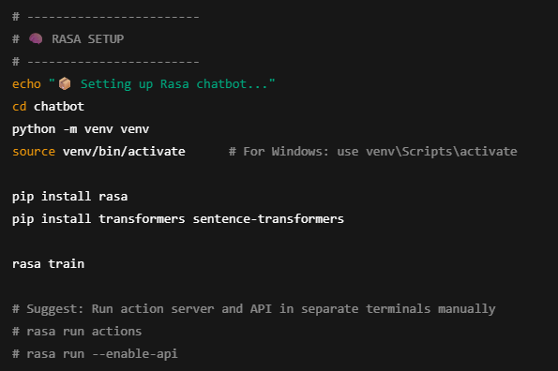
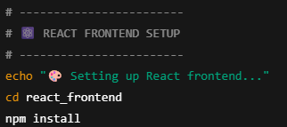
5.1.2 Frontend React setup

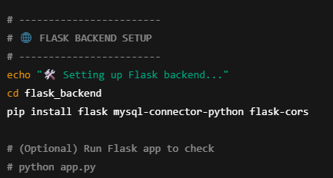
5.1.3 Backend Flask Setup

5.1.4 Database Setup
MySQL Tables:
  - users: stores user info.
  - chat_history: logs messages and bot replies.
  - feedback: stores like/dislike per message.
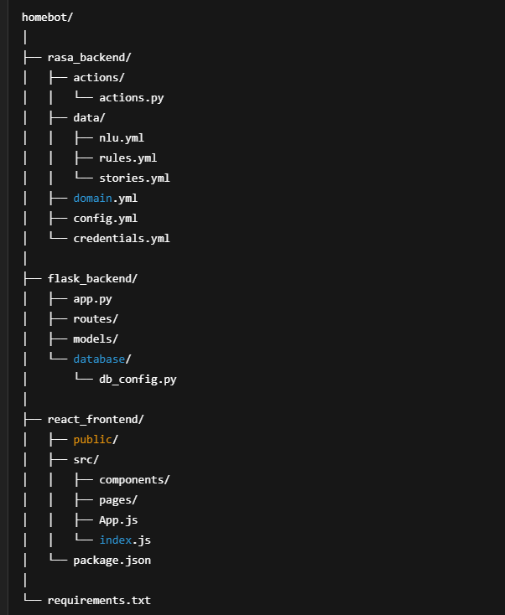
5.2 Directory Structure

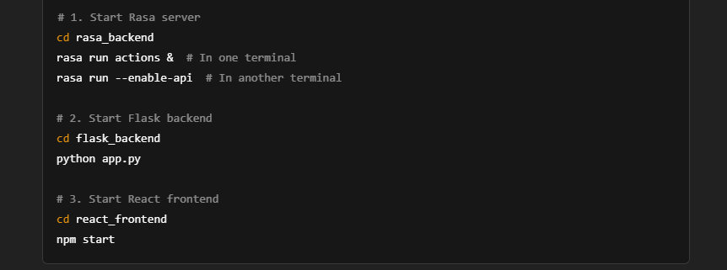
5.3 Running the Project

5.4 Interface and Functionality Snapshots
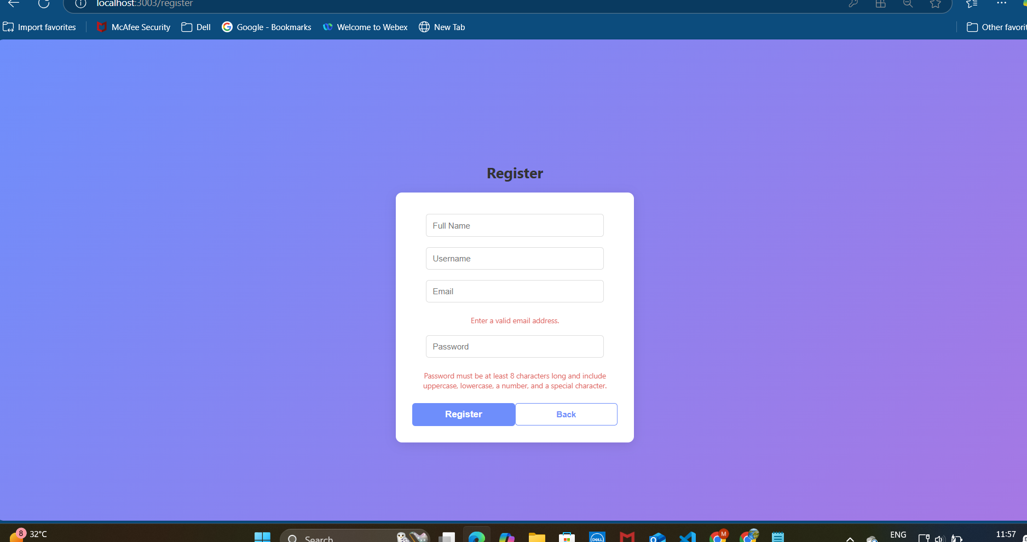
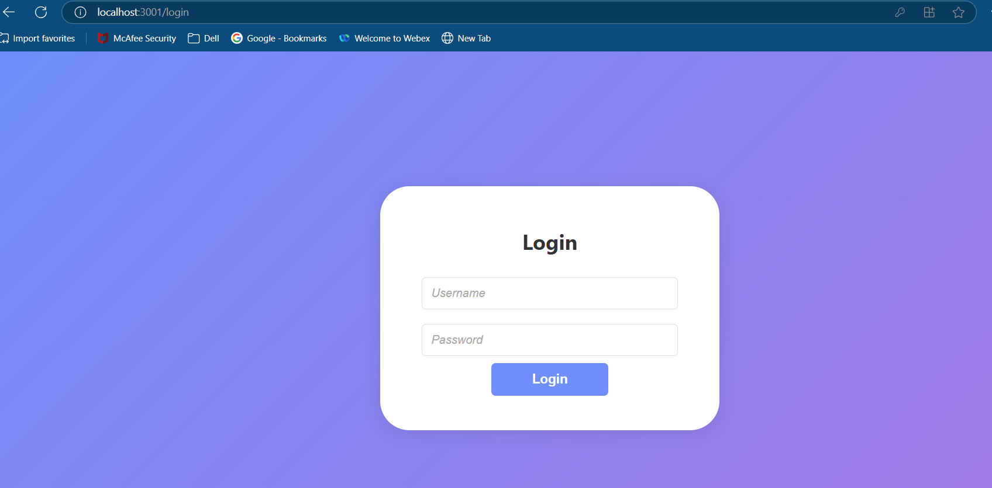
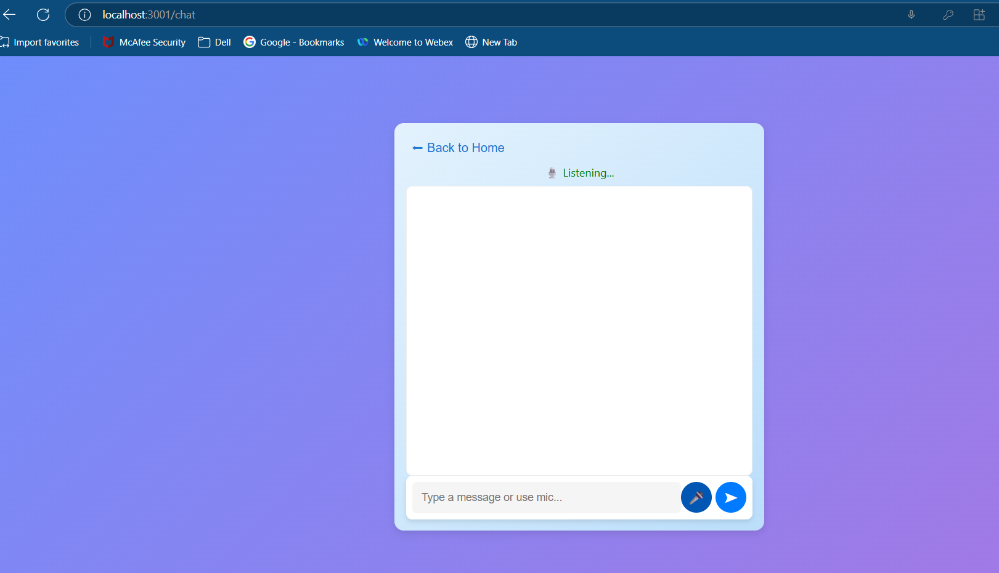
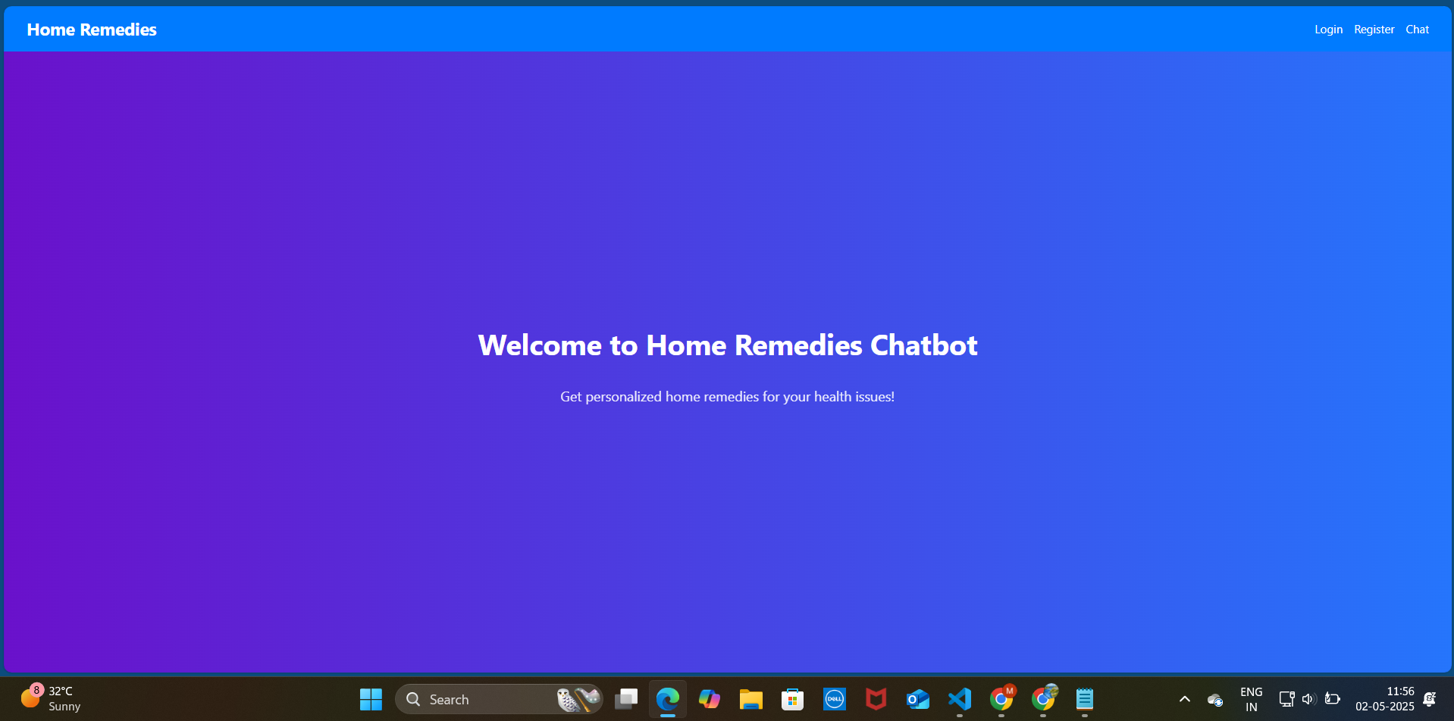

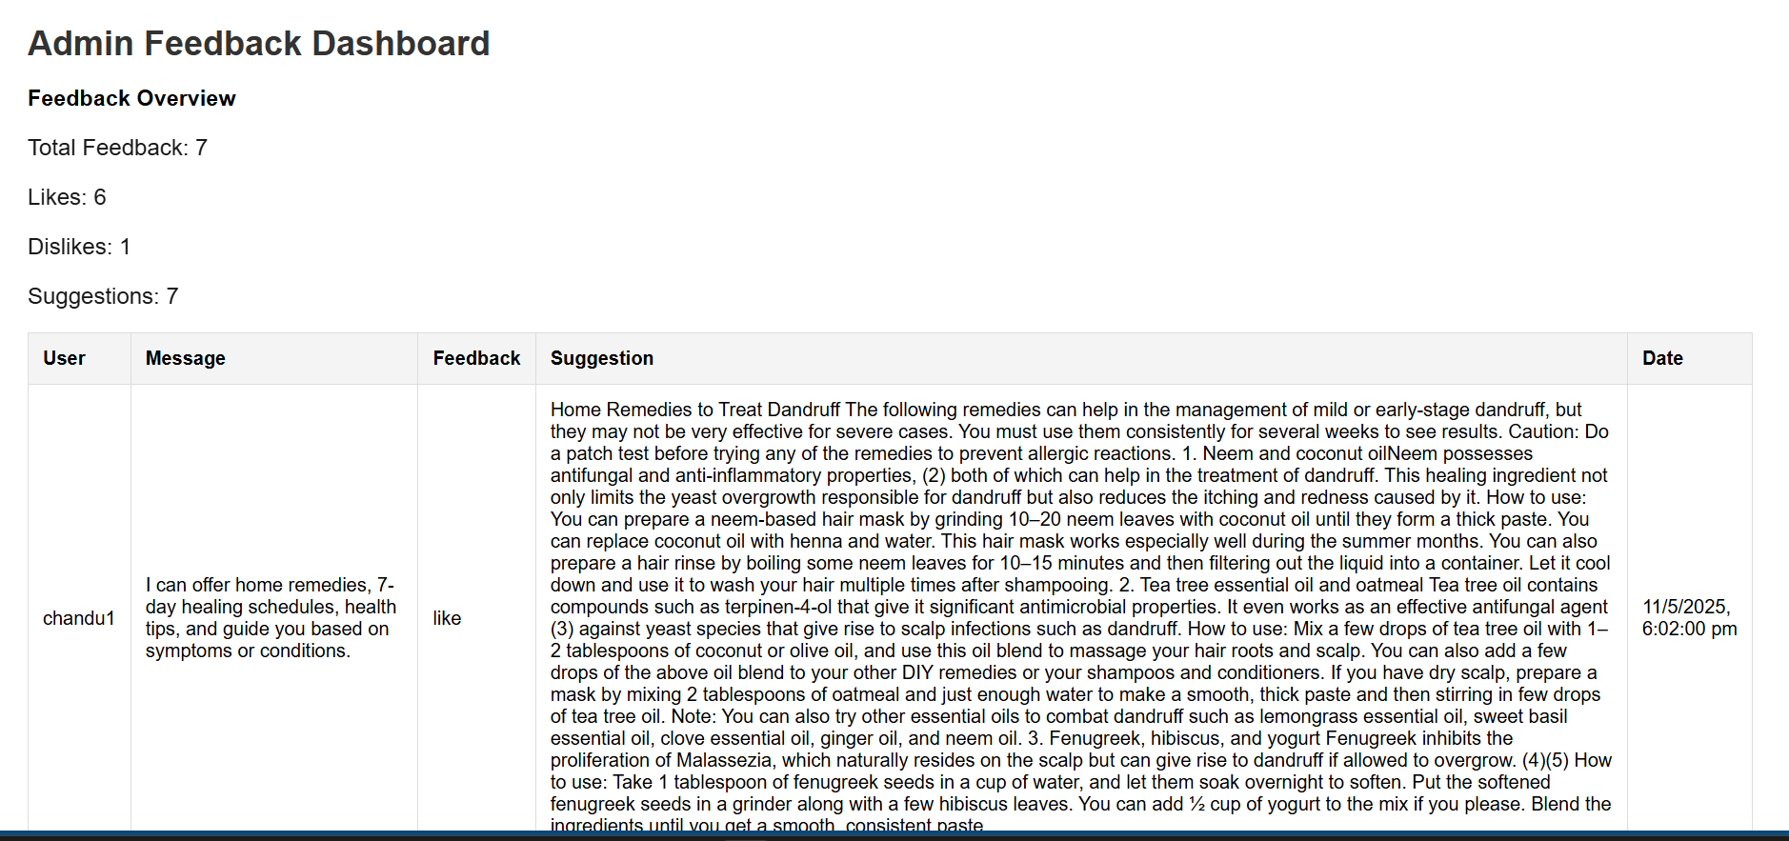
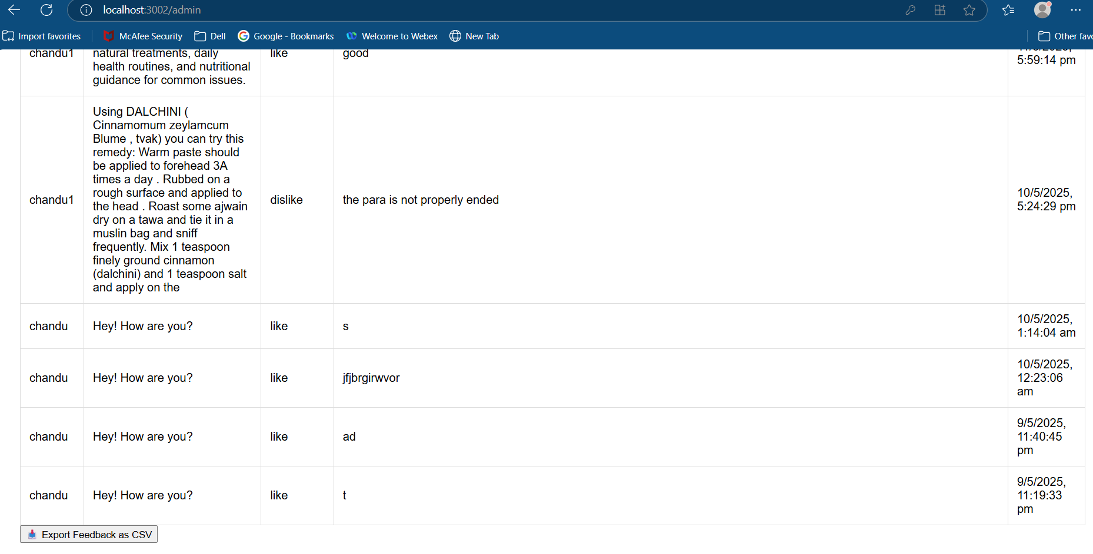

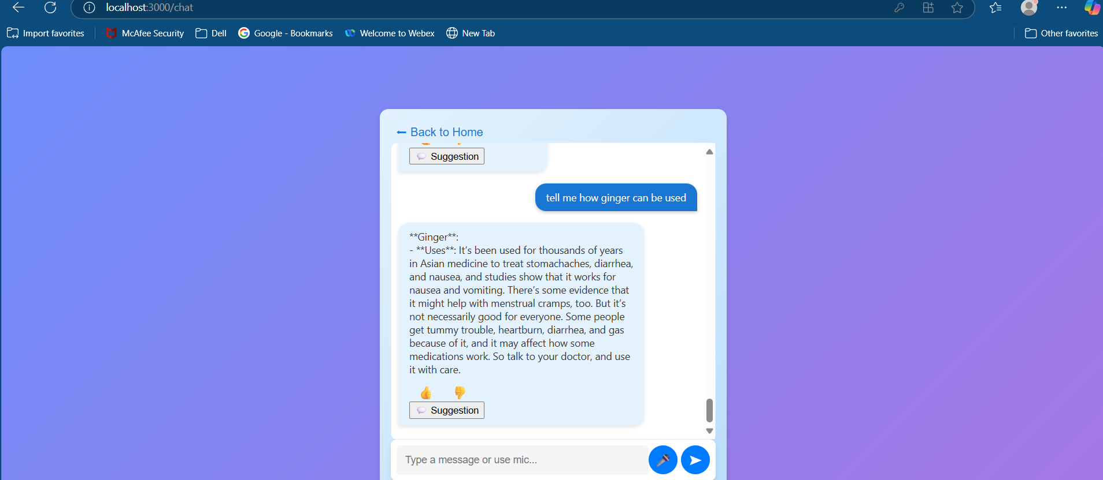
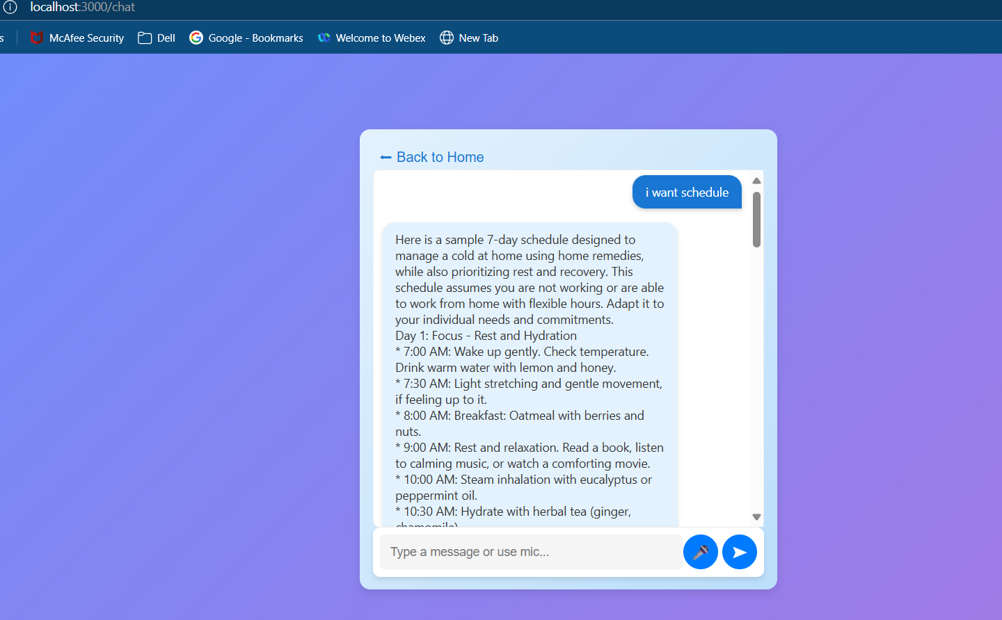

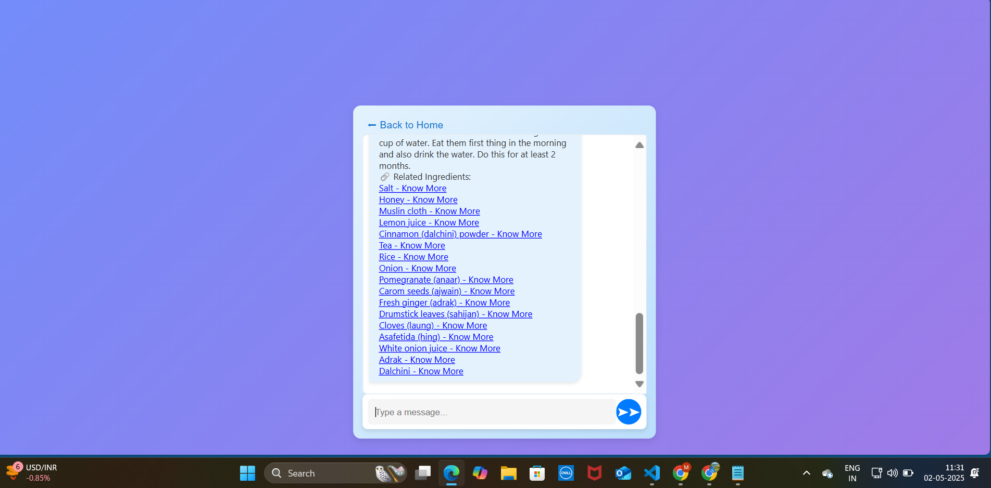
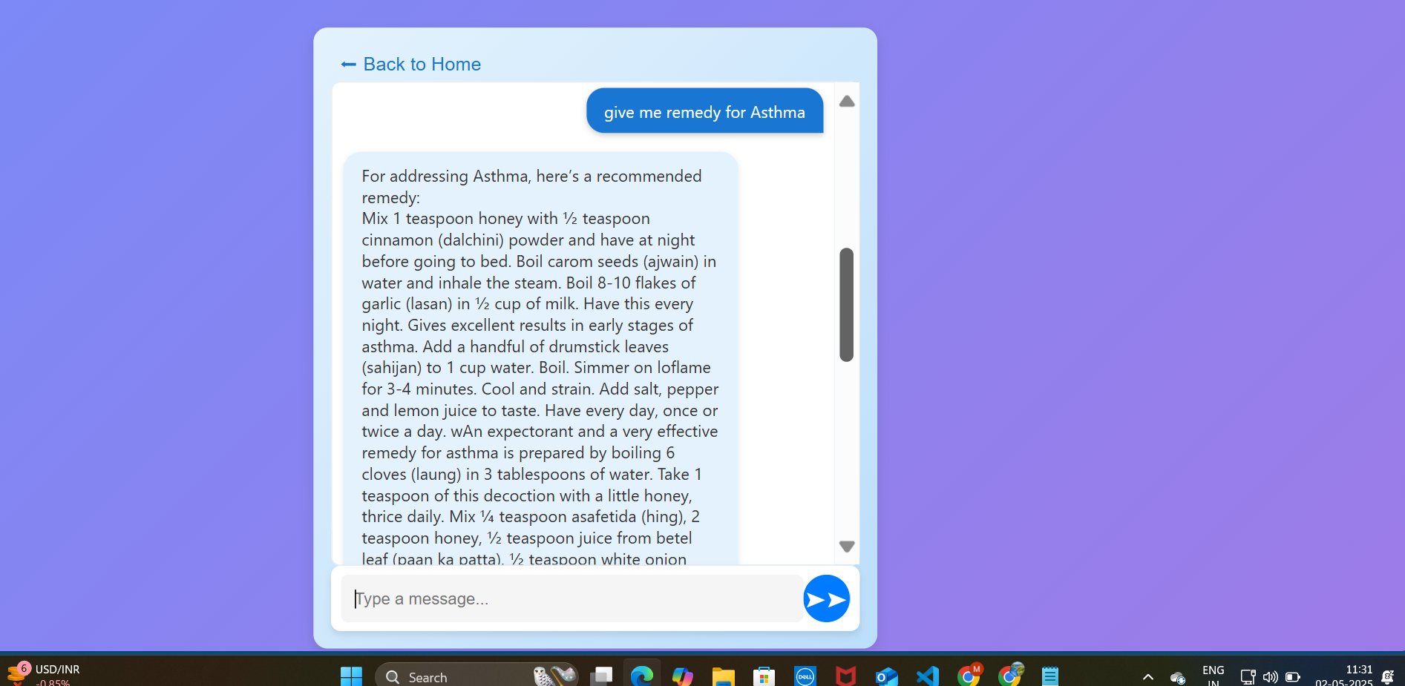

5.5 Performance Analysis
After rigorous testing, our Rasa chatbot has undergone thorough evaluation. Below are the corresponding confusion matrix and confidence histograms, providing insights into its performance. These visual representations comprehensively understand how our chatbot interprets user inputs and makes predictions effectively. Test stories can test the performance of the intent classifier and response selector. Rasa’s built-in feature generates confusion matrices and confidence histograms for each major component in the pipeline to evaluate the performance of both the NLU and core model.

Metric Type | Precision | Recall | F1-Score | Support | Accuracy
Entity | 1.0 | 1.0 | 1.0 | 39 | 1.0
Intent | 0.9843 | 0.9839 | 0.9839 | 373 | 0.9839
Stories | 1.0 | 1.0 | 0.945 | 36 | 0.914

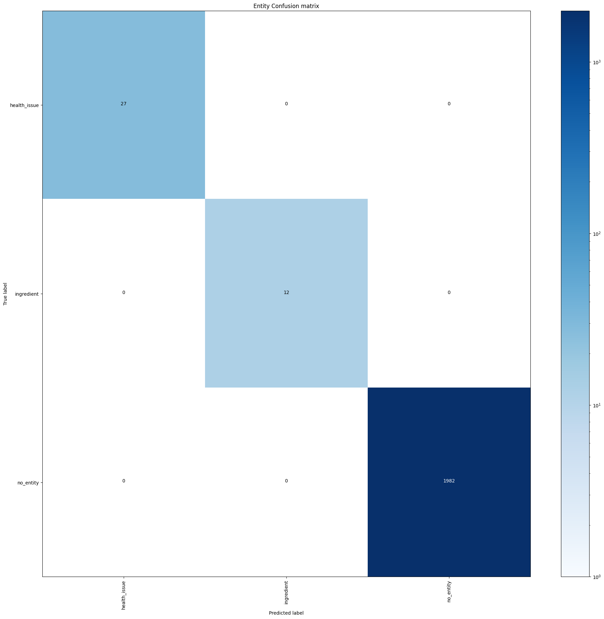
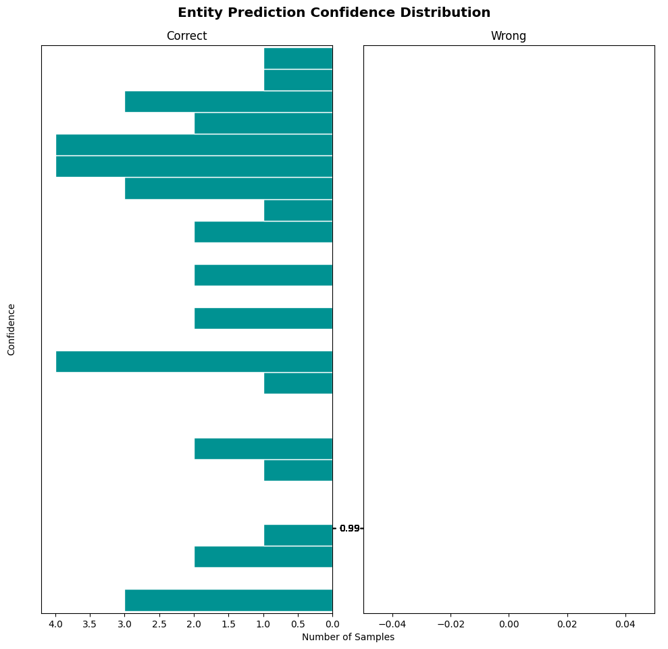
CONFUSION MATRIX ENTITY PREDICTION

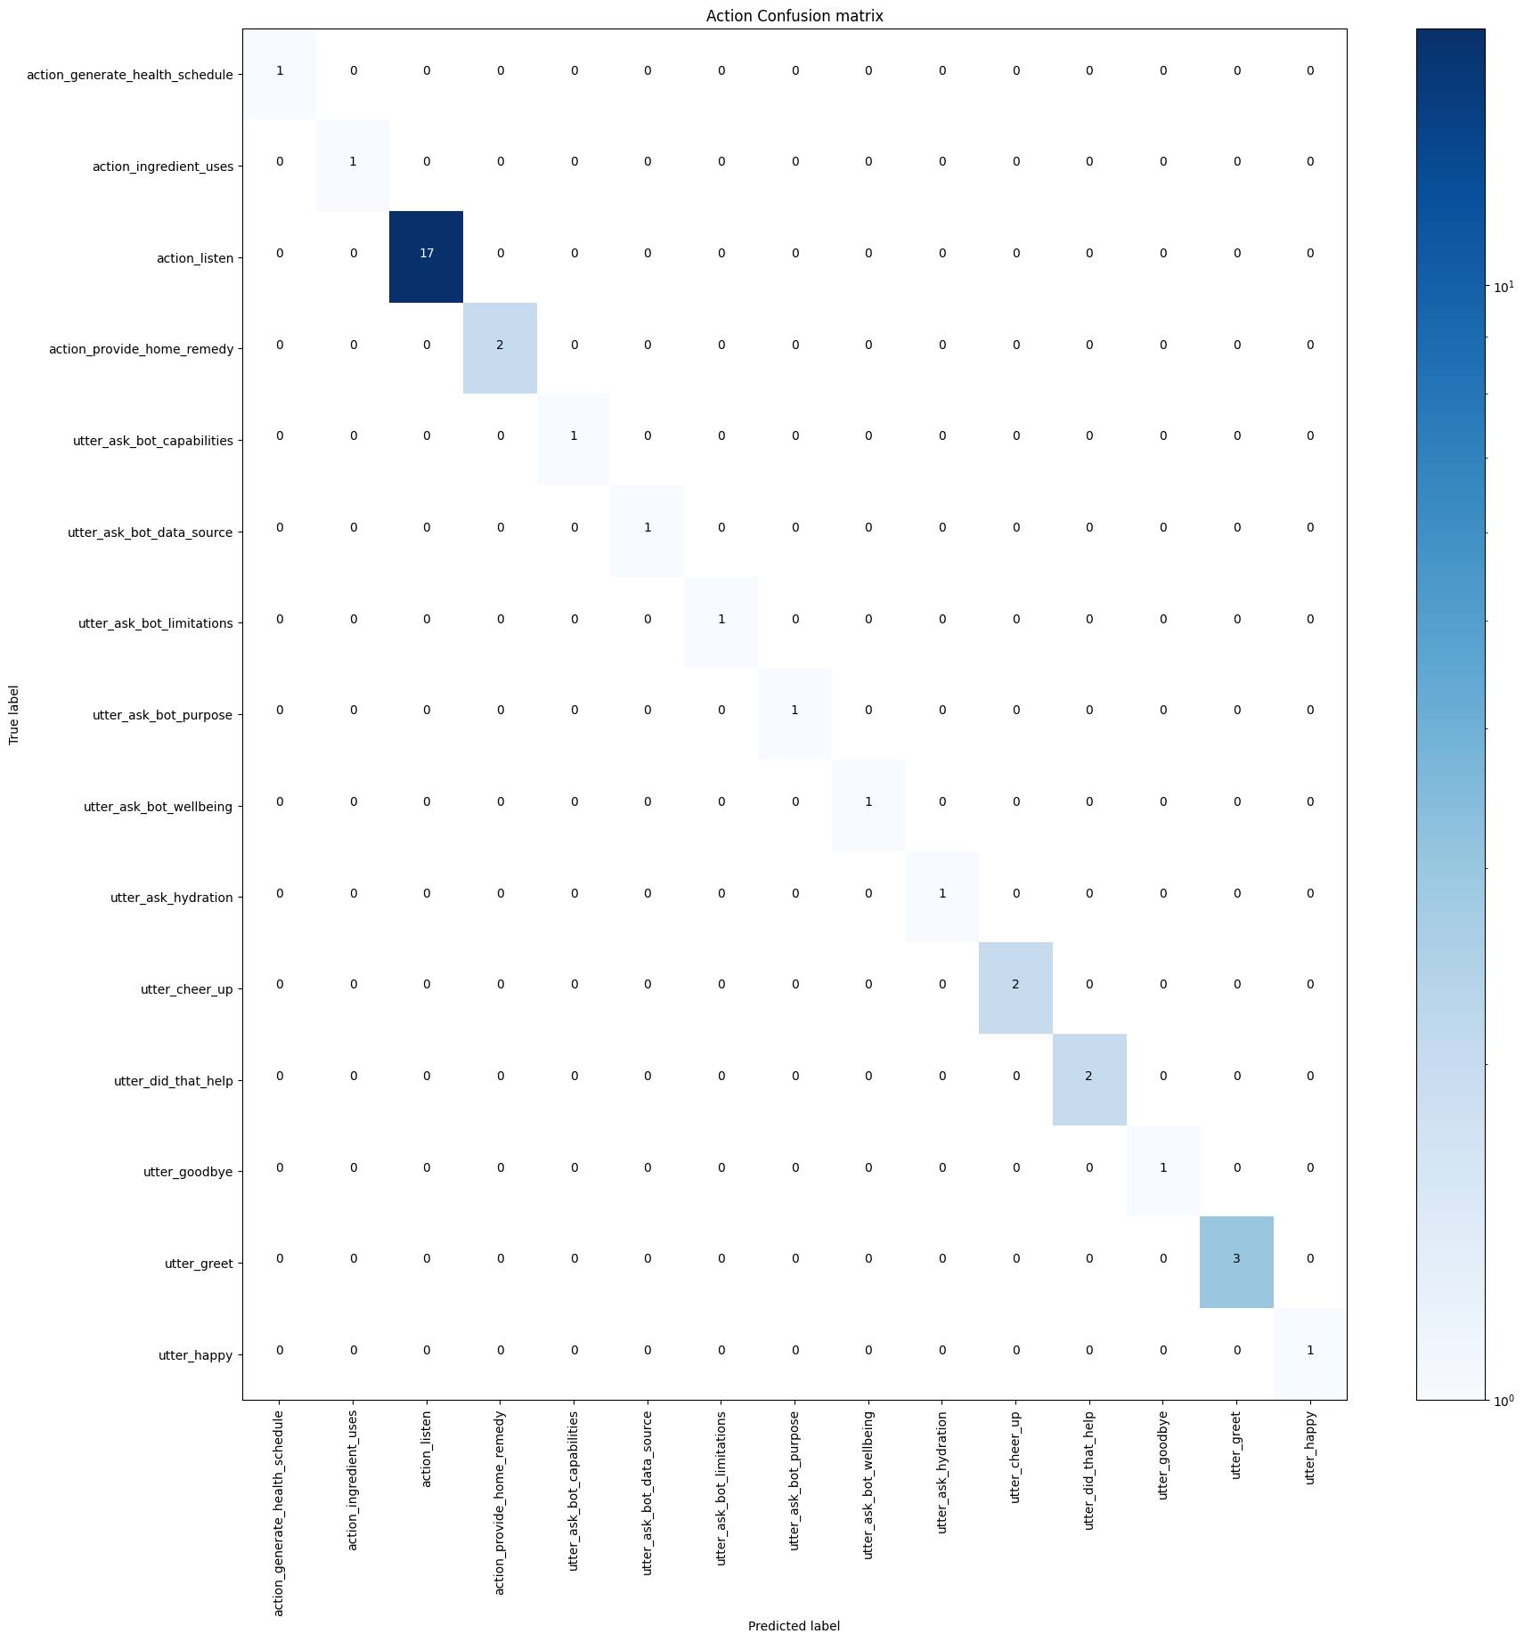
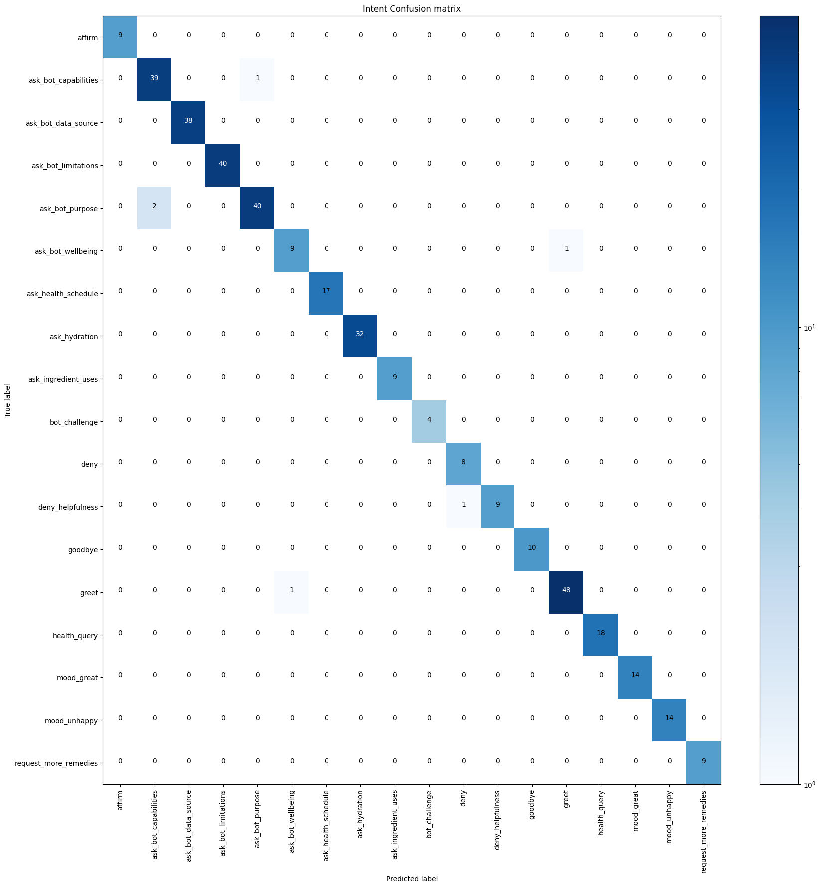
INTENT CONFUSION MATRIX STORIES CONFUSION MATRIX

Chapter VI

CONCLUSION AND FUTURE WORK
This project developed an intelligent home remedies chatbot using the Rasa framework, combining natural language processing, semantic similarity matching, and voice interaction to deliver effective health suggestions based on user symptoms. It accurately interprets diverse queries through models like sentence-transformers/gtr-t5-base for embeddings and T5 for paraphrasing, retrieving relevant remedies from a curated dataset. The system also incorporates feedback collection to improve over time. In the future, this chatbot can be enhanced by integrating image-based symptom detection (e.g., skin conditions), adding personalized recommendations based on user profiles, enabling multilingual support for broader accessibility, connecting with health APIs or wearable devices for real-time health monitoring, and incorporating a doctor consultation module when suitable remedies are unavailable.

REFERENCES

[1] M. N. U. R. Chowdhury, A. Haque, and H. Soliman, “Chatbots: A game changer in mHealth,” 2023 Sixth International Symposium on Computer, Consumer and Control (IS3C), Taichung, Taiwan, Jun. 2023, pp. 362–366, doi: 10.1109/IS3C55386.2023.10216769.
[2] A. Babu and S. B. Boddu, “BERT-Based Medical Chatbot: Enhancing Healthcare Communication through Natural Language Understanding,” Exploratory Research in Clinical and Social Pharmacy, vol. 13, Mar. 2024, Art. no. 100419, doi: 10.1016/j.rcsop.2024.100419.
[3]. Sara Perez-Soler., Gwendal Daniel, Jordi Cabot. " Towards Automating the Synthesis of Chatbots for Conversational Model Query." In Springer BPMDS 2020/EMMSAD 2020, LNBIP , pp. 257-265. Switzerland, Springer, 2020.

[4]. Sara Perez-Soler., Gwendal Daniel, Jordi Cabot. " Towards Automating the Synthesis of Chatbots for Conversational Model Query." In Springer BPMDS 2020/EMMSAD 2020, LNBIP , pp. 257-265. Switzerland, Springer, 2020.

[5]. Lukas Tommy, chandra Kiran, Leo Riska. "The Combination of Natural Language Processing and Entity Extraction for Academic Chatbot." In 2020 IEEE International Conference on Cyber and IT Service Management(CITSM), pp. 1-6. IEEE, 2020.

[6]. Udayakumar Shanmugam, Sowjanya Mani, Sneha Shivakumar and Rajeshwari P. " Human-Computer text conversation through NLP in Tamil using Intent Recognition." In 2019 IEEE International Conference on Vision Towards Emerging Trends in Communication and Networking(VitECoN), Chennai, India, pp. 1-5. IEEE, 2019.
.
[7] A Chatbot for Psychiatric Counseling in Mental Healthcare Service Based on Emotional Dialogue Analysis and Sentence Generation"; 2375-0324/17 $31.00 ©2017 IEEE, 2017 IEEE 18th International Conference on Mobile Data Management. Kyo-Joong Oh, DongKun Lee, ByungSoo Ko, Ho-Jin Choi;

[8]"Chatbot Utilization for Medical Consultant System";978-1-5386- 7573-1/18/$31.00 ©2018 IEEE, The 2018 Technology Innovation Management and Engineering Science International Conference (TIMES-iCON2018). Nudtaporn Rosruen and Taweesak Samanchuen;

