BUSINESS SALES PERFORMANCE
ANALYTICS

NAME: G.MANASA
INTERNSHIP: DATA SCIENCE & ML
TOOLS USED: PYTHON,PANDAS,MATPLOTLIB,GOOGLE COLAB

1.INTRODUCTION:
Business Sales Performance Analytics is the process of examining sales data to understand business performance and identify growth opportunities. In this project, sales data was analyzed using Python, Pandas, and Matplotlib in Google Colab. The main objective was to study revenue trends, identify top-selling products, evaluate category-wise performance, and compare sales across different regions.
Data analysis helps organizations make informed decisions by transforming raw data into meaningful insights. Through various data cleaning, processing, and visualization techniques, patterns and trends were identified from the dataset. Charts and graphs were created to better understand sales performance and highlight key business areas.
The findings of this project provide valuable insights that can help businesses improve sales strategies, optimize product offerings, and enhance overall performance. This project demonstrates the practical application of data analytics in solving real-world business problems and supporting data-driven decision-making.

Dataset Description
The dataset used in this project is the SampleSuperstore Dataset, which was obtained from Kaggle. This dataset contains detailed sales records of a retail superstore, including information about orders, products, categories, customers, sales, profits, and regional performance.
The dataset was selected because it provides a comprehensive view of business operations and is widely used for data analysis and visualization projects. It is suitable for analyzing sales trends, identifying top-selling products, evaluating category-wise performance, and comparing regional sales performance.
Key Features in the Dataset
- Order Date: Date when the order was placed.
- Product Name: Name of the product sold.
- Category: Product category such as Technology, Furniture, and Office Supplies.
- Sales: Revenue generated from each transaction.
- Profit: Profit earned from each sale.
- Region: Geographic region where the sale occurred.
- Customer Information: Details related to customers and their purchases.
- Ship Mode and Segment: Information about shipping methods and customer segments.
Purpose of Using the Dataset
The SampleSuperstore dataset was used to:
- Analyze revenue and sales trends over time.
- Identify the top-selling and most profitable products.
- Evaluate performance across different product categories.
- Compare sales performance among different regions.
- Generate business insights and recommendations for decision-making.

Data Processing
The dataset was imported into Google Colab and processed using Python libraries such as Pandas and Matplotlib. Data cleaning techniques, including checking for missing values and removing duplicates, were applied to ensure the accuracy and reliability of the analysis.
This dataset provided valuable insights into retail business performance and demonstrated how data analytics can support data-driven business decisions.
This version is specifically tailored to the dataset you used and will look professional in your internship report.

ANALYSIS & CHARTS:
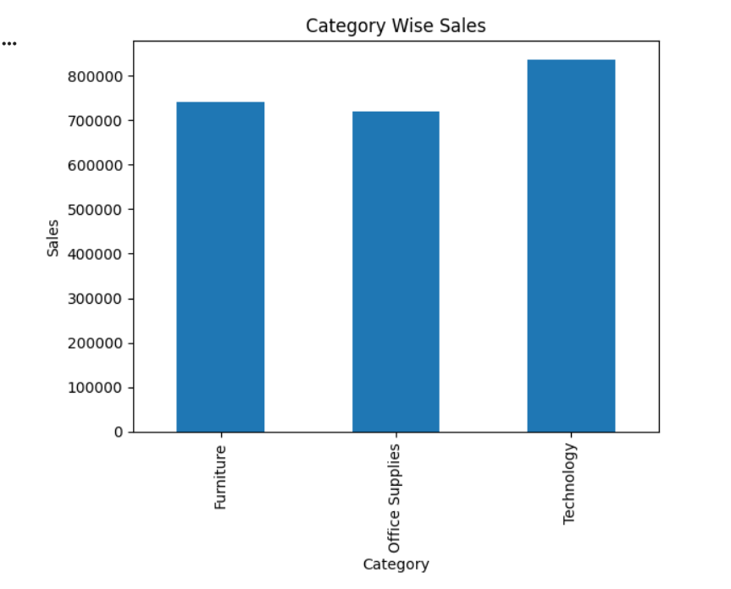
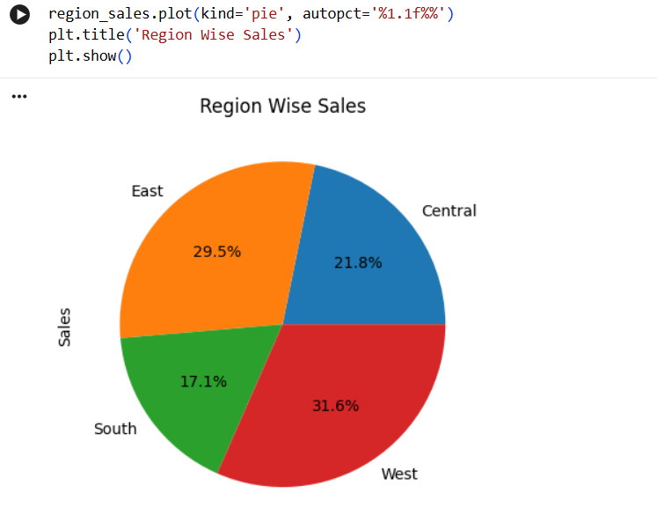
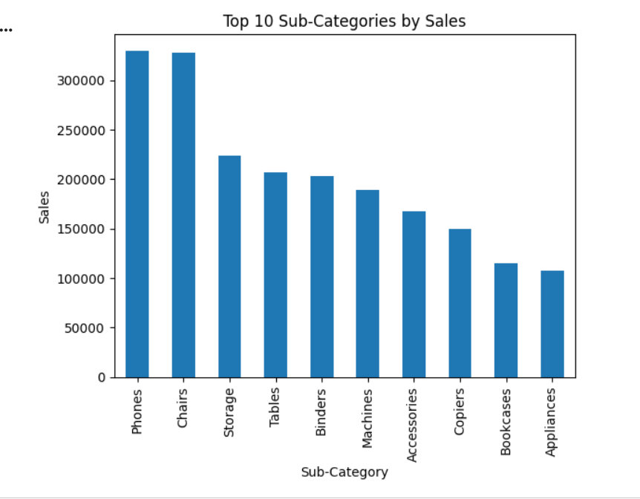
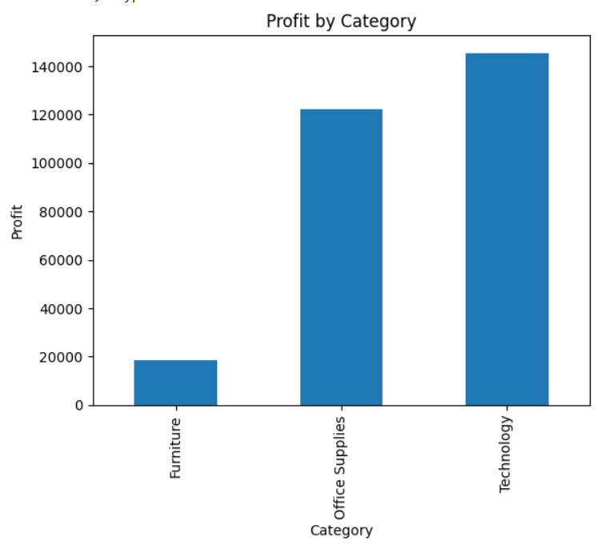
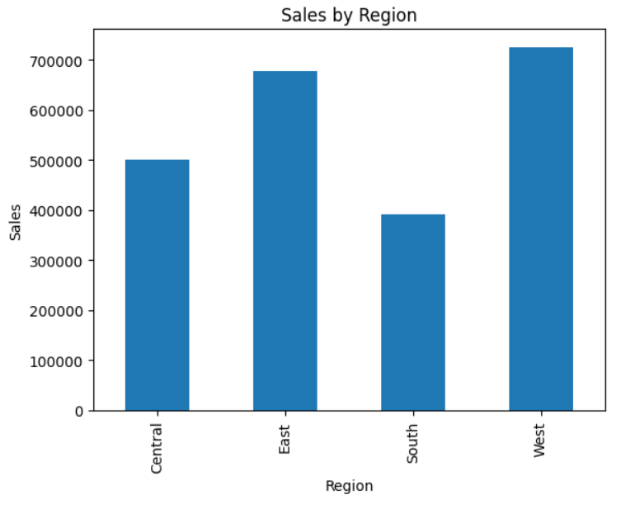

Key Insights
- The Technology category generated the highest sales among all product categories, indicating strong customer demand.
- The West Region recorded the highest overall sales performance, contributing significantly to total revenue.
- The top-selling products accounted for a major share of total sales, highlighting their importance to business growth.
- Sales performance varied across different regions, suggesting opportunities for targeted marketing strategies.
- Some product categories generated high sales but comparatively lower profits, indicating the need for better cost management.
- Sales trends showed fluctuations over time, with certain periods experiencing higher customer demand.
- Data visualization helped identify profitable business areas and provided valuable insights for decision-making.
Recommendations
- Focus marketing efforts on top-performing products.
- Increase sales activities in low-performing regions.
- Maintain adequate inventory for high-demand products.
- Improve profitability in categories with lower profit margins.
- Use data-driven strategies to enhance overall business performance.

Conclusion:
This project successfully analyzed the Sample Superstore Dataset to evaluate business sales performance. Using Python, Pandas, and Matplotlib in Google Colab, various analyses were performed to understand sales trends, top-selling products, category-wise performance, and regional sales distribution.
The analysis revealed important insights about product categories, regional performance, and revenue generation. Data visualization techniques helped in identifying patterns and trends that can support business decision-making. The findings indicate that focusing on high-performing products and regions can improve overall sales and profitability.
Overall, this project demonstrates the importance of data analytics in understanding business performance and making data-driven decisions. The insights and recommendations obtained from the analysis can help organizations improve their sales strategies, optimize resources, and achieve better business outcomes.

