**Build and Deploy an Sentiment Analysis of Reviews [ AWS and Python]**

Steps:

1. Build a model on your local box (Amazon Fine Food reviews) and store the model and other key model related variables in .pkl files
2. Launch a micro instance on AWS.
3. Connect to the AWS box [ssh]
4. Move the files to an AWS EC2 instance/box [scp]
5. Install all packages needed on the AWS box.
6. Run app.py on the AWS box.
7. Check the output in the browser.

Software needed:

1. Anaconda:
   1. **Windows 64 bit:** <https://repo.continuum.io/archive/Anaconda3-5.2.0-Windows-x86_64.exe>
   2. **Windows 32 bit:** <https://repo.continuum.io/archive/Anaconda3-5.2.0-Windows-x86.exe>
   3. **Mac :** <https://repo.continuum.io/archive/Anaconda3-5.2.0-MacOSX-x86_64.sh>
   4. **Linux 64 bit:** <https://repo.continuum.io/archive/Anaconda3-5.2.0-Linux-x86_64.sh>
   5. **Linux 32 bit:** <https://repo.continuum.io/archive/Anaconda3-5.2.0-Linux-x86.sh>
   6. **Check the previous Archives of Anaconda:** https://repo.continuum.io/archive/

2. Packages needed:

1. pip3
2. pandas
3. numpy
4. sklearn
5. beautifulsoup4
6. lxml
7. flask
8. regex

you can copy all these packages and try like this: <https://stackoverflow.com/a/15593865/4084039>

**[1] Launch a micro instance on AWS.**

**Creating an instance:**

1. Create an AWS account [https://aws.amazon.com](https://aws.amazon.com/?nc2=h_lg), <https://portal.aws.amazon.com/billing/signup#/start>
2. Login: [https://console.aws.amazon.com](https://console.aws.amazon.com/)

After login:

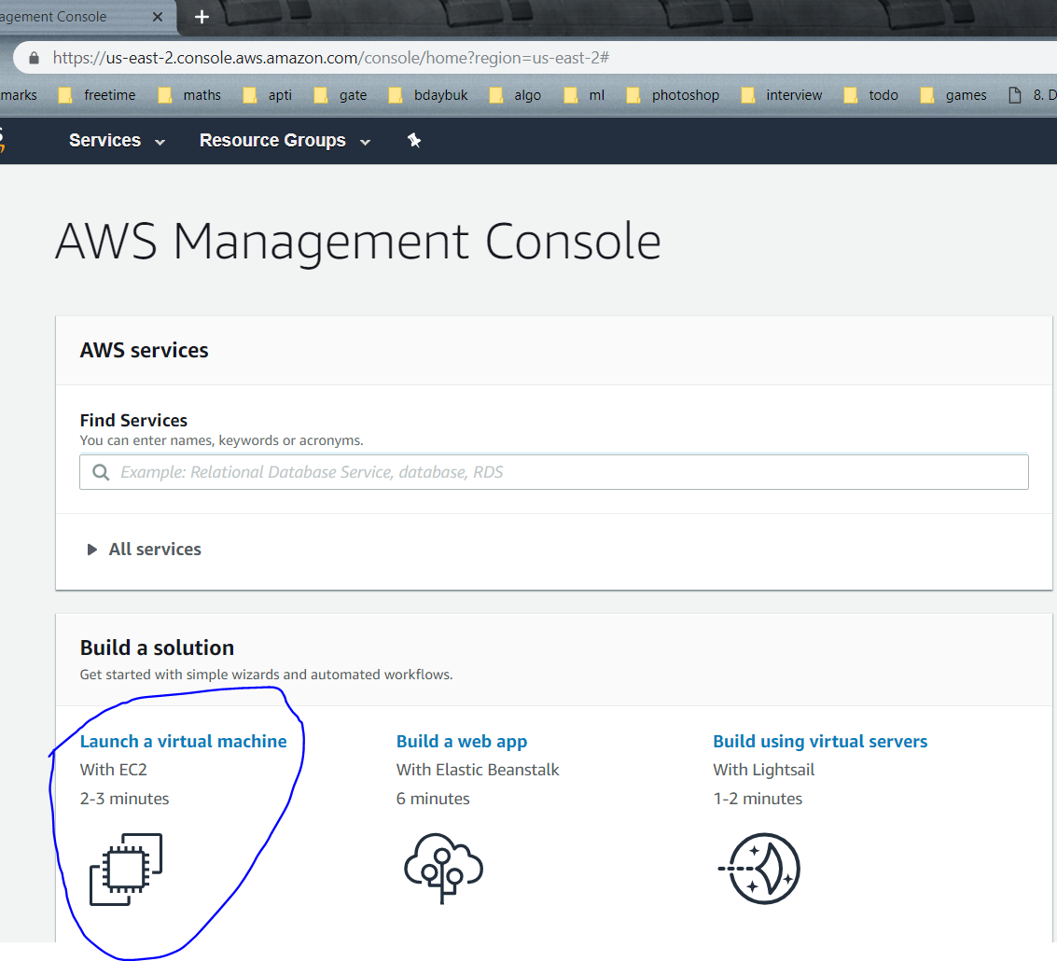

Launch the EC2 instance

3. Choose the ubuntu free tire

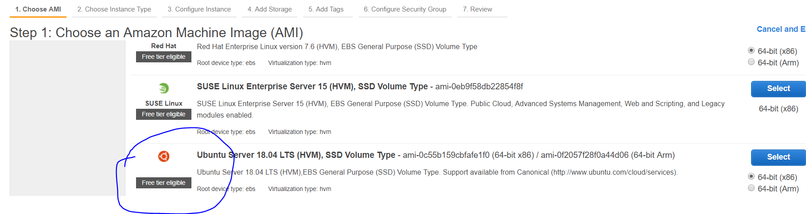

Click on select

4. Choose t2.micro free tier eligible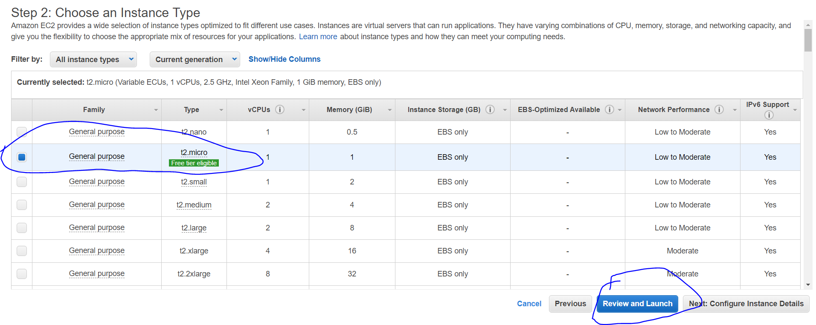

Click on review and launch

5. 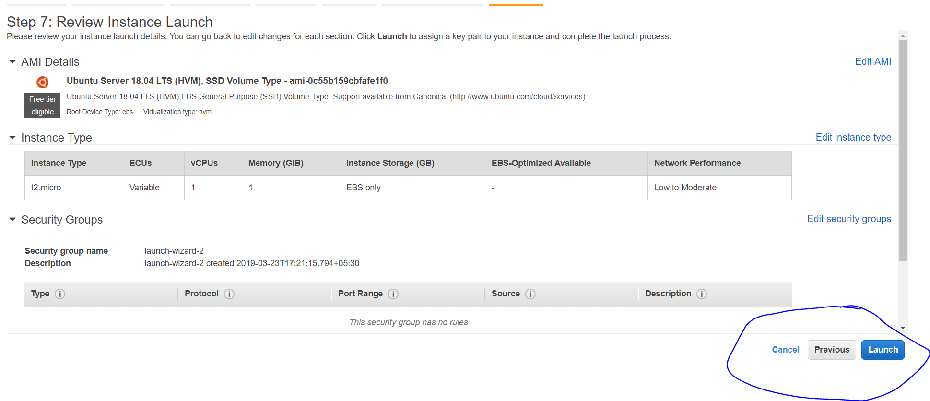

Click on launch

6. 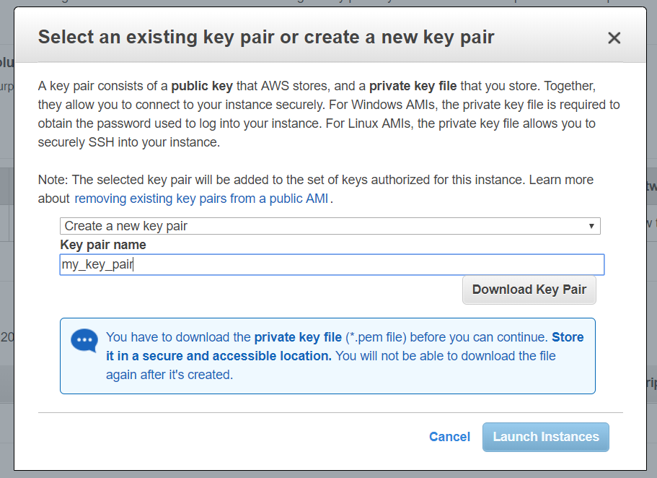

Click on “Download Key Pair” and save the .pem file then click on “Launch Instance”

7. 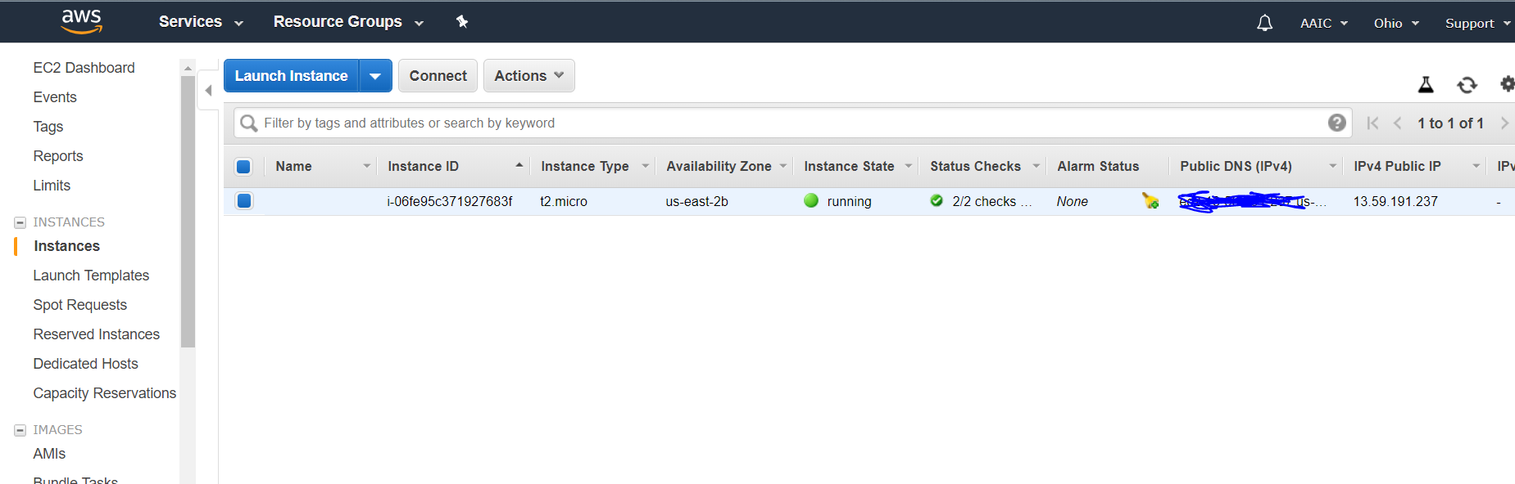

You will see this screen, you have successfully launched the an EC2 instance, now we need to launch an flask api in it

8. Final step:

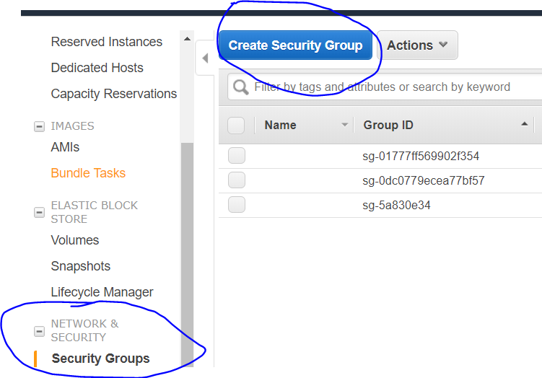

Select the “Network & security” -> Security groups and then click “Create Security Group”

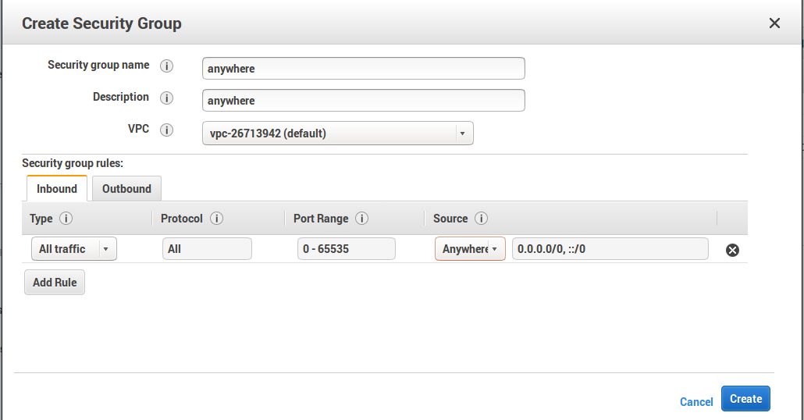

Then add the specific security group to **network interface**

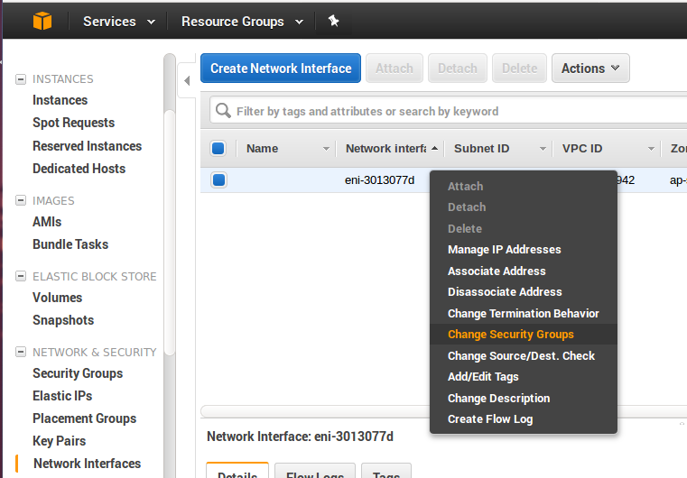

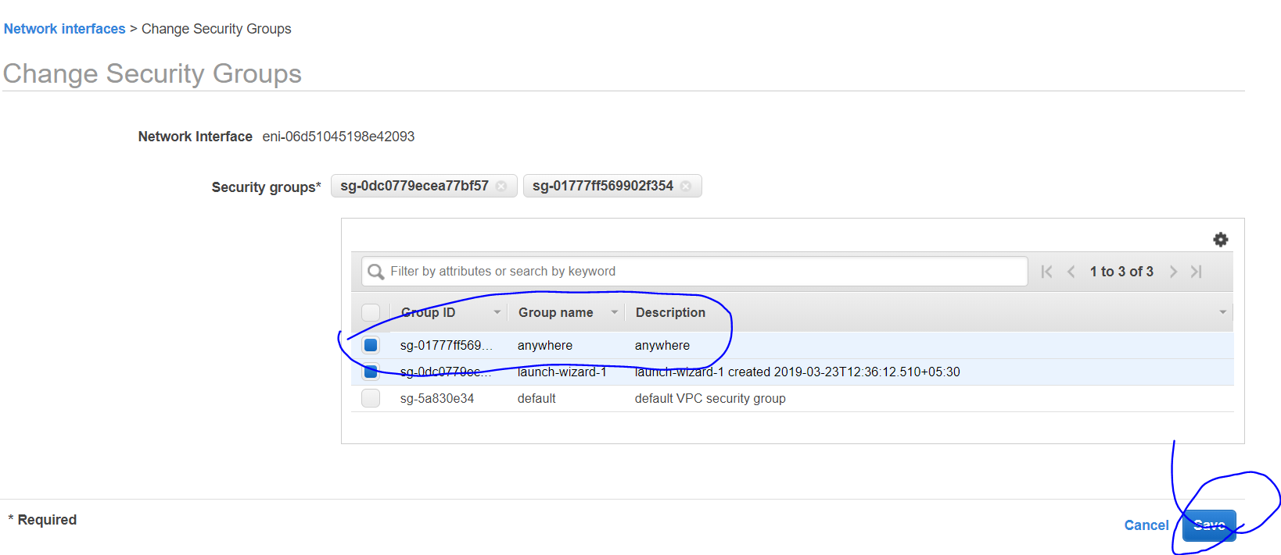

**[2] Connect to the AWS box**

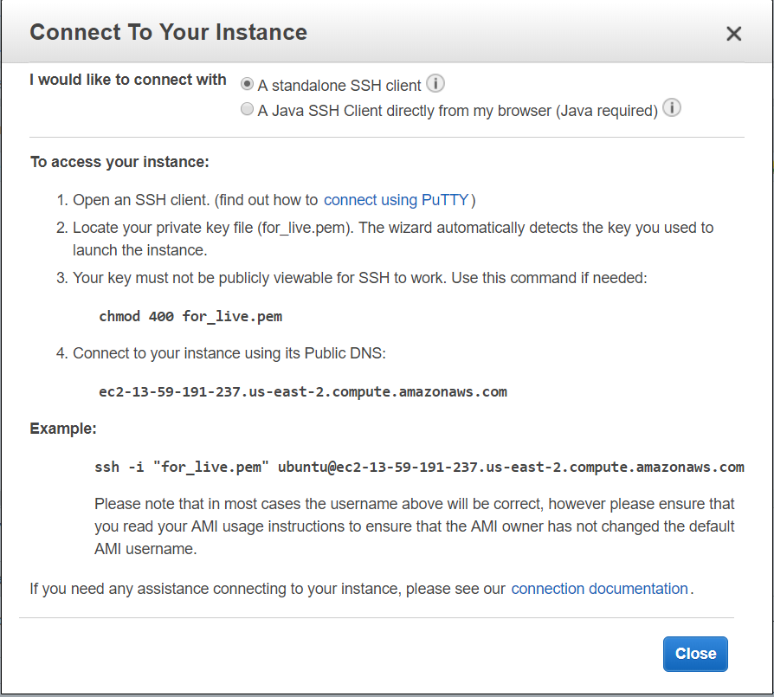

**[3] Move the files to an AWS EC2 instance/box []**

**Command line to copy files**

C:\Users\Asus\OneDrive\Desktop>**scp -i "for_live.pem" -r AFR** [**http://ec2-3-14-72-94.us-east-2.compute.amazonaws.com:~/**](http://ec2-3-14-72-94.us-east-2.compute.amazonaws.com:~/)

app.py 100% 3888 16.9KB/s 00:00

count_vect.pkl 100% 31MB 2.6MB/s 00:11

model.pkl 100% 79KB 312.4KB/s 00:00

model.py 100% 4864 19.7KB/s 00:00

index.html 100% 332 1.4KB/s 00:00

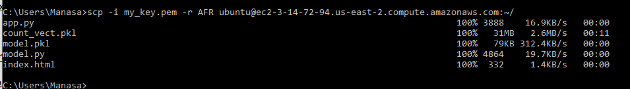

**[4] Install all packages needed on the AWS box.**

sudo apt-get install python3-pip

pip3 install <each of the following packages>

Packages needed:

pip3

pandas

numpy

sklearn

beautifulsoup4

lxml

flask

regex

**[5] Run app.py on the AWS box.**

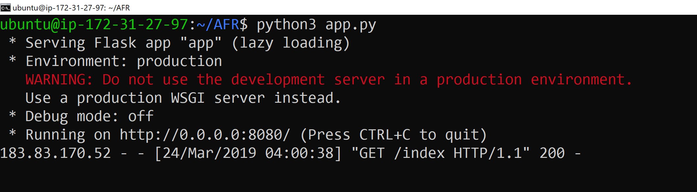

**[6] Check the output in the browser.**

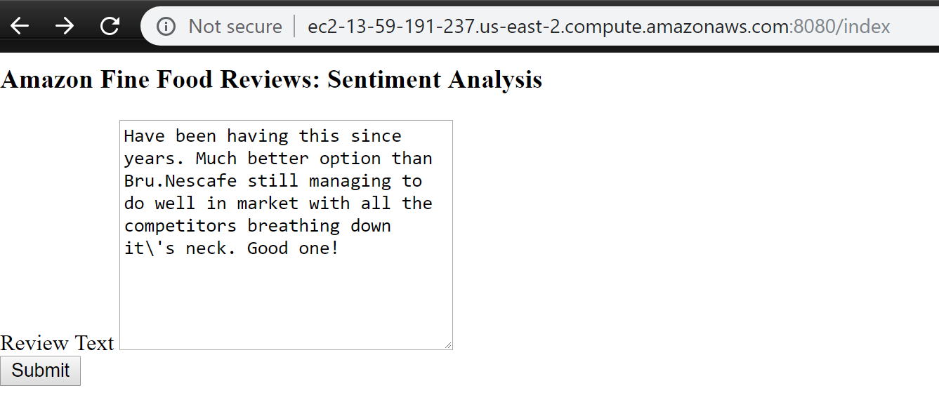

**[7] Check the result in the browser.**

