AN AI-DRIVEN ADAPTIVE AR/VR FRAMEWORK FOR PERSONALIZED REHABILITATION
Using Vision-Based Human Pose Estimation
Complete Technical Analysis & Project Documentation

Pose Estimation | Repetition Counting | Adaptive Difficulty | AR Overlay | 3D Room

Project Title | ARVR: Adaptive AR/VR Rehabilitation Framework
Programme | M.Tech project
Author | Manasa Krishnakumar
Version | Research prototype 0.1.0 (not a medical device)
Technology Stack | Python 3.10 | FastAPI | SQLite | React 19 + TypeScript | MediaPipe | three.js | Unity 6 (optional)
Evidence | REHAB26-ViewAngles and REHAB24-6 public datasets (no patients)
Source Code | github.com/manasakrishnakumar/ARVR-PROJECT
Report Date | 12 November 2026

1. Executive Summary

The ARVR framework is a local, camera-only system for guided home rehabilitation exercise. It estimates body pose in the browser from an ordinary webcam, measures joint angles, counts repetitions, assesses movement quality, gives short feedback, and suggests a gently adjusted difficulty level for the next session. The same pipeline drives four presentations: a 2D live-session page, a camera-overlay AR view, a desktop 3D room and an optional Unity client.
The adaptive controller is deliberately conservative and is tested for safety properties (it never raises difficulty on unreliable data, moves one level at a time, and reported pain only makes suggestions more cautious). Every stage of the pipeline was evaluated on public research recordings using participant-level splits and an external dataset.
Honest status. This is a research prototype. No patients took part, thresholds have not been reviewed by a clinician, and nothing here shows that the system improves recovery. Real webcam use on a laptop or phone, the Unity Play-mode check and immersive VR on a headset have not yet been tested (Section 14).

Key Features at a Glance
- Browser pose estimation (MediaPipe Pose Landmarker, CPU); video never leaves the browser
- Confidence-gated 2D joint angles with an isotropic correction for non-square video
- Repetition counter (state machine with hysteresis) and optional per-user range calibration
- Rule-based movement assessment with one plain-language tip per repetition; Random Forest as a baseline
- Conservative adaptive difficulty with multi-session confirmation, a pain rule and stated reasons
- Nine exercises defined as data (JSON); adding an exercise needs no code change
- AR camera overlay: ghost trainer, joint colours, setup hints, rep flash, voice cues, front/back camera, full screen
- Desktop 3D rehabilitation room with a virtual trainer; experimental web 'Enter VR' (untested without a headset)
- Optional accounts with export, backup, restore and delete; Docker and local HTTPS verified; about 290 automated tests

Measured Results at a Glance
Question | Result
Browser joint-angle accuracy vs motion capture | MAE 8.02°, RMSE 14.24°, r 0.97 (49,171 frames)
Repetition counting (REHAB26) | F1 0.90 with illustrative ranges, 0.97 with per-user calibration
Quality classification, new dataset | balanced accuracy 0.49 (angle only), 0.61 (all features), 0.686 with a threshold chosen on training data (95% CI 0.625–0.761)
Probability calibration | over-confident: mean predicted 0.69–0.72 vs 0.40 observed
Backend speed (in-process) | about 4 µs analysis per sample; WebSocket round trip mean 0.76 ms, p99 1.5 ms against 66 ms per sample
Adaptive controller | bounded and safe in tests and simulation; says nothing about benefit to real people

2. Project Architecture

2.1 Directory Structure
The project is a monorepo with a Python backend, a React frontend, an optional Unity client, documentation and scripts:
Path / File | Description
ARVR project/ | Repository root
backend/app/ | FastAPI application (about 4,300 lines in 58 Python files)
angle_calculation/ | Authoritative angle maths and smoothing
repetition_detection/ | Repetition counter state machine, features, posture features
exercise_assessment/ | Rule-based assessment of each repetition
personalization/ | Adaptive controller, config.json, simulation
exercises/definitions/ | Nine exercise JSON files (data, not code)
services/analysis.py | StreamAnalyzer: the live pipeline
api/, core/, database/ | REST and WebSocket API, auth, rate limit, security headers, SQLite models
ml/ | Importers, evaluations, Random Forest baseline, performance CLI
backend/tests/ | 29 test files (about 2,400 lines)
frontend/src/ | React + TypeScript app (about 4,200 lines in 56 files)
pose/ | Pose estimators (MediaPipe, synthetic demo), skeleton drawing, guidance, speech, WebXR helper
pages/, components/ | Pages, charts, command palette, movement demo, effects
unity-client/ | Optional Unity 6 client with OpenXR packages and a local pose relay
docs/ | User guide, installation, API, architecture, results, thesis draft, this report
scripts/ | Dev certificate script, figure and report builders
docker-compose*.yml | Docker run (nginx proxy) and optional HTTPS override

2.2 Technology Stack
Layer | Technology | Purpose
Backend framework | FastAPI (Python 3.10) | REST API and WebSockets
Persistence | SQLAlchemy 2 + SQLite | Users, sessions, repetitions, decisions; in-place column upgrades
Machine learning | scikit-learn | Random Forest quality baseline, evaluation
Pose estimation | MediaPipe tasks-vision (browser) | 33 body landmarks per frame, CPU
Frontend | React 19, TypeScript, Vite 8 | Pages, routing (react-router 7)
Charts and 3D | Recharts, three.js, @react-three/fiber | Dashboard charts, 3D room, WebXR
Testing | pytest, vitest, Testing Library, Unity edit-mode | About 290 automated tests
Packaging | Docker Compose, nginx | One-command run; optional HTTPS on 8443

2.3 Live Data Flow
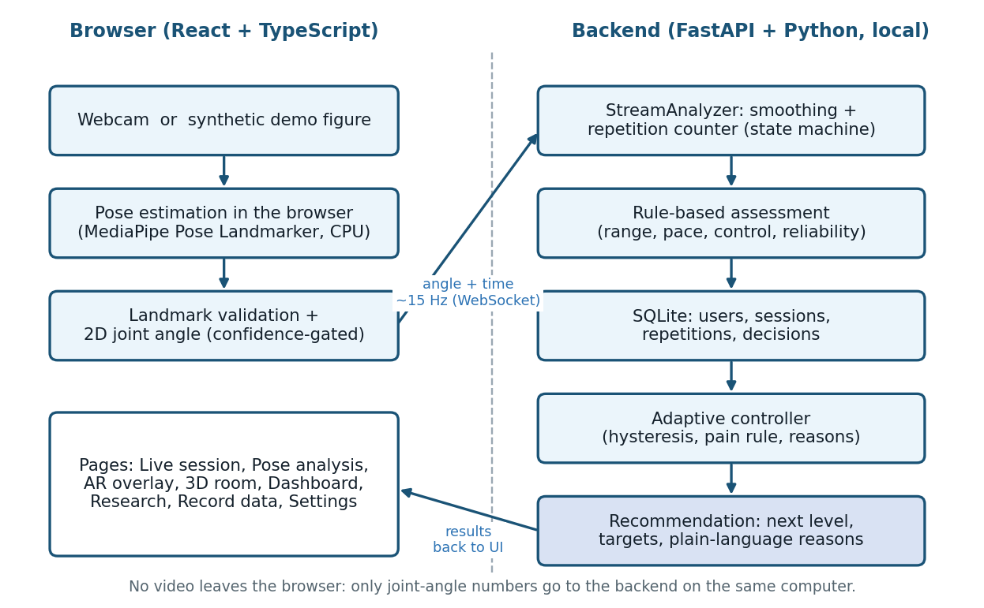
Figure 2.1 System architecture: pose in the browser, analysis and adaptation in the backend
- Browser: camera frame → MediaPipe → landmarks → exercise angle → a small message {time, angle} about every 66 ms.
- WebSocket /api/ws/analysis: the StreamAnalyzer smooths the angle, runs the counter (rest → moving out → target → returning) and replies with a state per frame and a rep message when a repetition ends.
- POST /api/sessions/{id}/complete summarises the session, asks the controller for a recommendation using the user's history, stores the decision and returns both.
- Guest and synthetic-demo sessions are never saved to history; accounts can be deleted completely.

3. Pose Estimation and Angle Measurement

3.1 Browser Pose Estimation
MediaPipe Pose Landmarker (lite model) runs inside the page on the CPU. The pose code sits behind a small PoseEstimator interface so the model can be replaced; a synthetic demo figure implements the same interface, which allows every page to be tested without a camera. A landmark with visibility below 0.5, a non-finite value or a zero-length segment gives no angle (null), never a guess.

3.2 Joint Angle
The angle at a joint is the 2D angle between three landmarks. Image coordinates are normalised separately per axis, so x is multiplied by width/height before any angle is computed (an isotropic correction); skipping it distorts angles on non-square video. Angles are 2D image-plane estimates, not 3D anatomical angles and not clinical measurements.

3.3 Smoothing
Exponential smoothing skips gaps and rejects one-off spikes but accepts a persistent jump, so a real fast movement is not hidden.

3.4 Repetition Counting and Calibration
Progress is normalised between a start angle (0) and a target angle (1), so increasing and decreasing movements are handled alike. The counter moves through rest, moving out, target and returning, with hysteresis, a minimum repetition duration and an abort on long gaps.
With calibration enabled, the start and target come from the user's own first seconds (10th and 90th percentile after at least 5 s, 30 valid samples and 15° of movement). Repetitions made during calibration are replayed, so none are lost. The result describes the range the user demonstrated, not a target.
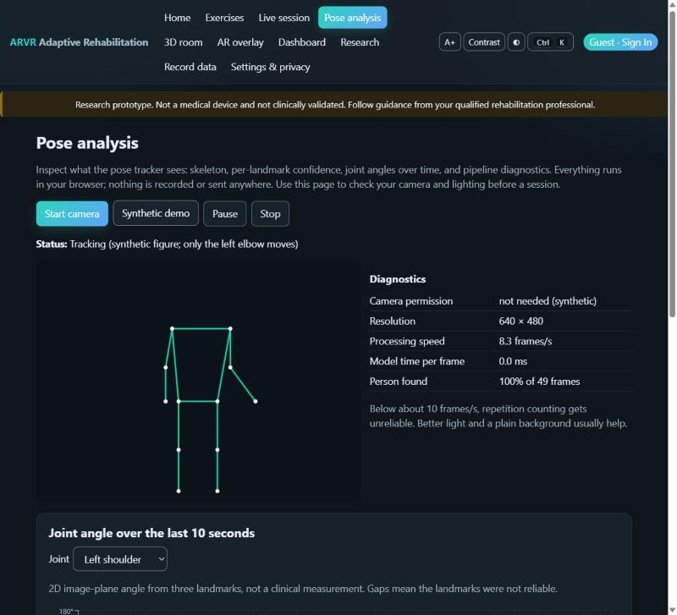
Figure 3.1 Pose analysis page: skeleton, diagnostics (frame rate, person-found rate) and joint-angle chart; synthetic demo figure

4. Movement Assessment

4.1 Rule-Based Labels
A transparent rule set labels each repetition acceptable, insufficient range, incomplete, too fast, uncontrolled or insufficient data. Insufficient data is used whenever the measurement was unreliable; the system never guesses.

4.2 Features
Per repetition the system computes range, duration, speed, direction reversals and reliability. Posture features (torso tilt, shoulder elevation asymmetry, head tilt, elbow bend, left-right asymmetry, knee valgus, heel lift, knee over toe) and MediaPipe depth cues bring the total to 14.

4.3 Machine-Learning Baseline
A Random Forest is trained on repetition features as a compared baseline. It is preliminary: on independent recordings it is only modestly better than chance, so the application relies on the transparent rules and the Research page reports the model honestly (Section 9).
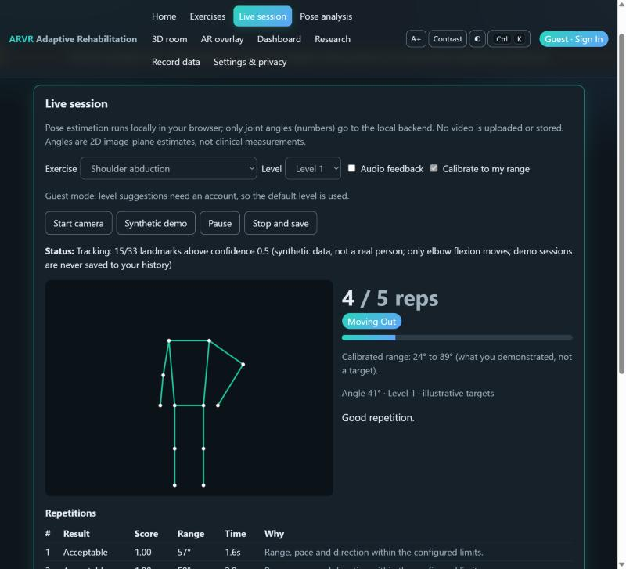
Figure 4.1 Live session page: repetition counter, phase, calibrated range and per-repetition feedback (synthetic demo)

5. Adaptive Difficulty Controller

5.1 Design Principles
- Unreliable data never raises difficulty.
- Changes are one level at a time, between sessions, within levels 1 to 3.
- Two confirming sessions are needed to raise or lower the level; a dead zone prevents flip-flopping.
- A very poor session suggests a pause; reported pain only makes the suggestion more cautious.
- Every suggestion lists its reasons, and the user can reset.

5.2 Thresholds (backend/app/personalization/config.json)
Rule | Setting
Minimum reliable repetitions / fraction | 5 repetitions and at least 80% reliable
Minimum sessions at a level | 2
Increase | quality ≥ 0.85, flagged share ≤ 0.20, all target repetitions done, range spread ≤ 0.15, confirmed in 2 sessions
Decrease | quality ≤ 0.50 or flagged share ≥ 0.50, confirmed in 2 sessions
Pause | quality below 0.30 or flagged share at least 0.80
Pain check-in | pain ≥ 4/10: no increase; pain ≥ 7/10: pause

These values are illustrative and have not been reviewed by a clinician. A rehabilitation professional must review them before any real use.

5.3 Simulation Result
The controller was run against made-up user models (200 simulated users per model, 40 sessions each). This checks behaviour only; it does not show that adaptive difficulty helps real people.
User model | Policy | Mismatch (lower is better) | Level changes | Reversals
stable | best fixed level (level 1) | 0.475 | 0.0 | 0.0
stable | adaptive | 0.197 | 2.2 | 1.1
improving | best fixed level (level 2) | 0.471 | 0.0 | 0.0
improving | adaptive | 0.114 | 2.2 | 0.6

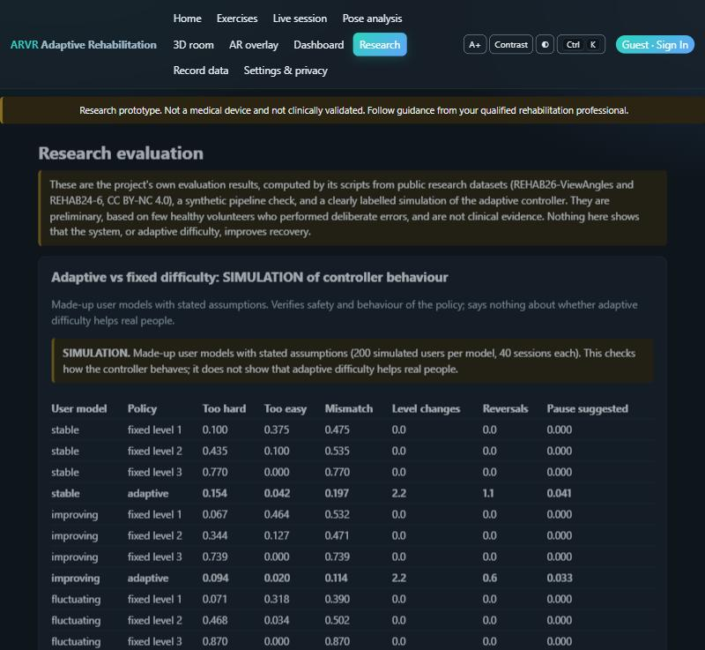
Figure 5.1 Research page: the simulation table is clearly labelled SIMULATION

6. Exercise Library

Nine exercises are defined as JSON files; start and target angles are illustrative placeholders, not prescriptions. All use three levels (5, 8 and 10 repetitions; 60%, 75% and 90% of the range; minimum repetition time 1.5, 1.2 and 1.0 s).
Exercise | Joint | Start → target | Things the system can notice
Elbow flexion | elbow | 160° → 50° | Incomplete bend; Moving too fast; Shoulder compensation
Hip abduction (standing) | hip | 176° → 150° | Insufficient leg raise; Moving too fast; Trunk leaning
Hip flexion (standing march, side-on) | hip | 176° → 100° | Insufficient knee lift; Moving too fast; Leaning back
Knee extension (seated, side-on) | knee | 95° → 165° | Insufficient leg straightening; Moving too fast; Lifting the thigh
Knee flexion | knee | 170° → 90° | Incomplete bend; Moving too fast
Shoulder abduction | shoulder | 20° → 90° | Insufficient arm raise; Moving too fast; Trunk leaning
Shoulder extension | shoulder | 10° → 45° | Torso bent forward; Shoulder elevated; Torso rotation
Shoulder flexion | shoulder | 20° → 100° | Insufficient arm raise; Moving too fast
Sit-to-stand | knee/hip | 170° → 95° | Incomplete rise; Moving too fast; Forward lean

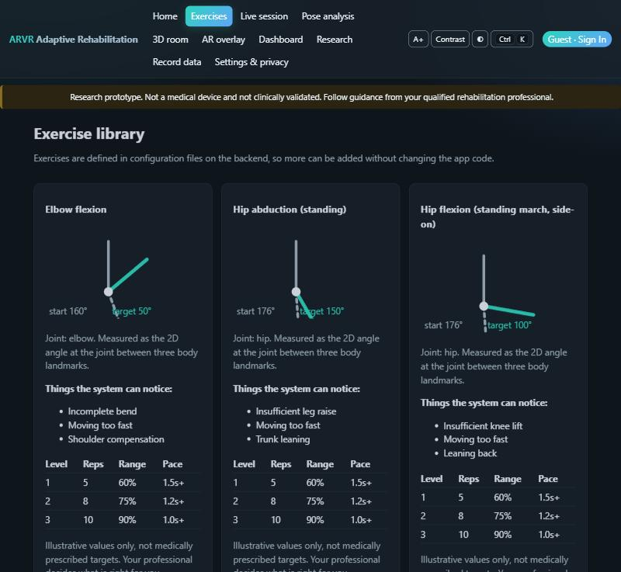
Figure 6.1 Exercise library page with diagrams and illustrative level tables

7. Web Application

7.1 Pages
Page | Route | What it does
Home | / | Introduction, an interactive 'raise your arms' demo, links to every mode
Exercises | /exercises | Exercise library with diagrams, errors it can notice and level tables
Live session | /session | Camera or synthetic demo; counter, phase, range, feedback, save and suggestion
Pose analysis | /analysis | Skeleton, per-landmark confidence, angle chart, pipeline diagnostics
3D room | /room | Desktop 3D view with a virtual trainer; experimental Enter VR
AR overlay | /ar | Camera-overlay AR: guidance drawn over the live camera picture
Dashboard | /dashboard | Trends, level history, weekly strip, milestones, CSV export
Session summary | /sessions/:id | Per-repetition table, suggestion with reasons, pain check-in, printable report
Research | /research | Evaluation results, simulation, performance
Record data | /collect | Consent-gated recording of landmark numbers for research (no video)
Settings & privacy | /settings | Privacy facts, export, backup and restore, delete account

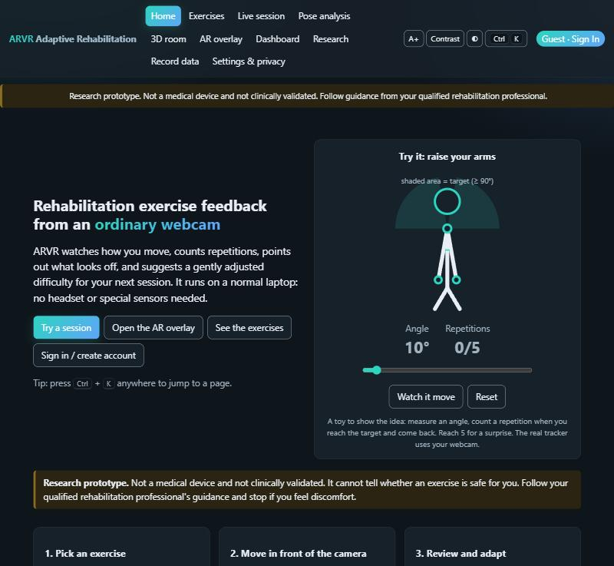
Figure 7.1 Home page with the interactive movement demo

7.2 AR Overlay
The camera-overlay AR page is the primary experience when no headset is available. It draws a translucent ghost trainer fitted to the user's torso, colours the exercising joint green, amber or red, shows setup hints (step back, step closer, face the camera), a progress bar and a 'Good / Slower / Go further' flash after each repetition. It offers optional voice cues, front or back camera and full screen. It is a camera overlay, not immersive headset AR: WebXR cannot expose camera frames to a page, so body tracking in a headset is not possible from the web.
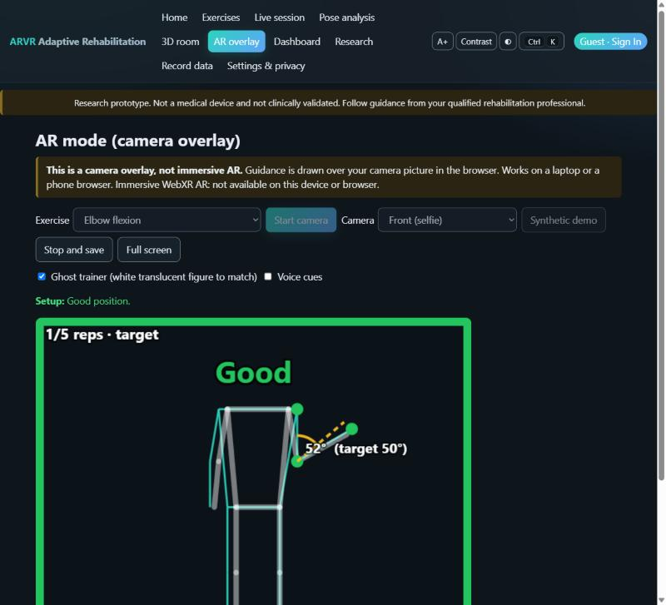
Figure 7.2 AR overlay: ghost trainer, target angle and 'Good' flash (synthetic demo)

7.3 3D Room and VR
The 3D room shows an amber virtual trainer and a teal figure that mirrors the user. An 'Enter VR' button appears only when the browser reports a WebXR headset; it has never been tried on a headset and is documented as untested.
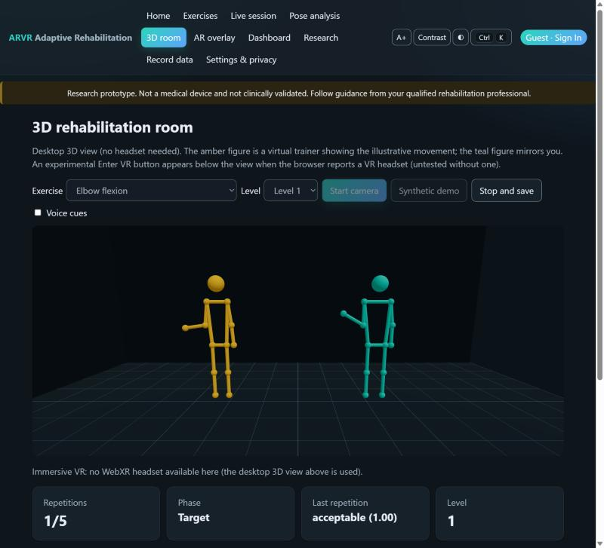
Figure 7.3 3D rehabilitation room: trainer (amber) and mirrored user (teal)

7.4 Interactive Touches
- Home page demo: drag the arms or use the slider; a repetition counts after reaching 90° and returning below 20°. It is a toy with no camera.
- Ctrl + K (or /) opens a page switcher; a theme button cycles automatic, light and dark.
- Dashboard: a 7-day strip, a streak flame and fun milestones computed from the user's own sessions (not medical).
- Confetti only after a real session that reached its target with a score of at least 0.8. All motion stops if the system asks for reduced motion.
- Display options for low vision: larger text and high contrast; every control works from the keyboard.
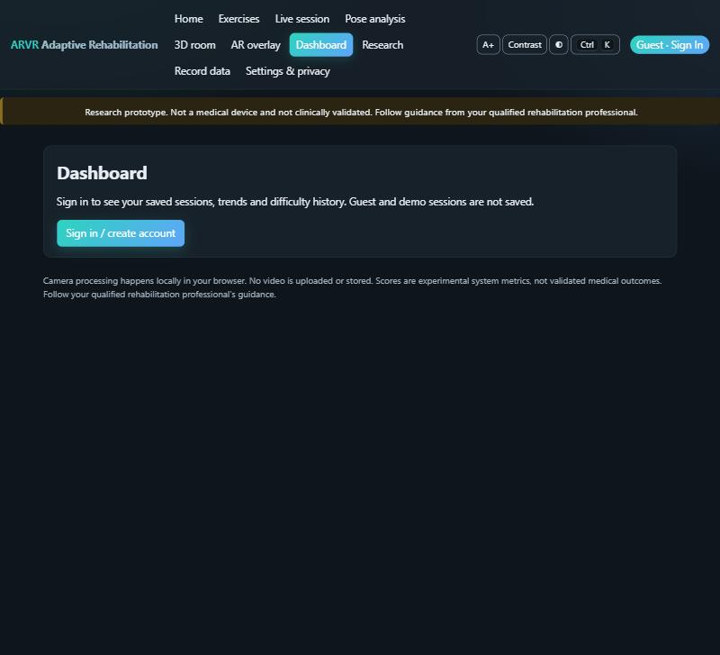
Figure 7.4 Dashboard for a guest: sign-in prompt (saved data needs an account)
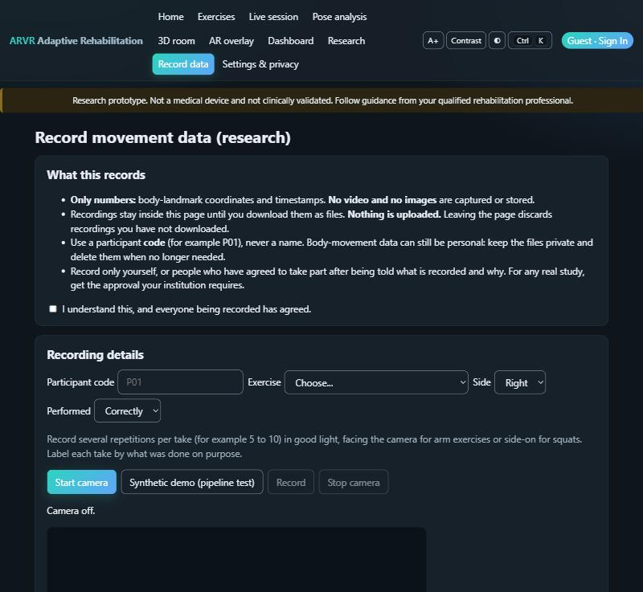
Figure 7.5 Record data page: consent first, then numbers only, with participant codes

8. Backend API and Database

8.1 Endpoints (prefix /api)
Method | Path | Purpose
GET | /health | Status and the safety disclaimer
GET | /exercises, /exercises/{id} | Exercise library
POST | /auth/register, /auth/login, /auth/logout | Optional accounts (scrypt hashing, hashed bearer tokens)
GET/PATCH/DELETE | /me | Profile; delete removes the account and its data
GET/POST | /me/backup, /me/restore | Idempotent, ownership-safe backup and restore (JSON)
POST | /sessions | Start a session (guest, signed-in or demo)
POST | /sessions/{id}/repetitions | Save a finished repetition
POST | /sessions/{id}/complete | Summary, recommendation, optional pain and note
POST | /sessions/{id}/checkin | Pain check-in that re-evaluates the suggestion
GET | /sessions, /sessions/{id}, /sessions/{id}/detail | History and per-repetition detail
GET | /progress, /summary, /analytics/weekly, /export.csv | Dashboard data and CSV export
POST | /recommend, /reset, GET /state | Adaptive controller access
POST | /assessment/evaluate | Stateless assessment of a repetition
GET | /results, /models/status | Evaluation results and model status for the Research page
WS | /ws/analysis | Live angle stream → counter and assessment
WS | /ws/relay/{room} | Local pose relay for the Unity client

8.2 Database Tables
Table | Main columns
users | id, username (unique), password_hash (scrypt), age_range, goals, preferences, created_at
auth_tokens | token_digest (SHA-256 only), user_id, created_at, expires_at
sessions | id, user_id (null = guest), exercise_id, is_demo, difficulty, ws_key, started_at, ended_at, summary, pain (0–10), note
repetitions | id, session_id, index, range_of_motion_deg, duration_s, quality_label, quality_score, counted, reliable, features
adaptive_decisions | id, user_id, exercise_id, session_id, from_level, to_level, action, classification, reasons, metrics, created_at

8.3 Security Measures
- Passwords hashed with scrypt; only a SHA-256 digest of each bearer token is stored.
- Sign-in lockout after 5 failures in 5 minutes per username and IP; general rate limit of 300 requests per minute per IP.
- Security headers on every response (HSTS only over HTTPS); per-session secret for the live stream; ownership checks on every session route.
- Only joint-angle numbers reach the backend, which runs on the user's own computer; no cloud service, analytics or external AI is used.

9. Evaluation and Results

9.1 Datasets
Two public datasets were used (CC BY-NC 4.0; raw data is not redistributed). REHAB26-ViewAngles (Zenodo 23018128): 5 healthy volunteers, 3 exercises, 1,665 labelled repetitions; participants are pseudonymised R26-P1 to R26-P5. REHAB24-6 (Zenodo 13305826): volunteers recorded with motion capture and video; used for angle accuracy and as the external test set. All results are preliminary and non-clinical.

9.2 Joint-Angle Accuracy (RQ1)
Group | Frames | MAE (°) | RMSE (°) | Pearson r
All frames | 49,171 | 8.02 | 14.24 | 0.97
shoulder abduction | 28,427 | 8.92 | 17.16 | 0.96
sit to stand | 20,744 | 6.80 | 8.78 | 0.98

Bias -2.14°, 95% limits of agreement -29.7° to +25.5°, over 31 recordings. The error depends on the camera (mean absolute error 9.0° for one camera and 4.3° for the other). Part of the error is definitional (motion-capture joint centres versus landmarks). Useful for counting and coarse range; not a clinical measurement.

9.3 Repetition Counting (RQ2)
Setting | Labelled | Detected | Precision | Recall | F1 | Count error
REHAB26, illustrative ranges | 1,665 | 1,506 | 0.95 | 0.86 | 0.90 | 1.02
REHAB26, per-user calibration | 1,635 | 1,642 | 0.96 | 0.97 | 0.97 | 0.20
REHAB24-6, illustrative ranges | 369 | 385 | 0.87 | 0.91 | 0.89 | 1.23
REHAB24-6, per-user calibration | 369 | 385 | 0.87 | 0.91 | 0.89 | 1.16

Calibration clearly helps on REHAB26 (F1 0.90 → 0.97, count error 1.0 → 0.2). On the REHAB24-6 motion-capture set it does not, so calibration is not a universal improvement.

9.4 Movement-Quality Classification (RQ3–RQ5)
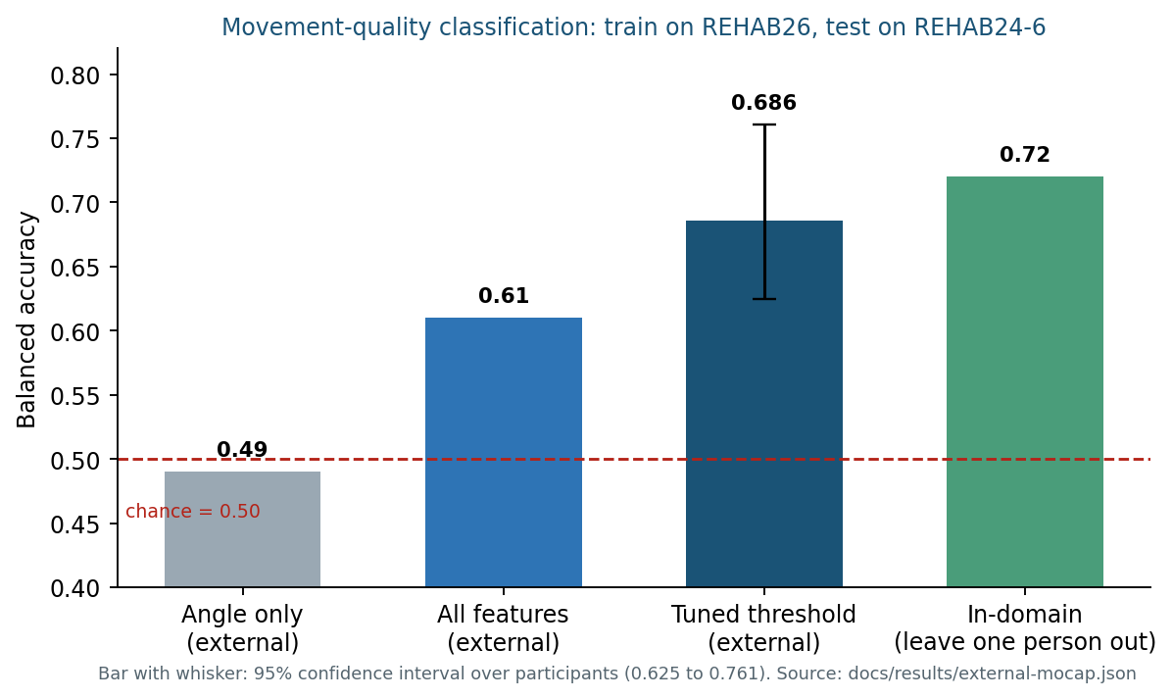
Figure 9.1 Balanced accuracy of the quality model when trained on REHAB26 and tested on REHAB24-6
Angle features alone are near chance (0.49). Posture and depth features raise it to 0.61, and a decision threshold chosen on training data only gives 0.686 (95% CI 0.625–0.761). Inside a single dataset (leave one person out) the model reaches about 0.72, so the gap reflects people and setup shift rather than the skeleton source. The model is over-confident: the mean predicted probability of an error was 0.69 for angle-only and 0.72 with posture features, against 0.40 observed; probabilities must not be shown to users as certainty.

9.5 Backend Performance
Measure | Result
Analysis cost per sample | about 4 µs
WebSocket round trip | mean 0.76 ms, 99th percentile 1.5 ms
Budget | one sample every 66 ms

Measured in-process with a test client on one computer; it excludes the network and the browser's pose estimation.

9.6 Reading the Results Honestly
- Transfer between datasets is modest; the in-domain figure is not what a new user should expect.
- Five training participants cannot support deployment-grade claims.
- No patients took part, so there is no evidence of rehabilitation benefit.
- Thresholds have not been reviewed by a clinician.

10. How to Use the Application

10.1 Starting the Application
Native run (two terminals):
cd backend ; .\.venv\Scripts\python.exe -m uvicorn app.main:app --port 8000
cd frontend ; npm run dev
Then open http://localhost:5173. Docker alternative: `docker compose up --build` (nginx proxy); local HTTPS for phone use is described in docs/installation.md.

10.2 Step-by-Step Usage
- Open Exercises and pick an exercise; open Live session (or AR overlay).
- Press Start camera and allow the camera, or Synthetic demo to see the pipeline without a camera.
- Tick Calibrate to my range to use your own demonstrated range; optionally enable audio or voice cues.
- Move; watch repetitions, phase and feedback update. Press Stop and save (signed-in users) to get the summary and a suggestion.
- Report pain on the summary page if you feel any; the suggestion becomes more cautious.
- Open the Dashboard for trends, export CSV or a backup from Settings & privacy.

10.3 Phone and Headset
On the same Wi-Fi, create the development certificate (scripts/make_dev_cert.ps1), start Vite with HTTPS, open the computer's address on the phone, accept the certificate warning and use the AR overlay with the back camera. The optional Unity 6 client (OpenXR packages installed) can show the room in VR; both phone and headset paths are untested.

11. Privacy, Safety and Ethics

- Camera: the browser asks for permission every time; pose estimation runs locally; video is not uploaded or stored and the camera is switched off when you stop.
- Backend receives: only joint-angle numbers and timestamps, on your own computer.
- Saved for signed-in users: username and salted password hash, optional age range and goals text, preferences, and completed sessions with scores and suggestions. Guest and demo sessions are not saved.
- Not collected: medical information, video, images or location. Please do not type medical details into the goals or note fields.
- Research recordings: numbers only, participant codes instead of names, consent checkbox first; get your institution's approval for any real study.
- Not a medical device. The system cannot tell whether an exercise is safe for you; follow a qualified professional and stop if you feel discomfort.

12. Testing and Quality

Suite | Scope | Result
Backend (pytest) | angle maths, counter, assessment, controller bounds (including property tests over long random histories), API validation and ownership, persistence, importers, evaluation code, rate limits, security headers, performance | 203 passed
Frontend (vitest) | pose guidance, WebXR helper, display options, components, pages, interactive features | 72 passed
Type check (tsc) | TypeScript strict check of the frontend | clean
Production build (vite) | bundle the frontend | OK
Unity (edit mode) | client logic | 15 passed (last run earlier in the project)

What tests cannot cover (a real camera, lighting, bodies, phones, headsets) is listed in docs/limitations-and-safety.md with a manual test protocol.

13. Scientific References and Standards

Only sources that are named in the project's own documentation are listed here. The literature review (Chapter 2 of the thesis) is not written yet and no citations were invented; verify each reference on its own page before using it.
- REHAB26-ViewAngles dataset: Zenodo record 23018128 (DOI 10.5281/zenodo.23018128), CC BY-NC 4.0. Cite the record and the related paper named on the Zenodo page.
- REHAB24-6 dataset: Zenodo record 13305826 (DOI 10.5281/zenodo.13305826), CC BY-NC 4.0; the record lists Cernek, Sedmidubsky and Budikova (SISAP 2024) as authors; verify the exact reference on the Zenodo page.
- MediaPipe Pose Landmarker (Google), used for browser pose estimation.
- WebXR Device API (W3C), used for the experimental VR button.
- Evaluation methods used: leave-one-participant-out validation, participant-level bootstrap intervals, Brier score and expected calibration error (described in docs/research-methodology.md).

14. Limitations and Future Scope

14.1 Current Limitations
- Single-camera 2D angles are view dependent and are not clinical measurements.
- Small, healthy, non-patient samples; coarse labels; differences between datasets in camera, setting and labelling.
- Quality classification transfers only modestly between datasets and is over-confident.
- Thresholds and exercise ranges are illustrative and not clinician-reviewed.
- No own-webcam data has been collected yet; browser pose-estimation speed and end-to-end latency are not measured.
- Immersive VR, phone use and the newer Unity features have not been tested by hand.
- Rate limits are shared per proxy IP behind nginx; the self-signed certificate is for a local network only.

14.2 Remaining Work
# | Task | Who or what is needed
1 | Webcam check on a laptop and a phone (manual protocol in the user guide) | You, a webcam and a phone
2 | Unity Play-mode check of the newer features | You, the Unity Editor
3 | Own recordings with the Record data page and the external test | You and consenting volunteers
4 | Literature review (Chapter 2) from verified sources | You
5 | Clinician review of ranges, difficulty and pain thresholds | A rehabilitation professional
6 | A study with participants (ethics approval first) | Participants, ethics committee
7 | VR on a headset | An OpenXR/WebXR headset

14.3 Future Enhancements
- Browser end-to-end tests (Playwright).
- A recurrent-network (LSTM/GRU) baseline compared against the Random Forest.
- A proper internet-facing deployment: certificate from a certificate authority, authentication review and hardening.

15. Glossary

Term | Meaning
Pose estimation | Finding body landmarks (joints) in a camera image
Landmark | One of 33 body points returned by MediaPipe, with a visibility score
Joint angle | The 2D angle between three landmarks at a joint, in degrees
Range of motion | How far a joint moves during a repetition
Hysteresis | Different thresholds for entering and leaving a state, to avoid flicker and flip-flopping
Calibration | Using the user's own demonstrated range instead of illustrative targets
Adaptive controller | The rule set that suggests the next difficulty level, with reasons
MAE / RMSE | Mean absolute error / root mean square error of the angle versus motion capture
Pearson r | Correlation between measured and reference angles (1 = perfect)
Balanced accuracy | Average of recall on each class; 0.50 is chance for two classes
Leave-one-participant-out | Train on all people but one, test on the one left out, repeat
Bootstrap CI | A confidence interval from resampling participants
Brier score / ECE | Measures of how trustworthy predicted probabilities are
WebSocket | A persistent connection used to stream angles to the backend
WebXR | Browser standard for VR/AR devices
AR overlay | Guidance drawn on top of the live camera picture (not immersive)
CC BY-NC 4.0 | Licence allowing non-commercial use with attribution

16. Live Verification (12 November 2026)

The application was started again from the project folder on Windows 11 (Python 3.10, Node, Vite) and every page in Section 7 was opened in a browser; the screenshots in this report were captured from that running application. The synthetic demo figure was used on the Live session, Pose analysis, AR overlay and 3D room pages because no webcam test has been done yet. The automated checks were then run:
Check | Result
Backend tests | 203 passed
Frontend tests | 72 passed
TypeScript check | clean
Frontend production build | OK
Pages opened and checked in a browser | Home, Exercises, Live session, Pose analysis, AR overlay, 3D room, Research, Record data, Settings, Dashboard
Interactive features checked in a browser | Home demo counted a repetition; Ctrl+K palette navigated to the Dashboard

Not verified: a real webcam on a laptop or phone, immersive VR on a headset, the Unity Play-mode check, and any study with people (Section 14.2).

