BANGALORE CLIMATE ANALYTICS SYSTEM
Complete Technical Analysis & Project Documentation

Advanced Climate Analysis | Anomaly Detection | SARIMA Forecasting | Flask Web Application

Project | Bangalore Climate Analytics System
Data Coverage | 1951 – 2024 | 73 Years | 882 Monthly Records
Technology | Python 3.10 | Flask | SARIMA | SQLite
Methodology | WMO SPI (WMO-No. 1090, 2012)
Report Date | 16 June 2026

1. Executive Summary

The Bangalore Climate Analytics System is a full-stack scientific web application that provides historical climate analysis, Z-score based anomaly detection, composite Climate Extreme Score (CES) computation, and 12-month SARIMA-based forecasting for Bangalore, India. It covers 73 years of daily meteorological data (1951–2024) with 882 monthly aggregated records, following the WMO Standardized Precipitation Index (WMO-No. 1090, 2012) methodology.

Key Highlights
- 73-year historical dataset — 882 monthly records from IMD (1951–2024)
- Z-score anomaly detection for Rainfall, Temperature, and Humidity
- CES = 0.6×Z_rain + 0.4×Z_temp with WMO-calibrated thresholds (1.051 Moderate, 1.300 Extreme)
- Three SARIMA(1,1,1)(1,1,1,12) models for Rainfall, Temperature, Humidity forecasting
- User-input-driven 12-month CES forecast: extreme input → risk alerts in early months
- User authentication (Flask-Login + SQLite), prediction history, dashboard, REST API
- 15+ auto-generated analytical charts covering trends, anomalies, seasonal analysis

2. Architecture & System Diagrams

Figure 1: System Architecture Overview
High-level layered architecture showing all six tiers of the application from the browser presentation layer down to the raw data and database layer.
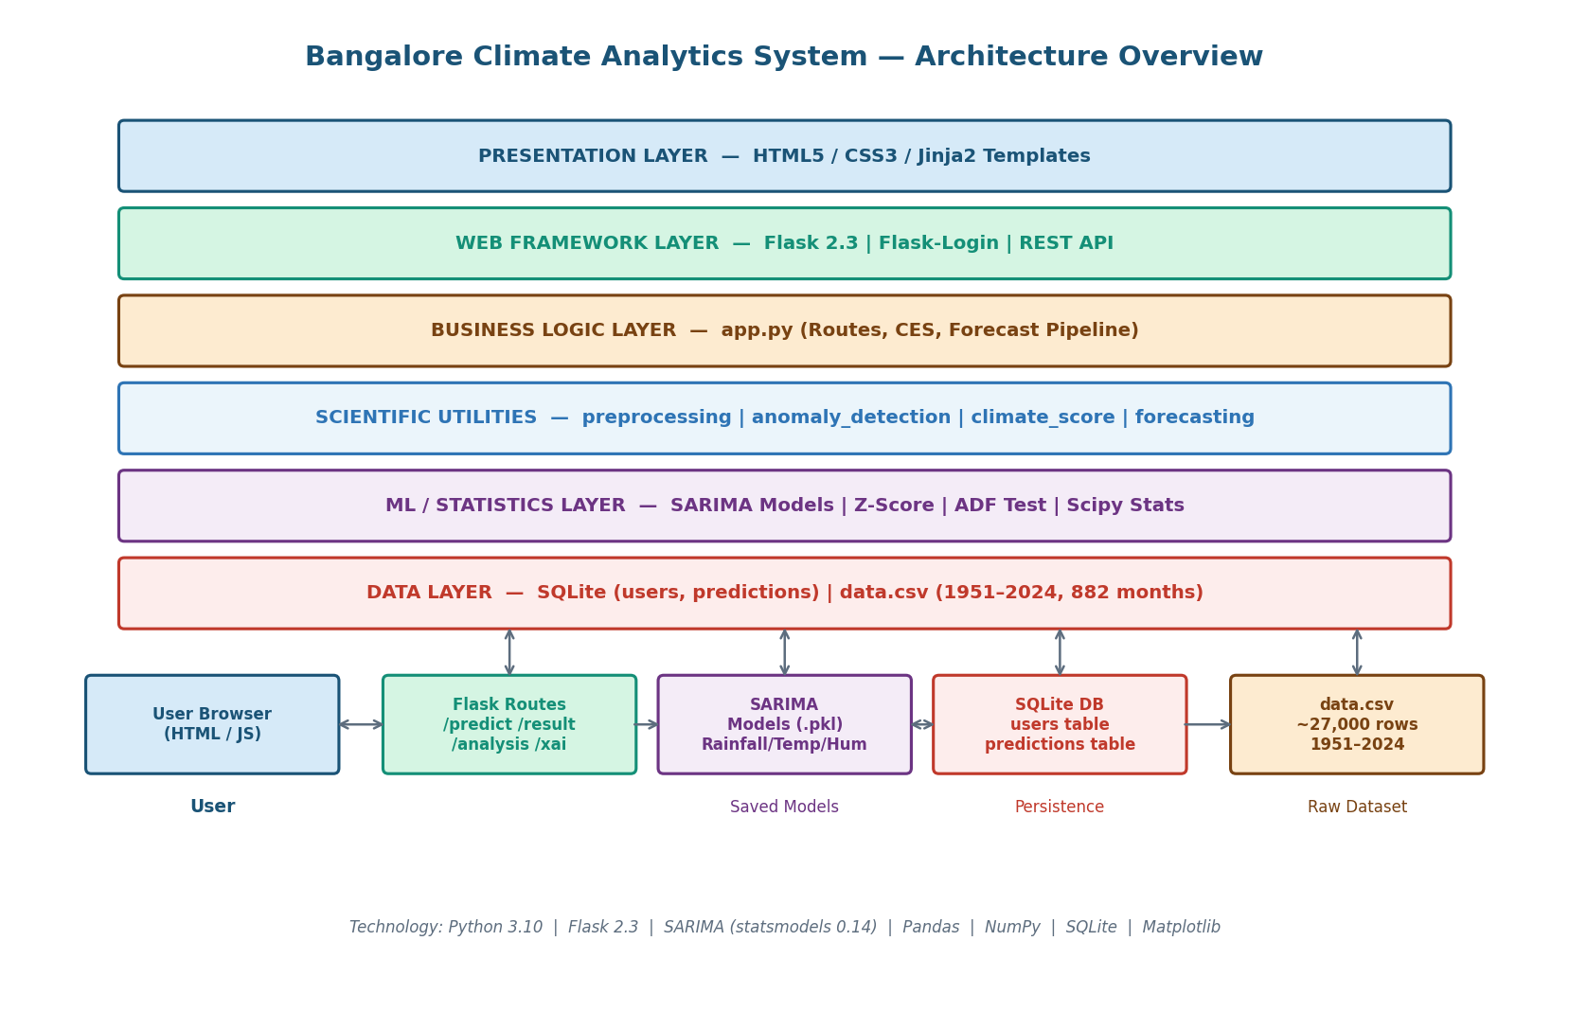
Figure 1: System Architecture Overview

Figure 2: Data Pipeline Flowchart
Step-by-step data transformation pipeline from the raw 27,000-row daily CSV file through preprocessing, monthly aggregation, baseline computation, anomaly detection, and final CES calculation.
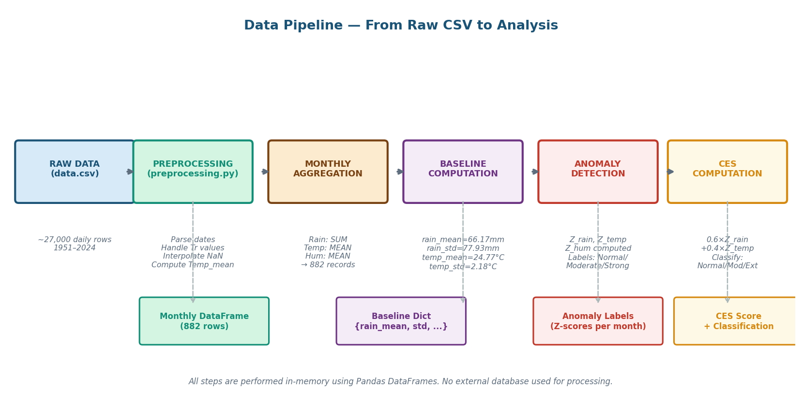
Figure 2: Data Pipeline Flowchart

Figure 3: CES Computation Flow
Detailed computation graph showing how rainfall and temperature inputs are converted to Z-scores, weighted, summed, and classified into Normal / Moderate / Extreme CES bands.
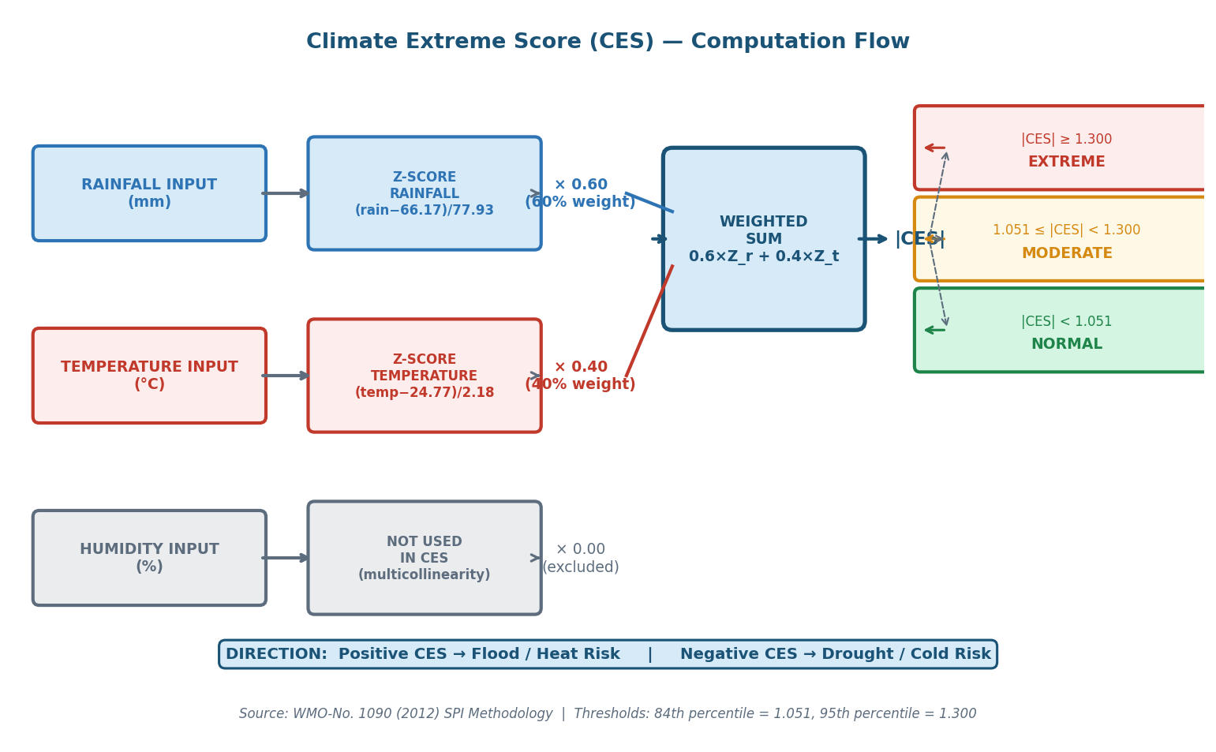
Figure 3: CES Computation Flow

Figure 4: SARIMA Forecasting Pipeline
Complete SARIMA modeling pipeline including training (ADF test → model fit → evaluation → save) and inference (load models → forecast → caps → user blending → result page).
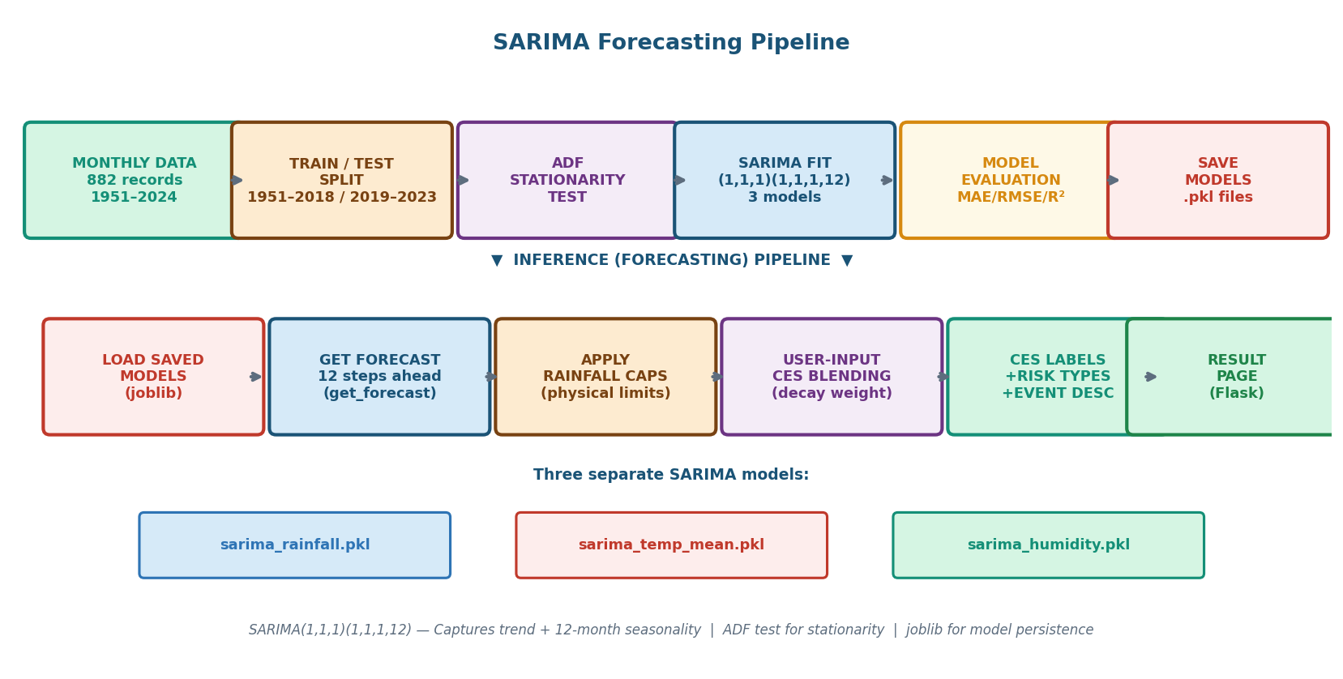
Figure 4: SARIMA Forecasting Pipeline

Figure 5: Web Application — User Journey & Page Flow
Full user journey through the web application showing all pages, navigation flows, authentication gates, and how the result page outputs map back to underlying computations.
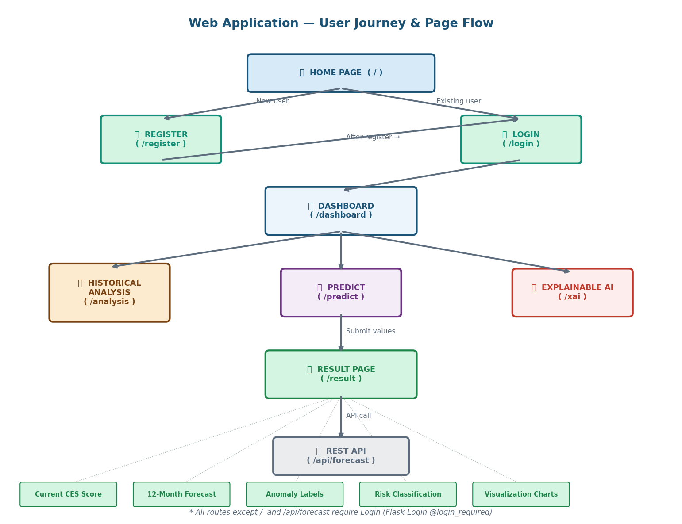
Figure 5: Web Application — User Journey & Page Flow

Figure 6: CES Scale — Normal / Moderate / Extreme Bands
Visual representation of the CES scale from −3 to +3 showing the Normal (green), Moderate (orange), and Extreme (red) bands with historical event markers.
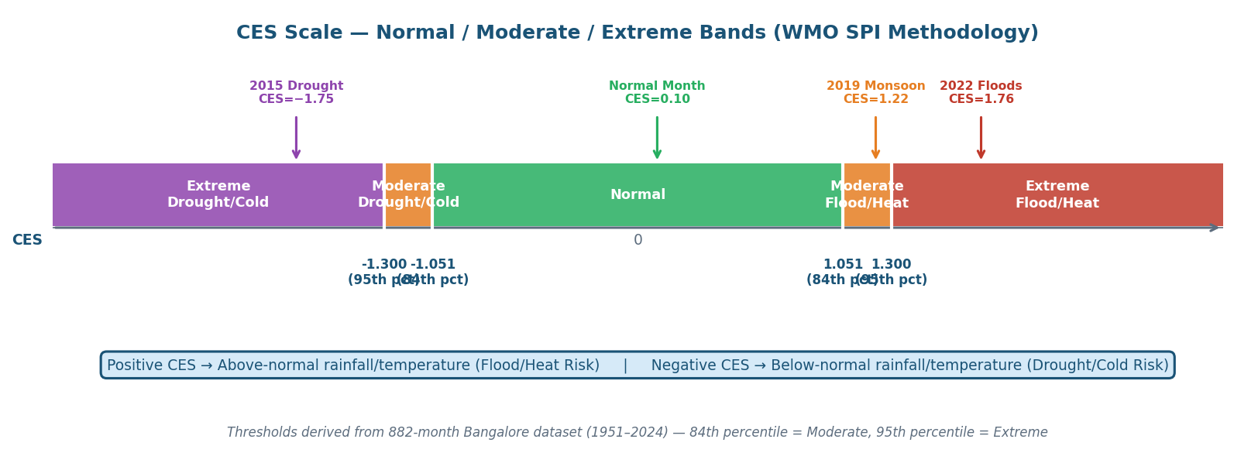
Figure 6: CES Scale — Normal / Moderate / Extreme Bands

Figure 7: Module Dependency Map
Module dependency graph showing how app.py imports from all utility modules and how each module connects to data sources, databases, and saved models.
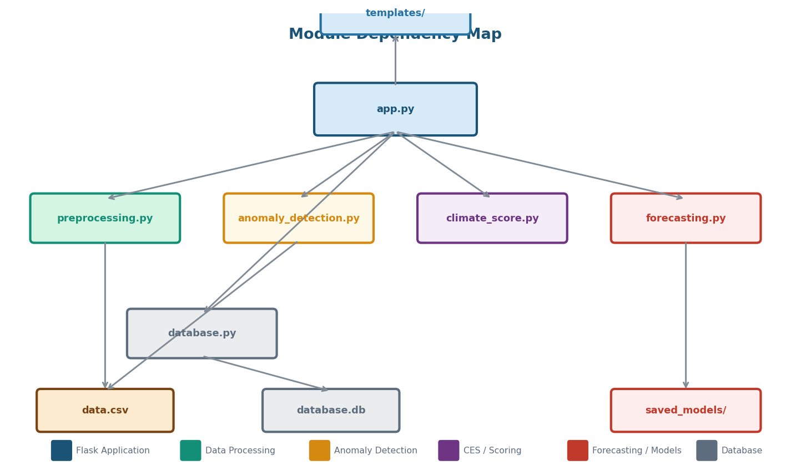
Figure 7: Module Dependency Map

Figure 8: 12-Month CES Forecast — User-Input Blending
Comparison of forecast CES trajectories for three input scenarios: pure SARIMA, extreme user input (Rain=200mm, Temp=29°C), and normal user input — demonstrating the user-driven blending.
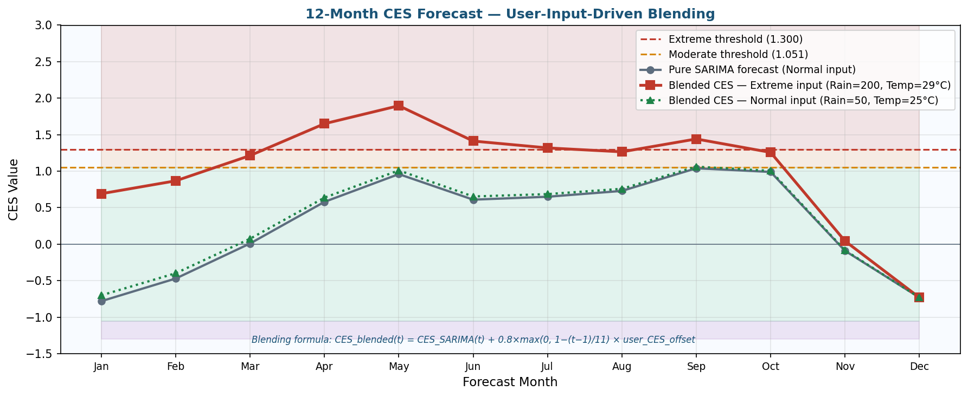
Figure 8: 12-Month CES Forecast — User-Input Blending

3. Technology Stack

Layer | Technology | Version | Purpose
Backend Framework | Flask | 2.3.3 | Web server, routing, session management
Authentication | Flask-Login | 0.6.2 | User sessions, @login_required protection
Data Processing | Pandas | 2.0.3 | DataFrames, aggregation, groupby
Numerical Computing | NumPy | 1.24.3 | Z-scores, array operations, decay weights
Time Series | Statsmodels | 0.14.0 | SARIMA fitting, ADF test, forecasting
Auto ARIMA | pmdarima | 2.0.4 | Automatic order selection support
Statistical Tests | SciPy | 1.11.1 | Linear regression for trend analysis
ML Metrics | Scikit-Learn | 1.3.0 | MAE, RMSE, R² model evaluation
Visualization | Matplotlib | 3.7.2 | All 15+ charts and diagrams
Model Persistence | Joblib | 1.3.2 | Save/load SARIMA .pkl files
Database | SQLite | Built-in | User accounts, prediction history
Frontend | HTML5+CSS3+JS | — | Jinja2 templates, responsive UI

4. Data Pipeline

4.1 Raw Dataset
Column | Description | Unit | Notes
Date | Observation date | YYYY-MM-DD | Parsed as datetime
Rainfall | Daily rainfall | mm | 'Tr'/'Trace' → 0.0
Temp_Max | Daily maximum temperature | °C | Used in Temp_mean
Temp_Min | Daily minimum temperature | °C | Used in Temp_mean
Humidity | Relative humidity | % | Daily average

4.2 Baseline Statistics (1951–2024)
Variable | Mean | Std Dev | Used In
Rainfall | 66.17 mm | 77.93 mm | Z-score, CES
Temperature | 24.77 °C | 2.18 °C | Z-score, CES
Humidity | 78.5 % | ~5.8 % | Z-score (reference only)

5. Climate Extreme Score (CES) Methodology

5.1 Formula
CES = (0.6 × Z_rainfall) + (0.4 × Z_temperature)

5.2 WMO Thresholds & Historical Validation
|CES| Range | Classification | Percentile | Historical Example
< 1.051 | Normal | Below 84th | Typical months (~84% of dataset)
1.051 – 1.300 | Moderate | 84th – 95th | 2019 Above-Normal Monsoon (CES=1.216)
≥ 1.300 | Extreme | Above 95th | 2022 Bangalore Floods (CES=1.756)

6. Forecasting System

6.1 SARIMA Configuration
Parameter | Value | Meaning
Order (p,d,q) | (1,1,1) | AR(1), first differencing, MA(1)
Seasonal Order (P,D,Q,m) | (1,1,1,12) | Seasonal AR, differencing, MA — 12-month period
Training Period | 1951–2018 | 816 monthly observations
Test Period | 2019–2023 | 60 months held out for evaluation
Models | 3 separate | Rainfall.pkl, Temp_mean.pkl, Humidity.pkl

6.2 User-Input-Driven CES Blending Formula
CES_blended(t) = CES_SARIMA(t) + decay(t) × user_CES_offset
decay(t) = 0.8 × max(0, 1 − (t−1)/(T−1)) where T = 12

7. Web Application Routes

Route | Page | Auth Required | Description
/ | Home | No | Landing page with feature overview
/register | Register | No | New user account creation
/login | Login | No | User authentication
/dashboard | Dashboard | Yes | Overview, history, 6-month forecast preview
/predict | Predict | Yes | Input form for climate values
/result | Result | Yes | Full CES analysis and 12-month forecast
/analysis | Analysis | Yes | Period, decade, seasonal historical analysis
/xai | Explainable AI | Yes | Scientific methodology transparency
/api/forecast | REST API | No | JSON: forecast + CES data

8. How to Use — Demo Values

Scenario | Rainfall (mm) | Temp (°C) | Humidity (%) | Expected CES | Classification
Extreme Flood/Heat | 200 | 29 | 88 | ~+1.84 | EXTREME
Moderate Risk | 150 | 28 | 82 | ~+1.24 | MODERATE
Normal Conditions | 50 | 25 | 75 | ~+0.10 | NORMAL
Extreme Drought/Cold | 0 | 18 | 45 | ~−1.75 | EXTREME

Server Startup Command
python app.py → http://127.0.0.1:5000

9. Scientific References

[WMO-No. 1090 (2012)] World Meteorological Organization. Standardized Precipitation Index User Guide.
[IMD SOP 2021] India Meteorological Department. Standard Operating Procedure for Monsoon Monitoring.
[IMD Climate Change Trends (2020)] India Meteorological Department. Climate Change Trends over India.
[Box, Jenkins (2015)] Time Series Analysis: Forecasting and Control. 5th Ed. Wiley.
[Dickey & Fuller (1979)] Distribution of the Estimators for Autoregressive Time Series with Unit Root. JASA.

Bangalore Climate Analytics System | 16 June 2026 | Python + Flask + SARIMA + WMO SPI

