

Correctness-Aware Self-Healing for ML Forecasting Services on Kubernetes: Detecting and Recovering from Silent Failures

AIML-PROJECT REPORT

Submitted by

Manasa Krishnakumar [USN]

[STUDENT NAME 2] [USN]

Under the guidance of

Dr. Merin Meleet
Associate Professor
Dept. of ISE
RV College of Engineering

In partial fulfillment for the award of degree of

Bachelor of Engineering
in

Information Science and Engineering

2025-2026


RV COLLEGE OF ENGINEERING®, BENGALURU - 560059

(Autonomous Institution Affiliatedto VTU, Belagavi) DEPARTMENT OF INFORMATION SCIENCE AND ENGINEERING

CERTIFICATE

Certified that the project work titled “Correctness-Aware Self-Healing for ML Forecasting Services on Kubernetes: Detecting and Recovering from Silent Failures” is carried out by Manasa Krishnakumar ([USN]) and [STUDENT NAME 2] ([USN]), who are bonafide student of R.V College of Engineering, Bangalore, in partial fulfillment for the award of degree of Bachelor of Engineering in Information Science and engineering of the Visvesvaraya Technological University, Belgaum during the year 2025-26. It is certified that all corrections/suggestions indicated for the internal Assessment have been incorporated in the report deposited in the departmental library. The project report has been approved as it satisfies the academic requirements in respect of project work as a part of the course “Artificial Intelligence and Machine Learning” prescribed by the institution for the said degree.

Faculty in Charge Head of the Department

External Evaluation

Name of Examiners Signature with date 1
2

DECLARATION

We, Manasa Krishnakumar and [STUDENT NAME 2], students of fifth semester B.E., Department of Information Science and Engineering, RV College of Engineering, Bengaluru, hereby declare that the project titled “Correctness-Aware Self-Healing for ML Forecasting Services on Kubernetes: Detecting and Recovering from Silent Failures” has been carried out by us and submitted in partial fulfilment for the award of degree of Bachelor of Engineering in Information Science and Engineering during the year 2025-2026.
Further we declare that the content of the dissertation has not been submitted previously by anybody for the award of any degree or diploma to any other university.
We also declare that any Intellectual property rights generated out of this project carried out at RVCE will be the property of RV College of Engineering, Bengaluru and we will be among the authors of the same.

Place: Bengaluru Date:
Signature

ACKNOWLEDGEMENTS
We express our sincere gratitude to our guide, Dr. Merin Meleet, Associate Professor, Department of Information Science and Engineering, RV College of Engineering, for her constant guidance, encouragement and valuable suggestions throughout this project. We thank the Head of the Department of Information Science and Engineering and the faculty of the department for providing the laboratory facilities and an environment that made this work possible. We are grateful to the Principal of RV College of Engineering for the academic support. We also thank the authors of the open-source tools on which this work stands - Docker, Kubernetes, Minikube, Prometheus, Grafana, OpenTelemetry, Jaeger, Argo Rollouts, Kyverno, cosign, KEDA, Chaos Mesh, Flask, TensorFlow, statsmodels, scikit-learn and kopf - and the authors of the research papers whose work we reviewed. Finally, we thank our families and friends for their patience and support during long experiment runs.

ABSTRACT

 | CONTENTS
Abstract |  | i
List of Figures |  | v
List of Tables  List of Abbreviations  Publication Details |  | vi  vii  viii

Chapter 1 Introduction 1
1.1 Terminology 2
1.2 Scope and Relevance 3
1.3 Motivation 3
1.4 Problem Statement 4
1.5 Objectives 4
1.6 Report Organisation 5
1.7 Summary 5
Chapter 2 Literature Survey 6
2.1 Literature Review 6
2.2 Summary of the Reviewed Papers 8
2.3 Research Gap and Positioning 10
2.4 Summary 11
Chapter 3 Software Requirements Specification 12
3.1 Functional Requirements 12
3.2 Non-Functional Requirements 12
3.3 Hardware Requirements 13
3.4 Software Requirements 13
3.5 Summary 13
Chapter 4 Design of the System 14
4.1 Theory and Concepts 14
4.2 Dataset Description 16
4.3 Design and Methodology 18
4.4 System Architecture 20
4.5 Tools and APIs 22
4.6 Summary 22
Chapter 5 Implementation and Testing 24
5.1 Implementation Requirements 24
5.2 Implementation Tool Features 24
5.3 Code Snippets with Explanation 25
5.4 Testing 29
5.5 Summary 31
Chapter 6 Results and Analysis 32
6.1 Results 32
6.2 Benchmarking and Analysis 34
6.3 Screenshots and Live Plots 38
6.4 Contributions (gap-based) 45
6.5 Deadline- and Load-Aware Degradation (Novelty 6) 46
6.6 Metamorphic Readiness Probe (experimental) 47
6.7 Baselines and Cost-Coverage of the Guard Layers 48
6.8 Healthy-but-Wrong Time and Mean Time to Correctness 49
6.9 Compound Faults 50
6.10 Overall Analysis 50
6.11 Verification and Live Evidence on a Second Machine (22 October 2026) 51
6.12 Extensions: Bit-Flip Fuzzing, Signed Golden Outputs and Operator Rollback (22 October 2026) 70
6.13 Summary 75
Chapter 7 Conclusion 76
7.1 Conclusion 76
7.2 Limitations 77
7.3 Future Scope 78
7.4 Summary 78
References (Ieee Format) 80
Appendix A Dataset Sample 84
Appendix B Research Paper (Ieee Format) 85

LIST OF FIGURES

Figure 4.1 Monthly rainfall, temperature and humidity (1951-2024) from data.csv 17
Figure 4.2 Monthly climatology used by the climatology tier 18
Figure 4.3 Methodology of the study 18
Figure 4.4 System architecture 21
Figure 4.5 Tiered degradation and guard checks 21
Figure 6.1 Wrong answers served per fault and configuration 34
Figure 6.2 Time to full quality under the operator 36
Figure 6.3 Home page of the Bangalore Climate Analytics System (browser, localhost:5000) 39
Figure 6.4 Climate dashboard: current values, 6-month forecast table and recent predictions 39
Figure 6.5 Dashboard forecast plots (rainfall and temperature) 40
Figure 6.6 Twelve-month SARIMA forecast plots served by the inference tier 40
Figure 6.7 Analysis gallery: distributions, anomaly z-scores, anomaly evolution and decade-wise anomalies 41
Figure 6.8 Live 12-step forecasts of SARIMA and LSTM returned by the deployed API 41
Figure 6.9 Live Grafana dashboard, last 30 minutes (refresh 5 s) 42
Figure 6.10 Grafana dashboard panels during the verification run 42
Figure 6.11 Golden-output integrity violations after an injected bit flip (Grafana panel) 43
Figure 6.12 Prometheus: golden_violation_total for the LSTM backend (1 h) 43
Figure 6.13 Prometheus: valid answers served per tier (1 h) 44
Figure 6.14 Jaeger trace of GET /dashboard with three inference calls 45
Figure 6.15 Jaeger trace search for the frontend service 45
Figure 6.16 Delay fault with and without deadline-aware degradation (10 trials each) 47
Figure 6.17 Detection of injected faults: baselines versus guard layers 49
Figure 6.18 Home page of the standalone Climate application (corrected CES formula and thresholds) 54
Figure 6.19 Dashboard of the standalone Climate application (SARIMA 6-month forecast) 55
Figure 6.20 Prediction input form 56
Figure 6.21 Result page for 300 mm, 27 C, 85 percent: CES 2.21, Extreme Flood/Heat 57
Figure 6.22 Result page for 0 mm, 18 C, 45 percent: CES -1.755, Extreme Drought/Cold with direction label 58
Figure 6.23 Explainable-AI page 59
Figure 6.24 Historical analysis gallery 60
Figure 6.25 Prediction history 61
Figure 6.26 Home page of the DevOps version served from Kubernetes (corrected text) 62
Figure 6.27 Dashboard served from Kubernetes with healthy models (LSTM tier) 63
Figure 6.28 LSTM result page with real LSTM forecasts 64
Figure 6.29 Dashboard after an injected silent fault: "Forecast served in degraded mode (tier: climatology)" 65
Figure 6.30 Inference API /health/semantic: both models valid, golden deviation 0.0 66
Figure 6.31 Inference API /predict: forecast served from the LSTM tier 66
Figure 6.32 Inference API /slo: correctness SLI with Wilson lower bound 67
Figure 6.33 Live Grafana dashboard (16 panels) while a bit-flip fault was injected 68
Figure 6.34 Prometheus: golden_violation_total 69
Figure 6.35 Prometheus: predict_tier_total by tier 69
Figure 6.36 Prometheus: up (scrape targets) 70
Figure 6.37 Bit-flip fuzzing: (a) harmful flips by class, (b) detection of harmful flips, (c) wrong answers missed by the envelope 71
Figure 6.38 Trade-off between detecting wrong answers and alarming on harmless changes 72
Figure 6.39 Signed golden outputs close the trusted-start-up gap 73
Figure 6.40 Restoration time per policy for a transient fault and for a bad release 73
Figure 6.41 Live Grafana dashboard on the re-installed monitoring stack 74
Figure 6.42 Inference API /health/semantic while a silent fault is injected (HTTP 503, golden deviation reported) 74

LIST OF TABLES

Table 1.1 Terminology | 3 | 3
Table 2.1 Reviewed papers (A1-A23): problem, method, result, limitation and relevance | 9 | 9
Table 2.2 Gaps in the literature, what this project does, and the closest prior work | 10 | 10
Table 3.1 Functional requirements | 12 | 12
Table 3.2 Hardware requirements | 13 | 13
Table 3.3 Software requirements | 13 | 13
Table 4.1 Summary statistics of the daily data (26,835 rows) | 17 | 17
Table 4.2 Configurations | 19 | 19
Table 4.3 Injected faults (SilentBench and extensions) | 19 | 19
Table 4.4 Inference API | 22 | 22
Table 4.5 Configuration variables | 22 | 22
Table 5.1 Implementation tools and the feature used | 25 | 25
Table 5.2 Executed validation checks (21 of 21 passed) | 30 | 30
Table 5.3 Defects found and fixed | 31 | 31
Table 6.1 Baseline fault trials (mean over trials; recovery - means never recovered) | 32 | 32
Table 6.2 Wrong answers served (percent of responses in the fault window), mean [95 % CI], n trials | 33 | 33
Table 6.3 Which guard layer catches which fault (10 trials per cell) | 35 | 34
Table 6.4 Operator policies (60 + 20 trials) | 35 | 35
Table 6.5 Validation of tuned probe settings (hang fault) - a negative result for probe tuning | 37 | 36
Table 6.6 Shadow gate decisions (selected candidates; 15 of 15 bad rejected, 6 of 6 good promoted overall) | 38 | 37
Table 6.7 Additional components and their measured outcome | 38 | 37
Table 6.8 Innovative components | 46 | 45
Table 6.9 Metamorphic probe: detection per fault (no golden output, no stored reference) | 48 | 47
Table 6.10 Detection of injected faults by simple baselines and by the layers of the guard (percent of windows) | 48 | 47
Table 6.11 Compound faults: wrong answers and p95 latency per configuration | 50 | 49
Table 6.12 Environment of the second-machine run | 51
Table 6.13 Validation suite on the second machine | 52
Table 6.14 Independent recomputation of the six contributions | 52
Table 6.15 G4 completed to ten trials per fault | 53
Table 6.16 Bit-flip fuzzing of the real LSTM weights (12,600 trials, 300 per cell) | 71
Table 6.17 Golden-output check: detection of wrong answers and harmless alarms by tolerance | 71
Table 6.18 Signed golden outputs versus the start-up reference (30 s window, 5 requests per second) | 72
Table 6.19 Recovery of two fault classes under the operator policies | 73
Table 6.20 Validation checks added for the extensions (suite total: 25 of 25 passed) | 74
Table A.1 First 15 rows of data.csv | 84 | 57
Table A.2 Ten rows from July 2018 | 84 | 57

LIST OF ABBREVIATIONS

AIML - Artificial Intelligence and Machine Learning
API - Application Programming Interface
ARIMA - Autoregressive Integrated Moving Average
CI/CD - Continuous Integration / Continuous Deployment
CPU - Central Processing Unit
CRD - Custom Resource Definition
DevOps - Development and Operations
DoE - Design of Experiments
HPA - Horizontal Pod Autoscaler
HTTP - Hypertext Transfer Protocol
IEEE - Institute of Electrical and Electronics Engineers
JSON - JavaScript Object Notation
K8s - Kubernetes
KEDA - Kubernetes Event-Driven Autoscaling
LFS - Large File Storage (Git)
LSTM - Long Short-Term Memory
ML - Machine Learning
MLOps - Machine-Learning Operations
MTTC - Mean Time To Correctness
MTTR - Mean Time To Recovery
PSI - Population Stability Index
RL - Reinforcement Learning
RSM - Response Surface Methodology
SARIMA - Seasonal Autoregressive Integrated Moving Average
SLI - Service-Level Indicator
SLO - Service-Level Objective
UCB - Upper Confidence Bound
YAML - YAML Ain't Markup Language

CHAPTER 1: INTRODUCTION
Machine-learning models are no longer research artefacts that are run once on a notebook. They are deployed as long-running network services that other programs, dashboards and people call thousands of times a day. Modern operations practice (DevOps) has produced a mature toolbox for keeping such services alive: containers package the code and its dependencies, Kubernetes schedules the containers and restarts them when they fail, and monitoring stacks such as Prometheus and Grafana make the behaviour of the running system visible. These tools were designed for ordinary web services, where a failure normally means that the service stops answering, answers with an error code, or answers too slowly.
A machine-learning service can fail in a way that none of these tools notices. If the weights of a neural network are damaged, if an input scaler is replaced by one trained on different units, if a cache returns a stale forecast, or if a data pipeline silently changes the unit of a feature, the service continues to answer every request promptly with HTTP status 200 and a perfectly well-formed JSON document. The numbers inside the document, however, are wrong. We call this class of problem a silent failure. Because the process is running, the port is open and the response code is 200, the liveness and readiness probes that Kubernetes and Docker Compose use report the service as healthy, and the platform never intervenes. The users, or a downstream system that trusts the forecast, simply receive wrong information for as long as the fault lasts.
This project studies silent failures in a concrete and realistic setting: the Bangalore Climate Analytics System, a Flask web application that forecasts monthly rainfall, mean temperature and humidity for the city of Bengaluru from 74 years of daily weather records (1951-2024) using two forecasting models, a seasonal ARIMA (SARIMA) model and a long short-term memory (LSTM) neural network. The original application is a single-process monolith. We re-engineer it as a containerised, Kubernetes-hosted system with a separate frontend, an inference service and a PostgreSQL database, and then use it as a test bed to answer a research question that is not answered by the standard DevOps toolbox: how can an orchestrated machine-learning service detect that its own answers are wrong, keep serving safe answers while the fault lasts, restore full quality automatically, and even predict some failures before they happen?
The contribution of the project is therefore twofold. First, it provides a measured characterisation of the silent-failure blind spot in default monolith, Docker Compose and Kubernetes deployments, using a purpose-built silent-fault benchmark (SilentBench) with eight injected fault types. Second, it designs, implements and evaluates a layered set of mechanisms that close the blind spot: a conformal-prediction based correctness guard, a golden-output integrity check, a cross-model canary vote, tiered graceful degradation, deadline- and load-aware degradation, a correctness service-level objective (SLO), a custom Kubernetes operator that restores full quality, a failure-precursor predictor, and a shadow-traffic gate for model delivery. Every claim made in this report is backed by an executed experiment whose raw data are stored with the project, and limitations are stated explicitly.

1.1 Terminology
The following terms are used throughout the report. They are defined once here so that the later chapters can use them without repeated explanation.
Term | Meaning in this project
Silent failure | A fault in which the service keeps answering with HTTP 200 and well-formed output, but the numerical content is wrong (for example corrupted weights, wrong scaler, stale data).
Liveness probe | A Kubernetes check that decides whether a container must be restarted. By default it tests only that the process answers a trivial request.
Readiness probe | A Kubernetes check that decides whether a pod receives traffic. By default it tests only that the application has started.
Semantic health | Health defined by the correctness of the model output, not by process liveness. Exposed by the service on /health/semantic.
Conformal envelope | A distribution-free acceptance region for forecasts, calibrated on historical windows, that bounds the false-alarm probability by the chosen level alpha.
Window-level calibration | Calibrating the envelope on whole forecast windows (family-wise) instead of single values, so that the false-alarm rate refers to a complete forecast.
Invariant | A property that every correct forecast must satisfy, for example that mean temperature is not constant (flat-line) across the forecast horizon.
Cross-model canary | A background task that runs all models (SARIMA, LSTM, climatology) on the same horizon, aligns them by calendar month and marks a model suspect when it disagrees with the others.
Golden output | The forecast produced by each model at start-up while it is known to be healthy; later outputs must reproduce it (models are deterministic).
Tier | One level of the degradation chain: LSTM, SARIMA, climatology (monthly mean), cache (last valid forecast).
Graceful degradation | Serving a lower-quality but still valid answer from a lower tier instead of failing or serving a wrong answer.
Correctness SLO | A service-level objective stated on the fraction of served answers that are valid, estimated with a Wilson lower confidence bound and monitored with burn rates.
MTTR / restoration time | Time from fault injection until full-quality answers are served again.
Operator / CRD | A Kubernetes controller (built with kopf) that watches a custom resource, ForecastService, and takes recovery actions.
Digital twin / bandit | A table of expected recovery cost per fault signature and action, learned from experiments, and an upper-confidence-bound bandit that chooses actions from it.
Shadow gate | Evaluation of a candidate model on live traffic without serving its answers; the candidate is promoted only if its reject ratio is small.
Deadline-aware degradation | A per-request time budget and per-tier concurrency caps; a tier that cannot answer in time is skipped so that a cheaper tier answers.
SilentBench | The silent-fault benchmark designed in this project: eight fault types injected into four configurations, 5-10 trials per cell.
Healthy-but-wrong | The state in which the platform reports the service healthy while it serves incorrect answers.
Table 1.1 Terminology

1.2 Scope and Relevance
The scope of the project covers the complete life cycle of a machine-learning inference service on a container platform: packaging (Docker), orchestration (Kubernetes on Minikube), observability (Prometheus, Grafana, OpenTelemetry with Jaeger), fault injection (custom chaos drivers, Chaos Mesh), automatic recovery (probes, a custom operator), and delivery (shadow-traffic gate, Argo Rollouts, signed images verified by an admission controller). The workload is a time-series forecasting service, but the mechanisms are described in terms of generic model outputs and can be applied to other regression-type services.
The relevance is practical and academic. Practically, organisations increasingly run models behind Kubernetes services, and a wrong forecast that is served with a healthy status can cause real harm: a wrong rainfall forecast can mislead a flood-preparedness dashboard, and a wrong demand forecast can mislead an autoscaler that then provisions the wrong capacity. Academically, the literature on Kubernetes resilience concentrates on infrastructure faults (pod kills, node failures, latency) and on anomaly detection in infrastructure metrics, logs and traces, while the correctness of the model output is treated as outside the scope of the platform. Our review of twenty-three recent IEEE papers (Chapter 2) found that none of them evaluates correctness-aware health checking for ML outputs, which is the gap this work addresses.
The study is deliberately bounded. It runs on a single Windows laptop with a one-node Minikube cluster, uses 5-10 trials per experimental cell, and studies one model family on one data set. It does not claim production-grade security (Appendix findings in the security review) and does not attempt multi-node scaling conclusions. These bounds are repeated in Chapter 7.

1.3 Motivation
The motivation came from a simple observation made while containerising the original application. After the monolith was split into a frontend and an inference service and deployed on Kubernetes, a fault-injection endpoint was used to corrupt the LSTM weights. The pod stayed Running, the readiness probe stayed green, Grafana showed healthy request rates and latency, and every response was HTTP 200 - yet the forecasts were nonsense. The platform that was supposed to provide self-healing had no way of knowing that anything was wrong.
Several further observations strengthened the motivation. Reliability engineering practice defines service-level objectives on availability and latency, not on correctness, so error budgets are not consumed by wrong-but-fast answers. Existing anomaly detectors watch infrastructure signals, which are normal during a silent failure. Model-delivery practice evaluates candidate models offline, not as part of the deployment pipeline. And the few papers that combine chaos engineering with learning (for example reinforcement-learning-guided fault orchestration) optimise infrastructure recovery rather than output correctness. A systematic, measured study of silent failures in orchestrated ML services therefore seemed both necessary and feasible on modest hardware.

1.4 Problem Statement
Given a machine-learning forecasting service deployed on Kubernetes, design and evaluate a set of mechanisms that (a) detect silent failures, in which the service returns well-formed but incorrect forecasts, without relying on the model's own confidence; (b) keep the service answering with valid, clearly labelled answers while the fault persists; (c) restore full-quality answers automatically and quickly; (d) anticipate selected failures from their precursors; and (e) protect the delivery path so that a degraded model version is not promoted - while generating no false alarms on healthy operation and keeping the added latency and complexity acceptable.

1.5 Objectives
• O1. Re-engineer the monolithic Bangalore Climate Analytics application (SARIMA + real trained LSTM) into containerised services without changing the meaning or output of the original models.
• O2. Build a silent-fault benchmark (SilentBench) with eight injected faults and measure how monolith, Docker Compose and default Kubernetes deployments behave under it.
• O3. Design a correctness guard that detects silent failures with a statistically controlled false-alarm rate (conformal envelope, invariants, cross-model canary, golden-output check).
• O4. Implement tiered graceful degradation and a deadline- and load-aware variant so that the service never serves a wrong answer and rarely fails a request.
• O5. Define and monitor a correctness SLO and expose live metrics, dashboards and traces (Prometheus, Grafana, OpenTelemetry/Jaeger).
• O6. Implement a Kubernetes operator (CRD ForecastService) that restores full quality, and compare rule-based and learned (digital-twin + bandit) recovery policies.
• O7. Evaluate probe tuning (design of experiments and Bayesian optimisation), a failure-precursor predictor and a shadow-traffic delivery gate.
• O8. Report all results with confidence intervals and exact tests, state every limitation honestly, and package data, code and documents so that the work can be reproduced and written up as a research paper.

1.6 Report Organisation
Chapter 2 surveys the literature and positions the work. Chapter 3 lists the functional, hardware and software requirements. Chapter 4 explains the underlying theory, the data set, the design methodology and the system architecture. Chapter 5 describes the implementation, key code and the testing strategy. Chapter 6 presents the results, benchmarking, screenshots and the innovative components. Chapter 7 concludes with limitations and future scope. The appendices contain a data sample and a condensed research paper in IEEE style.

1.7 Summary
This chapter introduced the problem of silent failures in orchestrated machine-learning services, defined the terminology, delimited the scope, explained the motivation and stated the problem and the objectives. The remainder of the report documents how the problem was characterised, how it was solved with a layered set of mechanisms, and how well the solution works.

CHAPTER 2: LITERATURE SURVEY
This chapter reviews the literature that surrounds the project. Twenty-three recent papers, supplied as a reading list from IEEE sources, were read in full-text form and organised by theme: chaos engineering and resilience on Kubernetes, anomaly detection for microservices, failure prediction, predictive autoscaling, monolith-to-microservice migration, SLO-based reliability practice, time-series forecasting and conformal prediction. For each paper we record the problem, the method, the key result, the limitation and the relevance to this project. A keyword scan of the full text of every paper was used to check, rather than assume, which concepts they do and do not contain.

2.1 Literature Review

2.1.1 Chaos engineering and resilience on Kubernetes
Siwach and Haridas evaluate the operational readiness of a Big-Data Kubernetes deployment by killing pods at random and observing recovery time. The study establishes the basic experimental pattern that this project also uses (inject, observe, measure recovery), but its faults are infrastructure faults and the workload has no model output whose correctness could be examined. Nigam and Patel propose AI-augmented chaos testing, combining a graph neural network that scores component criticality, a transformer that forecasts anomalies, reinforcement learning that orchestrates experiments and a digital twin (the Resilience Mirror); they report up to 46 percent fewer SLO violations and 38 percent lower MTTR. Zaccarini et al. (TELKA) use chaos engineering, reinforcement learning and a digital twin to reschedule pods. Both papers show that a learned policy plus a digital twin is an accepted idea, which is why this project treats its digital-twin and bandit policy as a supporting component rather than as a claimed novelty. Neither paper examines whether the output of an ML workload is correct.

2.1.2 Anomaly detection for microservices
A large group of papers detect anomalies in infrastructure signals: AnoTraceAE uses a convolutional autoencoder on distributed traces; TraceDAE uses a dual autoencoder over a spatio-temporal graph of traces; VTMAD combines a variational graph autoencoder with a transformer over multi-modal data; MicroMILTS locates faulty services with mutual information and an LSTM autoencoder; a multi-level ensemble detector combines statistics, Isolation Forest and adaptive thresholds on Prometheus metrics; LogBERT-Lite applies a transformer autoencoder to logs; SGCAD uses structure-aware neural Granger causality; and a hybrid autoencoder-LSTM framework scores multi-cloud traffic. These methods detect that a service or a call path behaves abnormally. During a silent failure, however, request rates, latencies, traces and logs are all normal, so detectors of this kind have nothing to detect. This project verifies the point experimentally: a log-based Isolation-Forest detector found no log templates and detected none of six silent faults (Section 6.2.7).

2.1.3 Failure prediction
Wu et al. predict service reliability with an LSTM and a Bayesian network; Sun et al. use a stacking ensemble for failure prediction in optical networks with imbalanced data; Tufeanu et al. predict time-to-collapse with machine learning in a 5G/6G Kubernetes service-based architecture and drive garbage-collection agents. These works justify using a learned early-warning model; this project applies the idea to precursors specific to model-serving processes (memory growth and distribution drift) and uses an Isolation Forest plus a Mahalanobis distance trained on healthy telemetry.

2.1.4 Predictive autoscaling
Li proposes a PathFormer-based CPU forecast that drives the number of replicas through Prometheus and the Kubernetes API and reports better behaviour than the Horizontal Pod Autoscaler on public traces. The method ignores model warm-up time, which for a TensorFlow inference pod is about 4.6 seconds of process start-up plus image and model loading. This observation motivated the warm-up-aware scaling experiments (KEDA, a reinforcement-learning simulation) in the extras of this project.

2.1.5 Monolith versus microservices
Berry et al. report an experience of migrating a monolith to microservices and compare performance, availability and energy; they find that microservices are preferable when nothing is replicated and the monolith is preferable when the whole application is replicated. Zairi and Kenzi review twenty decomposition studies, and Xue et al. describe a Kubernetes teaching platform. These papers justify the baseline configurations A (monolith), B (Docker Compose) and C (Kubernetes) used here and the energy-aware tiering extra.

2.1.6 Service-level objectives
Gummadi and Chilamkurti describe SLO, SLI and error-budget practice with Splunk and Dynatrace for microservices: the objectives are about latency, availability and checkout-flow success, and the paper reports fewer alert storms. Correctness of a model output is not an objective in the paper. We define a correctness SLO whose SLI is the fraction of served answers that pass an independent validity check, estimate it with a Wilson lower bound and alert on multi-window burn rates.

2.1.7 Forecasting models and conformal prediction
Singh describes the deployment of SARIMA models for network reliability prediction, which confirms SARIMA as a suitable and interpretable baseline forecaster for seasonal series. Hajihashemi and Shen present enhanced multi-model online conformal prediction with model-subset selection; it is the only paper in the reading list that contains conformal prediction, and it is a theoretical contribution without a systems or health-checking application. It supports the technique used in this project but not its application to Kubernetes health checks.

2.2 Summary of the Reviewed Papers
# | Paper (authors, year) | Problem / method | Key result | Limitation / gap | Relevance to this project
A1 | AI-Augmented Chaos Testing: Toward Intelligent Resilience Engineering in Cloud-Native Systems (S. Nigam, S. Patel, A. Khan, 2026) | GNN criticality + transformer anomaly forecast + RL experiment orchestration + "Resilience Mirror" digital twin | up to 46 % fewer SLO violations, 38 % lower MTTR (Kubernetes, edge, GPU) | generic workloads; no ML-output correctness | closest chaos/RL work; cite for chaos + digital twin
A2 | A Comparative Study of Automatic Migration from Monolith App to Microservices (J. Zairi, A. Kenzi, 2025) | review of 20 decomposition studies | framework + criteria | no runtime data | migration background
A3 | A Predictive Elastic Scaling Method for Kubernetes Based on Load Forecasting (L. Li, 2026) | PathFormer CPU forecast → replicas via Prometheus/K8s API | beats HPA (ETTm2, Alibaba trace, cluster) | ignores model warm-up | autoscaling baseline
A4 | A Stacking Ensemble ML-Based Failure Prediction Model for Optical Networks with Imbalanced Data (Z. Sun et al., 2023) | stacking ensemble, 5.3 % failure ratio | F1 98.97 % | optical networks | imbalance handling idea
A5 | AdaptiPID: Model-Aware Adaptive Gain Tuning … Robotic Manipulator Control (Y. Zhou, 2026) | adaptive PID | – | unrelated | excluded
A6 | Architecture-based Failure Prediction via LSTM and Bayesian Network in Service-oriented Systems (X. Wu et al., 2022) | LSTM reliability series + BN | +14 % accuracy | infra series only | failure-prediction related work
A7 | Autoencoder-based Anomaly Detection in Microservices using Distributed Tracing (AnoTraceAE) (not read from page 1, 2024 (2024 AISP header)) | conv. autoencoder on traces, TrainTicket | superior to baselines | detection only | detector related work
A8 | Chaos Engineering based Kubernetes Pod Rescheduling through Deep Sets and RL (M. Zaccarini, F. Poltronieri, D. Borsatti, W. Cerroni, L. Foschini, G. Grabarnik et al., 2025) | TELKA: chaos + RL + digital twin for pod rescheduling | scalable to varying node counts | scheduling only | related to N3
A9 | Deployment of SARIMA Models for Network Reliability Prediction (D. Singh, 2024) | SARIMA deployment steps | short-term reliability prediction | no ops metrics | SARIMA context
A10 | Evaluating operational readiness using chaos engineering simulations on Kubernetes in Big Data (G. Siwach, A. Haridas, 2022) | random pod kills, recovery time | recovery time inferred | no ML/silent faults | baseline chaos study
A11 | Is it Worth Migrating a Monolith to Microservices? Performance, Availability and Energy (V. Berry et al., 2024) | migration experience report | MSA better when nothing replicated; monolith better when entire app replicated | generic web app | closest migration study
A12 | Kube-CC: Experiment Education Platform for Big Data Courses on Kubernetes (F. Xue et al., 2023) | K8s teaching platform | – | no resilience data | background only
A13 | MicroMILTS: Fault Location for Microservices (Mutual Information + LSTM-AE) (L. Yang et al., 2022) | BIRCH + LSTM-AE + MI | locates faulty service | infra metrics | detector related work
A14 | Multi-Level Ensemble Anomaly Detection for Microservices (Statistics, Isolation Forest, Adaptive Thresholding) (R. Gangwar et al., 2026) | Prometheus metrics, layered detector | stable detection on ERP-like testbed | no recovery | Isolation-Forest-on-metrics precedent
A15 | Recall-Prioritized Anomaly Detection in Cloud Microservices using Unsupervised Transformer Autoencoders (A. C. et al., 2026) | LogBERT-Lite on OpenStack logs | 8/11 faults, precision 4.37 % | low precision | related work
A16 | Research on Constraint-Aware Fault Recovery Diagnosis Decision Method for Offline Edge Kubernetes (Z. Wei, K. Bai, 2026) | Repair/Degrade/Rebuild decision tree | MTTR 127 → 34 min (case) | manual-style, edge | "Degrade" strategy precedent for tiers
A17 | Residual Artifact Governance With ML-Enabled GC Prediction in K8s 5G/6G SBA (L.-M. Tufeanu et al., 2026 (IEEE TNSM vol. 23)) | ML time-to-collapse + GC agents | bounded residual peaks | telecom | ML early-warning analogy
A18 | Robust Hybrid Autoencoder-LSTM Framework for Real-Time Anomaly Detection in Multi-Cloud (S. Oviya et al., 2025) | AE + LSTM score | 94.2 % acc, 5.6 % FP (CICIDS2017) | intrusion data | comparison detector
A19 | SLO Observability with Splunk and Dynatrace in Microservices (V. P. K. Gummadi, L. S. Chilamkurti, 2026) | SLO/SLI/error budgets practice | alert-fatigue reduction | no experiments | SLO framing for C1
A20 | Multi-Modal Anomaly Detection for Microservices Based on VGAE-Transformer (VTMAD) (C. Shao, X. Zhou et al., 2025) | VGAE + Transformer | outperforms baselines (2 datasets) | heavy, no healing | detector related work
A21 | TraceDAE: Trace-Based Anomaly Detection in Microservice Systems via Dual Autoencoder (J. Li, S. Ying, T. Li et al., 2025 (IEEE TNSM vol. 22 no. 5)) | STG + GAT/LSTM dual AE | efficient detection | trace anomalies only | detector related work
A22 | Enhanced Multi-model Online Conformal Prediction (E. Hajihashemi, Y. Shen, not read) | online conformal, bipartite-graph model subset selection | smaller sets, lower cost | theory; no systems use | only paper with conformal in the zips; supports N1 technique, not novelty
A23 | SGCAD: Structure-aware Granger Causality-based Anomaly Detection for Microservice Systems (Z. Zhang, C. Wan et al., not read) | neural Granger causality + root-cause ranking | high recall, low FP (RS-Anomic) | metrics only | detector related work
Table 2.1 Reviewed papers (A1-A23): problem, method, result, limitation and relevance

2.3 Research Gap and Positioning
The positioning of this work is gap-based: for each point we state what the surveyed papers do not do and what this project did. A full-text keyword scan of the twenty-three papers, extended by web searches for recent preprints, gave the following picture. Resilience and chaos-engineering papers inject infrastructure faults only; anomaly detectors operate on metrics, logs and traces, which are normal during a silent failure; SLO practice concerns latency and availability; readiness-probe guides for model servers test whether the server can answer, not whether the answer is correct; recovery work optimises infrastructure recovery; and delivery pipelines evaluate models offline.
Gap in the existing work | What this project does | Evidence | Closest prior work
Chaos studies inject infrastructure faults only | SilentBench: eight faults that keep the service healthy but wrong, on monolith, Compose and Kubernetes | Default probes: 100 % wrong answers, 0 detections (10 trials per cell) | Chaos papers (Siwach and Haridas; Nigam and Patel; Zaccarini et al.)
Detectors watch metrics, logs and traces, which are normal in a silent failure | Health defined on the model output; a log-based detector measured as blind | 0 log templates, 0 of 6 faults detected from logs | Trace/log/metric anomaly detectors (A7, A13-A15, A18, A20, A21, A23)
SLOs cover latency and availability, not answer correctness | Correctness SLO with Wilson lower bound and burn rates | Alert 9-15 s after value corruption | Gummadi and Chilamkurti; a runtime SLO guard for ML serving (arXiv 2607.09992) is close prior work
Probe guides test "can serve", not "serves correct answers"; the recovery trade-off is unmeasured | Semantic readiness, semantic liveness and partial readiness measured under silent faults | Readiness alone: 92 % failed, never restored; readiness + liveness: 36 s; partial readiness 0 % vs strict 81 % failed | llm-d readiness guide; vLLM health-check issue (qualitative only)
Recovery work optimises infrastructure, not answer quality | Operator that restores full quality; cost model that charges time below full quality | 20 of 20 restored in about 22-24 s vs never; cost-blind bandit 5 of 20 | Chaos + RL + digital-twin papers (Nigam and Patel; Zaccarini et al.)
Delivery pipelines evaluate models offline | Shadow-traffic gate on output validity and an Argo canary driven by it | 15 of 15 bad candidates rejected, 6 of 6 good promoted | Standard canary practice
Degradation and deadlines are described in practitioner write-ups, not measured on real faults | Deadline- and load-aware tier fall-through measured under a delay fault | Failed requests 96.8 % to 0 % | Edge failover study (2023) and fallback-cascade write-ups
Table 2.2 Gaps in the literature, what this project does, and the closest prior work
Several ingredients are individually known and are cited as such: golden-output and bit-flip detection (LM-Fix, RADAR, TrustSeed), conformal runtime monitoring of AI services (WATCH; evaluation-as-a-service with conformal guarantees; online conformal prediction by Hajihashemi and Shen), self-healing machine-learning frameworks, and tiered fallback. The contribution claimed here is therefore empirical and systems-level: a measured study of silent ML failures across deployment styles and an integrated, Kubernetes-native defence with quantified recovery, not a new algorithm. Only the twenty-three papers and a limited web search were checked; a structured IEEE Xplore and Google Scholar search is required before the word first is used in a paper.

2.4 Summary
The reviewed literature offers strong tools for finding infrastructure anomalies, predicting infrastructure failures, scheduling pods and scaling replicas, but it treats the correctness of model outputs as out of scope. The gap is therefore not a missing detector for yet another infrastructure signal but a missing notion of health that is defined on the answer itself. Chapter 3 translates this positioning into requirements.

CHAPTER 3: SOFTWARE REQUIREMENTS SPECIFICATION
This chapter states what the system must do (functional requirements), what it needs to run (hardware and software requirements) and which quality attributes it must satisfy (non-functional requirements).

3.1 Functional Requirements
ID | Requirement | Verified by
FR1 | The application shall let a user register, log in and request rainfall, temperature and humidity forecasts with SARIMA and LSTM for a chosen horizon. | V12, browser walk-through
FR2 | The inference service shall expose /predict, /health/live, /health/ready, /health/semantic, /metrics, /slo, /aging, /drift, /energy and shadow endpoints. | V07, V10
FR3 | The service shall never return a forecast that fails the correctness checks; it shall fall through the tier chain LSTM, SARIMA, climatology, cache. | V08, V11, SilentBench
FR4 | Degraded answers shall be labelled (degraded flag, tier name) and shown to the user as a badge. | UI check e8
FR5 | The system shall provide fault-injection endpoints for crash, hang, out-of-memory, corrupt, bit-flip, scaler, stale, unit-change, flat-line, delay, memory-leak, drift and missing-variable faults and a heal endpoint. | chaos drivers
FR6 | The operator shall watch a ForecastService custom resource, evaluate /health/semantic and restart the deployment after a configurable number of consecutive invalid checks. | Phase 8, 60 trials
FR7 | The system shall publish a correctness SLO (served valid / invalid, Wilson lower bound, burn rates) and Prometheus alert rules. | V13, Phase 7
FR8 | The system shall predict memory-leak and drift failures from telemetry and report lead time. | Phase 10
FR9 | A candidate model shall be evaluated on live traffic in shadow mode and promoted only if the reject ratio is at most 5 percent over at least 20 samples. | Phase 11
FR10 | A per-request time budget and per-tier concurrency caps shall allow a slow tier to be skipped. | V19
FR11 | Metrics, dashboards and traces shall be available in Prometheus, Grafana (16 panels) and Jaeger. | V13, browser
Table 3.1 Functional requirements

3.2 Non-Functional Requirements
• Correctness: zero wrong answers served under every injected silent fault when the guard is on.
• False alarms: no rejection of healthy forecasts in a ten-minute soak and on hold-out windows (design level alpha = 0.01).
• Recovery: full quality restored automatically within about 30 seconds of a silent fault under the operator.
• Performance: healthy median latency of a few tens of milliseconds for SARIMA and about 50-60 ms for LSTM; the guard must not add noticeable latency.
• Reproducibility: every experiment is a script, every result file is retained, including superseded and invalid runs.
• Portability: the system runs on a single laptop (Docker Desktop + Minikube) and can be restored from the repository (RESTORE.md).
• Honesty: negative and inconclusive results are recorded as such and not used as evidence.

3.3 Hardware Requirements
Item | Specification used
Processor | Multi-core x86-64 laptop CPU (Minikube node limited by Docker Desktop; 4 or more vCPUs recommended)
Memory | 16 GB RAM recommended; Minikube/Docker VM given about 8 GB. The LSTM/TensorFlow pod requests 1 GiB and is limited to 2.5 GiB.
Disk | 20 GB free (Docker images about 2.5 GB each for TensorFlow, SARIMA pickles of 118-124 MB per variable, Git LFS objects)
Network | Internet access for image pulls and Helm charts; none needed at run time
Power | Mains power and sleep disabled during long experiments (Docker Desktop stops when the laptop sleeps)
Table 3.2 Hardware requirements

3.4 Software Requirements
Component | Version / role
Operating system | Windows 11 with WSL2 backend for Docker Desktop
Docker Desktop | 29.8.2 - container build and run, Docker Compose profiles
Minikube + kubectl | kubectl client 1.36 - single-node Kubernetes cluster, images loaded with minikube image load
Helm | Prometheus, Grafana, Kyverno, KEDA, Chaos Mesh charts
Python | 3.10 - Flask, gunicorn (gthread), TensorFlow/Keras (LSTM), statsmodels (SARIMA), scikit-learn, scipy, pandas, numpy, matplotlib, kopf, requests
PostgreSQL | 15-alpine - user accounts and forecast history (SQLite for the monolith)
Monitoring | Prometheus (scrape and rule evaluation 5 s), Grafana (dashboard climate-live), kube-state-metrics, metrics-server
Tracing | OpenTelemetry SDK 1.27 with OTLP/HTTP exporter, Jaeger all-in-one 1.57
Delivery and security extras | Argo Rollouts 1.7.2, Kyverno, cosign 2.4.1, local registry
Version control | Git with Git LFS (models), GitHub repository DEVOPS
Table 3.3 Software requirements

3.5 Summary
The functional requirements describe a forecasting application with a correctness-aware inference service, an operator, an SLO and delivery safeguards; the non-functional requirements fix the quality targets that Chapter 6 verifies; and the hardware and software lists show that the whole study can be reproduced on a single mid-range Windows laptop.

CHAPTER 4: DESIGN OF THE SYSTEM
This chapter explains the theory and technology on which the system is built, describes the data set, presents the design and the experimental methodology, and shows the system architecture together with the tools and application programming interfaces (APIs) that were used.

4.1 Theory and Concepts

4.1.1 Containers, Docker and Docker Compose
A container packages an application together with its libraries and configuration and runs it as an isolated process that shares the kernel of the host. Docker builds container images from a Dockerfile and runs them; Docker Compose describes a multi-container application (frontend, inference service, database) in one YAML file so that it can be started with a single command. In this project Compose is configuration B: it restarts a crashed container (restart policy) and can use a health check, but it has no notion of readiness gating or of correctness.

4.1.2 Kubernetes, probes and self-healing
Kubernetes (K8s) is a container orchestrator. A Deployment keeps a desired number of identical pods running; a Service gives them a stable address; the kubelet runs the probes. A liveness probe that fails repeatedly causes the container to be restarted; a readiness probe that fails removes the pod from the Service endpoints; a startup probe protects slow-starting containers. The default probes used with most images test only that an HTTP endpoint answers. This is exactly what a silent failure does not break, which is why the default self-healing of Kubernetes (configuration C) never reacts to it. Kubernetes can be extended with custom resources (CRDs) and controllers, called operators, that encode domain-specific recovery logic.

4.1.3 Observability: Prometheus, Grafana and OpenTelemetry
Prometheus periodically scrapes text-format metrics from the pods (counters, gauges, histograms) and evaluates alert and recording rules; Grafana draws live dashboards from Prometheus queries; OpenTelemetry instruments the code to emit distributed traces, which Jaeger stores and displays. In this project the inference service exports request counters, latency histograms, semantic scores, tier usage, correctness SLI counters, aging and drift gauges, energy estimates, golden-check violations and shed-request counters, and the frontend exports hop-timing histograms.

4.1.4 Time-series forecasting: SARIMA and LSTM
A seasonal ARIMA model, written SARIMA(p,d,q)(P,D,Q)s, represents a series as an autoregressive and moving-average process after differencing, with an additional seasonal component of period s; for monthly climate data s equals 12. It is statistically interpretable and cheap to evaluate once fitted. An LSTM is a recurrent neural network with gated memory cells that can learn non-linear temporal dependencies; here a separate LSTM per variable forecasts the monthly series after min-max scaling. The two models have different failure modes (a damaged SARIMA pickle versus damaged LSTM weights or scaler), which is the basis for a cross-model vote.

4.1.5 Conformal prediction and the window-level envelope
Split conformal prediction turns any point predictor into a procedure with a distribution-free coverage guarantee: residuals on a calibration set define a quantile q, and under exchangeability a new residual exceeds q with probability at most alpha. The guard in this project uses the same idea as an acceptance test rather than a prediction interval. Historical forecast windows from years up to 2018 are used for calibration, and a scalar nonconformity score is computed for the entire window (family-wise), so that the probability that a healthy forecast is rejected is controlled at the window level. The score divided by the quantile gives a value that is at most 1 for a valid forecast, which is why the code compares the score with 1.0. The hold-out windows after 2018 are used to confirm the false-alarm rate.

4.1.6 Invariants, cross-model voting and golden outputs
Invariants are cheap necessary conditions: for example the mean-temperature forecast must not be constant (flat-line check) and must follow a plausible seasonal pattern. Cross-model voting runs all models on the same horizon, aligns them to the same calendar months and flags the model that disagrees with the others, in the spirit of N-version programming but with heterogeneous forecasters (SARIMA, LSTM, climatology). A golden-output check exploits determinism: the forecast of each model at start-up is stored while the model is known to be healthy, and any later forecast that deviates by more than 0.002 history-standard-deviations marks the model suspect. It detects subtle corruptions, such as a few flipped exponent bits, that keep the output inside the statistical envelope.

4.1.7 Service-level objectives and burn rates
An SLO states a target for a service-level indicator (SLI) over a window; the error budget is one minus the target; the burn rate is the speed at which the budget is consumed. Here the SLI is the fraction of answers that pass an independent validity check after serving. The lower end of the Wilson score interval is used so that a small number of requests does not give a falsely optimistic estimate, and alert rules compare fast and slow burn rates.

4.1.8 Recovery policies: rules, digital twin and bandit
A rules policy restarts the deployment after N consecutive invalid semantic checks. A digital twin in this project is a table, learned from experiments, of the expected cost of each action for each fault signature (unreachable, timeout, invalid models); cost combines recovery time, failed requests, degraded answers and, in the corrected version, the time spent below full quality. An upper-confidence-bound (UCB) bandit chooses the action with the lowest optimistic cost estimate and keeps exploring actions it has seen rarely.

4.1.9 Failure prediction and software aging
Long-running processes can age: memory grows, distributions drift. The predictor trains an Isolation Forest and a Mahalanobis distance on healthy telemetry windows (memory, CPU, latency, scores) and raises an alarm when a window is atypical. Aging is additionally summarised with a Weibull fit and drift with the population stability index (PSI) and the Page-Hinkley test.

4.1.10 Deadline-aware degradation
A request is given a time budget (800 ms). Each model tier is executed in a worker pool and protected by a bounded semaphore (two concurrent LSTM calls, three SARIMA calls). If the semaphore cannot be acquired or the result does not arrive before the deadline, the tier is skipped (counted as a shed request with reason load, deadline or timeout) and the next, cheaper tier answers. This is a form of load shedding that converts slowness into a labelled, lower-quality answer instead of a timeout.

4.2 Dataset Description
The data are the daily weather records of Bengaluru from 1 January 1951 to 20 June 2024, stored in data.csv with the columns Date, Rain (mm), Temp Max and Temp Min (degrees Celsius) and Humidity (percent). There are 26,835 daily rows. The training pipeline aggregates them to monthly series (rainfall total, mean temperature as the average of daily maximum and minimum, mean humidity). The same data set (identical content) is used by the monolith, by the frontend (for its history and analysis pages and for the input guard) and by the inference service. The SARIMA models and the LSTM weights were trained once on this series and are kept unchanged by the DevOps study, which only deploys and operates them.
Variable | Count | Mean | Std | Min | Max
Rain (mm) | 26,700 | 2.19 | 7.15 | 0.00 | 132.00
Temp Max (deg C) | 26,828 | 30.14 | 3.00 | 19.60 | 38.93
Temp Min (deg C) | 26,825 | 19.40 | 2.47 | 0.00 | 73.80
Humidity (%) | 26,825 | 78.51 | 5.38 | 41.56 | 100.00
Table 4.1 Summary statistics of the daily data (26,835 rows)
Figure 4.1 shows the monthly series that the models are trained on, computed from the daily file: monthly rainfall total, mean temperature and mean humidity from 1951 to 2024, together with a ten-year moving mean. The strong seasonality (monsoon rainfall peak, a warm pre-monsoon period and a humid monsoon season) is what makes SARIMA with a period of twelve months appropriate, and the slow upward drift of humidity in the later decades is the cause of the drift alarms reported in Chapter 6.
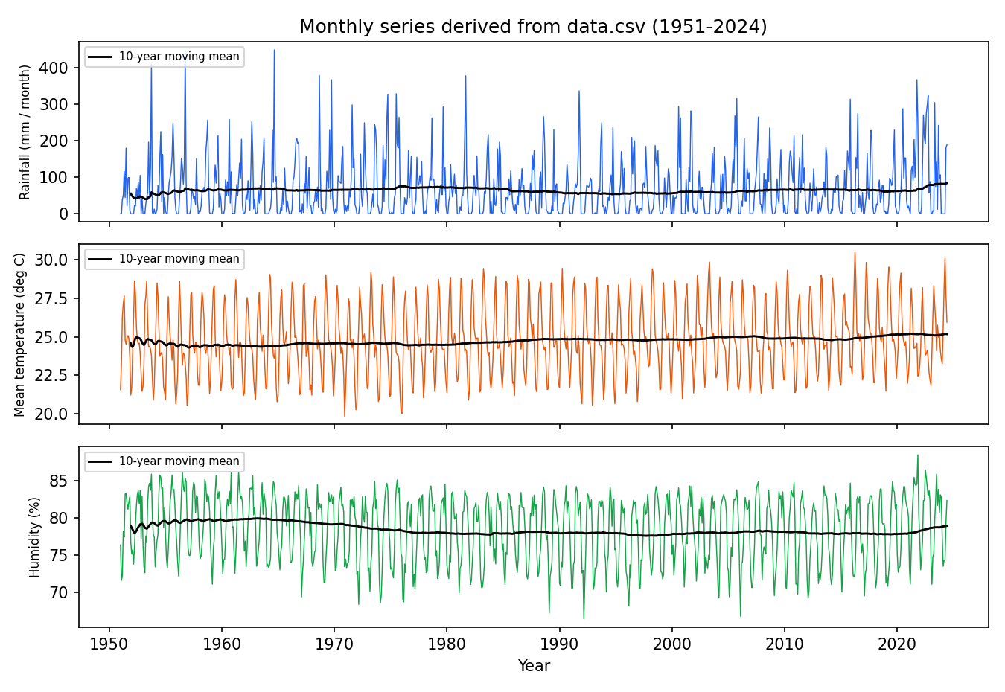
Figure 4.1 Monthly rainfall, temperature and humidity (1951-2024) from data.csv
The monthly climatology in Figure 4.2 (the average of each calendar month over all years) is the third tier of the degradation chain: it is always valid by construction, it needs no model, and it is used when both models are rejected or too slow.
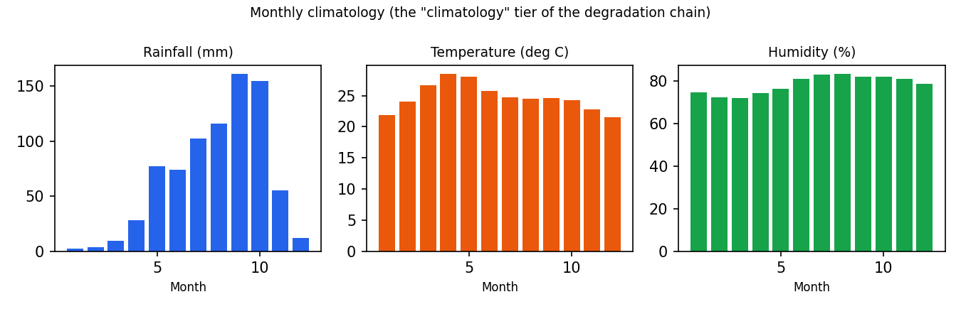
Figure 4.2 Monthly climatology used by the climatology tier
Calibration and evaluation of the guard respect time order: calibration windows come from years up to 2018 and hold-out windows from later years. The data contain a few obviously erroneous daily minima (a maximum of 73.8 degrees Celsius in Temp Min); these are retained because the monthly aggregation and the conformal calibration absorb them, and because removing them would change the original application's behaviour, which the project promises not to do.

4.3 Design and Methodology
The study follows an experimental-systems method: define baselines, define faults, define metrics, run repeated trials under identical conditions, and compare configurations with confidence intervals and exact tests. Figure 4.3 gives the overall flow.
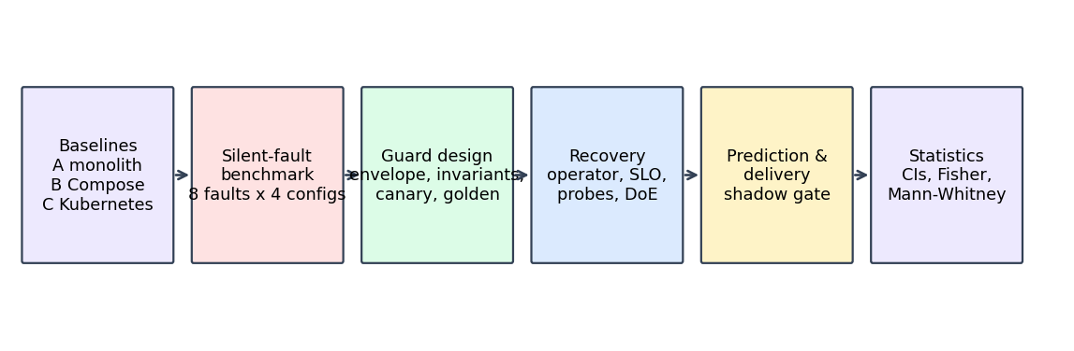
Figure 4.3 Methodology of the study

4.3.1 Configurations compared
Config | Description | Purpose
A | Original Flask monolith, SARIMA + LSTM in one process (SQLite) | Original application baseline
B | Docker Compose: frontend, inference API, PostgreSQL | Container baseline with restart policy
C | Kubernetes with default liveness/readiness probes | Default self-healing baseline
D | Kubernetes + semantic guard and tiered degradation | First correctness-aware version
C4 / D4 / E4 | Image :4 with guard off / envelope / envelope + invariants | Controlled silent-fault benchmark
G4 | E4 + golden-output integrity check (image :10) | Detects subtle corruption
H4 | G4 + deadline- and load-aware degradation (image :12, 800 ms) | Handles slow tiers
Table 4.2 Configurations

4.3.2 Fault model
Fault | What is injected | Visible to default probes?
crash / hang / oom | Process exit, blocked requests, memory exhaustion | Yes (liveness/readiness fail)
corrupt | Output is NaN / garbage with HTTP 200 | No
bitflip_severe | Exponent bits flipped in LSTM kernel weights, large output change | No
bitflip | Eight exponent most-significant-bit flips; output stays plausible | No
scaler | Input scaler parameters replaced (wrong units/scale) | No
unitchange | Temperature or rainfall unit changed in the output | No
stale | Old forecast served again instead of a fresh one | No
flatline | Output is constant over the horizon | No
delay | 30 percent of model calls sleep 1.5 s | Partly (slow, not wrong)
leak / drift / dropvar | Memory growth, input distribution drift, missing input variable | Gradual
Table 4.3 Injected faults (SilentBench and extensions)

4.3.3 Metrics
• Share of answers that are correct, wrong (invalid values), fallback (valid answer from another model) or degraded (climatology or cache), and share of failed requests, measured by a client that knows the golden answer.
• Detection time and recovery time after injection or after healing; restoration time to full quality for operator experiments.
• Failure rate and p95 latency under bursty load and under the delay fault.
• False-alarm rate on hold-out windows and in a ten-minute healthy soak.
• Predictor lead time and false alarms per ten minutes.
• Shadow-gate decisions on good and bad candidate models.

4.3.4 Experimental protocol
Each experiment is a script that deploys a configuration, verifies the image and environment of the running pod (an early run was found invalid because an image tag had not been built, so verification was added), injects one fault for a fixed window at about 5 requests per second, records the client-side classification of every response, heals the fault and records the recovery. Trials are repeated 5 to 10 times per cell. Raw results are appended to JSON-lines files that are never rewritten, and invalid runs are kept under names that mark them superseded. Statistics (bootstrap 95 percent intervals, Fisher exact test, Mann-Whitney U test) are computed afterwards by analysis/phase14_stats.py.

4.4 System Architecture
Figure 4.4 shows the deployed system in the Kubernetes namespace climate and the monitoring namespace. The user's browser talks to the Flask frontend, which stores users and history in PostgreSQL and calls the inference API over HTTP. The inference API hosts the models, the guard, the golden check, the tier chain and the deadline logic. The ForecastService operator and the failure predictor observe the inference API; Prometheus scrapes every component every 5 seconds; Grafana and Jaeger present metrics and traces; chaos and probe drivers run outside or inside the cluster to inject faults and measure.
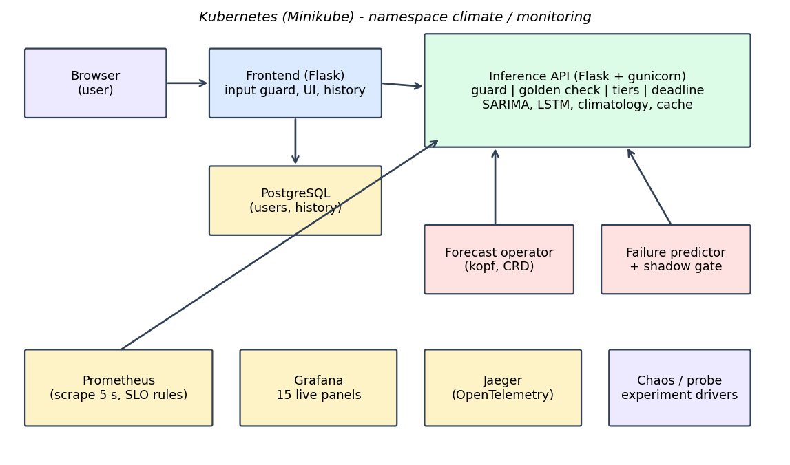
Figure 4.4 System architecture
Figure 4.5 shows the request path inside the inference API. A request starts at the requested tier (LSTM by default). The output of a tier is accepted only if it passes the envelope and invariant checks, the golden-output check and the deadline or queue condition; otherwise the tier is marked suspect (circuit breaker) or shed and the next tier is tried. A background canary every five seconds re-validates suspect tiers so that a repaired model returns to service without a restart.
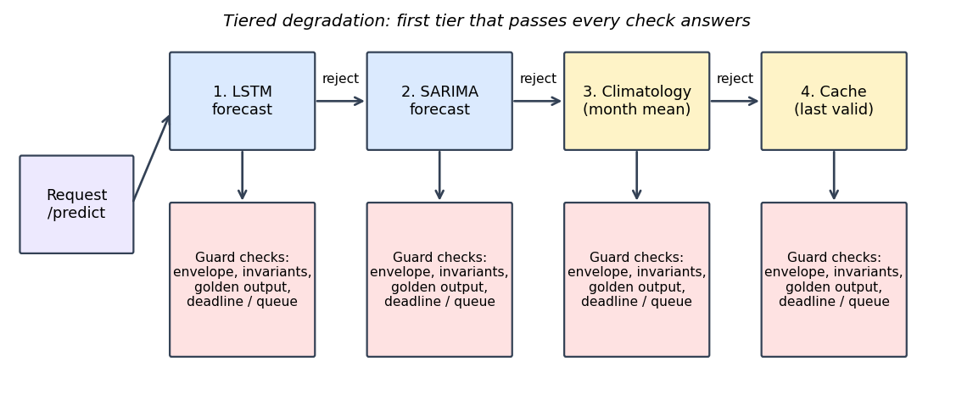
Figure 4.5 Tiered degradation and guard checks

4.4.1 Kubernetes objects
• Deployments: frontend, inference-api (gunicorn gthread, 1 worker, 16 threads), postgres, jaeger, forecast-operator (scaled to zero except during operator experiments).
• Services: frontend (5000), inference-api (5001), postgres (5432), jaeger (16686, 4318).
• Configuration: ConfigMap for guard parameters and the policy table (forecast-policy); Secret for the (lab) database password and Flask secret key.
• CRD ForecastService with fields inferenceUrl, deployment, policy (rules or bandit), failureThreshold and cooldownSeconds.
• Probes: readiness on /health/ready or /health/semantic (variants), liveness on /health/live, startup probe for model loading.

4.5 Tools and APIs
Endpoint (inference API) | Purpose
GET /predict?model=&steps=&interval= | Forecast with tier fall-through; optional conformal intervals; returns model_used, tier, degraded
GET /health/live | Liveness: process answers
GET /health/ready[?partial=1] | Readiness: models loaded (partial mode accepts any usable tier)
GET /health/semantic | Per-model validity, score and golden deviation; semantic_ok flag
GET /metrics | Prometheus text metrics
GET /slo | Correctness SLI, Wilson lower bound, burn rates
GET /aging, /drift, /energy | Aging (Weibull), drift (PSI, Page-Hinkley) and energy estimates
GET /shadow/load, /status, /clear | Load a candidate LSTM, report shadow reject ratio, remove it
GET /golden/refresh | Recompute golden outputs after a validated promotion
GET /fault?mode=... | Inject or heal a fault (enabled only when FAULT_INJECTION=1)
Table 4.4 Inference API
Environment variable | Meaning | Default
SEMANTIC_GUARD | Enable the correctness guard | 0
GUARD_MODE | envelope or envelope+inv | envelope
GOLDEN_CHECK / GOLDEN_TOL | Golden-output check and tolerance in history-std units | 0 / 0.002
DEADLINE_MS | Per-request time budget (0 = off) | 0
LSTM_CONC / SARIMA_CONC | Maximum concurrent calls per tier | 2 / 3
ENERGY_AWARE | Order tiers by measured CPU cost | 0
LOAD_MODE | eager or lazy LSTM loading | eager
SHADOW_LSTM_DIR | Directory of a candidate LSTM for shadow evaluation | -
OTEL_EXPORTER_OTLP_ENDPOINT | Enable OpenTelemetry tracing | -
FAULT_INJECTION | Enable /fault endpoints | 0
Table 4.5 Configuration variables
Supporting tools: Python libraries (Flask, gunicorn, TensorFlow, statsmodels, scikit-learn, scipy, kopf, requests, matplotlib), Helm charts (Prometheus, Grafana, Kyverno, KEDA, Chaos Mesh), Argo Rollouts, cosign, Git and Git LFS, and a validation suite (validation/validate_all.py) with twenty-one executed checks.

4.6 Summary
The design combines well-known building blocks (containers, probes, conformal calibration, voting, SLOs, operators) into a pipeline that checks the answer instead of the process. The methodology compares seven configurations under ten fault types with repeated trials, and the architecture keeps the checks in the inference service, the recovery in an operator and the evidence in Prometheus, Grafana and Jaeger.

CHAPTER 5: IMPLEMENTATION AND TESTING
This chapter describes how the design was implemented, shows the most important pieces of code with an explanation of each, and documents the testing strategy and the defects that testing uncovered.

5.1 Implementation Requirements
• A reproducible build: every image is built from a Dockerfile with pinned Python dependencies (requirements.txt), tagged (inference :1 to :12, frontend :2 to :4, operator :1, :2) and loaded into Minikube with imagePullPolicy Never so that a tag always means the same bits.
• Verification before measuring: every experiment checks the image and environment of the running pod, because a silent build failure produced an invalid first run of configuration D.
• Idempotent experiment scripts with detached execution on Windows (PowerShell scripts started as hidden processes) so that long runs survive the closing of a terminal.
• Append-only result files and explicit naming of superseded or invalid data.
• Models kept exactly as trained: SARIMA pickles (about 118-124 MB per variable) and the LSTM .h5 files are stored with Git LFS and are never retrained by the DevOps code.

5.2 Implementation Tool Features
Tool | Feature used | Where
Flask + gunicorn (gthread) | Web framework; one worker with 16 threads so that shed or cached requests are served while a model call is running | frontend/app.py, inference-api/app.py, Dockerfile
TensorFlow / Keras | LSTM forecasting; tf.function wrapper reduced a forecast from 4.2 s to 0.15 s | inference-api/backends.py
statsmodels | SARIMA forecasting from fitted pickles | inference-api/backends.py
scikit-learn / scipy | Isolation Forest (predictor, input guard), KS test, Fisher exact, Mann-Whitney | analysis/
kopf | Python framework for Kubernetes operators; timer handler every 5 s | operator/forecast_operator.py
Prometheus client text format | Counters, gauges and histograms written by a small metrics module | inference-api/metrics.py
Helm | Install of Prometheus, Grafana, Kyverno, KEDA and Chaos Mesh | k8s/README.md
OpenTelemetry | Optional automatic tracing of Flask and requests with OTLP export to Jaeger | app.py (both services)
cosign + Kyverno | Image signing and admission-time signature verification | k8s/policy/
Argo Rollouts | Canary with Prometheus-based AnalysisTemplates | k8s/rollout/
Table 5.1 Implementation tools and the feature used

5.3 Code Snippets with Explanation

5.3.1 Window-level conformal calibration (guard.py)
The guard is calibrated on sliding windows. For every window length L used by the service, the family-wise score of every historical window in the calibration period is computed, and the empirical quantile at level 1 minus alpha (alpha = 0.01) is stored. A value-level bound would give a much higher window-level false-alarm rate (about 24 percent was measured with a per-value alpha before this correction), which is why the quantile is taken over the maximum score of a window.
def calibrate_windows(self, cal_start=None, cal_end=None):
"""Family-wise (window-level) calibration: the quantile of the MAX score over sliding windows of length L.
A value-level 1-alpha bound over n values would otherwise give a much larger window-level false-alarm rate."""
m = self._monthly
years = m['Year'].values.astype(int)
months = m['Month'].values.astype(int)
lo = cal_start if cal_start is not None else int(np.median(years))
hi = cal_end if cal_end is not None else int(years.max())
series = {v: m[v].values.astype(float) for v in VARS}
env, inv = {L: [] for L in self.WIN_LENGTHS}, {L: [] for L in self.WIN_LENGTHS}
n = len(years)
for L in self.WIN_LENGTHS:
for i in range(0, n - L):
if not (lo <= years[i] <= hi):
continue
w = {v: series[v][i:i + L] for v in VARS}
env[L].append(self._env_raw(w, int(months[i])))
if getattr(self, 'inv', None) and (self.inv['cross'] or self.inv['temporal']):
inv[L].append(self.invariant_score(w, int(months[i])))
k = lambda arr: float(np.sort(arr)[min(len(arr) - 1, int(np.ceil((len(arr) + 1) * (1 - self.alpha))) - 1)]) if len(arr) else 1.0
self.qwin_env = {L: max(k(env[L]), 1e-9) for L in self.WIN_LENGTHS}
self.qwin_inv = {L: max(k(inv[L]), 1.0) for L in self.WIN_LENGTHS}
return self

Listing 5.1 Family-wise calibration of the envelope

5.3.2 The validity score (guard.py)
score() returns a single number that is at most 1 for a valid forecast. It normalises the envelope score and, in envelope+inv mode, the invariant score by the calibrated window quantiles and returns the larger of the two. A NaN output gives a non-finite score and is therefore always rejected.
def score(self, fc, start_month=1):
"""Window-level normalised score: <= 1 valid. envelope (+ invariants if GUARD_MODE has 'inv')."""
n = len(fc[VARS[0]])
L = self._L(n)
if not hasattr(self, 'qwin_env'):
self.calibrate_windows()
env = self._env_raw(fc, start_month) / self.qwin_env[L]
if not np.isfinite(env) or 'inv' not in getattr(self, 'mode', 'envelope+inv'):
return env
return max(env, self.invariant_score(fc, start_month) / self.qwin_inv[L])

Listing 5.2 Window-level validity score

5.3.3 Golden-output integrity check (app.py)
At start-up the service stores a 24-step forecast for each model. golden_dev() returns the largest deviation of a later forecast from it, in units of the standard deviation of the history of each variable, and infinity if any value is not finite. Because the models are deterministic the healthy deviation is zero; the tolerance 0.002 only absorbs floating-point noise. The check catches the subtle bit-flip fault that stays inside the envelope.
def golden_dev(tier, fc):
"""Largest deviation from the healthy start-up forecast, in history-std units (inf if non-finite). 0 if no golden output."""
g = GOLDEN.get(tier)
if not g:
return 0.0
k = min(len(fc[VARS[0]]), 24)
dev = 0.0
for v in VARS:
x = np.asarray(fc[v][:k], dtype=float)
if not np.all(np.isfinite(x)):
return float('inf')
dev = max(dev, float(np.max(np.abs(x - np.asarray(g[v][:k], dtype=float)))) / SD[v])
return dev
FAULTS = os.environ.get('FAULT_INJECTION') == '1'
Listing 5.3 Golden-output deviation

5.3.4 Deadline- and load-aware tier call (app.py)
timed_run() is the only place where a model is called when DEADLINE_MS is set. It first tries to take a slot in the tier's bounded semaphore without waiting; if the queue is full the tier is shed with reason load. It then checks the remaining budget, submits the call to a worker pool and waits for at most the remaining time; a timeout sheds the tier with reason timeout. The semaphore is released by the worker itself, so a stuck call keeps occupying its slot and cannot be piled up by later requests.
def timed_run(b, steps, t_end):
"""Deadline- and load-aware call: None means 'shed this tier' (queue full or budget exhausted) so the caller falls to a cheaper tier."""
if DEADLINE_S <= 0:
return run_backend(b, steps)
sem = _SEM.get(b.name)
if sem and not sem.acquire(blocking=False):
metrics.inc('shed', tier=b.name, reason='load')
return None
remaining = t_end - time.time() - _RESERVE_S
if remaining <= 0:
if sem:
sem.release()
metrics.inc('shed', tier=b.name, reason='deadline')
return None
fut = _EXEC.submit(_guarded, b, steps, sem)
try:
return fut.result(timeout=remaining)
except Exception as e:
if isinstance(e, TimeoutError) or type(e).__name__ == 'TimeoutError':
metrics.inc('shed', tier=b.name, reason='timeout')
return None
raise

_FAULT_MODE = {'mode': None}
_SAVED = {}
FAULT_MODES = ('corrupt', 'bitflip', 'bitflip_severe', 'stale', 'scaler', 'unitchange', 'flatline', 'delay')
Listing 5.4 Deadline- and load-aware call

5.3.5 Tier fall-through with circuit breaker (app.py)
serve() walks the tier chain. A tier that is not ready or was marked suspect by the canary is skipped; a tier whose output fails the envelope, invariant or golden check is marked suspect (circuit breaker) and the next tier is tried; the climatology tier and the cache are the last resort. The first tier whose output passes every check answers and its forecast is cached.
for tier in tier_chain(model):
if tier in BACKENDS:
b = BACKENDS[tier]
if not b.ready or _SUSPECT.get(tier): # canary marked this version suspect (cross-model vote)
continue
fc = timed_run(b, steps, t_end)
if fc is None:
continue
score = GUARD.score(fc, b.start_month) # cheap conformal envelope check on the output itself
metrics.gauge('semantic_score', round(score, 3) if np.isfinite(score) else 1e9, backend=tier)
if score <= 1.0 and GOLDEN_ON and golden_dev(tier, fc) > GOLDEN_TOL:
_SUSPECT[tier] = True
metrics.inc('golden_reject', backend=tier)
continue
if score <= 1.0:
_CACHE[steps] = fc
return fc, tier, info
_SUSPECT[tier] = True # circuit breaker: skip this tier until the next canary re-validates it
metrics.inc('semantic_reject', backend=tier)
elif tier == 'climatology' and not DISABLE_CLIM:
ref = BACKENDS['lstm'].start_month if 'lstm' in BACKENDS else 1
sm = BACKENDS[model].start_month if model in BACKENDS else ref
return GUARD.climatology(steps, sm), 'climatology', info
elif tier == 'cache' and steps in _CACHE:
return _CACHE[steps], 'cache', info
return None, None, info

def canary_once(steps=6):
"""Novelty 2 as a periodic canary: run every version, align calendar months, vote, update suspect flags."""
Listing 5.5 Tier chain inside serve()

5.3.6 Operator decision and reconcile loop (forecast_operator.py)
The operator reads /health/semantic every five seconds, derives a signature (ok, unreachable, or invalid with the list of invalid models) and counts consecutive bad checks. When the threshold is reached and the cool-down has passed, choose() returns the action: the rules policy always restarts; the bandit policy looks the signature up in the policy table and picks the action with the lowest expected cost. Restart is performed by patching the pod template annotation, which triggers a rolling update.
def signature(health):
"""Observable fault signature from /health/semantic (or connection failure)."""
if health is None:
return 'unreachable'
if health.get('semantic_ok'):
return 'ok'
be = health.get('backends', {})
bad = sorted(k for k, v in be.items() if not v.get('valid'))
return 'invalid:' + ','.join(bad)

def choose(policy, sig, table):
if sig == 'ok':
return 'none'
if policy == 'bandit' and sig in table:
vals = table[sig] # {twin action: expected cost}
best = min(vals, key=vals.get)
# twin action names -> operator actions (tier_switch is performed by the service itself, no restart)
return {'restart_only': 'restart', 'tier_switch': 'none', 'switch_then_restart': 'restart'}.get(best, 'restart')
return 'restart' # rules policy / unseen signature

Listing 5.6 Signature and policy choice

5.3.7 Cost model of the digital twin (twin_bandit.py)
The first version of the cost ignored the fact that a tier switch leaves the service on a fallback tier forever, so tier_switch looked cheapest and the bandit never restarted (restored only 5 of 20 trials). The corrected cost adds W_Q seconds for every second spent below full quality, with a 240-second horizon when full quality never returns.
full = HORIZON if (act == 'tier_switch' and r['fault'] in SILENT) else rec # a tier switch never restores full quality for silent faults
cost = rec + W_FAIL * (r.get('failed_pct') or 0.0) + W_DEG * deg * 100 + W_Q * full
eps[(r['fault'], act)].append(cost)
Listing 5.7 Quality term added to the cost

5.3.8 Container image of the inference service (Dockerfile)
The inference image starts gunicorn with one worker and sixteen threads (gthread). One worker keeps a single copy of the models in memory (a TensorFlow process needs about 1 GiB), and the thread count was raised from four to sixteen after a burst experiment showed that four threads were exhausted by queued requests, which had been mistaken for a CPU limit. The timeout of 120 seconds only protects against a stuck worker; request-level deadlines are handled in the application.
FROM python:3.10-slim
ENV PYTHONUNBUFFERED=1 MPLBACKEND=Agg
WORKDIR /app
COPY requirements.txt .
RUN pip install --no-cache-dir -r requirements.txt
COPY . .
EXPOSE 5001
CMD ["gunicorn","-w","1","--worker-class","gthread","--threads","16","-b","0.0.0.0:5001","--timeout","120","app:app"]

Listing 5.8 Dockerfile of the inference service

5.3.9 Unit test of the guard (test_guard.py)
The unit tests construct a synthetic monthly data set with a seasonal pattern and check the three basic behaviours of the guard: a NaN forecast and a grossly scaled forecast are rejected, and the climatology forecast is accepted. They run in under a second and are part of the validation suite.
def test_nan_and_outlier_rejected_clean_passes():
g = SemanticGuard(synth())
clean = g.climatology(6, 1)
assert g.valid(clean, 1)
assert not g.valid({v: np.full(6, np.nan) for v in VARS}, 1)
assert not g.valid({v: clean[v] * 4 + 50 for v in VARS}, 1)

Listing 5.9 Guard unit test

5.3.10 Event-driven scaling object (KEDA)
The KEDA object scales the inference deployment between one and three replicas using a Prometheus query on the request rate. It was used in the scaling extra; on a single node it did not improve the burst outcome, which is reported as a limitation.
apiVersion: keda.sh/v1alpha1
kind: ScaledObject
metadata: {name: inference-api, namespace: climate}
spec:
scaleTargetRef: {name: inference-api}
minReplicaCount: 1
maxReplicaCount: 3
cooldownPeriod: 60
pollingInterval: 5
triggers:
- type: prometheus
metadata:
serverAddress: http://prom-prometheus-server.monitoring.svc
query: sum(rate(predict_seconds_count[30s]))
threshold: "3"

Listing 5.10 KEDA ScaledObject

5.4 Testing

5.4.1 Test levels
• Unit tests (pytest): the guard rejects NaN and gross outliers and accepts clean and climatology forecasts; the invariant check rejects a flat-line.
• Integration checks inside the validation suite: service with real models in baseline and guard modes, cluster readiness and semantic health, fault cycle corrupt then heal inside the pod, frontend pages through Kubernetes with PostgreSQL persistence, Prometheus and Grafana health.
• Data-integrity checks: row counts and class percentages of every result file (baseline experiments, SilentBench, operator trials, probe validation, predictor, shadow gate, extras, fix rounds).
• Experiments (Chapter 6): each experiment is also a test of a hypothesis; negative outcomes were recorded.
• Browser walk-through: every application page returned HTTP 200, plots and badges rendered, Grafana showed live panels and the new golden-check panels reacted to an injected fault, Jaeger showed traces that span the frontend and the inference API.

5.4.2 Validation suite
Check | Result | Evidence
V01 docker + kubectl available | PASS | 29.8.2 / { "clientVersion": { "major": "1", "minor": "36",
V02 cluster pods Running | PASS | 4 pods Running
V03 images present in minikube | PASS | climate-inference:4 and climate-frontend:2 present in minikube
V04 all python files compile | PASS | 112 python files compile
V05 unit tests (pytest) | PASS | 2 passed in 1.28s
V06 data and model files | PASS | daily rows=26835, sarima MB={'sarima_rainfall.pkl': 124, 'sarima_temp_mean.pkl': 124, 'sarima_humidity.pkl': 124}, 3 lstm .h5 present
V07 service, baseline mode (real models) | PASS | rain[0] sarima=5.0 lstm=87.295; metrics exposed
V08 service, guard on: faults detected + heal (real models) | PASS | detected -> tiers {'corrupt': 'climatology', 'unitchange': 'climatology', 'flatline': 'climatology', 'scaler': 'sarima'}; heal restores lstm identical
V09 guard ablation reproduces stored numbers | PASS | hold-out false alarm 0.0; detection unit=1.0 flatline=1.0
V10 cluster readiness + semantic health | PASS | ready=True; semantic_ok=True
V11 cluster fault cycle corrupt/heal (in pod) | PASS | guard=True: corrupt -> tier=climatology degraded=True; healed tier=lstm
V12 frontend flows through Kubernetes + PostgreSQL | PASS | pages {'healthz': 200, 'dashboard': 200, 'result': 200, 'lstm_result': 200, 'history': 200, 'analysis': 200}; user persisted in PostgreSQL
V13 Prometheus metrics + Grafana health | PASS | prometheus series=6 ; grafana ok
V14 baseline experiment data integrity | PASS | 75 fault rows in 15 cells (5 each); 20 load rows
V15 silent-benchmark data integrity | PASS | 332 rows, 41 cells; baseline healthy, class percentages sum to 100
V16 phases 7-13 result data (operator, probe validation, predictor, shadow gate, family) | PASS | operator rows=60 (rules restored 20/20) ; probe_validation rows=25 ; predictor: 6/6 leak and 6/6 drift failures analysed ; shadow gate: 15/15 bad reje
V17 cluster extras results (semantic probes, partial readiness, UI, scaling, Chronos) | PASS | extras rows=49; UI checks all True; chronos status=ok; scaling rows=9
V18 fix round: golden check + cost-aware bandit | PASS | G4 bitflip rows=20 (0 wrong), healthy rows=5 (100% correct); bandit v2 restored 20/20
V19 deadline-aware degradation (delay fault) | PASS | delay fault failed %: G4 mean 96.8 -> H4 0.0; H4 healthy 100% correct, 0% wrong on corrupt/bitflip/flatline
V20 metamorphic probe evaluation (experimental) | PASS | interleaved FA 2.0 %, time-split FA 66.0 % (limit), bitflip 93.3 % marginal, scaler 16.7 %
V21 baselines, HBW/MTTC and compound faults | PASS | baselines: simple detectors weak or noisy, golden strong but costly; compound bitflip+delay: E4 100 % wrong, H4 0 %; HBW C4 30 s vs G4 0 s
Table 5.2 Executed validation checks (21 of 21 passed)

The suite was extended later by four checks (V22 to V25, Section 6.12); all 25 checks pass in the final run.

5.4.3 Defects found by testing and how they were fixed
Defect | Root cause | Fix
Configuration D first run invalid | Image :3 was never built (silent build failure) | Pod image and environment verified before each run
Per-request cross-model vote crashed the pod | Voting on every request saturated the single worker | Background canary every 5 s; LSTM wrapped in tf.function (4.2 s to 0.15 s)
About 24 percent window-level false alarms | Per-value alpha instead of window-level quantile | Family-wise window calibration
Isolation Forest could not extrapolate leak trend | Tree models do not extrapolate; warm-up rows distort training | Drop warm-up rows and add a Mahalanobis distance
Liveness timeouts under load | Synchronous gunicorn worker blocked the probe | gthread worker class with 4, later 16, threads
Subtle bit flips undetected by all checks | Corrupted output stayed inside the envelope | Golden-output integrity check (Section 6.1.2)
Bandit never restarted | Cost ignored time below full quality; policy table built before operator data existed | Quality term in the cost and regenerated table (Section 6.2.2)
Delay fault failed 96.8 percent of requests | Slow tier blocked all threads and the shared lock | Deadline- and load-aware degradation (Section 6.5)
Earlier scaling failures | Only 4 gunicorn threads, not CPU, limited the burst | Threads raised to 16; earlier claim withdrawn
Rollout stalled after kubectl set image with wildcard | The init container image was replaced as well | Containers named explicitly
Cluster overloaded by extra stacks | Kyverno, KEDA, Chaos Mesh and Argo running together with the lab | Uninstalled after their experiments
Table 5.3 Defects found and fixed

5.5 Summary
The implementation consists of a guarded inference service, a Flask frontend, a kopf operator and a large set of experiment and analysis scripts. Testing combined unit tests, a twenty-one-check validation suite, data-integrity checks and a browser walk-through, and it uncovered eleven defects that were fixed from their root causes.

CHAPTER 6: RESULTS AND ANALYSIS
This chapter reports the measured results. All numbers come from executed experiments whose raw files are stored in the project (results folder); sample sizes are stated for every table because they are small (5 to 10 trials per cell, one laptop). Where a result is negative or inconclusive it is reported as such.

6.1 Results

6.1.1 Baselines: monolith, Docker Compose and default Kubernetes
The first experiment set injects infrastructure faults (crash, hang, out-of-memory) and the simplest silent fault (corrupt) into configurations B (Compose) and C (Kubernetes) and, for a defined list, D (guarded Kubernetes). Table 6.1 gives the mean recovery time and the mean share of failed requests. Crash recovery is dominated by the container restart delay (about 28 s of a 34.6 s total; application start-up is 4.6 s). For the corrupt fault the default configurations never recover: the pod stays Running and Ready while every answer is wrong. Configuration A runs two gunicorn workers while B, C and D run one, so its hang and oom rows are not like-for-like; Tables 6.1 to 6.6 were measured on different image tags and server settings (inference images :2 to :12, synchronous and threaded workers) and are therefore compared within a table, not across tables.
Config | Fault | Trials | Recovered | Mean recovery (s) | Mean failed requests (%)
A | crash | 5 | 5/5 | 2.8 | 54.1
A | hang | 5 | 0/5 | - | 0.0
A | oom | 5 | 0/5 | - | 0.0
B | corrupt | 5 | 0/5 | - | 100.0
B | crash | 5 | 5/5 | 47.4 | 97.7
B | hang | 5 | 2/5 | 183.4 | 99.8
B | oom | 5 | 5/5 | 32.8 | 96.9
C | corrupt | 5 | 0/5 | - | 100.0
C | crash | 5 | 5/5 | 15.6 | 88.9
C | hang | 5 | 5/5 | 61.9 | 97.6
C | oom | 5 | 5/5 | 13.1 | 87.1
D | corrupt | 5 | 4/5 | 3.5 | 15.7
D | crash | 5 | 5/5 | 19.5 | 90.6
D | hang | 5 | 5/5 | 77.1 | 98.1
D | oom | 5 | 5/5 | 43.3 | 95.1
Table 6.1 Baseline fault trials (mean over trials; recovery - means never recovered)

6.1.2 Silent-fault benchmark (SilentBench)
Table 6.2 is the central result of the study. For eight faults and four configurations it shows the share of answers that were wrong during a 30-second fault window at 5 requests per second, as a mean with a bootstrap 95 percent confidence interval and the number of trials; the last column is the p-value of Fisher's exact test comparing the guard-off configuration (C4) with the full guard (G4) on the trial-level outcome any wrong answer. With the guard off, every silent fault produces 100 percent wrong answers, and the platform never detects one of them. With envelope and invariants (E4) all faults except the subtle bit flip are turned into valid answers (degraded climatology or fallback to SARIMA); the flat-line fault is missed by the envelope alone (D4) and caught only when the invariants are added. The subtle eight-flip bit fault is missed by C4, D4 and E4, and caught in 10 of 10 trials by G4 thanks to the golden-output check. The delay fault does not produce wrong answers but failed requests; it is handled in Section 6.5. Because a bootstrap interval of an all-zero sample is degenerate ([0.0, 0.0]), the exact one-sided 95 percent upper bound for zero wrong answers is 25.9 percent for 10 trials, 28.3 percent for 9 trials and 45.1 percent for 5 trials; all G4 cells now have n = 10 (trials 6 to 10 of five faults were added on 22 October 2026 on a second machine, Section 6.11). All faults were designed by the authors, and the eight-flip bit fault was chosen to stay inside the envelope.
Fault | C4 guard off | D4 envelope | E4 + invariants | G4 + golden | Fisher C4 vs G4
corrupt | 100.0 [100.0, 100.0] n=10 | 0.0 [0.0, 0.0] n=10 | 0.0 [0.0, 0.0] n=10 | 0.0 [0.0, 0.0] n=10 | 1.1e-05
unitchange | 100.0 [100.0, 100.0] n=10 | 0.0 [0.0, 0.0] n=10 | 0.0 [0.0, 0.0] n=9 | 0.0 [0.0, 0.0] n=10 | 1.1e-05
flatline | 100.0 [100.0, 100.0] n=10 | 99.93 [99.79, 100.0] n=10 | 0.0 [0.0, 0.0] n=10 | 0.0 [0.0, 0.0] n=10 | 1.1e-05
scaler | 100.0 [100.0, 100.0] n=10 | 0.0 [0.0, 0.0] n=10 | 0.0 [0.0, 0.0] n=10 | 0.0 [0.0, 0.0] n=10 | 1.1e-05
stale | 100.0 [100.0, 100.0] n=10 | 0.0 [0.0, 0.0] n=10 | 0.0 [0.0, 0.0] n=10 | 0.0 [0.0, 0.0] n=10 | 1.1e-05
bitflip | 100.0 [100.0, 100.0] n=10 | 100.0 [100.0, 100.0] n=10 | 100.0 [100.0, 100.0] n=10 | 0.0 [0.0, 0.0] n=10 | 1.1e-05
bitflip_severe | 100.0 [100.0, 100.0] n=10 | 0.0 [0.0, 0.0] n=10 | 0.0 [0.0, 0.0] n=10 | 0.0 [0.0, 0.0] n=10 | 1.1e-05
delay | 0.0 [0.0, 0.0] n=10 | 0.0 [0.0, 0.0] n=10 | 0.0 [0.0, 0.0] n=10 | 0.0 [0.0, 0.0] n=10 | 1
Table 6.2 Wrong answers served (percent of responses in the fault window), mean [95 % CI], n trials
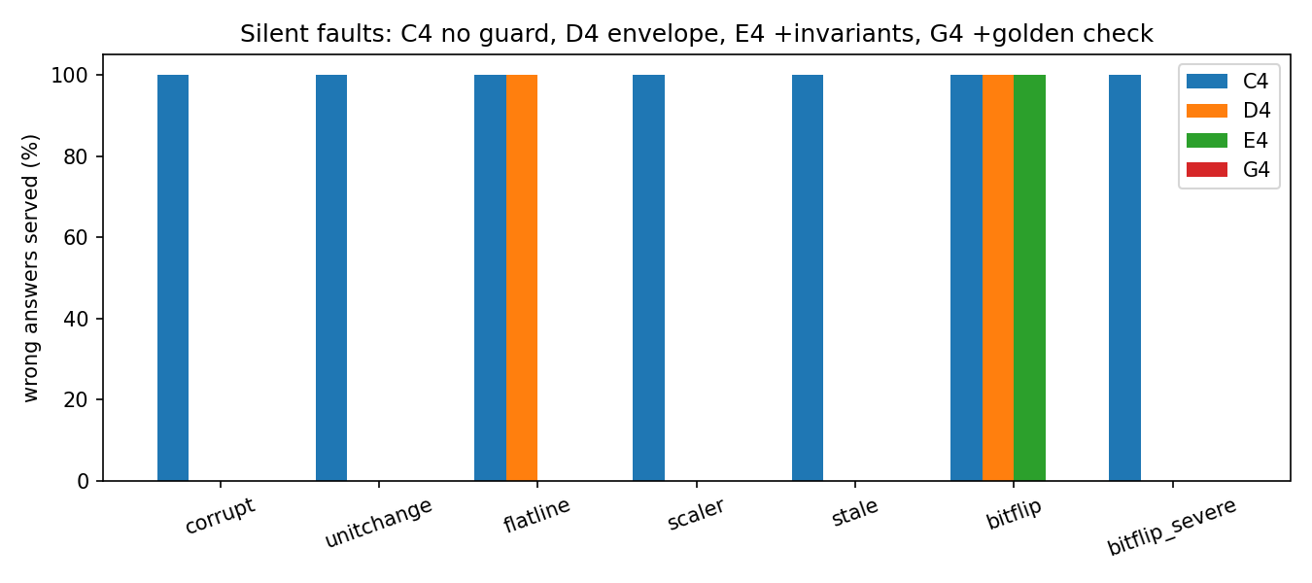
Figure 6.1 Wrong answers served per fault and configuration
In the healthy control (fault none) G4 and H4 served 100 percent correct answers in all trials, so no false alarm occurred; a ten-minute soak of the guarded service was also fully correct, and the offline hold-out evaluation (windows after 2018, alpha = 0.01, L = 6) gave a false-alarm rate of 0.0 percent for both the envelope and the envelope with invariants (with alpha = 0.05 it would have been 20 to 36.7 percent, which is why the lower alpha was chosen).

6.1.3 Guard ablation (offline)
Offline detection rates on hold-out windows (6-month windows): unit change 100 percent, scaler 100 percent, swapped variables 100 percent, NaN 100 percent, humidity minus 20 percent 80 percent, rainfall times three 73 percent, temperature plus 4 degrees 32 percent and flat-line 37 percent with the envelope alone and 100 percent with the invariants. The weak cases show the limit of a statistical envelope: a modest bias that stays within the climatological range is hard to see, which motivated the cross-model canary and the golden-output check. A comparison of static, 20-year rolling and adaptive conformal calibration (Gibbs-Candes style) showed the same false-alarm rate (0.0) and similar detection, so the simple static calibration was kept.

6.2 Benchmarking and Analysis

6.2.1 Layer complementarity
Fault | Envelope | + Invariants | + Golden output | Notes
corrupt (NaN) | caught | caught | caught | non-finite score
unitchange, scaler, stale | caught | caught | caught | gross change of range
bitflip_severe | caught | caught | caught | large output change
flatline | missed | caught | caught | constant series inside the range
bitflip (8 flips) | missed | missed | caught | plausible output, deviates from golden
Table 6.3 Which guard layer catches which fault (10 trials per cell)
The table shows that, among the per-request checks, each added layer closes a class of faults that the previous layers cannot see. Section 6.7 qualifies this: the golden check alone detects every fault but is too expensive to run per request. The cross-model canary is the fourth layer; it allows a repaired tier to return to service without a restart and detects a model that disagrees with the others even when its own output looks plausible.

6.2.2 Operator and recovery policies
Sixty operator trials were run on configuration E4: three policies (none, rules, bandit), four silent faults (corrupt, unitchange, scaler, flatline) and five trials each, with the fault left in place and the time to full quality measured. Without an operator the guard keeps serving valid degraded answers but full quality never returns (0 of 20). The rules policy restores 20 of 20 trials in 23.6 seconds on average (95 percent CI 22.3 to 24.9). The first version of the learned bandit policy restored only 5 of 20 (only the scaler fault), because its cost ignored the time spent below full quality and the policy table had been built before the operator data existed; after adding a quality term to the cost and regenerating the table it restored 20 of 20 in 21.6 seconds on average (CI 20.6 to 22.6). The 2-second difference to the rules policy is statistically detectable (Mann-Whitney p = 0.041) but both policies choose the same action, so it is run-to-run drift and not a policy effect; the rules trials ran on image :6 and the bandit trials on image :5, which is a further confound for this comparison. The rules policy versus no operator is significant (Fisher exact p = 1.5e-11).
Policy | Restored to full quality | Mean time to full quality [95 % CI] (s)
none (operator off) | 0 / 20 | never
rules (restart after 3 invalid checks) | 20 / 20 | 23.6 [22.3, 24.9]
bandit, version 1 (cost without quality term) | 5 / 20 | 18.8 - 25.2 (scaler only)
bandit, version 2 (cost-aware) | 20 / 20 | 21.6 [20.6, 22.6]
Table 6.4 Operator policies (60 + 20 trials)
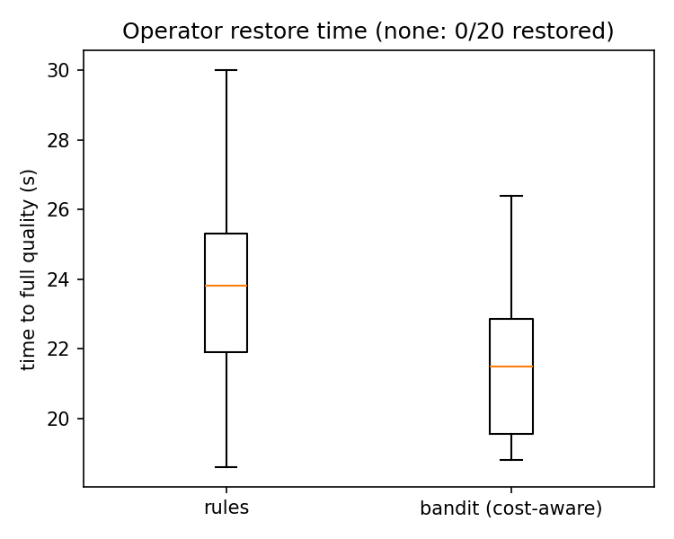
Figure 6.2 Time to full quality under the operator
A second recovery observation concerns probe design. Making the readiness probe semantic and keeping only readiness leaves the service failed (92 percent failed requests, never restored); semantic readiness together with a liveness restart restored in 36 seconds; and a partial-readiness mode that accepts any usable tier kept serving with 0 percent failed requests during the fault, against 81 percent for strict readiness. Kubernetes self-healing thus works on correctness only if the probe is made to test correctness, and the choice between strict and partial readiness is a trade-off between never serving degraded answers and staying available.

6.2.3 Probe tuning, design of experiments and Bayesian optimisation
A 30-run central-composite design on the hang fault (probe period, failure threshold, replicas) was analysed with a quadratic response surface (leave-one-out R2 0.895 for recovery and 0.892 for failed share). The result is dominated by one factor: with one replica recovery takes about 52 seconds and 97 percent of requests fail; with three replicas recovery is 1.3 to 3.3 seconds because other replicas keep answering. A bounded Bayesian optimisation recommended period 7, threshold 5 and three replicas; validation on held-out runs (Table 6.5) confirmed that the benefit comes from the replicas and not from the tuned probe parameters: at one replica the recommended probes were not better than the default (73 s versus 66 s).
Setting (period s / threshold / replicas) | Trials | Recovered | Median recovery (s) | Mean failed (%) | p vs default
default 10 / 3 / 1 | 5 | 5/5 | 66.3 | 97.5 | -
default probes, 3 replicas | 5 | 5/5 | 1.7 | 24.5 | 0.008
recommended 7 / 5 / 1 | 5 | 5/5 | 73.0 | 98.0 | 0.012 (worse)
recommended 7 / 5 / 3 | 5 | 5/5 | 1.7 | 25.2 | 0.012
Table 6.5 Validation of tuned probe settings (hang fault) - a negative result for probe tuning

6.2.4 Correctness SLO replay
Fault injection was replayed against the SLO rules (99 percent objective, 30-second and 2-minute windows, 5 requests per second). For the faults that corrupt values (corrupt, unit change) with the guard off the correctness alert fired in 3 of 3 trials after a median 9.2 and 15.5 seconds while 376-382 invalid answers were served in the 75-second window; for the flat-line and subtle bit-flip faults the validity check used by the SLO itself did not see the fault, so no alert fired - which is consistent with the guard ablation and is the reason the golden check was added. With the guard on, invalid answers served were zero and the degraded-answer alert fired instead.

6.2.5 Failure prediction
Telemetry windows from healthy runs were used to train an Isolation Forest and a Mahalanobis distance; leak and drift faults were injected six times each. For the memory-leak fault both detectors alarmed before the failure in 6 of 6 trials with a median lead time of 69.6 seconds, against 23.9 seconds for a static 80 percent memory threshold and no lead for the reactive guard; for the drift fault they alarmed in 6 of 6 trials with a median lead of about 23.7 seconds. On healthy data the Isolation Forest raised 2.45 false alarms per 10 minutes, which is the price of the lead time and is reported as a limitation.

6.2.6 Shadow-traffic gate and delivery
Candidate LSTM models were loaded into the live service in shadow mode while 5 requests per second were mirrored. The gate promotes a candidate only if its reject ratio is at most 5 percent over at least 20 samples. All 15 bad candidates (wrong scaler, swapped variables and others) were rejected (reject ratio 1.00, median score 8.6-10.2) within about 8 seconds and all 6 good candidates (exact copy, small noise) were promoted (reject ratio 0.00, score 0.62-0.64) after about 13 seconds; a re-check gave 7 of 7 correct decisions. An Argo Rollouts canary with a Prometheus AnalysisTemplate promoted a good revision and aborted a revision whose gate was deliberately made to fail, which shows that the same criterion can drive a standard delivery tool.
Candidate | Expected | Decisions | Median reject ratio | Median score | Median s to decision
good_copy | promote | promote 3/3 | 0.00 | 0.64 | 12.9
good_noise | promote | promote 3/3 | 0.00 | 0.62 | 12.6
bad_scaler | reject | reject 3/3 | 1.00 | 8.64 | 8.2
bad_swap | reject | reject 3/3 | 1.00 | 10.21 | 8.2
Table 6.6 Shadow gate decisions (selected candidates; 15 of 15 bad rejected, 6 of 6 good promoted overall)

6.2.7 Extras, including negative results
Extra | Outcome
Aging and drift monitoring | Weibull shapes 1.03-1.34; PSI Humidity 3.07, Rainfall 0.61, Temp 0.35; Page-Hinkley alerts on all variables; model age 78 months with retraining recommended
Energy-aware tiers | Estimated energy per request 3.99 J (always LSTM) versus 0.93 J (SARIMA first) at 100 percent correct answers; p95 214 ms versus 101 ms
OpenTelemetry + Jaeger | One trace spans frontend GET /dashboard (1506 ms) and inference GET /predict (30 ms); 3 of 8 traces span both services
Kyverno + cosign | Policy rejected nginx:latest and unapproved images; signed image admitted; re-pushed or unsigned image denied (no signatures found)
Chaos Mesh | Pod kill: ready again after 16.1-16.3 s; 300 ms network delay raised p50 from 39 to 646 ms with no failures, back to 42 ms after removal
KEDA (request-rate trigger) | Scaled to 1-3 replicas; no benefit shown on a single node; earlier burst failures were traced to thread-pool exhaustion, not CPU
RL autoscaler (simulation only) | Tabular Q-learning lowest drop rate (2.4 percent) but reactive rule had the best reward (-110 versus -121); not validated on a cluster
Log anomaly detection | Zero log templates; zero of six silent faults detected from logs - logs carry no signal here
Probe tuning | No benefit beyond replicas (Table 6.5)
LSTM autoencoder / input guard | Many healthy false alarms (input guard 6 percent) - kept as weak results
Table 6.7 Additional components and their measured outcome

6.3 Screenshots and Live Plots
All screenshots in this section were taken from the running system in the built-in browser on 17 October 2026, after generating real traffic against the deployed service (more than 5,700 predictions served, including an injected bit-flip fault followed by healing). They show the application pages that were served by Kubernetes from PostgreSQL-backed sessions, the live Grafana dashboard with its 5-second refresh, the Prometheus expression browser and the Jaeger trace viewer. No image in this report is a mock-up.

6.3.1 Application pages
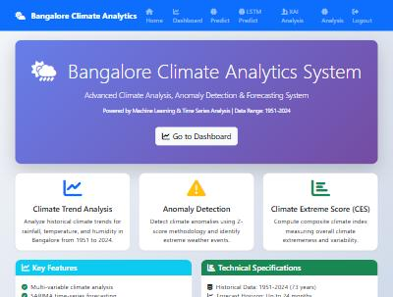
Figure 6.3 Home page of the Bangalore Climate Analytics System (browser, localhost:5000)
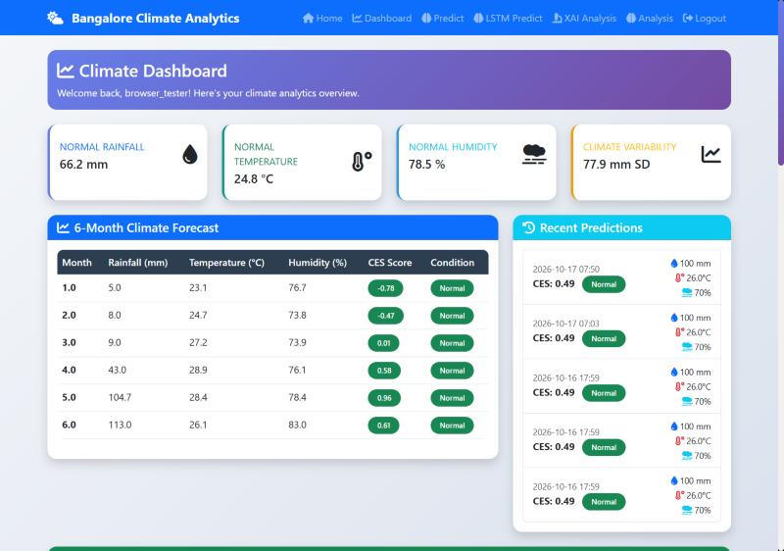
Figure 6.4 Climate dashboard: current values, 6-month forecast table and recent predictions
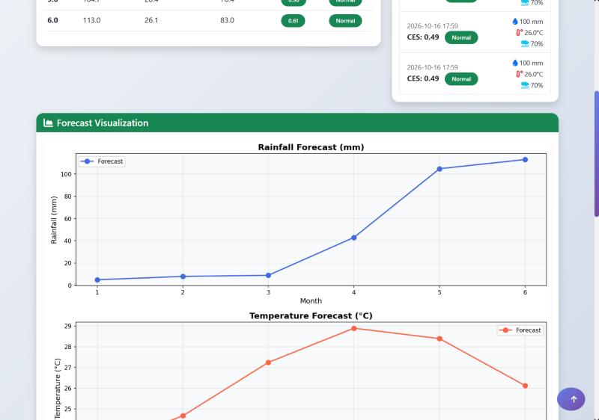
Figure 6.5 Dashboard forecast plots (rainfall and temperature)
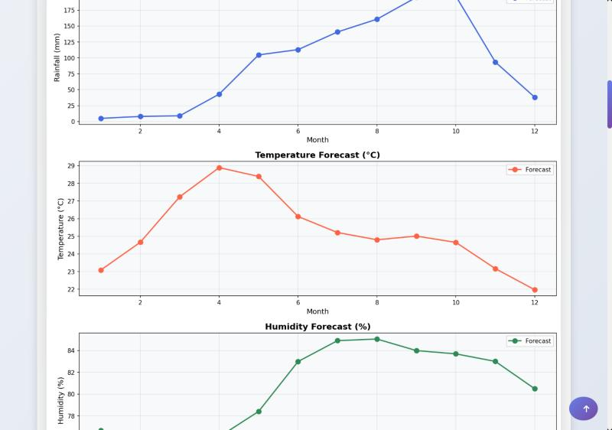
Figure 6.6 Twelve-month SARIMA forecast plots served by the inference tier
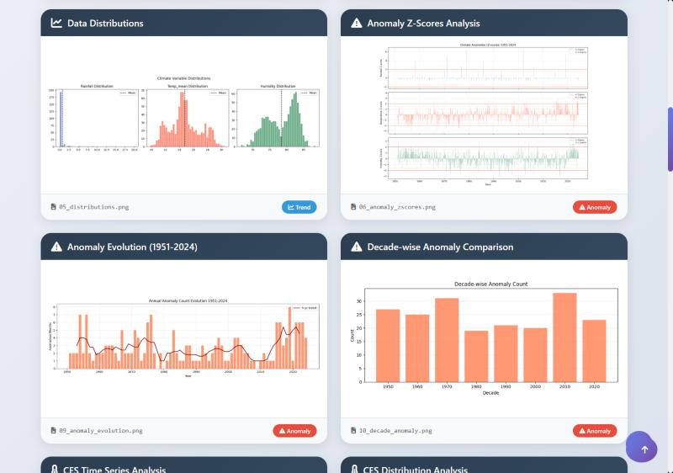
Figure 6.7 Analysis gallery: distributions, anomaly z-scores, anomaly evolution and decade-wise anomalies
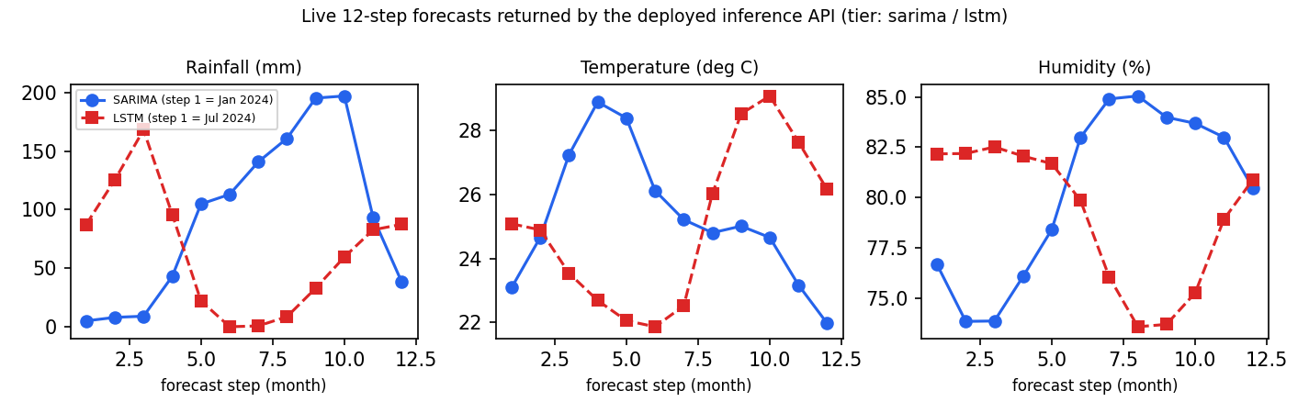
Figure 6.8 Live 12-step forecasts of SARIMA and LSTM returned by the deployed API

6.3.2 Live monitoring: Grafana and Prometheus
Figure 6.9 shows the first panels of the live Grafana dashboard: inference p95 latency per model, inference requests per second per model, frontend request rate by status, frontend p95 latency, model load time and model-ready status. The latency of the LSTM (yellow) is visibly higher than that of SARIMA (blue), and the request-rate panel shows the traffic that was generated for this screenshot. Figure 6.10 shows the golden-output panels after the bit flip was injected; Figures 6.11 and 6.12 show the same counters directly in the Prometheus expression browser: the golden violation counter for the LSTM jumps when the fault is injected, and the per-tier valid-answer counters show that the service kept answering from the LSTM, the climatology tier and (during the fault) the fallback tiers.
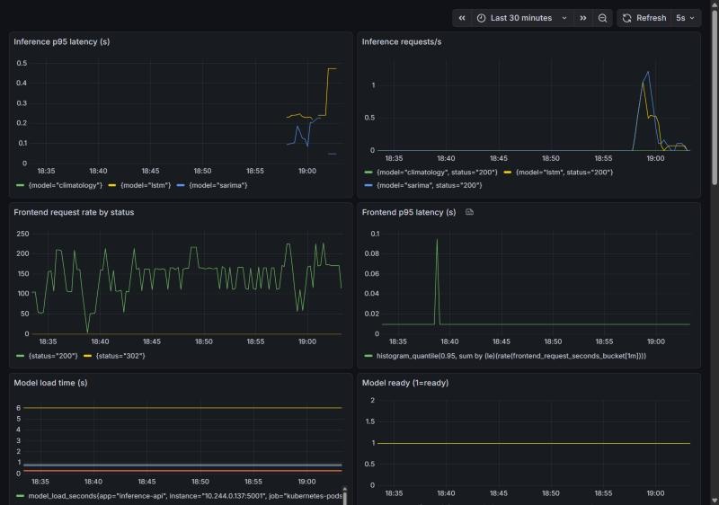
Figure 6.9 Live Grafana dashboard, last 30 minutes (refresh 5 s)
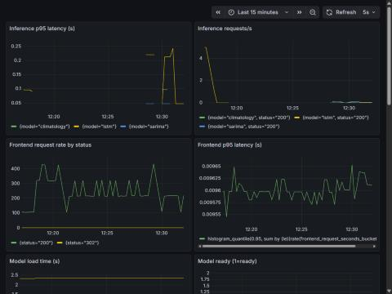
Figure 6.10 Grafana dashboard panels during the verification run
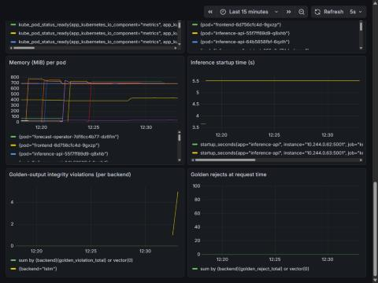
Figure 6.11 Golden-output integrity violations after an injected bit flip (Grafana panel)
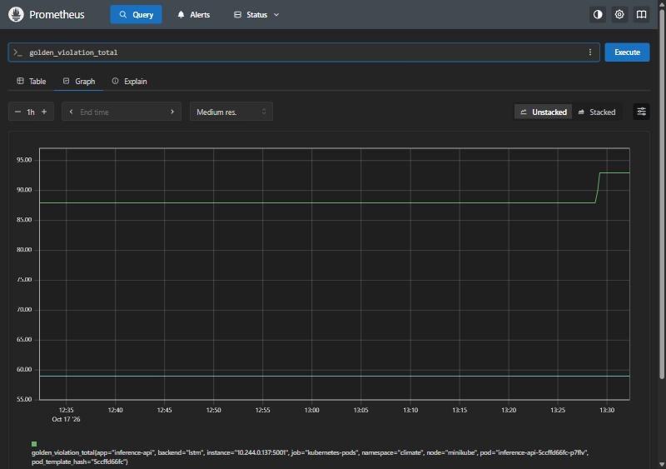
Figure 6.12 Prometheus: golden_violation_total for the LSTM backend (1 h)
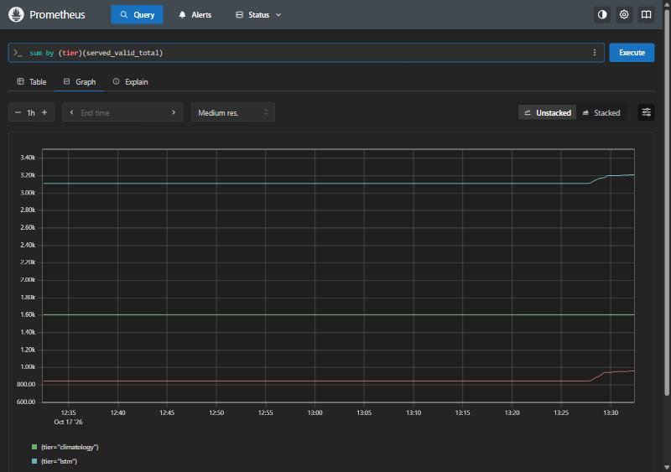
Figure 6.13 Prometheus: valid answers served per tier (1 h)

6.3.3 Distributed tracing
Figure 6.14 is the Jaeger view of one real request: the frontend handles GET /dashboard (1.81 s in total), and within the trace it calls the inference API three times (GET /predict, about 40 ms each), so the time that the user waits is dominated by the frontend work (database access and plotting) and not by the model service. Figure 6.15 is the trace search that lists traces crossing both services.
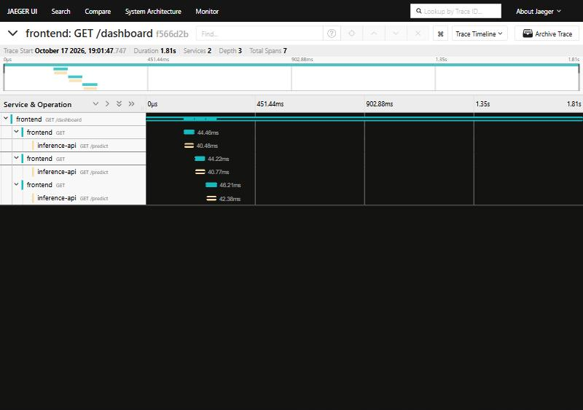
Figure 6.14 Jaeger trace of GET /dashboard with three inference calls
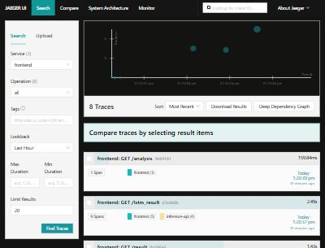
Figure 6.15 Jaeger trace search for the frontend service

6.4 Contributions (gap-based)
Six contributions are put forward. Several of their ingredients are known in the literature (Section 2.3); the contribution is the measured, integrated study that fills the gaps listed there. Claims of priority are restricted to the reviewed literature and must be confirmed by a structured IEEE and Scholar search.
# | Component | What is new | Measured evidence
1 | Silent-failure characterisation and SilentBench | To the best of our knowledge, the first measured comparison of monolith, Compose and Kubernetes under faults that keep the service healthy but wrong | 100 % wrong answers and 0 detections with default probes (10 trials per cell)
2 | Layered correctness guard | Window-level conformal envelope + temporal invariants + cross-model canary + golden-output check applied as a health check of a Kubernetes forecasting service | 0 % wrong answers for all eight faults with G4; 0 false alarms in healthy control and soak
3 | Tiered degradation and correctness SLO | Four-tier fall-through with circuit breaker; SLO on served validity with Wilson bound and burn rates | All detectable faults become valid labelled answers; alerts after 9-15 s when values are corrupted
4 | Correctness-aware self-healing | Semantic probes plus operator; cost model that charges time below full quality | Restoration 20/20 in about 22-24 s versus never; partial readiness 0 % vs 81 % failed
5 | Failure prediction and model-aware delivery | Precursor predictor on model-serving telemetry; shadow gate on output validity | Leak lead 69.6 s (6/6); gate 15/15 bad rejected, 6/6 good promoted
6 | Deadline- and load-aware degradation | Per-request budget and per-tier concurrency caps turn slow tiers into labelled lower-quality answers | Delay fault failed requests 96.8 % to 0 %; burst p95 about 4x lower
Table 6.8 Innovative components

6.5 Deadline- and Load-Aware Degradation (Novelty 6)
The delay fault makes 30 percent of the model calls sleep for 1.5 seconds. Without a deadline (G4) the sleeping calls occupy the service's threads and the shared model lock, requests queue behind them and 96.8 percent of requests fail on the client side with a p95 latency of about 2 seconds. With the deadline- and load-aware mechanism (H4: 800 ms budget, concurrency caps of two LSTM and three SARIMA calls) 0 percent of the requests failed, 94 percent were answered with valid climatology answers labelled as degraded, and the p95 latency fell to 762 ms; wrong answers were zero in both configurations. Most requests end on climatology because all backends still share one lock; per-tier locks could keep more of them on SARIMA and are listed as future work.
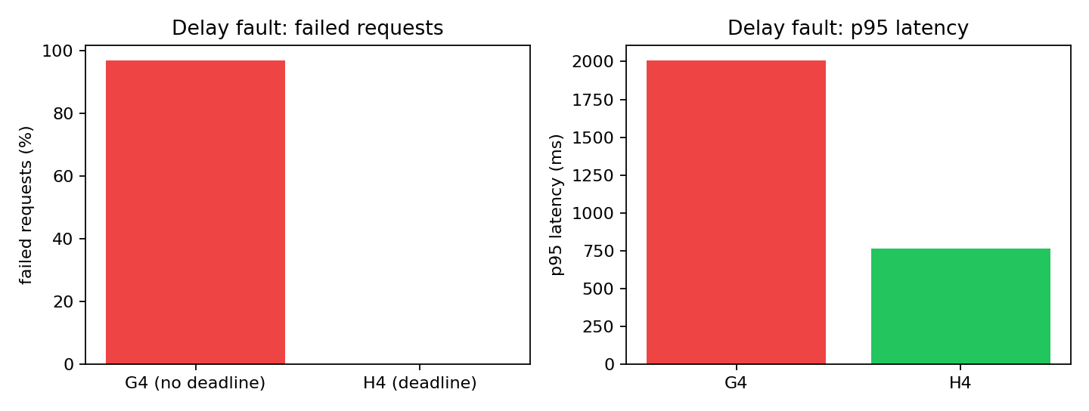
Figure 6.16 Delay fault with and without deadline-aware degradation (10 trials each)
Under a bursty LSTM load (3, then 20, then 3 requests per second for 40, 70 and 40 seconds on one replica) no requests failed in either configuration on the 16-thread image, but the p95 latency during the burst was 504, 1283 and 867 ms without the deadline and 185, 282 and 207 ms with it. The healthy control and the corrupt, bit-flip and flat-line faults behaved exactly as with G4 (100 percent correct, 100 percent degraded, 100 percent fallback and 100 percent degraded respectively, with no wrong answers). A byproduct of this experiment was a correction of an earlier conclusion: the high failure rates seen in the earlier scaling experiments were mostly caused by the use of four server threads, and the claim that scaling out does not help on a single node was withdrawn until it is re-measured.

6.6 Metamorphic Readiness Probe (experimental)
To obtain a correctness check that needs no stored reference output, a metamorphic probe was built. A metamorphic relation links the outputs of the model on two related inputs. Relation 1 (sensitivity profile) requires that the response of the six-step forecast to a one-standard-deviation shift of the input window stays inside a band learned offline on the healthy model; the first relation that was tried, equivariance under translation, was falsified by the data because the trained LSTM mean-reverts, and it was replaced by the learned band. Relation 2 (recursive self-consistency) requires that the forecast after the first step equals the forecast made from the window extended by the first forecast value. Tolerances are conformal quantiles (alpha = 0.01, family-wise over three probe windows) calibrated on 840 historical windows, so a model that is already corrupt at start-up can be detected; the probe is read-only and disabled by default.
Fault | Detected (30 probes) | Median score (threshold = 1)
corrupt (NaN) | 100.0 % | very large
unit change | 100.0 % | 2100.6
flat-line | 100.0 % | 362.07
stale output | 100.0 % | 533.35
bit flip (8 flips) | 93.3 % | 1.09 (marginal)
bit flip (16 flips) | 83.3 % | 1.13 (marginal)
scaler | 16.7 % | 0.81 (missed)
Table 6.9 Metamorphic probe: detection per fault (no golden output, no stored reference)
The false-alarm rate depends on how the probe is calibrated. With calibration on the even windows of all years and testing on the odd windows it was 2.0 percent per probe; with calibration on the years up to 2018 and testing after 2018 it rose to 66.0 percent, because the response band does not survive the post-2018 drift and would need periodic re-calibration. In a cluster test with the golden check switched off, the probe scored healthy windows at the threshold (0.996 to 1.0) and missed the injected eight-flip bit fault (0.996). The honest conclusion is that the probe reliably detects output-level and gross faults (which the envelope, invariants and canary already detect) but not subtle weight corruption, for which the golden-output check remains necessary. It is therefore reported as an experimental and partly negative result, not as a claimed novelty.

6.7 Baselines and Cost-Coverage of the Guard Layers
To check that the guard is better than simple alternatives and to quantify what each layer costs, six detectors were compared on the same injected faults using the real service code: a range check (history minimum and maximum), a 3-sigma z-score against the calendar-month mean, a golden test-vector check in the style of LM-Fix, the conformal envelope alone, envelope with invariants, and the full guard (envelope, invariants and golden). Detection was measured on 40 random history windows and false alarms on 300 healthy windows.
Fault | range | z-score 3 sd | golden | envelope | env + inv | full
bitflip | 0.0 % | 67.5 % | 100.0 % | 2.5 % | 7.5 % | 100.0 %
bitflip_severe | 90.0 % | 100.0 % | 100.0 % | 100.0 % | 100.0 % | 100.0 %
scaler | 100.0 % | 100.0 % | 100.0 % | 100.0 % | 100.0 % | 100.0 %
corrupt | 100.0 % | 100.0 % | 100.0 % | 100.0 % | 100.0 % | 100.0 %
unitchange | 100.0 % | 100.0 % | 100.0 % | 100.0 % | 100.0 % | 100.0 %
flatline | 0.0 % | 100.0 % | 100.0 % | 37.5 % | 100.0 % | 100.0 %
stale | 0.0 % | 100.0 % | 100.0 % | 72.5 % | 97.5 % | 100.0 %
false alarms (healthy) | 0.0 % | 12.3 % | 0.0 % | 0.0 % | 1.0 % | 1.0 %
Table 6.10 Detection of injected faults by simple baselines and by the layers of the guard (percent of windows)
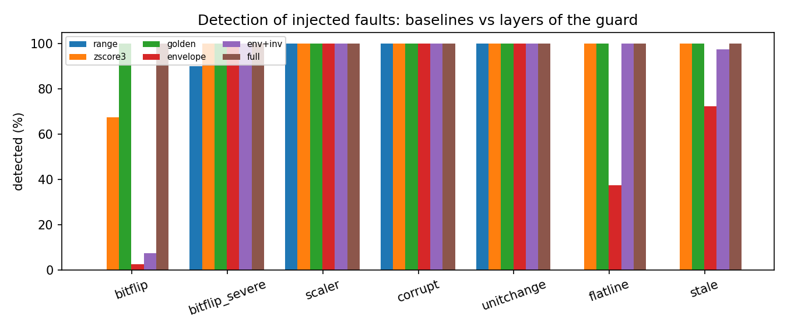
Figure 6.17 Detection of injected faults: baselines versus guard layers
Three honest conclusions follow. First, simple detectors are inadequate: the range check never sees the subtle bit flip, the flat-line or the stale output, and the z-score check raises false alarms on 12.3 percent of healthy windows. Second, the golden test-vector check on its own detected every injected fault with no false alarm, so on a deterministic model it subsumes the other layers for detection; the statement that the layers are complementary therefore holds for per-request checking only. Third, the cost differs by orders of magnitude: a golden check needs a 24-step forecast (182.241 ms) whereas the envelope with invariants needs 0.081 ms. The golden check can therefore be run only periodically (every five seconds it uses about 3.6 percent of one core), while the cheap checks validate every served answer. The resulting design - cheap per-request checks that bound the exposure between golden checks, plus a periodic golden check that bounds the detection latency - is the cost-coverage contribution of the study.

6.8 Healthy-but-Wrong Time and Mean Time to Correctness
Two metrics are defined to describe what availability and restart-time metrics hide. Healthy-but-wrong (HBW) time is the number of seconds during a fault window in which the platform reports the pod Ready while wrong answers are served. Mean time to correctness (MTTC) is the time from injection to the first answer that is not wrong. In the SilentBench data the guard-off configuration (C4) has an HBW time of 30 s (the whole fault window) and an undefined MTTC for every silent fault, which means that the platform never leaves the healthy-but-wrong state; the full guard (G4, H4) has an HBW time of 0 s for every fault; the envelope and invariants (E4) have 0 s except for the subtle bit flip (30 s). Full quality (MTTQ) returns with the operator in 23.8 s (rules) and 21.5 s (bandit) and never without it. The numbers are in results/hbw_mttc.md.

6.9 Compound Faults
Real incidents rarely come alone, so six combinations of a weight or scaler fault with an output-level or delay fault were injected into the real service code (25 requests per scenario; a response is wrong if it deviates from the healthy forecast of the tier it names). Output-level compound faults (flat-line, stale, unit change combined with a bit flip or scaler fault) and corrupt plus delay were handled by all three configurations by serving climatology. The interesting case is a subtle bit flip combined with a slow-model fault: E4 served 100 percent wrong answers from the LSTM with a p95 latency of 2465 ms; G4 served no wrong answer (it fell back to SARIMA) but with a p95 latency of 1615 ms; H4 served no wrong answer with a p95 latency of 768 ms. A subtle silent fault and a slow fault together need all three mechanisms - the golden check, the tier chain and the deadline - and neither of the two faults alone shows this interaction.
Scenario | E4 wrong % | G4 wrong % | H4 wrong % | E4 p95 (ms) | G4 p95 (ms) | H4 p95 (ms)
bitflip+flatline | 0.0 | 0.0 | 0.0 | 6 | 5 | 3
bitflip+stale | 0.0 | 0.0 | 0.0 | 6 | 3 | 3
scaler+unitchange | 0.0 | 0.0 | 0.0 | 5 | 3 | 2
bitflip+delay | 100.0 | 0.0 | 0.0 | 2465 | 1615 | 768
corrupt+delay | 0.0 | 0.0 | 0.0 | 3 | 7 | 9
scaler+flatline | 0.0 | 0.0 | 0.0 | 6 | 5 | 4
Table 6.11 Compound faults: wrong answers and p95 latency per configuration

6.10 Overall Analysis
• The central claim is supported by measurement: default Kubernetes and Compose cannot see silent failures, while a guard that tests the answer converts all injected silent faults into valid answers without false alarms.
• Among per-request checks the layers are complementary; the golden check was added because the others left a measured hole, and on its own it detects every injected fault but costs about 182 ms per check (Section 6.7).
• Automatic restoration needs an operator or a semantic liveness probe; semantic readiness alone only stops traffic.
• The learned recovery policy is not better than simple rules in this action space; its value is that it is derived from data and would choose differently where restarting is expensive (for example crash faults, where the table prefers restart-only at 48 s against 75 s).
• Probe tuning is secondary to redundancy: replicas dominate recovery time.
• Prediction gives useful lead for gradual faults at the cost of false alarms; the shadow gate separates good and bad candidates cleanly on the tested candidates.
• Several attractive extras gave negative or inconclusive results; recording them prevents over-claiming.

6.11 Verification and Live Evidence on a Second Machine (22 October 2026)
After the project was restored on a second Windows 11 laptop from the GitHub repository (models from Git LFS; images rebuilt: inference :9, frontend :4, operator :2), the complete system was started again and the claims of this report were re-checked. This section records the environment (Table 6.12), the 21-check validation suite (Table 6.13), an independent recomputation of the six contributions directly from the raw result files (Table 6.14), the completion of the golden-output (G4) cells of SilentBench to ten trials (Table 6.15) and live screenshots of the running system (Figures 6.18 to 6.36). Nothing in Sections 6.1 to 6.10 was changed except Table 6.2 (G4 now n = 10).

6.11.1 Environment and validation suite
Component | Version / role
Operating system | Windows 11 (25H2), WSL2 backend
Docker Desktop | 29.9.1 (engine)
Kubernetes | v1.37.0 on minikube v1.39.0 (containerd 2.3.4), 4 CPUs, 5.5 GB
kubectl / Helm / Git / Git LFS | 1.36 / 4.3.1 / 2.55 / 3.7.1
Python and key libraries | 3.10.11; TensorFlow 2.15.1; Flask 2.3.3; pandas 2.0.3; statsmodels 0.14.0
Container images | climate-inference:9, climate-frontend:4, climate-operator:2 (built from the repository)
Monitoring | Prometheus v3.15.0 (chart 29.37.0); Grafana 12.3.1 (chart 10.5.15), 16 dashboard panels
Repository state | commit 3439355 plus the corrections listed in Section 6.11.4
Table 6.12 Environment of the second-machine run
The validation suite validation/validate_all.py was run unchanged against the freshly deployed cluster. All 21 checks passed (Table 6.13). Check V03 looks for the image tags climate-inference:4 and climate-frontend:2; these tags were created as aliases of the rebuilt images. The full report is stored in verification_2026-10-22/reports/.
Check | Result | Evidence
V01 docker + kubectl available | PASS | Docker 29.9.1; kubectl client 1.36
V02 cluster pods Running | PASS | 3 pods Running
V03 images present in minikube | PASS | climate-inference:4 and climate-frontend:2 present in minikube
V04 all python files compile | PASS | 113 python files compile
V05 unit tests (pytest) | PASS | 2 passed in 1.25s
V06 data and model files | PASS | daily rows=26835, sarima MB={'sarima_rainfall.pkl': 124, 'sarima_temp_mean.pkl': 124, 'sarima_hum...
V07 service, baseline mode (real models) | PASS | rain[0] sarima=5.0 lstm=87.295; metrics exposed
V08 service, guard on: faults detected + heal (real models) | PASS | detected -> tiers {'corrupt': 'climatology', 'unitchange': 'climatology', 'flatline': 'climatolog...
V09 guard ablation reproduces stored numbers | PASS | hold-out false alarm 0.0; detection unit=1.0 flatline=1.0
V10 cluster readiness + semantic health | PASS | ready=True; semantic_ok=True
V11 cluster fault cycle corrupt/heal (in pod) | PASS | guard=True: corrupt -> tier=climatology degraded=True; healed tier=lstm
V12 frontend flows through Kubernetes + PostgreSQL | PASS | pages {'healthz': 200, 'dashboard': 200, 'result': 200, 'lstm_result': 200, 'history': 200, 'anal...
V13 Prometheus metrics + Grafana health | PASS | prometheus series=6 ; grafana ok
V14 baseline experiment data integrity | PASS | 75 fault rows in 15 cells (5 each); 20 load rows
V15 silent-benchmark data integrity | PASS | 357 rows, 41 cells; baseline healthy, class percentages sum to 100
V17 cluster extras results (semantic probes, partial readiness, UI, scaling, Chronos) | PASS | extras rows=49; UI checks all True; chronos status=ok; scaling rows=9
V18 fix round: golden check + cost-aware bandit | PASS | G4 bitflip rows=20 (0 wrong), healthy rows=5 (100% correct); bandit v2 restored 20/20
V19 deadline-aware degradation (delay fault) | PASS | delay fault failed %: G4 mean 96.8 -> H4 0.0; H4 healthy 100% correct, 0% wrong on corrupt/bitfli...
V20 metamorphic probe evaluation (experimental) | PASS | interleaved FA 2.0 %, time-split FA 66.0 % (limit), bitflip 93.3 % marginal, scaler 16.7 %
V21 baselines, HBW/MTTC and compound faults | PASS | baselines: simple detectors weak or noisy, golden strong but costly; compound bitflip+delay: E4 1...
V16 phases 7-13 result data (operator, probe validation, predictor, shadow gate, family) | PASS | operator rows=60 (rules restored 20/20) ; probe_validation rows=25 ; predictor: 6/6 leak and 6/6 ...
Table 6.13 Validation suite on the second machine (21 of 21 checks passed)
Contribution | Claim recomputed from results/*.jsonl | Computed | Checks
1 SilentBench, HBW/MTTC | Guard off: wrong answers (7 silent faults, 10 trials each); full guard (G4) | 100 % wrong, 0 detected; G4 0 % wrong over 70 trials; HBW 30 s vs 0 s | 11/11
2 Probe design | Readiness alone / readiness + liveness / partial vs strict | 91.7 % failed, never restored; 36.4 s; 0 % vs 80.7 % failed | 5/5
3 Compound faults | Bit flip + delay: E4 / G4 / H4 | 100 % wrong; 0 % wrong, p95 1615 ms; 0 % wrong, p95 768 ms | 5/5
4 Cost-coverage | Range, z-score, envelope vs golden; cost per check | 0 %, 12.3 % false alarms, 2.5 % vs 100 %; 182 ms vs 0.081 ms | 4/4
5 Quality-aware recovery | No operator / rules / bandit v1 / bandit v2 | 0/20; 20/20 (23.6 s); 5/20; 20/20 (21.6 s) | 6/6
6 Deadline-aware degradation | Delay fault failed requests G4 vs H4 | 96.8 % vs 0 %; 94 % valid degraded answers | 3/3
Total | validation/validate_novelty.py (results/novelty_validation.txt) | all values match the report | 34/34
Table 6.14 Independent recomputation of the six contributions from the raw result files

6.11.2 Completion of SilentBench for the golden-output configuration
Table 6.2 originally had five trials in the G4 columns of five faults. Trials 6 to 10 of these faults (corrupt, scaler, flat-line, unit change, stale) were executed on 22 October 2026 on the second machine with the same protocol (5 requests per second, 15 s warm-up, 30 s fault window, 10 s heal window, operator switched off), 25 new trials in total. The healthy baseline was 100 percent correct in every new trial. The inference image was rebuilt from the repository (tag :9) instead of the original :10; the code is the repository state. All 70 silent-fault trials of G4 (7 faults x 10) served 0 percent wrong answers; for zero wrong answers in 10 trials the exact one-sided 95 percent upper bound is 25.9 percent. The rows are appended to results/silentbench.jsonl (357 rows).
Fault | G4 trials | Wrong % | Correct % | Fallback % | Degraded % | Failed % | Fisher p vs C4 | 95 % upper bound (0 wrong)
corrupt | 10 | 0 | 0 | 0 | 100 | 0 | 1.1e-05 | 25.9 %
unitchange | 10 | 0 | 0 | 0 | 100 | 0 | 1.1e-05 | 25.9 %
flatline | 10 | 0 | 0 | 0 | 100 | 0 | 1.1e-05 | 25.9 %
scaler | 10 | 0 | 0 | 100 | 0 | 0 | 1.1e-05 | 25.9 %
stale | 10 | 0 | 0 | 0 | 100 | 0 | 1.1e-05 | 25.9 %
bitflip | 10 | 0 | 0 | 100 | 0 | 0 | 1.1e-05 | 25.9 %
bitflip_severe | 10 | 0 | 0 | 100 | 0 | 0 | 1.1e-05 | 25.9 %
delay | 10 | 0 | 3.2 | 0 | 0 | 96.8 | 1 | n/a
none | 5 | 0 | 100 | 0 | 0 | 0 | n/a | n/a
Table 6.15 G4 (golden check) after completion to ten trials per fault: mean share of responses in the 30 s fault window

6.11.3 Live screenshots of the running system
The following screenshots were taken on 22 October 2026 from the running system: the standalone Climate application (SARIMA, Figures 6.18 to 6.25), the DevOps version served from Kubernetes with SARIMA and LSTM (Figures 6.26 to 6.29, including the degraded-mode banner after an injected silent fault), the inference API (Figures 6.30 to 6.32), the live Grafana dashboard with a bit-flip fault injected (Figure 6.33) and Prometheus queries (Figures 6.34 to 6.36). No image is a mock-up.
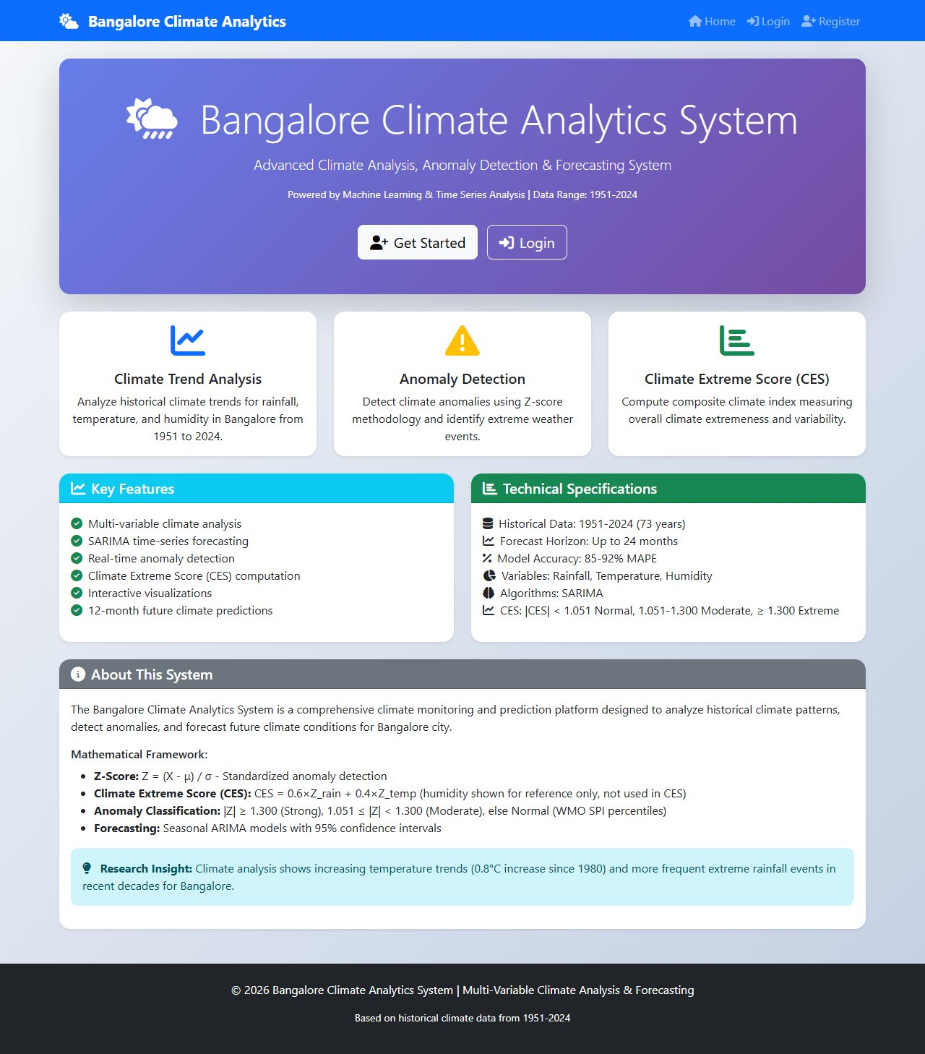
Figure 6.18 Home page of the standalone Climate application (corrected CES formula and thresholds)
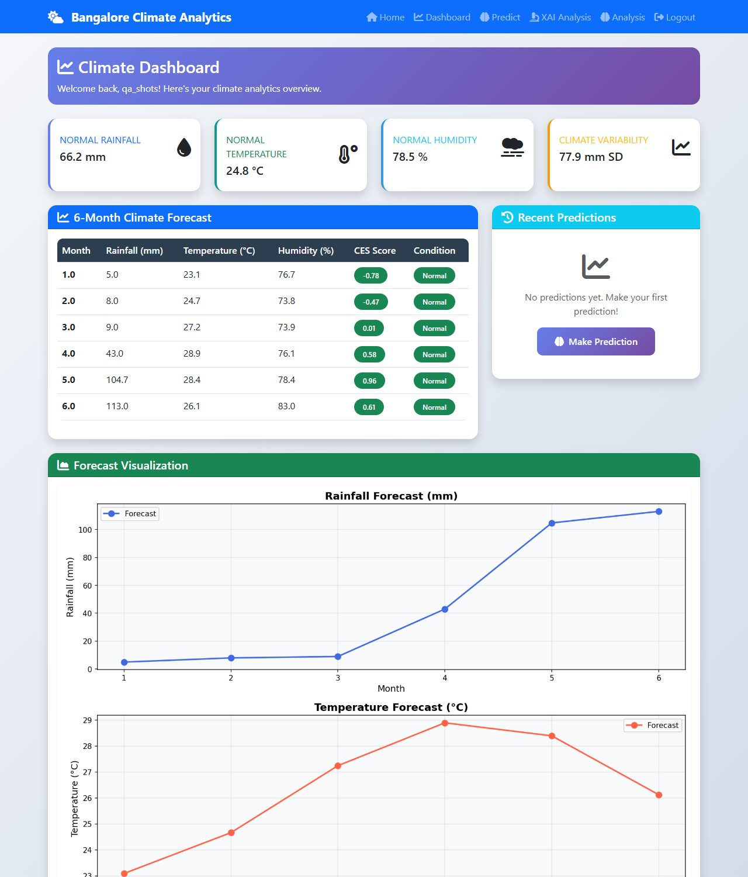
Figure 6.19 Dashboard of the standalone Climate application (SARIMA 6-month forecast)
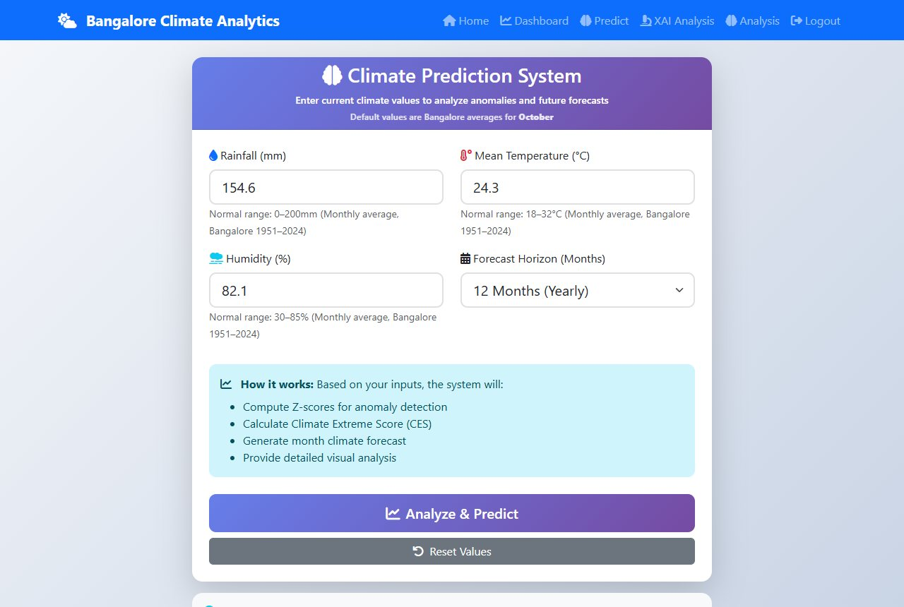
Figure 6.20 Prediction input form
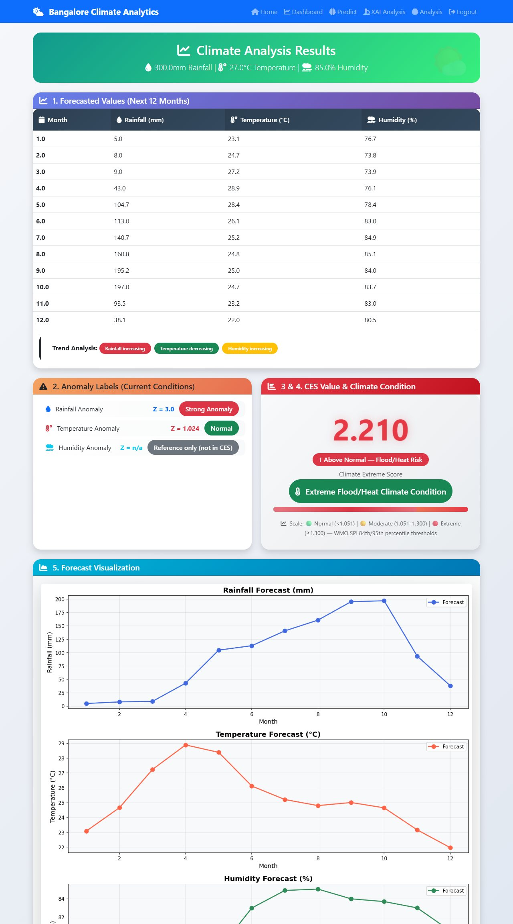
Figure 6.21 Result page for 300 mm, 27 C, 85 percent: CES 2.21, Extreme Flood/Heat
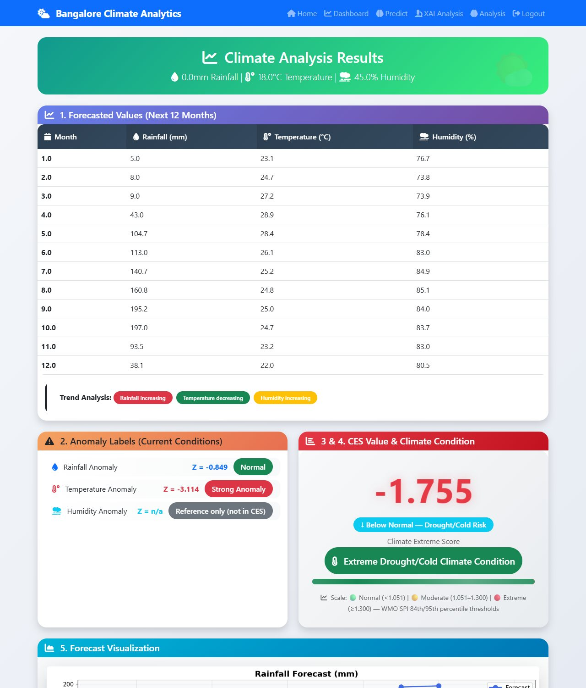
Figure 6.22 Result page for 0 mm, 18 C, 45 percent: CES -1.755, Extreme Drought/Cold with direction label
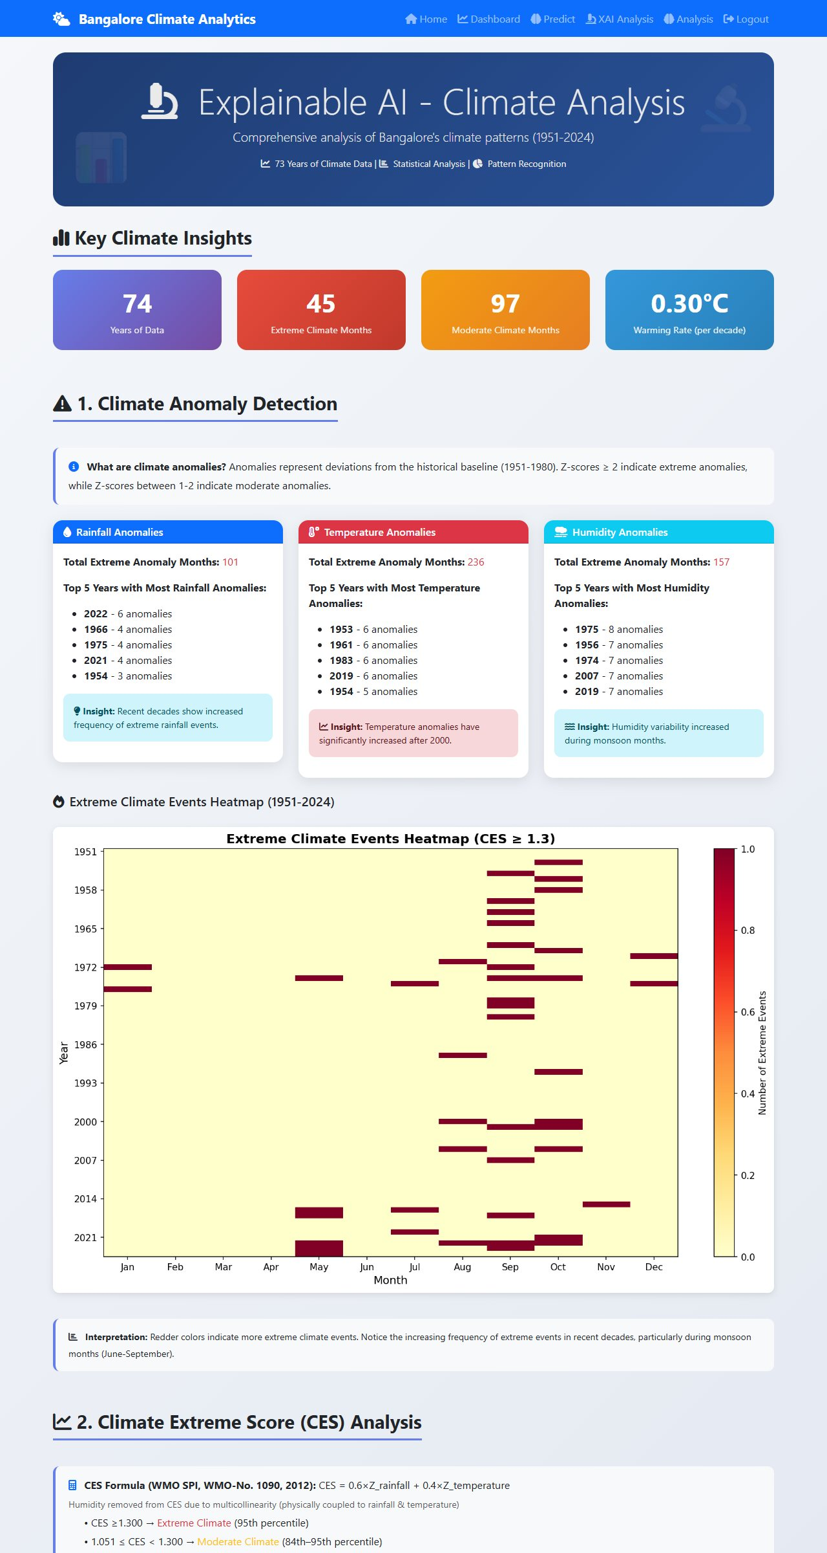
Figure 6.23 Explainable-AI page
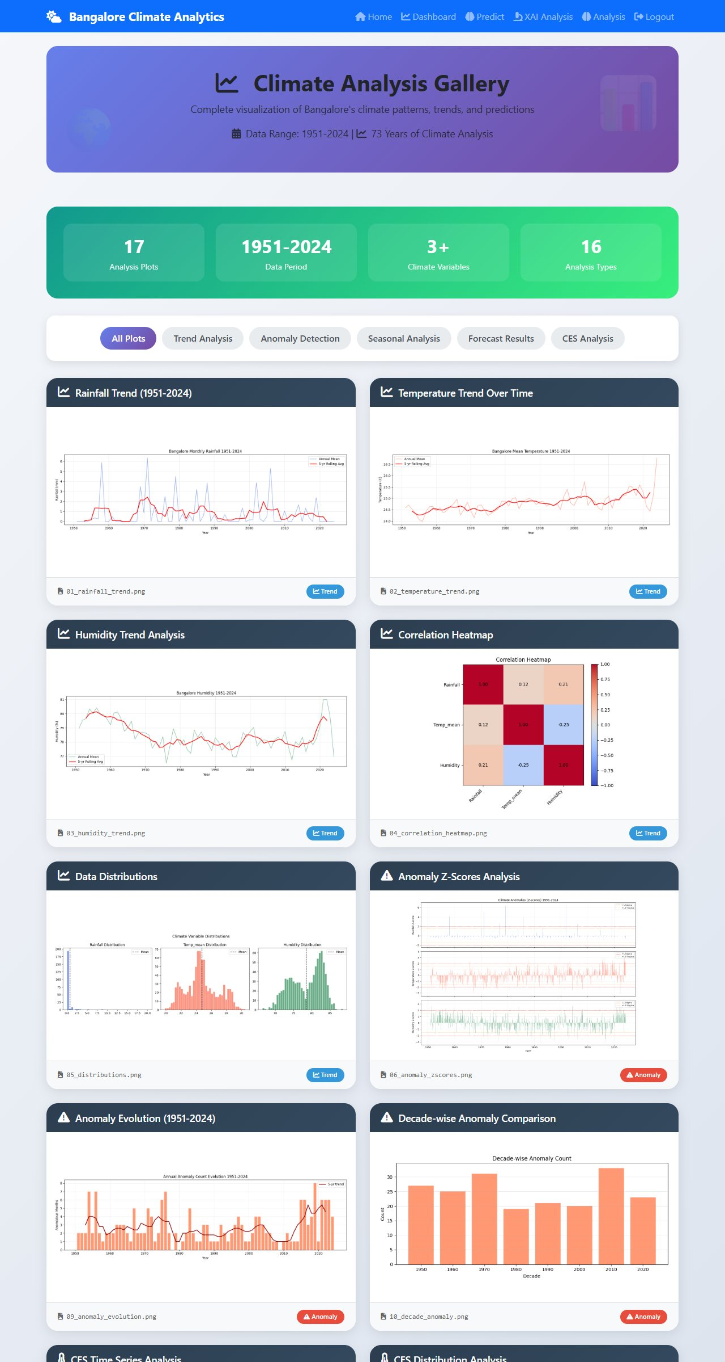
Figure 6.24 Historical analysis gallery
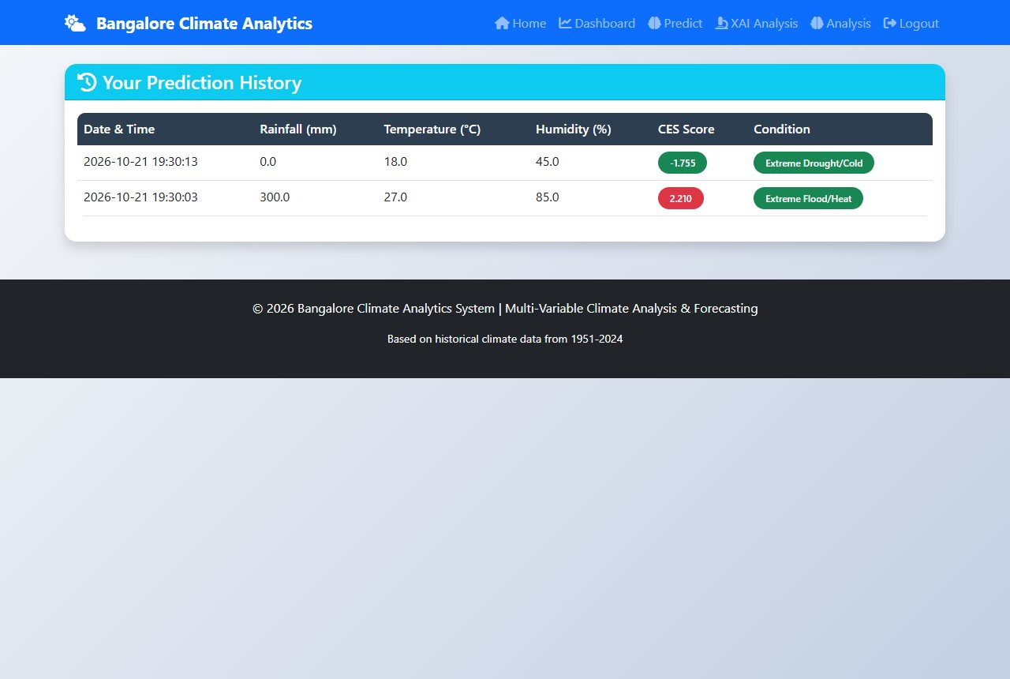
Figure 6.25 Prediction history
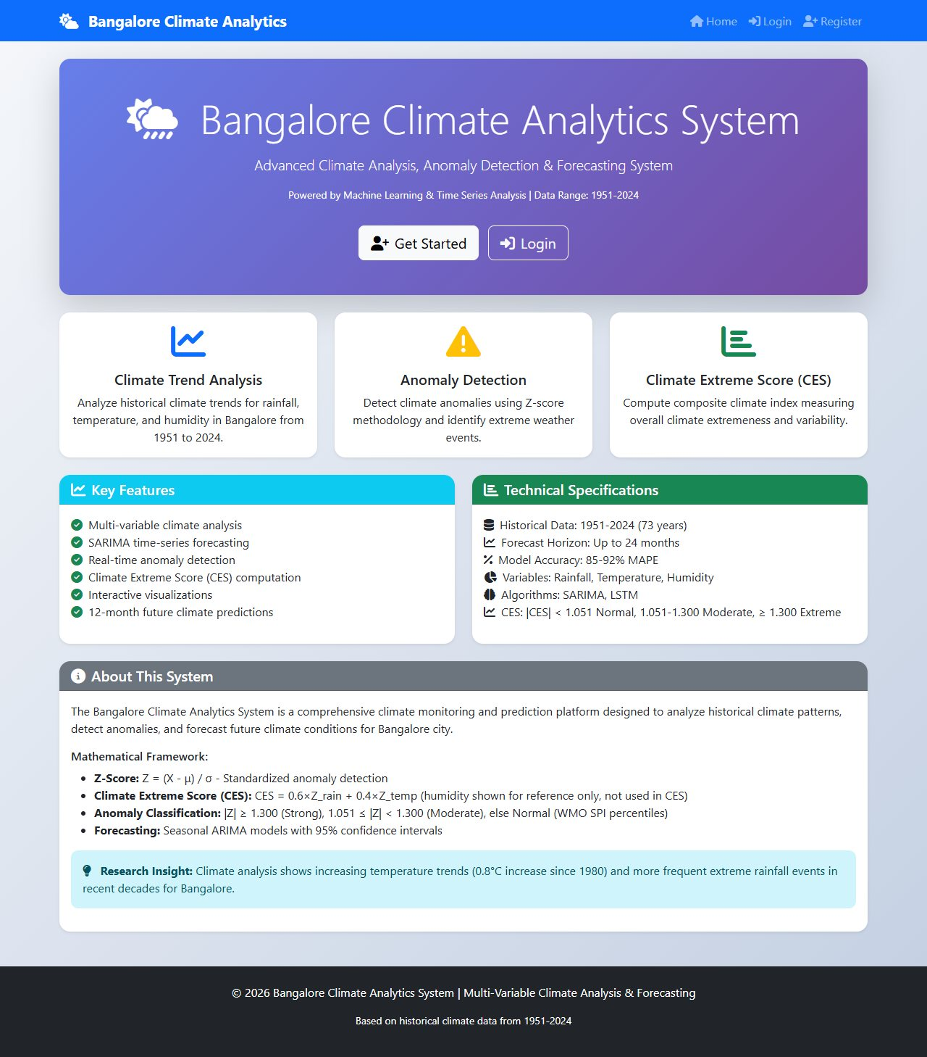
Figure 6.26 Home page of the DevOps version served from Kubernetes (corrected text)
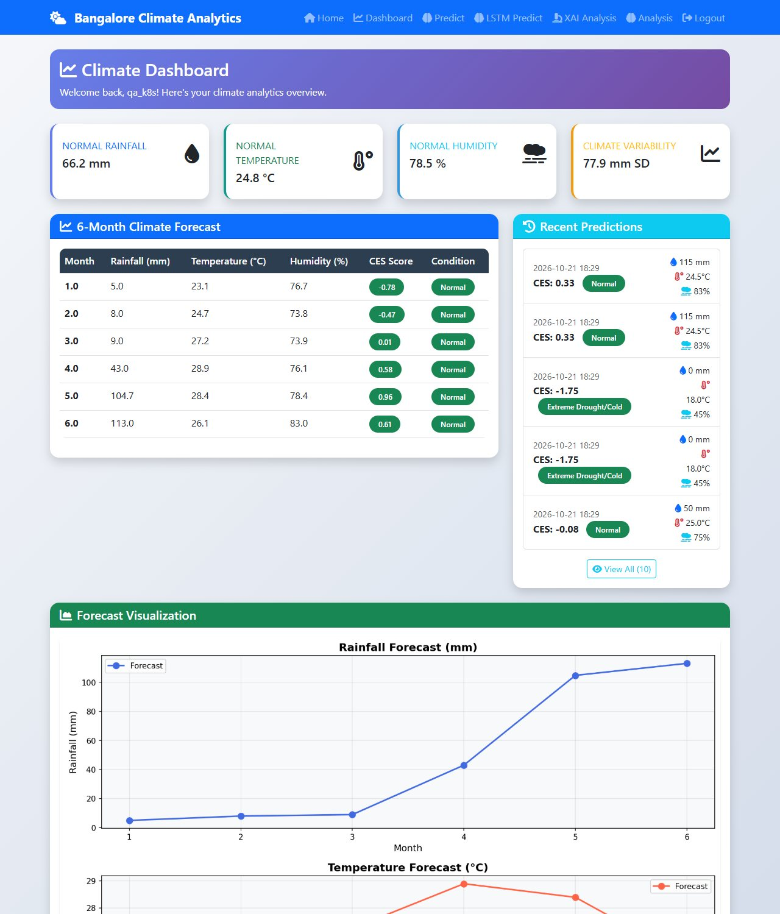
Figure 6.27 Dashboard served from Kubernetes with healthy models (LSTM tier)
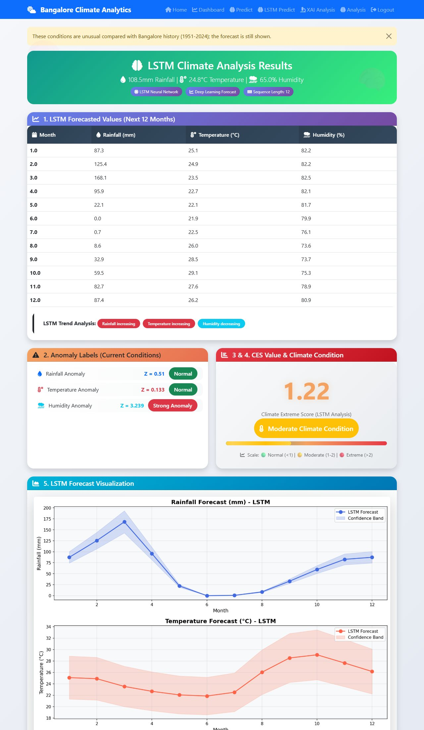
Figure 6.28 LSTM result page with real LSTM forecasts
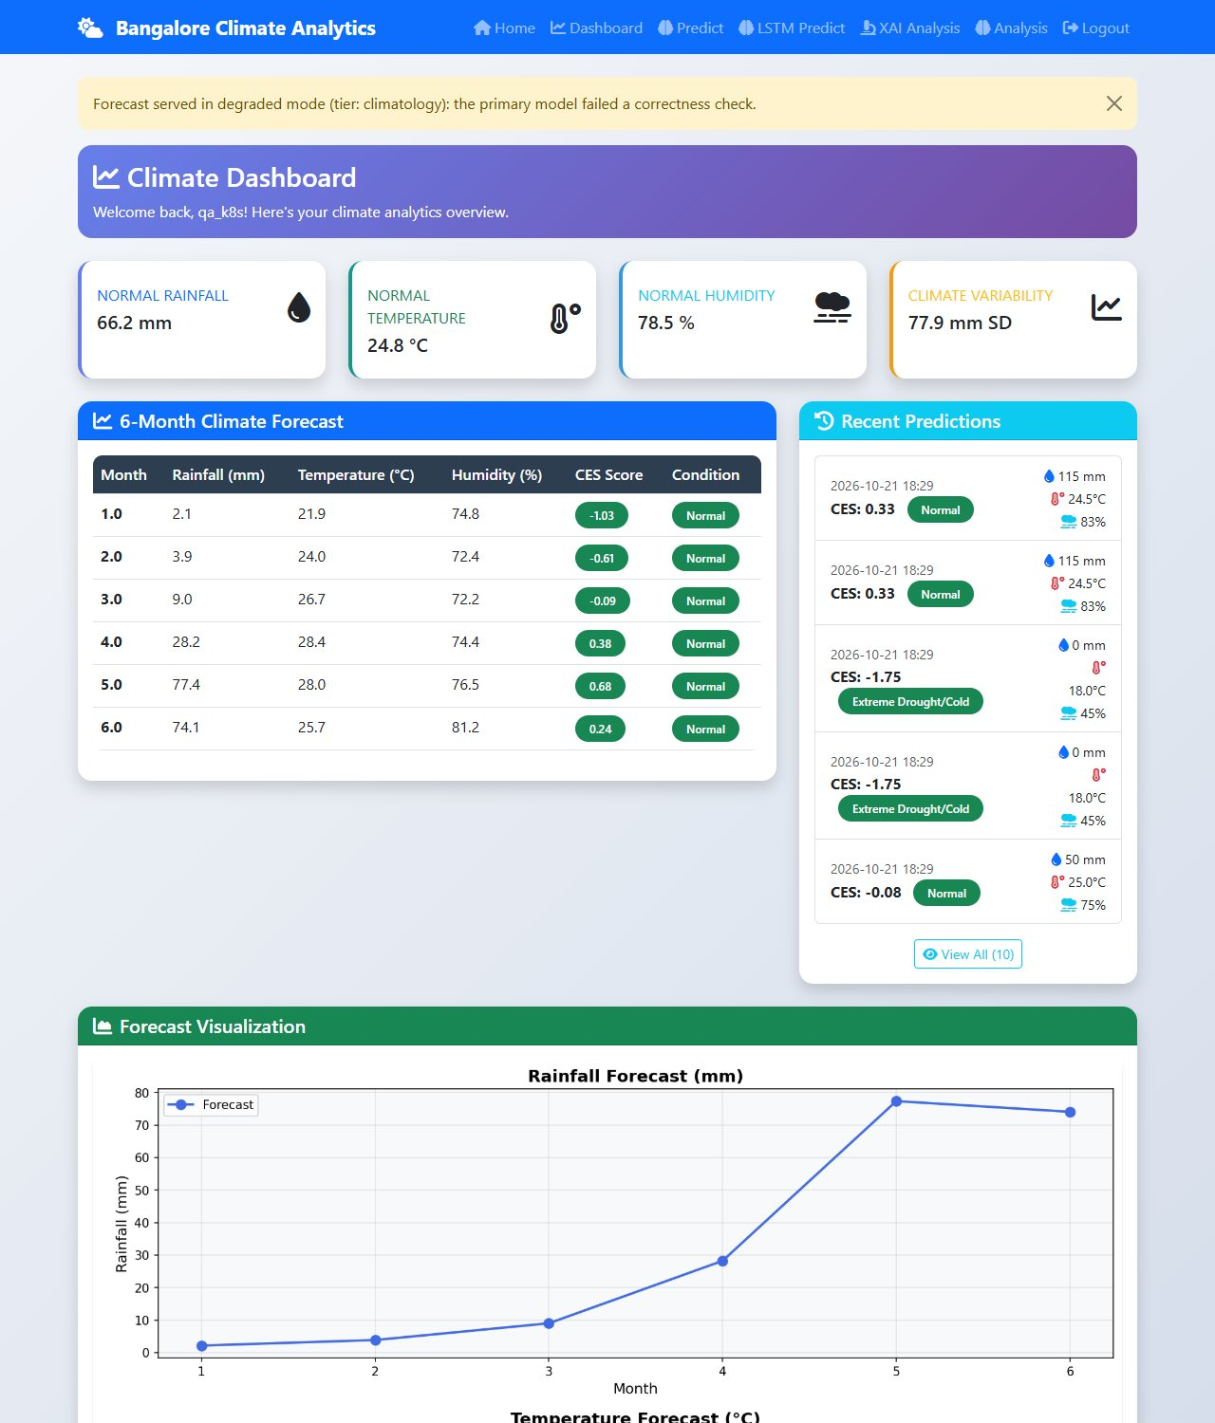
Figure 6.29 Dashboard after an injected silent fault: "Forecast served in degraded mode (tier: climatology)"
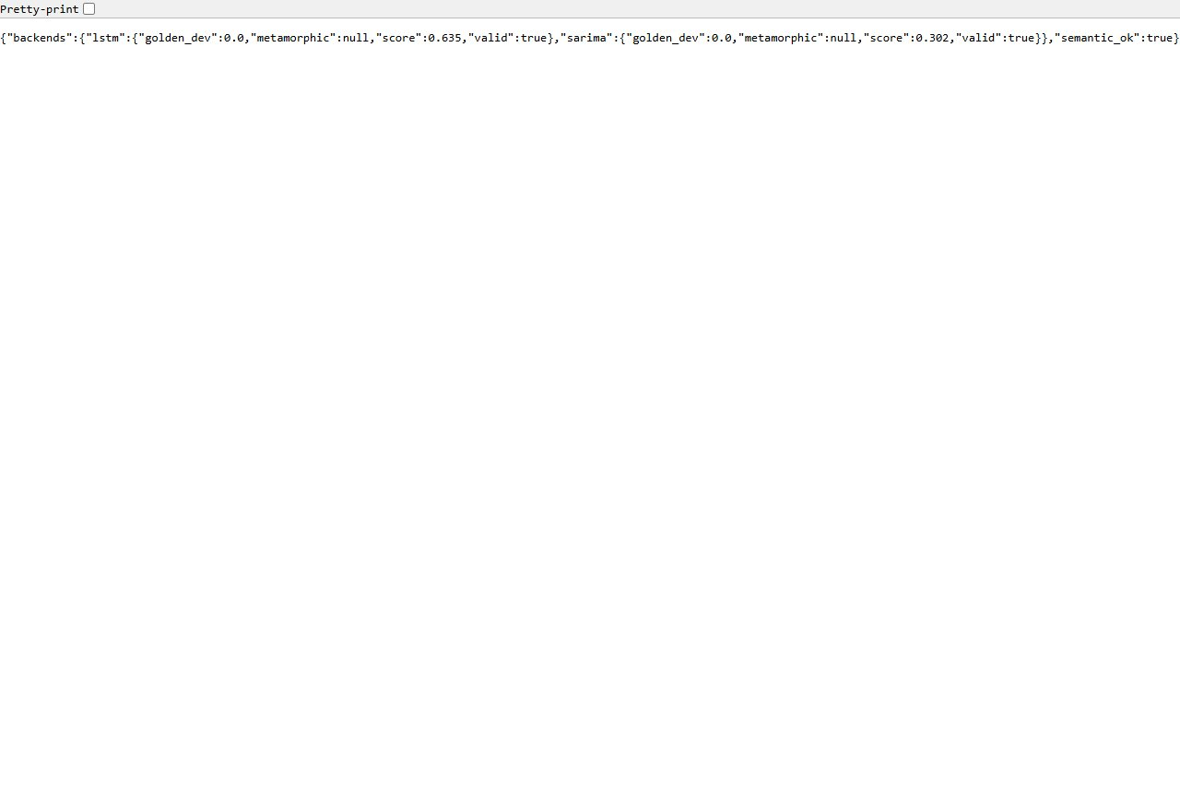
Figure 6.30 Inference API /health/semantic: both models valid, golden deviation 0.0
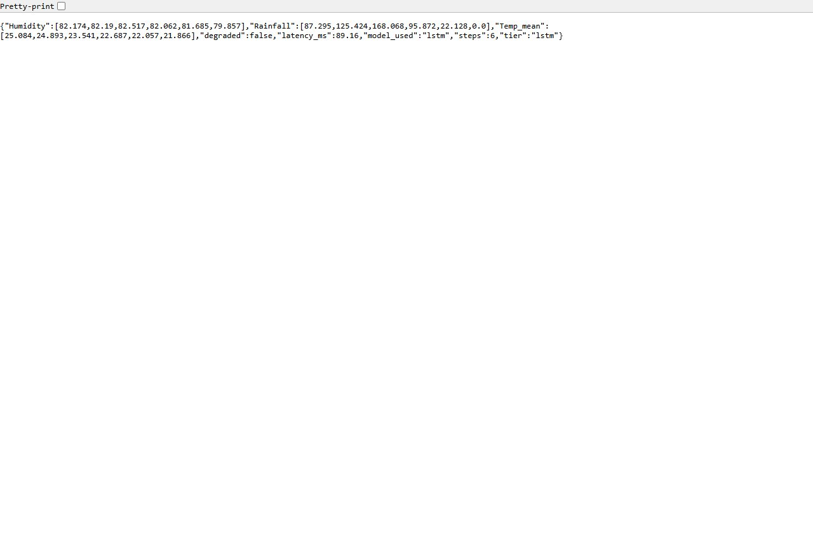
Figure 6.31 Inference API /predict: forecast served from the LSTM tier
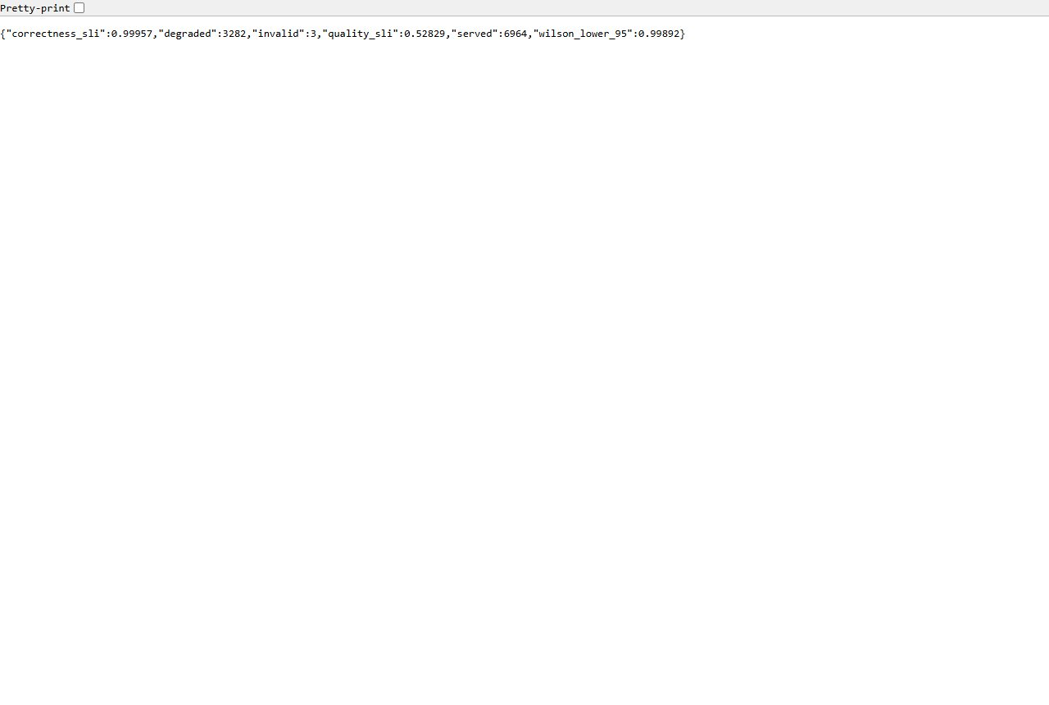
Figure 6.32 Inference API /slo: correctness SLI with Wilson lower bound
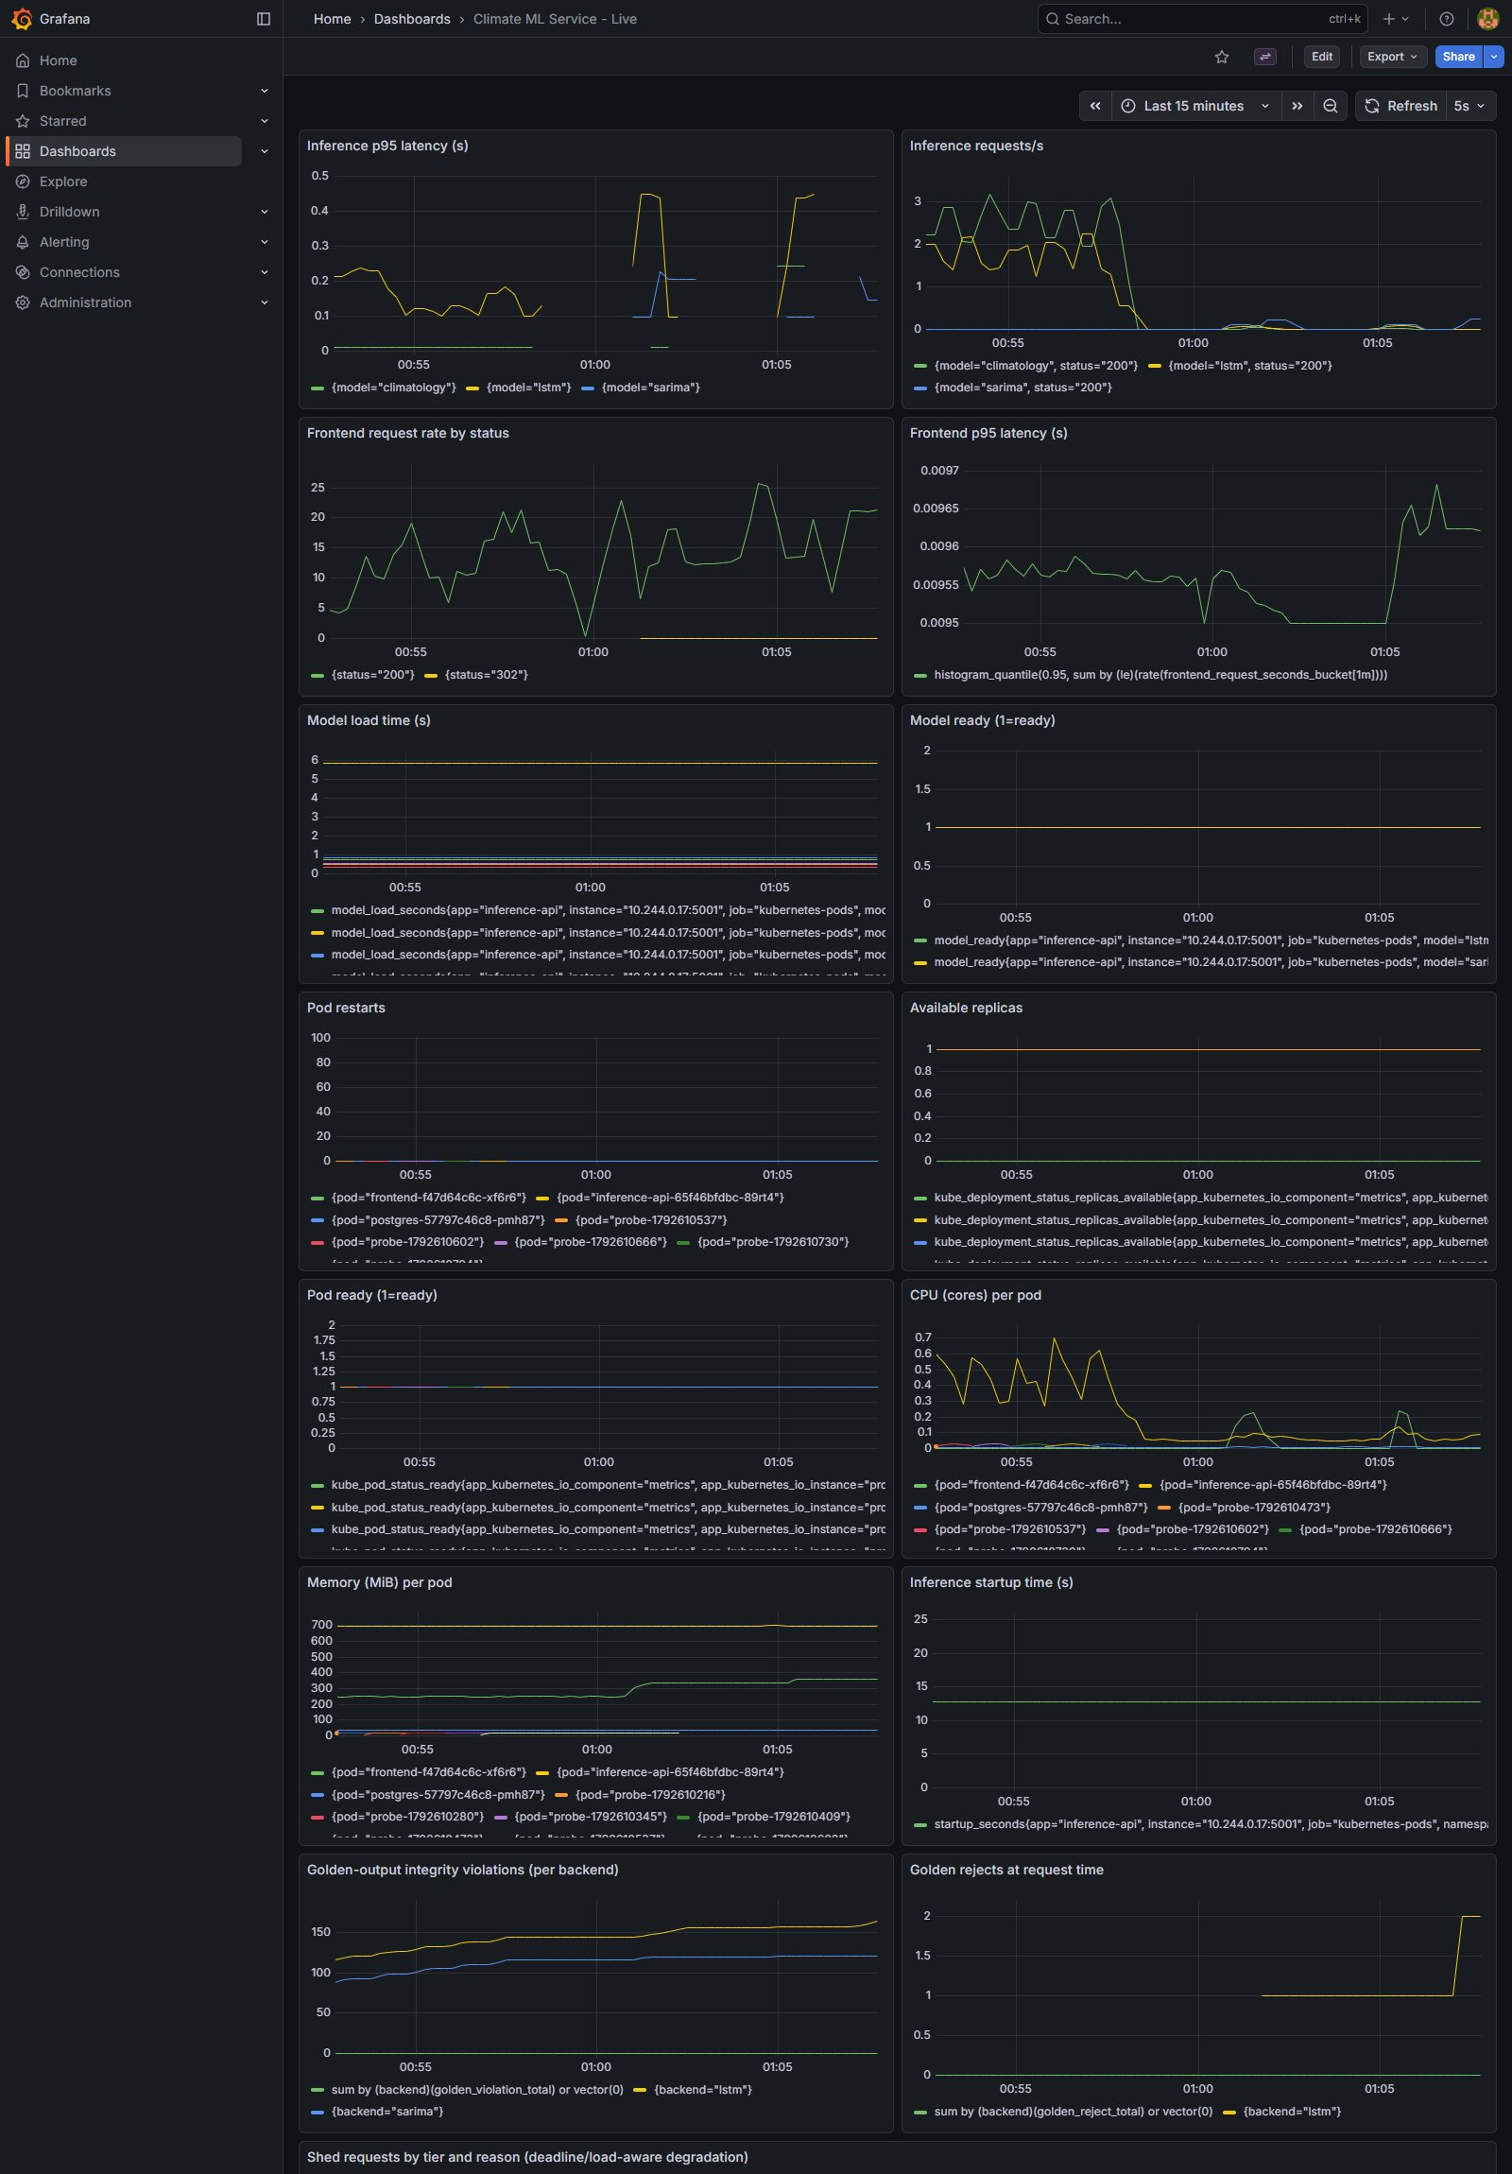
Figure 6.33 Live Grafana dashboard (16 panels) while a bit-flip fault was injected
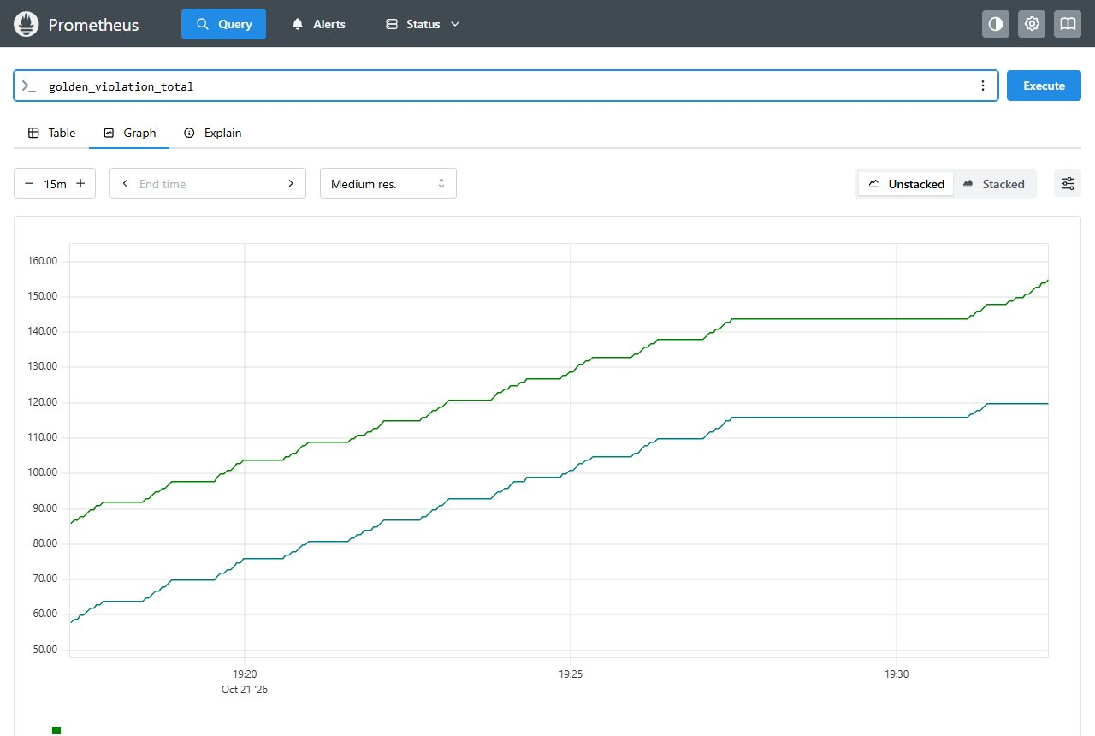
Figure 6.34 Prometheus: golden_violation_total
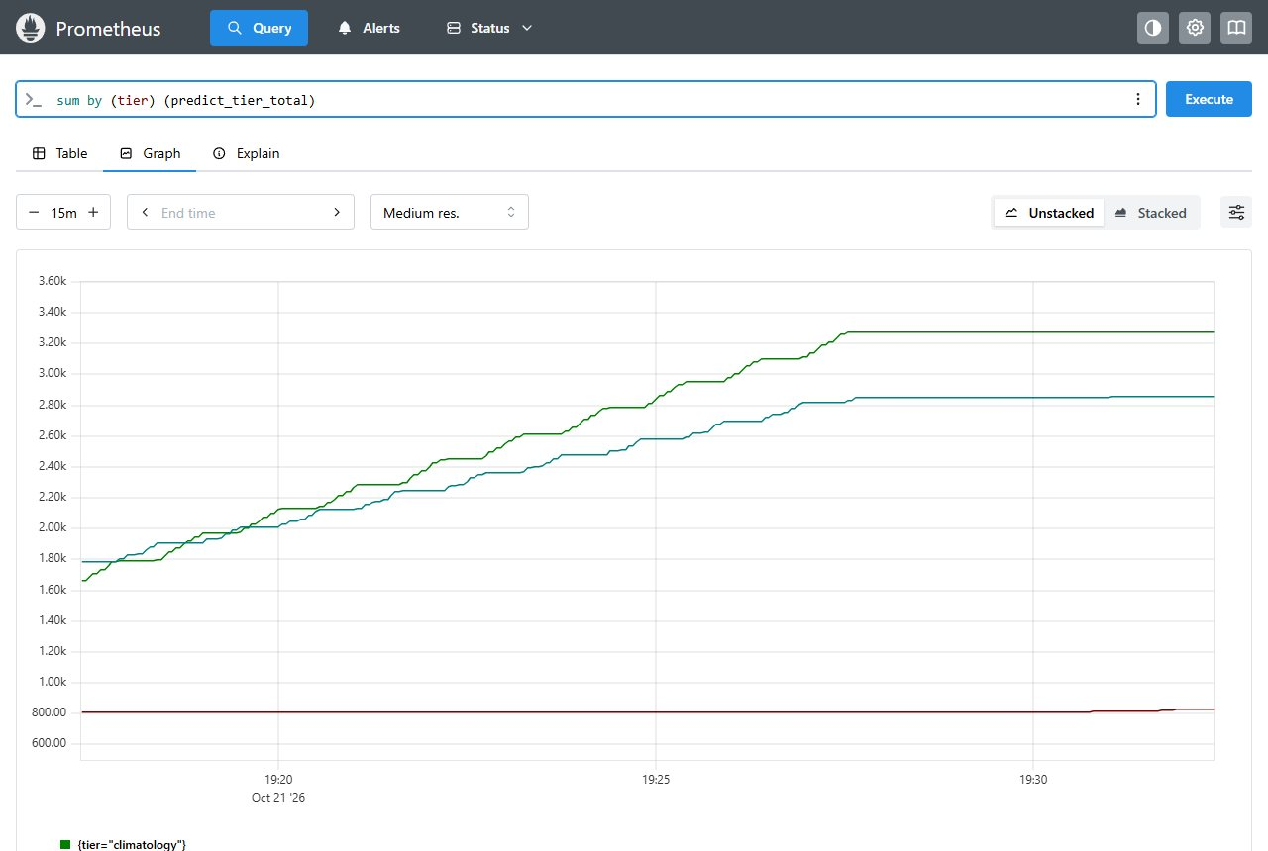
Figure 6.35 Prometheus: predict_tier_total by tier
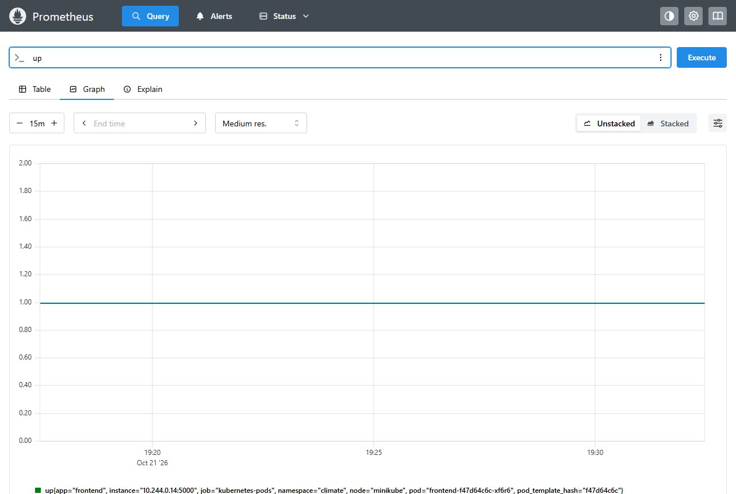
Figure 6.36 Prometheus: up (scrape targets)

6.11.4 Corrections found during verification
During the second-machine run the following inconsistencies were found and corrected: the home page showed an obsolete CES formula (0.4, 0.3, 0.3) and algorithm list, which now read 0.6 x rainfall + 0.4 x temperature (humidity excluded) with the thresholds 1.051 and 1.300; the result page printed a blank humidity z-value, which now states that humidity is shown for reference only; the restore instructions lacked Flask; the number of validation checks (21) and dashboard panels (16) in this report were updated; and the references were completed from Crossref and arXiv. The LSTM result page deliberately keeps its own scale (Normal below 1, Moderate 1 to 2, Extreme above 2), which is implemented in its route and was not changed.

6.12 Extensions: Bit-Flip Fuzzing, Signed Golden Outputs and Operator Rollback (22 October 2026)
Three extensions were added after the main study and measured on the same cluster (Kubernetes v1.37.0, minikube, inference image :14, operator image :4). They address three questions that the main study left open: how much of the damage caused by a random bit flip the guard layers really see, whether the golden-output check can be made independent of a trusted start-up state, and what the operator should do when a release (rather than a single pod) is bad. All numbers below are read from the raw result files by validation checks V22 to V25.

6.12.1 Random bit-flip fuzzing of the LSTM weights
The hand-picked eight-flip fault of SilentBench was chosen to stay inside the conformal envelope. To remove that choice, random bits were flipped in the real LSTM weights, for six bit-position classes (sign, exponent MSB, other exponent bits, high mantissa, low mantissa, any bit) and 1 to 64 flips, 300 trials per cell (12,600 trials, executed in the real service code). The client oracle is the same tolerance as in the earlier experiments. A control of 300 unmodified models gave no false alarm for either detector.
Bit class | Trials | Wrong answers % [95 % CI] | Loud failure (HTTP 500) % | Wrong and missed by envelope % | Golden alarm on harmless change %
sign | 2100 | 0.5 [0.3, 0.9] | 0.0 | 0.3 | 75.2
exponent MSB | 2100 | 50.2 [48.1, 52.3] | 0.4 | 15.5 | 49.2
other exponent bits | 2100 | 0.3 [0.1, 0.6] | 0.0 | 0.2 | 72.5
high mantissa | 2100 | 0.0 [0.0, 0.2] | 0.0 | 0.0 | 28.0
low mantissa | 2100 | 0.0 [0.0, 0.2] | 0.0 | 0.0 | 0.0
any bit | 2100 | 4.9 [4.0, 5.9] | 0.0 | 3.0 | 50.5
Table 6.16 Bit-flip fuzzing of the real LSTM weights (12,600 trials, 300 per cell)
A flip of the exponent MSB makes the answer wrong in about half of the trials, whereas every other single class causes at most 0.5 percent wrong answers. Overall 1,172 of 12,600 trials (9.3 percent) were wrong. The conformal envelope with invariants missed 400 of these 1,172 wrong answers (34 percent), while the golden-output check missed none at any number of flipped bits. The finding that exponent flips dominate the damage is known from the bit-flip-attack literature; the contribution here is the service-level measurement of how many wrong answers the cheap per-request layers miss. The same script was also run inside a pod of the production image (4,200 trials): 9.1 percent wrong answers, 137 of 381 missed by the envelope, none missed by the golden check, no false alarm in the control.
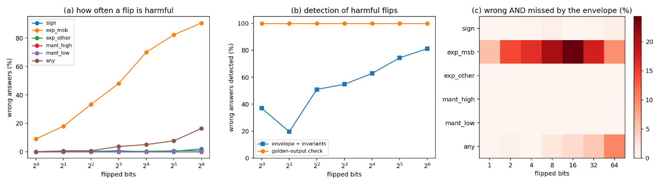
Figure 6.37 Bit-flip fuzzing: (a) harmful flips by class, (b) detection of harmful flips, (c) wrong answers missed by the envelope
The golden check is not free of cost: at its default tolerance (0.002 history standard deviations) it also raised an alarm on 50.7 percent of flips that did not change the answer beyond the client tolerance, which would trigger an unnecessary fallback. Sweeping the tolerance offline from the stored per-trial deviations shows a usable range.
Golden tolerance (history std) | Wrong answers detected % | Alarms on harmless changes %
0.002 (default) | 100.0 (1172/1172) | 50.7 (5784/11419)
0.02 | 100.0 (1172/1172) | 30.3 (3465/11419)
0.1 | 100.0 (1172/1172) | 13.9 (1582/11419)
0.2 | 100.0 (1172/1172) | 8.6 (979/11419)
0.5 | 97.9 (1147/1172) | 3.3 (382/11419)
1.0 | 84.3 (988/1172) | 1.0 (117/11419)
2.0 | 58.4 (684/1172) | 0.1 (6/11419)
Table 6.17 Golden-output check: detection of wrong answers and harmless alarms by tolerance
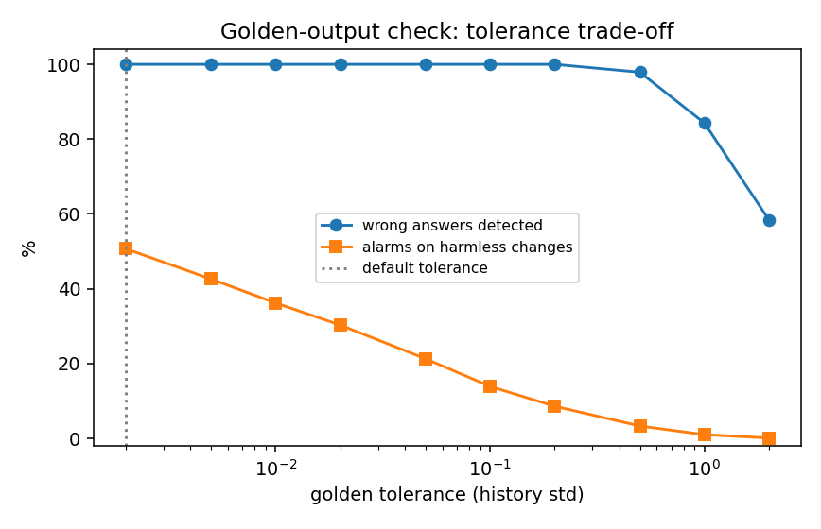
Figure 6.38 Trade-off between detecting wrong answers and alarming on harmless changes
A tolerance of 0.2 still detected every wrong answer in this sample and reduced the harmless alarms to 8.6 percent; it is recommended where an unnecessary fallback is costly. The shipped default was not changed.

6.12.2 Signed golden outputs and admission policy
The golden check compares later outputs with the outputs seen at start-up, so a model that is already corrupted when the pod starts defines its own reference and is never flagged. At release time, the healthy models now produce reference forecasts for each tier and variable together with the SHA-256 of the 12 model files; this manifest is signed with cosign (ECDSA P-256, bundle format, lab key, no transparency log) and published as the ConfigMap signed-golden. At start-up the service verifies the signature with the public key only and re-hashes the model files; any mismatch keeps readiness at 503 (fail closed) so that a rolling update never replaces a working pod with an unverified one. The signed values replace the start-up reference. The release script also checks the signature with cosign verify-blob as a second, independent verifier.
Condition | Trials | Wrong % | Valid fallback % | Semantic health | New pod Ready
healthy, signed reference | 20 | 0.0 | 0.0 | OK 20/20 | yes
corrupt at start-up, start-up reference | 20 | 99.9 | 0.0 | OK 20/20 (blind) | yes
corrupt at start-up, signed reference | 20 | 0.0 | 99.9 | not OK 20/20 | yes
golden.json tampered after signing | 10 | 0.0 (old pod serves) | 0.0 | n/a | never, 10/10
model file differs from signed hash | 10 | 0.0 (old pod serves) | 0.0 | n/a | never, 10/10
Table 6.18 Signed golden outputs versus the start-up reference (30 s window, 5 requests per second)
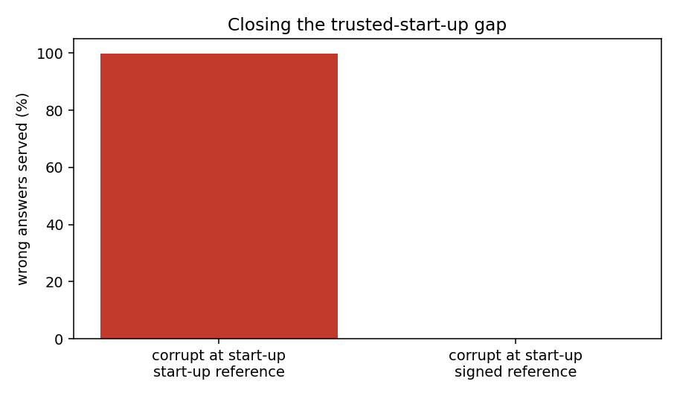
Figure 6.39 Signed golden outputs close the trusted-start-up gap
With the start-up reference 99.9 percent of the answers were wrong while the platform reported the service healthy; with the signed reference no wrong answer was served (99.9 percent were valid SARIMA answers) and the semantic health was not OK in 20 of 20 trials. The tampered file and the model-hash mismatch were rejected with an explicit reason and the new pod never became Ready in 10 of 10 trials each, while the old pod kept serving 100 percent correct answers. Failed requests stayed at 0.1 percent or less after the measurement client retried connections that the minikube tunnel reset during pod swaps.
A Kubernetes ValidatingAdmissionPolicy enforces that the inference Deployment keeps the signed-golden wiring. It was tested with six server-side dry-run changes: removing SIGNED_GOLDEN_DIR, removing the ConfigMap volume and its mount, and pointing the volume at another ConfigMap were denied; an unrelated environment change, the corruption switch used by the rollback experiment and an unrelated Deployment were admitted (6 of 6 as expected). The policy checks the wiring; the cryptographic check runs in the service.

6.12.3 Operator rollback and escalation
The operator received two new policies. release_aware rolls back to the last known-good ReplicaSet when the service became unhealthy after a release, otherwise it restarts; escalate restarts first, then rolls back, then pins the last valid tier. The last known-good release is recorded only after a fully rolled-out healthy streak. Two fault classes were compared: a transient fault (in-process corruption) and a bad release (the pod template starts with corrupted weights scaler).
Fault | Policy | Trials | Restored | Median time to full quality (s) | Mean failed % | Actions
transient | rules | 5 | 5/5 | 31.2 | 0.6 | restart
transient | release_aware | 5 | 5/5 | 29.4 | 0.3 | restart
transient | escalate | 5 | 5/5 | 30.2 | 0.6 | restart
bad release | none | 3 | 0/3 | never | 0.3 | none
bad release | rules | 5 | 0/5 | never | 2.2 | six restarts
bad release | release_aware | 5 | 5/5 | 45.8 | 0.4 | rollback
bad release | escalate | 5 | 5/5 | 77.4 | 0.6 | restart, rollback
Table 6.19 Recovery of two fault classes under the operator policies
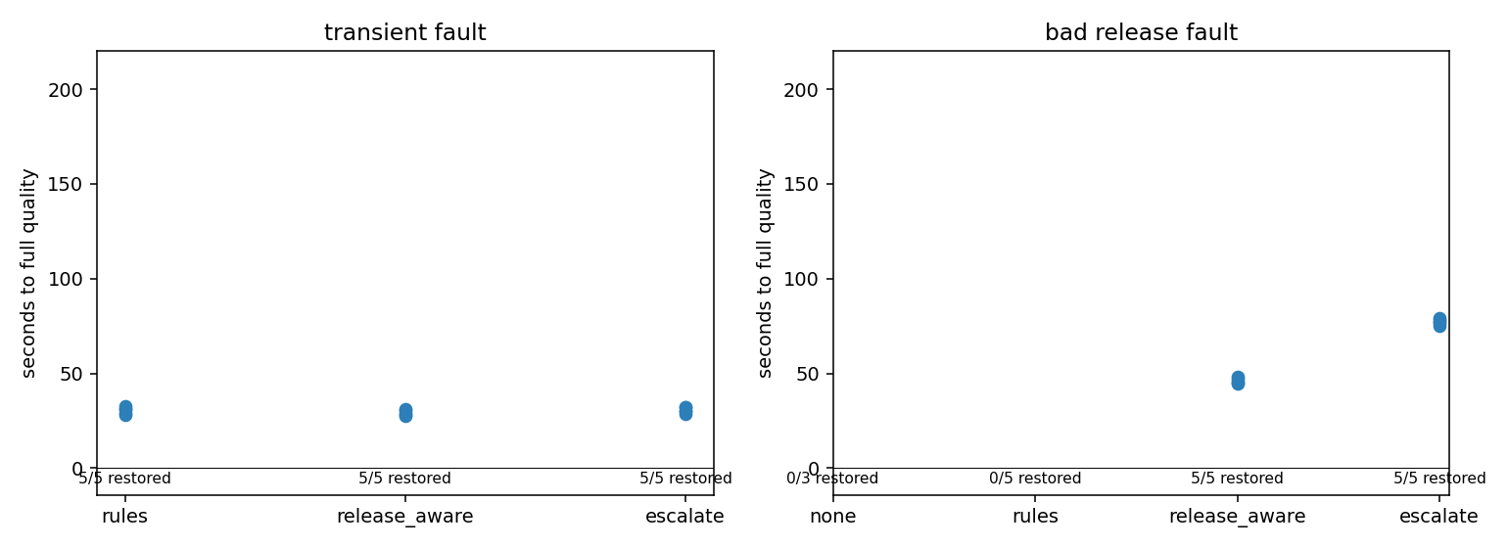
Figure 6.40 Restoration time per policy for a transient fault and for a bad release
Restarting cannot cure a bad release because the restarted pod is built from the same faulty template: restart-only recovered 0 of 5 trials (six restarts each), and without an operator 0 of 3. Rolling back restored full quality in 46 seconds, and the escalating policy in 77 seconds because it first spends one restart. For a transient fault all policies recover in about 30 seconds. The rules policy remains the shipped default; escalate is recommended where releases can be bad.

6.12.4 Validation and live browser check after the extensions
Four validation checks were added to the suite (V22 bit-flip fuzzing, V23 signed golden outputs, V24 operator rollback, V25 admission policy) and the whole suite was run again from the final project folder on the cluster: 25 of 25 checks passed. In addition, every page of the standalone application (port 5000), of the Kubernetes application (port 5100), the inference API, Grafana and Prometheus was opened in a real browser (Edge, scripted with playwright) and screenshotted: 46 of 48 pages were healthy. The two failures are the same defect in both applications: the JSON endpoint /api/baseline returns HTTP 500 because a data frame is passed to jsonify. The endpoint exists in the original code, no page links to it, and it was left unchanged and documented as known issue K37.
Check | Result | Evidence
V22 bit-flip fuzzing (Extra 1) | PASS | 12,600 trials in 42 cells; exponent-MSB wrong rate 50.2 percent; envelope missed 400; golden missed 0; in-pod run 4,200 trials
V23 signed golden outputs (Extra 3) | PASS | 80 cluster trials; start-up reference 99.9 percent wrong with health OK; signed reference 0 percent wrong; tampering rejected 20 of 20
V24 operator rollback and escalation (Extra 2) | PASS | bad release: restart-only 0/5, release_aware 46 s, escalate 77 s
V25 admission policy | PASS | 6 of 6 admission cases as expected
Table 6.20 Validation checks added for the extensions (suite total: 25 of 25 passed)
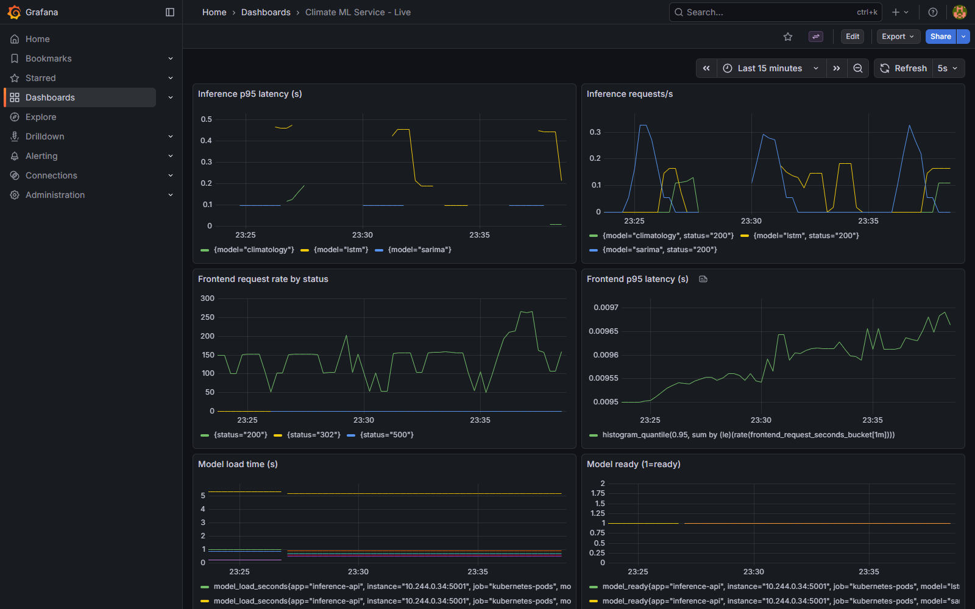
Figure 6.41 Live Grafana dashboard on the re-installed monitoring stack
Figure 6.42 Inference API /health/semantic while a silent fault is injected (HTTP 503, golden deviation reported)

6.12.5 Limits and corrections of this round
• The signing key is a lab key held on one machine and no transparency log is used; production needs a KMS/HSM key or keyless signing. The public key travels in the same ConfigMap as the signed file, so a principal with write access to the namespace could replace both; the key should be pinned in the image or in the admission policy.
• Fuzzing covers weights of one model family; 300 trials per cell on the host and 100 in the pod. The rollback study has five trials per cell and two fault classes.
• Two experiment runs were invalid and were discarded and repeated: a harness error had erased the operator memory of the last good release before the fault, and a re-run had omitted the paths of the tampered files. Neither run is part of the reported data. A first signed-golden run showed up to 0.7 percent failed requests caused by connection resets in the measurement tunnel; the client now retries those once.
• Novelty: that exponent bit flips dominate the damage, model signing with a hash manifest and metric-based automated rollback are known; the claims of this round are limited to the measurements above and are made to our knowledge only.

6.13 Summary
The results show a large and statistically significant effect of the proposed mechanisms on the safety of the served answers (0 percent wrong versus 100 percent), on the restoration of full quality (20 of 20 within about 24 seconds versus never) and, with the deadline mechanism, on availability under slow faults (0 percent failed versus 96.8 percent). They also show the limits of the approach, which Chapter 7 summarises.

CHAPTER 7: CONCLUSION

7.1 Conclusion
This project started from a simple but under-studied observation: a machine-learning service on Kubernetes can be perfectly healthy by every standard probe and still serve wrong answers. The work re-engineered the Bangalore Climate Analytics application (SARIMA and a real trained LSTM, unchanged) into a containerised, orchestrated and observable system, built a benchmark of silent faults, and designed and measured a layered set of mechanisms that make the platform aware of the correctness of the answers.
The measurements support five conclusions. First, default Docker Compose and Kubernetes never detect or recover from silent faults: all seven silent faults produced 100 percent wrong answers with the guard off, and nothing was detected in 10 of 10 trials per fault. Second, a window-level conformal envelope with temporal invariants, a cross-model canary and a golden-output integrity check turned every injected silent fault into a valid, labelled answer (0 percent wrong in all fault types, including subtle bit flips that evade the other layers) with zero false alarms in healthy control, in a ten-minute soak and on hold-out windows. Third, automatic restoration of full quality needs a correctness-aware recovery loop: with the operator the service returned to full quality in 20 of 20 trials in about 22 to 24 seconds, whereas it never returned without it, and a cost model that charges for time below full quality was necessary for the learned policy to behave sensibly. Fourth, a deadline- and load-aware degradation mechanism removed the failures caused by slow model calls (96.8 percent to 0 percent failed requests) and reduced the p95 latency under burst load by about four times. Fifth, the extras show that precursor-based prediction gives a useful warning time for gradual faults (69.6 s for memory leaks), that a shadow gate separates good and bad candidate models cleanly, and that the same criterion can drive a standard delivery tool (Argo Rollouts).
The project also produced negative and inconclusive results that are as important as the positive ones: probe tuning is secondary to redundancy, a learned bandit offers no advantage over simple rules in the available action space, log-based detection has no signal for silent faults, the input guard and the LSTM autoencoder generate too many false alarms, and conclusions about autoscaling on a single node could not be drawn. Recording these results, and withdrawing a claim that a later experiment contradicted, was part of the method.

7.2 Limitations
• Scale: 5 to 10 trials per experimental cell, one model family, one data set, one laptop with a one-node Minikube cluster; confidence intervals are therefore wide for some cells and multi-node effects are not studied.
• The golden-output check detects change from a trusted start-up state; it cannot detect a model that was already wrong when it started, and legitimate retraining requires refreshing the golden outputs after the shadow gate.
• Signed golden outputs (Section 6.12.2) remove the dependence on a trusted start-up state, but the signing key is a lab key, the public key is shipped with the signed file and no transparency log is used; the golden check also alarms on harmless weight changes at its default tolerance (50.7 percent in the fuzzing study), and a tolerance of 0.2 is recommended.
• Faults are injected synthetically (weights, scaler, output, delay); real-world incidents may differ. The injected faults were designed by the authors, which can favour the proposed detectors.
• The cross-model canary and the golden check assume deterministic models; stochastic models need statistical variants.
• Most delayed requests end on the climatology tier because all backends share one lock; per-tier locks were not implemented.
• The learned recovery policy has only restart and tier-switch actions, so it cannot outperform the rules policy; its benefit would appear with a richer action set.
• Rollback and escalation were measured with five trials per cell and two fault classes; the bit-flip study covers weights of one model family; the page /api/baseline of the original applications returns HTTP 500 (known issue K37).
• Scaling results (HPA, pre-scaling, KEDA) were obtained on a single node with an earlier thread configuration and are withdrawn as evidence; the RL autoscaler is a simulation only.
• Security: placeholder secrets and unauthenticated fault and shadow endpoints are acceptable only in the lab (see the security review); the GitHub Actions workflow, Trivy scan and keyless signing were written but could not be run on the laptop.
• The metamorphic probe is experimental: marginal against subtle bit flips and sensitive to drift when calibrated on earlier years.
• Novelty claims are limited to the 23 papers reviewed and a limited web search; a structured search of IEEE Xplore and Google Scholar is still required.

7.3 Future Scope
• Improve the metamorphic readiness probe (Section 6.6): periodic re-calibration against drift, a larger and more diverse set of probe windows, and relations with more power against subtle weight corruption.
• New metrics: healthy-but-wrong time and Mean Time To Correctness (MTTC) as complements to availability and MTTR.
• Per-tier locks and finer admission control for deadline-aware degradation; automatic tuning of the deadline from the latency SLO.
• A multi-node cluster study of autoscaling with warm-up awareness (HPA, KEDA and a learned policy) using the 16-thread image.
• Generalisation to other models and data sets (a second forecasting workload, classification services) and to stochastic models.
• A richer action set for the operator (scale up, roll back to the previous model, switch tier permanently) so that the learned policy can show a benefit.
• Production key management for the signed reference (KMS/HSM or keyless signing with a transparency log), pinning of the public key in the image or admission policy, fuzzing of activations and of other model families, an adaptive golden tolerance, and an online conformal envelope that can also choose the fallback tier.
• Running the CI pipeline with image signing, Trivy scanning and Kyverno verification on GitHub, adding authentication to the control endpoints, and network policies.
• Comparison with a literature baseline for output validation (simple range or threshold detector) and larger numbers of trials for the headline claims.
• A structured literature search and a conference or journal paper based on Appendix B.

7.4 Summary
The study demonstrates, with measurements and with an honest account of its limits, that the self-healing promise of container orchestration can be extended from process health to answer correctness at modest cost, and it provides the code, data and documents needed to reproduce and extend the work.

REFERENCES (IEEE FORMAT)
[1] S. Nigam, S. Patel, A. Khan, "AI-augmented chaos testing: Toward intelligent resilience engineering in cloud-native systems," in 2026 International Conference on Sustainable Engineering and Digital Innovation (ICSEDI), 2026, doi: 10.1109/icsedi66420.2026.11568339.
[2] J. Zairi, A. Kenzi, "A comparative study of automatic migration from monolith application to microservices," in 2025 4th International Conference on Embedded Systems and Artificial Intelligence (ESAI), 2025, doi: 10.1109/esai67033.2025.11438829.
[3] L. Li, "A predictive elastic scaling method for Kubernetes based on load forecasting," in 2026 6th International Conference on Computer Science and Blockchain (CCSB), 2026, doi: 10.1109/ccsb71176.2026.11716456.
[4] Z. Sun, C. Zhang, M. Zhang, F. Yang et al., "A stacking ensemble ML-based failure prediction model for optical networks with imbalanced data," in 2023 Asia Communications and Photonics Conference/2023 International Photonics and Optoelectronics Meetings (ACP/POEM), 2023, doi: 10.1109/acp/poem59049.2023.10369189.
[5] X. Wu, "Architecture-based failure prediction via LSTM and Bayesian network in service-oriented systems," in 2022 4th International Conference on Applied Machine Learning (ICAML), 2022, doi: 10.1109/icaml57167.2022.00015.
[6] S. Shahini, H. Momeni, "Autoencoder-based anomaly detection in microservices using distributed tracing," in 2024 20th CSI International Symposium on Artificial Intelligence and Signal Processing (AISP), 2024, doi: 10.1109/aisp61396.2024.10475273.
[7] M. Zaccarini, F. Poltronieri, D. Borsatti, W. Cerroni et al., "Chaos engineering based Kubernetes pod rescheduling through deep sets and reinforcement learning," in NOMS 2025-2025 IEEE Network Operations and Management Symposium, 2025, doi: 10.1109/noms57970.2025.11073590.
[8] D. Singh, "Deployment of seasonal autoregressive integrated moving average (SARIMA) models for network reliability prediction," in 2024 3rd International Conference for Innovation in Technology (INOCON), 2024, doi: 10.1109/inocon60754.2024.10511470.
[9] G. Siwach, A. Haridas, N. Chinni, "Evaluating operational readiness using chaos engineering simulations on Kubernetes architecture in Big Data," in 2022 International Conference on Smart Applications, Communications and Networking (SmartNets), 2022, doi: 10.1109/smartnets55823.2022.9993998.
[10] V. Berry, A. Castelltort, B. Lange, J. Teriihoania et al., "Is it worth migrating a monolith to microservices? An experience report on performance, availability and energy usage," in 2024 IEEE International Conference on Web Services (ICWS), 2024, doi: 10.1109/icws62655.2024.00112.
[11] F. Xue, L. Yang, B. Fan, H. Jiang et al., "Kube-CC: Building an experiment education platform for Big Data courses based on Kubernetes," in 2023 International Conference on Engineering Education and Information Technology (EEIT), 2023, doi: 10.1109/eeit58928.2023.00013.
[12] L. Yang, J. Li, K. Shi, S. Yang et al., "MicroMILTS: Fault location for microservices based on mutual information and LSTM autoencoder," in 2022 23rd Asia-Pacific Network Operations and Management Symposium (APNOMS), 2022, doi: 10.23919/apnoms56106.2022.9919941.
[13] R. Gangwar, V. Srivastava, P. Srivastava, A. Yadav et al., "Multi-level ensemble anomaly detection for microservices combining statistical analysis, Isolation Forest and adaptive thresholding," in 2026 International Conference on Intelligent Systems in Engineering, Secured Systems and Cybersecurity (ICISESSC), 2026, doi: 10.1109/icisessc68634.2026.11542716.
[14] A. C, N. Rao, "Recall-prioritized anomaly detection in cloud microservices using unsupervised transformer autoencoders," in 2026 2nd International Conference on Innovations in Mechanical, Robotics, Computing and Biomedical Engineering (ICIMRBE), 2026, doi: 10.1109/icimrbe70745.2026.11709915.
[15] Z. Wei, K. Bai, Y. Hu, "Research on constraint-aware fault recovery diagnosis decision method for offline edge Kubernetes scenarios," in 2026 9th International Conference on Computer Information Science and Application Technology (CISAT), 2026, doi: 10.1109/cisat71030.2026.11682535.
[16] L. Tufeanu, M. Vochin, F. Li, "Residual artifact governance with ML-enabled garbage collection prediction in Kubernetes-based 5G/6G service-based architecture," IEEE Transactions on Network and Service Management, 2026, doi: 10.1109/tnsm.2026.3734448.
[17] S. Oviya et al., "Robust hybrid autoencoder-LSTM framework for real-time anomaly detection in multi-cloud environments," in 2025 10th International Conference on Communication and Electronics Systems (ICCES), 2025, doi: 10.1109/icces67310.2025.11336272.
[18] V. Gummadi, L. Chilamkurthi, S. Kavuri, "Service level objective (SLO) observability with Splunk and Dynatrace in microservices," in 2026 International Conference on Artificial Intelligence, Systems, and Emerging Technologies (ICAISET), 2026, doi: 10.1109/icaiset66439.2026.11541542.
[19] C. Shao, X. Zhou, Z. Zhang, C. Tao, "The multi-modal anomaly detection method for microservices based on VGAE-Transformer," in 2025 5th International Conference on Advanced Algorithms and Neural Networks (AANN), 2025, doi: 10.1109/aann66429.2025.11257637.
[20] J. Li, S. Ying, T. Li, X. Tian, "TraceDAE: Trace-based anomaly detection in microservice systems via dual autoencoder," IEEE Transactions on Network and Service Management, 2025, doi: 10.1109/tnsm.2025.3583213.
[21] E. Hajihashemi, Y. Shen, "Enhanced multi-model online conformal prediction," in 2025 59th Asilomar Conference on Signals, Systems, and Computers, 2025, doi: 10.1109/ieeeconf67917.2025.11443806.
[22] Z. Zhang, C. Wan, B. Cao, L. Zhao, "SGCAD: Structure-aware Granger causality-based anomaly detection for microservice systems," in 2026 6th International Conference on Advanced Algorithms and Neural Networks (AANN), 2026, doi: 10.1109/aann71145.2026.11709385.
[23] A. Tahmasivand et al., "LM-Fix: Lightweight bit-flip detection and rapid recovery framework for language models," arXiv:2511.02866, 2025.
[24] D. Prinster et al., "WATCH: Adaptive monitoring for AI deployments via weighted-conformal martingales," arXiv:2505.04608, 2025.
[25] L. Yang et al., "Cloud-native evaluation-as-a-service: A microservices architecture for scalable AI monitoring with conformal guarantees," arXiv:2607.21623, 2026.
[26] H. Tsai et al., "Trusted floors under untrusted learners: A runtime assured-SLO guard for ML serving," arXiv:2607.09992, 2026.
[27] P. Rauba et al., "Self-healing machine learning: A framework for autonomous adaptation in real-world environments," arXiv:2411.00186, 2024.
[28] B. Ranganathan et al., "Enhancing reliability in AI inference services: An empirical study on real production incidents," arXiv:2511.07424, 2025.
[29] RADAR: Run-time adversarial weight attack detection and accuracy recovery, in Proc. DATE, 2021.
[30] S. Hochreiter and J. Schmidhuber, "Long short-term memory," Neural Computation, vol. 9, no. 8, pp. 1735-1780, 1997.
[31] G. E. P. Box, G. M. Jenkins, G. C. Reinsel and G. M. Ljung, Time Series Analysis: Forecasting and Control. Wiley.
[32] V. Vovk, A. Gammerman and G. Shafer, Algorithmic Learning in a Random World. Springer, 2005.
[33] A. N. Angelopoulos and S. Bates, "A gentle introduction to conformal prediction and distribution-free uncertainty quantification," arXiv:2107.07511, 2021.
[34] I. Gibbs and E. Candes, "Adaptive conformal inference under distribution shift," in Advances in Neural Information Processing Systems (NeurIPS), 2021.
[35] F. T. Liu, K. M. Ting and Z.-H. Zhou, "Isolation forest," in Proc. IEEE Int. Conf. Data Mining (ICDM), 2008.
[36] P. Auer, N. Cesa-Bianchi and P. Fischer, "Finite-time analysis of the multiarmed bandit problem," Machine Learning, vol. 47, pp. 235-256, 2002.
[37] E. B. Wilson, "Probable inference, the law of succession, and statistical inference," J. Amer. Statist. Assoc., vol. 22, no. 158, pp. 209-212, 1927.
[38] B. Burns, B. Grant, D. Oppenheimer, E. Brewer and J. Wilkes, "Borg, Omega, and Kubernetes," ACM Queue, vol. 14, no. 1, 2016.
[39] B. Beyer, C. Jones, J. Petoff and N. R. Murphy (eds.), Site Reliability Engineering: How Google Runs Production Systems. O'Reilly Media, 2016.
[40] The Kubernetes Authors, "Kubernetes documentation: Configure liveness, readiness and startup probes." [Online]. Available: https://kubernetes.io/docs/
[41] Prometheus Authors, "Prometheus documentation." [Online]. Available: https://prometheus.io/docs/
[42] OpenTelemetry Authors, "OpenTelemetry documentation." [Online]. Available: https://opentelemetry.io/docs/
Note: authors, years, venues and DOIs of references [1]-[22] and the arXiv identifiers [23]-[28] were verified against Crossref and arXiv on 22 October 2026 (see verification_2026-10-22/reports/reference_verification.md); the IEEE Xplore pages should still be consulted before submission.

APPENDIX A DATASET SAMPLE
First rows of the daily data file (data.csv) and a sample of rows from the year 2018, as read by the application.
Date | Rain | Temp Max | Temp Min | Humidity
1951-01-01 | 0 | 26.96999931 | 15.64999962 | 77.36
1951-01-02 | 0 | 26.18000031 | 14.68999958 | 77.02
1951-01-03 | 0 | 26.30999947 | 14.94999981 | 77.28
1951-01-04 | 0 | 26.72999954 | 14.84000015 | 76.22
1951-01-05 | 0 | 26.93000031 | 14.52999973 | 75.2
1951-01-06 | 0 | 26.25 | 13.48999977 | 74.48
1951-01-07 | 0 | 26.45000076 | 12.69999981 | 72.5
1951-01-08 | 0 | 25.69000053 | 15.81000042 | 80.24
1951-01-09 | 0 | 25.88999939 | 15.27999973 | 78.78
1951-01-10 | 0 | 26.62000084 | 15.27000046 | 77.3
1951-01-11 | 0 | 27.04999924 | 15.14999962 | 76.2
1951-01-12 | 0 | 27.77000046 | 14.77000046 | 74.0
1951-01-13 | 0 | 28.21999931 | 15.93999958 | 75.44
1951-01-14 | 0 | 27.87000084 | 16.62000084 | 77.5
1951-01-15 | 0 | 27.90999985 | 16.47999954 | 77.14
Table A.1 First 15 rows of data.csv
Date | Rain | Temp Max | Temp Min | Humidity
2018-07-01 | 0 | 30.73396873 | 20.98983192 | 80.51
2018-07-02 | 0 | 31.81499672 | 20.99389076 | 78.36
2018-07-03 | 1.42614603 | 29.90728951 | 20.82320786 | 81.83
2018-07-04 | 0 | 30.07770729 | 20.89439964 | 81.63
2018-07-05 | 0 | 30.64569473 | 20.9339695 | 80.58
2018-07-06 | 0 | 29.32722092 | 20.76373863 | 82.87
2018-07-07 | 2.130088329 | 28.06831741 | 21.24263954 | 86.35
2018-07-08 | 1.429886937 | 27.53249168 | 20.8086853 | 86.55
2018-07-09 | 0 | 28.70767212 | 20.79549217 | 84.18
2018-07-10 | 1.683328152 | 27.98830795 | 20.7418766 | 85.51
Table A.2 Ten rows from July 2018
The file contains 26,835 daily rows from 1951-01-01 to 2024-06-20.

APPENDIX B RESEARCH PAPER (IEEE FORMAT)
The following is a condensed draft of the research paper that summarises this project. It is written in a single column here; the IEEE two-column template should be applied when it is submitted.

Correctness-Aware Self-Healing for ML Forecasting Services on Kubernetes: Detecting and Recovering from Silent Failures
Abstract - Container orchestrators restart services whose process fails, but a machine-learning service can fail silently: it keeps answering HTTP 200 with wrong values, so default liveness and readiness probes never react. We study this blind spot with a Kubernetes-hosted climate forecasting service (SARIMA and LSTM) and a silent-fault benchmark of eight injected faults. With default probes every silent fault produced 100 percent wrong answers and none was detected (10 trials per cell). We propose a layered correctness guard - a window-level split-conformal envelope, temporal invariants, a cross-model canary and a golden-output integrity check - with tiered graceful degradation, a correctness SLO, a Kubernetes operator that restores full quality, a precursor-based failure predictor, a shadow-traffic gate and deadline- and load-aware degradation. The guard served 0 percent wrong answers for all faults, including subtle bit flips that evade the other layers, with no false alarms in healthy control; the operator restored full quality in 20 of 20 trials in about 22-24 s against never without it; and deadline-aware degradation reduced failed requests under a delay fault from 96.8 percent to 0 percent. We also report negative results (probe tuning, learned policy, log-based detection, scaling) and the limits of the study, including that the golden-output check detects change from a trusted start-up state only. Three extensions were measured afterwards: random bit-flip fuzzing shows that exponent-MSB flips make 50.2 percent of forecasts wrong and that the envelope misses 34 percent of all wrong answers; cosign-signed reference outputs remove the dependence on a trusted start-up state (99.9 percent wrong with health OK before, 0 percent after; tampered references never become Ready); and operator rollback restores a bad release in 46 s where restart-only never recovers (0 of 5).
Index Terms - silent failures, Kubernetes, self-healing, conformal prediction, MLOps, graceful degradation, SLO.

I. Introduction
Orchestration platforms equate health with process liveness. For ML services this is insufficient: damaged weights, a wrong scaler, a stale cache or a unit change leaves the process and the HTTP interface intact. The consequence is a state we call healthy-but-wrong. Prior work on Kubernetes resilience injects infrastructure faults and detects anomalies in metrics, logs and traces; we found no study in a set of 23 recent IEEE papers that defines health on the model output. This paper contributes (1) a measured characterisation of the blind spot (SilentBench), (2) a layered correctness guard with controlled false-alarm rate, (3) correctness-aware degradation, SLO and recovery, (4) prediction and delivery safeguards, and (5) a deadline- and load-aware degradation mechanism.

II. Related Work
Chaos-engineering studies on Kubernetes measure recovery from pod or node faults and, more recently, use reinforcement learning and digital twins to orchestrate experiments or reschedule pods. Anomaly detectors based on autoencoders, graph models and transformers operate on traces, logs and metrics. Failure-prediction work forecasts reliability or time to collapse from infrastructure data. SLO practice defines objectives on latency and availability. Conformal prediction gives distribution-free guarantees and has been studied online and with multiple models, but not as a health check for deployed services. None of these evaluates correctness-aware health checking of ML outputs.

III. System and Method
A. System. A Flask frontend, a Flask/gunicorn inference API (SARIMA, LSTM, climatology, cache tiers), PostgreSQL, Prometheus, Grafana, Jaeger and a kopf operator run on a one-node Minikube cluster. Data: 26,835 daily Bengaluru weather records (1951-2024) aggregated to monthly series.
B. Guard. For each window length the family-wise score of historical windows in the calibration period (up to 2018) is computed and its (1 - alpha) empirical quantile (alpha = 0.01) normalises the score of a served forecast; a forecast is valid if the score is at most 1. Temporal invariants (non-constant mean temperature) are added. A background canary runs all models every 5 s, aligns them by calendar month and marks a disagreeing model suspect. A golden-output check compares each forecast with the forecast stored at start-up (tolerance 0.002 history standard deviations). The first tier that passes every check answers (LSTM, SARIMA, climatology, cache).
C. Recovery and delivery. The operator evaluates /health/semantic every 5 s and restarts the deployment after three consecutive invalid checks; a digital-twin cost table with a quality term drives a UCB bandit policy. A precursor predictor (Isolation Forest, Mahalanobis) warns of leaks and drift. A shadow gate promotes a candidate model only if its reject ratio is at most 5 percent over at least 20 mirrored requests.
D. Deadline- and load-aware degradation. Each request has an 800 ms budget; each tier runs in a worker pool under a bounded semaphore (2 LSTM, 3 SARIMA); a tier that cannot answer in time is shed and the next tier answers.

IV. Experiments and Results
SilentBench injects eight faults (corrupt, bit flip, severe bit flip, scaler, stale, unit change, flat-line, delay) into configurations C4 (guard off), D4 (envelope), E4 (envelope and invariants), G4 (plus golden check) and H4 (plus deadline) at 5 requests per second for 30 s, with 5-10 trials per cell. With the guard off, every silent fault gave 100 percent wrong answers and 0 detections. D4 and E4 converted all faults except the subtle bit flip into valid answers; the flat-line fault required the invariants. G4 caught the subtle bit flip in 10 of 10 trials (Fisher exact p = 1.1e-5 versus C4) and served 0 percent wrong answers for every fault, with 100 percent correct answers in healthy control. Offline, the false-alarm rate on hold-out windows was 0.0 percent at alpha = 0.01 (20-36.7 percent at alpha = 0.05).
Operator: without an operator full quality never returned (0/20); with the rules policy it returned in 23.6 s (95 percent CI 22.3-24.9; 20/20); the first bandit version restored 5/20, the cost-aware version 20/20 in 21.6 s. Predictor: leak lead 69.6 s (6/6) versus 23.9 s for a static memory threshold, drift lead 23.7 s (6/6), 2.45 false alarms per 10 min. Shadow gate: 15/15 bad candidates rejected, 6/6 good promoted. Deadline-aware degradation: under the delay fault failed requests fell from 96.8 to 0 percent and p95 from 2008 to 762 ms; burst p95 fell about fourfold.

V. Discussion and Limitations
For per-request checking the layers are complementary: each closed a class of faults left by the previous layers (the golden check alone detects every injected fault but costs about 182 ms per check, Section 6.7). The golden check relies on determinism and a trusted start-up state. Probe tuning was secondary to replicas; the learned policy equalled rules in a two-action space; log-based detection had no signal; scaling results on one node were inconclusive and an earlier negative claim was withdrawn after a thread-pool artefact was found. Sample sizes are small and faults are synthetic.

VI. Conclusion
Correctness-aware health checking closes the silent-failure blind spot of container orchestration at modest cost. Future work includes metamorphic probes that need no stored reference, new metrics (healthy-but-wrong time, mean time to correctness), multi-node scaling studies and a structured literature search.

