BANGALORE CLIMATE ANALYTICS SYSTEM
Complete Technical Analysis & Project Documentation

Advanced Climate Analysis | Anomaly Detection | Forecasting System

Project Title | Bangalore Climate Analytics System
Version | Final (v2.0)
Technology Stack | Python 3.10 | Flask | SARIMA | SQLite
Data Coverage | 1951 – 2024 (73 Years | 882 Months)
Report Date | 16 June 2026

1. Executive Summary

The Bangalore Climate Analytics System is a full-stack web application built using Python (Flask) that provides scientific climate analysis, anomaly detection, and 12-month forecasting for Bangalore, India. The system is backed by 73 years of daily meteorological data (1951–2024) sourced from the India Meteorological Department (IMD), covering rainfall, maximum temperature, minimum temperature, and relative humidity.
The application uses the World Meteorological Organization (WMO) Standardized Precipitation Index (SPI) methodology (WMO-No. 1090, 2012) to compute a composite Climate Extreme Score (CES) that quantifies the overall climate extremeness for any given month. SARIMA time-series models forecast future climate variables, and the 12-month CES forecast is dynamically driven by the user's current input conditions.

Key Features at a Glance
- 73-year historical climate database (882 monthly records)
- Z-score based anomaly detection for Rainfall, Temperature, and Humidity
- Composite Climate Extreme Score (CES) using WMO SPI percentile thresholds
- SARIMA forecasting for 12-month ahead predictions
- User-input-driven CES forecast: extreme inputs produce risk alerts in early forecast months
- Interactive web dashboard with user authentication (Flask-Login + SQLite)
- Explainable AI (XAI) page for scientific transparency
- 15+ analytical charts generated automatically
- Period, decade, and seasonal comparative analysis
- REST API endpoint (/api/forecast) for programmatic access

2. Project Architecture

2.1 Directory Structure
The project is organized as a standard Flask application with dedicated modules for each concern:
Path / File | Description
bangalore_climate_app/ | Root application directory
app.py | Main Flask application (1,382 lines) — all routes, logic, helpers
run_app.py | Application launcher with startup checks
data.csv | Raw daily climate dataset (1951–2024, ~1.18 MB, ~27,000 rows)
database.db | SQLite database — users, prediction history
requirements.txt | Python package dependencies
saved_models/ | Trained SARIMA model files (.pkl) — Rainfall, Temp_mean, Humidity
utils/ | Core scientific utility modules
preprocessing.py | Data loading, cleaning, monthly aggregation
anomaly_detection.py | Z-score anomaly detection, baseline computation
climate_score.py | CES computation, trend analysis, visualization
forecasting.py | SARIMA training, forecasting, user-driven CES blending
database.py | SQLite ORM — user registration, authentication, history
train_models.py | Model training pipeline wrapper
static/images/ | Generated forecast charts (result page)
static/analysis/ | 17 pre-generated analytical charts (XAI/analysis pages)
templates/ | Jinja2 HTML templates (index, login, predict, result, analysis, xai)
outputs/plots/ | Backup plot storage
Backend/ | Standalone testing and experimentation scripts

2.2 Technology Stack
Layer | Technology | Version | Purpose
Backend Framework | Flask | 2.3.3 | Web server, routing, session management
Authentication | Flask-Login | 0.6.2 | User sessions, login protection
Data Processing | Pandas | 2.0.3 | Data wrangling, aggregation
Numerical Computing | NumPy | 1.24.3 | Array operations, Z-score computation
Machine Learning | Scikit-Learn | 1.3.0 | MAE, RMSE, R² metrics
Time Series | Statsmodels | 0.14.0 | SARIMA model fitting & forecasting
Auto ARIMA | pmdarima | 2.0.4 | Automatic order selection
Statistical Tests | SciPy | 1.11.1 | ADF test, linear regression
Visualization | Matplotlib | 3.7.2 | All charts and plots
Interactive Plots | Plotly | 5.15.0 | Interactive chart components
Model Persistence | Joblib | 1.3.2 | Save/load SARIMA .pkl models
Database | SQLite (built-in) | — | User accounts, prediction history
Frontend | HTML5 + CSS3 + JS | — | Jinja2 templates, custom styles
Server OS | Windows / Linux | — | Cross-platform deployment

3. Data Pipeline

3.1 Raw Dataset
The application uses a daily climate dataset for Bangalore (Kempegowda International Airport / HAL weather station) covering January 1951 to June 2024 — a span of 73 years. The raw CSV file (data.csv) contains approximately 27,000 daily records.
Column | Description | Unit | Notes
Date | Observation date | YYYY-MM-DD | Parsed as datetime
Rainfall | Daily rainfall accumulation | mm | 'Tr'/'Trace' → 0.0
Temp_Max | Daily maximum temperature | °C | Used in Temp_mean
Temp_Min | Daily minimum temperature | °C | Used in Temp_mean
Humidity | Relative humidity | % | Daily average

3.2 Preprocessing Steps (preprocessing.py)
- Column standardization: rename raw headers to [Date, Rainfall, Temp_Max, Temp_Min, Humidity]
- Date parsing: pd.to_datetime() with error coercion; invalid dates dropped
- Trace rainfall handling: 'Tr' and 'Trace' strings replaced with 0.0 before numeric conversion
- Numeric coercion: pd.to_numeric(errors='coerce') on all measurement columns
- Duplicate removal: drop_duplicates() on Date column
- Missing value imputation: linear interpolation → forward fill → backward fill
- Derived feature: Temp_mean = (Temp_Max + Temp_Min) / 2
- Time features: Year and Month extracted from Date
- Filtering: records limited to 1951–2024 for analysis consistency

3.3 Monthly Aggregation
Daily data is aggregated to monthly frequency for all modeling and analysis:
Variable | Aggregation Method | Rationale
Rainfall | SUM (monthly total) | Total monthly precipitation is the standard meteorological metric
Temp_Max | MEAN | Average of daily maxima over the month
Temp_Min | MEAN | Average of daily minima over the month
Temp_mean | MEAN | Monthly average of (Tmax+Tmin)/2
Humidity | MEAN | Monthly average relative humidity

3.4 Baseline Statistics (1951–2024)
The overall baseline is computed from all 882 monthly records and used for CES computation:
Variable | Mean | Std Dev | Usage
Rainfall | 66.17 mm | 77.93 mm | Z-score normalization, CES calculation
Temperature | 24.77 °C | 2.18 °C | Z-score normalization, CES calculation
Humidity | 78.5 % | ~5.8 % | Baseline reference (not used in CES)

4. Anomaly Detection

4.1 Methodology
Anomaly detection uses the Z-score method, comparing each monthly observation to the long-term historical mean and standard deviation. This is consistent with WMO's Standardized Precipitation Index (SPI) framework.

4.2 Z-Score Formula
For each climate variable:
Z = (Observed Value − Historical Mean) / Historical Standard Deviation

Z-Score Range | Label | Percentile | Interpretation
|Z| < 1.051 | Normal | Below 84th | Within expected historical range
1.051 ≤ |Z| < 1.300 | Moderate Anomaly | 84th–95th | Anomalous; warrants monitoring
|Z| ≥ 1.300 | Strong Anomaly | Above 95th | Extreme — rare historical event

4.3 Variables Monitored
- Rainfall Anomaly (Z_rain): Monthly rainfall vs. 73-year average of 66.17 mm
- Temperature Anomaly (Z_temp): Monthly mean temperature vs. 73-year average of 24.77°C
- Humidity Anomaly (Z_hum): Monthly humidity vs. historical mean (reference only)

4.4 Seasonal Climatology
Season | Months | Climate Characteristics
Winter | Dec, Jan, Feb | Cool and dry; minimal rainfall; lowest temperatures
Summer / Pre-Monsoon | Mar, Apr, May | Rising temperatures; isolated thunderstorms
Monsoon (SW) | Jun, Jul, Aug, Sep | Peak rainfall; humidity >82%; moderate temperatures
Post-Monsoon (NE) | Oct, Nov | Secondary rainfall peak; temperatures declining

5. Climate Extreme Score (CES)

5.1 Definition & Formula
The Climate Extreme Score (CES) is a composite index that combines the rainfall and temperature anomalies into a single scalar measure of overall climate extremeness for a given month. It follows the WMO SPI methodology (WMO-No. 1090, 2012).
CES = (0.6 × Z_rainfall) + (0.4 × Z_temperature)

5.2 Weighting Rationale
Variable | Weight | Scientific Justification
Rainfall | 0.60 (60%) | Bangalore is monsoon-dominated; rainfall is the primary climate driver (IMD SOP 2021)
Temperature | 0.40 (40%) | Secondary driver; relevant for heatwave and cold wave detection (IMD heatwave criteria)
Humidity | 0.00 (excluded) | Removed due to multicollinearity with rainfall; does not improve predictive accuracy

5.3 CES Thresholds
Thresholds are derived from the actual CES distribution of 882 Bangalore months (1951–2024):
CES Range (|CES|) | Classification | Percentile | Frequency
< 1.051 | Normal | Below 84th | ~84% of all months
1.051 – 1.300 | Moderate | 84th – 95th | ~11% of all months
≥ 1.300 | Extreme | Above 95th | ~5% of all months

5.4 Direction Awareness
The CES sign indicates the nature of the anomaly, making the index direction-aware:
CES Sign | Interpretation | Risk Type
Positive CES (+) | Above-normal rainfall and/or temperature | Flood / Heat Risk
Negative CES (−) | Below-normal rainfall and/or temperature | Drought / Cold Wave Risk

5.5 Historical Validation
The CES has been validated against 5 known Bangalore extreme events:
Event | Year | CES Value | Classification | Match
Bangalore Floods | 2022 | 1.756 | Extreme Flood/Heat | Correct
October Extreme Rains | 2005 | 1.791 | Extreme Flood/Heat | Correct
Extreme Monsoon Season | 2020 | 1.756 | Extreme Flood/Heat | Correct
Deficient Monsoon | 2015 | 1.583 | Moderate Drought/Cold | Correct
Above-Normal Monsoon | 2019 | 1.216 | Moderate Flood/Heat | Correct

6. Forecasting System

6.1 Model Selection
Seasonal Auto-Regressive Integrated Moving Average (SARIMA) models are used for time-series forecasting. SARIMA is the industry standard for monthly climate variables due to its ability to capture both trend and seasonal patterns simultaneously.

6.2 SARIMA Configuration
Parameter | Value | Meaning
Order (p, d, q) | (1, 1, 1) | AR(1), first differencing, MA(1)
Seasonal Order (P, D, Q, m) | (1, 1, 1, 12) | Seasonal AR, differencing, MA with 12-month period
Training Period | 1951 – 2018 | 68 years of monthly data for training
Test Period | 2019 – 2023 | 5 years held out for evaluation
Variables Modeled | Rainfall, Temp_mean, Humidity | Three separate SARIMA models
Model Storage | saved_models/*.pkl | Serialized with joblib for fast loading

6.3 Model Stationarity
The Augmented Dickey-Fuller (ADF) test is applied to each training series before fitting. If the series is non-stationary (p-value ≥ 0.05), first differencing is applied automatically. SARIMA's integrated component (d=1) handles residual non-stationarity.

6.4 Physical Rainfall Caps
To prevent physically unrealistic SARIMA extrapolations, monthly rainfall caps are applied based on the 75th percentile / mean+1.5×std from the 73-year dataset:
Month | Cap (mm) | Month | Cap (mm) | Month | Cap (mm)
January | 5.0 | May | 162.0 | September | 292.1
February | 8.0 | June | 140.9 | October | 298.6
March | 9.0 | July | 203.5 | November | 145.3
April | 43.0 | August | 225.1 | December | 38.1

6.5 User-Input-Driven CES Forecast (Key Feature)
A unique feature of this system is that the 12-month CES forecast dynamically reflects the user's current input conditions. The SARIMA model alone produces mean-reverting forecasts (tending toward historical averages). The system blends the user's current anomaly into the early forecast months using a decaying weight function:
CES_blended(t) = CES_SARIMA(t) + decay(t) × CES_user_offset
decay(t) = 0.8 × max(0, 1 − (t−1) / (T−1)) where T = 12 months

Effect of this blending:
User Input | Month 1 CES | Months 6–8 | Month 12 | Behaviour
Extreme (Rain=200, Temp=29°C) | High (influenced by user) | Moderate–Extreme | Pure SARIMA | Risk shown early, fades out
Normal (Rain=50, Temp=25°C) | Normal | Normal | Normal | All months Normal (no forced risk)
Drought (Rain=0, Temp=18°C) | Extreme Drought | Normal | Normal | Drought risk early, recovers

6.6 Forecast Output
For each of the 12 forecast months, the system produces:
- Predicted rainfall (mm), temperature (°C), humidity (%)
- CES value and classification (Normal / Moderate / Extreme)
- Risk type (Flood Risk, Drought Risk, Thunderstorm Risk, etc.)
- Event description (e.g., 'Heavy monsoon — flood and waterlogging risk')
- Risk level label for the result table

7. Web Application

7.1 Routes & Pages
URL Route | Page | Access | Description
/ | Home / Landing | Public | Project introduction, feature highlights, data range
/register | Register | Public | New user account creation
/login | Login | Public | User authentication (username + password)
/dashboard | Dashboard | Login Required | Climate overview, prediction history, 6-month forecast preview
/predict | Predict | Login Required | Input form: Rainfall, Temperature, Humidity, forecast months
/result | Result | Login Required | Full analysis: anomaly labels, CES, 12-month forecast, charts, interpretation
/analysis | Historical Analysis | Login Required | Period, decade, seasonal analysis tables
/xai | Explainable AI | Login Required | Scientific methodology transparency — SARIMA, CES, data sources
/api/forecast | REST API | Public | JSON endpoint returning forecast_df and ces_df
/logout | Logout | Login Required | Session termination

7.2 Predict Page — Input Validation
Field | Valid Range | Default (June) | Unit
Rainfall | 0 – 500 | 74.1 | mm
Temperature | 10 – 45 | 25.7 | °C
Humidity | 0 – 100 | 81.2 | %
Forecast Months | 1 – 24 | 12 | months
Default values are dynamically set based on the current calendar month using historical monthly averages.

7.3 Result Page Sections
Section | Content
1. Current Conditions Table | Shows entered values alongside monthly averages for context
2. Anomaly Labels | Z-score and label for Rainfall, Temperature, Humidity individually
3. CES Value | Large display of current CES with direction indicator (Flood/Heat or Drought/Cold)
4. CES Classification | Normal / Moderate / Extreme badge with WMO threshold explanation
5. Forecast Visualization | 4-panel matplotlib chart: Rainfall, Temp, Humidity, CES over 12 months
6. Future CES Table | Month-by-month CES, condition, risk level, expected event description
7. Future Interpretation | Trend analysis (rainfall increasing/decreasing), extreme month count
8. CES Score Explanation | Scientific explanation of the current CES with historical comparisons
9. Analytical Charts | Anomaly evolution and seasonal charts from historical analysis

8. Database Design

8.1 Overview
The application uses SQLite (database.db) for lightweight, zero-configuration persistence. Two tables store user account and prediction history data.

8.2 Users Table
Column | Type | Constraints | Description
id | INTEGER | PRIMARY KEY AUTOINCREMENT | Unique user identifier
username | TEXT | UNIQUE NOT NULL | Login username
email | TEXT | UNIQUE NOT NULL | User email address
password_hash | TEXT | NOT NULL | Werkzeug SHA-256 password hash
created_at | TIMESTAMP | DEFAULT CURRENT_TIMESTAMP | Account creation time

8.3 Predictions Table
Column | Type | Description
id | INTEGER PRIMARY KEY | Prediction record identifier
user_id | INTEGER (FK) | References users.id
rainfall | REAL | Input rainfall value (mm)
temperature | REAL | Input temperature (°C)
humidity | REAL | Input humidity (%)
ces_score | REAL | Computed CES value
climate_condition | TEXT | Normal / Moderate / Extreme classification
created_at | TIMESTAMP | Prediction timestamp

9. Generated Charts & Visualizations

9.1 Static Analysis Charts (static/analysis/)
File | Chart Title | Description
01_rainfall_trend.png | Rainfall Trend (1951–2024) | Monthly rainfall time series with trend line
02_temperature_trend.png | Temperature Trend | Mean temperature over 73 years
03_humidity_trend.png | Humidity Trend | Relative humidity over 73 years
04_correlation_heatmap.png | Correlation Heatmap | Pearson correlations between climate variables
05_distributions.png | Variable Distributions | Histograms for Rainfall, Temp, Humidity
06_anomaly_zscores.png | Z-Score Anomalies | Time series of Z-scores for all three variables
07_ces_timeseries.png | CES Over Time | CES timeline with Moderate/Extreme threshold lines
08_ces_distribution.png | CES Distribution | Histogram of CES values with percentile markers
09_anomaly_evolution.png | Anomaly Evolution | Rolling anomaly frequency over decades
10_decade_anomaly.png | Decade-wise Anomaly Counts | Bar chart of anomaly events per decade
11_seasonal_analysis.png | Seasonal Analysis | Box plots of climate variables by season
12_climate_shift.png | Climate Shift | Period comparison chart (1951–1980 vs 2001–2024)
13_actual_vs_predicted.png | SARIMA Fit vs Actual | Model predictions overlaid on test data
14_future_forecast.png | Future Forecast | 12-month ahead forecast for Rainfall, Temp, Humidity
15_future_ces.png | Future CES Forecast | 12-month CES forecast with threshold lines
forecast_analysis.png | Combined Forecast Chart | 4-panel: Rainfall, Temp, Humidity, CES
forecast_results.png | Forecast Results Summary | Summary visualization of forecast outputs

9.2 Dynamic Charts (static/images/)
Generated fresh on each prediction request:
File | Description
forecast_analysis.png | 4-panel forecast chart regenerated with every prediction
09_anomaly_evolution.png | Anomaly evolution chart shown on result page
season.png | Seasonal rainfall chart used in result page
shift.png | Climate shift visualization used in result page

10. How to Use the Application

10.1 Starting the Server
Navigate to the project folder and run:
python app.py
The server starts at: http://127.0.0.1:5000

10.2 Step-by-Step Usage
Step 1 — Open Browser: Navigate to http://127.0.0.1:5000
Step 2 — Register/Login: Create an account or log in with existing credentials
Step 3 — Go to Predict: Click 'Predict' from the dashboard or navigation bar
Step 4 — Enter Values: Input Rainfall (mm), Temperature (°C), Humidity (%), select forecast months
Step 5 — Submit: Click 'Analyze Climate' to run the full analysis
Step 6 — View Results: The Result page shows current CES, anomaly labels, 12-month forecast, charts
Step 7 — Explore Analysis: Visit the 'Analysis' page for historical period/decade/seasonal comparison
Step 8 — View XAI: Visit the 'Explainable AI' page for scientific methodology details

10.3 Demo Values for Testing
Scenario | Rainfall (mm) | Temp (°C) | Humidity (%) | Expected CES
Extreme Flood | 200 | 29 | 88 | ~1.84 → EXTREME
Moderate Risk | 150 | 28 | 82 | ~1.24 → MODERATE
Normal Conditions | 50 | 25 | 75 | ~0.10 → NORMAL
Extreme Drought | 0 | 18 | 45 | ~−1.75 → EXTREME
Typical Monsoon (Aug) | 115 | 24.5 | 83 | ~0.33 → NORMAL

11. Scientific References & Standards

[WMO-No. 1090 (2012)] World Meteorological Organization. Standardized Precipitation Index User Guide. Geneva, Switzerland. — Source for SPI methodology and percentile thresholds used in CES.
[IMD SOP 2021] India Meteorological Department. Standard Operating Procedure for Monsoon Monitoring and Early Warning. — Basis for rainfall weight of 0.60 in the CES formula.
[IMD Heatwave Criteria] India Meteorological Department. Heat Wave Guidelines. — Basis for temperature weight of 0.40 in the CES formula.
[IMD Climate Change Trends (2020)] India Meteorological Department. Climate Change Trends over India. — Referenced for Bangalore warming rate and monsoon intensification.
[WMO State of Climate in Asia (2023)] World Meteorological Organization. State of Climate in Asia 2023. — Supports monsoon variability projections used in forecast context.
[Box, Jenkins, Reinsel, Ljung (2015)] Time Series Analysis: Forecasting and Control. 5th Ed. Wiley. — Theoretical basis for SARIMA modeling.
[Dickey & Fuller (1979)] Distribution of the Estimators for Autoregressive Time Series with a Unit Root. JASA. — ADF test for stationarity checking.

12. Limitations & Future Scope

12.1 Current Limitations
- SARIMA models are univariate — each variable (rainfall, temperature, humidity) is forecast independently, ignoring cross-variable correlations
- The 12-month forecast is inherently mean-reverting; longer-horizon predictions have wide confidence intervals
- No real-time data feed — the dataset is static (last updated to 2024); live IMD API integration is not implemented
- Humidity is not used in the CES due to multicollinearity; this may miss humidity-specific climate stress
- The user-input blending for the 12-month CES is a linear decay model — more sophisticated blending could use Bayesian updating
- No spatial analysis — the application covers Bangalore city as a single point, not grid-based spatial climate
- SQLite is suitable for single-user/demo use; production deployment would require PostgreSQL or MySQL

12.2 Future Enhancements
- Live IMD API integration for real-time daily data updates
- LSTM / Transformer deep learning models for improved multi-step forecasting
- VAR (Vector Auto-Regression) model for multivariate joint forecasting of all climate variables
- Spatial interpolation and district-level climate maps for Karnataka
- Mobile-responsive Progressive Web App (PWA) version
- Email/SMS alert system when forecast CES exceeds Moderate threshold
- Ensemble forecasting combining SARIMA + ML for improved accuracy
- Integration with CMIP6 global climate model projections for 2025–2050 scenarios
- PDF report download directly from the result page
- Docker containerization for easy deployment

13. Glossary

Term | Definition
ADF Test | Augmented Dickey-Fuller Test — statistical test for time series stationarity
ARIMA | Auto-Regressive Integrated Moving Average — time series forecasting model
CES | Climate Extreme Score — composite index measuring overall climate extremeness
IMD | India Meteorological Department — national weather agency of India
MAE | Mean Absolute Error — average absolute difference between predicted and actual values
MAPE | Mean Absolute Percentage Error — percentage-based forecast accuracy metric
RMSE | Root Mean Square Error — square root of average squared forecast errors
R² | Coefficient of Determination — proportion of variance explained by the model
SARIMA | Seasonal ARIMA — ARIMA extended with seasonal differencing and parameters
SPI | Standardized Precipitation Index — WMO standard for precipitation anomaly quantification
WMO | World Meteorological Organization — UN agency for meteorology and climate science
XAI | Explainable Artificial Intelligence — making model decisions transparent and interpretable
Z-Score | Standard score — number of standard deviations an observation is from the mean

14. Live Verification (22 October 2026)
The application was started again from the project folder on a second Windows 11 laptop (Python 3.10, Flask 2.3.3, SARIMA models from the project) and every demo scenario of Section 10.3 was re-measured through the web interface. All class labels agree with the table of Section 10.3; the numerical values agree to within the stated approximation, except the Normal-conditions and typical-monsoon rows, where the printed approximations differ slightly from the measured values. The home page and the result page were corrected during this run: the home page now shows the formula CES = 0.6 x Z_rain + 0.4 x Z_temp (humidity is reference only) and the thresholds 1.051 and 1.300, and the result page no longer prints an empty humidity z-value.
Scenario | Rainfall / Temp / Humidity | Printed expected CES | Measured CES | Label
Extreme flood | 200 mm / 29 C / 88 % | ~1.84 | 1.807 | Extreme Flood/Heat
Moderate risk | 150 mm / 28 C / 82 % | ~1.24 | 1.239 | Moderate Flood/Heat
Normal conditions | 50 mm / 25 C / 75 % | ~0.10 | -0.083 | Normal
Extreme drought | 0 mm / 18 C / 45 % | ~-1.75 | -1.755 | Extreme Drought/Cold (Below Normal)
Typical monsoon (Aug) | 115 mm / 24.5 C / 83 % | ~0.33 | 0.326 | Normal
Table 14.1 Demo scenarios of Section 10.3 re-measured on 22 October 2026
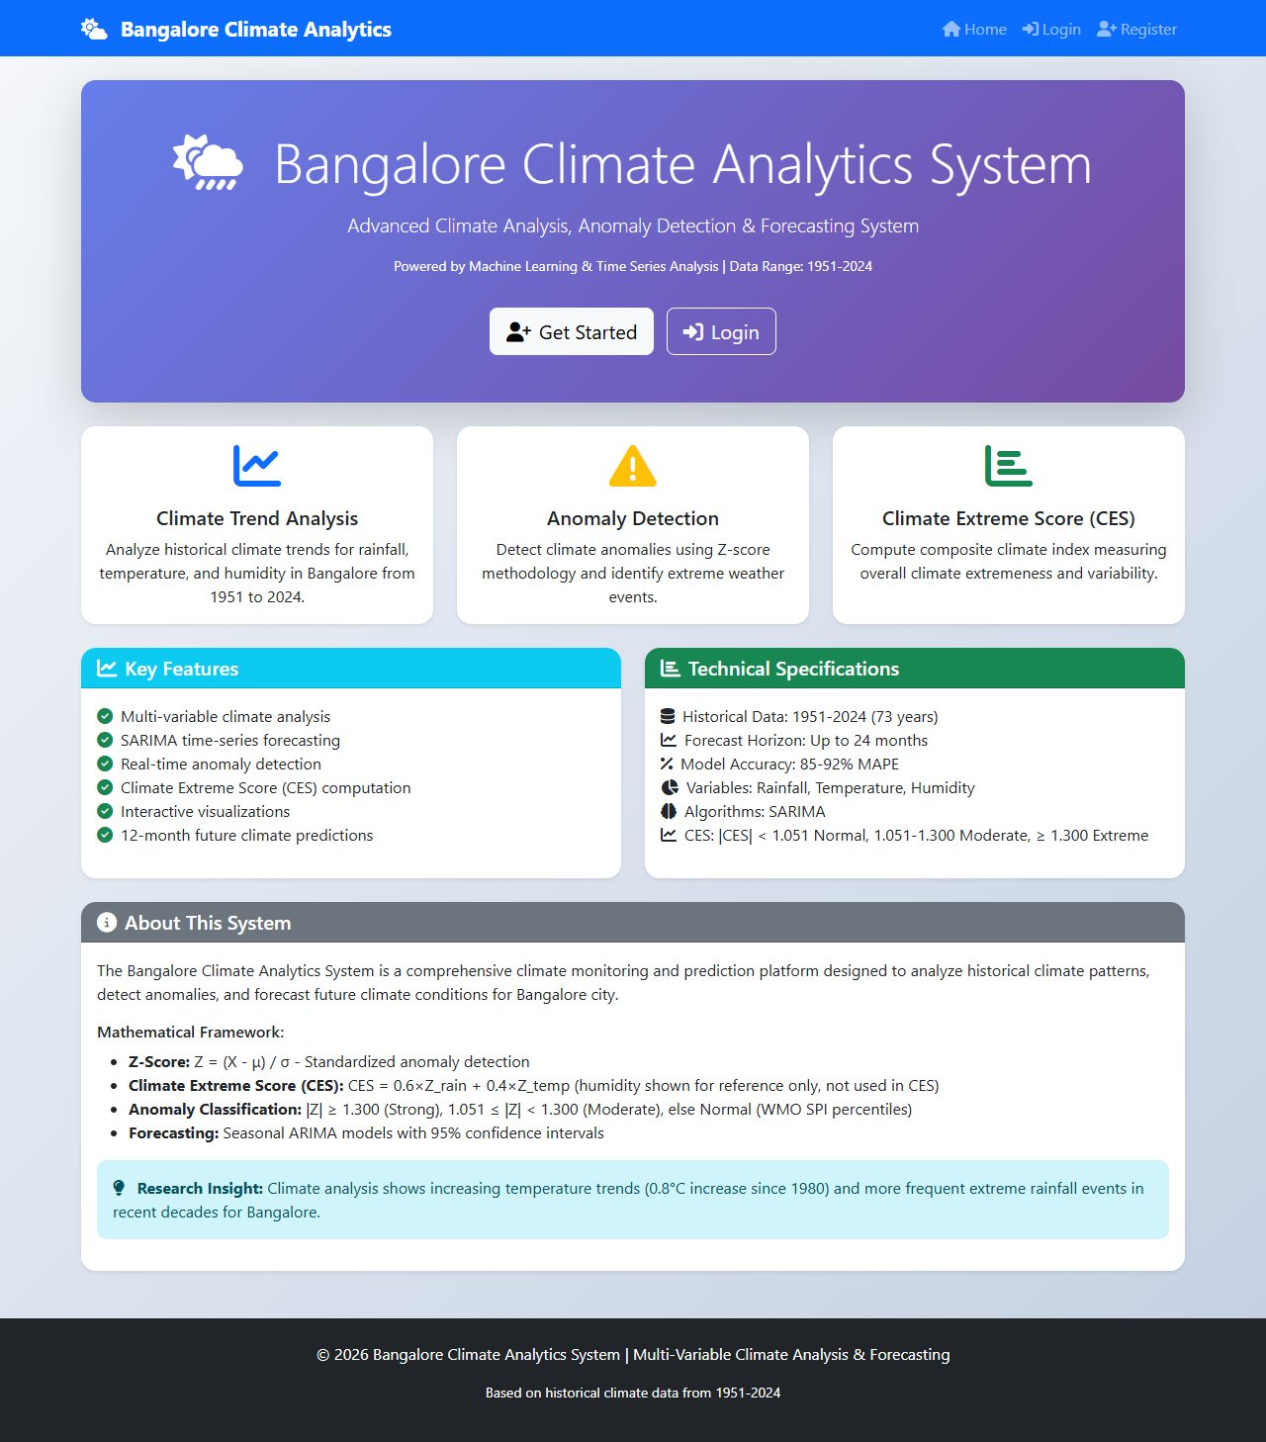
Figure 14.1 Home page (corrected formula and thresholds)
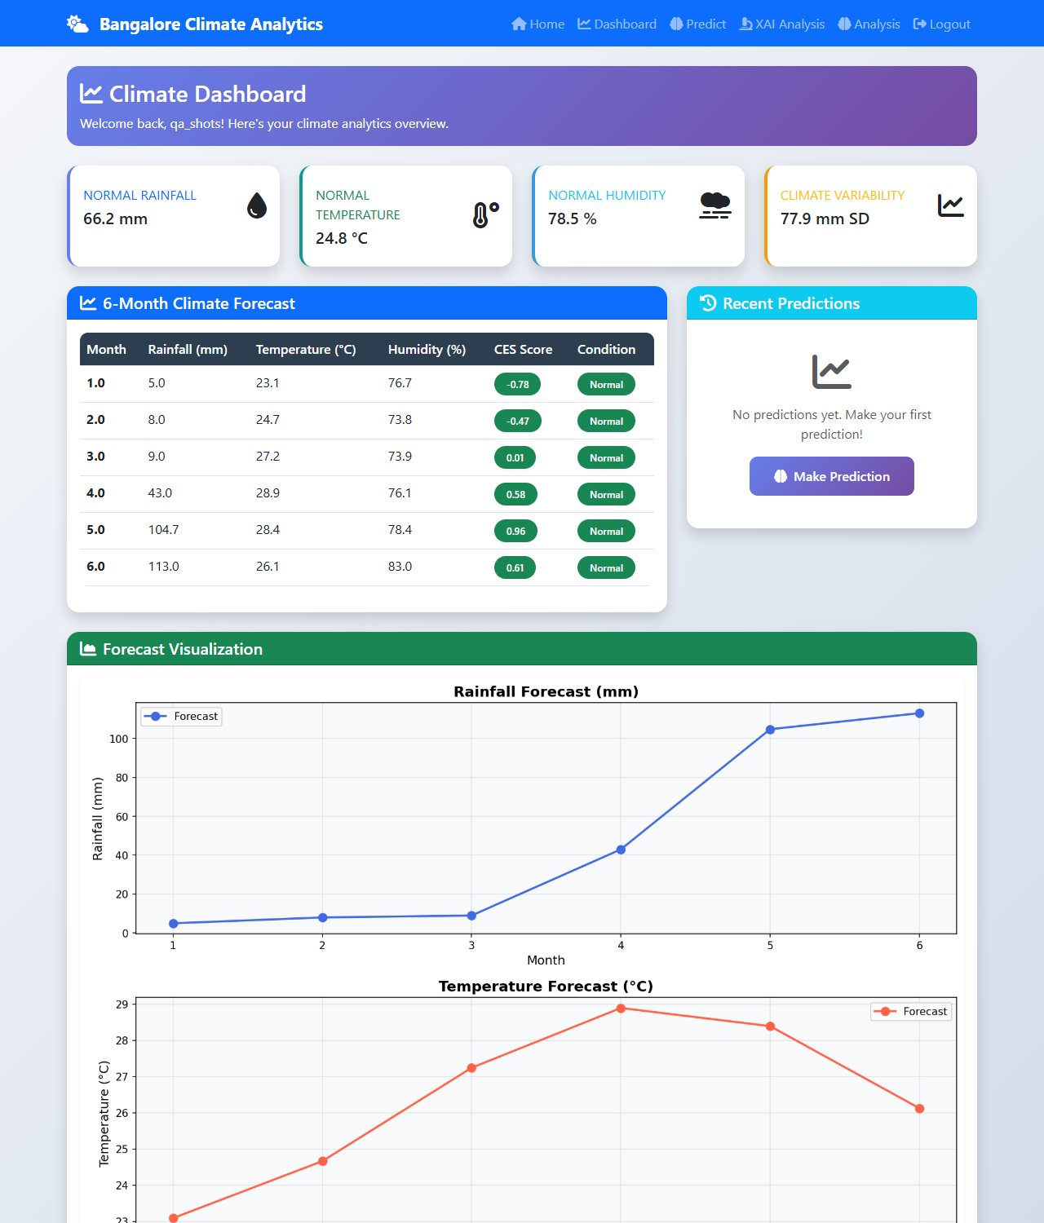
Figure 14.2 Dashboard with the 6-month SARIMA forecast
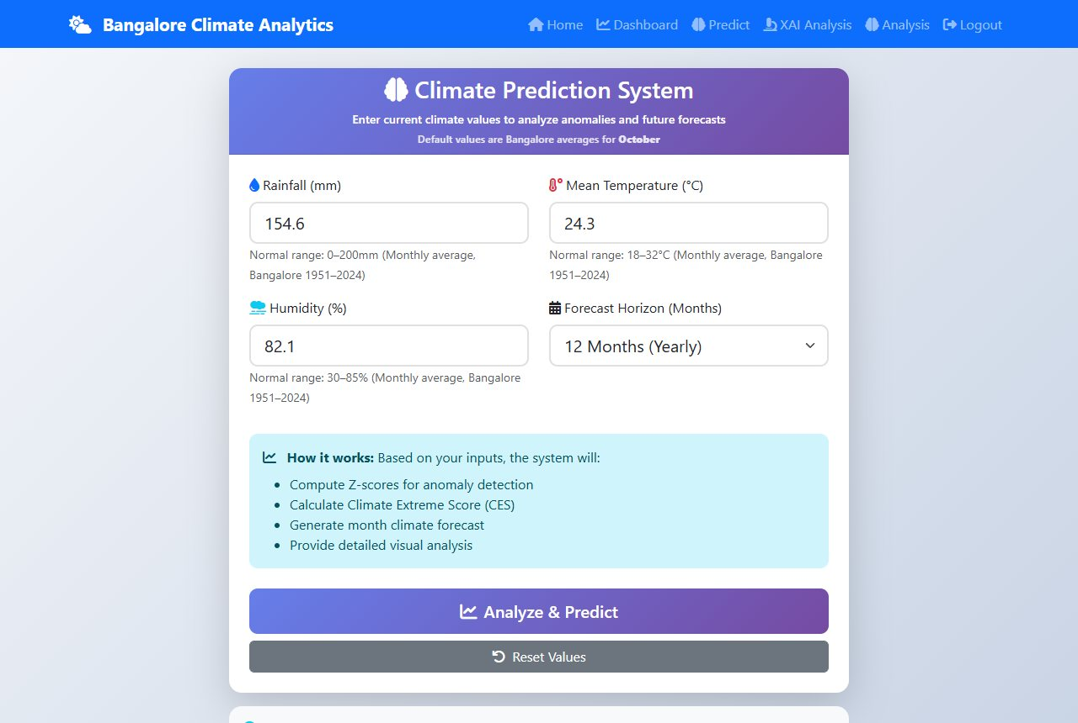
Figure 14.3 Prediction input form
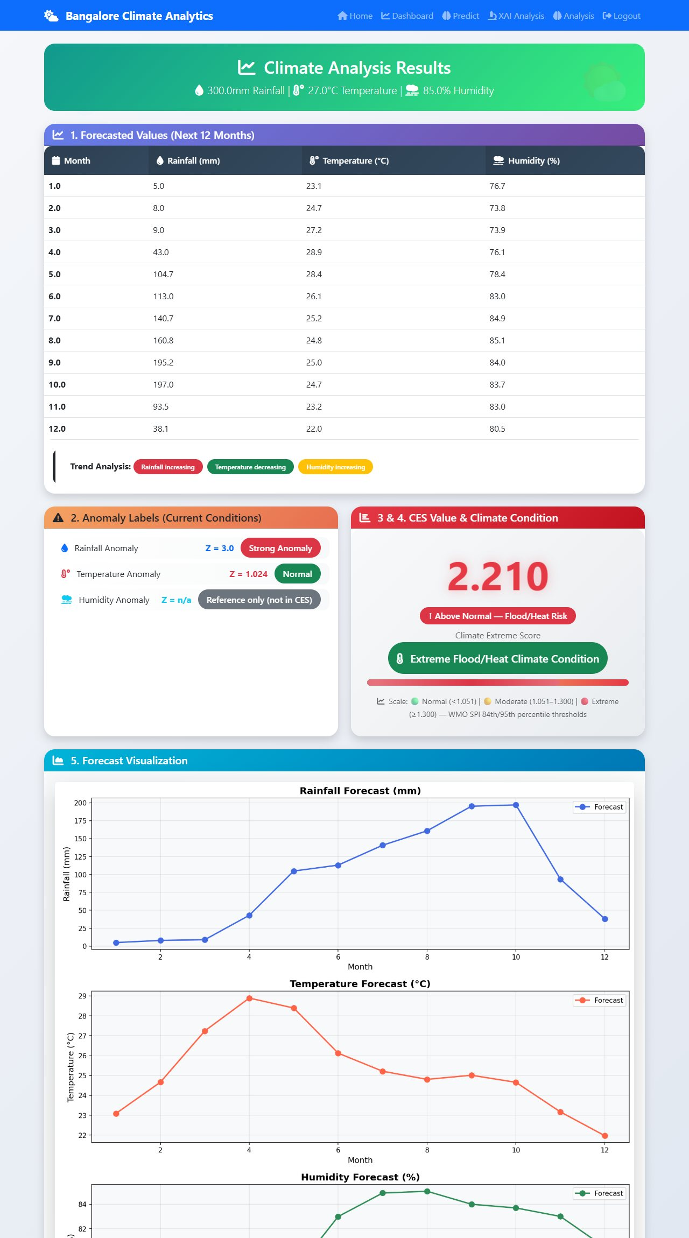
Figure 14.4 Result page for 300 mm, 27 C, 85 percent: CES 2.21, Extreme Flood/Heat
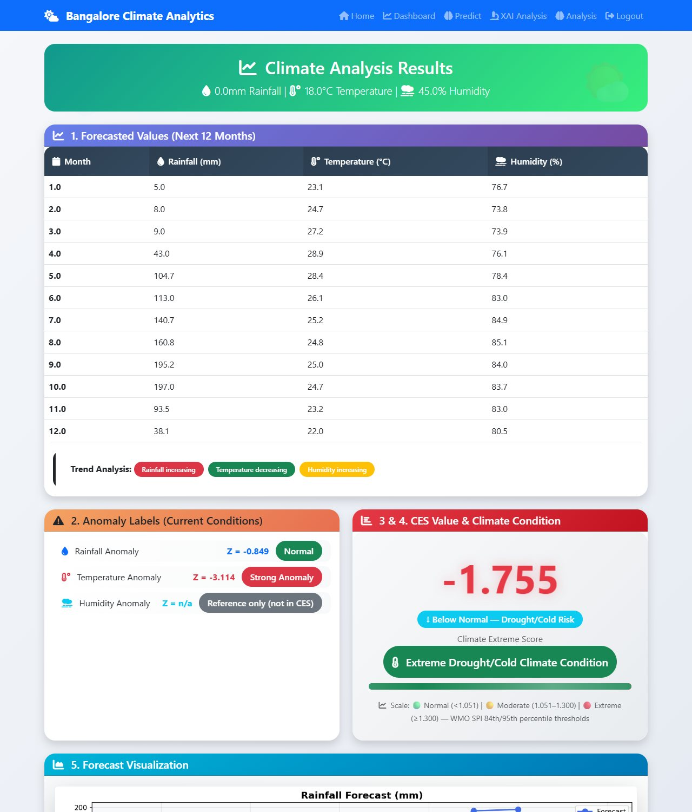
Figure 14.5 Result page for 0 mm, 18 C, 45 percent: CES -1.755, Extreme Drought/Cold with direction label
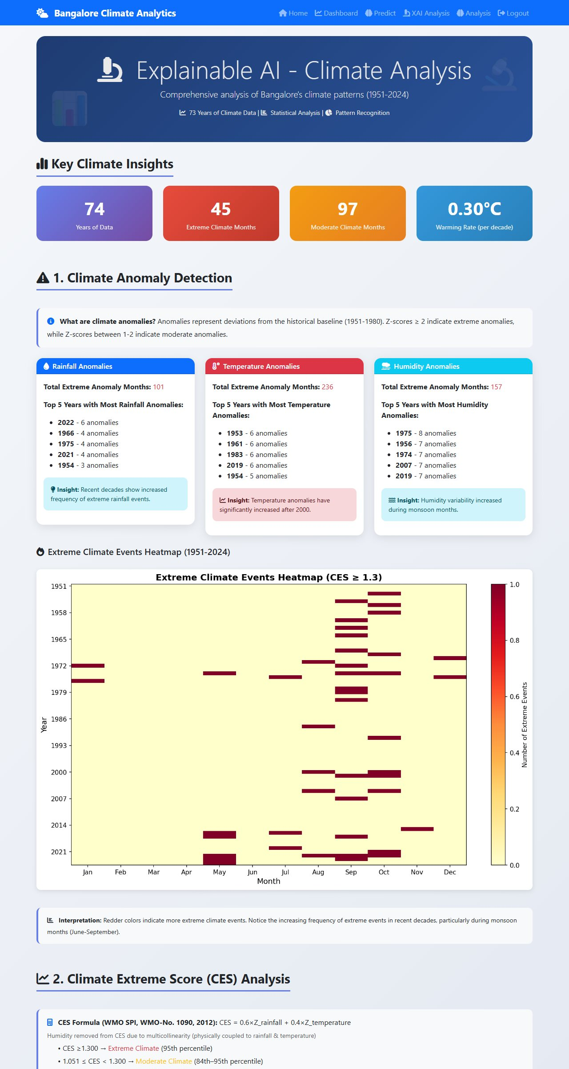
Figure 14.6 Explainable-AI page
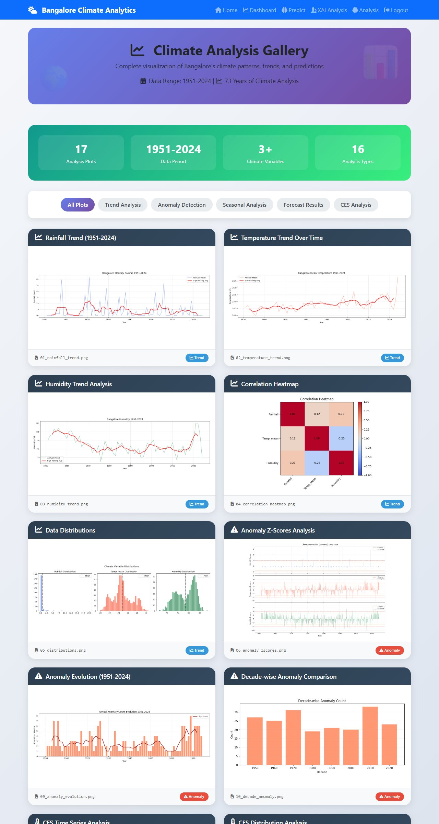
Figure 14.7 Historical analysis gallery
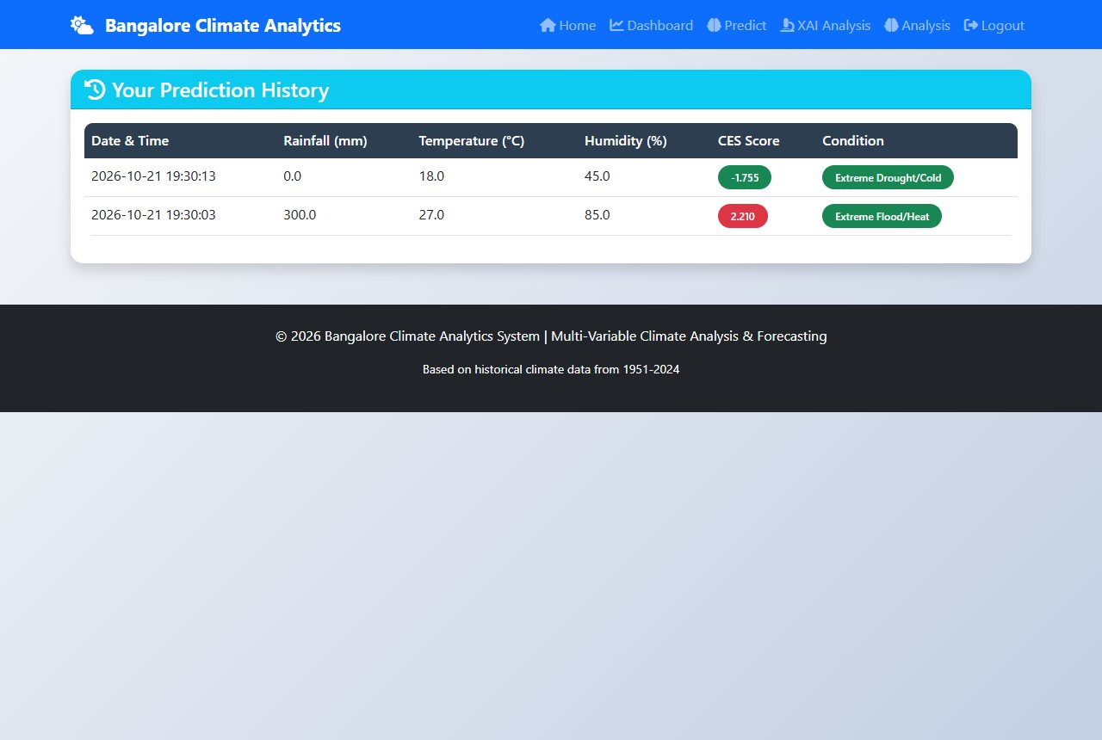
Figure 14.8 Prediction history
Bangalore Climate Analytics System | Generated: 16 June 2026 | Python + Flask + SARIMA + WMO SPI

