NAME: - MANASA M K

REGISTRATION NUMBER - 211039034

Q1) Assume a 32-bit number in 40000004H. Add nibble4 and nibble0 and store the result in 4000000CH.

;Implement an ASM Program for the following. Assume a 32-bit number in 40000004h.

;Add nibble 4 and nibble 0 and store the result in 4000000Ch.

AREA ADD_nibble,CODE,READONLY

ENTRY

MAIN

LDR R5, NUMBER ; Load the Address value assigned to the number

LDR R4, [R5] ; Load the content stored in R5 into R4

MOV R6, #0X0000000F ; Here we are using mov instruction and we are masking the value(0x0000000F) for selecting Nibble0

MOV R7, #0X000F0000 ; Here we are using mov instruction and we are masking the value(0x000F0000) for selecting Nibble4

AND R3, R4, R6 ; Using AND operator add the original number with masked value to select Nibble0 value

AND R2, R4, R7 ; Using AND operator add the original number with masked value to select Nibble4 value

LSR R2,R2,#16 ; LogicalShiftLeft R2 register content to move it to LowestNibble

ADD R1, R3, R2 ; Add both the nibble values and Store in R1

LDR R5,RESULT

STR R1,[R5] ; Loading the value of result to mentioned address location

SVC &11 ; SuperVisor Call

NUMBER DCD &40000004

RESULT DCD &4000000C

END

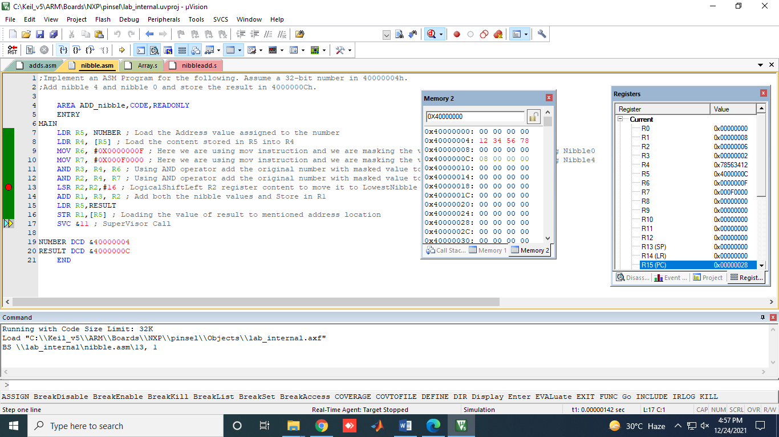

2)  Consider an array of number present from 40000000H. Add only if the numbers are positive. 40000000H has the count of the array.

AREA ADD_ARRAY,CODE,READONLY   
ENTRY   
MAIN   
LDR R0,TABLE ; In the table first value is count followed by array elements   
LDR R2,[R0] ;Load the count   
EOR R3,R3,R3 ;Clear Register R3 for storing sum of positive elements   
LOOP   
CMP R2,#0  ; Compare count with Zero   
BEQ DONE   
LDR R1,[R0,#4]!  ;Load the array elements to R1 register   
CMP R1,#0  ;Compare R1 register content with 0   
BMI LOOP1  ;If the number is negative then Branch to Loop1 and   
;decrement the count   
;BMI - Branch if minus ; It checks the Negative Flag if it is set Branch to Loop1   
ADD R3,R3,R1  ;If the number is positive Add it with R3 register content   
SUB R2,R2,#1  ;Decrement the count   
B LOOP   
LOOP1   
SUB R2,R2,#1   
CMP R2,#0   
BEQ DONE   
BNE LOOP   
DONE LDR R4,RESULT   
STR R3,[R4]  ;Load the Result in R3 to desired location   
STOP B STOP   
   
TABLE DCD &40000000   
RESULT DCD &4000003C   
END

