To integrate Postman execution via Jenkins

1. Invoke Jenkins ( applicable for local setup ) ( enabled UTF-8 encoding )

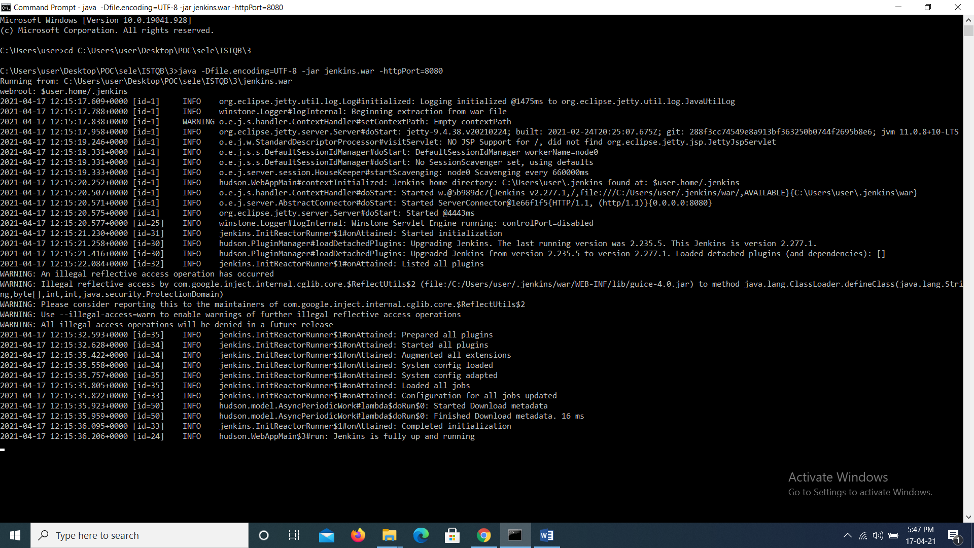

1. Login into Jenkins and create a Freestyle Project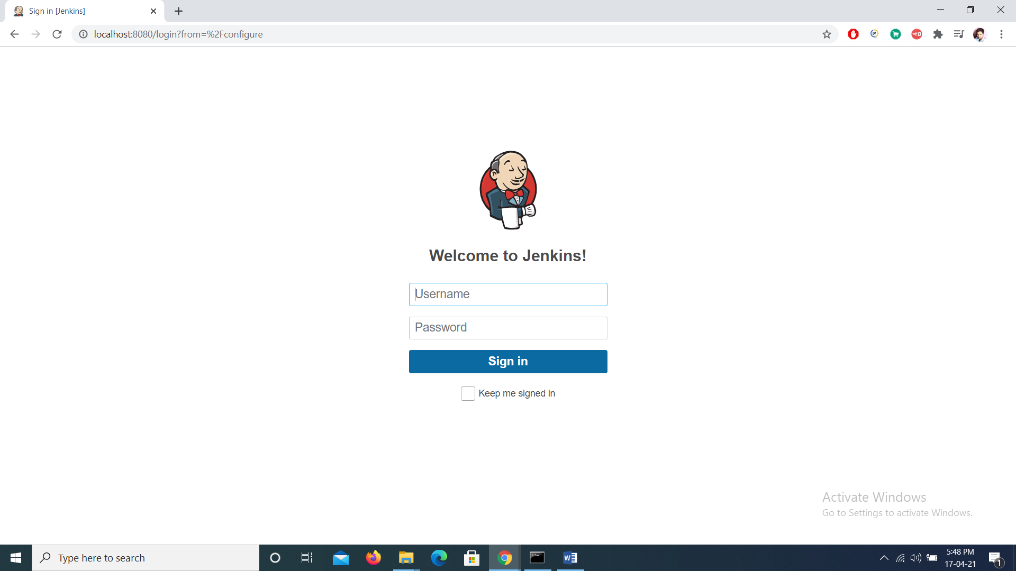

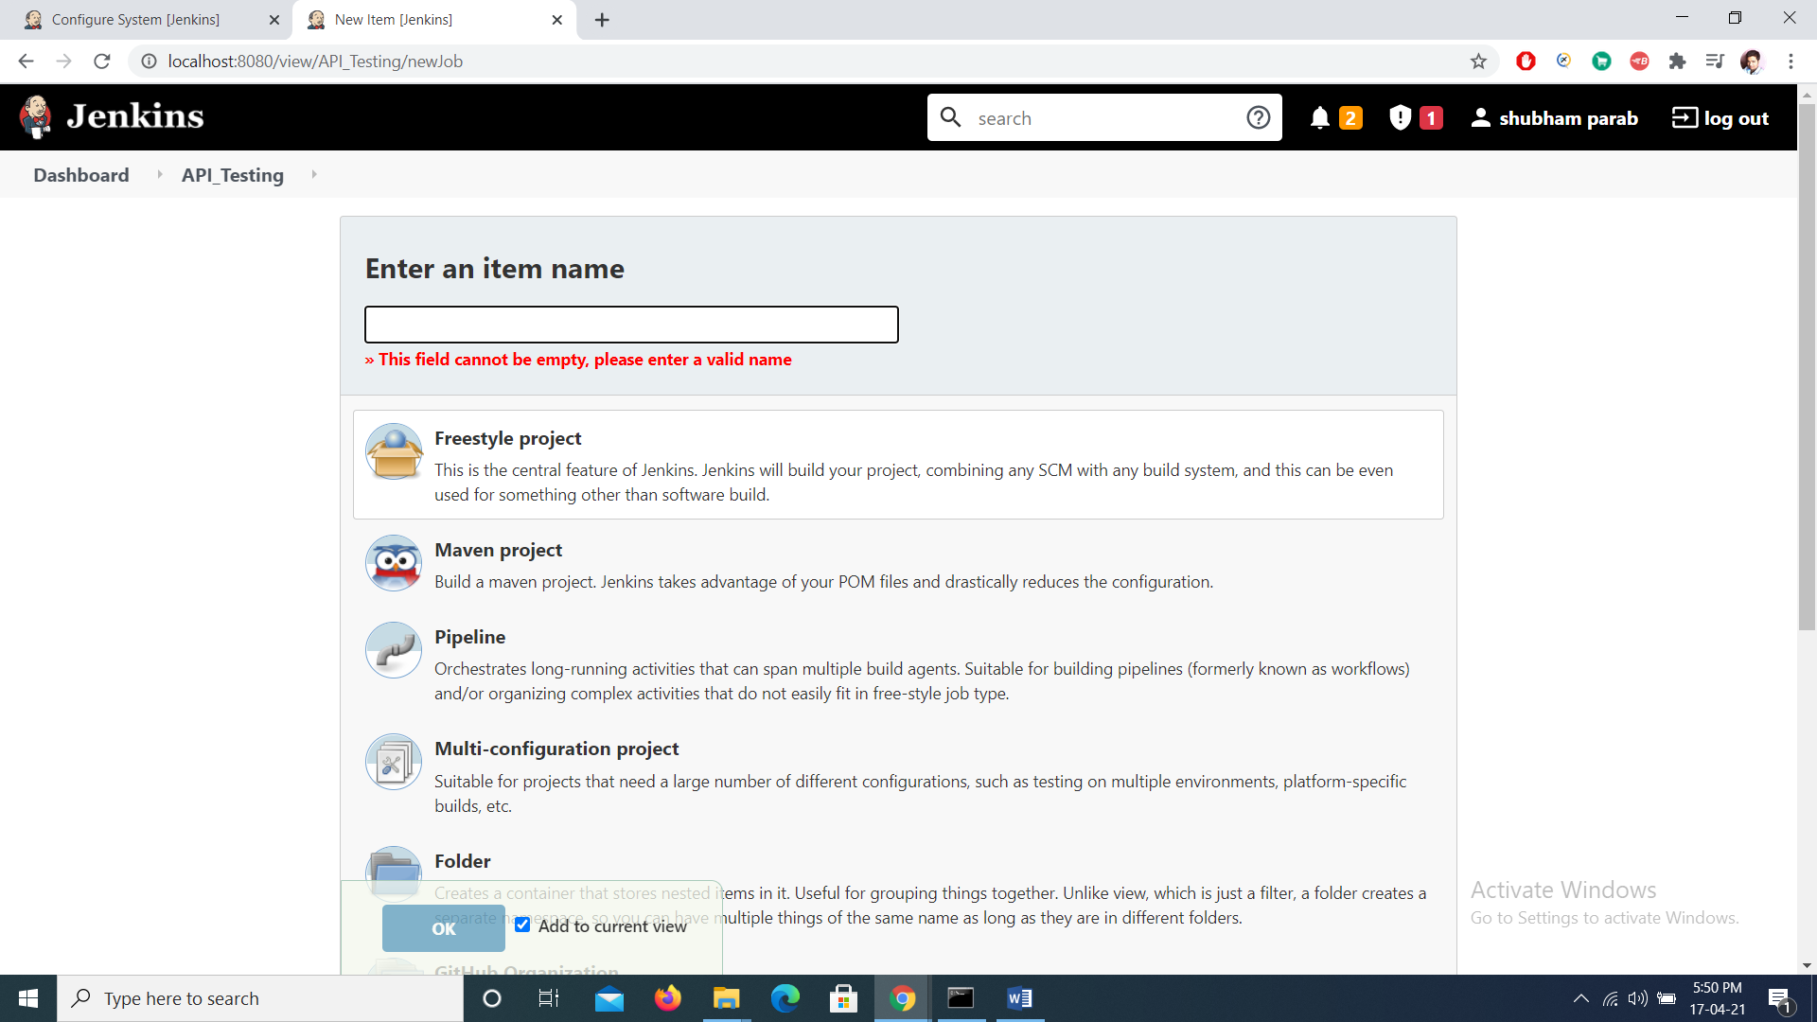

1. Once Project is created do following configuration changes
2. From dashboard

Manage Jenkins -> Configuration Settings ( set env path as per given in your local system )

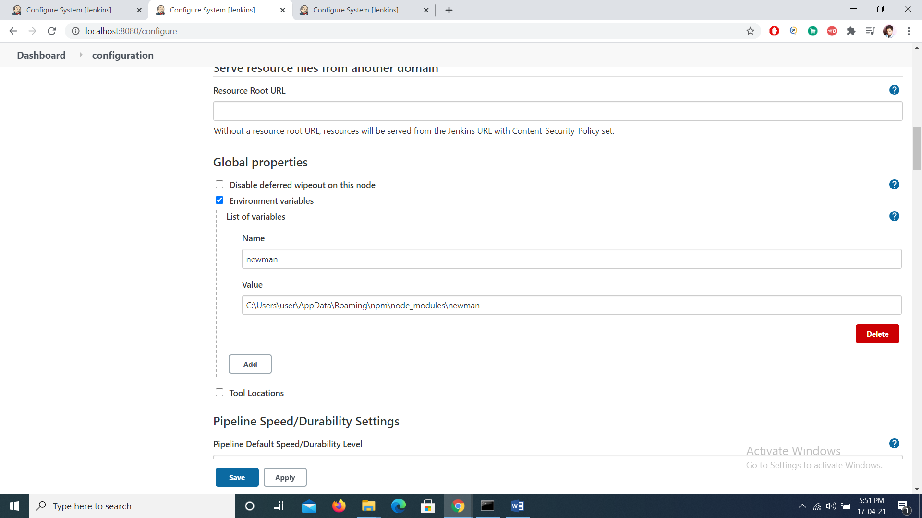

1. Global Configuration

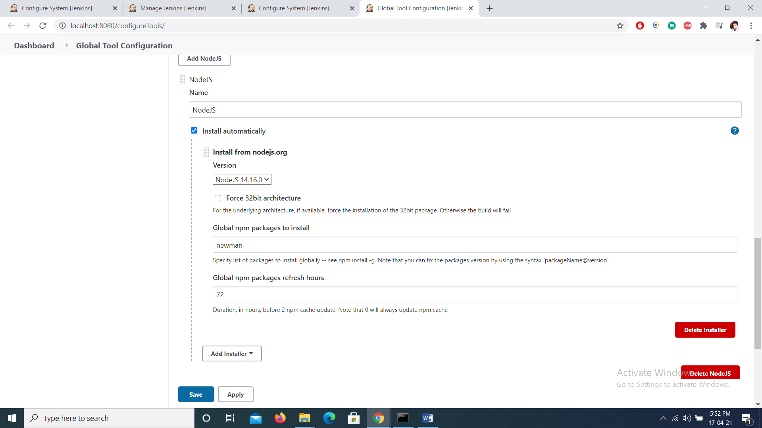

1. Configure Project for Execution

Select Windows execute shell ( for windows ) or execute shell ( unix )

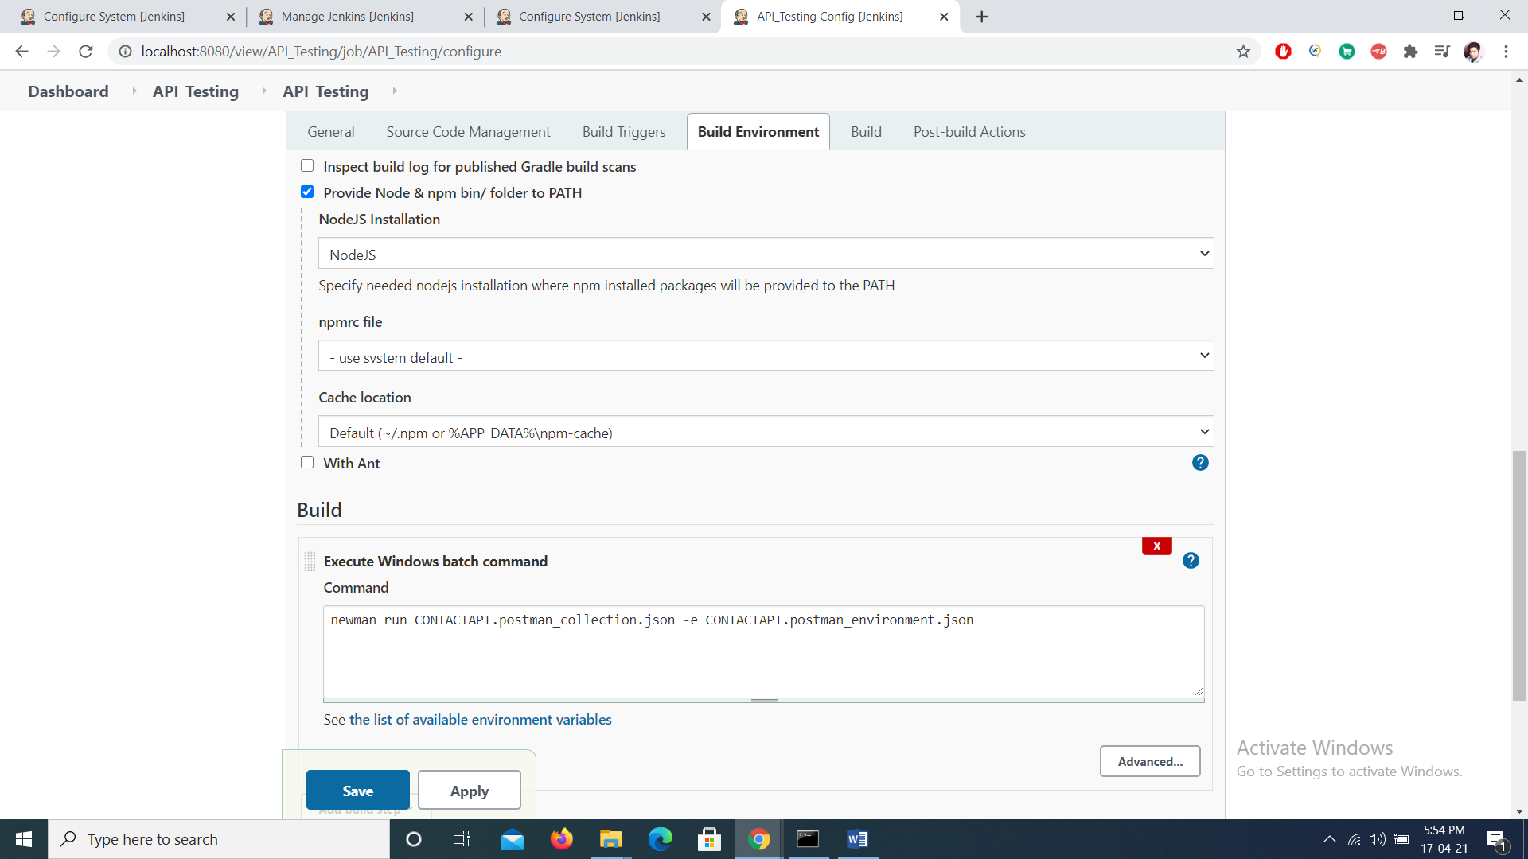

Apply and save .

Click on Build now

Console Will be viewable in project ( go to build -> Console Output )

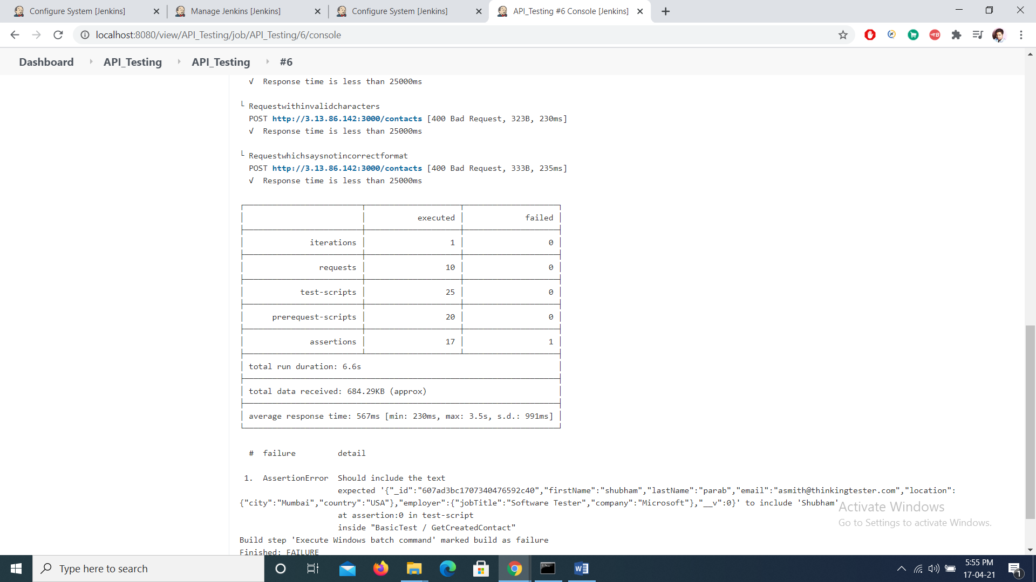

**Note : This Document just gives a basic demo of integration with Jenkins**

We can further configure nodes js installed in Jenkins by installing several packages like

Newman reporter for generating html reports

To install these packages just add following commands

**npm install –g newman-reporter-html**

**npm install –g newman-reporter-htmlextra**