ASSIGNMENT-9.3

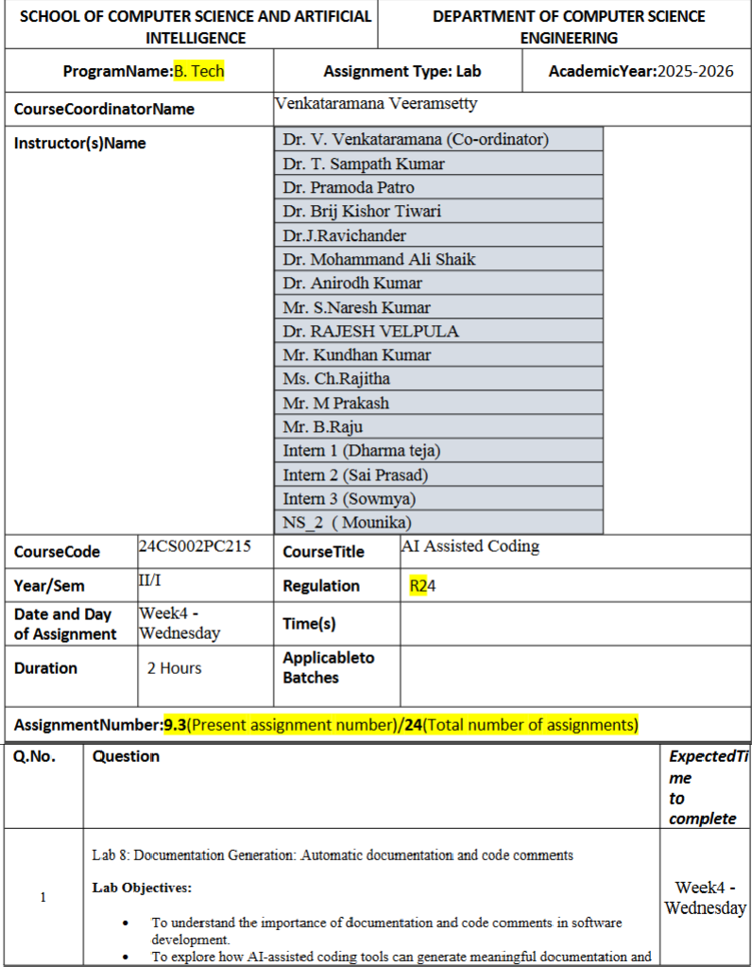

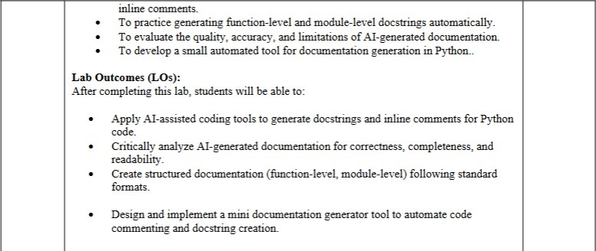

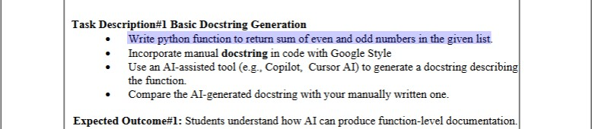

prompts :

1. Write python function to return sum of even and odd numbers in the given list user defined with out doc string
2. add doc string erasing my docstring

code::

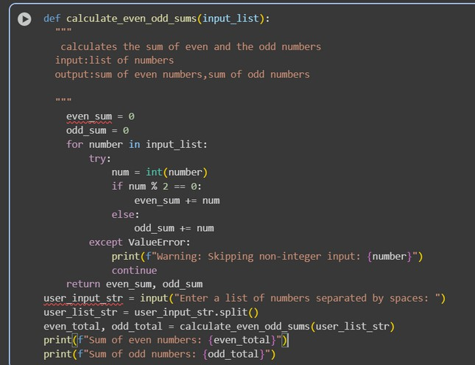

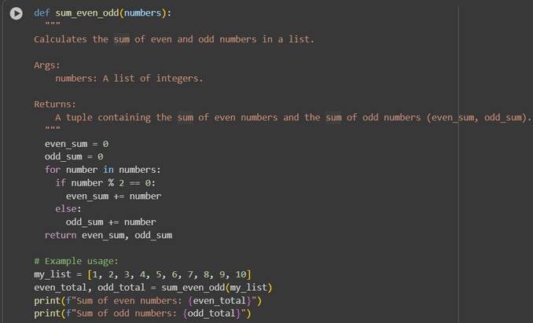

output:

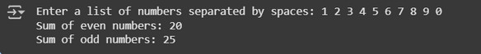

observations and code expalnation

1. Manual docstring is short and simple, while AI docstring is detailed and structured.
2. Manual explains input/output in plain words, AI uses standard Google Style format.
3. Manual is easy to write quickly, AI looks professional and formal.
4. Manual may lack data types and clarity, AI clearly specifies arguments and return values.
5. Manual is suitable for small assignments, AI is better for real-world coding practices.

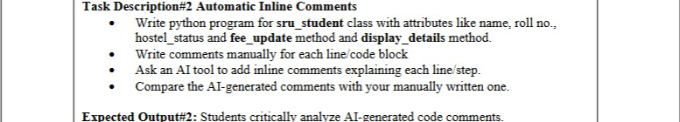

prompts :

* 1. Write python program for sru_student class with attributes like name, roll no., hostel_status and fee_update method and display_details method with out comments or doc string user defined without comments and with user input
  2. now remove my manually added comments and add your comments

code:

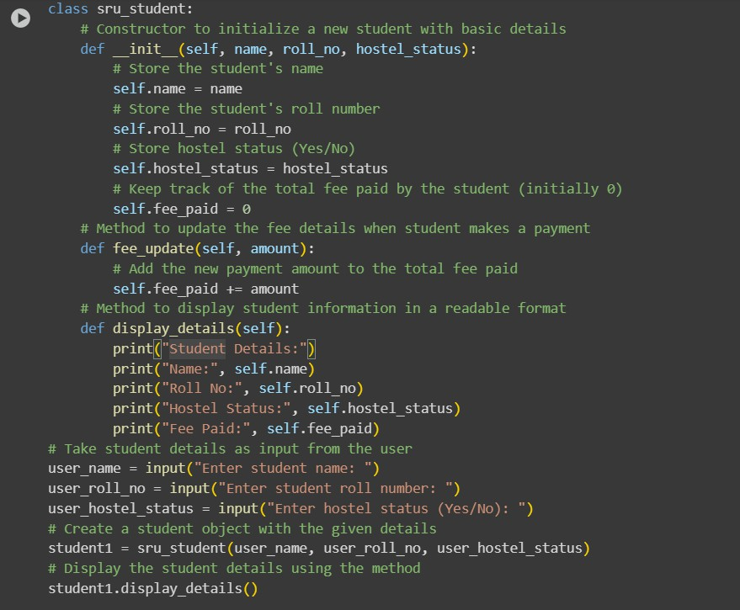

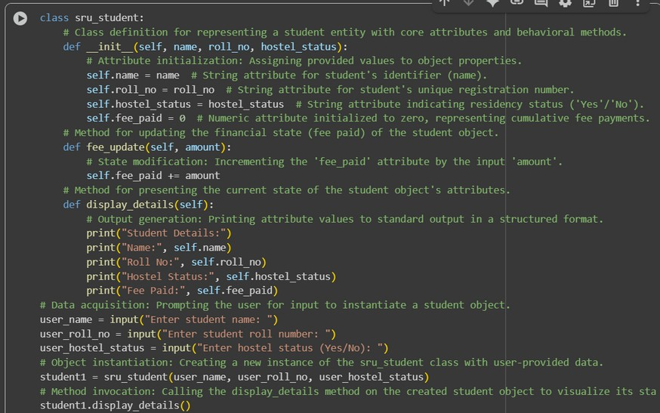

output:

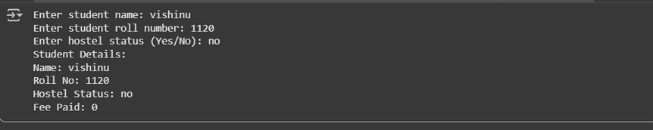

observations and code expalnation

 Manual comments are conversational, while AI comments are formal and technical.

 Manual focuses on explaining the purpose, AI focuses on describing each step.

 Manual feels natural for beginners, AI feels structured but robotic.

 Manual is better for learning/exams, AI is better for professional projects.

 Manual may miss standardization, AI may miss the “why” behind the code.

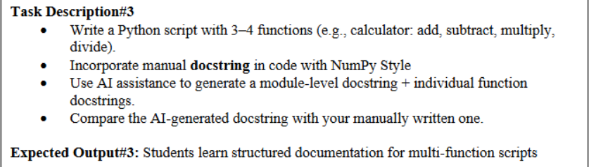

prompts :

1. Create a python function with multiple functions such as a calculator take input from user.
2. Generate module level docstring and individual function docstrings.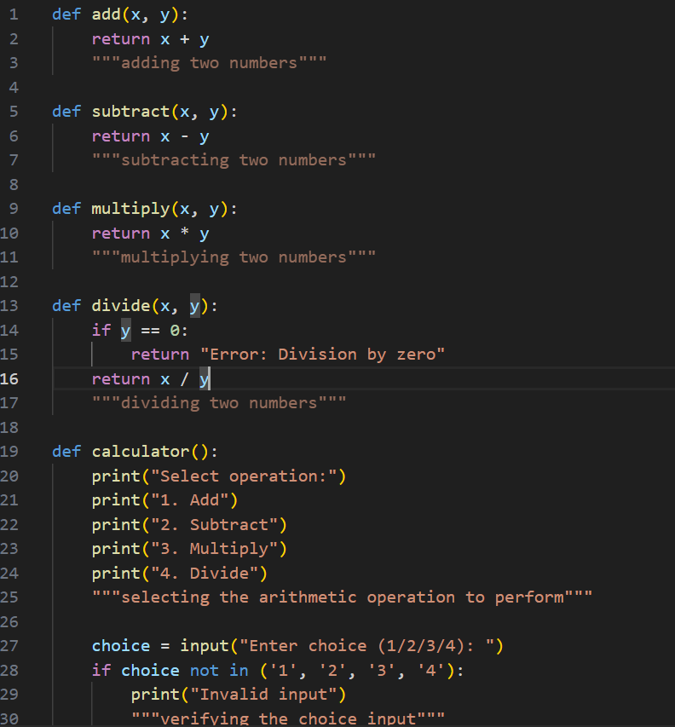

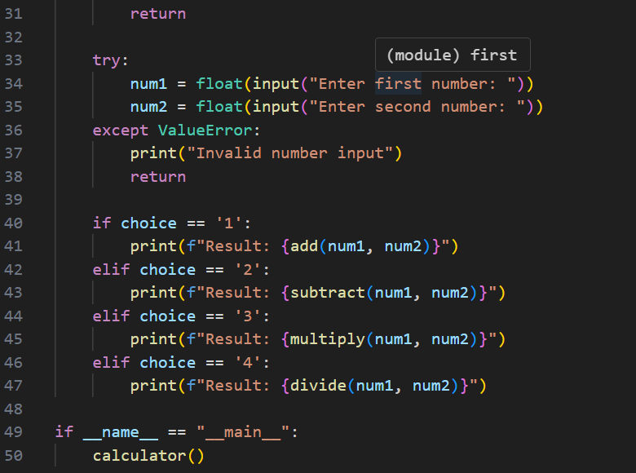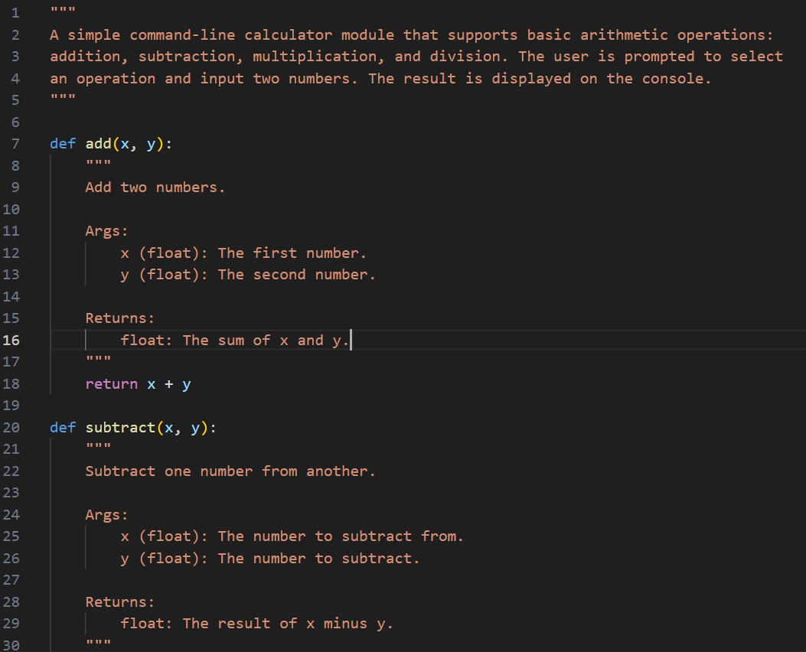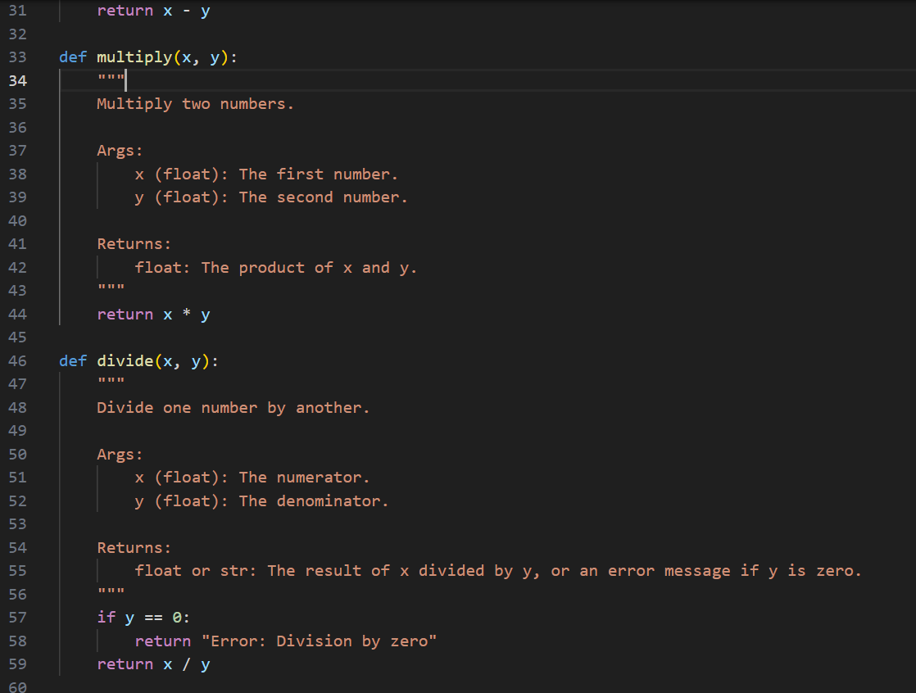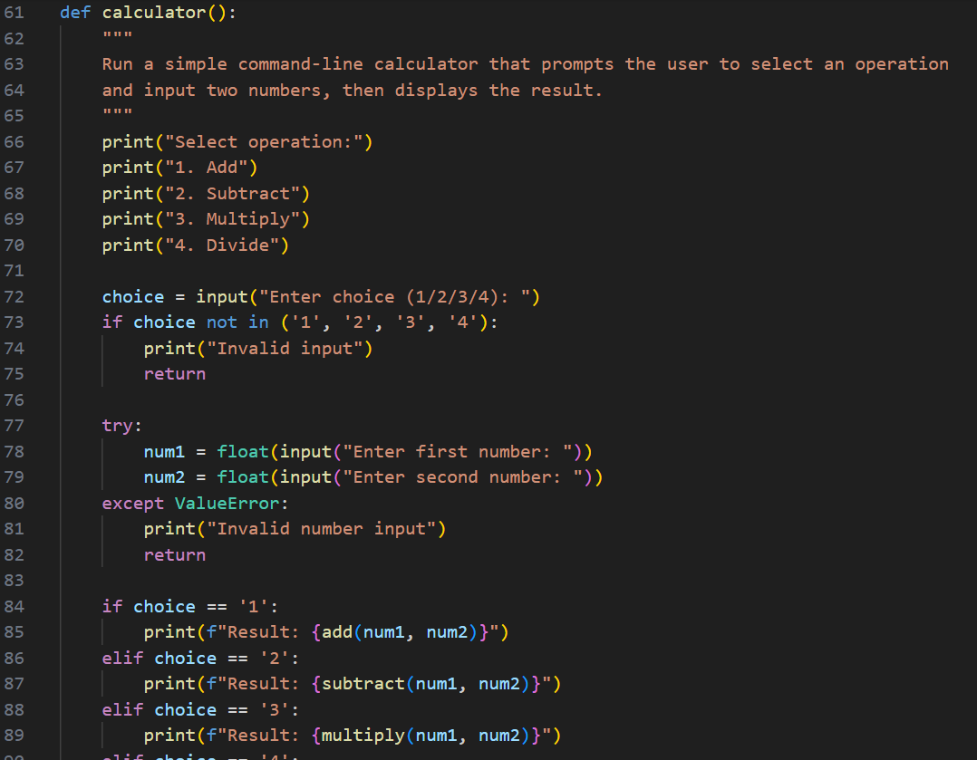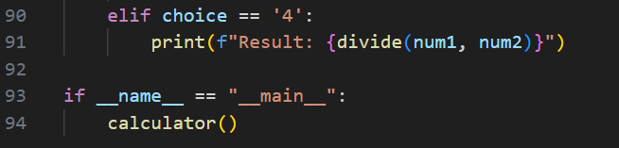

output:

