Amazon Product Reviews Analysis Dashboard
Introduction
This project analyzes Amazon customer reviews using Power BI to understand customer satisfaction and rating patterns.

Dataset
- Source: Kaggle
- Total Records: 568,454

Objectives
- Analyze customer ratings
- Identify review distribution
- Visualize customer behavior

Dashboard Components
- Total Reviews
- Average Rating
- Highest Rating
- Five-Star Reviews
- Bar Chart
- Pie Chart
- Rating Filter
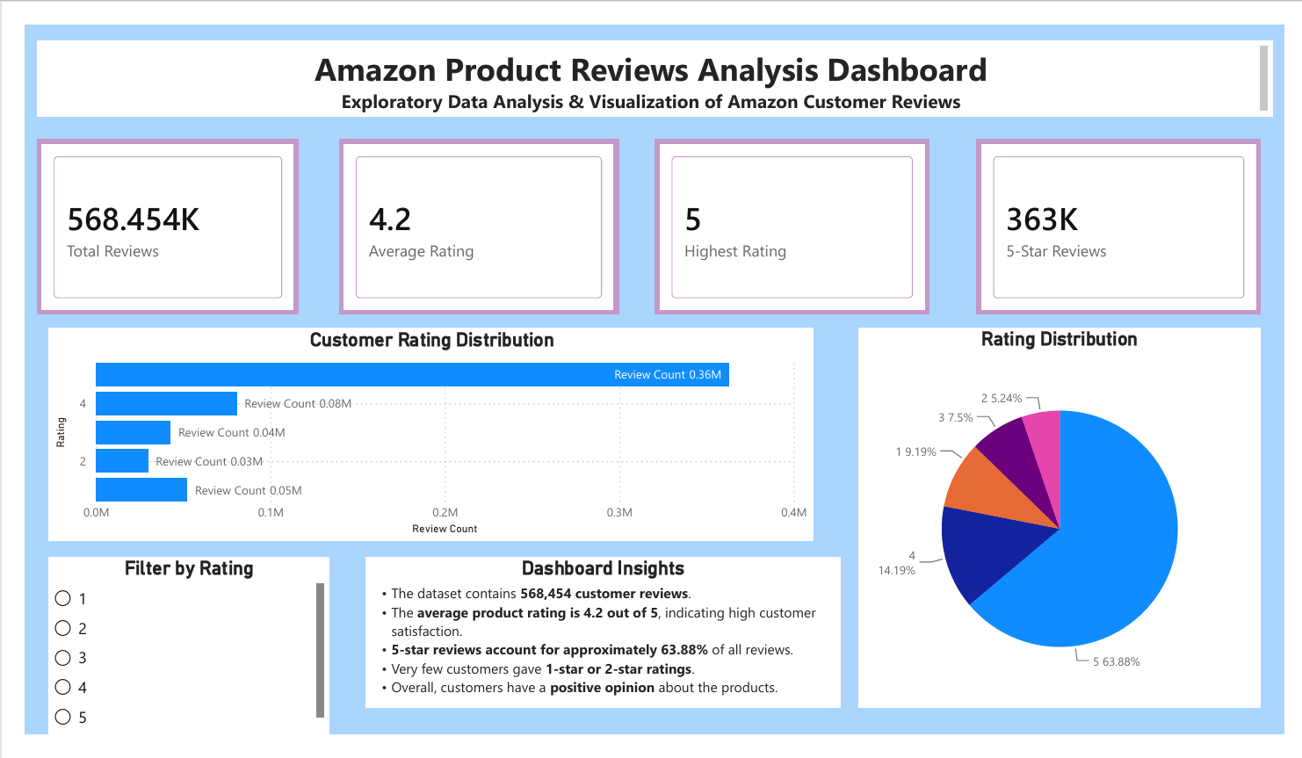

Findings
- Average rating is 4.2.
- Majority of customers gave 5-star ratings.
- Overall customer satisfaction is high.

Conclusion
Power BI helped transform raw review data into an interactive dashboard, making it easier to identify trends and customer satisfaction levels.

