Movie Ratings Analysis for RSVP Movies

**Dataset Overview**

The database contains multiple tables:

* movie: Core movie information (title, year, country, etc.)
* ratings: Average and median ratings plus vote counts
* genre: Movie genres
* director_mapping: Links directors to movies
* role_mapping: Links actors/actresses to movies
* names: Information about directors and actors

**Key Insights**

**1. Data Volume Analysis**

**Table Row Counts:**

* Movie: 7997 rows
* Ratings: 7997 rows
* Genre: 14662 rows
* Director Mapping: 3867 rows
* Role Mapping: 15615 rows
* Names: 25735 rows

**Null Values in Movie Table:**

* Country: 20 nulls
* Worldwide Gross Income: 3724 nulls
* Languages: 194 nulls
* Production Company: 528 nulls

**2. Release Trends**

**Monthly Movie Release Distribution:**

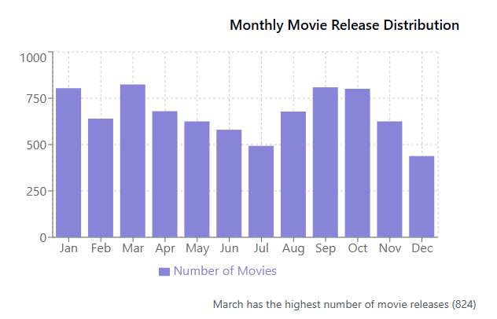

**Finding:** March shows the highest movie release frequency (824 movies), while December has the lowest (438 movies).

**3. Genre Analysis**

**Top Genres by Movie Count:**

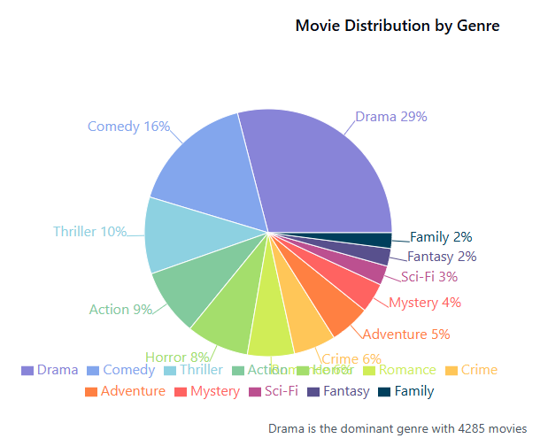

**Key Findings:**

* Drama is the dominant genre (4285 movies)
* Comedy is second (2412 movies)
* Thriller ranks third (1484 movies)
* 3289 movies belong to only one genre

**4. Genre Duration Analysis**

**Average Duration by Genre:**

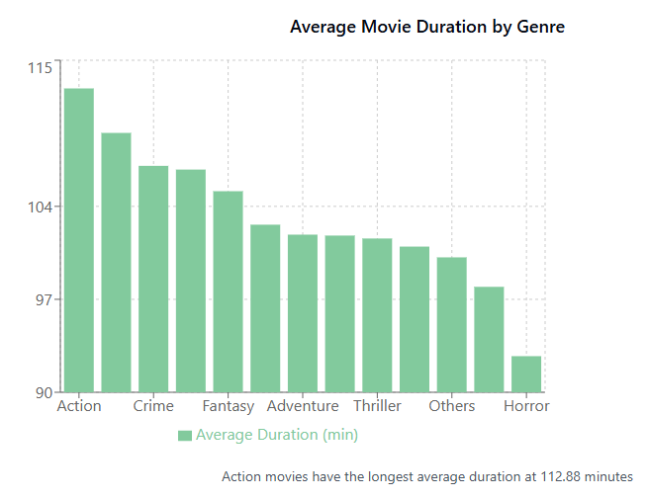

**Finding:** Action movies have the longest average duration (112.88 minutes), while Horror films have the shortest (92.72 minutes).

**5. Rating Analysis**

**Movies by Median Rating:**

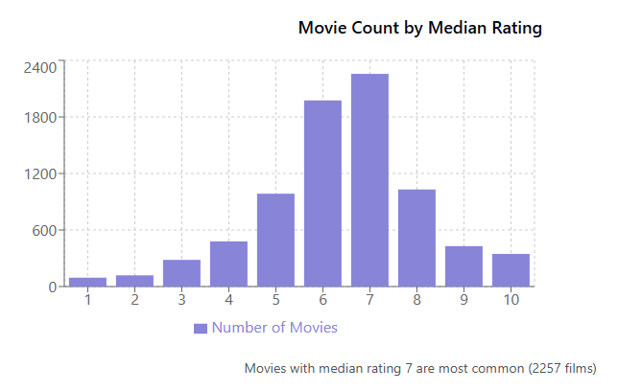

**Finding:** Most movies have a median rating of 7 (2257 films), suggesting audiences generally rate films favorably.

**6. Production House Analysis**

**Top Production Houses with High-Rated Movies:**

* Dream Warrior Pictures leads with 3 high-rated movies (avg rating > 8)
* National Theatre Live also has 3 high-rated movies

**7. Language and Country Analysis**

**Regional Success:**

* German movies average 746.99 votes per movie
* Italian movies average 438.56 votes per movie

**Top Indian Actors by Average Rating:**

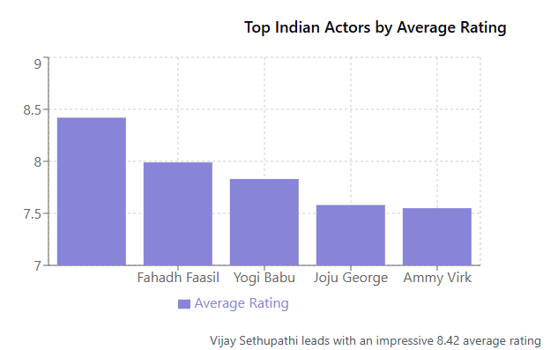

**Top Hindi Actresses by Average Rating:**

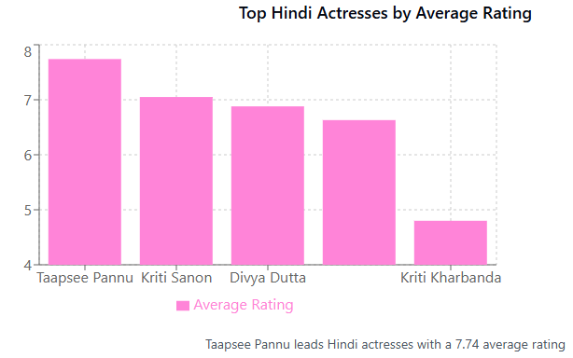

**8. Director Analysis**

**Top Directors for High-Rated Movies in Top 3 Genres:**

* James Mangold (4 movies)
* Anthony Russo (3 movies)
* Soubin Shahir (3 movies)

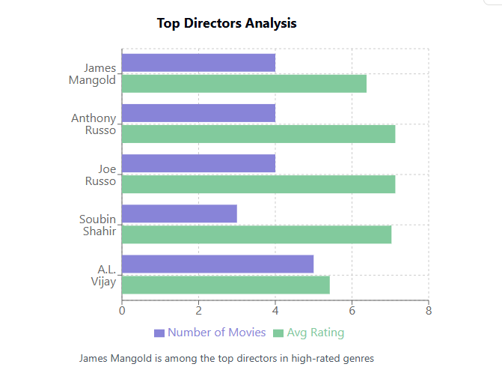

**9. Box Office Analysis**

**Top Grossing Movies by Genre (2019):**

* Drama: "Avengers: Endgame" ($2,797,800,564)
* Comedy: "Toy Story 4" ($1,073,168,585)
* Thriller: "Joker" ($995,064,593)

## Strategic Recommendations for RSVP Movies (Insights)

1. **Genre Selection:** 
   * Focus on Drama as the primary genre (highest movie count)
   * Consider Drama-Thriller or Drama-Comedy hybrid genres for broader appeal
2. **Release Timing:** 
   * Target March or September for release (highest movie frequency)
   * Avoid December (lowest release numbers)
3. **Talent Acquisition:** 
   * Consider top-rated Indian actors like Vijay Sethupathi (8.42 avg rating)
   * For Hindi segments, consider Taapsee Pannu (7.74 avg rating)
   * James Mangold would be an excellent director choice for high ratings
4. **Production Partnerships:** 
   * Explore collaborations with Marvel Studios (highest vote count)
   * Dream Warrior Pictures or National Theatre Live for quality productions
5. **Movie Duration:** 
   * For Drama films, aim for approximately 107 minutes
   * For multi-genre films, adjust based on secondary genre averages
6. **Target Rating:** 
   * Focus on creating content worthy of a rating of 7+ (most common rating range)
   * Quality threshold of 8+ for "superhit" status

The analysis clearly shows that while Drama dominates the market, incorporating elements of Thriller or Comedy could help reach a wider audience. Partnering with established production houses and utilizing talent with proven track records will increase chances of success in the global market.